 CHEMICAL ENGINEERING TRANSACTIONS  VOL. xxx, 2026 | A publication of  
The Italian Association
of Chemical Engineering
Online at www.cetjournal.it

Guest Editors: Valerio Cozzani, Bruno Fabiano, Genserik Reniers
Copyright © 2026, AIDIC Servizi S.r.l.
ISBN 979-12-81206-xx-x; ISSN 2283-9216

3D Fire Detection Mapping Assessment for Oil & Gas Industries: the life cycle from the engineering phase to the plant operation
Roberta Miglionico*, Annamaria di Padova, Fabrizio Tallone
Saipem, Loss Prevention and Environment Department, Energy Carriers, Via Toniolo 1, 61032, Fano, Italy
roberta.miglionico@saipem.com
The design of Fire and Gas Detection System (FGDS) is by now a consolidated practice in the Oil & Gas industries. Excluding the building application (covered by specific standards), the design of the FGDS in terms of type, location, and number of the field fire and gas detection devices has been left to the single Oil & Gas Company Standards and Codes. Current discussions within the international community focus on how the FGDS should be designed so that it can be considered as a truly effective safety measure, capable of reducing the frequency of occurrence and/or the magnitude of the accidental event. In this context, the effectiveness of the FGDS depends not only on the reliability of its hardware and software, but also on the level of detection coverage it is able to ensure. Detection coverage is usually evaluated by analysing the overlap of coverage area of single detectors, while also considering blockage effects caused by structures, equipment, and piping. The detection coverage degree is defined as the ratio between the volume covered by detectors (detected volume) and the volume where the hazard can occur (risk zone). This paper focuses on the aspects of fire coverage degree, which can be evaluated by a 3D Detection Mapping Assessment (3DMA). The paper highlights how the flame Field of View (FOV) may be impaired in case of obstacles or improper installation and analyses the FGDS engineering life cycle from the definition of fire zones, the fire detectors voting for automatic alarms and Emergency Shut-Down (ESD) system activation, the impact on process solutions for shut-down and blowdown activation and the relevant 3DMA to the fire detectors installation and operation.
  - Introduction
The Oil & Gas industry is inherently associated with a variety of hazards, such as fire, explosion, toxic releases, and environmental contamination, primarily due to the specific properties and nature of the flammable, combustible, and hazardous fluids handled within its operations. In this context, an effective risk reduction strategy is crucial to protect personnel, assets, and the environment while also ensuring regulatory compliance and operational continuity. Risk reduction techniques in the Oil & Gas sector are generally classified according to their primary function within the risk management process. Two main categories can be identified: preventive measures and mitigation measures. The preventive measures aim to reduce the likelihood of a potentially hazardous event. They focus on preventing incidents before they happen by addressing root causes, improving operational controls, and minimizing exposure to hazards. Instead, mitigation measures are designed to minimize the impact or severity of an incident should it occur. They do not prevent the event itself but limit its effects on people, assets, and the environment.
Fire and Gas Detection Systems (FGDS) are widely adopted in the Oil and Gas industry as risk reduction measures and are designed to mitigate the consequences of an accidental release of hazardous substances (Flammable and Toxic Gas Detection), and that could lead to fire (Fire Detection). However, for a FGDS to be effective, it must be properly designed, installed and operated, focusing both on performance and reliability. Excluding the building applications, which are covered by specific technical standards such as NFPA 72, UNI 9795, the design of the FGDS in terms of type, location and number of the field fire and gas detection devices has been left to the single Oil & Gas Company Standards and Codes. In particular, flame detectors design in plant areas often face critical challenges during installation and operation. Improper installation, such as incorrect positioning or inadequate alignment, can significantly reduce detection reliability. Additionally, false alarms caused by environmental factors (e.g., solar reflection) or equipment interference (structures obstruction, piping insulation reflection) often occur, leading operators to bypass or disable the flame detectors that generate frequent false alarms. Such practices compromise safety and undermine the system’s intended purpose of providing early fire detection and protection.
This paper is therefore focused on the evaluation of fire coverage degree, which allows for estimating the fire detection performance by means of a 3D Detection Mapping Assessment (3DMA) and highlights how the flame Field of View (FOV) may be impaired in case of obstacles or improper installation. Technical evaluations are reported following the FGDS engineering life cycle, starting from the concept definition of fire zones, fire detectors voting, and Emergency Shut-Down (ESD) system activation, and concluding with the fire detectors installation and operation.
  - Fire Detection Life Cycle
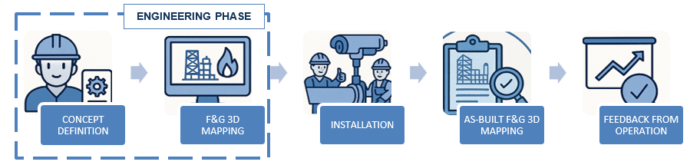
The life cycle of a Flame Detection System (FDS) encompasses engineering, procurement, installation, commissioning, as well as operation, testing, and revalidation. Adopting a comprehensive life cycle approach is essential to ensure both reliability and effective coverage performance for fire scenarios commonly encountered in Oil & Gas facilities. Each phase, from initial design through operational feedback, plays a critical role, enabling continuous improvement and the application of lessons learned to future projects. Figure 1 illustrates the FDS life cycle followed in a typical Oil & Gas Project and highlights the importance not only of the initial phases of system design and 3DMA, but also of the subsequent phases of installation and feedback from operation.
Figure 1: FDS Life Cycle followed in a typical Oil & Gas Project
FDS performance depends on many factors, including performance target preparation, 3D mapping, installation, commissioning, and maintenance. These aspects shall be given an appropriate level of importance throughout the life cycle of an FDS.
    - Concept Definition Phase
During the concept definition phase, the objective is to define what must be detected, how fast, and with what confidence. This starts by identifying credible fire scenarios, typically pool fires and jet fires, via structured studies such as HAZID/HAZOP and, where appropriate, quantitative techniques, such as Fire and Explosion Risk Assessment (FERA) and Quantitative Risk Assessment (QRA). Based on these studies, the areas to be protected, usually referred to as “fire-zones,” and the most appropriate sensor typology can be determined. This step also establishes the high‑level interfaces with plant safety systems (e.g., Emergency Shutdown System, active fire protection systems, etc.), the Detectors Voting Logics and plant protection strategies, ensuring the detection barrier is scoped as a true safety function rather than mere instrumentation.
The outputs of this phase are consolidated in key project documents such as the FGDS Philosophy, the Fire Zone Layout, the Flame Detectors Layouts, and the Cause and Effect F&G Matrix.
    - Detection Mapping Assessment Phase
During the detailed design phase, the preliminary concepts are translated into engineering deliverables that define the flame detection system in full detail. This stage refines detector placement through a 3D Detection Mapping Assessment (3DMA). 3DMA is usually performed with the aim of assessing the coverage of the provided F&G detectors against defined coverage targets, using specific 3D mapping software, in order to optimize the numbers and locations of detectors to maximize their performance.
The main objectives of the 3DMA study are as follows:
- To review the location, number, and suitability of F&G detectors as defined during the Concept Definition Phase.
- To determine the extent of detection coverage through a quantitative mapping assessment (geographic coverage) using three-dimensional (3D) computational tools for the facilities.
- To provide relevant recommendations to achieve the required coverage targets in accordance with performance targets or to achieve compliance, if deemed necessary.
- To develop a comprehensive report containing details of performance targets, coverage maps (for 1ooN and 2ooN detection), and FGDS recommendations, if necessary (e.g. devices type, quantity, position expressed as X, Y, Z coordinates and angles of rotation and declination, voting logic, etc.).

3DMA methodology can be summarized as a sequence of steps outlined in the following Figure 2. The first step consists of the identification of “fire-zone” where fire hazard may occur, based on FGDS Concept Definition (FGDS Philosophy, Layouts, Cause and Effects Matrices, Voting, etc.). The “3D mapping fire risk zone” may be smaller than the “fire-zone” as it is focused on areas close to the release sources where the detector cover is required (e.g., around specific equipment handling flammable fluids). In the second step, the Detection Performance Criteria can be defined in accordance with International Industrial Guidelines such as DEP 32.30.20.11, ISA-TR84.00.07, which specify target coverage percentages for 1ooN and 2ooN detection (e.g., DEP 32.30.20.11 requires a coverage target of 90 % in case of 1ooN detection and 85 % for 2ooN). The third step involves importing a 3D model of the facilities in the F&G Mapping software, including the F&G detectors modelling. The 3D files, originally developed using the Project 3D Model tool, are imported directly into the F&G Mapping software. Once the “3D mapping fire risk zones” and detectors have been modelled in the F&G Mapping software, it is possible to proceed with the detection coverage calculation (fourth step). Detection coverage is typically evaluated through a Geographic Coverage Assessment (GCA) of a specific risk zone (fire risk zone) where potential sources of hazardous release (flammable) and consequent fire are present. The detection coverage degree is defined as the ratio between the volume covered from detectors, considering also the blockage effects from all structures, equipment and piping (detected volume) and the volume where the hazard may occur (risk zone). The fifth step is focused on the review of coverage results and the optimization of F&G detectors placement to improve detection coverage (if necessary). During the sixth step, the 3DMA Report is prepared, including all details relevant to the mapping assumption, methodology, coverage calculation, results, optimization, and recommendations, where applicable. The final step (seventh step) consists of the export of F&G detectors' coordinates expressed as X, Y, Z coordinates and angles of rotation and declination (for flame detectors). 3DMA coordinates must then be incorporated into the Project 3D model to ensure the correct positioning of the detectors during engineering and construction phases.
Identification of Fire & Gas Risk Zones
Definition of Detection Performance Criteria
Import 3D Model in the F&G Mapping Software
1
2
3
Assessment of Detection Coverage
Review and Optimization of Coverage Results
3DMA Report Preparation
4
5
6
7
Export F&G Detectors Coordinates
Figure 2: Sequence of steps planned during 3D Detection Mapping Assessment (3DMA)
The effectiveness of the FGDS depends on both the reliability of its hardware and software (i.e., ability to function on demand) and the level of detection coverage that it is able to ensure. Detection coverage, in turn, depends on the number and positioning of F&G detectors, as optimized through 3D Detection Mapping Assessment (3DMA). Historically, significant effort has been invested in ensuring detectors function on demand, while less attention has been paid to their positioning (Jones, 2020). However, in recent years, the 3DMA is increasingly requested by major Oil & Gas companies. Therefore, 3DMA can be considered as a key tool for improving FGDS coverage efficiency, which, in addition to its reliability, allows the system to be considered as effective in the risk reduction of fire, flammable gas dispersion, toxic gas dispersion, and explosion scenarios.
    - Installation
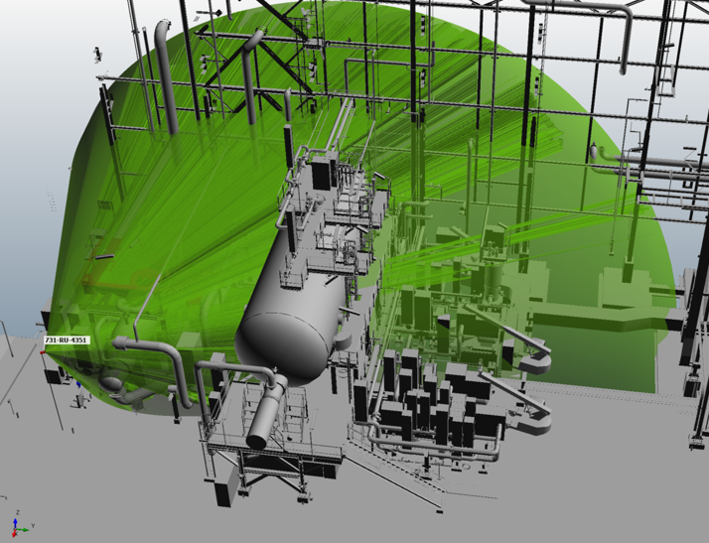
All flame detector manufacturers provide a Field of View (FOV) diagram for their flame detectors, which includes a graphical description of the detector sensitivity illustrating the relationship between the distance from the fire center and response time. With respect to the fire size detection, the performance specification for flame detection requirements shall specify the maximum viewing distances and relevant angles (angle of rotation or “azimuth angle” and angle of beam, from the horizontal plane or “polar angle”) for flame detectors, placed to cover the identified hazards onsite. The effective view distance of the flame detector at which the detector shall respond to a flame is a function of the intensities (low, medium, and high) of the flame detector. Figure 3 shows the FOV (green zone) of a flame detector installed in a typical process unit of an Oil & Gas Plant.
Figure 3: Field of View (FOV) of a flame detector (green zone) installed in a typical Oil & Gas Plant process unit
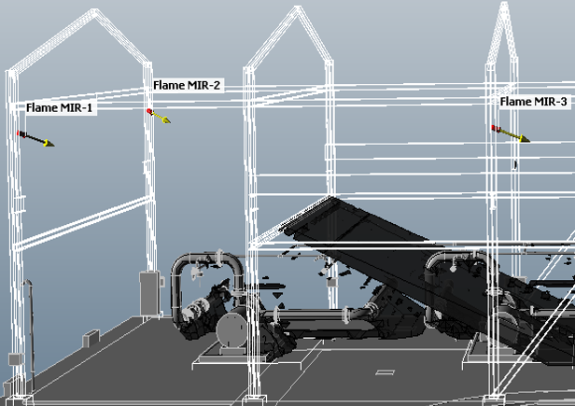
The flame detection volume is modelled using thousands of individual rays covering each detector FOV through a ray casting algorithm to assess blockages within the FOV. For this reason, it is important to verify the presence of obstacles in the proximity of flame detectors. It is therefore essential, during the detailed engineering phase (in particular, in the 3D model development) and during the construction and installation phases, to check the presence of any structures, equipment, piping, or other items around the detectors to avoid the possibility that these obstacles may adversely affect detection performance and therefore invalidate the 3DMA results. Figure 4 shows the obstruction effect (black zone) on the FOV of a flame detector (Flame Multi Infra-Red n. 2, MIR-2) installed in a typical Oil & Gas Pump Shelter, caused by the presence of a beam (civil structure) installed at low height.
Figure 4: obstruction effect on the Field of View (FOV) of a flame detector (black zone) due to the presence of a civil structure (beam at low height)
In addition, during the Installation Phases of an Oil & Gas Project, an adequate maintenance space area around the F&G detectors must also be guaranteed, and particular attention must be given to large and mobile equipment, such as cranes typically installed on the ceiling of industrial buildings and process shelters, as this equipment may interfere with the F&G detectors' coverage.
All the above considerations should therefore be investigated during the life cycle of a Flame Detection System (FDS).
    - As Built Phase
To ensure efficient workflow throughout all the Project execution phases, it is advisable to have a Register Sheet containing all the coordinates of the detectors (X, Y, Z coordinates and angles of rotation and declination for flame detectors) as defined in the mapping study. The purpose of this register is to monitor any potential variations during the construction and installation phases in order to verify any impact in terms of detection coverage. The Register Sheet should be constantly checked and updated by the construction team and ultimately frozen in the final as-built revision. Moreover, it is also good practice to allow for a certain tolerance in the position of the detectors. It may be assumed that repositioning flame detectors by ± 0.5 meters and gas detectors by ± 1.0 meters does not significantly affect the F&G mapping results.
An example of F&G detectors coordinates Register Sheet is reported in Table 1: the comparison sheet allows to monitor changes in the F&G detectors position during the Project 3D Model development (engineering, construction, as built) with respect to F&G Mapping coordinates, with the aim to validate 3DMA results.
Table 1: F&G Detectors Coordinates Register Sheet
F&G Tag | Type | F&G Mapping Coordinates |  |  |  |  | 3D Model/Site Coordinates |  |  |  |  | Δ coordinates
 |  | X | Y | Z | Azimuth Angle | Polar Angle | X | Y | Z | Azimuth Angle | Polar Angle | X | Y | Z
100-FD-01 | FLAME | 100.0 | 150.0 | 502 | 15 | 20 | 100.5 | 149.5 | 502 | 20 | 20 | +0.5 | -0.5 | 0
100-FD-02 | FLAME | 100.0 | 160.0 | 502 | 335 | 20 | 100.5 | 159.5 | 502 | 330 | 20 | +0.5 | -0.5 | 0
100-TG-01 | TOXIC | 102.0 | 155.0 | 501 |  |  | 103.0 | 156.0 | 501 |  |  | +1.0 | +1.0 | 0
100-TG-02 | TOXIC | 106.0 | 155.0 | 501 |  |  | 105.0 | 156.0 | 501 |  |  | -1.0 | +1.0 | 0
100-FG-01 | FLAMM | 110.0 | 156.0 | 501 |  |  | 111.0 | 157.0 | 501 |  |  | +1.0 | +1.0 | 0
100-FG-02 | FLAMM | 114.0 | 156.0 | 501 |  |  | 113.5 | 157.0 | 501 |  |  | -0.5 | +1.0 | 0
    - Operation Phase
During the operational phase, the Fire and Gas Detection System (FGDS) is truly put to the test. It is at this stage that the main issues tend to emerge, particularly those related to false alarms or system malfunctions. Ideally, such problems should be reported back to the engineering team, both to seek effective solutions and to capture valuable lessons learnt for future projects. However, this feedback loop frequently encounters challenges, as input from plant operators is not consistently provided. Furthermore, the solutions adopted to address FGDS-related issues may sometimes prove inadequate, precisely due to a lack of proper interface and communication with the engineering team.
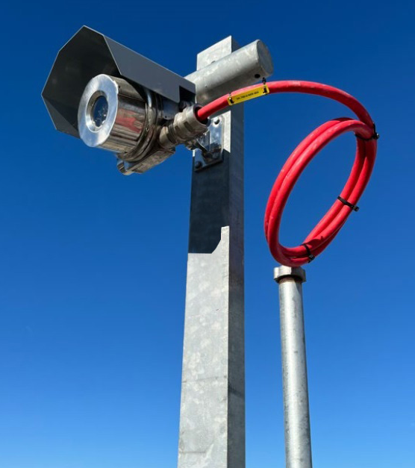
In the event of FGDS malfunctions, it is always advisable to liaise directly with the engineering team to identify appropriate solutions. This approach helps to preserve the performance of the FGDS as originally engineered, ensuring that specific risks are effectively mitigated and that defined safety targets are achieved. In particular, improper operation of flame detectors is often recorded during the flame detector test: false alarms caused by environmental factors (e.g., solar reflection, dust, moisture, and window contamination) or equipment interference (e.g. structures obstruction, piping insulation reflection, hot process equipment/surfaces) frequently occur. Moreover, detailed investigations have shown that sensors are, in some cases, mounted incorrectly, with an incorrect polar angle with respect to the horizontal plane (close to 0°), as reported in the photo in Figure 5.
Figure 5: Flame detector installed with an incorrect polar angle with respect to the horizontal plane.
This installation error often causes false alarms, requiring on-site interventions with impacts on operational activities and costs, sometimes also requiring plant downtime.
  - Conclusions
This paper focuses on the FGDS life cycle, with particular attention to the development of 3D Detection Mapping Assessment (3DMA) finalized to optimize the numbers and locations of detectors and to maximize their performance in terms of coverage. Continuous monitoring of the 3D model development, together with verification of correct installation during site activities and during the operation plant phase, is essential to ensure that the FGDS coverage remains consistent with the 3DMA results and that the FGDS fulfills its intended safety function. During engineering, construction, installation and operation phases, it is recommended to verify the presence of any structures, equipment, piping, or other items to avoid these obstacles from adversely affecting detection performance. Attention should also be paid to the correct polar angle inclination of the sensor with respect to the horizontal plane to avoid false alarms due to solar or piping insulation reflection, etc. These verifications should confirm that the 3DMA results remain valid and that the detector coverage performance is not compromised. Potential variations of detectors' coordinates (X, Y, Z coordinates and angles of rotation and declination for flame detectors), during the construction and installation phases, should also be checked to ensure that repositioning of detectors is always included between ± 0.5 m (flame) and ± 1.0 m (gas), to avoid any impact on the F&G mapping results. For this purpose, it is advisable to maintain a Register Sheet containing all the coordinates of the detectors (X, Y, Z coordinates and angles of rotation and declination for flame detectors) and their potential variations: the F&G detectors coordinates Register Sheet should be shared between the engineering and the construction team, and ultimately be frozen in a final as-built revision. Finally, it is essential that all issues encountered on site are properly documented and that any lessons learnt are shared with the engineering team. This approach supports continuous improvement and helps prevent the recurrence of similar problems in future projects.
References
CCPS (Center for Chemical Process Safety), Continuous Monitoring for Hazardous Material Releases. John Wiley & Sons, Inc., Hoboken, NJ, USA, 2009.
DEP 32.30.20.11-Gen., Desing and Engineering Practice Shell Group of Companies, DEP Specification, Fire, Gas and Smoke Detection Systems, February 2011.
ISA-TR84.00.07-2010 Technical Report, Guidance on the Evaluation of Fire, Combustible Gas and Toxic Gas System Effectiveness, International Society of Automation, North Caroline, 2010.
Jones T., 2020, How do we define good practice for Fire and Gas Detector Mapping?, IChemE, Hazards 30, Symposium Series No. 167.
Mariotti E., Di Padova A., Barbaresi T., Tallone F., Tugnoli A., Spadoni G., Cozzani V., 2014, Development of Improved Strategies for the Lay-Out of Fire and Gas Detectors, Chemical Engineering Transactions, 36, 283-288
Mohan V., Siddiqui N. A., Srivastava A., 2018, Application & Effectiveness of Fire & Gas Mapping Assessment in Hydrocarbon industry, International Journal of Advance Engineering and Research Development, Volume 5
NFPA (National Fire Protection Agency) NFPA 72: National Fire Alarm and Signaling Code NFPA, Quincy, MA, USA, 2013
UNI (Ente Nazionale Italiano di Unificazione) UNI 9795: Automatic Fire Detection and Fire Alarm System – Design, Installation and Operation, Italy, 2021

