 CHEMICAL ENGINEERING TRANSACTIONS  VOL. xxx, 2026 | A publication of  
The Italian Association
of Chemical Engineering
Online at www.cetjournal.it
The Evolution of Energy Use and CO₂ Emissions in Mexico: Climate Change–Induced NaTech Risks and Sectoral Insights
Adriana Palacios^{a,}*, Erika Palacios-Rosas^{b,}*, Tawfiq Abdul-Aziz-Al-Mughanam ^{c,}*, Fernanda Karime Cordova-Moraª

ªChemical Engineering Department, Universidad de las Américas Puebla, Sta. Catarina Martir SN. San Andres, Cholula, Puebla, 72810, Mexico.
^{b}Health Sciences Department, Universidad de las Américas Puebla, Sta. Catarina Martir SN. San Andres, Cholula, Puebla, 72810, Mexico.
^{c}Department of Mechanical Engineering, College of Engineering, King Faisal University, P.O. Box 380, Al-Ahsa 31982, Saudi Arabia.
*Corresponding authors: adriana.palacios@udlap.mx; erika.palacios@udlap.mx; talmughanam@kfu.edu.sa
This study analyses energy consumption and CO₂ emissions trends in Mexico, focusing on the contribution of major sectors and the evolution of the national energy matrix. Using a life-cycle assessment approach, six energy technologies (solar, wind, hydroelectric, geothermal, nuclear, and fossil-based) are evaluated to compare their environmental impacts. Results show that, although Mexico’s emissions are lower than those of major global emitters, they have steadily increased, surpassing 428 million tons by 2020. Fossil fuels continue to dominate the energy mix and exhibit the highest carbon footprint across all stages, while renewable technologies present significantly lower emissions, particularly during operation. The analysis also identifies key structural challenges, including limited diversification of primary energy sources, aging thermoelectric infrastructure, and growing dependence on natural gas imports. These factors constrain energy security and hinder alignment with international climate goals. The findings highlight the need to accelerate the transition toward cleaner energy systems through infrastructure modernization, greater integration of renewables, and stronger policy support.

1. Introduction
Energy consumption and CO₂ emissions are central indicators for assessing environmental impact and sustainability strategies worldwide. Global emissions have increased exponentially since the Industrial Revolution, reaching more than 37 billion tonnes of CO₂ in 2023. Large emitters such as China and the United States continue to dominate global inventories; however, developing countries, including Mexico, show persistent growth driven by industrialization, population expansion, and transportation demand. In Mexico, CO₂ emissions have risen notably since the mid-20th century, particularly due to the expansion of fossil-based electricity generation and the increasing use of motor vehicles (IEA, 2024). Although the country has adopted renewable technologies in recent decades, the penetration of clean energy remains limited compared to national needs.
This article provides a compact evaluation of the evolution of Mexico’s energy consumption by sector, the progression of CO₂ emissions compared against major economies, and the carbon footprint associated with the life cycle of the most relevant energy technologies used in the national energy matrix.

2. Methodology
The analysis was conducted using historical datasets from international energy and emissions repositories. Data were compiled from 45 sources (see Supplementary Material; Palacios et al., 2026). National consumption was separated into four sectors: transportation, industrial, commercial, and residential, while energy production was classified by fuel type (natural gas, oil, coal, and renewables) to evaluate the evolution of Mexico’s energy matrix. For CO₂ emissions, the comparison includes global emissions and the trajectories of China, the United States, and Mexico between 1840 and 2023. A life-cycle assessment (LCA) approach was applied for six energy sources: solar, wind, hydroelectric, geothermal, nuclear, and fossil, considering four stages: construction, operation, maintenance, and decommissioning.
3. Results

3.1. Global and National CO₂ Emissions
Global CO₂ emissions increased from approximately 120 million tonnes in 1840 to over 37 billion tonnes in 2023. China surpassed the United States as the world’s largest emitter in the last decade, reflecting rapid industrial expansion. Mexico contributes around 1% of global emissions but shows a continuous upward trend, rising from near-zero emissions in the 19th century to over 428 million tonnes by 2020. Figure 1 shows the historical evolution of CO₂ emissions from 1840 to 2023, comparing Mexico with the United States, China, and the global total. The graph highlights the exponential increase in global emissions, the rapid acceleration in China's emissions in recent decades, and the steady yet continuous growth trend observed in Mexico.

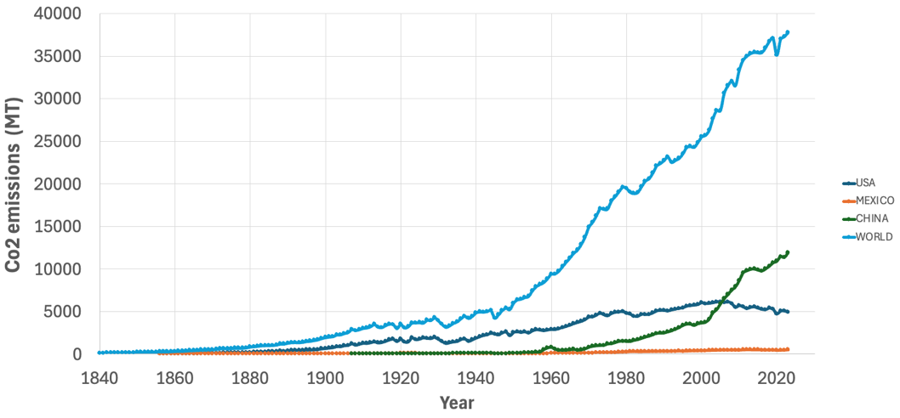
Figure 1. CO₂ Emissions Analysis: Comparative Assessment of Mexico, the US, China, and the Global Total.

3.2. Sectoral Energy Consumption in Mexico
Energy consumption in Mexico has expanded significantly in all sectors since 1965 (SENER, 2023). The transportation sector shows the highest and fastest-growing demand due to dependence on gasoline and diesel. By 2023, transportation is expected to consume over 2,500 PJ, surpassing all other sectors. The residential and commercial sectors exhibit moderate growth linked to urbanization and increased use of appliances and climate control. Industrial consumption has also increased in recent years, but at a slower rate. Figure 2 shows the evolution of energy consumption by sector in Mexico, including transportation, residential, commercial, and industrial uses. The transportation sector clearly dominates total consumption, while residential and commercial sectors show moderate, sustained growth linked to urbanization and increasing electricity demand.

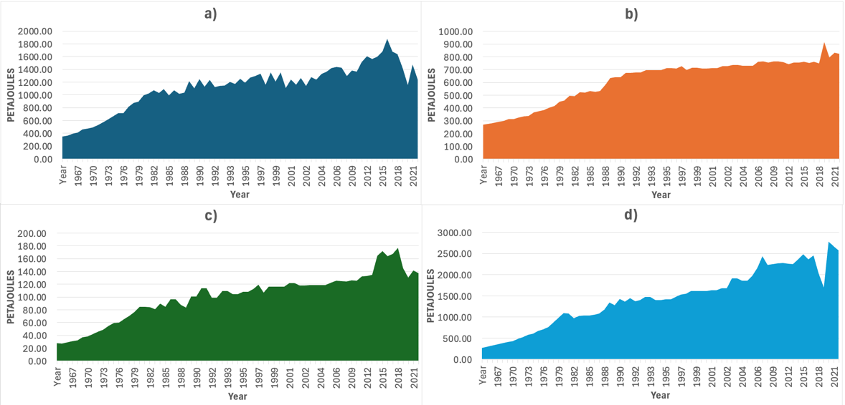
Figure 2. Energy consumption in Mexico: a) Industrial; b) Residential; c) Commercial; d) Transport.
Transportation’s dominant role correlates with the CO₂ emission profile of the country, revealing the need for electrification, efficient mobility, and fuel diversification. In addition to sectoral growth, the distribution of final energy consumption reveals structural inefficiencies. For instance, the transportation sector maintains an unusually high reliance on internal combustion technologies compared to OECD averages, while public transportation systems remain underdeveloped in several metropolitan regions. This imbalance amplifies national energy demand and contributes to elevated CO₂ levels. Meanwhile, the residential and commercial sectors experience increased load profiles due to the widespread adoption of air conditioning, refrigeration, and other electronic devices, particularly in warmer regions of the country.

3.3. Energy Consumption by Fuel Type
Mexico’s energy production remains largely dependent on fossil sources (SENER, 2023). Historically, oil consumption has dominated, although natural gas has become the leading fuel since the 2000s due to its use in combined-cycle plants. Coal remains marginal but persistent. Renewable energy shows significant long-term growth from less than 100 PJ in 1965 to nearly 730 PJ in 2023, but its share is still insufficient to offset fossil dependence. The strong dependence on natural gas also introduces vulnerabilities associated with price volatility and external supply constraints, especially because more than 70% of the gas used to generate electricity in Mexico is imported from the United States. Such dependency exposes the national energy system to geopolitical and market fluctuations. In contrast, renewable energy sources provide greater long-term stability due to their domestic availability; however, their variability requires complementary investment in storage systems and flexible grid infrastructure. Coal consumption, although relatively small, continues to represent one of the most carbon-intensive components of the energy matrix, reinforcing the urgency of accelerating its displacement. Figure 3 shows the evolution of Mexico’s energy consumption by fuel type, including renewable energy, oil, coal, and natural gas. The data illustrate a persistent dependence on fossil fuels, particularly natural gas, while renewable sources exhibit a gradual but still insufficient growth compared to total demand.

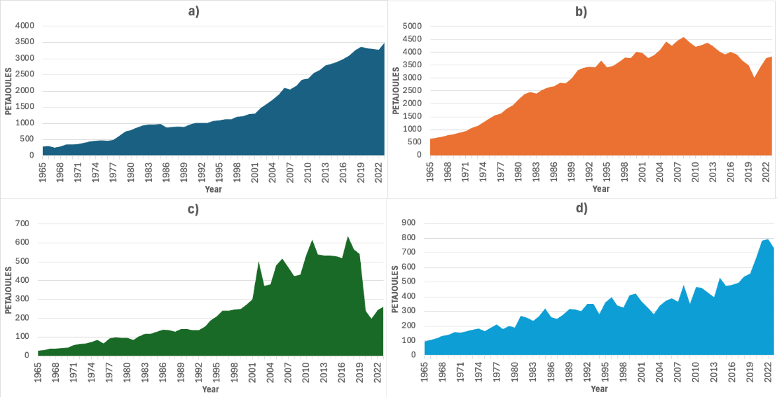
Figure 3. a) Natural gas energy; b) Oil energy; c) Coal energy; d) Renewable energy.
The increased contribution of natural gas reduces emissions relative to oil or coal but maintains dependency on imported fuel and fossil infrastructure. In terms of long-term planning, the relative stagnation of fossil-based generation efficiency further complicates the energy landscape. While modern combined-cycle units provide improved thermal efficiency, older plants still operate with considerably lower performance and higher emissions. The coexistence of both technologies results in heterogeneous environmental impacts across the national grid. This contrast highlights the importance of upgrading conventional plants while simultaneously expanding the renewable capacity to reduce the long-term carbon intensity of the electricity sector.

3.4. Electricity Generation by Source
An analysis of electricity generation in Mexico from 2000 to 2024 shows accelerated incorporation of renewable technologies. Wind generation increased from negligible values to over 34,000 GWh by 2024 (SENER, 2023). Hydroelectric generation remains stable, while geothermal and solar sources grow progressively. Photovoltaic generation achieved one of the sharpest increases among renewables. Despite this progress, fossil-based electricity still accounts for the largest share of total generation.
A deeper examination of generation patterns also reveals clear regional disparities in renewable deployment. Wind power development has been concentrated mainly in the Isthmus of Tehuantepec, where high-capacity factors make these projects highly competitive, while solar photovoltaic installations have expanded primarily in northern states with high irradiation levels. However, the central and south-eastern regions continue to depend predominantly on fossil fuel generation due to limited grid interconnection and fewer renewable incentives. This uneven distribution of generation assets creates localized stress on transmission corridors, underscoring the need for coordinated planning to balance renewable expansion with grid reliability. The persistence of fossil electricity generation continues to drive national emissions upward, despite the expansion of renewable energies. Figure 4 shows the comparison between electricity generated from renewable and non-renewable sources in Mexico. Although renewable generation has increased sharply in recent years, non-renewable sources continue to account for most of the national electricity production.

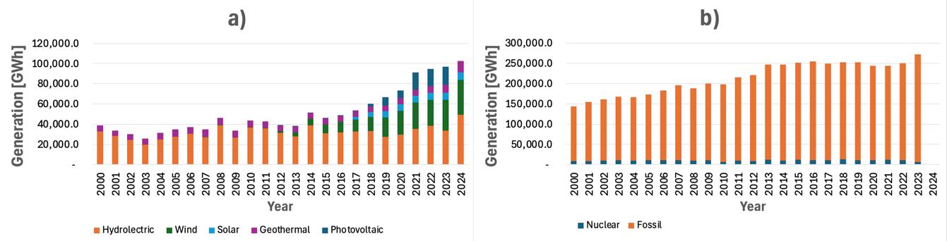

Figure 4. a) Renewable energy generated; b) Non-renewable energy generated.

3.5. Installed Renewable Capacity

Mexico has significantly expanded its installed renewable energy capacity. Wind energy grew from only 2 MW in 2000 to nearly 11,000 MW in 2024. However, the rapid expansion of wind and solar generation has also introduced operational challenges for Mexico’s electrical grid. Variability in renewable output requires enhanced forecasting capabilities, demand-response mechanisms, and regional transmission upgrades to ensure system stability. Additionally, although geothermal energy represents one of the most reliable and continuous renewable sources available, its deployment has been limited by high exploration costs and regulatory uncertainty. These factors suggest that the future growth of renewable electricity will depend not only on technology costs but also on institutional capacity and grid modernization. Although renewables exhibit strong development, fossil installed capacity remains dominant, exceeding 30 GW in recent years, limiting potential reductions in CO₂ emissions.
Figure 5 shows the evolution of the installed capacity for renewable and non-renewable energy in Mexico. Despite the significant increase in wind and solar installations, fossil-based capacity remains dominant, limiting the overall reduction of CO₂ emissions.

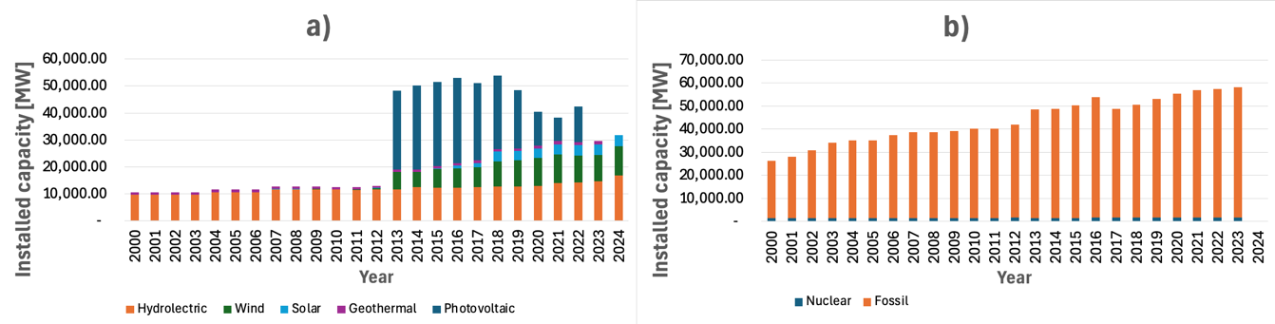

Figure 5. a) Installed renewable energy; b) Installed non-renewable energy.

3.6. Carbon Footprint by Life-Cycle Stage
A life-cycle analysis demonstrates that fossil fuels produce the highest emissions across all stages of construction, operation, maintenance, and decommissioning. Emissions related to fossil plant operation exceed 8 million tonnes annually, far surpassing all other technologies. Renewable technologies, especially wind and solar, show minimal emissions during operation and maintenance. Hydroelectric plants exhibit small but constant operational emissions, while nuclear power maintains stable and low emissions except during construction and decommissioning. Figure 6 shows the carbon footprint associated with each life-cycle stage of different energy technologies. Fossil fuels present the highest emissions in all phases, while renewable sources such as wind and solar exhibit minimal emissions during operation and maintenance.

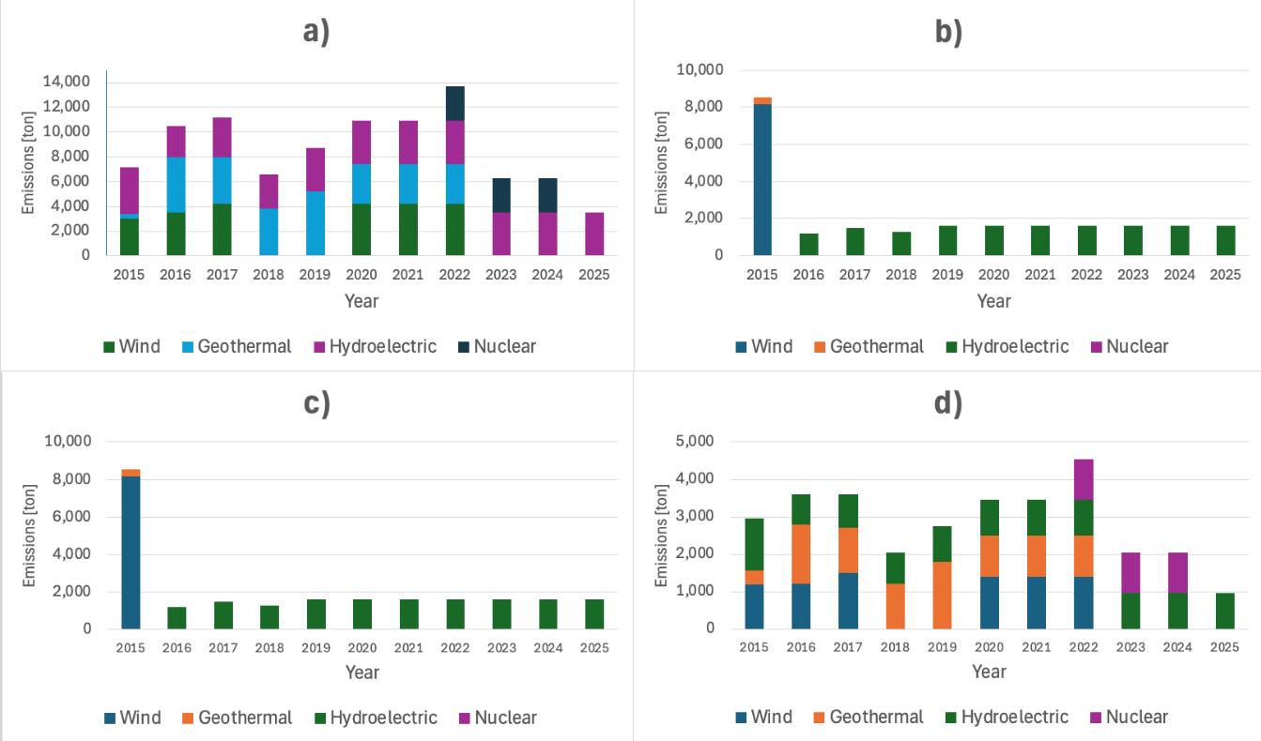

Figure 6. a) Carbon footprint by construction without considering fossil and solar; b) Carbon footprint by operation without considering fossil and solar; c) Carbon footprint by maintenance without considering fossil and solar; d) Carbon footprint by decommissioning without considering fossil and solar energies.

4. NaTech Risks
Mexico’s historical reliance on fossil fuels, combined with the uneven distribution of energy infrastructure, has contributed not only to rising CO₂ emissions but also to increased systemic exposure to climate-related hazards. As extreme weather events intensify, the interaction between natural and technological systems becomes increasingly critical. This interplay gives rise to Natural Hazard Triggering Technological (NaTech) risks, whereby natural phenomena—such as floods, hurricanes, wildfires, or heatwaves—affect energy and industrial facilities, generating cascading environmental and socio-economic consequences (Cruz, 2019). The growing frequency and intensity of climate extremes introduce new layers of risk for Mexico’s energy and industrial systems, where hazards are no longer isolated environmental events but potential triggers of technological accidents in critical infrastructure.
In coastal regions along the Gulf of Mexico—including Veracruz, Tabasco, and Tamaulipas—refineries, petrochemical complexes, and natural gas facilities are highly exposed to hurricanes, storm surges, and flooding. Such events can damage storage tanks, pipelines, and processing units, increasing the likelihood of fires, explosions, and hazardous material releases. Meanwhile, inland regions hosting thermoelectric plants and industrial corridors, such as Hidalgo and Guanajuato, face rising temperatures, drought, and increasingly irregular precipitation patterns that threaten cooling systems, electricity generation, and transmission stability. These vulnerabilities are exacerbated by aging infrastructure and the continued reliance on fossil-based technologies identified in previous sections. Moreover, sectors with high energy consumption and emissions—particularly transportation and industry—are more exposed to NaTech risks due to their dependence on extensive and interconnected fuel supply networks, where disruptions in refineries, pipelines, or storage facilities can propagate across the entire energy system.
Recent NaTech events in Mexico illustrate the scale and real-world implications of these risks. In 2021, severe flooding in Tula, Hidalgo, disrupted critical infrastructure, including electricity supply systems and healthcare facilities, demonstrating how extreme hydrometeorological events can trigger cascading failures across technological systems and essential services (Gobierno de México, 2021). Similarly, flooding in Coatzacoalcos, Veracruz, has affected petrochemical and industrial facilities, increasing the risk of hazardous material releases and operational disruptions (SENER, 2023). In addition, Hurricane Max in 2017 impacted the Salina Cruz refinery in Oaxaca, causing operational interruptions and highlighting the vulnerability of oil infrastructure to extreme weather (PEMEX, 2018). Flood-related NaTech events also reveal the fragility of storage systems: under extreme conditions, tanks containing hazardous substances may become buoyant, detach from their foundations, and rupture, leading to large-scale spills, soil contamination, and potential fires or explosions (Cruz and Krausmann, 2009). Furthermore, prolonged heatwaves can increase the risk of equipment overheating, while wildfires may directly affect energy infrastructure such as transmission lines and substations, broadening the spectrum of climate-induced threats.
Integrating NaTech risk assessment into Mexico’s energy planning and climate policy is therefore essential. Identifying high-exposure zones, strengthening infrastructure resilience, and incorporating climate adaptation measures into energy projects would not only reduce the likelihood of technological disasters but also support a safer, more reliable, and more sustainable energy transition.

5. Conclusions
Mexico is facing a critical challenge in its transition toward a low-carbon energy system. Although energy demand has grown across all sectors, transportation remains the primary consumer and a major source of national emissions. Fossil fuels continue to dominate electricity generation and installed capacity, which limits progress in mitigation strategies. Nevertheless, renewable energies, particularly wind, solar, and geothermal, have expanded significantly in both installed capacity and generation. Life-cycle assessment clearly shows that renewables have the lowest carbon footprint, especially when compared to fossil fuels, whose emissions remain extremely high across all stages. To accelerate the transition, Mexico must strengthen public policy, modernize energy infrastructure, expand grid capacity for renewable integration, and increase investment in clean technologies. Additionally, the increasing exposure to NaTech risks highlights the need to integrate climate resilience into Mexico’s energy transition strategies. The results highlight both the urgency and the opportunity: Mexico has the technical potential to build a more sustainable energy matrix, but the speed of implementation will determine the country’s alignment with global mitigation commitments. Overall, the comparative analysis across sectors, technologies, and life-cycle stages highlights not only the environmental implications of Mexico’s current energy configuration but also the strategic opportunities available to accelerate decarbonization. Integrating storage technologies, modernizing transmission infrastructure, and promoting research in geothermal and next-generation solar materials could significantly enhance the country’s renewable portfolio. Strengthening regulatory frameworks and aligning national goals with international climate agreements remain essential steps for achieving long-term sustainability. Looking forward, the country’s decarbonization pathway will require aligning national development goals with global climate strategies. Policies that promote electrification of transportation, diversification of energy sources, and technological innovation in energy storage could significantly reduce long-term emissions. Strengthening collaboration between industry, academia, and government institutions is also essential to accelerate the adoption of clean technologies. Ultimately, Mexico’s ability to transition to a low-carbon energy system will depend on a combination of technical feasibility, economic incentives, and regulatory clarity.

References
Cruz A.M., 2019, Understanding NaTech risk: natural hazard triggering technological disasters, International Journal of Risk Analysis, 12(4), 215–230
Cruz A.M., Krausmann E., 2009, Hazardous-material releases from offshore oil and gas facilities during hurricanes, Journal of Loss Prevention in the Process Industries, 22(1), 59–65
Gobierno de México, 2021, Inundaciones en Tula, Hidalgo: reporte de afectaciones y respuesta de emergencia, Mexico <gob.mx> accessed 16.04.2026
International Energy Agency (IEA), 2024, World CO₂ emissions trends, Paris, France, 1840–2023, IEA Report <iea.org/reports/world-co2-emissions-trends-1840-2023> accessed 16.04.2026
Palacios A., Palacios-Rosas E., Abdul-Aziz-Al-Mughanam T., Cordova-Mora F.K., 2026, Supplementary material: complete list of the 45 sources used in this study, Associated with this article <docs.google.com/document/d/1FZBrpfLCfD-nEx3GhlkSInsXNNK6eHh3/edit> accessed 16.04.2026
Petróleos Mexicanos (PEMEX), 2018, Informe anual 2017, Mexico <pemex.com/acerca/informes_publicaciones/Paginas/informes_anuales.aspx> accessed 16.04.2026
Secretaría de Energía (SENER), 2023, Historical energy consumption and fuel mix in Mexico 1965–2023, National energy statistics, Mexico <gob.mx/sener> accessed 16.04.2026

