 CHEMICAL ENGINEERING TRANSACTIONS  VOL. xxx, 2026 | A publication of  
The Italian Association
of Chemical Engineering
Online at www.cetjournal.it

Guest Editors: Valerio Cozzani, Bruno Fabiano, Genserik Reniers
Copyright © 2023, AIDIC Servizi S.r.l.
ISBN 978-88-95608-98-3; ISSN 2283-9216
MEIRA (Mechanical Equipment Ignition Risk Assessment): Advantages and limitations of a semi-quantitative approach
Lorenzo Pellegrini*, Aurora Lafiosca, Federica Parenti, Sara Perelli
*DEKRA Italia s.r.l., Process Safety Business Unit, Via Fratelli Gracchi 27, 20122 Cinisello Balsamo (MI)
Lorenzo.pellegrini@dekra.com
Mechanical Equipment Ignition Risk Assessment (MEIRA) is a risk assessment methodology aimed at identifying and mitigating hazards associated with the presence of potential effective ignition sources on industrial equipment. This study analyses the application of a semi-quantitative approach to MEIRA on industrial plants and devices, with the aim of assessing the feasibility and effectiveness of such integration.
The article presents a case study of the use of MEIRA in certain equipment used in the pharmaceutical industry.
The proposed approach combines qualitative expert judgements with quantitative data available in the literature and in the plant. An Operability Matrix is used to correlate the presence of explosive atmospheres with the presence of possible ignition sources and to define the acceptability of the scenarios identified.
This methodology allows corrective actions to be prioritised, focusing resources on the most critical scenarios and providing a common benchmark for comparison with other risk analysis techniques (e.g. HazOp).
The results highlight the advantages of greater structuring of the decision-making process and better communication between stakeholders. However, the results also reveal intrinsic limitations: dependence on incomplete data, the experience of the working team and the difficulty of representing complex phenomena with simplified metrics.
Through concrete examples, the study highlights how a semi-quantitative approach can be a powerful tool for achieving more consistent, objective and immediately understandable results, improving the management of mechanical explosion risk.
  - Introduction
Despite decades of progress in explosion protection and ATEX compliance, day‑to‑day decisions on mechanical equipment operating in hazardous atmospheres still hinge on a recurring practical question: when is an ignition source “credible enough” to warrant intervention, and what type of intervention is proportionate? In many plants, this judgement is either embedded implicitly in equipment selection practices or dispersed across heterogeneous documents (HAC reports, maintenance strategies, OEM manuals, change management records), making it difficult to ensure consistency over time and across assets. MEIRA was developed precisely to bridge this gap by focusing on the equipment–environment pairing and by structuring the reasoning around ignition source presence, effectiveness, and the Basis of Safety. However, the adoption of MEIRA in industrial settings often faces two competing pressures: on one side the need for a disciplined, auditable and repeatable process; on the other, the operational reality that data are incomplete, phenomena such as frictional heating or electrostatics are strongly context‑dependent, and risk decisions must remain comprehensible to multidisciplinary teams. This work addresses these tensions by framing a semi‑quantitative MEIRA workflow that makes assumptions explicit, encourages the use of simple physical screening where feasible, and clarifies how barrier evidence and recommendations translate into scenario acceptability within an operability matrix, using pharmaceutical granulation equipment as an illustrative application domain.
  - Methodology
The semi-quantitative approach to MEIRA enables the methodology to be applied systematically across different industrial facilities, ensuring greater consistency in risk evaluation. This risk assessment technique allows the analysis to be structured according to a well-defined methodological framework.

Figure 1 - Meira worksheet workflow
From Figure 1 it is possible to deduce the typical workflow involved in analysing a scenario in MEIRA. Starting from the left and moving to the right, the portion of equipment analysed associated with its relative ATEX zoning is identified. Next, the potential ignition source to be managed is identified, along with the cause that makes this ignition source available and its relative frequency.
At this point, the barriers in place are described, and a frequency is given for the occurrence of the cause, taking into account the effectiveness of the barriers considered. The resulting frequency of the cause and the ATEX zone considered produce as output the need or otherwise for one or more recommendations to further lower the frequency of occurrence of the cause (See‎‎2.3-Operability Matrix ).
Once the frequency of the cause has been established after the implementation of corrective actions, a final check is carried out to ensure that the risk level is acceptable.
In order to be able to do the above, it is essential that certain key starting points in terms of documentation and concepts are available before the MEIRA study is carried out, these will be introduced in the following sub-sections.
    - Hazardous Area Classification (HAC)
A sound and accurate Hazardous Area Classification (HAC) represents a fundamental prerequisite for conducting a MEIRA. Establishing a correct HAC from the outset provides the essential baseline upon which the entire assessment is built, ensuring that subsequent evaluations—particularly those related to ignition risks and safety measures—are both meaningful and technically robust.
In this context, the relevant regulatory framework is defined by IEC 60079-10-1:2020 for the classification of areas where flammable gases and vapours may be present, and IEC 60079-10-2:2020 for the classification of areas associated with combustible dusts.
In North American practice, analogous guidance is commonly derived from the NFPA framework—most notably NFPA 70 (NEC) for hazardous (classified) locations—together with NFPA 497 (flammable gases/vapours) and NFPA 499 (combustible dusts) to support area classification and equipment suitability. Although terminology and classification schemes may differ (e.g., Class/Division vs. Zone), the NFPA-based approach can be aligned with IEC zoning to maintain coherence in MEIRA applications across regulatory contexts.
These standards collectively provide the methodological foundation required to perform a consistent and defensible HAC within MEIRA.
    - Ignition sources
The assessment of the probability that ignition sources may become effective can be carried out by applying the UNI EN 1127-1 standard, which identifies thirteen general categories of ignition sources, shown in Figure 2.
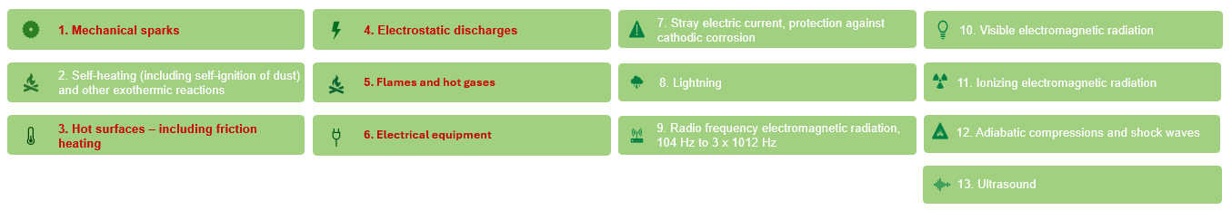
Figure 2 - Ignition sources list
Of the 13 ignition sources, 5 are most found in the process industry. These are shown in red in image Figure 2.
In the context of Ignition Risk Assessment (IRA) applied to MEIRA, the verification of ignition source “effectiveness” (i.e., its ability to ignite a dust cloud or a flammable mixture within explosibility limits) is typically based on physical relationships and quantitative comparison criteria derived from technical standards and scientific literature. In practice, a representative parameter of the ignition source (e.g., maximum temperature, discharge energy, contact speed) is compared with the ignition sensitivity properties of the substance (e.g., MIT/LIT for hot surfaces, MIE for electrostatics), using standardized thresholds and safety factors. For hot surfaces, maximum permissible equipment temperatures may be determined according to IEC 60079-14, NFPA 652 and NFPA 70 (NEC), including the dependence on dust layer thickness, and compared with the maximum foreseeable asset temperature. For electrostatics, available discharge energy is estimated using established formulas and compared with the MIE according to IEC/TR 60079-32-1, ISO/IEC 80079-20-2 and ASTM E2019. For mechanical sources, criteria such as peripheral speed limits and classifications from EN ISO 80079-36 allow operating conditions to be translated into quantitative ignition plausibility. Overall, the use of standardized formulas and thresholds enables process data to be converted into repeatable estimates of ignition effectiveness. A detailed discussion of sources, criteria and numerical examples is provided in Gritti et al. (2024).
    - Operability Matrix
In Mechanical Equipment Ignition Risk Assessment (MEIRA), the matrix logic is similar in form and communicative purpose to the matrices used in HAZOP studies but differs substantially in terms of input variables and the meaning of the result. In HAZOP practice, the risk matrix is created by crossing the likelihood/probability of an accident scenario with the magnitude/severity of the consequences, allowing the risk to be graded according to the combination of “how often” and “how serious,”. In MEIRA, on the other hand, the operability matrix crosses the ATEX zone (which represents the expected frequency/duration of the presence of an explosive atmosphere) with the frequency of the presence of a potential ignition source attributable to mechanical equipment (e.g., hot surfaces, friction, mechanical sparks, electrostatic charges), providing a judgment of compatibility between the “environment” and the ‘ignition tendency’ of the component.
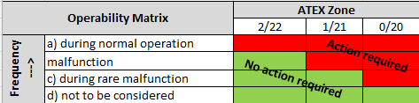
Figure 3 - MEIRA Operability Matrix
It follows that, while severity is a discriminating factor in the HAZOP matrix (outcomes can range from minor to catastrophic), in MEIRA severity is often implicitly high because the feared event is the igniting of an explosive atmosphere; the matrix therefore becomes a tool closer to verifying the level of protection required by the zone (consistent with the idea of Equipment Protection Level/concept of suitability for use in the zone) than to the probabilistic-consequential quantification of a process “top event.” The main similarity lies in the use of ordinal scales and in the decision support function (transparency, repeatability, traceability of assumptions); the key difference is that HAZOP assesses scenario risk (process safety), while MEIRA assesses the acceptability of the equipment-area pairing in terms of ignition prevention (explosion safety), focusing on ignition sources and plausible operating/failure conditions of mechanical equipment.
    - Process Knowledge
An adequate level of process knowledge is a fundamental prerequisite for the effective application of a Mechanical Equipment Ignition Risk Assessment (MEIRA). In this study, process knowledge is intended as the structured collection of information regarding the hazardous properties of the substances handled, the operating conditions and phases of the equipment, and the technical and organisational measures adopted to manage the process. These elements can be viewed inTable 1.
Table 1 - Process knowledge
Area | Data category | Relevant data for MEIRA | Relevance to ignition risk assessment
Powder/gas properties | Substance identification | Chemical/commercial name, physical state, ATEX group | Identification of the type of potentially present explosive atmosphere
Powder/gas properties | Flammability/explosibility | LEL–UEL (gases), Kst and Pmax (dusts), St class | Evaluation of explosion severity and potential consequences
Powder/gas properties | Ignition sensitivity | Minimum Ignition Energy (MIE), auto‑ignition temperature, dust cloud and dust layer ignition temperatures | Direct comparison with potential mechanical ignition sources
Powder/gas properties | Physical characteristics | Particle size distribution, moisture content, relative density | Influence on formation, persistence and dispersion of explosive atmospheres
Powder/gas properties | Data reliability | Data source (SDS, literature, laboratory tests), data uncertainty | Justification of conservative assumptions adopted in the assessment
Process variables and operations | Operating conditions | Temperature, pressure, rotational and translational speeds | Assessment of the likelihood of mechanical ignition source generation
Process variables and operations | Operating mode | Continuous or batch operation, normal and transient conditions | Identification of the most critical operating phases
Process variables and operations | Performed operations | Charging/discharging, transfer, mixing, cleaning | Identification of situations with potential dust or gas release
Process variables and operations | Critical phases | Start‑up, shutdown, product changeover, maintenance | Increased risk compared to nominal operating conditions
Process variables and operations | Explosive atmosphere presence | Frequency, duration, ATEX zoning (Zone 0/1/2 – 20/21/22) | Direct input for the construction of the Operability Matrix
Process management | Operating procedures | SOPs, ATEX instructions, emergency procedures | Reduction of the probability of hazardous operational deviations
Process management | Technical control measures | Sensors, interlocks, automatic shutdown systems | Mitigation of ignition risk in case of abnormal conditions
Process management | Maintenance and housekeeping | Preventive maintenance plans, dust accumulation management | Control of conditions favouring mechanical ignition
Process management | Human factors | Operator training and experience | Influence on the probability of human error
Process management | Historical experience | Accidents, near‑misses, non‑conformities | Validation of risk assumptions and scenario acceptability
    - Recommendations
One of the main outcomes of the MEIRA application is the structured definition and prioritization of risk reduction measures. By correlating the presence of explosive atmospheres with potential mechanical ignition sources through the Operability Matrix, the analysis allows the identified scenarios to be ranked according to their level of criticality. This ranking supports the formulation of targeted recommendations aimed at reducing each scenario to an acceptable level of ignition risk. The recommended actions are defined as a function of the specific ignition source involved and focus on mitigating the likelihood of ignition and/or the exposure conditions. Consequently, resources can be allocated more effectively, avoiding generic or overly conservative measures. The prioritized recommendations represent the logical conclusion of the MEIRA study and provide a transparent basis for decision‑making, while their implementation remains under the responsibility of plant management and operational personnel.
  - Case Study
The images below (Figure 4; Figure 5 ) show four scenarios from a MEIRA analysis carried out for a pharmaceutical company. The process analysed relates to some of the machinery required for the granulation process.
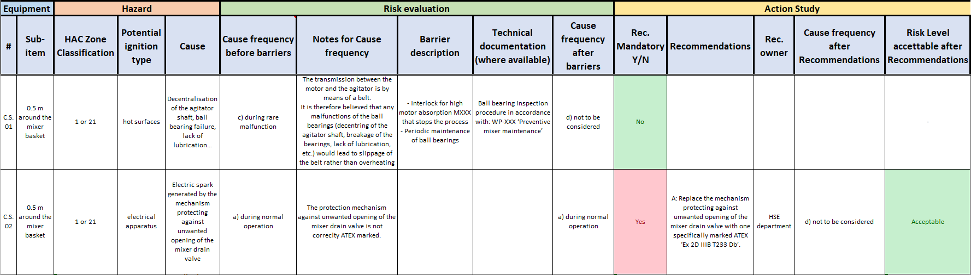
Figure 4 - Case Study 01 and Case Study 02
In scenario C.S.01 (Figure 4), the semi-quantitative assessment reports the analysis of the ignition scenario for hot surfaces caused by a malfunction of the mixing mechanism. This scenario provides an opportunity to address one of the frequent errors made in MEIRAs: hot surfaces are often treated as an “always present” source, with excessively conservative frequencies assigned, whereas in practice their effective presence depends on degraded conditions (abnormal friction, insufficient lubrication, misalignments, accumulation of insulating dust, loss of heat exchange) and the availability of protective barriers (temperature measurements, maintenance trends, interlocks). Furthermore, the same “hot surface” does not have the same severity in different atmospheres: for many combustible dusts, ignition can become plausible at relatively low temperatures (typically in the order of ~130 °C for some layers/accumulations, with smoldering phenomena), while for gases/vapours such as methane, ignition by hot surface alone requires much higher temperatures (in the order of hundreds of °C), making the hazard in certain cases dominated by sparks/impulsive mechanisms rather than stationary heating.
In scenario C.S.02 (Figure 4), the semi-quantitative assessment reports the analysis of the ignition scenario due to an electric spark originating from a malfunction of the mixer components. One of the most common errors in MEIRA analysis is to assume that the ATEX marking of the equipment is a sufficient condition of suitability: in reality, the marking must be read in relation to the specific zone, the type of atmosphere (gas or dust) and the characteristics of the material present (e.g. ignition/auto-ignition temperature, spark sensitivity), because “ATEX” equipment may not be suitable for that combination of EPL/Category, group and temperature class, or for conditions of use not covered by the conformity assumption.
This issue is also crucial in the correct definition of corrective actions. As shown in Figure 4 for scenario C.S.02, the recommendation should not only state that unsuitable equipment should be replaced with something marked “ATEX”, but should also provide guidance to ensure that the new marked equipment is technically consistent with the classification (1/21), the type of atmosphere, and the permitted methods of use, so that the action can be verified.
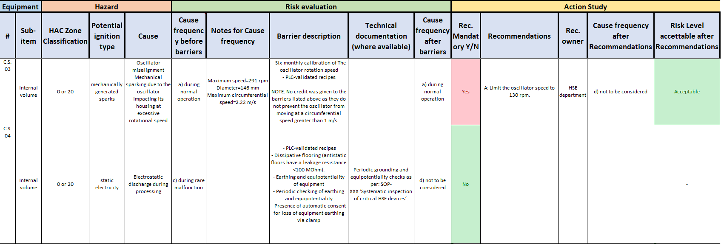
Figure 5 - Case Study 03 and Case Study 04
In C.S.03 (Figure 5), MEIRA demonstrates a particularly robust application because the credibility of the ignition is not inferred by analogy (misalignment → sparks’) but is tested with an explicit physical calculation. The scenario considers the misalignment of the oscillator with possible contact between the rotating part and the casing (mechanical sparking due to oscillator impacting its housing at excessive rotational speed’) and reports the parameters useful for quantification: maximum speed 291 rpm and diameter 146 mm, from which a maximum peripheral speed of 2.22 m/s is derived. This step is methodologically relevant because it transforms a qualitative judgement into a measurable plausibility criterion, improving the repeatability and defensibility of the assessment. Consistently, the cause frequency is set to “a) during normal operation” both before and after the barriers, indicating that the existing measures (six-monthly calibration and validated PLC recipes) are recognized but not “credited” as capable of interrupting the causal chain of contact/impact energy.
The recommended (mandatory) action, on the other hand, is extremely targeted: limiting the oscillator speed to 130 rpm, i.e. a set-point/recipe change that typically has a limited impact on productivity and costs, but which acts directly on the physical prerequisite for igniting. In the table, this intervention allows the residual frequency to be reclassified as “d) not to be considered” and an “Acceptable” outcome to be obtained, illustrating one of the strengths of MEIRA: often the transition from “unsafe” to “safe” does not require invasive redesign, but rather the identification of a quantitative and easily implementable “safe operating envelope”.
C.S.04 (Figure 5) addresses electrostatic discharges during processing, which are among the most complex ignition mechanisms in the ATEX field because they depend not only on the equipment, but also on the interaction between materials, operating conditions and the environment. In the row, the scenario is placed in internal volume with HAC 0 or 20, and the initial cause frequency is assessed as “c) during rare malfunction”: a choice consistent with an approach in which electrostatic ignition is not considered ‘intrinsic’ to normal operation in all configurations, but associated with abnormal conditions (e.g. loss of equipotential continuity, device degradation, unforeseen configurations). The table shows a structured Base of Safety: validated PLC recipes, dissipative flooring (indicated with resistance < 100 MΩ), periodic earthing and equipotentiality checks, and above all the presence of automatic consent/monitoring for loss of earthing (loss of equipment earthing via clamp), supported by documentation (SOP and systematic inspection of critical HSE devices).
In light of this evidence, the post-barrier frequency is changed to ‘d) not to be considered’ without further mandatory recommendations, demonstrating a typical aspect of MEIRA: electrostatic discharge can only be ‘closed’ when the assessment demonstrates not only the presence of grounding/bonding, but also the existence of a verifiable and monitored system that drastically reduces the possibility of conditions that make discharge effective. This case is also an excellent opportunity to clarify that the management of electrostatic ignition differs significantly between combustible dusts and flammable gases/vapours: in dusts, charge generation is often favoured by particle movement and friction (transport, filling, filtration), and specific mechanisms become relevant (accumulation on insulated surfaces, charge on dusts and layers, discharges linked to deposits and insulators); in gases/vapours, on the other hand, the atmosphere can be highly sensitive to spark discharges, making it crucial to eliminate insulated conductors, ensure equipotential continuity and prevent even temporary disconnections/insulations. In both cases, the added value of MEIRA is not in declaring “grounding present”, but in demonstrating with evidence that the “generation-accumulation-effective discharge” chain is interrupted or rendered unreliable.
Finally, the case studies reinforce two often overlooked practices: MEIRA should not duplicate the assessment of equipment that has already been correctly selected and documented according to the requirements for use in the area (where compliance has already been demonstrated), and is generally inefficient when the equipment is already protected by “strong” explosion protection measures (e.g., panels/venting or equivalent systems), because the added value of the assessment shifts from semi-quantitative ranking to verification of the integrity of barriers and design assumptions.
  - Conclusions
Overall, the case study confirms that a semi-quantitative MEIRA can enhance the consistency, transparency, and comparability of combustion risk decisions when integrated into a structured workflow linking HAC, combustion source taxonomy, barrier accreditation, and operability matrix acceptability. The scenarios analyzed demonstrate the practical value of evidence-based screening and simple physical checks (e.g., contact velocity calculations), which help avoid both overly conservative classifications and vague corrective actions. It is important to emphasize that risk reduction is often achieved through targeted, minimally invasive operational modifications (safe operational envelopes) rather than costly redesigns or equipment replacements. At the same time, MEIRA remains dependent on the completeness of data and the knowledge of the team, particularly for complex mechanisms such as electrostatics, where the “presence of grounding” is insufficient without verifiable and monitored checks. Finally, the method adds most value as a decision-making and prioritization tool, while offering limited marginal benefit where equipment suitability and explosion protection measures have already been fully demonstrated and documented.
References
American Society for Testing and Materials, 2019, ASTM E2019-03, Standard Test Mehod for Minimum Ignition Energy of a Dust Cloud in Air.
European Committee for Standardization / European Committee for Electrotechnical Standardization, CEN / CENELEC, 2019, EN 1127-1 Explosive atmospheres - Explosion prevention and protection - Part 1: Basic concepts and methodology.
Gritti A., Carluccio L.M., Pellegrini L., 2024, Semi-quantitative Dust Hazard Analysis: Advantages and Limitations of Using a Risk Matrix in DHA, Chemical Engineering Transactions, 111, 265-270.
International Electrotechnical Commission, 2020, IEC 60079-10-1 Explosive atmospheres - Part 10-1: Classification of areas - Explosive gas atmospheres, Geneva, Switzerland.
International Electrotechnical Commission, 2015, IEC 60079-10-2 Explosive atmospheres - Part 10-2: Classification of areas - Explosive dust atmospheres, Geneva, Switzerland.
International Electrotechnical Commission, 2024, IEC 60079-14 Explosive atmospheres - Part 14: Electrical installation design, selection and installation of equipment, including initial inspection, Geneva, Switzerland.
International Electrotechnical Commission, 2017, Technical Report, CLC/TR 60079-32-1 Explosive atmospheres - Part 32-1: Electrostatic hazards, guidance, Geneva, Switzerland.
International Electrotechnical Commission, 2016, ISO/IEC 80079-20-2 Explosive atmospheres - Part 20-2: Material characteristics - Combustible dust methods.
International Organization for Standardization (ISO) 2016, Explosive atmospheres—Part 36: Non-electrical equipment for explosive atmospheres—Basic method and requirements (ISO 80079-36:2016), ISO, Geneva
National Fire Protection Association, NFPA 70, 2023, National Electrical Code.
National Fire Protection Association, NFPA 497, 2024, National Electrical Code.
National Fire Protection Association, NFPA 499, 2024, National Electrical Code.
National Fire Protection Association, NFPA 652, 2019, National Electrical Code.

