 CHEMICAL ENGINEERING TRANSACTIONS  VOL. xxx, 2026 | A publication of  
The Italian Association
of Chemical Engineering
Online at www.cetjournal.it

Guest Editors: Valerio Cozzani, Bruno Fabiano, Genserik Reniers
Copyright © 2026, AIDIC Servizi S.r.l.
ISBN 979-12-81206-xx-x; ISSN 2283-9216
Hazard-Adjusted Round-Trip Efficiency: Integrating Safety into the Comparative Evaluation of Green Hydrogen and Ammonia Energy Pathways
Burcu Yigitoglu¹, HILMAN ALI HAZMI¹, Marcos Gabriel Millan Agorio^{1,2}, Sunhwa Park^{1,2*}
¹ Chemical Engineering Department, King Fahd University of Petroleum and Minerals (KFUPM), Dhahran 31261, Saudi Arabia
² KFUPM Interdisciplinary Research Center for Refining and Advanced Chemical, Dhahran 31261, Saudi Arabia
*Correspondence: sunhwa.park@kfupm.edu.sa

Green hydrogen and green ammonia are leading carbon-free energy carriers for decarbonizing hard-to-abate sectors. Conventional evaluation based on round-trip efficiency (RTE) consistently favors hydrogen but fail to account for safety. This study introduces Hazard-Adjusted Round-Trip Efficiency (HA-RTE) metric, which integrates energy efficiency with quantified safety penalties derived from a normalized Extended Inherent Safety Index. Eight grid-to-grid Power-to-X-to-Power pathways are assessed by pairing green hydrogen and green ammonia with gas turbines, internal combustion engines, solid oxide fuel cells, and alkaline fuel cells. Hydrogen pathways exhibit higher baseline RTE, reaching 34.10% in H₂-SOFC systems; however, they are associated with elevated chemical and process hazards, resulting in substantial efficiency penalties. After hazard adjustment, ammonia pathways retain more usable performance, with NH₃-SOFC achieving the highest HA-RTE at 20.12%, surpassing H₂-SOFC at 18.08%. Sensitivity analyses confirm that increasing chemical or process hazard weighting and maximum penalty severity disproportionately penalize hydrogen pathways. The results demonstrate that HA-RTE provides a more realistic and decision-relevant comparison of energy carriers than RTE alone and highlights ammonia as a safer and more robust option for large-scale energy deployment.
  - Introduction
Decarbonizing energy-intensive sectors such as heavy industry, shipping, and long-distance power storage requires scalable, low-carbon energy carriers. Among the available options, green hydrogen (H₂) and green ammonia (NH₃) are emerged as leading candidates due to their carbon-free end-use characteristics and compatibility with renewable electricity systems (Kumar et al., 2024). Hydrogen offers high gravimetric energy density and favorable conversion efficiencies, while ammonia benefits from higher volumetric density, moderate storage conditions, and a well-established global infrastructure (Negro et al., 2023). Most comparative assessments of these carriers rely on round-trip efficiency (RTE), defined as the fraction of input electrical energy recovered as useful output. Under this metric, hydrogen-based pathways consistently outperform ammonia-based alternatives. However, RTE-only evaluation implicitly assumes idealized operation and neglects safety risks, which play a critical role in real-world system design, operation, and deployment (Müller et al., 2024). Hydrogen is characterized by wide flammability, low ignition energy, and high diffusivity, leading to elevated combustion accidents—fire and explosions (Park et al. 2025). By contrast, ammonia presents significant toxicity and corrosiveness concerns along with flammability characteristics, but lower risk than hydrogen. These hazard profiles influence material selection, safety distances, regulatory requirements, and ultimately system feasibility and cost (Sarangi et al., 2024). To address this limitation, this study introduces Hazard-Adjusted Round-Trip Efficiency (HA-RTE) as a unified performance metric that explicitly combine efficiency with quantified inherent hazard penalties. By integrating chemical, process, and health-related hazards through the Extended Inherent Safety Index (EISI), HA-RTE enables a more holistic and decision-relevant comparison of green hydrogen and green ammonia energy pathways.
  - Methodology
This study develops a dual-criteria evaluation framework that integrates energy efficiency and inherent hazard to assess the performance of green hydrogen and green ammonia energy pathways. The framework extends the conventional RTE concepts by incorporating quantified hazard penalties derived from the EISI, resulting in a composite performance metric termed HA-RTE. The methodological workflow consists of five sequential steps: (1) pathway definition, (2) energy flow analysis, (3) hazard quantification, (4) efficiency adjustment, and (5) sensitivity analysis.
    - Pathway definition and system boundary
A grid-to-grid Power-to-X-to-Power (PtX–P) system boundary is adopted to ensure consistent comparison between hydrogen- and ammonia-based energy carriers. The boundary encompasses renewable electricity input, carrier production, storage and transport, and reconversion to electricity. Auxiliary processes—such as compression, liquefaction, and internal reforming—are included where applicable. All energy flows are normalized on hydrogen-equivalent mass basis, enabling direct comparison across pathways with chemical compositions and energy densities. Eight representative pathways are evaluated (See Figure 1):
- Four H₂-based pathways (PtH–P): H₂–GT, H₂–ICE, H₂–SOFC, and H₂–AFC
- Four NH₃-based pathways (PtA–P): NH₃–GT, NH₃–ICE, NH₃–SOFC (direct feed), and NH₃–AFC (direct feed)
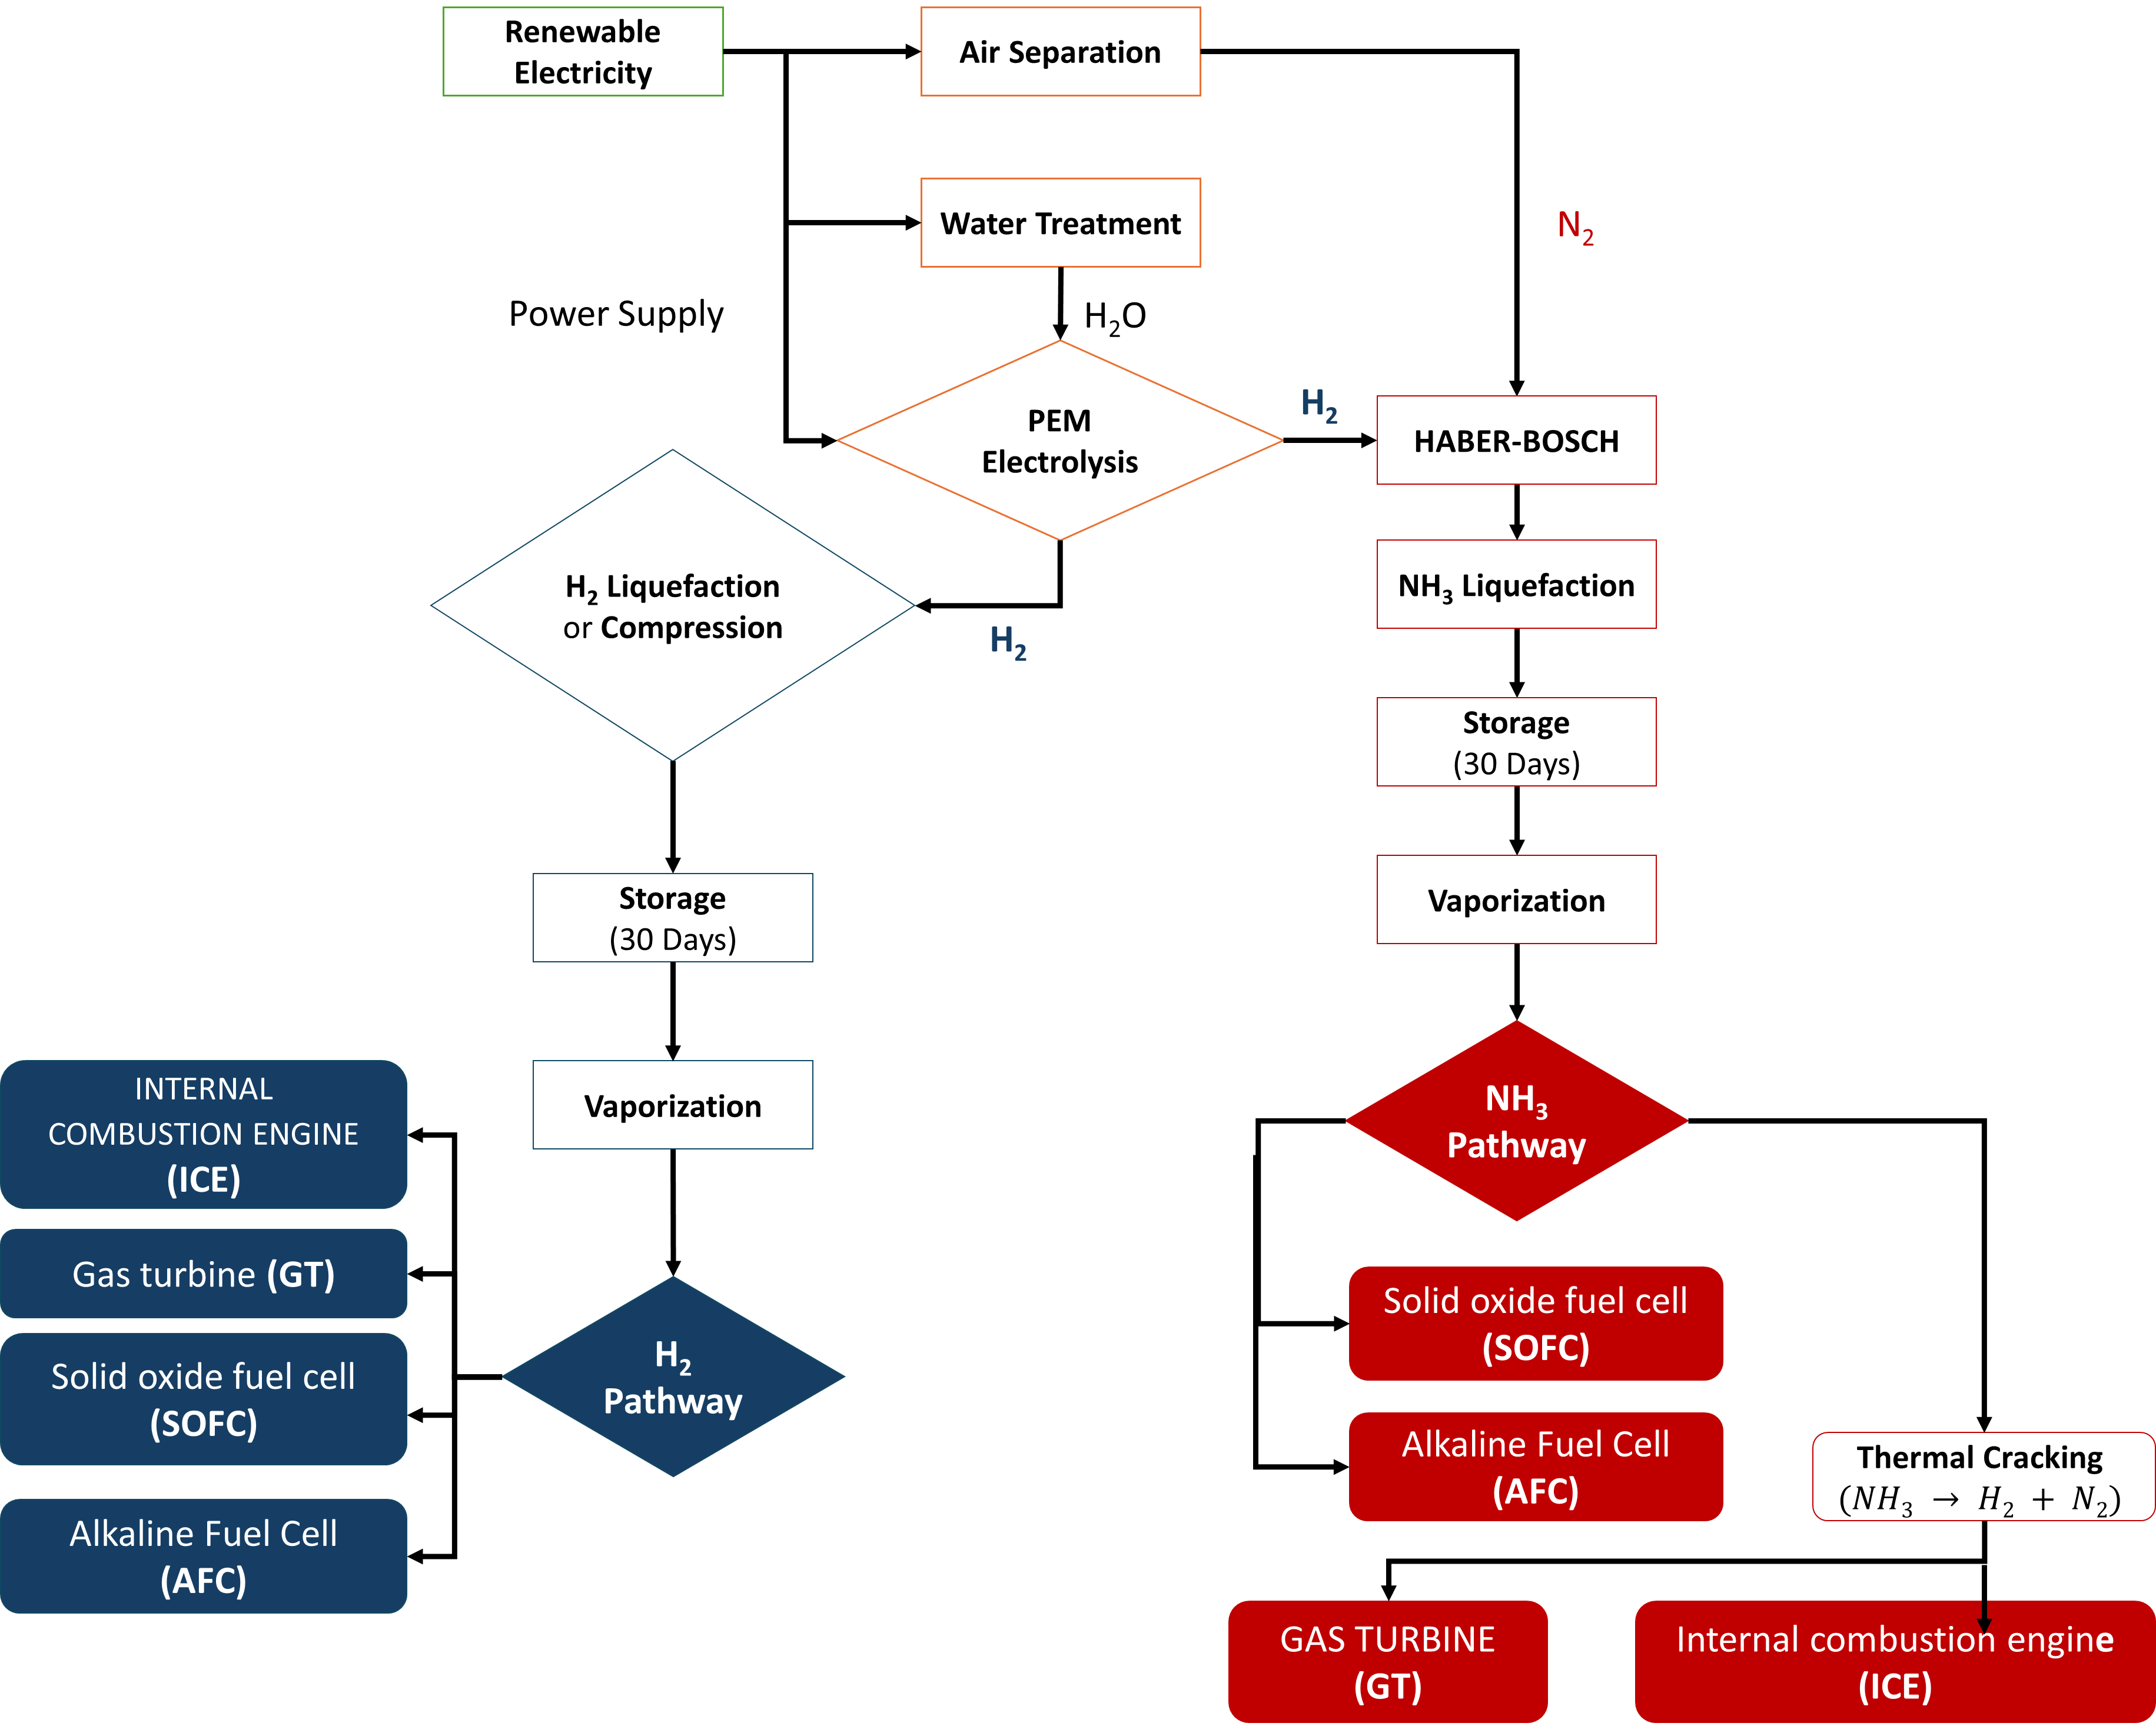
Figure 1. Overview of Green Hydrogen and Green Ammonia Energy Pathways and System Boundaries.
    - Baseline energy performance
The baseline RTE quantifies the purely technical energy performance of each pathway and is defined as:
$RTE=\frac{E_{out}}{∑E_{in}}×100\%$ (1)
The total energy input includes electricity consumption for electrolysis, ammonia synthesis, compression or liquefaction, storage losses, and reconversion to power. This baseline metric serves as the reference against which hazard-adjusted performance is evaluated.
    - Inherent hazard assessment for safety consideration
Inherent hazards are quantified using the Extended Inherent Safety Index (EISI), a structured framework for evaluating chemical and process hazards in early-stage design (Park et al., 2022), which evaluates hazards across three domains:
- Inherent Chemical Index (ICI), accounting for flammability, explosiveness, toxicity, corrosiveness, and reaction energetics;
- Inherent Process Index (IPI), reflecting operating pressure, temperature, material inventory, equipment complexity, and storage configuration; and
- Inherent Biological Index (IBI), capturing health and environmental exposure hazards.

To enable proportional scaling and cross-pathway comparability, a normalized and weighted formulation is adopted.
$EISI_{norm}=w_{1}\frac{ICI}{ICI_{max}}+w_{2}\frac{IPI}{IPI_{max}}+w_{3}\frac{IBI}{IBI_{max}}$ (2)
The weighting factors $w_{1}$, $w_{2}$, and $w_{3}$ allow prioritization of chemical, process, and biological hazards depending on regulatory or operational context. A balanced base case with equal weighting is used to represent moderate safety emphasis.
    - Hazard adjustment and HA-RTE
The normalized EISI is converted into a continuous hazard adjustment factor, $H_{adj}$, which penalizes the baseline RTE according to inherent hazard severity:
$H_{adj}=1+\frac{\left(EISI_{norm} − EISI_{low}\right)}{\left(EISI_{high} − EISI_{low}\right)}(H_{max}-1)$ (3)
Here, $EISI_{low}$and $EISI_{high}$define the lower and upper bounds of inherent safety severity, while $H_{max}$represents the maximum efficiency penalty applied to the most hazardous pathway. This formulation avoids discrete safety classes and ensures smooth, proportional efficiency degradation across pathways.
The HA-RTE is then defined as:
$HA- RTE=\frac{RTE}{H_{adj}}$ (4)
The HA-RTE represents the effective efficiency retained after accounting for inherent hazard constraints. Uncertainty associated with RTE calculations (±3–6%) is propagated consistently to HA-RTE.
To clarify interpretation, the normalized EISI is bounded between $EISI_{low}$and $EISI_{high}$, representing the least and most hazardous pathways within the evaluated set. HA-RTE therefore reflects the relative inherent safety severity across configurations. Lower normalized EISI values indicate comparatively safer systems requiring standard industrial safeguards, whereas higher values indicate greater inherent hazard and the need for stricter mitigation measures. Although these ranges do not represent regulatory limits, they support structured early-stage comparison of energy carriers.
In addition, pathways with HA-RTE values below approximately 10% may be considered potentially impractical for large-scale or seasonal storage applications, as very low adjusted efficiencies imply substantial renewable overcapacity requirements. This threshold serves as a comparative feasibility indicator rather than a strict technical boundary.
    - Sensitivity analysis
To evaluate the robustness of pathway rankings under varying safety priorities, sensitivity analyses are conducted by systematically varying the chemical hazard weighting ($w_{1}$), the process hazard weighting ($w_{2}$), and the maximum penalty cap ($H_{max}$).
  - Results and Discussion
    - Inherent hazard characterization
The inherent hazard assessment clearly differentiates hydrogen- and ammonia-based pathways across chemical, process, and biological domains. Hydrogen pathways exhibit consistently higher chemical hazard indices, dominated by extreme flammability and explosion potential, resulting in uniformly elevated hazard scores across all conversion technologies. In contrast, ammonia pathways show lower flammability and explosion risks, leading to reduced chemical hazard scores, although this benefit is partially offset by higher toxicity and corrosiveness. From a process safety perspective, hydrogen systems again present higher hazard levels due to demanding operating conditions, including high pressures, elevated temperatures, and complex storage requirements. Ammonia systems operate under comparatively moderate pressures and well- established containment and handling practices, yielding lower and more uniform process hazard indices across turbine, ICE, SOFC, and AFC pathways. The biological hazard index remains identical for both vectors, reflecting hydrogen’s asphyxiation risk at high concentrations and ammonia’s acute toxicity. Overall, hydrogen emerges as the more hazardous vector, particularly in chemical and process domains, while ammonia presents a more balanced safety profile.
3.2 Baseline RTE versus hazard-adjusted performance
Baseline RTE results confirm hydrogen’s thermodynamic advantage across all technologies. As illustrated in Figure 2, the hydrogen–SOFC pathway achieves the highest baseline RTE (≈34%), followed by hydrogen ICE and AFC systems. Ammonia pathways show consistently lower baseline efficiencies due to additional synthesis and handling steps. However, incorporating safety penalties through HA-RTE significantly alters pathway rankings. Hydrogen systems experience substantial efficiency reductions due to higher chemical and process hazards; for example, hydrogen–SOFC decreases from approximately 34% RTE to about 18% HA-RTE, while hydrogen ICE drops to nearly 10.5%. In contrast, ammonia pathways retain a larger fraction of usable performance after hazard adjustment. The ammonia–SOFC configuration achieves the highest HA-RTE (≈20.1%), surpassing its hydrogen counterpart. Similar reversals are observed for ICE, turbine, and AFC systems. These trends are demonstrating that thermodynamically optimal pathways may lose competitiveness once safety considerations are internalized.

The baseline RTE values obtained in this study are consistent with previous literature. Müller et al. (2024) reported hydrogen round-trip efficiencies in the range of 28–35% for fuel-cell-based systems, while ammonia pathways typically ranged between 15–28% depending on conversion route. Similar conclusions were drawn by Law et al. (2021), who highlighted hydrogen’s thermodynamic advantage but emphasized ammonia’s practical storage and infrastructure benefits. While the present baseline results align with these findings, the HA-RTE framework extends prior work by explicitly internalizing inherent safety into the comparative efficiency assessment.

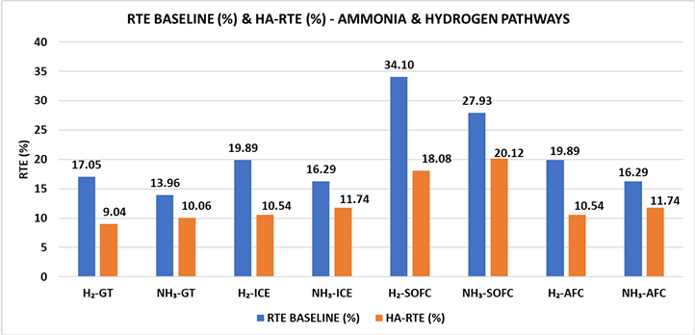
Figure 2. RTE Baseline vs. HA-RTE for Green Hydrogen & Ammonia Pathways

3.3 Sensitivity analysis
Sensitivity analysis confirms the robustness of ammonia pathways under varying safety assumptions. Increasing chemical (w₁) and process (w₂) hazard weightings disproportionately penalizes hydrogen systems due to their higher flammability and more demanding operating conditions (Figures 3 and 4). Across all scenarios, pathway rankings remain stable, with ammonia maintaining greater resilience under safety-constrained conditions. Similarly, raising the maximum penalty factor (Hmax) reduces HA-RTE for all pathways but affects hydrogen more severely, with several configurations falling below 8–10%, while ammonia pathways retain comparatively higher adjusted efficiencies (Figure 5).

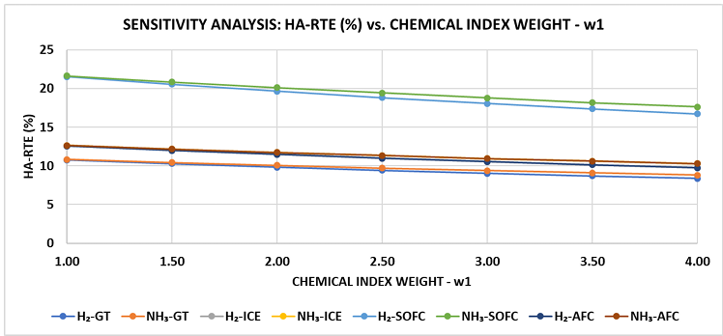
Figure 3. Sensitivity Analysis of HA-RTE to w₁ - Green Hydrogen & Ammonia Pathways
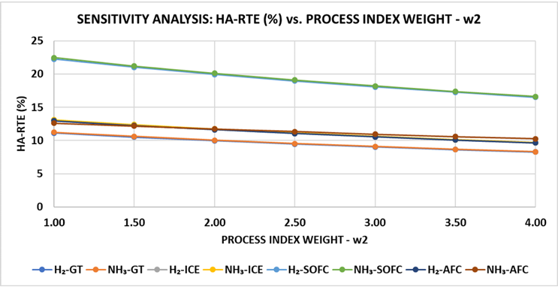
Figure 4. Sensitivity Analysis of HA-RTE to w₂ - Green Hydrogen & Ammonia Pathways
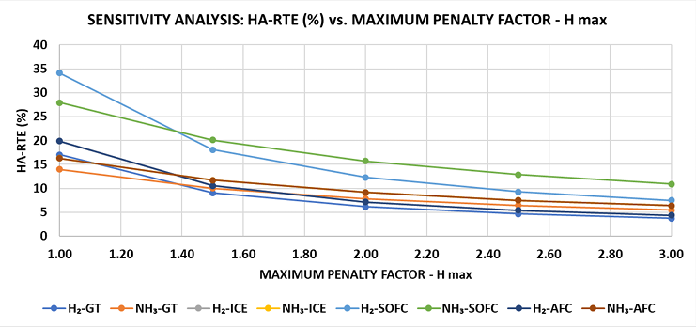
Figure 5. Sensitivity Analysis of HA-RTE to H_{max} - Green Hydrogen & Ammonia Pathways
4. Conclusions
This study introduces HA-RTE as a comprehensive metric that integrates conventional energy efficiency with inherent hazard considerations. By coupling RTE with a normalized EISI, the framework enables a more realistic assessment of green hydrogen and green ammonia energy pathways. The results show that hydrogen pathways, while achieving higher baseline RTE values, are strongly penalized due to elevated chemical and process hazards. Ammonia pathways, despite lower thermodynamic efficiency, consistently retain higher hazard-adjusted performance across turbines, internal combustion engines, and fuel cell systems. The ammonia–SOFC configuration achieves the highest HA-RTE, highlighting the importance of pairing energy carriers with compatible conversion technologies. Sensitivity analyses confirm the robustness of these findings across a wide range of safety weightings and penalty assumptions. Under stricter safety constraints, hydrogen pathways experience rapid efficiency erosion, whereas ammonia pathways maintain comparatively stable performance. Overall, the HA-RTE framework demonstrates that efficiency alone is insufficient for selecting sustainable energy carriers. When safety is explicitly internalized, ammonia emerges as a safer and more balanced alternative for large-scale decarbonization and long-distance energy transport, while hydrogen may remain better suited for niche or tightly controlled applications. The proposed framework provides a valuable decision-support tool for early-stage energy system design and policy evaluation.
  - Nomenclature

AFC – Alkaline fuel cell
EISI – Extended Inherent Safety Index
GT – Gas turbine
HA-RTE – Hazard-Adjusted Round-Trip Efficiency
IBI– Inherent Biological Index
ICE – Internal combustion engine
ICI– Inherent Chemical Index
IPI– Inherent Process Index
PtX–P – Power-to-X-to-Power
RTE – Round-Trip Efficiency
SOFC – Solid oxide fuel cell

  - Acknowledgments
The authors gratefully acknowledge the Deanship of Research Oversight and Coordination (DROC) at King Fahd University of Petroleum & Minerals (KFUPM) for supporting this work through the Young Grant Project EC241011.
  - References
González R., Gómez X., 2024, Ammonia can be currently considered one of the best green energy allies, Sustainable Chemistry, 5, 163–195.
Juanga F.B., Irhamma A.R., Aziz M., 2021, Production of ammonia as potential hydrogen carrier: Review on thermochemical and electrochemical processes, International Journal of Hydrogen Energy, 46, 1–15.
Kumar A., Tiwari A.K., Milani D., 2024, Decarbonizing hard-to-abate heavy industries: Current status and pathways towards net-zero future, Process Safety and Environmental Protection, 187, 408–430.
Law L., Foscoli B., Mastorakos E., Evans S., 2021, A comparison of alternative fuels for shipping in terms of lifecycle energy and cost, Energies, 14, 8502.
Müller M., Pfeifer M., Holtz D., Müller K., 2024, Comparison of green ammonia and green hydrogen pathways in terms of energy efficiency, Fuel, 357, 129843.
Negro V., Noussan M., Chiaramonti D., 2023, The potential role of ammonia for hydrogen storage and transport: A critical review of challenges and opportunities, Energies, 16, 7192.
Park S., Pasman H.J., El-Halwagi M.M., 2022, Progress in inherently safer design for chemical processes, Chemical Engineering Transactions, 90, 1–6.
Park, S., Hashim, B., Zahid, U., & Kim, J. (2025). Global risk assessment of hydrogen refueling stations: Trends, challenges, and future directions. International Journal of Hydrogen Energy, 106, 1462-1479.
Rounce D.R., Hock R., Maussion F., Hugonnet R., Kochtitzky W., Huss M., 2023, Global glacier change in the 21st century: Every increase in temperature matters, Science, 379, 78–83.
Sarangi P.K., Srivastava R.K., Gitanjali J., Sathiyan G., Venkatesan G., Kandasamy S., 2024, Exploring cutting-edge advances in green ammonia production and storage technologies, Fuel, 371, 131863.

