 CHEMICAL ENGINEERING TRANSACTIONS  VOL. xxx, 2026 | A publication of  
The Italian Association
of Chemical Engineering
Online at www.cetjournal.it

Guest Editors: Valerio Cozzani, Bruno Fabiano, Genserik Reniers
Copyright © 2026, AIDIC Servizi S.r.l.
ISBN 979-12-81206-xx-x; ISSN 2283-9216

Preliminary design and performance analysis of a fire-fighting system for an historical Villa
Alessandra Renziª*, Maria Elyas^{b}, Anna Visigoti^{c}
DEKRA Italia s.r.l., Process Safety Business Unit, Via Fratelli Gracchi 27, 20092 Cinisello Balsamo (MI)
alessandra.renzi@dekra.com
DEKRA Italia s.r.l., Process Safety Business Unit, Via Fratelli Gracchi 27, 20092 Cinisello Balsamo (MI)
maria.elyas@dekra.com
DEKRA Italia s.r.l., Process Safety Business Unit, Via Fratelli Gracchi 27, 20092 Cinisello Balsamo (MI)
anna.visigoti@dekra.com

Lithium-ion batteries are increasingly adopted in stationary applications such as uninterruptible power supply (UPS) systems, introducing complex fire safety challenges, particularly in confined and heritage-sensitive environments. One of the most critical hazards is thermal runaway, a self-sustaining electrochemical failure process capable of releasing, in a very short time, large amounts of energy, flammable gases, and toxic by-products, with potential cascading propagation between adjacent cells. This study presents a performance-based fire engineering assessment of a nitrogen inert gas suppression system designed to protect a basement technical compartment within a historic Venetian villa. A lithium-ion battery runaway scenario with cascading potential is analysed through computational fluid dynamics (CFD) modelling; input parameters and modelling assumptions are derived from institutional and experimental literature and the effectiveness of early nitrogen inertization in preventing ignition and arresting runaway propagation is evaluated. Results confirm that oxygen depletion represents an effective mitigation strategy for confined lithium-ion battery installations where conventional water-based systems show significant limitations.

Introduction
The rapid diffusion of lithium-ion batteries in stationary electrical applications, including UPS and energy storage systems, has significantly altered the fire risk profile of modern buildings (Corpo Nazionale dei Vigili del Fuoco and ENEA, 2020; Siemens AG, 2019). These systems combine high energy density with the use of flammable organic electrolytes, making them inherently susceptible to severe fire scenarios characterized by rapid heat release, gas emission, and complex failure mechanisms (Corpo Nazionale dei Vigili del Fuoco and ENEA, 2020; Siemens AG, 2019).
Among the identified hazards, thermal runaway represents the most critical and challenging scenario since it is a self-accelerating process initiated by internal short circuits, overheating, mechanical damage, or aging-related defects that once triggered leads to exothermic reactions within the cell, electrolyte vaporization, venting of flammable gases, and potentially violent ignition events (Corpo Nazionale dei Vigili del Fuoco and ENEA, 2020; Siemens AG, 2019). In battery assemblies, this process may propagate from cell to cell, resulting in cascading failure and large-scale fire development (Siemens AG, 2019; Russo et al., 2018).
Institutional studies conducted by ENEA, Agenzia nazionale per le nuove tecnologie, l'energia e lo sviluppo economico sostenibile, in collaboration with the Italian National Fire Brigade identify thermal runaway as the reference worst-case scenario for lithium-ion battery fire safety analysis, particularly for stationary installations (Corpo Nazionale dei Vigili del Fuoco and ENEA, 2020). The confined nature of technical rooms and basement compartments further exacerbates the consequences of such events due to limited ventilation and delayed heat dissipation (Corpo Nazionale dei Vigili del Fuoco and ENEA, 2020).
Recent experimental investigations and applied fire protection studies have demonstrated that oxygen-depleted environments obtained through inert gas systems, particularly nitrogen-based solutions, are capable of preventing electrolyte vapor ignition and arresting thermal runaway propagation (Siemens AG, 2019; Russo et al., 2018). In this context, performance-based fire engineering supported by CFD modelling provides a robust framework for evaluating mitigation strategies beyond prescriptive approaches (Ministero dell'Interno, 2015; UNI, 2019).
This paper presents a performance-based analysis of a nitrogen inert gas fire suppression system protecting a basement UPS compartment within a historic Venetian villa, focusing on a lithium-ion battery runaway scenario with cascading potential.
The fire safety strategy adopted in this study follows a performance-based design approach consistent with Italian fire prevention principles and international fire engineering practice (Ministero dell'Interno, 2015). Rather than prescribing fixed protection measures, this methodology defines performance objectives and quantitatively evaluates system response under selected fire scenarios.
The basement compartment hosting the UPS installation is treated as a critical technical space requiring measures capable of limiting fire development, preventing damage escalation, and preserving structural integrity. Due to the historic nature of the building, traditional water-based suppression systems were excluded, and a clean agent solution based on nitrogen inert gas was selected.
The performance-based approach allows the explicit assessment of thermal runaway scenarios and the effectiveness of oxygen depletion as a mitigation strategy, supported by numerical modelling and literature-based validation (Siemens AG, 2019; Corpo Nazionale dei Vigili del Fuoco and ENEA, 2020).

State of the Art on Lithium-Ion Battery Fire Suppression
Conventional fire protection strategies for electrical installations have historically relied on water-based sprinkler systems, primarily designed to control flaming combustion through surface cooling. While effective for a wide range of fire scenarios, several studies highlight their limitations when applied to lithium-ion battery hazards.​
Thermal runaway is governed by electrochemical and thermochemical reactions occurring inside the battery cell and does not require sustained external combustion or heat transfer to progress. As a consequence, flame suppression alone does not necessarily interrupt the runaway mechanism or prevent the release of flammable and toxic gases. Institutional analyses emphasize that water application may reduce external temperatures without addressing internal heat generation or gas venting. Additional concerns arise from the interaction between water and battery components, including the generation of hazardous by-products such as hydrogen fluoride and the risk of electrical damage to sensitive UPS equipment. These limitations are particularly relevant in confined technical rooms and heritage buildings, where water discharge may be incompatible with structural and conservation requirements.​
Before applying water to battery systems, it is also essential to ensure, with a very high degree of certainty, that the electrical installation connected to the battery is fully de-energized. Electrical isolation represents a mandatory safety requirement regardless of the extinguishing agent adopted; however, when water is used, this requirement becomes particularly critical due to the intrinsic electrical conductivity of the extinguishing medium and the associated risk of short circuits, arc formation, and damage to connected equipment. For this reason, the implementation of fast detection and automatic electrical isolation systems is strongly recommended. Early detection technologies based on infrared monitoring can be particularly effective, as abnormal temperature increases may originate inside UPS enclosures and may not be immediately detectable through conventional smoke or gas detection systems.​
Conversely, experimental evidence indicates that oxygen depletion through inert gas systems can effectively suppress ignition phenomena and prevent runaway propagation. By reducing oxygen concentration below critical thresholds, nitrogen inertization inhibits combustion of electrolyte vapours and limits secondary fire development, transforming a potentially uncontrollable event into a manageable condition. In particular, Siemens AG (2019) reported that thermal runaway propagation occurred under normal atmospheric conditions at 21% oxygen, whereas no significant propagation to adjacent cells was observed when the oxygen concentration was reduced to about 11.3%.
It should be noted that nitrogen does not instantaneously penetrate into sealed battery cells. However, combustion phenomena associated with electrolyte vapours and vented gases naturally consume the available oxygen in the surrounding environment. Once oxygen concentration is reduced below flammability thresholds, additional combustion processes cannot be sustained, and the external environment no longer provides the oxidizer required to support further fire development. At the same time, the exact limiting oxygen concentration cannot be considered universal, since higher extinguishing concentrations may be necessary depending on the electrolyte used

Case Study Description
The analysed case study concerns a historic Venetian villa characterized by masonry construction and architectural constraints typical of heritage buildings. The basement level hosts technical installations, including lithium-ion battery-based UPS systems serving essential building functions. The presence of these UPS systems is required because the upper floors host bank offices; therefore, ensuring electrical power continuity is critical to guarantee the uninterrupted operation of financial services, IT infrastructure, security systems, and data integrity, in compliance with operational and regulatory requirements typical of the banking sector. The compartment is fully enclosed, with limited natural ventilation and defined leakage characteristics. While separation from adjacent spaces is ensured through fire-resisting elements, a total flooding nitrogen inert gas suppression system is installed to protect the entire basement volume. Battery systems are arranged in modular racks, representing a realistic configuration for stationary UPS installations, furthermore this layout introduces the potential for thermal runaway propagation between adjacent cells and modules, forming the basis for the selected fire scenario. The reference fire scenario considers the initiation of thermal runaway within a lithium-ion battery cell due to an internal short circuit, representative of aging-related failure or manufacturing defects and the scenario is defined as a conservative worst-case condition, consistent with institutional guidance. Following initiation, the cell undergoes rapid temperature increase, electrolyte decomposition, and venting of flammable gases. In the absence of mitigation, heat transfer to adjacent cells may trigger secondary runaway events, resulting in cascading propagation throughout the battery module which represents the dominant hazard for stationary battery installations. The fire suppression system analysed in this study employs nitrogen as an inert agent to reduce oxygen concentration within the protected compartment below the threshold required to sustain combustion and it is designed compliant with UNI EN 15004-1:2019 and UNI EN 15004-8. Nitrogen is stored in high-pressure cylinders located in the close boiler room, which is naturally ventilated through an external air intake. This configuration ensures that, in the event of accidental nitrogen leakage, oxygen availability for boiler combustion is maintained. The design initially considers cylinders with a nominal volume of 140 L, charged at pressures between 200 and 300 bar, and designed to operate within a temperature range of −20 °C to +50 °C, fully compatible with the external climatic conditions. The discharge system consists of multiple nozzles sized to achieve the design concentration uniformly throughout the protected volume. System activation is manual, with a release station positioned outside the UPS room, adjacent to the REI-rated door, ensuring that discharge occurs only after occupant evacuation.
The distribution network is designed as a hydraulically unbalanced system, characterized by:
- differences in equivalent pipe lengths greater than 10%;
- equal discharge flow rates at each nozzle.
A pressure relief system is also included to prevent excessive overpressure during gas discharge.

Calculation of the Required Nitrogen Quantity
For non-liquefied gases, UNI EN 15004-1 provides the following formulation to calculate the total flooding agent mass:
$$Q=\frac{V }{ν}\ln\left(\frac{100 }{100-C}\right)$$
where:
- Q is the required agent mass [kg],
- C is the design concentration [% vol] which is equal to 40,3% according to UNI 15004-1:2019
- V is the net protected volume [m³],
- $ν$ is the specific volume of the gas [m³/kg] calculated as:
$$ν=k1+k2*T$$
where k1 and k2 are agent-specific constants and T is the minimum ambient temperature.
Assuming:
- protected volume V = 600 m3
- ambient pressure of 101,325 Pa,
- minimum temperature of 20 °C,
The calculated nitrogen mass required to reach the design concentration is 361 kg. Applying the mandatory 15% safety margin, the total design mass becomes 415,15 kg that corresponds to a nitrogen volume of 1700L.
When using 140 L cylinders, the system therefore requires 13 cylinders.
Using UNI EN 15004-1 formulations, the post-discharge concentrations are calculated obtaining a nitrogen concentration of approximately 45% v/v, exceeding the minimum design requirement and an oxygen concentration of 11.5% v/v. For inert gas-based agents, the discharge time is the time required to discharge from the nozzle 95% of the extinguishing agent necessary to reach the minimum design concentration and in the case of nitrogen it must be a maximum of 120 seconds. Afterwards, it is also necessary to have an adequate dwell time to avoid any re-ignition, specifically the Italian legislation recommends 10 minutes.

The nitrogen distribution system consists of eight radial nozzles, centrally positioned within each room of the basement archive. The nozzles are characterized by an orifice diameter of approximately 7 mm, while the cylinder discharge valve has an effective area of 3 × 10⁻⁵ m². To evaluate gas discharge behaviour, MATLAB was used to solve the governing mass balance and compressible flow equations, including both sonic and subsonic discharge regimes. The model computes instantaneous discharge rate and gas velocity as functions of internal cylinder pressure.
Initial simulations of an uncontrolled discharge from a 140 L cylinder predicted:
- peak mass flow rate of approximately 1.2 kg/s,
- initial gas velocity of approximately 170 m/s,
which was considered unacceptable due to excessive turbulence and potential damage to stored materials. To ensure safe discharge conditions, the maximum gas velocity was constrained to 40 m/s, consistent with accepted design practice for inert gas systems. MATLAB simulations showed that, under this constraint, the discharge time exceeded the regulatory limit of 120 seconds. To comply with the standard requirement that 95% of the agent be discharged within 120 s, the cylinder volume was reduced to 70 L, resulting in a final configuration of 26 cylinders. MATLAB simulations confirmed that, with this configuration, more than 95% of the nitrogen is released within the prescribed time while maintaining controlled flow velocities.
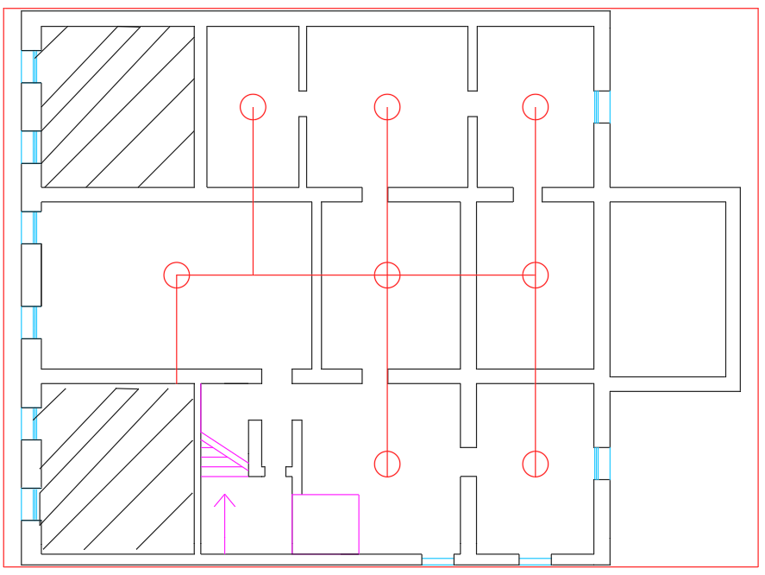
Figure 1 Nitrogen distribution system
The rapid discharge of inert gas can generate significant overpressure within the protected enclosure. As basement windows are normally kept closed, leakage areas were conservatively assumed to be negligible. Therefore, pressure relief vent sizing was carried out in accordance with CEA (Comité Européen des Assurances) guidelines, which indicated a required vent area of 0.30 m². This requirement can be met by the automatic opening of two basement windows.

CFD Modelling Approach
The simulations were conducted on the FDS simulator by NIST to analyse fire development and the effectiveness of nitrogen inertization. The numerical model includes detailed representation of compartment geometry, battery fire source characteristics, species transport, and inert gas discharge, while heat release rates, gas generation, and runaway progression parameters were derived from experimental and institutional literature. Simulations evaluate temporal evolution of temperature fields, oxygen concentration, and fire propagation under mitigated conditions.
The initiation of the runaway event was represented in the model by means of an externally imposed burner-type heat source acting on the first battery cell. This assumption was derived from institutional modelling approaches adopted in lithium-ion battery fire studies, in which ignition is reproduced through an assigned heat release rate over a defined surface to obtain a repeatable thermal abuse scenario. Although this method does not strictly replicate internal short-circuit failure, it provides a practical and conservative representation of the initial thermal insult for performance-based fire analysis.​
Fire propagation to adjacent cells was modelled using diethyl carbonate as a representative electrolyte solvent. The evaporation and subsequent combustion of the solvent triggered cascade reactions, reproducing the thermal runaway propagation mechanism in simplified form. The material definition adopted in the FDS model included an electrolyte species release associated with the battery cells, while a dedicated combustion reaction was used to represent ignition of vented flammable vapours.
The nitrogen inertization system was activated 200 s after ignition. This delay was defined on a performance-based basis as the sum of the smoke detector response time predicted in the simulated scenario and an additional interval accounting for alarm recognition, operator reaction, movement to the manual release station located outside the room, and manual system actuation. The selected activation time was therefore intended to represent a credible and conservative intervention sequence for the assumed emergency conditions.​
In the implemented FDS case, the nitrogen mass flux ramp starts at 201 s and remains active until 351 s. The analysis therefore captures both the discharge phase and the subsequent atmospheric stabilization period. The output configuration included oxygen monitoring devices at multiple locations, together with slice files for oxygen, nitrogen, temperature, carbon monoxide, carbon dioxide, electrolyte vapour, and heat release rate per unit volume.

Results and Discussion
Simulation results indicate that early nitrogen discharge markedly modifies the development of the battery fire scenario. Following activation of the inert gas system, oxygen concentration is reduced below critical thresholds for combustion, temperature rise is significantly attenuated, and the conditions required for sustained ignition of electrolyte vapours become progressively less favorable. These findings are consistent with experimental observations reported in the literature, confirming the effectiveness of oxygen depletion strategies for lithium-ion battery fire mitigation in confined environments.
The achieved design post-discharge oxygen concentration of approximately 11.5% v/v was evaluated against available experimental evidence on lithium-ion battery inertization. In propagation tests reported by Siemens AG (2019), thermal runaway initiated under a reduced-oxygen atmosphere of 11.3% did not propagate to adjacent cells, whereas full propagation was observed under normal atmospheric conditions at 21% oxygen. This indicates that oxygen concentrations in the 11–12% v/v range may be sufficient to suppress secondary ignition and interrupt cascade effects in confined battery configurations. In the present case, the calculated design value of 11.5% is therefore consistent with the range reported as effective for nitrogen-based protection systems. However, the safety margin with respect to the cited threshold remains limited, and the exact limiting oxygen concentration may vary depending on electrolyte composition, vent gas mixture, enclosure leakage, and local concentration non-uniformity. For this reason, the selected design concentration should be interpreted as a performance-based engineering target supported by literature evidence rather than as a universally conservative threshold.
The CFD simulations were used to evaluate the temporal and spatial evolution of oxygen concentration, temperature field, and combustion-related quantities during the battery fire scenario and the subsequent nitrogen discharge. In the CFD model, nitrogen discharge was initiated at 200 s. The fastest oxygen depletion was observed in the region closest to the battery rack and the discharge path, while more distant points exhibited a slightly delayed response, indicating transient spatial non-uniformity during the early phase of gas distribution.​
At the fire location, the oxygen concentration decreased from the initial ambient value to approximately 5% v/v by 202 s. This markedly lower value compared with the nominal design target of 11.5% v/v reflects the combined effect of nitrogen inert gas dilution and the consumption of oxygen by ongoing combustion of the ignition source and electrolyte vapours. In a substantially confined environment with initially closed openings, active combustion processes further deplete oxygen beyond the dilution effect of nitrogen discharge alone. For this reason, the local oxygen minimum predicted by the CFD model should not be interpreted as the sole result of extinguishing system sizing, but rather as the combined outcome of inert gas flooding and combustion-driven oxygen depletion.
The oxygen concentration histories recorded at the central and far-field monitoring points showed a more gradual decrease and a progressive tendency toward spatial homogenization as the discharge proceeded. This behaviour is consistent with a multi-nozzle distribution system operating in a finite-volume compartment. The temporal evolution of oxygen concentration therefore supports the conclusion that nitrogen discharge is able to establish an inert atmosphere throughout the protected enclosure, although not instantaneously and with local minima more pronounced near the combustion zone.

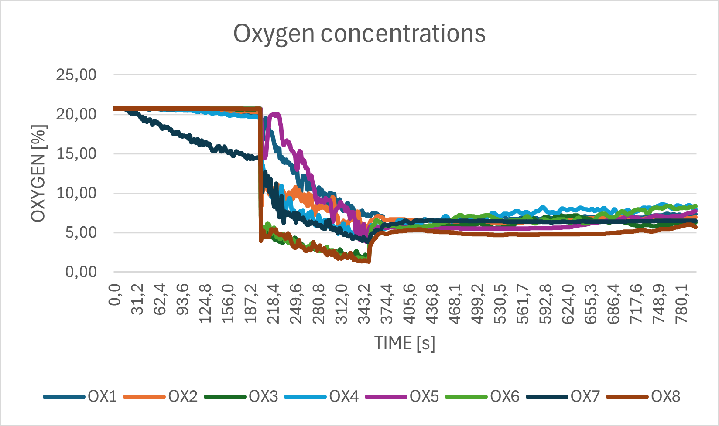
Figure 2 Temporal evolution of oxygen concentration at representative locations inside the protected compartment

Temperature field snapshots further confirmed the beneficial effect of nitrogen inertization. Before nitrogen release, the simulation showed a localized high-temperature region in the battery area associated with the ignition source and the onset of combustible vapour release. After activation of the inert gas system, the thermal field became progressively less severe, with clear attenuation of the high-temperature zone and reduction in the spatial extent of the combustion plume. The corresponding oxygen field snapshots show that this attenuation is associated with the progressive development of an oxygen-depleted atmosphere in the compartment.

 | Temperature field in a vertical section before and after nitrogen discharge | Oxygen concentration field in a vertical section during nitrogen discharge
190 s | 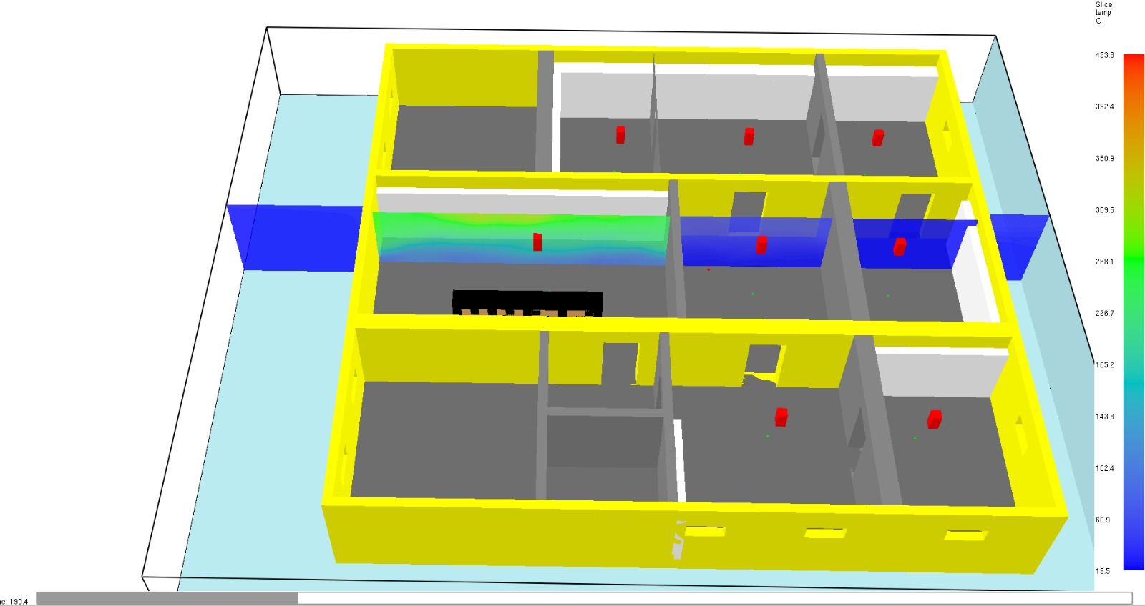 | 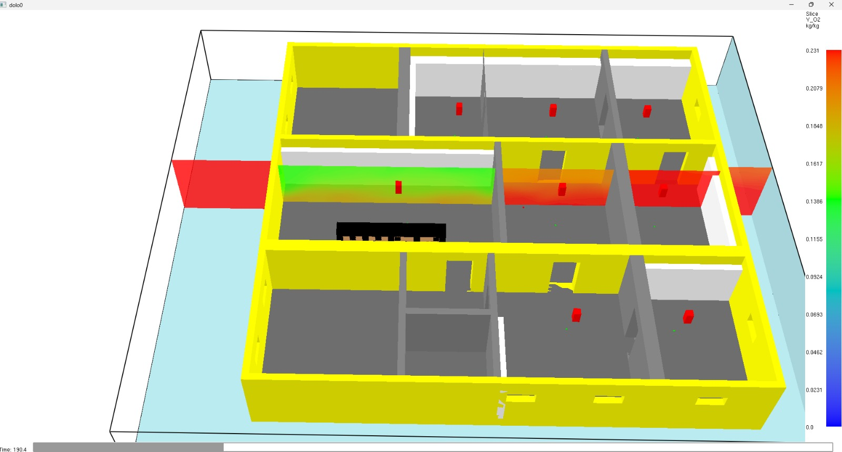
240 s | 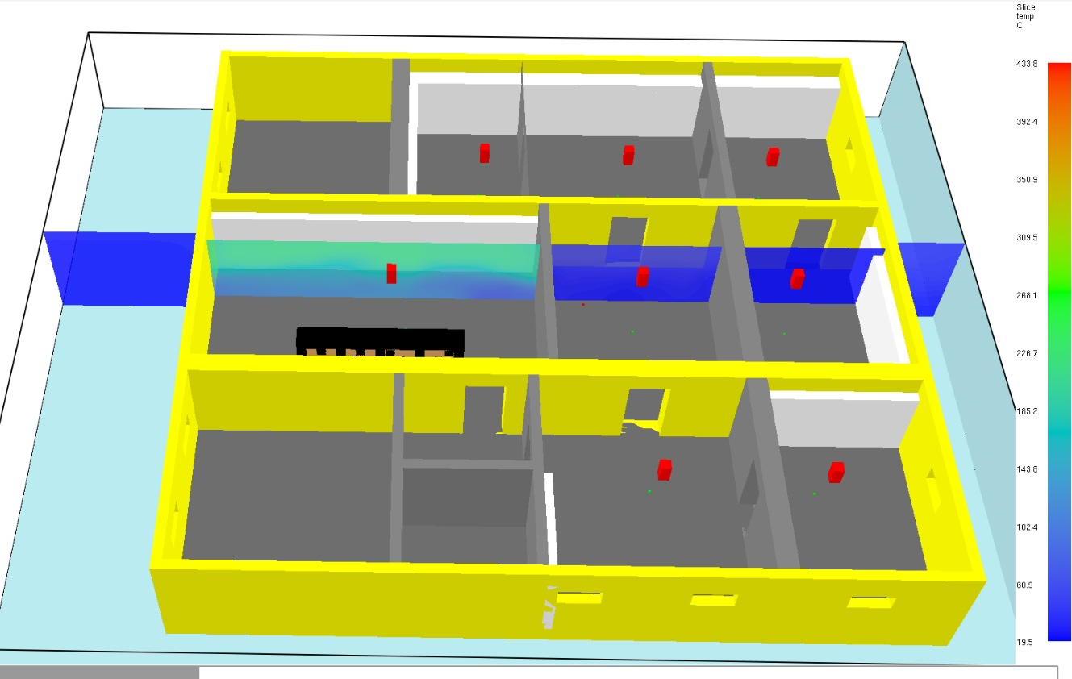 | 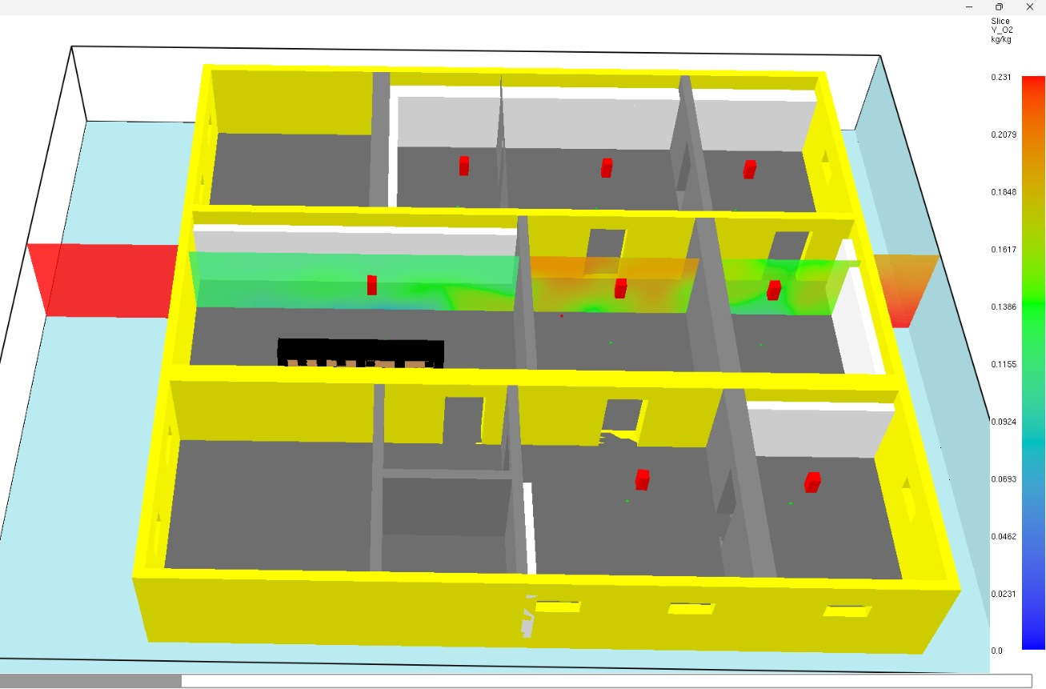
320 s | 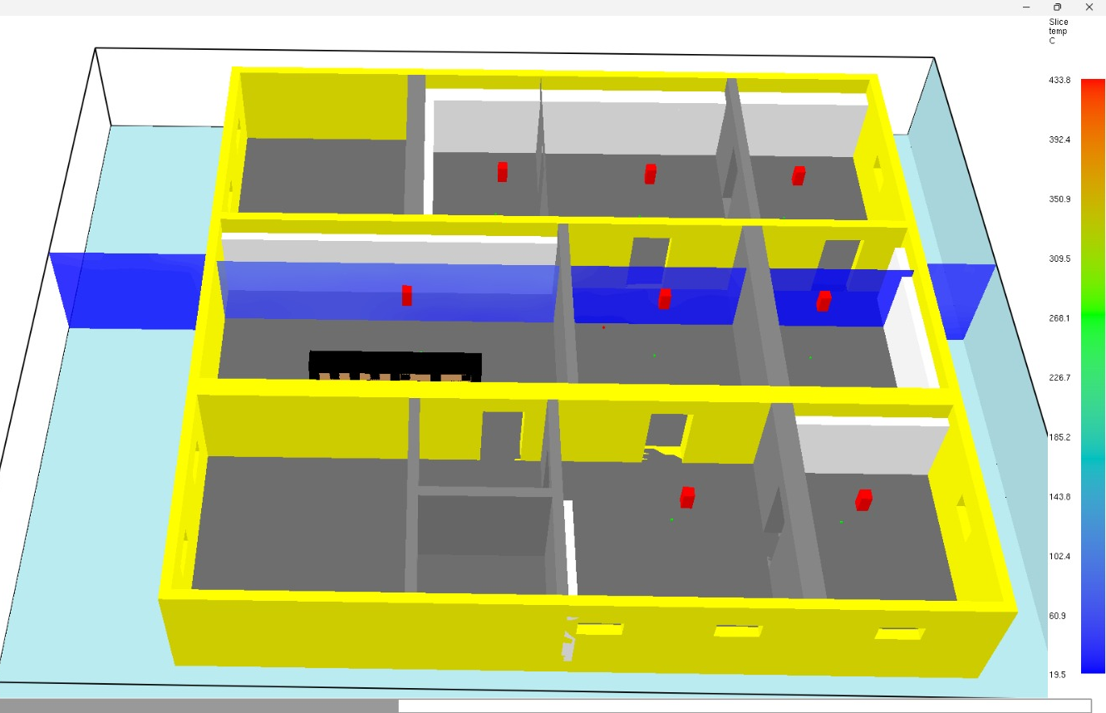 | 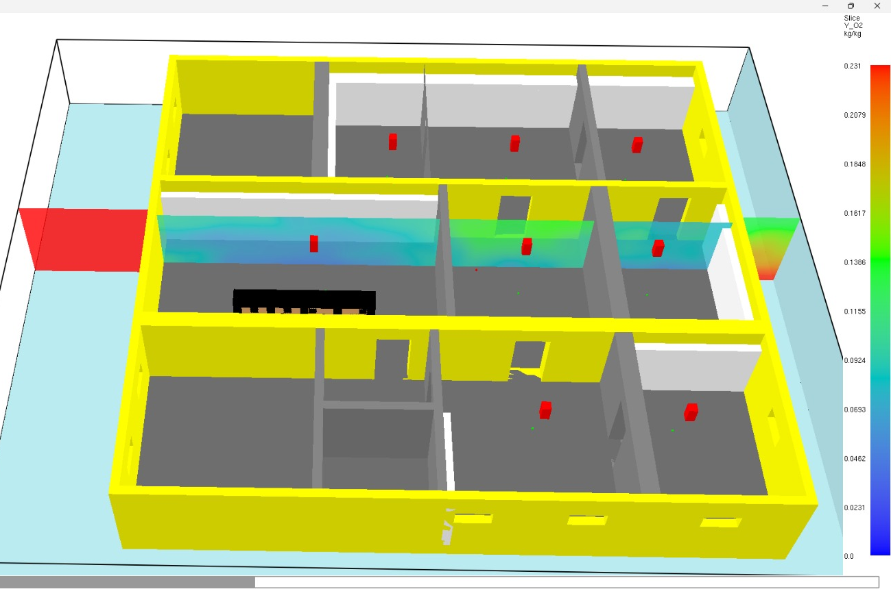

Additional slice outputs for electrolyte vapour and heat release rate per unit volume indicate that the most reactive region remains localized around the initiating battery cluster and weakens as oxygen depletion progresses. This behaviour is consistent with the performance objective of preventing large-scale flame spread and limiting the transition from a localized battery failure to a compartment-involving fire. The evolution of carbon monoxide and carbon dioxide fields is likewise consistent with a reduction in overall combustion intensity as oxidizer availability decreases.​
Overall, the simulation results indicate that early nitrogen discharge can transform the analysed event from a potentially escalating battery fire scenario into a more controlled condition. The combined analysis of oxygen depletion, thermal field attenuation, and reduced combustion intensity supports the conclusion that nitrogen inertization is an effective mitigation strategy for confined lithium-ion battery UPS installations, in agreement with experimental evidence reported in the literature for reduced-oxygen protection systems.
At the same time, the results should be interpreted considering the assumptions of the present preliminary model. In particular, the effectiveness of the strategy depends on activation time, discharge duration, compartment leakage conditions, and spatial mixing of the extinguishing gas. The current FDS input also uses a simplified representation of thermal runaway initiation and a prescribed nitrogen discharge ramp. For this reason, the present analysis should be regarded as a performance-based demonstration of feasibility, while future developments should include additional sensitivity analyses on activation delay, compartment leakage, and local non-uniformity of oxygen concentration.

Conclusions
This study demonstrates the applicability of performance-based fire engineering to the mitigation of lithium-ion battery thermal runaway hazards in confined UPS installations within heritage buildings. CFD analysis confirms that nitrogen inert gas suppression systems can effectively prevent ignition and limit cascading propagation when early inertization is achieved.​
The proposed approach provides a robust framework for integrating clean agent fire suppression systems into architecturally constrained environments hosting modern electrical infrastructure. The results also highlight that the actual oxygen concentration predicted during the event may locally fall below the nominal design value due to the combined effect of nitrogen dilution and combustion-driven oxygen consumption.
From an operational safety perspective, post-emergency management represents a critical phase. After inert gas discharge, access to the protected enclosure shall be restricted until oxygen concentration has returned to safe levels and the inert atmosphere has been adequately removed. Practical solutions may include the use of existing HVAC systems, when available, combined with oxygen concentration monitoring, or dedicated forced ventilation systems. In specific scenarios, controlled re-pressurization using breathable compressed air may also be considered as part of emergency response procedures.​
These aspects are addressed within the reference regulatory framework for gaseous fire suppression systems. The UNI EN 15004 series specify safety requirements for inert gas systems, including measures to prevent hazardous exposure to low-oxygen atmospheres. The standard requires pre-discharge alarms and time delays to allow safe evacuation prior to agent release and mandates technical provisions to limit personnel exposure in case of oxygen depletion. Furthermore, it requires warning systems, evacuation procedures, and provisions for natural or forced ventilation to remove extinguishing gases after discharge and restore safe environmental conditions before re-entry.​
However, despite the effectiveness of inertization in suppressing combustion and limiting propagation, this approach does not directly ensure thermal stabilization of lithium-ion battery cells. Since gaseous nitrogen systems primarily act by reducing oxygen availability rather than by removing the residual heat stored within damaged cells, internal energy may persist even after the required inert gas hold time. As a consequence, delayed thermal runaway phenomena or re-ignition may still occur if oxygen is subsequently restored while battery temperatures remain above critical thresholds. This limitation highlights the need for complementary strategies addressing post-suppression thermal management, atmosphere restoration, and safe re-entry conditions.

Further Developments
Future research will focus on the development and validation of integrated protection concepts capable of combining ignition suppression with post-event thermal stabilization and controlled atmosphere restoration. Particular attention will be devoted to defining safe re-entry criteria based on multi-parameter monitoring, including oxygen concentration, temperature evolution, and gas composition.
In parallel, further investigation is required on post-event smoke and combustion by-product management. Lithium-ion battery incidents may generate significant quantities of toxic and corrosive gases, requiring dedicated removal strategies before safe access and recovery operations can be performed.
This requirement is consistent with the Italian Fire Prevention Code (DM 3 August 2015), which includes smoke and heat control as part of the fire safety strategy. In particular, Chapter S.8 requires the implementation of smoke and heat exhaust measures aimed at facilitating firefighting and rescue team operations during and after emergency scenarios.
Future developments will therefore address the integration of inert gas suppression systems with smoke exhaust and post-event atmosphere management solutions within performance-based fire engineering frameworks. Such integration is expected to be particularly relevant in confined technical environments and heritage buildings, where architectural constraints and conservation requirements limit the applicability of conventional fire protection and ventilation solutions.

References
Bettati Antincendio s.r.l., 2010, Manuale di Progettazione Sistema a Spegnimento Gas Inerti, Reggio Emilia, Italy.
Corpo Nazionale dei Vigili del Fuoco and ENEA, 2020, Rischi Connessi Con Lo Stoccaggio Di Sistemi Di Accumulo Litio-Ione, Agenzia Nazionale per le Nuove Tecnologie, l'Energia e lo Sviluppo Economico Sostenibile, Rome, Italy.
Di Bari, C., 2018, Sicurezza Degli Accumulatori Litio-Ione Ed Elettromobilità: Indice Commentato degli Studi Effettuati nel Triennio 2015-2017, Report RdS/PAR2018/131, ENEA, Rome, Italy.
Ministero dell'Interno, 2015, Codice di Prevenzione Incendi - Decreto Ministeriale 3 Agosto 2015, Gazzetta Ufficiale della Repubblica Italiana, Rome, Italy.
NIST (National Institute of Standards and Technology), 2023, Fire Dynamics Simulator (FDS) User's Guide, U.S. Department of Commerce, Gaithersburg, Maryland, USA.
Russo, P., Di Bari, C., Mazzaro, M., De Rosa, A., Morriello, I., 2018, Effective Fire Extinguishing Systems for Lithium-ion Battery, Chemical Engineering Transactions, 67, 619–624. https://doi.org/10.3303/CET1867104
Siemens AG, 2019, Fire Protection for Li-ion Battery Energy Storage Systems, White Paper, January 2019, Munich, Germany.
UNI (Ente Italiano di Normalizzazione), 2019, UNI EN 15004-1:2019 Installazioni Fisse Antincendio - Sistemi a Estinguenti Gassosi - Parte 1: Progettazione, Installazione e Manutenzione, Milan, Italy.
UNI (Ente Italiano di Normalizzazione), 2019, UNI EN 15004-8:2019 Installazioni Fisse Antincendio - Sistemi a Estinguenti Gassosi - Parte 8: Requisiti Specifici per i Sistemi a Azoto, Milan, Italy.
VTT Technical Research Centre of Finland, 2018, Fire Dynamics Simulator with Evacuation: FDS+EVAC Technical Reference and User's Guide, Espoo, Finland.

