 CHEMICAL ENGINEERING TRANSACTIONS  VOL. , 2026 | A publication of  
The Italian Association
of Chemical Engineering
Online at www.cetjournal.it

Guest Editors: Valerio Cozzani, Bruno Fabiano, Genserik Reniers
Copyright © 2023, AIDIC Servizi S.r.l.
ISBN 978-88-95608-98-3; ISSN 2283-9216

Hybrid mixture: implementing Hazardous Area Classification (HAC) case study
Aurora Lafiosca*, Lorenzo Pellegrini, Federica Parenti, Sara Perelli
*DEKRA Italia s.r.l., Process Safety Business Unit, Via Fratelli Gracchi 27, 20122 Cinisello Balsamo (MI)
aurora.lafiosca@dekra.com
In process industries involving the generation, handling, or storage of combustible dusts, hazardous area classification is a fundamental activity for assessing the risk of explosive atmosphere formation. This classification, governed by international technical standards such as IEC 60079-10-2 and NFPA 499, provides the methodological basis for implementing effective protection measures in compliance with industrial safety requirements.
This paper analyzes complex scenarios characterized by the presence of hybrid mixtures—i.e., potentially explosive atmospheres consisting simultaneously of flammable gases/vapors and combustible dusts. In particular, it examines operating conditions in which, during the manual loading of reactors containing flammable solvents, the introduction of powders by the operator can generate hybrid mixtures with high explosive potential.
Several different options will be examined and discussed, showing benefits and disadvantages for each configuration. The main parameters that will be used in the discussion will be the ones related to the flammability and ignitability of gases / vapors and combustible dusts.
In conclusion, the document provides operational recommendations and technical insights aimed at mitigating explosion risks in environments characterized by high process complexity, promoting a risk management approach aligned with the principles of safety engineering.

  - Introduction
This article, in addition to referencing the relent regulatory framework, is predominantly informed by DEKRA’s consolidated field experience in the domain of Hazardous Area Classification (HAC).
The process industries have progressively developed a heightened awareness of the hazards associated with the formation of explosive atmospheres. A series of major incidents, extensively investigated by organizations such as the Chemical Safety Board (CSB) (Perelli, 2023), has demonstrated that the accidental dispersion of combustible dusts and flammable gases/vapours within industrial environments can initiate severe explosion events, resulting in significant loss of life, extensive damage to equipment and infrastructure, and substantial economic consequences. These events have acted as a catalyst for both regulatory and technical communities, prompting the refinement of standards and guidelines aimed at improving the assessment and management of explosion risks.
Concurrently, the increasing complexity of modern industrial operations has led to the emergence of scenarios in which substances belonging to different hazard classes coexist. Among these, hybrid mixtures—explosive atmospheres comprising both flammable gases or vapours and combustible dusts—represent a particularly critical condition. Although hybrid mixtures have long been recognized within the scientific and technical literature, their practical management remains challenging, as they often exhibit ignition sensitivities and explosion dynamics that are more severe than those observed in single‑phase systems.
    - What is Hybrid Mixture?
Hybrid mixtures are potentially explosive atmospheres arising from the simultaneous presence of a gaseous fuel (flammable gases or vapours) and a dispersed combustible dust.
In particular, according to IEC 60079-10-1, the presence of flammable gases may reduce the Minimum Ignition Energy (MIE) of the dust cloud, while the dust can broaden the flammability range of the gas or lower its Lower Explosive Limit (LEL). The resulting mixtures exhibit increased ignition sensitivity and faster combustion dynamics. Moreover, the Minimum Explosible Concentration (MEC) of the dust may decrease in the presence of combustible vapours, enabling ignition at dispersion levels below those typically required for dust‑only atmospheres.
Hybrid mixtures may form during various process operations, especially during the charging of powders into equipment containing flammable solvents or in the presence of residual vapours. Their assessment is inherently complex, as the interaction between the gaseous and solid phases can significantly influence ignition sensitivity, combustion behavior and explosibility limits. Consequently, effective risk management requires a dedicated engineering approach based on a detailed understanding of the interaction mechanisms between the two combustible phases.
    - Learning from regulations
The IEC 60079-10-1 standard addresses hybrid mixtures by adopting a highly conservative approach, reflecting the limited availability of experimental data and the uncertainties associated with the simultaneous presence of flammable gases or vapours and combustible dusts. Under this guidance, a hybrid atmosphere is considered potentially explosive even when each component is below its individual flammability threshold. In the absence of specific test data, the mixture is assumed to be hazardous if the gas/vapour concentration exceeds 25% of the LFL or if the dust concentration exceeds 25% of the MEC.
The effectiveness of ventilation in such conditions must be evaluated carefully, as airflow may reduce vapour accumulation while simultaneously increasing dust dispersion, potentially elevating the overall explosion risk. Additional uncertainties may stem from chemical interactions within the hybrid mixture or from the release of flammable gases trapped within solid particles. Consequently, critical safety parameters—such as Minimum Ignition Energy and Minimum Auto-Ignition Temperature—should be selected using the most restrictive value of the two phases.
For hazardous area classification, international standards require applying the most stringent protection level defined for either gases/vapours or dusts, ensuring an adequate safety margin consistent with the complexity and unpredictability of hybrid explosive atmospheres.
  - Methodology
Hazardous Area Classification (HAC) is applied as a fundamental tool for preventing ignition sources and defining appropriate protection measures in processes where explosive atmospheres may occur. In this study, HAC is used to assess operating scenarios involving the potential coexistence of flammable gases or vapours and combustible dusts, with particular reference to manual powder handling operations.
The classification follows the methodology outlined in IEC 60079-10-1 (2020), starting from the identification of potential sources of release and the determination of the corresponding release grades. Conditions that are reasonably foreseeable during normal operation and foreseeable deviations are considered in order to ensure that the classification reflects unfavorable but credible operating scenarios.
For gas and vapour atmospheres, the extent of hazardous zones is evaluated using the analytical criteria provided by IEC 60079-10-1, taking into account the release characteristics and the effectiveness of ventilation. For dust atmospheres, where no explicit formulas are available, the zone classification is based on qualitative criteria, considering the likelihood of dust cloud formation, dispersion and accumulation.
When gas/vapour and dust releases may occur in the same area, the classification is performed by considering their combined presence and by adopting the most restrictive zoning and protection requirements resulting from the individual assessments. The outcomes of the HAC form the basis for the definition of hazardous zones and equipment protection levels used in the case study.
    - Why is Hazardous Area Classification (HAC) important?
Hazardous Area Classification plays a key role in the assessment of explosion consequences (Figure 1) by defining the conditions under which ignition may occur and the expected physical effects following ignition.
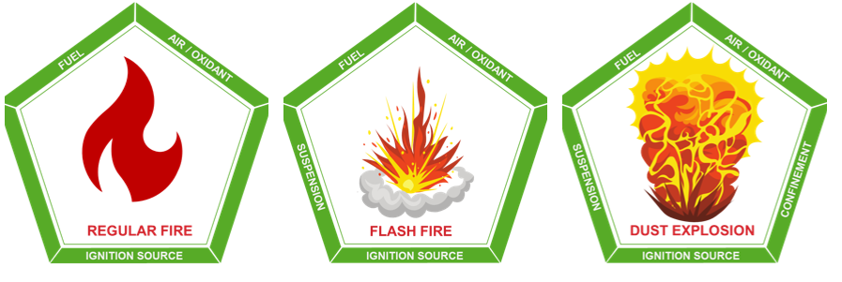
Figure 1: Consequences of ignition, based on the pentagon of fire
As a general principle, ignition within the confined volume of process equipment is likely to result in an explosion, whereas ignition in open or partially open areas more commonly leads to flash fire. In addition, internal explosions may give rise to secondary hazards, such as flame propagation to interconnected equipment and the projection of fragments, which can significantly increase the overall risk. For these reasons, a correct and conservative hazardous area classification is essential to support effective risk mitigation and the selection of appropriate protection measures.
  - Case studies: Manual powder charging into a reactor
The case study considers a manual powder charging operation into a reactor containing a flammable solvent, a configuration commonly associated with the potential formation of hybrid explosive atmospheres. The objective is to identify the conditions under which an explosive atmosphere may arise and to define the corresponding Hazardous Area Classification (HAC) in accordance with applicable technical standards.
The following Figure 2 illustrates the case study, providing an example of hazardous area classification with potential explosive atmospheres and highlighting the highest-risk operational scenarios to which the operator may be exposed.
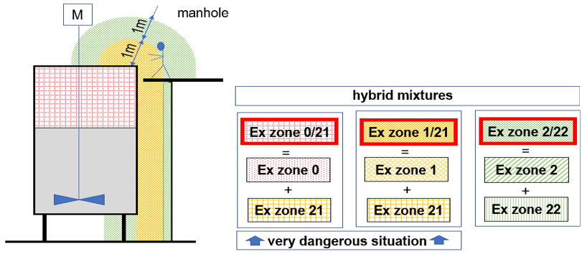
Figure 2: Manual powder loading operation
Based on this configuration, four representative operating scenarios were analysed to assess the impact of different risk control strategies on the formation of hybrid mixtures and on hazardous area classification.
- Non‑inerted system with sequential charging;
- Powder charging below the solvent flash point;
- Powder charging through an inerted airlock system;
- Venturi‑based powder charging without inerting.
The first scenario examined concerns the sequence of manual loading operations performed by the operator, under the assumption that the system is not inerted. The procedure consists of two main steps: the initial introduction of the powder into the reactor, followed by the addition of the flammable solvent. The Figure 3 below illustrates the prescribed sequence of operations—namely, charging the solid material first and subsequently introducing the flammable liquid—as well as the corresponding hazardous area classification. Although the two substances are not present simultaneously during charging, particular attention must be paid to agitation and mixing effectiveness once the solvent is added. Inadequate mixing may lead to localised accumulations of combustible dust or solvent vapours, potentially increasing the explosion hazard within the vessel.
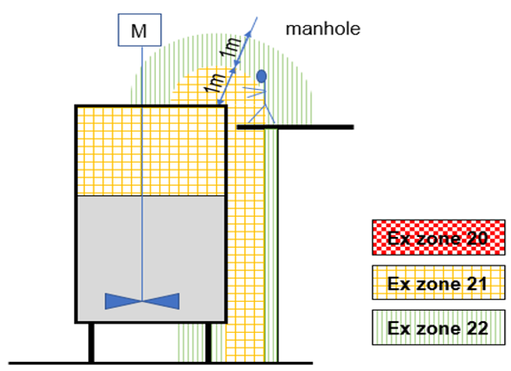 | 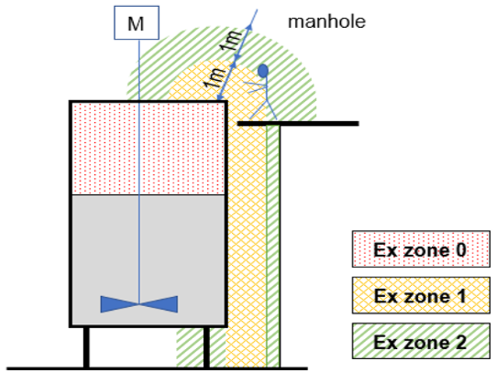
Figure 3: First scenario: sequential powder and solvent charging in a non‑inerted system
The second scenario (Figure 4) concerns the dosing of powder into a flammable solvent that has been cooled to a temperature range of approximately 20°C to 40 °C below its flash point. This range of operating condition significantly reduces the likelihood of vapour formation and, consequently, the probability of generating an explosive atmosphere during the charging phase. This range is generally selected based on industrial experience and specific company guidelines. The key distinction between this scenario and the previous one lies in the temperature-control strategy adopted: in this case, the system relies on an active thermal management arrangement designed to maintain the solvent at a sufficiently low temperature throughout the operation. Such control measures are essential to ensure that the solvent remains well below its critical ignition parameters, thereby mitigating the risk associated with hybrid mixture formation and limiting the extent of hazardous area classification.
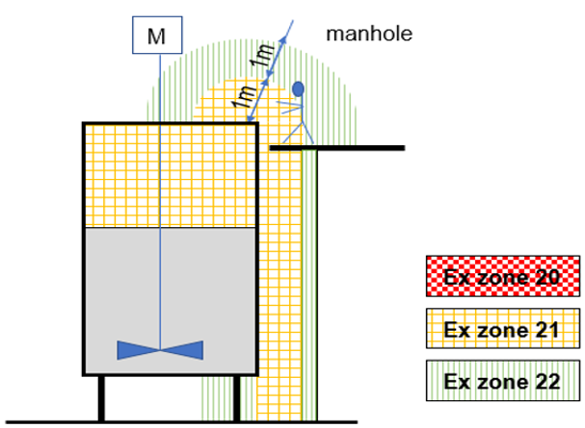 | 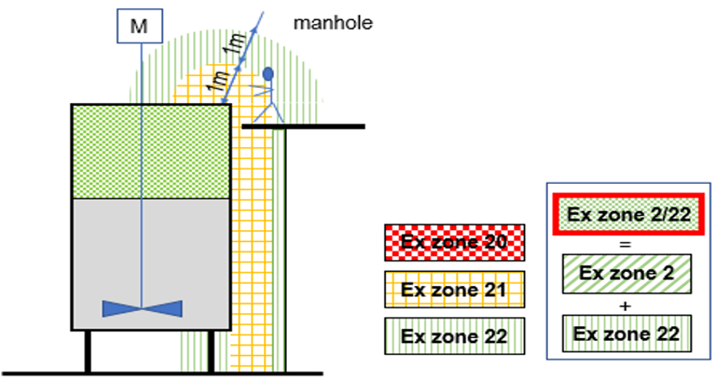
Figure 4: Second scenario: powder dosing in flammable solvent cooled 35°C below FP
The third scenario involves the dosing of powder through an optimized airlock system equipped with an inerting arrangement (Table 1). A good inerting corresponds to either:
$\% O2=LOC-2\% or \% O2=0,6·LOC$ (Limit Oxygen Concentration) | (1)
To achieve adequate levels of risk reduction using an inerting system, it is necessary to follow appropriate design and maintenance procedures, depending on the selected technology and the characteristics of the installation. When designing or increasing the automation level of a plant or process, it is essential to define safe operating conditions, taking into account the interactions between equipment, the materials handled, and the system atmosphere. In accordance with technical standard CEN/TR 15281:2022 (Figure 5), it is recommended to properly assess the achievable safety levels and to emphasize that effective inerting is a function of the LOC of the substance being processed, which represents the key reference parameter for determining the effectiveness of oxygen reduction.
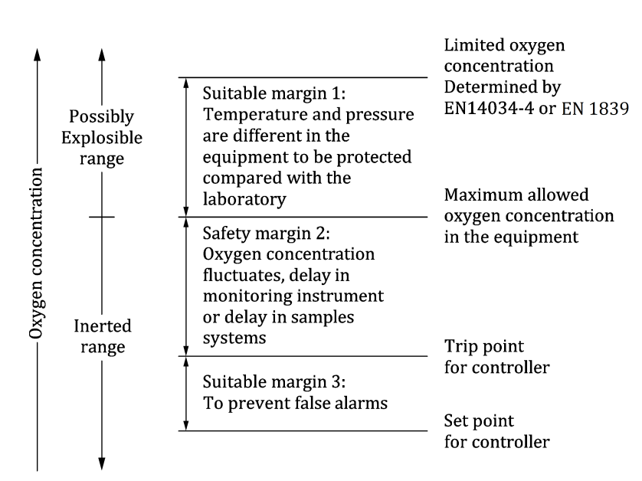
Figure 5: Oxygen concentrations to be observed when inerting equipment

Table 1: Inerting Level
Inerting Level | Description
Level 2 (Figure 6) | Inerting system having Pressure or Flowrate or Oxygen monitoring /alarming (manhole/equipment can be opened during process)
Level 2 (Figure 6) | Option A:  N2-Pressure or  N2-Flowrate or  O2 Concentration  controlled by BPCS | Option B:  Inerting procedure  controlled by SIL1 |  | Option C:  N2-Pressure or  N2-Flowrate or  O2 Concentration controlled by BPCS+ONE additional independent monitor/alarming as N2-Pressure or N2-Flowrate or O2 Concentration
Level 3 (Figure 7) | Inerting system having Pressure and Oxygen monitoring /alarming (manhole/equipment always closed during process)
Level 3 (Figure 7) | Option C:  N2-Pressure or N2-Flowrate or O2 Concentration controlled by BPCS+ONE additional independent monitor/alarming as N2-Pressure or N2-Flowrate or O2 Concentration |  | Option D:  Inerting procedure  controlled by SIL2
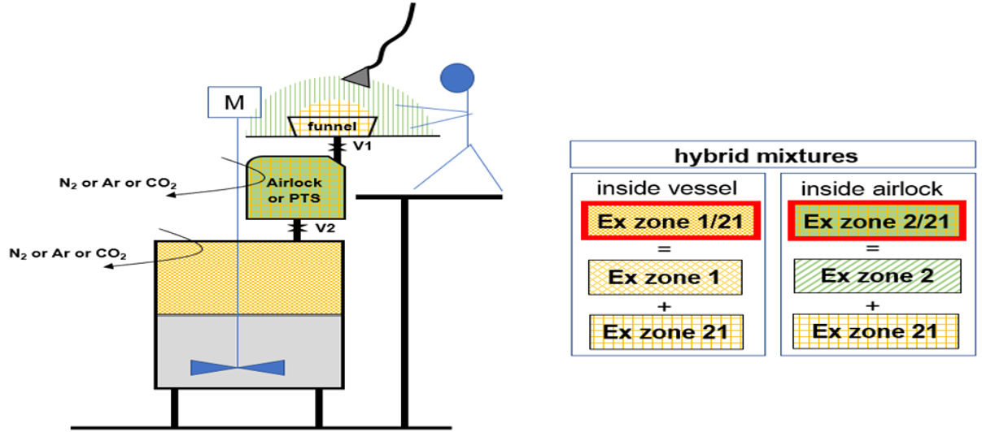
Figure 6: First configuration is based on Level 2 Option B or C
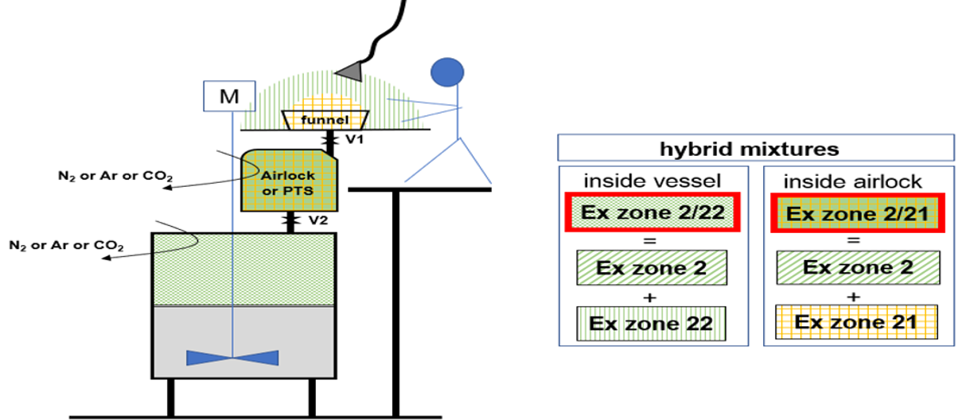
Figure 7: Second configuration considers Level 3 Option C or D
These configurations (Figure 6 and Figure 7) differ in terms of functional safety performance, redundancy, and diagnostic capability, thereby influencing the overall risk reduction associated with powder charging under inerted conditions.
The final scenario described in Figure 8, the dosing of powder using a Venturi-based system operating without inerting. The procedure begins with the charging of the flammable liquid, after which pump P1 is activated to establish liquid circulation. This circulation creates a localised vacuum that effectively retains solvent vapours within the equipment, even when the powder-charging point is open. The powder is subsequently introduced and is entrained by the vacuum generated by the recirculating stream, allowing it to be conveyed directly into the liquid phase. Under these conditions, the solid is immediately dispersed into the solvent, thereby preventing the formation of a hybrid explosive atmosphere. Once the powder has been fully incorporated, the resulting mixture is transferred to the designated vessel, ensuring that the discharge point avoids any dead zones within the receiving equipment. The Venturi-based configuration relies on the recirculation of the liquid through pump P1, which generates a localized depression at the powder feeding point. Field tests on comparable systems show depressions typically in the range of 20–40 mbar, sufficient to prevent outward vapour leakage under steady conditions. The powder is immediately entrained into the recirculating stream and dispersed directly into the liquid phase, limiting airborne dust formation and preventing hybrid mixture generation.
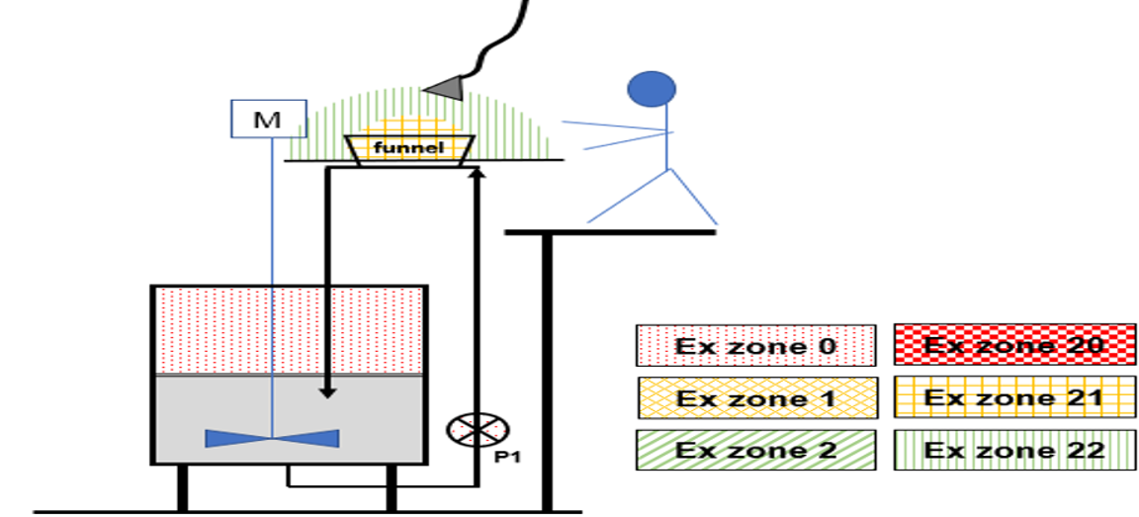
Figure 8: Venturi system without inerting
    - Mitigation and action plan development
In general, for all cases, operators, containers, installation (e.g. the spoon, directly in contact with the powder must be conductive or dissipative and grounded. Table 2 below shows the mitigation actions:
Table 2: Action plan for each scenario
Scenario | Mitigation
Scenario n°1 | Specific instruction and trainings must be provided to the operator. Double check procedure is mandatory for the powder dosing. Classification in Ex zones is a mix of both situations. No hybrid situation as both situations are sequenced
Scenario n°2 | Specific instruction and trainings must be provided to the operator. Double check procedure is mandatory for the powder dosing. Classification in Ex zones is simplified because vapors Ex zones disappear.
Scenario n°3 | Specific instruction and trainings must be provided to the operator. Double check procedure is mandatory for the powder dosing.  Charge the flammable liquid, close V2; inert equipment according to inerting level 2 or 3; open V1 and transfer the powder into the airlock or the PTS; close V1 and inert equipment according to the previous; open V2 transfer the powder into vessel
Scenario n°4 | Specific instruction and trainings must be provided to the operator.
Table 3: Comparative evaluation of the operating scenarios
Scenario | Reliability of Safeguards | Expected HAC zone | Hyb Mix likelihood | Operational complexity
Scenario n°1 | Medium | Internal (Zone 1); External (Zone 2) | Medium (phases not simultaneous but mixing critical) | Low
Scenario n°2 | High | Zone 2 or negligible depending on solvent temperature | Low | Medium (requires cooling control)
Scenario n°3 | Very High (SIL-based options) | Limited Zone 2 or none | Very Low | High
Scenario n°4 | Medium (dependent on pump conditions) | Very limited zone extent | Very low (immediate entrainment into liquid) | Medium

  - Conclusions
This study confirms that hybrid explosive atmospheres may form during manual powder charging into flammable solvents, with risk levels strongly dependent on process configuration. The comparative analysis shows that no universal mitigation strategy exists: sequencing, temperature control, inerting effectiveness, and alternative charging technologies all substantially influence HAC outcomes and residual risk.
Overall, inherently safer design options that prevent the simultaneous presence of dust and vapours offer the most reliable protection, while engineered and procedural safeguards serve as complementary measures. A logical extension of this work would be a focused study on inerting strategies, particularly on defining LOC criteria and verifying their effectiveness in preventing hybrid mixture formation.
Nomenclature
HAC – Hazardous Area Classification

IEC – International Electrotechnical Commission NFPA – National Fire Protection Association
CSB – Chemical Safety Board
MIE – Minimum Ignition Energy
LEL – Lower Explosive Limit
MEC – Minimum Explosive Concentration
LFL – lower Flammability Limit
FP –Flash Point, °C
LOC – Limit Oxygen Concentration
CEN – Comité Européen de Normalisation
TR – Technical Report
BPCS – Basic Process Control System
SIL – Safety Integrity Level
EX – EXplosibles
PTS – Powder Transfer System

References
International Electrotechnical Commission, 2020, IEC 60079-10-1 Explosive atmospheres - Part 10-1: Classification of areas - Explosive gas atmospheres, Geneva, Switzerland.
International Electrotechnical Commission (2015) IEC 60079-10-2 Explosive atmospheres - Part 10-2: Classification of areas - Explosive dust atmospheres, Geneva, Switzerland.
Perelli S., Carluccio L.M., 2023, Hazardous Area Classification due to Combustible Dust Atmospheres and Layers: Avoiding Common Mistakes, Chemical Engineering Transactions, 99, 211-216
CEN/TR 15281, 2022, Potentially explosive atmospheres - Explosion prevention and protection - Guidance on inerting for the prevention of explosions
National Fire Protection Association, NFPA 499, 2013, Recommended Practice for the Classification of Combustible Dusts and of Hazardous (Classified) Locations for Electrical Installations in Chemical Process Areas

