 CHEMICAL ENGINEERING TRANSACTIONS  VOL. | A publication of  
The Italian Association
of Chemical Engineering
Online at www.cetjournal.it
Guest Editors:
Copyright © AIDIC Servizi S.r.l.
ISBN 978-88-95608-xx-x ISSN 2283-9216

Reducing Human Risks in Chemical Industry through VR-Supported Safety Training
Jie Gengª, Morris Siu Yung, Jong^{b}*, Micaela Demichelaª, Huxiao Shiª,
Hongjie Tao^{c}
ª Applied Science and Technology Department, Politecnico di Torino, Turin, Italy
^{b} Department of Curriculum and Instruction & Centre for Learning Sciences and Technologies, The Chinese University of Hong Kong, Hong Kong SAR, China
^{c} Henan Joint Laboratory of Climate Change and Carbon Neutrality, Zhengzhou University of Technology mjong@cuhk.edu.hk

This study focused on reducing human risks in chemical industrial control rooms by applying the integrated STPA-SLIM method, supported by a customized Performance Shaping Factors (PSFs) framework. A comparative experiment was conducted with 68 participants: 34 in a VR-based learning group and 34 in a mobile-based learning group to evaluate the effectiveness of immersive safety training for industrial risk management. Descriptive statistics and independent t-tests were used for data analysis. Results showed that the VR-based learning group achieved slightly higher mean ratings across all training dimensions, with an overall PSF mean score of 76.00; the top-rated dimension was Experience & Training, while Procedure was the relative weakness. No statistically significant differences were found between the two training modes (p > 0.05). The validated PSF framework and STPA-SLIM approach enabled systematic identification and quantification of human reliability-related risks. These findings provided a practical human risk assessment tool for digital safety training in industrial control rooms, supporting safer and more reliable human-machine collaboration.
  - Introduction
Cybersecurity, unlike general IT security, mitigates threats to real-time operational disruption, equipment damage, and severe safety hazards driven by industrial digital transformation (Admass et al., 2024). In the main control room of a manufacturing industry, human-computer interaction involves dynamic perception of operational information, early risk warning, and collaboration among frontline operators through a stable network. Reducing human-induced risks arising from human-computer interactions is critical to guaranteeing system performance while ensuring distance collaboration between the control room and frontline operators. A dynamic and risk-oriented measure is integrated throughout every operational level. Safety training serves as the cornerstone for balancing operational productivity and comprehensive defence against continuously evolving cyber threats to key infrastructure and human security.

In cybersecurity safety training for control rooms, spherical video-based virtual reality (SVVR) enables immersive, risk-free simulations of real cybersecurity incidents within realistic control room environments. It helps trainees develop high-pressure situational awareness, bridging the theory–practice gap inherent in conventional training. Traditional training relies heavily on static formats and lacks practical modules for real-time cybersecurity decision-making. By contrast, VR complements conventional learning, transforming passive knowledge acquisition into active operational competence for cyber threat response. Improved human reliability can reduce cyberattack risks stemming from human errors.

Human reliability analysis techniques provide methods for identifying and analysing human risks. Ahn et al. (2022) combined System Theory Process Analysis (STPA, Salmon, 2022) and the Success Likelihood Index Method (SLIM, Embrey, 1986) to assess human reliability in interactions with emergency shutdown systems. STPA begins by defining unacceptable losses, system descriptions, and the system boundaries. The second step of STPA is to establish a system’s control structure. The third step involves analysing identified unsafe control actions and their associated losses. On this basis, the causes of unsafe control behaviours can be determined. Furthermore, the unsafe human activities are quantified by the SLIM as human error probabilities.
  - Case Study
    - Safety training design
This research designed an experiment with two student groups: 1) a VR-based learning group and 2) a mobile-based learning group. Figure 1 shows the SVVR environment. The left is the EduVenture-VR Composer; inside, a learning scenario including three stages was generated. The 360° photos were generated by using the 3D modelling tool — Autodesk Maya. Stage 1 shows the control room model. Inside, there is the main screen monitoring the whole plant operations and two human-computer interactive desks, including three screens to control the real operations. Stage 2 shows the methanol tank layout that can be seen on the screen. Stage 3 shows the real methanol tank operations in the real plant (see the middle of Figure 2). The right of Figure 2 shows the APP that could be downloaded through the mobile app store and enabled students to see the VR scenarios by using the VR equipment. On the other hand, mobile-based learning used plant layout pictures with teachers’ voices to create a 3-minute video learning material.
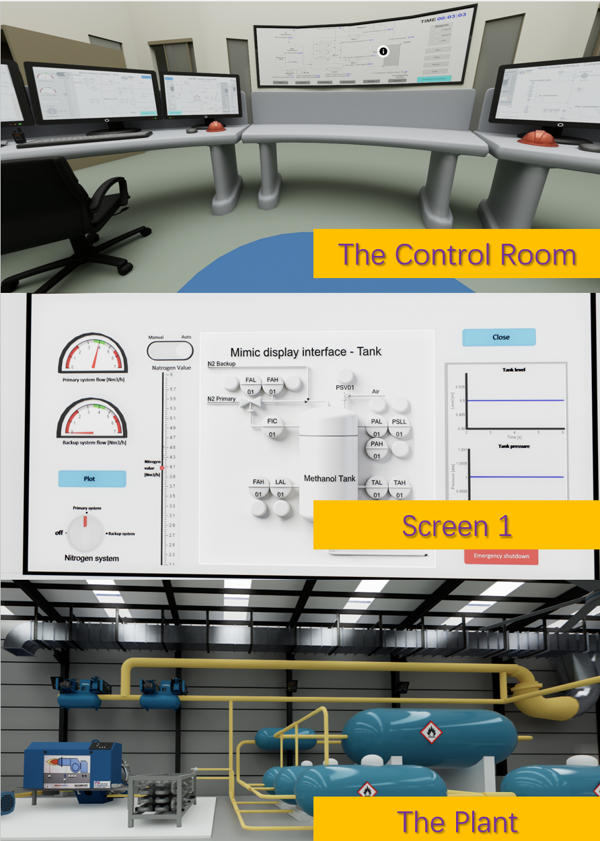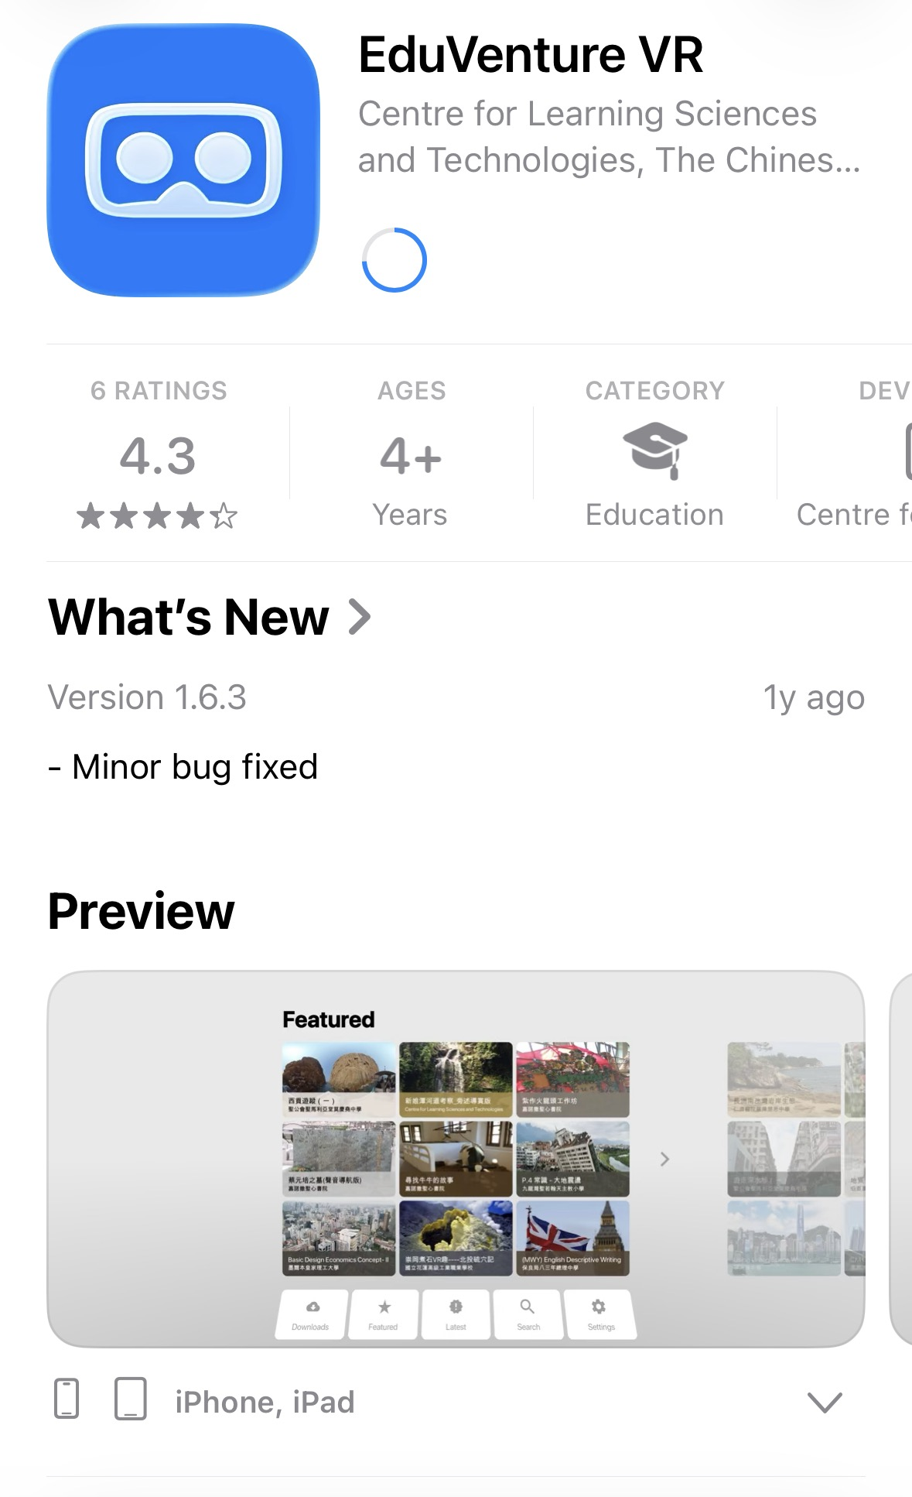
Figure 1. Spherical video-based virtual reality (SVVR) environment
    - Safety training implementations
The training focused on the topic of “risk assessment in the chemical industry”. First, a collective learning session was delivered by the teacher, consisting of 15 minutes of training taking the nitrogen-methanol preparation process as a case study. Then, the mobile-based learning group used mobile devices to watch the video. The VR-based learning group used a smartphone, VR glasses, and the EduVenture VR app to acquire relevant knowledge. After viewing the training video and VR materials, students were asked to complete an online questionnaire via their mobile phones and fill out the STPA-SLIM evaluation form (see Figure 2 and Figure 3).
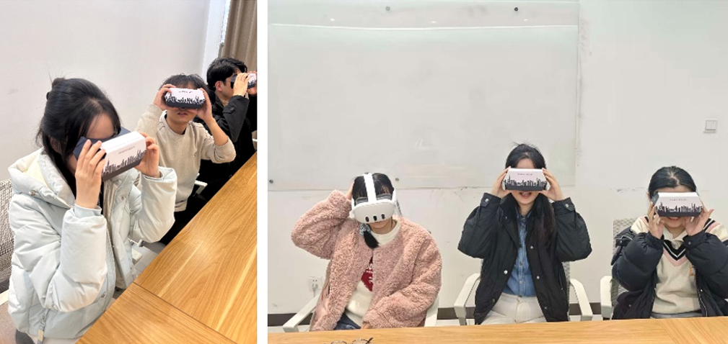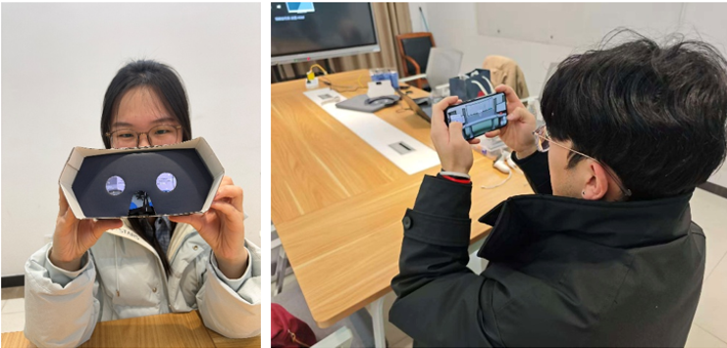
Figure 2. VR-based training implementation
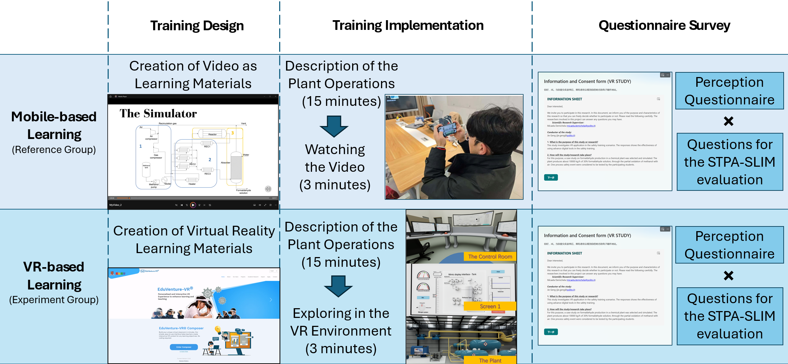
Figure 3. The safety training implementations
  - Data Analysis
    - Instrument design
A learners’ perception questionnaire was designed with five dimensions: Organization & Management, Learning Quality Control, Learning Interaction, Learning Service Promotion, and Learning Performance. This learners’ perception questionnaire was tested and validated in a previous onsite survey with 341 participants. Exploratory Factor Analysis (EFA) and Structural Equation Modelling (SEM) were conducted to validate the measurement instrument. The Kaiser-Meyer-Olkin (KMO) value (0.955) and Bartlett's test (p-value = 0.000***) indicated that the measurement model was suitable for EFA analysis. Principal Component Analysis (PCA) was used. To summarize, 22 items constituted the five dimensions of the extracted index system. Afterward, a reliability analysis of each subdimension was conducted, where Cronbach’s Alpha of all the subdimensions was above 0.7. SEM was applied using IBM® Amos 24. The goodness-of-fit of the model was obtained: χ²/df =1.805, NFI =0.896, IFI =0.951, TLI =0.942, CFI =0.950, and RMSEA =0.049. Meanwhile, the second questionnaire for STPA-SLIM evaluation was designed. Items regarding the customized PSFs scheme were proposed (see Table 1) for STPA-SLIM evaluation.
Table 1. Customized PSFs scheme for STPA-SLIM evaluation
PSFs | Items | PSFs | Items
PSF1  Interface | - personalized attention  - dynamic services  - a reliable content design  - customer-centric design | PSF5  Experience & training | - provision of reliable feedback  - clear learning assessments  - high quality of training  - reliable training  - innovative training  - gain something after training
PSF2  Procedure | - meets the skill requirements  - open and transparent information  - highly available resources | PSF6  Environmental condition | - good technical environment  - reliable communication system  - stable WIFI availability  - advanced network platforms
PSF3  Working condition | - equipment is safe and reliable  - high level of communication and information technology  - highly applicable tools  - highly applicable computer software | PSF7  Complexity | - satisfying task process  - clear positioning  - adjust strategies regarding operators
PSF4  Time | - a reasonable time to respond  - task design fulfils commitments on time and with quality  - timely feedback | PSF8  Organizational factors | - sound organizational management  - responding to problems  - professional competence of supervisors  - good communication of supervisors  - high professional ethics
    - Data collection
There were 68 students (37 females and 31 males) aged 18-22 participating in the test. To compare the learning experience, 34 students were trained using the mobile-based learning material, while 34 were trained using the VR-based learning material.
  - Data Analysis
    - Descriptive Analysis
The learners’ perception questionnaire used a five-point Likert scale, with anchors ranging from 1 = “strongly disagree” to 5 = “strongly agree”. Descriptive analyses were performed using the data from the experimental and reference groups. The aim was to investigate the influence of using advanced technology on the safety training performance.
    - The STPA-SLIM Evaluation
A hybrid STPA-SLIM method was applied to assess human reliability using both VR and mobile video for the safety training. According to the customized PSFs scheme (see Table 1), SLIM was an evaluation tool for quantifying human errors which consisted of three major steps: 1) task analysis, 2) performance shaping factors (PSFs) scale and score bounds (see Table 2), weighting, and rating, and 3) Success Likelihood Index (SLI) calculation and transformation to human error probabilities. The PSFs weighting in this study had equal weight. For each PSF, the items inside had equal weight. The following showed the equations for PSFs rating (see Eq. 1) and human error quantification (see Eq. 2 and Eq. 3).
$PSF ating \left(R_{i}\right)=\sum_{j=1}^{n}{\left(w_{j}×R_{ij}\right)}$ (1)
$SLI=\sum_{i=1}^{8}{\left(W_{i}×R_{i}\right)}$ (2)
$Log of Probability of Success =a ×SLI+b$ (3)
Table 2. Likert scale and score bounds
Likert Scale | Upper Bound | Lower Bound
Highly Positive | 85 | 100
Positive | 70 | 85
Moderate | 50 | 70
Negative | 30 | 50
Highly Negative | 0 | 30
  - Results
    - Descriptive Analysis
Table 2 showed that Group 2 (Experimental Group) had higher mean scores than Group 1 (Reference Group). The dimension with the most notable disparity was “Learning Quality Control” (difference: 0.152), while the smallest difference appeared in “Learning Service Promotion” (difference: 0.012). Both groups had mean scores ranging from 3.97 to 4.14 (out of 5 points), indicating generally high evaluation levels. Meanwhile, in the Reference Group, standard deviations ranged from 0.331 to 0.461 across all dimensions. In the experimental group, standard deviations ranged from 0.345 to 0.534 across dimensions. The standard deviation values indicated a mild data dispersion.
Table 2. Overall descriptive analysis
Dimensions | Mean Value |  | Mean Difference (Group2-Group1)
Dimensions | Reference Group | Experiment Group | Mean Difference (Group2-Group1)
Organization & Management | 3.976 | 4.073 | +0.097
Learning Quality Control | 3.985 | 4.136 | +0.152
Learning Interaction | 3.992 | 4.045 | +0.053
Learning Service Promotion | 4.103 | 4.115 | +0.012
Learning Performance | 3.977 | 4.038 | +0.061

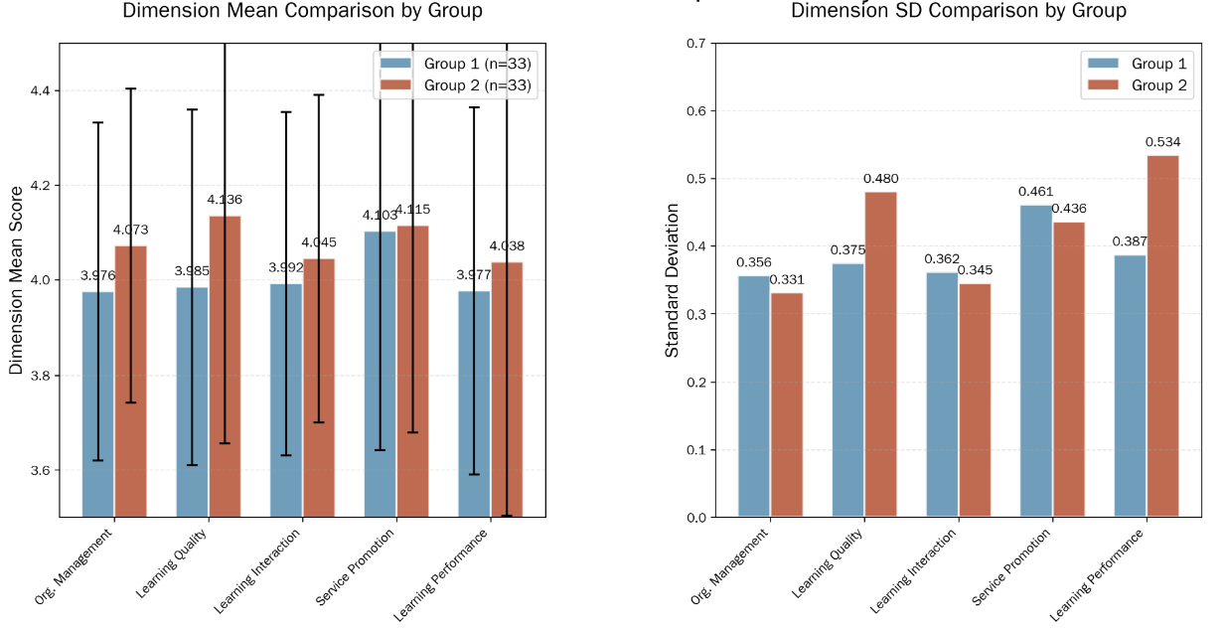
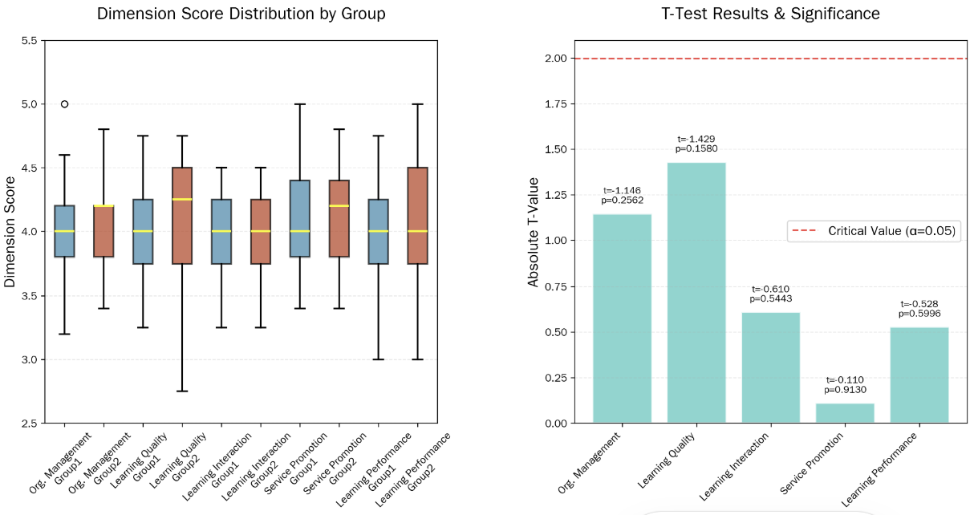
Figure 4. Descriptive and comparative analysis between groups
    - Comparative Analysis
A t-test was conducted between two groups. All p-values across the 5 dimensions were greater than 0.05, indicating no significant differences between Group 1 and Group 2 in any dimension. The results showed that there was no significant difference between advanced VR technology and mobile-based instructions. If advanced technologies were to be adopted in safety training, further improvements were required.
Table 3. T-test between groups
Dimensions | t-value | p-value | Significance
Organization & Management | -1.146 | 0.2562 | ns
Learning Quality Control | -1.429 | 0.1580 | ns
Learning Interaction | -0.610 | 0.5443 | ns
Service Promotion | -0.110 | 0.9130 | ns
Learning Performance | -0.528 | 0.5996 | ns
Note: ns = not significant
    - STPA-SLIM Evaluation Results
Table 4 presented a full descriptive analysis of the Performance Shaping Factors (PSFs) from the VR-based learning group. The overall evaluation was strongly positive, with a mean value of 76.00. Among all dimensions, PSF5 Experience & Training yielded the maximum mean value (77.75), while PSF2 Procedure had the minimum mean score (74.75).
Table 4. STPA-SLIM Evaluation Results
PSF Dimension | Mean | Std. Dev. | Skewness | Kurtosis
PSF1 Interface | 76.00 | 0.86 | -0.32 | -0.51
PSF2 Procedure | 74.75 | 0.93 | -0.28 | -0.63
PSF3 Working condition | 76.50 | 0.86 | -0.33 | -0.48
PSF4 Time | 75.00 | 0.88 | -0.30 | -0.56
PSF5 Experience & training | 77.75 | 0.88 | -0.35 | -0.59
PSF6 Environmental condition | 75.50 | 0.88 | -0.31 | -0.54
PSF7 Complexity | 75.00 | 0.88 | -0.30 | -0.56
PSF8 Organizational factors | 76.50 | 0.85 | -0.34 | -0.52
  - Discussion and Conclusion
This study validated the applicability of the STPA-SLIM hybrid method, combined with a customized PSF framework, for assessing human reliability by using different training instruments in the industrial safety training. Descriptive analysis confirmed strong overall participant satisfaction (mean = 76.00), with training experience and organizational and working conditions as major strengths, and procedural design as a key area for improvement. Although VR-based training yielded marginally better perceptual and learning outcomes than the mobile-based learning, the differences were not statistically significant, suggesting that technological immersion alone was insufficient to deliver distinct performance improvements. To effectively reduce human risks in control room operations, practitioners should prioritize improvements in procedural transparency, skill matching, and resource availability, while integrating VR tools with structured instructional design. The proposed method offered a systematic and scalable approach to enhancing human reliability, supporting safer human–computer interactions and more resilient industrial control systems.
  - References
Admass W. S., Munaye Y. Y., Diro A. A., 2024, Cyber security: State of the art, challenges and future directions, Cyber Security and Applications, 2, 100031.

Ahn S. I., Kurt R. E., Turan O., 2022, The hybrid method combined STPA and SLIM to assess the reliability of the human interaction system to the emergency shutdown system of LNG ship-to-ship bunkering, Ocean Engineering, 265, 112643.

Embrey D. E., 1986, SLIM‐MAUD: A computer‐based technique for human reliability assessment, International Journal of Quality & Reliability Management, 3(1), 5-12.

Salmon, P. M., Stanton, N. A., Walker, G. H., Hulme, A., Goode, N., Thompson, J., Read, G. J., 2022, The systems theoretic process analysis (STPA) method, In Handbook of systems thinking methods (pp. 71-89). CRC Press.

