 CHEMICAL ENGINEERING TRANSACTIONS  VOL. xxx, 2026 | A publication of  
The Italian Association
of Chemical Engineering
Online at www.cetjournal.it

Guest Editors: Valerio Cozzani, Bruno Fabiano, Genserik Reniers
Copyright © 2026, AIDIC Servizi S.r.l.
ISBN 979-12-81206-xx-x; ISSN 2283-9216

Assessment of an Integral Building Wake Model, including Comparison with CFD
Andreas Mack*, Paul Brasser
Gexcon Netherlands B.V., Princenhofpark 18, 3972 NG, Driebergen-Rijsenburg, The Netherlands
*andreas.mack@gexcon.com
Reliable assessment of hazardous distances, such as emissions originating from a battery thermal runaway, depends critically on the numerical modelling of the source term, but also on the modelling of the near and open field. For toxic releases, the effect distances can be of the order of hundreds of meters and accurate modelling of the turbulence properties of the atmospheric boundary layer in the usually-unobstructed open field is required. Integral dispersion models remain widely used due to their computational efficiency and proven performance in open field environments. In this domain, integral models provide relatively accurate solutions that allow for numerous parameter variations and/or scenarios due to the low computational costs.
Nevertheless, the dispersion process can strongly depend on the near field of the release, which is usually obstructed. This holds for toxic and flammable releases, where the influence of buildings or installations can significantly increase the entrainment of ambient air. In this domain, dominated by flow separation, wake formation, and recirculation effects that can significantly alter the concentration fields, Computational Fluid Dynamics (CFD) generally provides superior fidelity but requires significantly increased computational effort, compared to integral models.
To address this gap, building wake models have been developed in the past for integral models. In the dispersion model in Gexcon’s consequence modelling software, EFFECTS, a building wake model is incorporated into the integral dispersion model. This coupling enables rapid estimation of wake-driven concentration enhancements without requiring detailed geometric meshing or time intensive CFD simulations, while still capturing the main physical aspects of the problem.
In the present work, the implemented building wake model is compared with an experimental data set for dispersion around an isolated building, including additional comparison with CFD data for the same dataset. It is demonstrated that the integral-model-based approach captures the dominant physical mechanisms governing near field dilution as measured by the experiments. Benchmarking against the CFD simulation shows reasonable agreement in key metrics such as maximum concentration levels, plume size and location, while achieving computational speeds that are several orders of magnitude faster. In addition to the validation experiment, a real-world application is presented involving a large-scale double-wall storage tank reservoir. In the case of a hazard, the outer container, featuring an open top side, results in an elevated-pool evaporation scenario. The integral building wake model reproduces the main dispersion features which were observed in CFD predictions for this moderately complex geometry, supporting its relevance for practical industrial assessments.
  - Building wake model
For passive dispersion models like the gaussian plume model (GPM), building wake models have been developed in the past (Duijm and Webber, 1993), (Bosch, C. J. H., & Weterings, 2005), (Olesen & Genikhovich, 2000), (Röckle, 1990). The models are usually relatively straightforward and apply a virtual source based on the dimensions of the obstacle. In addition, plume dispersion parameters are adapted at the location of the virtual source. The Röckle model includes more physics, such as the dimensions and momentum of the separation in the building wake. The model described in the Yellow Book (Bosch, C. J. H., & Weterings, 2005) is part of the passive dispersion model based on the GPM model. The dispersion is based on lateral, vertical and horizontal dispersion functions, which include dedicated functions for point and area sources. In the case of an area source in a vertical plane, often called a “window”, the source dimensions are taken as the crosswind section of the obstacle or building. The window is defined by a virtual source width and height and a possible offset from the release point, see Figure 1. The source width and height are taken from the dimensions of the cross section of the downwind building wake recirculation zone. The assumption is that the release source term is entrained into the building wake and homogenously mixed within the initial cross section of the virtual source. The predilution is calculated by the sum of the release source term and the mass flow rate of the wind field through the virtual source. The release height of the source should be limited to half the virtual source height in order to keep the plume attached to the ground (since building wakes are usually ground-bounded). A schematic flow topology around a typical sharp-edged ground-bounded obstacle is given in Figure 2, including the wake separation, an upwind separation and a reparation on the roof. For sharp-edged buildings, additional separations can be present on the sidewalls. Although top and sidewall separations might be present, building wake models usually set the dimension of the wake separation zone to be the dimensions of the virtual source.
The model of Bosch & Weterings (2005), based on the GPM model which is developed for larger distances with tabulated dispersion parameters, includes additional limits for surface friction and wind velocity applied to the calculation of the dispersion. This includes the limitation of the surface friction $u^{*}>0.6/ln⁡(10/z_{0})$ to maintain a minimum level of turbulence under low wind conditions with the surface roughness length $z_{0}$. In addition, the wind velocity at the plume centerline is assumed to be taken at a height of 10m or above.

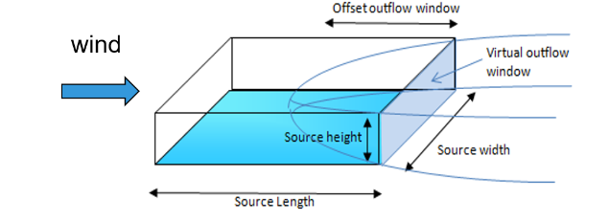
Figure 1: Virtual source definition (“window”)

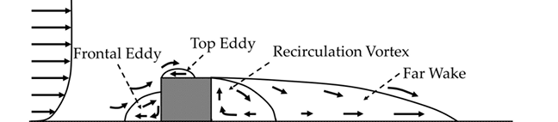

Figure 2: Flow topology around a surface mounted cube (Kimura et al., 2021)

This model is already implemented in the neutral dispersion model in Gexcon’s consequence modelling software, EFFECTS (the neutral gas dispersion mode in EFFECTS is a GPM model). However, the full integral dispersion model in EFFECTS (Mack, 2025), which is capable of modelling non-neutral releases, such as heavy or light gas dispersion, did not previously include this virtual source release model. The full integral dispersion model does now include the virtual source (referred to as the “user-defined window” in EFFECTS), has been validated and is now recommended for simulation of all gas dispersion scenarios, including heavy, passive and light gas dispersion. The implementation is relatively straightforward and follows Bosch & Weterings (2005), however the surface friction velocity constraint has not been applied. The dispersion model does not apply tabulated dispersion functions, but calculates them as part of the integral modelling approach. In this way, further physical effects are taken into account, such as buoyancy production and damping from the plume and atmospheric boundary layer properties, and the momentum and heat exchange between the plume and the atmospheric boundary layer. In the EFFECTS neutral gas (GPM) model, the dispersion scales directly with the applied wind speed. In the full EFFECTS integral dispersion model, the mass flow rate through the virtual window is defined by integrating the atmospheric boundary layer wind profile across the virtual source ${\dot{m}}_{w}$. Together with the release source term ${\dot{m}}_{s}$, this forms the plume mass flow rate through the virtual source ${\dot{m}}_{vs}$:
$${\dot{m}}_{vs}={\dot{m}}_{s}+{\dot{m}}_{w}$$ | (1)
The initial mass fraction of the substance in the virtual source, including its predilution with the entrained air from the wind field, is calculated by:
$$c_{vs}={\dot{m}}_{s}/{\dot{m}}_{vs}$$ | (2)
The temperature is calculated according to mixing rules. Where the GPM approach uses a representative wind speed, the integral building-wake model requires the plume velocity and predilution to be defined, to facilitate the modelling of plume buoyancy, momentum and thermal properties. The implementation also allows potential internal ventilation from the building to be taken into account. In this case, the release source term is prediluted with the ventilation flow rate before entrainment into the building wake. This means that thermal effects can be modelled more accurately, particularly for strongly buoyant releases. Since building ventilation rates are usually much lower than the flow of the atmospheric boundary layer through the virtual source, this effect only plays a role when high release- and/or ventilation- rates are combined with low wind velocities. The downwind position of the virtual source should be located at the beginning of the flow separation zone, which is usually the end of the sharp-edged building. For cylindrical, or irregularly shaped buildings, the location of the largest cross section should be taken since the flow separation is most likely to start there. If rectangular buildings are not aligned with the flow, then the cross section perpendicular to the flow should be taken as the reference cross section. When buildings are located close together, such that the building separation zones will reach the next building, the buildings should be considered as one object, with a corresponding cross section taken through all of them. For releases from windows or other flush mounted openings, the release is entrained along the building walls into the building wake, and so the building wake model can also be used for these. For releases through pipes away from the building wake, the model is not appropriate and classical jet releases should be modelled. As an additional option, without further explanation here, the virtual source can also be implemented as a single source, without being entrained into the building wake. In this case, the virtual window defines the release area for the mass flow source term.
  - Assessment of the building wake model
The building wake dispersion model cannot resolve details in the flowfield close to the obstacle itself; meaningful results can be expected from a downwind distance of approximately 5-10 times the characteristic length of the obstacle (usually taken as the height of the building). Therefore, the region of interest must be larger than this distance. Detailed datasets of single obstacle measurements are generally limited to a few obstacle diameters and so do not usually cover this range. To address this, a two-step approach has been taken: first, a detailed experimental dataset is compared with a CFD solution from Gexcon’s FLACS CFD software, to ensure that the CFD solution reproduces the experimental data set reasonably well; second, the CFD solution is extrapolated to a full scale scenario with a downwind range that is significantly greater than in the original dataset. To demonstrate, a geometrically more complex example of a pool release at height from a tank rupture scenario has been investigated and compared with 3D data obtained from CFD.

    - CEDVAL dataset: Simulation results for the dispersion around a single obstacle by CFD
A very detailed dataset of dispersion around a single obstacle building in a wind tunnel is included in the CEDVAL database provided by the University of Hamburg (CEDVAL, 2024). It includes a complete measurement set of the velocity field and also the dispersion, mainly in the wake region, including several hundred sensor datapoints. A tracer gas was released into the wake of a building with height H, width 1.2 H, and length 0.8 H. The release of the tracer gas was through 4 openings close to the ground at the leeside of the building. The dispersion measurement domain stretched from the frontside of the domain to 3.5 H downstream and +/- 2 H in a lateral direction and reached up to a height of 2 H. For the present investigation, testcase A1-5 was selected. The wind tunnel model (H = 125 mm) was scaled to full scale using a scaling factor of 20 (H = 2.5 m), so that the building dimensions corresponded approximately to those of a small container, such as is commonly used today for battery storage or for hydrogen refilling equipment. The wind conditions and the release source term were also scaled according to standard scaling rules. The wind speed was 17.17 m/s at a height of 2.16 m, with a surface roughness length of 0.014 m, and the release source term was 0.0192 kg/s.
As an initial step, simulations were performed with FLACS to get an insight into the flow topology around the obstacle and to compare with the experimental results. The computational grid contained 1.4 million cells; the resolution of the obstacle was 24 x 26 x 36 cells and the domain extended in the flow direction from -10 to 50 m; and extended 20 m and 10 m in the lateral and vertical directions, respectively. The concentration data were compared in the downwind direction (at z = 0.2 m), and at a downstream position of x = 7.5 m, z = 0.2 m in the lateral direction, and in the vertical direction at x = 7.5 m in the symmetry plane. The results are given in Figure 4. The FLACS solution follows the trends of the experimental data, but the maximum concentrations are slightly over predicted in the farfield, which is most probably due to an underprediction of the plume width (Figure 4, left). The flow separations on the sidewalls (due to the sharp edges) are slightly smaller in the simulated data, compared with the experimental data set. The concentration decay at the centerline is captured well in the simulation, with a slight deviation in the near field wake region (x < 5 m, Figure 4, right). Overall, the solutions are considered good and the main physical effects including local concentration maxima at approximately +/-2 m are well reproduced by the simulations.
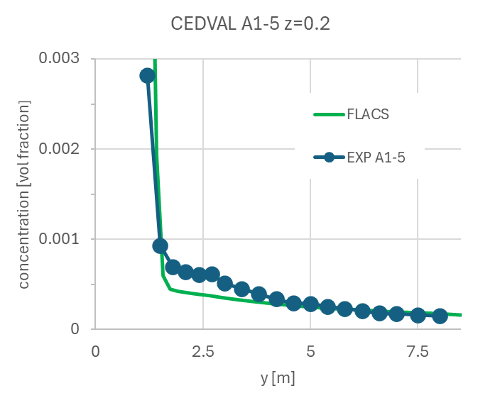
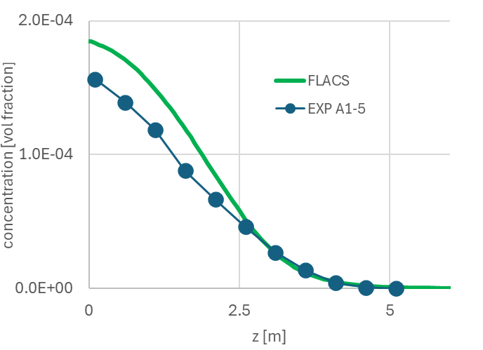
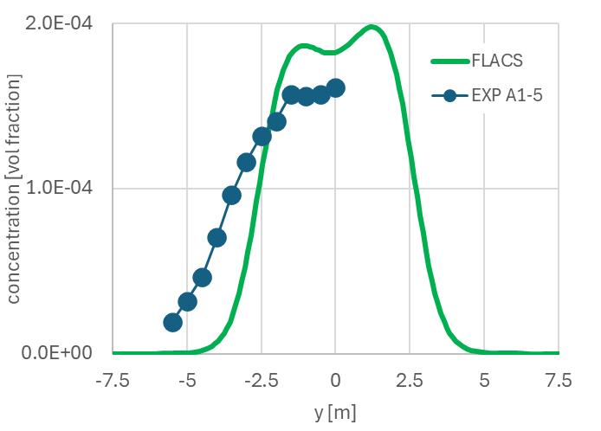

Figure 4: Comparison of concentration distributions in lateral direction at x = 7.5 m and z = 0.2 m (left), in vertical direction at x = 7.4 m and y = 0 m (middle) and in downwind direction at z = 0.2 m (right).

    - Simulation of single obstacle by building wake model and CFD
To compare the FLACS CFD solution with the integral building wake model in EFFECTS for a typical large scale scenario, with larger effect distances, the wind conditions of the CEDVAL A1-5 (see previous section) were adapted to a wind speed of 2 m/s at a reference height of 10 m and the release source term was increased to 0.05 kg/s to obtain higher concentration readings. The concentrations calculated using the building wake model in the integral dispersion model, and in the neutral gas dispersion model are compared in Figure 5. For the building wake models, the time averaging was set to 2 s (resulting in maximum concentration values) and 600 s, which accounts for plume meander due to fluctuations in wind conditions. A value of 600 s is typically recommended for toxic releases. The maximum concentrations in the downwind direction are compared (at ground level), and for the FLACS solution the concentration at 1.25 m height is also provided. Due to entrainment into the building wake, the EFFECTS simulations start with an average value, and the maximum peak concentration therefore cannot be correctly reproduced. It should be kept in mind that, without taking the building wake into account, the concentration distribution would begin at 1.0 which would lead to a significant overprediction of the concentration. From a distance of approximately 15 m, the building wake models for both the integral dispersion model (Figure 5, left) and the neutral gas dispersion model (Figure 5, right) agree reasonably well with the CFD solution. The simulations with 2 s time averaging slightly overpredict the CFD solution, while those with 600 s time averaging show a slight under prediction. Overall, the integral dispersion model shows slightly better agreement with the CFD solution than the neutral gas model with a lower spread due to time averaging. In the farfield, both building wake models agree well with the CFD solution with respect to the concentration decay.

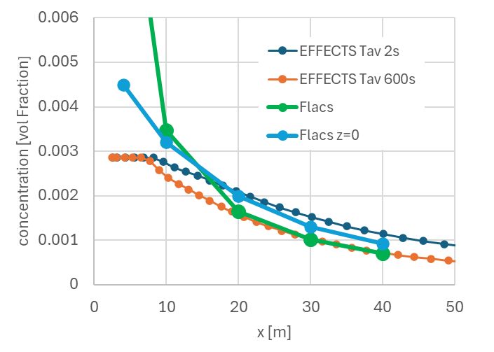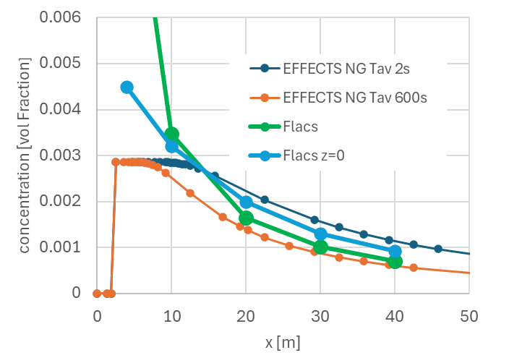
Figure 5: Comparison of building wake model with FLACS simulations with the EFFECTS integral dispersion model (left) and the neutral gas model (right).

    - Pool evaporation at height from a storage tank
Instead of a bund, storage tanks may feature a secondary outer compartment to contain the inventory in the case of a failure of the inner compartment. This leads to a pool evaporation surface at height in a circular shape around the inner compartment. From this pool, the liquid will evaporate and be entrained into the wake of the tank structure. Since this is a more complex case than a single obstacle, this case was both modelled with the EFFECTS building wake model and with FLACS for an ammonia storage tank. The pool evaporation source term was calculated in EFFECTS and also applied to the FLACS calculation, so as to ensure consistent gaseous source terms between the two models. The storage tank has a diameter and height of 20 m; the secondary outer compartment is 10 m high and has a diameter of 30 m. The source term is a at the top of the outer compartment (area 400 m²); the release source term is 4.5 kg/s. The wind speed is 2 m/s and the surface roughness length 0.3 m. The virtual source was defined with a height of 20 m and a width of 25 m to match the cross section of the setup and the overall height. The FLACS solution for the dispersion is shown in Figure 6 with an aerial view and a plume cross section. The plume sideview in EFFECTS is shown in Figure 7. Here, the origin of the virtual source was kept in the centre of the tank since the flow separation, and therefore the mixing process, begins at the maximum width.

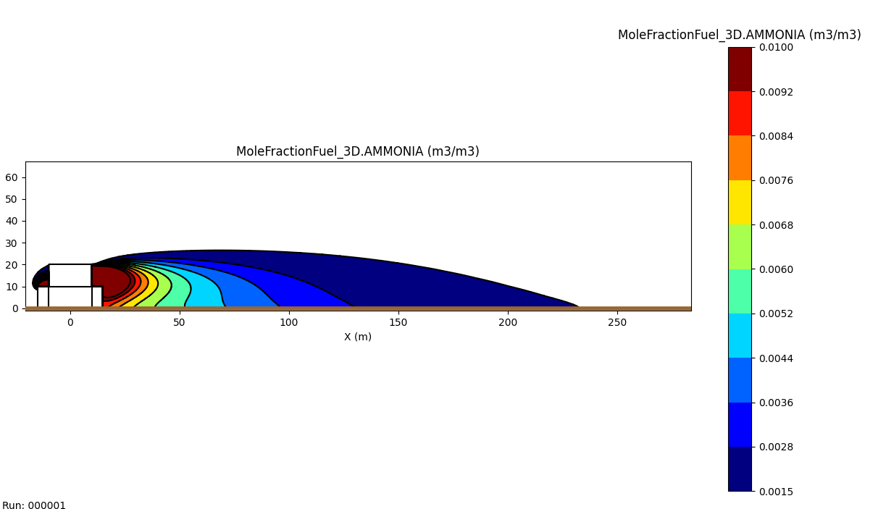
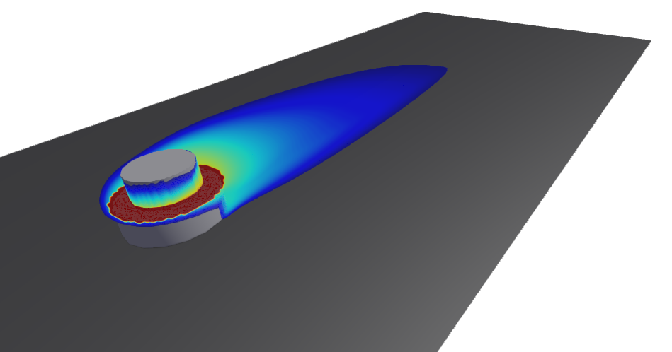
Figure 6: FLACS simulation of tank scenario: 3D dispersion (left) and plume sideview contours by ammonia volume fractions of between 0.0015 and 0.01(right)

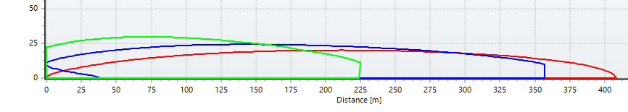

Figure 7: Plume sideview contours by ammonia volume fractions of 0.0015 for EFFECTS integral dispersion model with building wake (green), neutral gas dispersion model (pool at 10 m) and pool at ground (blue) for 600 s time averaging.

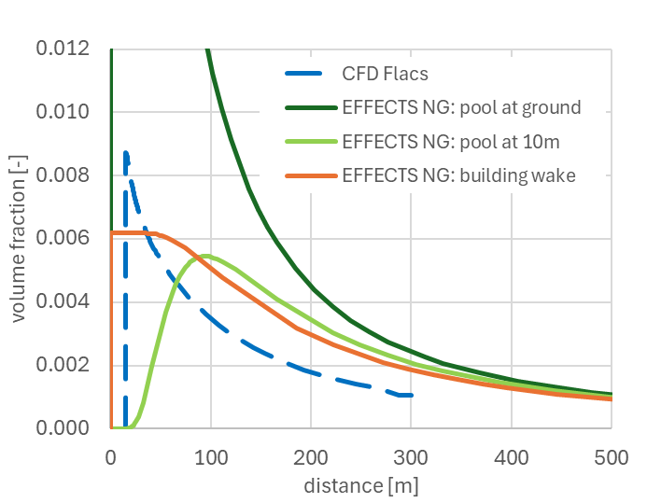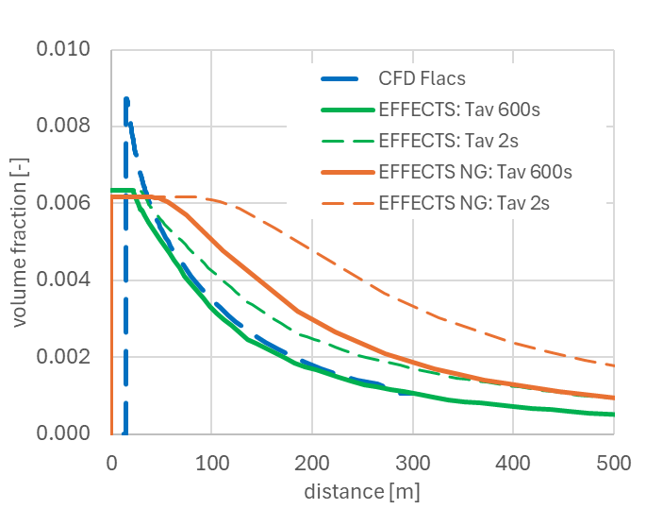
Figure 8: Comparison of concentrations at the ground for FLACS simulations and EFFECTS neutral gas model (averaging time 600s, left) and EFFECTS dispersion model and neutral gas model for averaging times of 2s and 600s (right).

For the EFFECTS neutral gas dispersion model, a pool release at ground height and a pool release at 10 m height were simulated to show the effect of neglecting the building wake. In both cases, this led to a significant overprediction (almost a factor of two) of the effect distance (Figure 7). In addition, the solution of the EFFECTS neutral gas dispersion model including the building wake is given in Figure 8; the building wake model only shows minor improvements compared with the pool at 10 m height. This is possibly due to the tabulated dispersion coefficients of this model. A relatively good agreement is achieved for the EFFECTS dispersion model with building wake (time averaging 600 s), compare Figure 6 (right), 7 and 8 (right). This model shows a faster decay in concentration for both averaging times compared with the neutral gas dispersion model as can be seen in Figure 8. Overall, the building wake model in the EFFECTS integral dispersion model, with 600 s time-averaging shows the best agreement with the FLACS CFD solution. At larger distances, the effect of the building wake vanishes as expected.
  - Conclusions
In the present paper, the implementation of a simple building wake model in the integral dispersion model used in EFFECTS is presented and was compared with dispersion data from CFD for different building wake scenarios, and with the neutral gas dispersion model in EFFECTS. The building wake model in the integral dispersion model resolves more physical effects compared with the neutral gas model; therefore it performs slightly better for a single building case. For the more complex scenario of a pool at height, the integral dispersion model including the building wake model also results in the best agreement with the CFD solution and is therefore the recommended model. When using the building wake model, the origin of the virtual source should be set to the beginning of the main separation zone, which is the end of the building (for a rectangular building), or alternatively, to the position of the largest cross section (vertical cylinder-shaped building). For toxic distances or other large distances of interest, a time averaging of 600 s can be applied to take the plume meander correctly into account. Shorter averaging times will tend to slight overpredictions at smaller distances. It should be kept in mind that for downwind distances lower than 5-10 times the building height, the recirculation zone dominates and the present building wake model may underpredict the maximum concentration. Nevertheless, the model shows a relatively good performance compared with CFD solutions at significantly lower computational cost, which makes it suitable for the design phase of projects and for estimating more realistic effect distances in QRA. In the future, simulation results from the model should be compared with more experimental data sets, including multiple buildings or larger setups such as facility sites.
Nomenclature
$c_{vs}$ – mass fraction virtual source, -
${\dot{m}}_{s}$ – mass flow rate source, kg/s
${\dot{m}}_{vs}$ – mass flow rate virtual source, kg/s
${\dot{m}}_{w}$ – mass flow rate wind field, kg/s
$u^{*}$ – surface friction velocity, m/s
$z_{0}$ – surface roughness length, m
CFD – Computational Fluid Dynamics
GPM – Gaussian plume model
QRA – Quantitative Risk Analysis

Acknowledgments
The authors would like to thank kindly Dr. Frank Harms of the Center for Earth System Research and Sus-tainability (CEN) of the University of Hamburg providing access to the CEDVAL data set.
References
CEDVAL, 2024, Compilation of Experimental Data for Validation of Micro scale Dispersion Models. Internet Database. Hamburg University, Germany. https://www.mi.uni-hamburg.de/en/arbeitsgruppen/windkanal labor/ data-sets.htm
Bosch, C. J. H., & Weterings, R.A.P.M., 2005, Methods for the calculation of physical effects, Yellow Book, CPR 14E.
Duijm, N. J., & Webber, D. M., 1994, Dispersion in the presence of buildings. Journal of loss prevention in the process industries, 7(2), 118-123.
Kimura, A., Asami, M., Oka, H., & Oka, Y., 2021. Development of an Algebraic Model of Empirical Parameterization of Near Wakes around a Vehicle. Fluids, 6(2), 75.
Mack, A., 2025, Dispersion Model in EFFECTS v12, Theoretical Background and Validation Report, Gexcon, Utrecht, The Netherlands.
Olesen, H. R., & Genikhovich, E., 2000, Building downwash algorithm for the OML atmospheric dispersion model. Ministry of Environment and Energy, National Environmental Research Institute.
Röckle, R., 1990, Bestimmung der Stomungsverhaltnisse im Bereich Komplexer Bebauugsstruckturen. Ph.D. Thesis, Vom Fachbereich Mechanik, der Technischen Hochschule Darmstadt, Darmstadt, Germany.

