 CHEMICAL ENGINEERING TRANSACTIONS  VOL. xxx, 2026 | A publication of  
The Italian Association
of Chemical Engineering
Online at www.cetjournal.it

Guest Editors: Valerio Cozzani, Bruno Fabiano, Genserik Reniers
Copyright © 2026, AIDIC Servizi S.r.l.
ISBN 979-12-81206-xx-x; ISSN 2283-9216

Modelling and Validation of Indoor Hydrogen Dispersion and Explosion in Ventilated Enclosures
Paul Brasser*, Andreas Mack
Gexcon Netherlands B.V., Princenhofpark 18, 3972 NG, Driebergen-Rijsenburg, The Netherlands
*paul.brasser@gexcon.com
The increasing use of hydrogen in the energy transition introduces safety challenges, particularly in indoor environments where accidental releases may lead to hazardous accumulations and explosion risks. Due to its low density, high diffusivity, and wide flammability range, hydrogen can rapidly form flammable mixtures, even for relatively small leaks. Accurate prediction of this behaviour is essential for quantitative risk assessment and safe system design.
This work presents an indoor dispersion and overpressure model for gaseous releases, implemented in the consequence modelling software EFFECTS. The model predicts gas accumulation, transport, and explosion effects under both mechanical and natural ventilation conditions and is applicable to hydrogen as well as other gases. Buoyancy-driven behaviour is captured using multiple approaches: ideal mixing for high release rates or neutral gases, a two-layer model for buoyant gases, and an inverse two-layer model for heavier-than-air gases. Additional sub-models account for jet release behaviour, ventilation effects, temperature, and overpressure following ignition.
Validation against experimental data and CFD studies shows good agreement for concentration build-up, steady-state values, and overpressure. Minor deviations at low concentrations and high ventilation rates are attributed to the simplified layer representation. Sensitivity analysis demonstrates that ventilation configuration and buoyancy effects strongly influence concentration levels and flammable cloud formation. The model provides an efficient and reliable tool for indoor consequence analysis and can be coupled with outdoor dispersion models for integrated risk assessment.
  - Introduction and model description
Hydrogen poses safety challenges in confined environments due to accumulation and flammable mixture formation. Predictive models are required for risk assessment, for which the Indoor Ventilation, Dispersion and Overpressure Model provides an efficient framework. To model buildup of chemicals due to leaks, it is assumed that only one room will be affected. Leakage to adjacent rooms is not considered. The model can be coupled with the outdoor dispersion models by treating the enclosure exhaust as a time-dependent source term. Four aspects of the dispersion process are modelled:
- Ventilation
- Chemical accumulation and release
- Temperature variations in the room and in the exhaust.
- Overpressure after ignition
    - Ventilation model
Two types of ventilation in a room are considered:
- Mechanical ventilation
- Natural ventilation
Mechanical ventilation is defined by the air exchange rate:
$$∅_{v}=R∙V$$ | (1)
In case of natural ventilation, air can enter a room through openings, windows, or leaks around doors and windows, creating drafts inside the building. The inflow of air is dependent on the angle of the wind with respect to the opening:
$$v_{in}=v_{wind}\cos{θ}$$ | (2)
The inflow follows from (Walker 2016):
$$∅_{in}=C_{d}Av_{in}$$ | (3)
In the ATEX guideline IEC 60079-10-1:2020, IDT, (ATEX 2021)., empirical relations are described for the ventilation flow through a room with various openings. Here the various opening configurations (angles) are combined into an overall equation for the effective opening area:
$$A_{effective,x,θ}=A_{1}\left(\frac{180-θ}{180}\left(1+x\right)+\frac{θ}{180}\frac{x}{\sqrt{1+x^{2}}}\right)$$ | (4)
With:
$$x=\frac{A_{2}}{A_{1}}$$ | (5)
The angle dependent discharge coefficient follows from:
$$C_{d}=\frac{180-θ}{180}0.025+\frac{θ}{180}C_{s}∙\sqrt{∆C_{p}}$$ | (6)
Multiple openings are combined using an angle-based aggregation into two representative openings.
    - Indoor dispersion model
The indoor dispersion model consists of three sub-models:
- Ideal mixing model (for neutral gases or for large releases, i.e. filling time < 100 seconds)
- Two-layer model (for gases, lighter than air)
- Inverse two-layer model (for gasses, heavier than air)
When ideal mixing is assumed, the change in concentration in time in a room follows from a mass balance:
$$V\frac{dC}{dt}=Q_{in}∙C_{in}+Q_{leak}∙C_{leak}-Q_{out}∙C_{out}$$ | (7)
This differential equation can be solved analytically if the leak flow and concentration will remain constant:
$$C_{out}=C_{leak}\frac{Q_{leak}}{Q_{out}}∙\left(1-exp\left(-\frac{Q_{out}}{V}t\right)\right)$$ | (8)
Buoyant gases such as hydrogen accumulate near the ceiling, forming a stratified two-layer system (Figure 1), with a clean lower layer and a gas–air mixture above (Kaye and Hunt 2004), (Lowesmith et al. 2009). The release of hydrogen is modelled as a turbulent jet. The jet concentration depends on the jet length and the corresponding air entrainment. The jet length is defined as the distance from the release point to the layer, accounting for horizontal or diagonal travel to a wall before vertical movement.
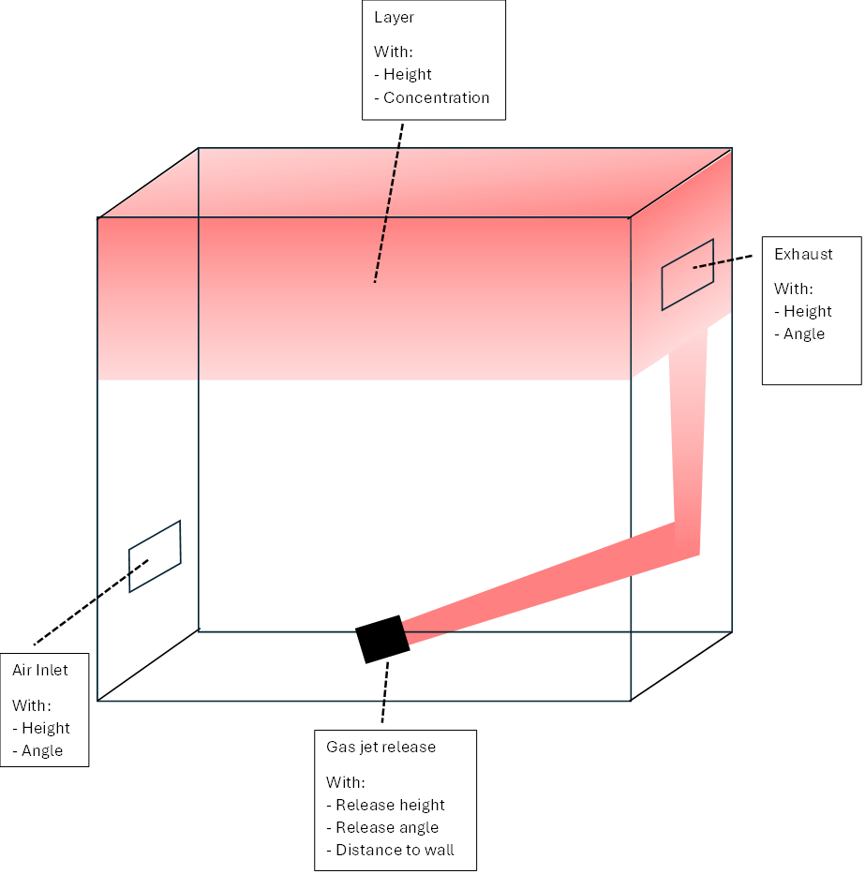
Figure 1 Schematic representation of the two-layer model
The upper layer volume and chemical concentration are predicted in:
$$\frac{dV_{1}}{dt}=Q_{i}-Q_{\text{out}}=Q_{i}-\left(Q_{\text{in}}+Q_{s}\right)$$ | (9)
A mass balance describes the accumulation of gas in the upper layer:
$$\frac{d\left(V_{1}x\right)}{dt}=V_{1}\frac{dx}{dt}+x\frac{dV_{1}}{dt}=Q_{s}-x\left(Q_{\text{in}}+Q_{s}\right)$$ | (10)
Leading to:
$$V_{1}\frac{dx}{dt}=Q_{s}-xQ_{j}$$ | (11)
The air inflow is driven by the ventilation flow, while buoyancy effects lead to a vertical flux in the room. This leads to a combined inflow, described as:
$$Q_{in}=\sqrt{Q_{B}^{2}+Q_{W}^{2}}$$ | (12)
The buoyancy flow is described by:
$$Q_{B}=\frac{C_{d}A_{v}}{\sqrt{2}}\sqrt{2g^{'}H_{1}}$$ | (13)
With the reduced gravity defined as:
$$g^{'}=g\frac{ρ_{\text{air}}-ρ_{l}}{ρ_{\text{air}}}$$ | (14)
The density of the mixture is calculated from the component densities and their fractions. Ventilation flow is calculated by the Ventilation Model. This can be calculated either mechanical or natural ventilation. Outflow depends on the relative position of the opening and the gas layer: no outflow occurs if the opening is below the layer, full layer concentration applies if it is above, and partial overlap results in a proportional outflow based on the fraction of the opening within the layer.
For the inverse two-layer model, the approach is comparable to the two-layer model but the chemical will accumulate at the bottom of the room. The height of the lowest opening dictates the outflow behaviour.
    - Temperature model
The temperature of the gas–air mixture is calculated from an energy balance considering the heat capacities and mass flows of the chemical and ventilation air:
$$T=\frac{xC_{p,chemical}T_{leak}+\left(1-x\right)\left(x_{air}C_{p,air,room}T_{room}+{\left(1-x_{air}\right)C}_{p,air,ambient}T_{ambient}\right)}{C_{p,mixture}}$$ | (15)
The volume fraction of indoor air (x_{air}) changes over time (t) as outdoor air is introduced via the ventilation system:
$$x_{air}\frac{V_{room}}{V_{room}+ϕ_{ventilation}t}$$ | (16)
The overall specific heat capacity of the air-chemical mixture follows from:
$$C_{p, mixture}=xC_{p,chemical}+\left(1-x\right)\left(x_{air}C_{p,air,room}+{\left(1-x_{air}\right)C}_{p,air,ambient}\right)$$ | (17)
    - Overpressure model
To calculate the overpressure due to a chemical reaction of a chemical, the total amount of moles of gas has to be calculated, both at the initial stage and at the stage after burning the chemical. This number of moles is the number of moles of the chemical, added with the number of moles of air, under stoichiometric conditions. Reaction products will be formed during explosion. The volume of the initial moles and the products are (assuming ideal gas law, adiabatic burning at a temperature of T_{adiabatic, flame} and constant room pressure):
$$\begin{matrix}V_{ini}={Moles}_{initial}\frac{RT_{room}}{P_{room}} \\ V_{prod}={Moles}_{products}\frac{RT_{adiabatic flame}}{P_{room}}\end{matrix}$$ | (18)
The expansion ratio follows from:
$$σ=\frac{V_{ini}}{V_{prod}}$$ | (19)
The overpressure will then be calculated with the following equation of Bauwens and Dorofeev (2014):
$$∆P=P_{0}\left({\left(\left(\frac{V_{Room}+V_{Chemical}}{V_{Room}}\right)\left(\frac{V_{Room}+V_{Stoich}\left(σ-1\right)}{V_{Room}}\right)\right)}^{γ}-1\right)$$ | (20)
Where γ is the Poisson number (ratio of specific heats) of air at room temperature (≈ 1.4 for air). The volume of the chemical is the volume of the chemical, when it was pure gas. The stoichiometric fraction is defined as:
$$f_{stoich}=1/{{Moles}_{initial}}$$ | (21)
The stoichiometric volume follows from:
$$V_{stoich}=\frac{V_{chemical}}{f_{stoich}}=\frac{M_{chemical, room}}{ρ_{chemical}{.f}_{stoich}}$$ | (22)
  - Validation
    - Two-layer model
Hydrogen releases (0.88, 6.7 and 9.22 kg/h) in a 60.4 m³ enclosure were carried out by Merilo et al. (2011). Very good agreement is found between measurements and calculations of the hydrogen concentration in the upper layer of the room for various release rates (Figure 12, Left). The effect of the ventilation rate was also studied. Mechanical ventilation was used, with refreshment rates of 6, 12, and 24 h⁻¹ (0.1, 0.2, and 0.4 m³/s; Figure 12, right). Good agreement is obtained for the lower refreshment rates, while at the highest rate the model slightly underpredicts concentrations, likely due to reduced stratification and local mixing effects.
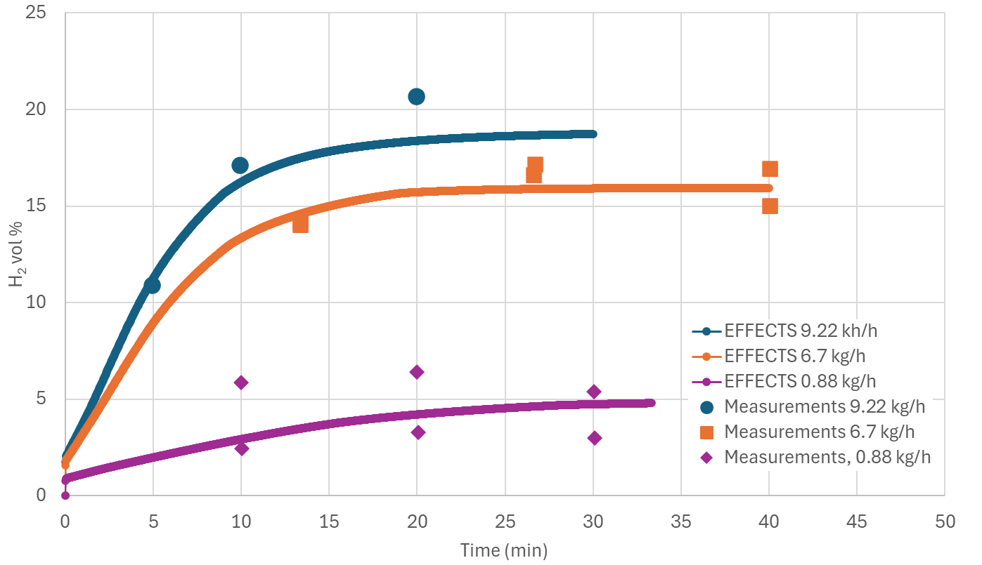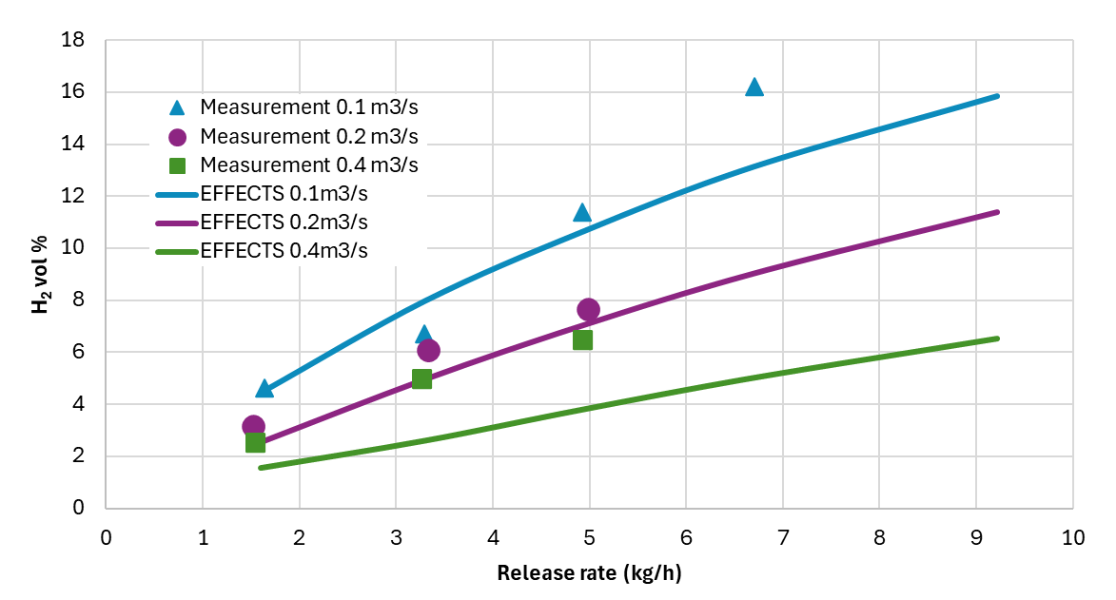
Figure 2 Left: Hydrogen volume fraction as a function of time for three release rates, Right: Hydrogen volume fraction as a function of the hydrogen release rate for three ventilation rates.
    - Inverse two-layer model
Wang, Hu, and Jiang (2013) performed concentration measurements on CO₂ jet releases in a room. The effect of the CO₂ release rate (0.01 - 0.1 kg/s) onto the volume fraction as a function of time was measured.
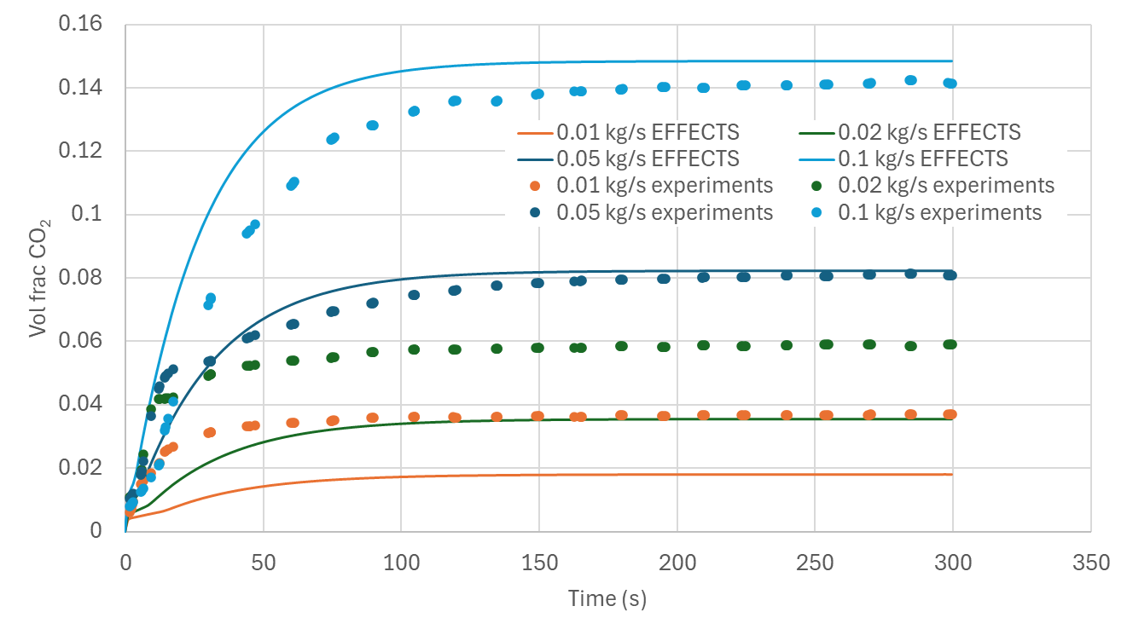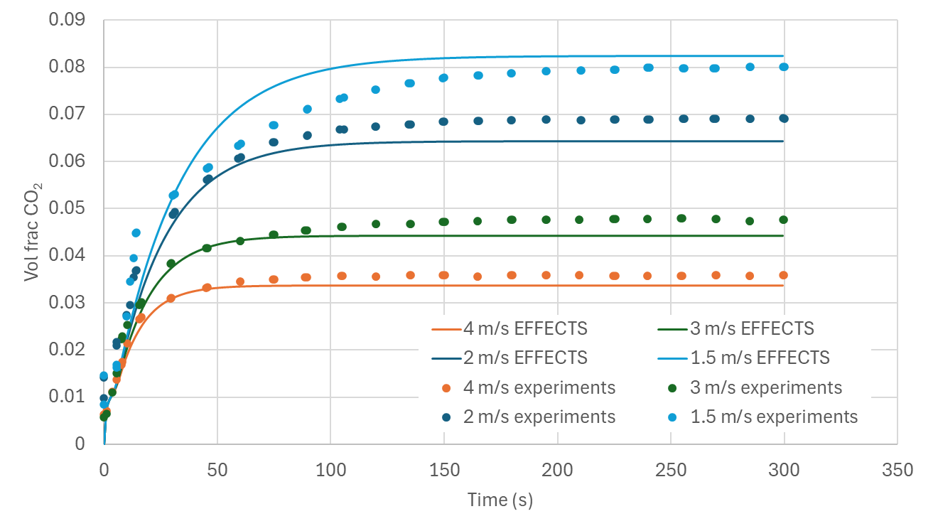
Figure 3 Left: The volume fraction of CO₂ in the layer for different release rates. Right: The volume fraction of CO₂ in the layer for different outdoor wind velocities.
The model slightly overpredicts CO₂ concentrations at high release rates and underpredicts them at low rates (Figure 3). This is attributed to the two-layer assumption, which neglects vertical gradients, with CO₂ accumulating near the floor and exceeding the layer-averaged concentration. The effect of the ventilation rate also was studied (air flow speeds of 1.5 - 4 m/s), where very good agreement was found between calculations and measurements.
    - Overpressure model
For the validation of the overpressure model, the volume fraction in the upper layer as a function of time was experimentally studied in (Ekoto et al. 2012), followed by indoor explosion, where the overpressure was measured, with varying ignition delay time (Figure 4).
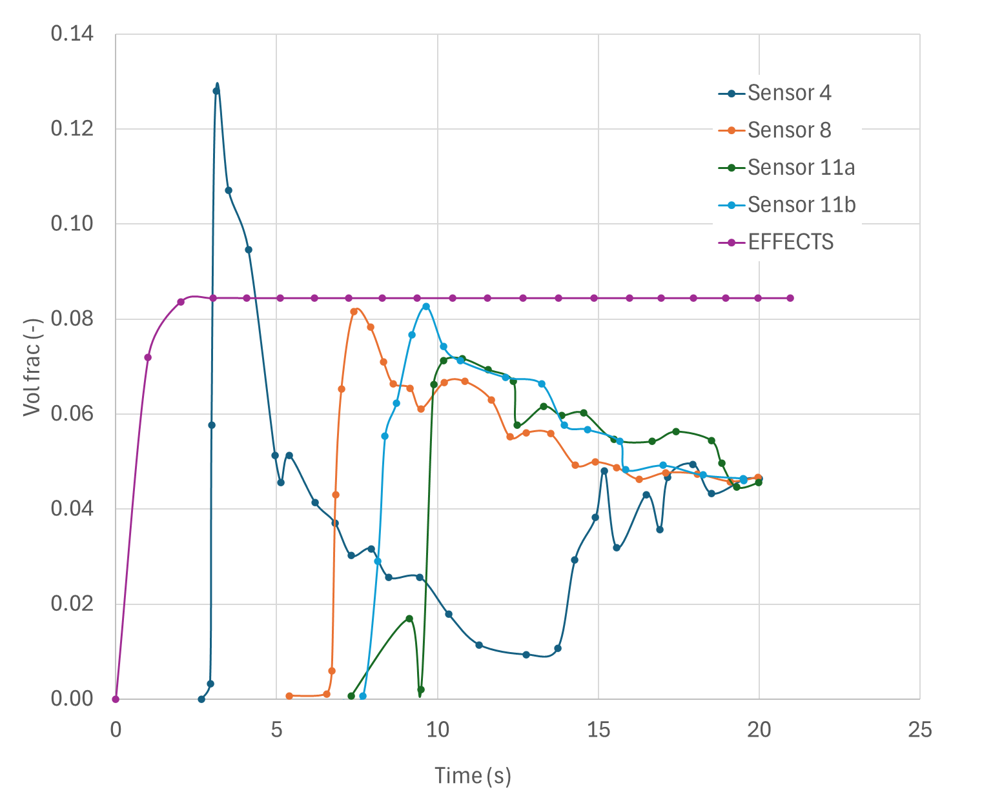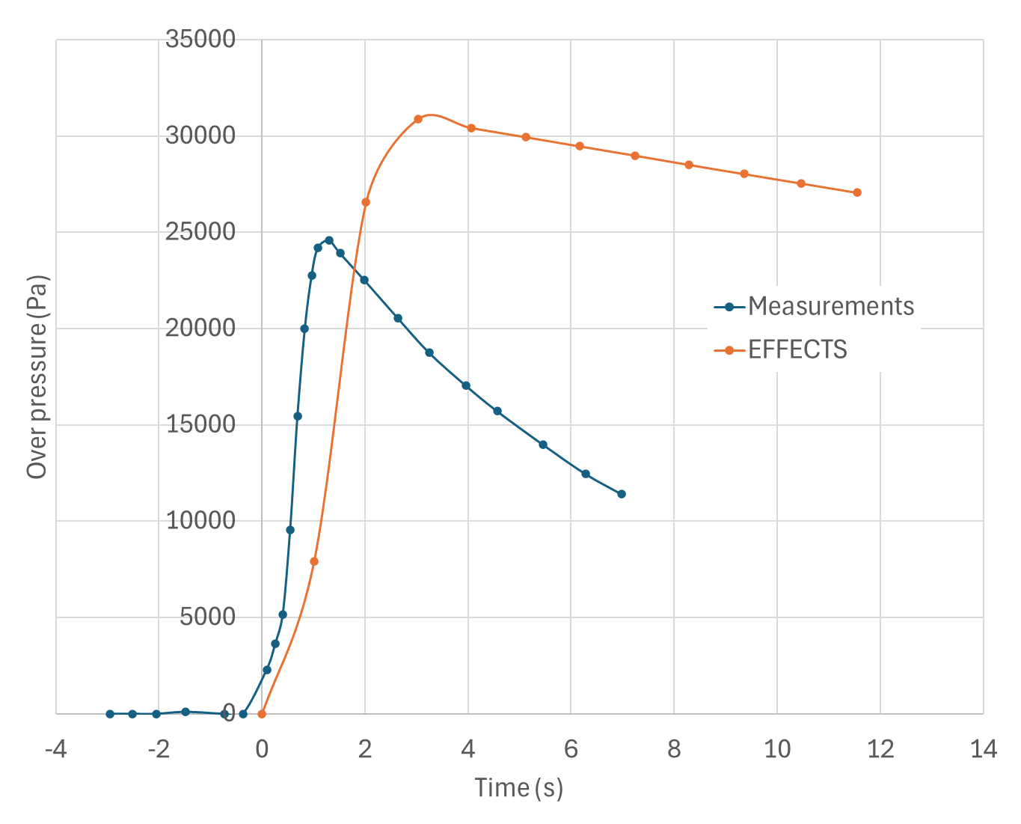
Figure 4 Left: Hydrogen concentrations as a function of time. Right: Overpressure as a function of time.
Both the concentration in time and the overpressure in time are reproduced well by the model. The height of the maximum pressure and the pressure decay in time show similar results, as the experiments. The somewhat slower pressure decay can be explained by the act that one of the walls in the container was made of thin plastic foil. The foil will deform before rupture due to the increased pressure, leading to a faster decay in pressure.
  - Sensitivity analysis
A sensitivity analysis evaluated the impact of key parameters on concentrations and flammable cloud formation.
    - Model switching threshold
The transition between the ideal mixing and two-layer model was assessed as a function of room volume and release rate model for hydrogen and methane at 10 °C. The threshold increases linearly with enclosure volume. This increase differs for hydrogen and methane due to density differences.
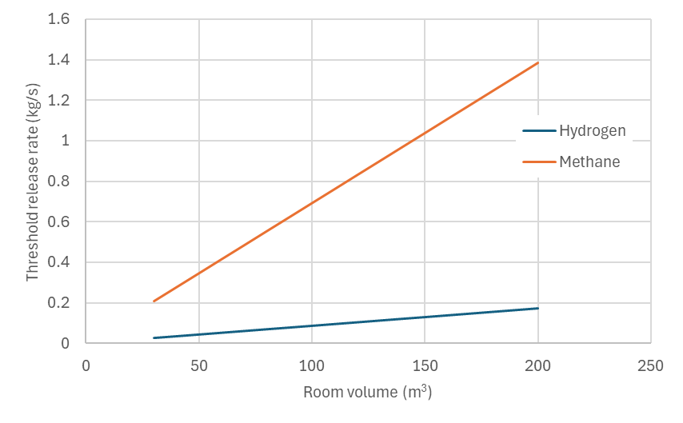
Figure 5 Release rate at which the model switches between the ideal mixing model and the two-layer model.
    - Ventilation opening configuration
The effect of opening orientation and size ratio on natural ventilation was analysed through the effective opening area and discharge coefficient. The results show that ventilation performance is strongly affected by opening geometry, with the largest sensitivity observed for small opening angles and unequal opening sizes.
    - Jet characteristics
The influence of release angle on jet length was evaluated because of its effect on entrainment and layer concentration. The jet length varied continuously with release angle, with discontinuities only at the critical geometric transition angles between floor and wall or wall and ceiling.
  - Conclusions
This work presents the mathematical formulation and validation of the EFFECTS Indoor Ventilation, Dispersion and Overpressure model, primarily for hydrogen but applicable to other gases. The model accounts for mechanical and natural ventilation and incorporates ideal mixing, two-layer, and inverse two-layer approaches, enabling simulation of a wide range of dispersion behaviour depending on release rate, buoyancy, and geometry. Additional features include temperature effects, jet behaviour, outflow modelling, and overpressure prediction following ignition.
Validation against experimental data shows good agreement for both light gases (hydrogen) and heavy gases (CO₂). The two-layer approaches accurately reproduce concentration build-up and steady-state behaviour, with minor deviations at low concentrations due to the simplified layer assumption. Ventilation effects are well captured, although a slight underprediction might occur at high refresh rates. The overpressure model also shows good agreement with experimental results.
Sensitivity analysis confirms consistent behaviour with theoretical expectations, including model switching, ventilation dependence on opening configuration, and jet effects. Coupling with other EFFECTS modules, such as the (outdoor) dispersion model, demonstrates applicability for integrated risk assessments.
The model provides a practical and reliable tool for assessing indoor gas dispersion and explosion risks, supporting the safe design of hydrogen and other flammable gas systems.
Nomenclature

$A$– opening area, m²
$A_{eff}$– effective opening area, m²
$C$– gas concentration, –
$C_{d}$– discharge coefficient, –
$C_{p}$– specific heat capacity, J/(kg·K)
$C_{p,mix}$– mixture specific heat capacity, J/(kg·K)
$g$– gravitational acceleration, m/s²
$g^{'}$– reduced gravity, m/s²
$H$– room height, m
$n$– air exchange rate, s⁻¹
$P_{0}$– ambient pressure, Pa
$Q$– volumetric flow rate, m³/s
$Q_{B}$– buoyancy-driven flow rate, m³/s
$Q_{s}$– source flow rate, m³/s
$Q_{w}$– ventilation flow rate, m³/s
$t$– time, s
$T$– temperature, K
$v$– wind velocity, m/s
$v_{w}$– wind velocity normal to opening, m/s
$V$– room volume, m³
$V_{1}$– upper layer volume, m³
$x$– volume fraction of gas, –
$x_{air}$– volume fraction of air, –
$γ$– heat capacity ratio (Poisson constant), –
$ρ$– density, kg/m³
$ρ_{air}$– air density, kg/m³
$ρ_{gas}$– gas density, kg/m³
$θ$– wind or jet angle, °

References
ATEX. 2021. “NEN-EN-IEC 60079-10-1 Explosive Atmospheres - Part 10-1: Classification Areas - Explosive Gas Atmospheres (IEC 60079- 10-1:2020,IDT).”
Bauwens, C. R., and S. B. Dorofeev. 2014. “CFD Modeling and Consequence Analysis of an Accidental Hydrogen Release in a Large Scale Facility.” Pp. 20447–54 in International Journal of Hydrogen Energy. Vol. 39. Elsevier Ltd.
Ekoto, Isaac W., William G. Houf, Greg H. Evans, Erik G. Merilo, and Mark A. Groethe. 2012. “Experimental Investigation of Hydrogen Release and Ignition from Fuel Cell Powered Forklifts in Enclosed Spaces.” International Journal of Hydrogen Energy 37(22):17446–56. doi:10.1016/j.ijhydene.2012.03.161.
Kaye, N. B., and G. R. Hunt. 2004. “Time-Dependent Flows in an Emptying Filling Box.” Journal of Fluid Mechanics 520:135–56. doi:10.1017/S0022112004001156.
Lowesmith, B. J., G. Hankinson, C. Spataru, and M. Stobbart. 2009. “Gas Build-up in a Domestic Property Following Releases of Methane/Hydrogen Mixtures.” International Journal of Hydrogen Energy 34(14):5932–39. doi:10.1016/j.ijhydene.2009.01.060.
Merilo, E. G., M. A. Groethe, J. D. Colton, and S. Chiba. 2011. “Experimental Study of Hydrogen Release Accidents in a Vehicle Garage.” International Journal of Hydrogen Energy 36(3):2436–44. doi:10.1016/j.ijhydene.2010.04.056.
Walker, Andy. 2016. “Natural Ventilation.” https://www.wbdg.org/resources/natural-ventilation.
Wang, Zhirong, Yuanyuan Hu, and Juncheng Jiang. 2013. “Numerical Investigation of Leaking and Dispersion of Carbon Dioxide Indoor under Ventilation Condition.” Energy and Buildings 66:461–66. doi:10.1016/j.enbuild.2013.06.031.

