 CHEMICAL ENGINEERING TRANSACTIONS  VOL. xxx, 2026 | A publication of  
The Italian Association
of Chemical Engineering
Online at www.cetjournal.it

Guest Editors: Valerio Cozzani, Bruno Fabiano, Genserik Reniers
Copyright © 2026, AIDIC Servizi S.r.l.
ISBN 979-12-81206-xx-x; ISSN 2283-9216

Modelling bottom corrosion of atmospheric storage tanks to support the safety management
Paolo Carbone^{a,}*, Elpida Piperopoulosª, Giancarlo Consolo^{b}, Maria Francesca Milazzoª
ªDepartment of Engineering, University of Messina, Contrada di Dio, 98166 Messina, Italy
^{b}Department of Mathematical, Computer, Physical and Earth Sciences, University of Messina, Viale Ferdinando Stagno d'Alcontres 31, 98166 Messina, Italy
paolo.carbone@studenti.unime.it
This study proposes a procedure for the prediction of the bottom conditions of storage tanks; it is based on the observations of the evolution of the pit corrosion in some carbon steel samples that were exposed over one year to a corrosive environment simulating a real case scenario. The pitting corrosion on the samples was monitored by laser-scanning their surface, then, the maximum corrosion depth was calculated for each sample. A probabilistic model, based on the extreme values theory, was developed to model the distribution of pits. The model aims to predict the probability distribution of the corrosion depths at a different time, building a simple time dependence for the distribution parameters and allowing to determine the expected bottom perforation probability. By comparing with previous studies, Bayesian inference was used to adjust the prediction of both the distribution parameters, without losing their interdependence. The extreme values theory, combined with Bayesian inference, allows the model to give an accurate prediction of failure probability; consequently, the residual useful life of the tank can be precisely estimated, mitigating the risk of release of dangerous substances while optimizing management costs.
  - Introduction
In the oil and gas industry, atmospheric storage tanks (ASTs) are critical infrastructure, as they play a crucial role in safely holding dangerous materials, but corrosion is one of the major problems (Komariah et al., 2021). Since these vessels are designed for long-term use, their safety heavily depends on the implementation of proper integrity monitoring and maintenance strategies. A major concern in petrochemical plants, oil terminals, and refineries is the degradation of the tank bottoms due to corrosion, a criticality that becomes especially concerning as the tank gets older. Corrosion can lead to hazardous leaks, with severe threats to both humans and the surrounding ecosystem posed by the stored chemicals (Argyropoulos et al., 2012; Laurent et al., 2021; Ikwan et al., 2021). To manage these risks, the industry heavily relies on the Risk-Based Inspection (RBI) methodology. Typically, inspectors estimate the corrosion rate by means of multiple observations of the metal thickness over the time (EEMUA, 2014). This calculation helps in predicting the equipment’s residual useful life and scheduling future maintenance. Frameworks like the API recommended practices demand extensive data regarding damage mechanisms (API, 2016a), which can be excessive for smaller facilities or fuel depots because of the high costs and resource drains. More importantly, taking discrete thickness readings simply cannot guarantee the knowledge of the absolute deepest point of corrosion. Tank bottoms are heavily subjected to localized pitting rather than uniform wear, meaning a critical flaw could easily slip past standard measurements.
This work aims to iterate on previous studies, where extreme value theory together with Bayesian inference is successfully used to model the corrosion rate (Kasai et al.,2026; Milazzo et al., 2022). This probabilistic approach gives an estimate of the maximum depth of corrosion by fitting the discrete thickness measurements into a Gumbel distribution. Rather than deriving the corrosion rate from these measurements, it is possible to measure the time dependence of the parameters for the Gumbel distribution, which allows the prediction of the probability of a given corrosion depth. This prediction is then further refined with the Bayesian inference, by adjusting the prediction of one of the two distribution parameters. This work introduces a modification in the previous methodology to allow the Bayesian inference to adjust both parameters at the same time, without losing their interdependence. By merging the data from recent inspections alongside historical trends from similar storage tanks, this technique offers a dynamic forecast that is tank-specific, stepping away from overly conservative blanket standards, allowing facility managers to establish the safest, most cost-effective timeline for the next full inspection. The manuscript is structured as follows: the methodology (experimental investigation, data collection and modelling) is given in Section 2; the results of the study and related discussion are reported in Section 3; finally, conclusions are given in Section 4.
  - Methodology
The probabilistic model estimating the maximum depth of corrosion was developed starting from a dataset built by means of laboratory experiments. The measures were taken at different time frames and fitted to a type 1 Gumbel distribution (Milazzo et al., 2022):
(1)
The distribution is then linearized by introducing the reduced variable:
(2)
By plotting y as a function of x in a semi-logarithmic diagram, the straight line obtained (plot position) has a slope and intercept as functions of the distribution parameters, respectively 1/α and – (β/α) (Figure 2). The cumulative probability is calculated as following:
$$F(y)=\frac{k}{n+k}$$ | (3)
    - Experimental setup
Carbon steel specimens 20 mm x 30 mm x 3 mm were immersed in a hydrocarbon solution (Figure 1). The solution simulates a corrosive environment for an atmospheric tank, at pH 2.5; hydrocarbon is mixed in a 4/1 ratio with Sour Water, as indicated in the NACE TM0177 Test Solution B (5.0 wt.% NaCl, 2.5 wt.% glacial acetic acid and sodium thiosulphate 10⁻¹ to 10⁻³ M in replacement of H₂S) (Calabrese et al., 2016). Before the immersion, the specimens were submerged in acetone (CH₃-CO-CH₃) and treated with ultrasound (frequency 30 kHz) to remove possible grease residues. Subsequently, they were left in a Clarke solution (250 mL of hydrochloric acid, 5 g of antimony oxide, 12.5 g of stannous chloride), in continuous stirring, at room temperature, for 35 minutes. Then, they were washed sequentially with soda, distilled water and ethanol. Over the span of one year, the samples were taken out of the corrosive solutions, thoroughly cleaned and then analysed with a laser scan to get a depth map of the surface.

(a) (b)
Figure 1 (a) Carbon steel specimens; (b) Containers for the simulation.
    - Dataset
By using a custom MATLAB script, the corrosion depth was calculated across each sample's surface, with a resolution of approximately ~0.1 mm. To generate a statistically robust dataset that recreates real-world tank inspections, the algorithm virtually divides each scanned specimen into ~40 distinct sections. Within each region, the script isolates and extracts the maximum recorded corrosion depth. This procedure effectively simulates 40 discrete measurement points, taken at specific time intervals under identical environmental conditions, closely replicating a scenario where grid measurements EEMUA or API standards are gathered from the bottom plate of the atmospheric storage tank.
To further expand the dataset and introduce realistic inspection variability before fitting the data to a probability distribution, a randomization technique is applied. For each established time interval, the script randomly deletes 8 of the 40 measurement points, repeating this randomized removal process 1,000 times. Consequently, this iterative resampling approach yields 1,000 datasets per time interval, essentially simulating the discrete inspection data of 1,000 different storage tanks having the same characteristics.
    - Corrosion modelling and predictions
To make a probabilistic modelling of corrosion, the parameters of Eq.(1) must be calculated by using the dataset obtained for each scanned surface. It is also possible to predict the parameters at each time frame by means of a developed correlation of these parameters vs. time. The values of the scale (α) and location (β) parameters were interpolated with a power law regression to calculate the time dependence and, then, predictions is compared to the actual measured parameters.
By using the 1,000 simulated datasets, a dedicated algorithm calculates discrete intervals for both α and β parameters for each time interval. By mapping the intersections of these specific intervals, the system constructs a two-dimensional index matrix. This matrix can be populated by counting the number of simulated storage tanks whose forecasted α and β values land within each respective coordinate pair. This is a representation of the joint probability distribution.
    - Bayesian Inference
By applying Bayesian inference to the two-dimensional distribution, the predictions of both α and β can be simultaneously updated. The observable variable, used for the inference, is the maximum recorded corrosion depth at the previous time frame (i.e. the 378 days predicted distribution is adjusted using the maximum corrosion depth recorded at 276 days). This variable effectively represents the location parameter (β).
In this framework, the smooth bivariate distribution serves as the prior probability, while the likelihood function Eq. (4) is constructed as a normal bell curve centered around the value of the observed variable:
(4)
The artificial deviation is the parameter that influences the spread of the likelihood bell curve; practically, it represents how much to trust the observed variable. The adjusted prediction (posterior probability) is then obtained as follows:
(5)
  - Results and discussion
The datasets, obtained for each specimen, were elaborated and the probabilistic models estimating the maximum depth of corrosion were obtained (Figure 2). The time dependence of α and β is given in Figure 3. The prediction of the distribution parameters at each time frame was made for each of the 1000 datasets and the results were compared with the actual values of both parameters.
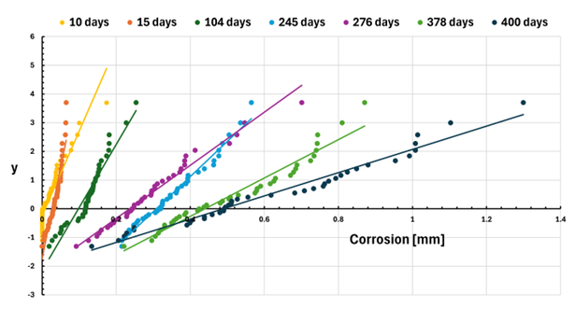
Figure 2 Linearized Gumbel distributions, the colors represent time of exposure in terms of days.
(a)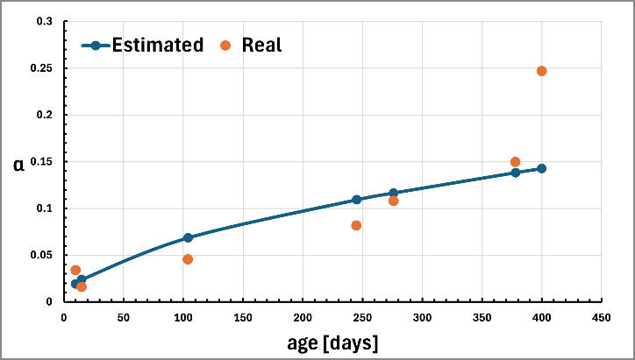 (b)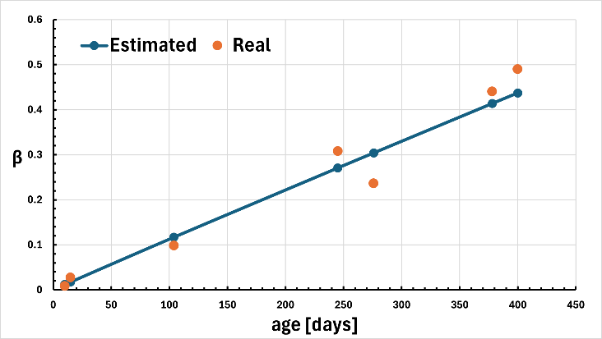
Figure 3 Power law regression of the distribution parameters: (a) scale parameter and (b) position parameter
Figure 4(a) gives the intersections of the discrete intervals for both α and β parameters and associated frequencies. This visual and mathematical representation effectively captures the joint probability distribution, allowing for the simultaneous characterization of how the scale and location parameters behave across the entire simulated population of tanks. The generated matrix is essentially an empirical bivariate probability distribution, where the underlying statistical correlation between the parameters is preserved. This distribution can be “smoothed out” by reconstructing it analytically to have a better representation of the data (Figure 4(b)). The distribution can be reconstructed using the following probability density function (PDF):
$${f(β,α)}_{i,j}=\frac{1}{2πσ_{β}σ_{α}\sqrt{1-ρ^{2}}}exp\left\{-\frac{1}{2\left(1-ρ^{2}\right)}\left[\frac{{\left(β_{i}-μ_{β}\right)}^{2}}{σ_{β}^{2}}+\frac{{\left(α_{j}-μ_{α}\right)}^{2}}{σ_{α}^{2}}-\frac{2ρ\left(β_{i}-μ_{β}\right)\left(α_{j}-μ_{α}\right)}{σ_{β}σ_{α}}\right]\right\}$$ | (6)

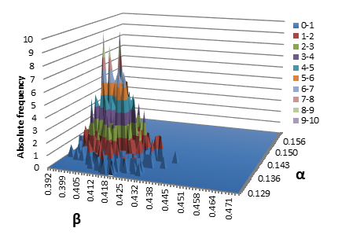  (a) | 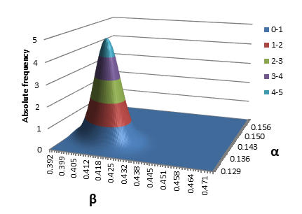  (b)
Figure 4 Frequency distribution matrix of the predicted distribution parameters at 378 days: (a) discrete values; (b) continuous values.
This step was also useful to remove the absolute zeros from the distribution, which can significantly limit the effect of the Bayesian inference. The resulting posterior bivariate distribution provides a dynamically updated, site-specific forecast of the corrosion development (Figure 5).
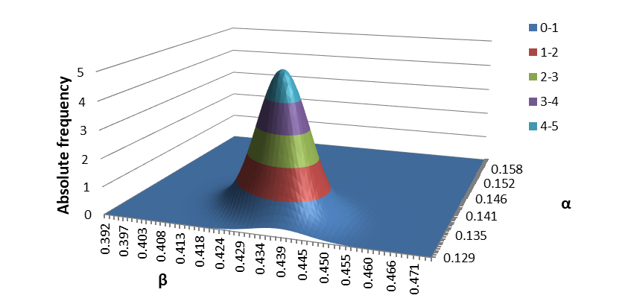
Figure 5 Updated predicted distribution at 378 days, using the actual data at 276 days.
To verify the effectiveness of the Bayesian inference, the predicted distribution was compared to the actual ones (Figure 6). The primary objective of this comparison was to evaluate how effectively the mathematical model transitions from a generalized theoretical state to a highly accurate, site-specific forecast.
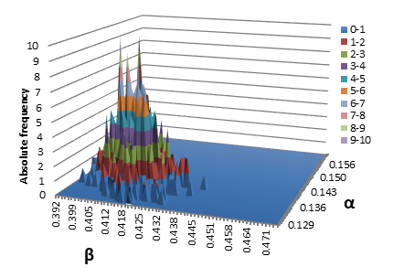  (a) | 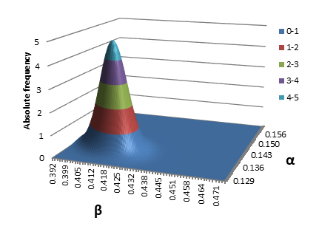  (b)
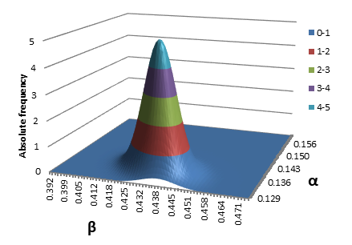  (c) | 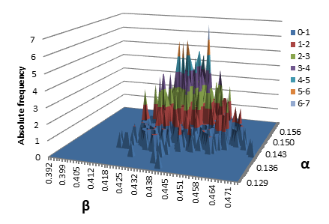  (d)
Figure 6 Comparison between the predicted distributions (both with and without Bayesian inference) and actual distributions: at 378 days (a) discrete predicted distribution; (b) continuous predicted distribution; (c) updated predicted distribution; (d) actual distribution.
From this comparison, it is clear that Bayesian inference allows for a more accurate prediction. The probability mass visibly shifts, effectively discarding irrelevant baseline noise and tuning the prediction to capture the unique conditions that may occur in the single tank, without the need for special measuring techniques or complex physical data.
  - Conclusions
Managing atmospheric storage tanks within major hazard establishments requires a balance between safety and operational efficiency. Operators are tasked with preventing hazardous bottom leakages while simultaneously avoiding the excessive financial costs and occupational risks associated with frequent tank emptying, cleaning, and internal inspections.
While the fundamental application of extreme value theory and Bayesian inference to predict the maximum depth of localized corrosion is an established approach in recent literature, the methodology presented in this study offers an essential refinement to these existing probabilistic frameworks. By transitioning from simplified or univariate parameter updates to a comprehensive bivariate distribution, this enhanced model successfully captures the joint probability of both the scale and location parameters simultaneously. Integrating empirical inspection data into the prior distribution yields a more precise, site-specific posterior forecast that closely mirrors actual physical degradation. With shifting energy demands and the transition toward low-carbon fuels, many ageing tanks will be forced to remain safely in service far beyond their original design lives. The presented framework can be a valuable support to the standard Risk-Based Inspection (RBI) protocols, leading to a more realistic evaluation of failure frequencies by predicting the exceedance probability of a given corrosion thickness. Consequently, it empowers facility managers to confidently determine the maximum safe time interval between successive physical inspections, minimizing the risk of unexpected environmental releases.

Nomenclature
F(x) | Cumulative distribution probability  (Type I Gumbel) | x_{max} | Maximum corrosion
 | Likelihood function | y | Reduced variable
F(y) | Linearized cumulative distribution probability (Type I Gumbel) | α | Scale distribution parameter
$$f({β,α)}_{i,j}$$ | Probability density function  (bivariate distribution) | β | Location distribution parameter
i, j | Matrix position indices | μ_{A}, μ_{B} | Average values of α and β
k | Corrosion measure rank | ρ | Correlation
n | number of corrosion measures | σ_{err} | Artificial deviation
x | Corrosion depth | σ_{A}, σ_{B} | Standard deviations of α and β
References
API, American Petroleum Institute, 2016a. Risk-Based Inspection. API Recommended Practice API RP, third ed., vol. 580 (New York, US).
Argyropoulos, C.D., Christolis, M.N., Nivolianitou, Z., Markatos, N.C., 2012. A hazards assessment methodology for large liquid hydrocarbon fuel tanks. J. Loss Prev. Process. Ind. 25, 329–335.
Calabrese L., Galeano M., Proverbio E., Di Pietro D., Cappuccini F., Donato A, 2016, Monitoring of 13% Cr martensitic stainless steel corrosion in chloride solution in presence of thiosulphate by acoustic emission technique, Corrosion Science, 111, 151-161.
EEMUA, 2014, Users’ Guide to the Inspection, Maintenance and Repair of above Ground Vertical Cylindrical Steel Storage Tanks, EEMUA 159.
Ikwan F., Sanders D., Hassan M., 2021. Safety evaluation of leak in a storage tank using fault tree analysis and risk matrix analysis. J. Loss Prev. Process. Ind. 73, 104597.
Kasai N., Mori S., Tamura K., Sekine K., Tsuchida T., Serizawa Y., 2016. Predicting maximum depth of corrosion using extreme value analysis and Bayesian inference. Int. J. Pressure Vessels Piping.
Komariah L.N., Arita S., Prianda B.E., Dewi T.K., 2021, Technical assessment of biodiesel storage tank; A corrosion case study, Journal of King Saud University - Engineering Sciences (forthcoming).
Laurent A., Pey A., Gurtel P., Fabiano B., 2021. A critical perspective on the implementation of the EU Council Seveso Directives in France, Germany, Italy and Spain. Process Saf. Environ. Protect. 148, 47–74.
Milazzo M.F., Ancione G., Bragatto P., Proverbio E, 2022, A probabilistic approach for the estimation of the residual useful lifetime of atmospheric storage tanks in oil industry, Journal of Loss Prevention in the Process Industries, Volume 77.

