 CHEMICAL ENGINEERING TRANSACTIONS  VOL. xxx, 2026 | A publication of  
The Italian Association
of Chemical Engineering
Online at www.cetjournal.it

Guest Editors: Valerio Cozzani, Bruno Fabiano, Genserik Reniers
Copyright © 2026, AIDIC Servizi S.r.l.
ISBN 979-12-81206-xx-x; ISSN 2283-9216

Socio-techno Study of Catalytic Pyrolysis of Jojoba Residue for Enhanced Bio-Oil Production
Nourhan H. Khashabaª, Noura F. Abdelsalamª, Hany A. Elazab^{b},c, Nuray Tan^{d}, Mamdouh A. Gadalla^{e,f*}, Thokozani Majozi^{f}, Fatma H. Ashourª
a Chemical Engineering Department, Faculty of Engineering, Cairo University, 12613, Egypt
b Chemical and Biochemical Engineering Department, Missouri University of Science and Technology, Rolla, MO 65409, USA.
c Applied Catalysis and Sustainability Laboratory (ACS Lab), Rolla, MO 65409, USA.
d Science and Art Centre, Çanakkale, Turkey
e Chemical Engineering Department, Faculty of Engineering, Port Said University, 42526, Egypt
f Faculty of Engineering and the Built Environment, University of the Witwatersrand, South Africa
*m.gadalla@eng.psu.edu.eg

This study evaluates the combined techno-chemical and socio-impact relevance of converting jojoba residue into bio-oil using ZnO as an in-situ catalyst. Experiments were performed in a bench-scale, electrically heated fixed-bed batch reactor under nitrogen with a water-cooled condensation train. Five runs were conducted using 500 g feed charges: 500 °C with 0, 3, 5, and 7 g ZnO, and a 600 °C non-catalytic run to isolate temperature effects. Product yields were quantified as bio-oil, biochar, and non-condensable gas via mass balance, and bio-oils were qualitatively characterized by Gas Chromatography-Mass Spectrometry (GC-MS). At 500 °C, bio-oil yield was 16.6–16.8 wt% for 0–3 g ZnO, increased to a maximum of 26.6 wt% at 5 g ZnO, and then decreased to 22.2 wt% at 7 g ZnO, indicating an optimum catalyst-to-biomass ratio. Increasing the temperature to 600 °C (0 g ZnO) raised the bio-oil yield to 33.4 wt%. GC–MS results show that the intermediate ZnO loading produced a more distributed chromatographic profile compared with the non-catalytic and high-loading cases, consistent with more favorable vapor upgrading, while the 600 °C control exhibited stronger early/mid-retention contributions consistent with enhanced cracking to lighter volatiles. Overall, tuning ZnO dosage and temperature improved bio-oil yield and produced a more upgrade-friendly composition, pending fuel-property testing.
  - Introduction
Agricultural residues are increasingly viewed as strategic feedstocks for renewable energy and circular bioeconomy pathways because they can expand bioenergy supply while mitigating waste-management burdens (IRENA, 2023). Thermochemical conversion, and particularly fast pyrolysis, provides a flexible route to convert lignocellulosic residues into liquid bio-oil alongside biochar and non-condensable gases (El Bari et al., 2024). However, raw fast-pyrolysis bio-oil is not a drop-in fuel due to its high oxygen content and associated drawbacks, including acidity, viscosity, low heating value, and limited storage stability (Bergvall et al., 2024). Catalytic fast pyrolysis has therefore attracted strong interest because in-situ vapor upgrading can shift product distributions and improve bio-oil quality proxies compared with non-catalytic operation (Rowland et al., 2024).
Metal oxides, including ZnO-based catalysts, are widely investigated for catalytic upgrading during pyrolysis because they can influence cracking, deoxygenation, and oxygenate selectivity. (Singh et al., 2023). ZnO has also been reported to modify pyrolysis product formation in model biomass systems, supporting its relevance for catalytic screening and optimization in real residues (Khashaba et al., 2026).
Jojoba residue (oilcake), referred to as jojoba meal, is an underutilized agro-industrial by-product whose valorization aligns with circular bioeconomy strategies and can diversify the value chain beyond primary oil production (Ravindran et al., 2025). Accordingly, the present work aims to determine how ZnO loading (0–7 g at 500 °C) and temperature (500 vs 600 °C) affect product yields and GC–MS compositional trends during jojoba-meal pyrolysis, identifying conditions that maximize bio-oil yield while shifting composition toward an upgrade-friendly profile. In parallel, the study frames a qualitative socio-impact perspective on residue-to-fuel valorization as a pathway to localized value creation, with a planned transition to quantitative assessment when scale-up enables semi-industrial or commercial operation.
  - Materials and methods
    - Pyrolysis Experiments
Jojoba oil was extracted by mechanical cold pressing at relatively low temperatures after seed cleaning, drying, and crushing to preserve oil quality. Simmondsia chinensis seeds contain approximately 50 wt% oil, and the solid residue after extraction is referred to as jojoba meal. The crop was cultivated near Ismailia, processed at a local extraction station, and subsequently processed at Egyptian Natural Oils Co., where the jojoba meal was collected. This meal was used as the feedstock for the catalytic fast pyrolysis experiments; its chemical composition (Table 1) was reported by El-Anany A.M. (2007). ZnO was used as the catalyst, obtained as a commercial-grade powder from a local supplier, and applied as received without further treatment.
Table 1: Chemical analysis of jojoba meal.
Component | Moisture | Crude Protein | Crude Oil | Crude Fiber | Ash | Nitrogen free extract | Simmondsin
Weight % | 10.3 | 22.9 | 1.20 | 15.40 | 4.10 | 53.38 | 0.43

The experiments were conducted in a locally built, bench-scale, electrically heated stainless-steel fixed-bed batch reactor (about 40 L internal volume). The reactor is equipped with internal thermocouples, automated temperature control, and nitrogen purging, followed by a condensation line comprising a water-cooled copper-coil condenser and a liquid collection vessel. This setup (Fig. 1a) was adapted from the recently published configuration of Khashaba et al. (2026). The design allows the products to be separated into condensed liquid (bio-oil), solid residue remaining in the reactor (biochar), and non-condensable gases (estimated from mass balance). The setup is equipped with temperature control for safety and proper ventilation for gas relief. For scale-up, HAZOP studies are recommended to mitigate risks. Although the unit can process ~10 kg per batch, runs were conducted with 500 g charges to promote more uniform heating and to keep condensate volumes manageable. In total, five experiments were performed: at 500 °C with ZnO loadings of 0, 3, 5, and 7 g per 500 g batch, and one additional run at 600 °C with 0 g ZnO to isolate the effect of temperature. ZnO was physically mixed with the prepared biomass at defined loadings before pyrolysis. It must be noted that the catalytic experiments were conducted at 500°C based on preliminary optimization studies indicating that ZnO exhibits significant catalytic activity at lower temperatures, enabling reduced energy input while maintaining product yield. The non-catalytic experiments at 600°C were selected to ensure sufficient thermal cracking in the absence of a catalyst (Khashaba et al., 2026).
After cooling under nitrogen, the collected condensate was weighed and reported as bio-oil, and the remaining solids were weighed as biochar; the gas yield was calculated by difference. On the other hand, the biochar mixed with catalyst are removed from the reactor (Fig. 1b). However, ZnO was not separated from the biochar, and it has been applied further in ongoing research to enrich the soil for crops cultivation. To ensure comparability, the recovery protocol (including condenser rinsing/transfer) was kept consistent, and overall mass closure was used as an internal check. Product yields (wt%) were determined by dividing the mass of products by the initial 500 g charge. Whereas the conversion of biomass is determined as 100%-biochar yield. Bio-oils were characterized qualitatively by GC–MS to track how conditions shift major compound families (e.g., oxygenates, phenolics, aromatics, nitrogen-containing species, and heavier fractions). Analyses were performed using a Thermo Trace GC Ultra coupled to an ISQ single-quadrupole MS with a TG-5MS column, Electron Ionization (EI) at 70 eV, helium carrier gas (1 mL/min), injector/transfer line at 280 °C, and a programmed oven temperature ramp; results were reported as % Total Ion Chromatogram (% TIC) peak area with tentative identifications based on NIST/WILEY library matching. Future work will expand the matrix to include additional temperatures and catalyst conditions beyond these initial five samples.
    - Social Assessment
The valorization of jojoba meal through catalytic fast pyrolysis contributes to circular bioeconomy development by transforming agricultural residues into valuable energy carriers and functional materials. From a socio-technical perspective, the integration of such thermochemical processes into rural systems has the potential to create localized value chains that enhance resource efficiency and reduce waste. The proposed system can support decentralized employment opportunities in biomass collection, preprocessing, and reactor operation. In particular, the inclusion of women in upstream activities such as feedstock preparation and logistics can contribute to more inclusive economic participation. However, these impacts are currently assessed qualitatively and will require quantitative validation in future studies. From a technical standpoint, the dual production of bio-oil and biochar offers multiple benefits: bio-oil can serve as a renewable energy carrier, while biochar can be applied in soil amendment and environmental remediation. These attributes support improved resource utilization and environmental sustainability. Future work will focus on developing a quantitative socio-economic and techno-economic assessment once pilot-scale or semi-industrial data become available, enabling a more rigorous evaluation of economic feasibility, scalability, and long-term societal impact.
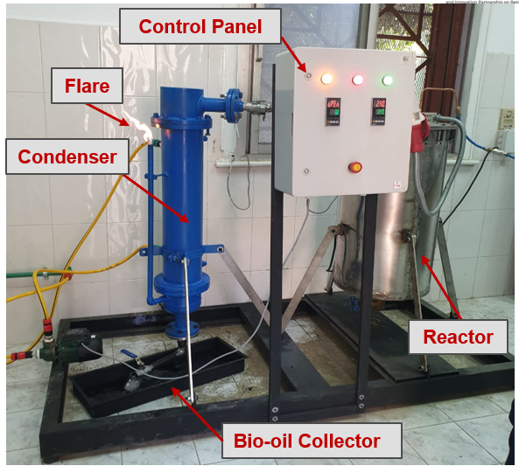
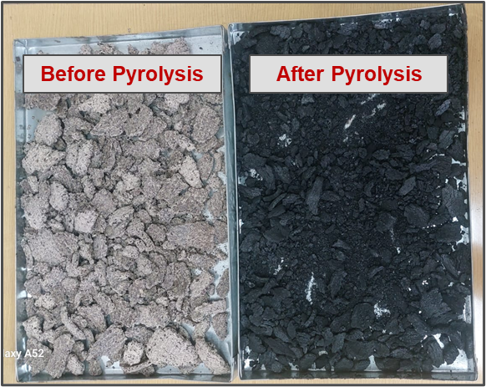
(a) (b)
Figure 1: (a) Pyrolysis reactor setup, and (b). Jojoba meal before and after pyrolysis.
  - Results and Discussion
    - Product Yields
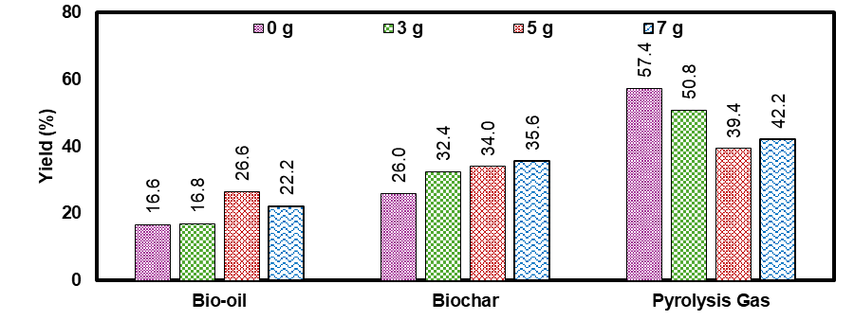
As shown in the yield distribution (Fig. 2), ZnO exhibited a loading-dependent effect on bio-oil recovery at 500 °C. The non-catalytic run (0 g) produced 16.6 wt% bio-oil (≈74% biomass conversion), while 3 g ZnO gave a nearly unchanged yield (16.8 wt%), indicating that low additive levels provided limited catalytic influence on the net condensable fraction under these conditions. Increasing ZnO to 5 g led to the highest bio-oil yield (26.6 wt% equivalent to 66% conversion), representing a substantial improvement over the non-catalytic. However, further increasing the loading to 7 g reduced the bio-oil yield to 22.2 wt%, suggesting that beyond an optimum catalyst-to-biomass ratio for bio-oil objective, secondary reactions increasingly divert vapors away from the condensable liquid fraction.
Figure 2: Effect of ZnO catalyst loading on jojoba meal pyrolysis product yields at 500°C.
The improvement at moderate ZnO loading (5 g) is consistent with the role of metal oxides in promoting oxygen-removal reactions (e.g., decarboxylation/decarbonylation) and modifying the vapor-phase reaction network, thereby reducing the prevalence of reactive oxygenates and increasing the fraction of vapors that condense as an organic liquid. Early work on ZnO treatment of biomass pyrolysis vapors reported measurable catalytic effects on pyrolysis liquids, including improved oil quality/stability, commonly associated with oxygen removal and compositional shifts in the condensate (Nokkosmäki et al., 2000). Broad reviews of catalytic pyrolysis also highlight that catalysts can enhance liquid production and/or improve liquid quality depending on acidity/basicity and operating severity, but that outcomes are strongly dependent on catalyst loading and contact conditions (Sun et al., 2025).
The decline in bio-oil yield at 7 g ZnO likely reflects over-severity in catalytic contact, where increased available surface area and longer effective vapor–solid interaction promote secondary cracking, repolymerization, and carbon deposition (coke/char formation), ultimately reducing the amount of condensable organics.
This interpretation is supported by the parallel shift toward higher solid formation seen at higher loading (biochar increasing from 26.0 wt% at 0 g to 35.6 wt% at 7 g) and aligns with literature describing the trade-off between upgrading reactions and loss of liquids to gas/solid via over-cracking and coking when catalytic severity becomes too high (Ungureanu et al., 2025). Overall, these results indicate that ZnO has an optimal loading window for maximizing bio-oil yield under the tested conditions, with 5 g per 500 g batch providing the best balance between beneficial vapor upgrading and minimizing secondary pathways that suppress liquid recovery.
At 600 °C without ZnO (control), the product yields were 33.4 wt% bio-oil, 28.5 wt% biochar, and 38.1 wt% pyrolysis gas, showing that the process under higher thermal severity still produced a substantial condensable fraction. Based on this higher-temperature baseline, it is reasonable to expect that introducing ZnO at 600 °C will substantially increase the bio-oil yield, because ZnO can catalyze vapor-phase deoxygenation reactions that favor formation of more stable condensable organics rather than reactive oxygenates (Chong et al., 2019). However, we acknowledge this limitation, and it will be further investigated in future work. At the same time, operating at 600 °C can intensify secondary reactions (cracking and repolymerization), so the net yield response will likely depend on ZnO loading and contact severity, potentially showing an optimum rather than a monotonic increase (Reza et al., 2023).
    - Bio-oil Quality
Under non-catalytic conditions at 500 °C (Fig. 3a), the bio-oil contains 16 detected components and exhibits a strongly skewed TIC: three compounds—benzyl (S)-2-amino-2-methyl-4-pentynoate (55.30%), methyl 3-hydroxy-2-methylene-pentanoate (19.48%), and benzyl 2-amino-2-methyl-4-pentynoate (7.88%)—account for 82.66% of total area, with a noticeable late-RT (Retention time) peak near the end of the run, indicating a measurable heavy fraction.
Introducing ZnO at 500 °C increases the number of detected compounds to 20 across the catalytic cases and modifies the volatility envelope. With 3 g ZnO (Fig. 3b), the TIC remains concentrated: the four major components— MYCOSIDE “defined by GC-MS” C(B1) (53.45%), 1-chloro-2-formyloxycyclohexane (17.15%), 5,6-dihydro-5-methyl-2H-pyran-2-one (7.42%), and rac-(4S)-4-hydroxybicyclo[3.2.1]octan-6-one (4.89%)—sum to 82.91%, which is comparable to the non-catalytic control in terms of dominance, but with major peaks distributed into mid/late retention windows (e.g., RT ~33–37 min), consistent with a product slate that still contains appreciable heavier constituents.
At an intermediate loading of 5 g ZnO (Fig. 3c), the chromatogram becomes less skewed than both the control and the 3 g case: the dominant peaks—methyl 3-hydroxy-2-methylenepentanoate (46.09%), a tetrahydropyran-derived oxygenate (15.78%), plus additional peaks (6.12% and 4.96%)—sum to 72.95%, indicating a more distributed composition (i.e., less reliance on a single/few dominant species).
This reduction in dominance is consistent with the common interpretation that broader product distributions reflect more diverse cracking/reforming pathways rather than accumulation into a narrow set of heavy products. (Carrasco Díaz et al., 2024).
At the highest loading of 7 g ZnO (Fig. 3d), the TIC becomes more concentrated again: the four largest peaks—(2-nitro-tetraphenylporphyrinato)nickel(II) (44.46%), bicyclo[4.1.0]heptane-7-carboxamide derivative (16.75%), dimethyl-3-(1′-methyl-1′-butenyl)cyclobutane-1-ethyl acetate (12.27%), and carbonyl-octaethyl-porphinato ruthenium(II) (5.76%)—sum to 79.24%, with clear mid/late-RT contributions (e.g., RT ~29.8 and 33.7 min).
This suggests that excessive ZnO loading does not monotonically improve “fuel-like” character under these conditions; rather, the most favorable trend (lowest skewness and more distributed peak pattern) occurs at intermediate loading (5 g). From a fuel-use perspective, a “better” raw bio-oil is typically associated with (a) reduced heavy-tailing (improved volatility/atomization), (b) reduced high-molecular-weight/oligomer-like content (better storage stability), and (c) fewer highly oxygenated/acidic species (improved corrosivity and heating value after upgrading). The ZnO series indicates that moderate ZnO loading shifts the product envelope toward a more distributed TIC, while too low or too high loading yields more concentrated compositions with notable mid/late-RT peaks (El Bari et al., 2024).
Temperature governs bio-oil composition through secondary reactions (decarboxylation, decarbonylation, dehydration), which shift functional groups and volatility windows as severity increases—exactly the interpretation used in the published-style analysis. The 500 °C control (Fig. 3a) is dominated by three peaks totaling 82.66% with 16 detected components. In contrast, the ZnO-free bio-oil produced at 600 °C (Fig. 4) contains 20 detected components and shows a more distributed TIC that is still dominated by an early-eluting oxygenated compound at RT 6.47 min (53.43%), assigned to (2R)-2-Methyl-4-[(tetrahydro-2H-pyran-2-yl)oxy]butan-1-ol. The next most abundant peaks also occur mainly in the early/mid region—RT 6.83 (9.58%) (exo-3,6-dioxatricyclo[6.4.0.0(2,7)]dodeca-9-ene) and RT 6.79 (3.86%) ((Ra*,1′R*,2′R*)-N,N-Diisopropyl-2-[1′-methyl-2′-(methylamino)-2′-phenylethyl]-1-naphthamide)—while a smaller but notable later component appears at RT 33.17 (4.95%) as 3-(2′-Methoxyethyl)-2,2-dimethyl-5-methylenecyclopentanol, giving a top-three sum of 67.96% and indicating strengthened early/mid-RT signals consistent with enhanced cracking to lighter volatiles.
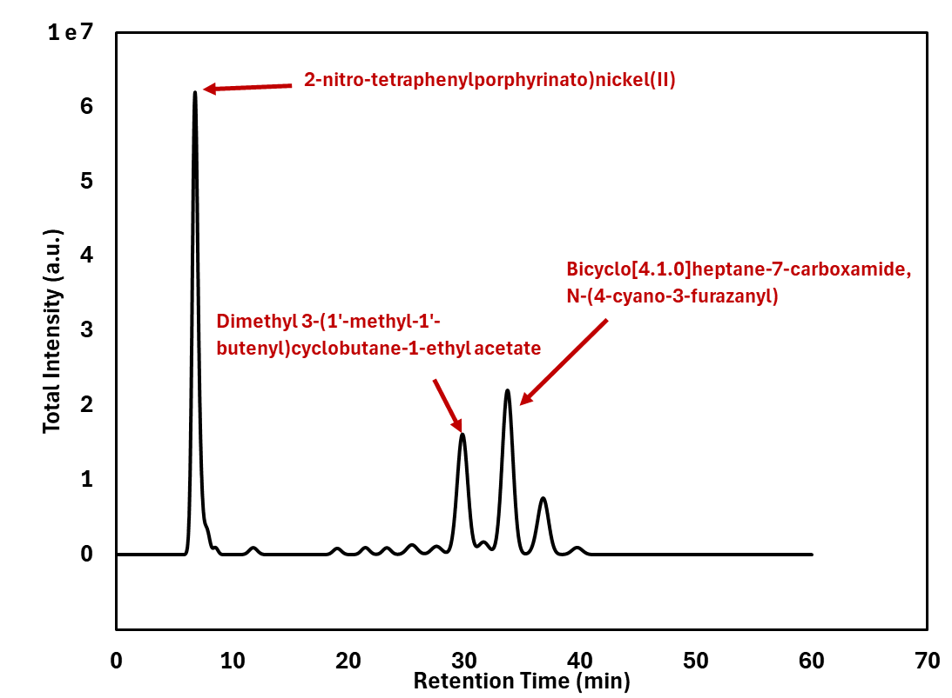
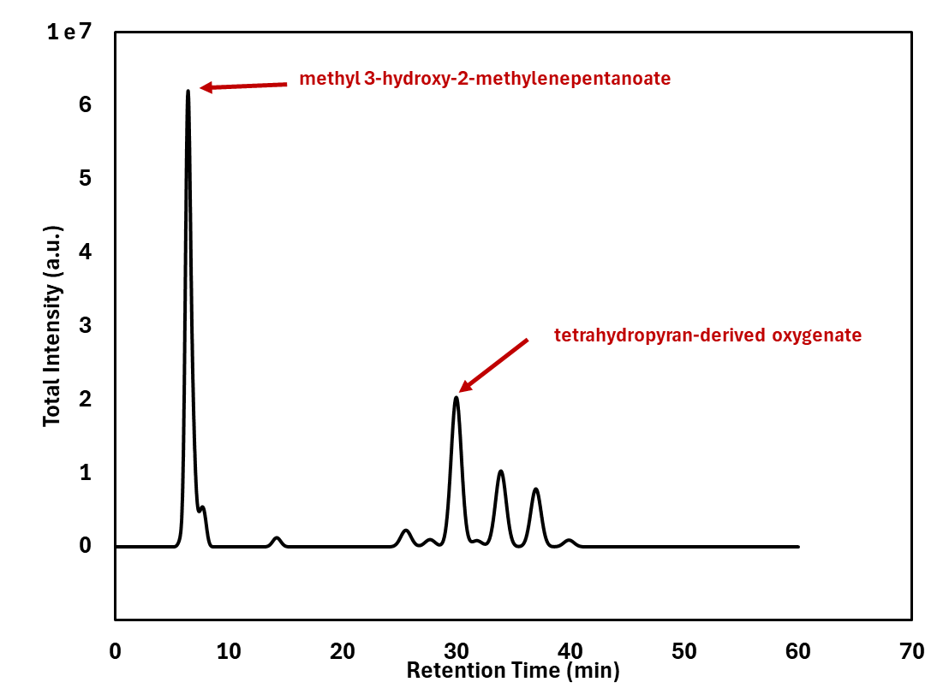
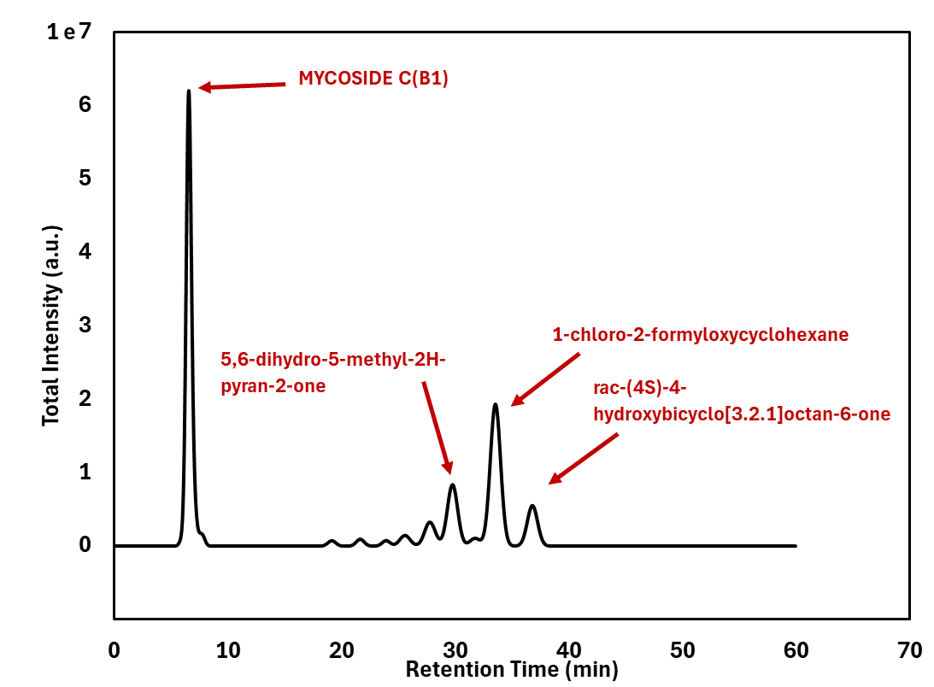
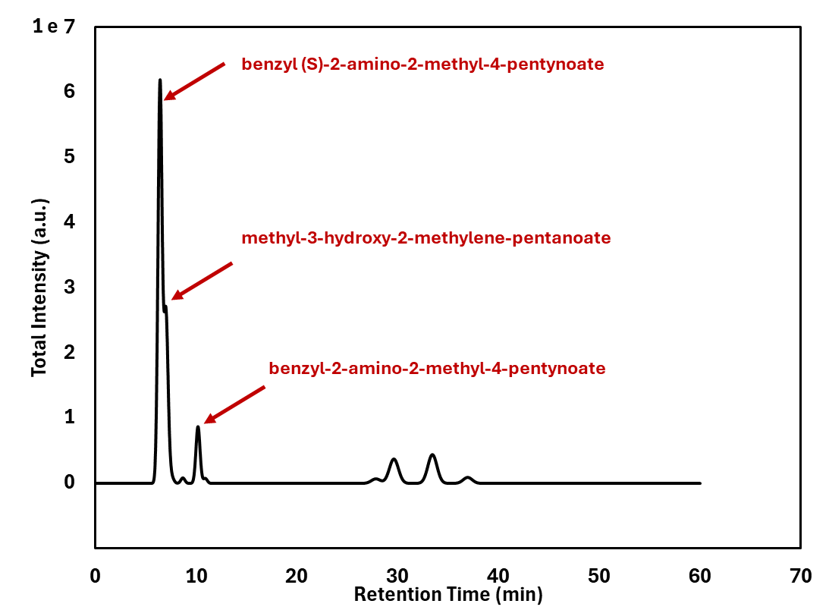
(a) (b)
(c) (d)
Figure 3: TIC overlay of produced bio-oils at 500 °C with various ZnO loadings; (a) 0 g, (b) 3 g, (c) 5 g, (d) 7 g.
While GC–MS trends alone cannot fully qualify a fuel (they do not measure water, acidity, viscosity, stability, or heating value), they provide a chemically meaningful proxy: a shift toward earlier/mid-RT components and attenuation of late heavy tails is commonly associated with improved “fuel-like” handling and upgrading behavior (Bergvall et al., 2024). Nevertheless, raw fast-pyrolysis bio-oil generally remains challenging as a direct drop-in transportation fuel because it typically has high oxygen content, high acidity, high viscosity, and lower calorific value relative to petroleum fuels, often requiring stabilization and hydrotreating (or other upgrading) before use in engines or refineries (Carrasco Díaz et al., 2024).Taken together, the present GC–MS results suggest that (i) at 500 °C, ZnO loading has a non-linear effect on quality, with intermediate loading giving the most distributed TIC (most “upgraded” in this chromatographic sense), and (ii) increasing severity from 500 to 600 °C (control oils) yields a more distributed, earlier-eluting profile consistent with a shift toward lighter volatiles—both of which are directionally favorable for downstream fuel upgrading, even though additional property measurements (water, TAN/acidity, viscosity, stability, HHV) and/or upgrading steps remain necessary before fuel deployment.
  - Conclusions
This study confirms that jojoba meals can be effectively valorized through fast pyrolysis and that ZnO loading and temperature are key operating levers controlling bio-oil yield and composition. At 500 °C, bio-oil yield increased from 16.6–16.8 wt% at 0–3 g ZnO to a maximum of 26.6 wt% at 5 g ZnO, then decreased to 22.2 wt% at 7 g ZnO, demonstrating a clear optimum catalyst-to-biomass ratio rather than a monotonic catalyst effect. Increasing temperature to 600 °C under ZnO-free operation further increased bio-oil yield to 33.4 wt%, highlighting the strong role of thermal severity in enhancing condensable production under the studied configuration.
At 500 °C, the intermediate catalyst condition produced a more distributed chromatographic profile (reduced dominance of a few peaks) compared with both the non-catalytic control and the highest ZnO loading, consistent with more favorable in-situ vapor upgrading during pyrolysis. In the temperature comparison, the 600 °C ZnO-free bio-oil exhibited stronger early/mid-retention contributions and lower top-peak dominance relative to the 500 °C control, consistent with enhanced cracking toward lighter volatiles. Collectively, these results indicate that the best balance among the catalytic 500 °C cases occurs at 5 g ZnO, while 600 °C maximizes bio-oil yield in the non-catalytic baseline. Future work will (i) extend the temperature study to ZnO-assisted pyrolysis at 600 °C (e.g., 3–7 g ZnO) to determine whether catalyst-assisted upgrading and yield trends persist at higher severity, and (ii) conduct the socio-impact assessment quantitatively once the process is scaled-up, enabling robust measurement of employment, value-chain, and local-economic impacts beyond the present qualitative assessment, (iii) hazard analysis and safety studies, and (iv) analyze the pyrolysis gas and the ZnO catalyst powder in terms grain size and purity.
Acknowledgments
This work is part of “Sustainable Biomass Conversion into Bioenergy through Pyrolysis (PyroBioFuel)” project, funded under the Europe–Africa Research and Innovation Programme on Renewable Energy (LEAP-RE).
References
Bergvall N., Cheah Y.W., Bernlind C., 2024, Upgrading of fast pyrolysis bio-oils to renewable hydrocarbons using slurry- and fixed bed hydroprocessing, Fuel Processing Technology, 253, 108009.
Carrasco Díaz A., Abdelouahed L., Brodu N., Montes-Jiménez V., Taouk B., 2024, Upgrading of Pyrolysis Bio-Oil by Catalytic Hydrodeoxygenation, a Review Focused on Catalysts, Model Molecules, Deactivation, and Reaction Routes, Molecules, 29(18), 4325.
Chong Y.Y., Thangalazhy-Gopakumar S., Ng H.K., Lee L.Y., Gan S., 2019, Effect of oxide catalysts on the properties of bio-oil from in-situ catalytic pyrolysis of palm empty fruit bunch fiber, Journal of Environmental Management, 247, 38–45.
El-Anany A.M., 2007, Nutritional, Biochemical and Histopathological Studies on Jojoba Protein Isolate, Brazilian Journal of Food Technology (Braz. J. Food Technol.), 10(3), 198–204.
El Bari H., Fanezoune C.K., Dorneanu B., Arellano-Garcia H., Majozi T., Elhenawy Y., Bayssi O., Hirt A., Peixinho J., Dhahak A., Gadalla M.A., Khashaba N.H., Ashour F.H., 2024, Catalytic fast pyrolysis of lignocellulosic biomass: Recent advances and comprehensive overview, Journal of Analytical and Applied Pyrolysis, 178, 106390.
IRENA, 2023, Agricultural residue-based bioenergy: Regional potential and sustainability considerations, International Renewable Energy Agency, https://www.irena.org/-/media/Files/IRENA/Agency/Publication/2023/Nov/IRENA_Agricultural_residue_bioenergy_2023.pdf accessed 28.02.2026.
Khashaba N.H., Abdelsalam N.F., Elazab H.A., Gadalla M.A., Majozi T., Ashour F.H., 2026, Comparative catalytic pyrolysis of wheat straw for enhanced bio-oil production, Biomass and Bioenergy, 210, 109097.
Nokkosmäki M.I., Kuoppala E.T., Leppämäki E.A., Krause A.O.I., 2000, Catalytic conversion of biomass pyrolysis vapours with zinc oxide, Journal of Analytical and Applied Pyrolysis, 55(1), 119–131.
Ravindran, N., Singh, S. K., & Singha, P., 2025. Sustainable valorization of jojoba oilcake: Pressing method-dependent protein stability and functionality for food applications. Biomass and Bioenergy, 194, 107660.
Reza M.S., Iskakova Z.B., Afroze S., Kuterbekov K., Kabyshev A., Bekmyrza K.Z., Kubenova M.M., Bakar M.S.A., Azad A.K., Roy H., et al., 2023, Influence of Catalyst on the Yield and Quality of Bio-Oil for the Catalytic Pyrolysis of Biomass: A Comprehensive Review, Energies, 16(14), 5547.
Rowland, S. M., Martinez, R., Wrasman, C. J., Iisa, K., Nimlos, M. R., & Griffin, M. B., 2024. Thermal reactivity of bio-oil produced from catalytic fast pyrolysis of biomass. Energy & Fuels, 38(20), 19626-19638.
Singh, R., Chakinala, N., Mohanty, K., & Chakinala, A. G. , 2023. Catalytic upgrading of biomass pyrolysis vapors for selective production of phenolic monomers over metal oxide modified alumina catalysts. Journal of Environmental Chemical Engineering, 11, 111518
Sun W., Yan Y., Wei Y., Ma J., Niu Z., Hu G., 2025, Catalytic Pyrolysis of Biomass: A Review of Zeolite, Carbonaceous, and Metal Oxide Catalysts, Nanomaterials, 15(7), 493.
Ungureanu N., Vlăduț N.-V., Biriș S.-Ș., Gheorghiță N.-E., Ionescu M., 2025, Biomass Pyrolysis Pathways for Renewable Energy and Sustainable Resource Recovery: A Critical Review of Processes, Parameters, and Product Valorization, Sustainability, 17(17), 7806.

