 CHEMICAL ENGINEERING TRANSACTIONS  VOL. xxx, 2026 | A publication of  
The Italian Association
of Chemical Engineering
Online at www.cetjournal.it

Guest Editors: Valerio Cozzani, Bruno Fabiano, Genserik Reniers
Copyright © 2026, AIDIC Servizi S.r.l.
ISBN 979-12-81206-xx-x; ISSN 2283-9216

CFD Evaluation of Hydrogen Dispersion and Flammability Risks in Underground Car Parks
Paola Russo^{a,*}, Maria Grazia Meoª, Michele Mazzaro^{b,}*
ª Dipartimento di Ingegneria Chimica Materiali Ambiente, Sapienza Università di Roma, via Eudossiana 18, 00184 Roma, Italia
^{b} Corpo Nazionale dei Vigili del Fuoco, Direzione Regionale VV.F. Campania, via Del Sole, 10, 80138 Napoli, Italia
* paola.russo@uniroma1.it
Growing international concern over environmental sustainability, together with the urgent need to reduce dependence on carbon-based energy systems, has intensified interest in hydrogen as a flexible and clean energy carrier. In the transportation sector, hydrogen fuel cell vehicles are regarded as a promising solution for achieving low-emission mobility. Nevertheless, the deployment of hydrogen technologies raises significant safety concerns, primarily due to hydrogen’s wide flammability range (4-75% v/v), which necessitates rigorous risk management strategies, especially in enclosed environments such as underground parking garages, where limited ventilation and restricted dispersion may lead to the accumulation of flammable hydrogen-air mixtures.
In this study, computational fluid dynamics (CFD) simulations were conducted to analyse hydrogen dispersion and associated flammability risks in an underground car park. Accidental hydrogen release from a 700-bar onboard storage tank was simulated in an underground parking garage of a residential building (floor area 435 m²) comprising 15 enclosed garage units. The results indicate that natural ventilation strategies, even when implemented with vent areas exceeding current national code requirements, may be insufficient to adequately control and mitigate hydrogen accumulation. These findings highlight the need to revise to existing safety guidelines, both with regard to the adoption of alternative ventilation solutions and the implementation of dedicated parking strategies for hydrogen-powered vehicles.
  - Introduction
The global transition towards low-carbon energy systems has placed hydrogen at the centre of numerous national and international decarbonisation strategies. As a versatile energy carrier, hydrogen offers significant advantages in terms of energy density and zero direct emissions at the point of use, making it particularly attractive for heavy-duty transport and fuel cell electric vehicles (FCEVs). Several European and Asian countries have already deployed or are actively planning hydrogen refuelling infrastructure to support the adoption of FCEVs (Molkov, 2012). In parallel, the growing residential use of FCEVs raises critical questions about the safety of hydrogen storage in confined spaces, particularly underground parking garages attached to residential buildings.
Hydrogen’s unique physical and chemical properties make its safe management in confined environments a non-trivial challenge. Its wide flammability range (4–75% v/v) and low ignition energy (0.017 mJ) significantly exceed those of conventional hydrocarbon fuels, such as natural gas or gasoline vapour (Molkov, 2012). Moreover, hydrogen’s low density and high diffusivity favour rapid buoyant dispersion in open or well-ventilated environments; however, in enclosed spaces, these same properties can lead to the formation of stratified flammable layers near the ceiling, which may persist for extended periods if ventilation is inadequate.
The risk of accidental hydrogen release in underground parking garages is particularly associated with the activation of the thermal pressure relief device (TPRD), a mandatory safety component installed on onboard high-pressure storage tanks (typically at 350 or 700 bar). In the event of fire exposure or abnormal heating, the TPRD vents hydrogen from the tank to prevent catastrophic failure. However, an unintended or spurious activation may result in a sustained high-momentum hydrogen jet, directed in a geometry-dependent manner within an enclosed space, potentially leading to flammable cloud accumulation and, ultimately, to a fire or explosion hazard (Shentsov et al., 2023).
Computational fluid dynamics (CFD) has established itself as a powerful and widely adopted tool for the quantitative assessment of hydrogen dispersion and associated hazards in complex geometries. Several studies have demonstrated the capability of CFD models to reproduce experimental hydrogen release and dispersion behaviour in tunnels and enclosed car parks with good accuracy (Giannissi et al., 2022). In particular, volumetric source approaches, combined with validated turbulence models such as the buoyancy-modified RNG k-ε model, have proven effective in representing the near-field and far-field dynamics of under-expanded hydrogen jets at reduced computational cost (Shentsov et al., 2023).
Despite the growing body of literature on hydrogen safety in road tunnels (Molkov et al., 2023) and open car parks (Dai et al., 2024; Hussein et al., 2020; Li et al., 2025; Russo et al., 2025), relatively few studies have specifically addressed the scenario of hydrogen dispersion in underground residential parking garages with compartmentalised layouts, which represent a realistic and widespread typology in European urban environments. In this context, the current Italian national fire prevention code (Italian Ministry of the Interior, 2022) prescribes natural ventilation requirements for parking garages based on floor-area ratios originally developed for gasoline and LPG-fuelled vehicles, whose hazard profiles differ substantially from those of hydrogen-powered vehicles.
The present work addresses this gap by applying CFD simulations to a real underground parking garage of a residential building in Italy, with the aim of evaluating the influence of different ventilation conditions and vehicle parking orientations on hydrogen concentration distributions and flammability hazards following an accidental TPRD release from a 700-bar onboard storage system. The blowdown dynamics were calculated using the analytical model proposed by Molkov (2012) in conjunction with the e-Laboratory online tools, and the hydrogen dispersion was subsequently simulated using the ANSYS CFX code with a volumetric source approach (Shentsov et al., 2023). The results are interpreted in terms of the temporal evolution and spatial extent of flammable clouds, with particular attention to the volumes supporting downward flame propagation and the most hazardous concentration ranges associated with explosive deflagration.
  - CFD simulations
The modelled scenario is a real underground parking garage of a residential building (Figure 1), with a floor area of 435 m², a ceiling height of approximately 3 m (total volume: about 1.250 m³), comprising 15 enclosed garage units and several service and technical rooms. The garage entrance (net area:15.7 m²) is permanently open, and two narrow air interspaces (0.80 m wide) border the external perimeter along the driving aisle.
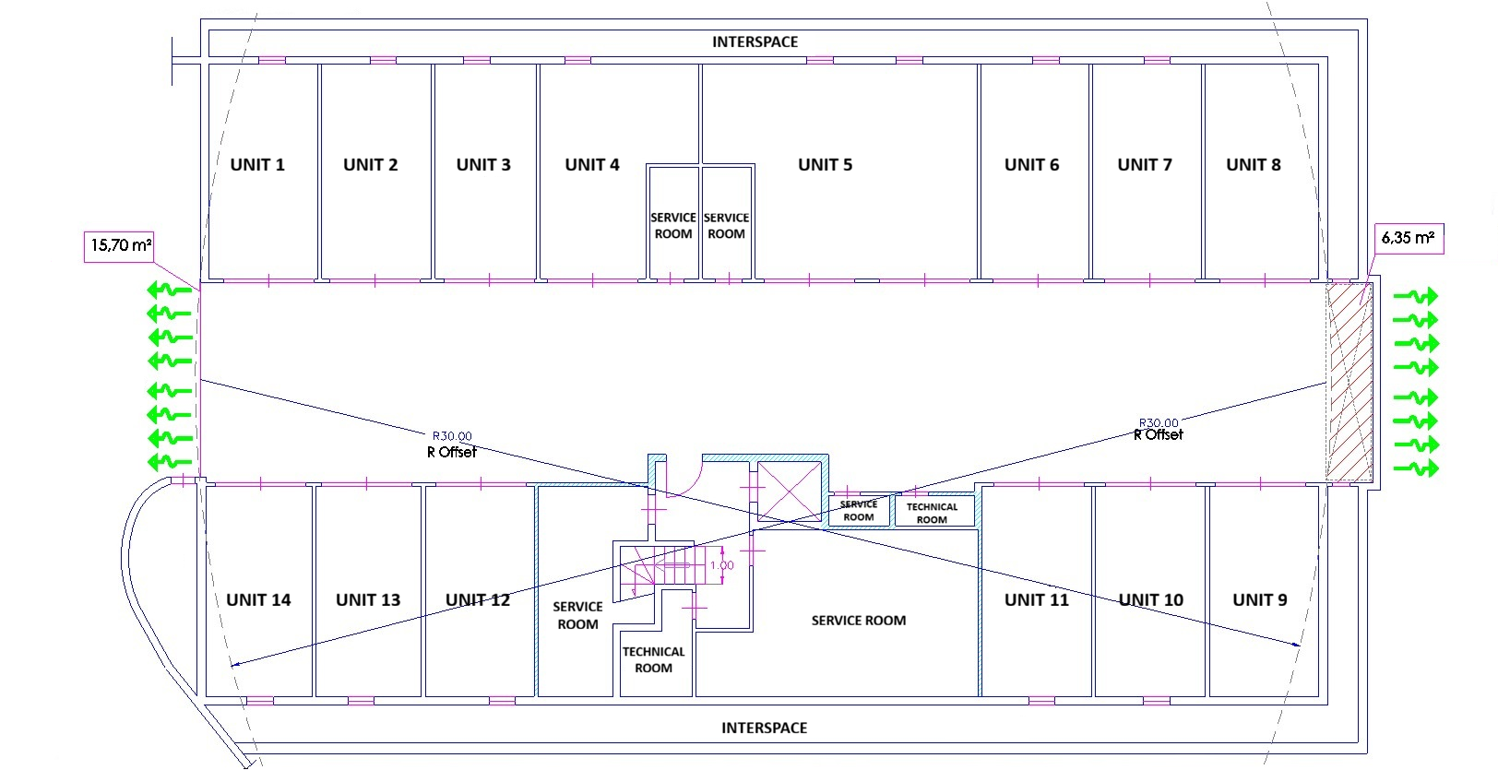
Figure 1. Layout of the underground garage and details of the current venting openings.
In accordance with the current Italian national fire prevention code (2022), the garage is equipped with natural ventilation through the entrance and a ceiling smoke-and-heat venting grille (vent area: 6.35 m²) for a total permanently open vent area of 22.05 m². This exceeds the minimum national requirements, which prescribe a total opening area of 2.5–4% of the floor area (depending on fire load), with at least 10% permanently open. Each enclosed garage unit is additionally required to have high- and low-level openings with a net free area of at least 1/100 of the unit's gross floor area.
The release scenario was modelled based on a standard sedan passenger vehicle, simplified as a rectangular prism (5 m x 2 m x 1.5 m, wheelbase 3 m, track width 1.5 m), positioned 0.2 m above ground level. The hydrogen storage system was configured with a 62.4 L Type IV composite tank pressurized to 70 MPa, containing approximately 2.5 kg of hydrogen at an initial temperature of 288 K. The tank was modelled at full capacity. The TPRD (2 mm diameter orifice) was positioned beneath the vehicle near the rear left wheel, directing the release downward at 45° toward the rear.
Blowdown dynamics were calculated using the analytical model by Molkov (2012) via the e-Laboratory online tools. This model estimates the under-expanded jet formed during release and its expansion to atmospheric pressure, providing the mass flow rate through an effective notional nozzle. The blowdown process lasts approximately 200 s, with the transition from under-expanded to expanded jet occurring at ~159 s, by which point ~98% of the stored hydrogen has been released. A volumetric source approach (Shentsov et al., 2023) was then employed in the CFD simulations to model the hydrogen leak, supplying source terms for mass, momentum, energy, and turbulence quantities based on notional nozzle conditions. The volumetric source was set as a fixed cube with side area equal to the notional nozzle area at the start of blowdown.
Simulations were carried out using ANSYS CFX (ANSYS, 2024). Preliminary simulations under standard conditions identified garage unit n°11 (floor area ~16 m², volume ~50 m³) as the location with the poorest ventilation in the driving aisle vicinity, and it was therefore selected as the vehicle parking location. Two ventilation conditions were examined: (i) unit n°11 closed by a shutter with high- and low-level openings (total net free area ~0.17 m²); (ii) unit n°11 fully open. For each condition, the vehicle was modelled in both head-first and reverse parking orientations.
The computational domain (Figure 2b) includes garage unit n°11, the driving aisle, and the air interspaces. An unstructured tetrahedral mesh was used, refined near vents, shutter openings, the vehicle, and the release direction, with cell sizes ranging from 0.02 to 0.5 m and a volumetric source refinement of 0.015 m (Shentsov et al. 2023). The final mesh comprised approximately 315,000 cells (closed unit) and 245,000 cells (open unit).
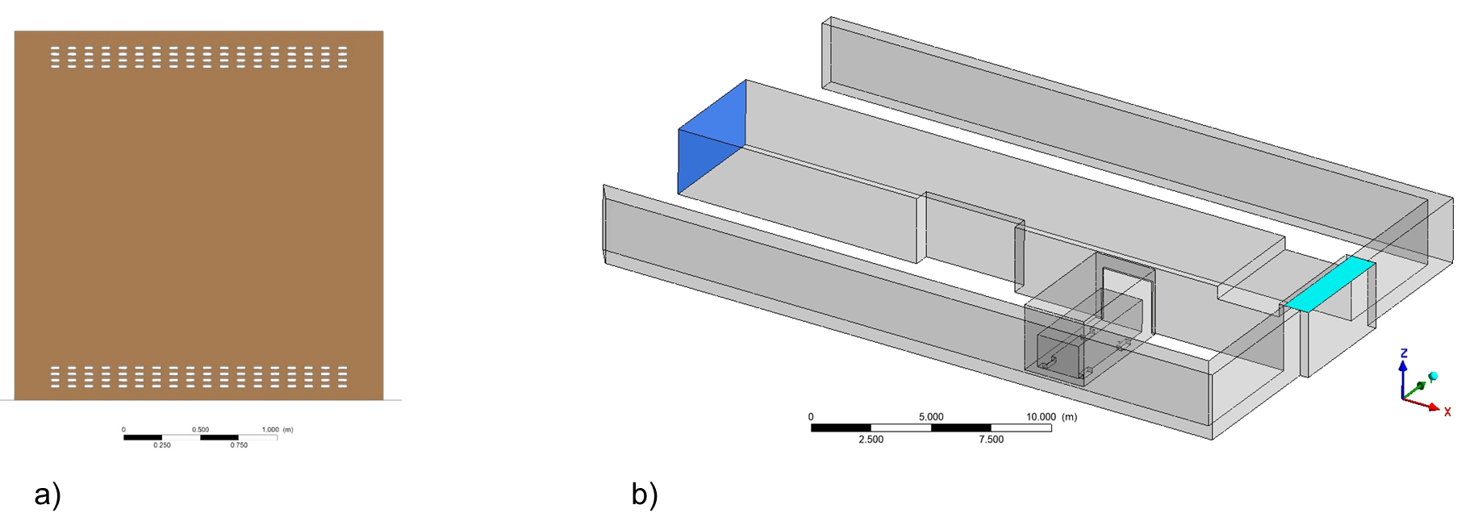
Figure 2. a) Upper and lower openings in the shutter of the garage unit; b) Computational domain.
Turbulence was modelled using the Buoyancy-Modified RNG k-ε model. Spatial discretization employed the high-resolution advection scheme, and time discretization used the second-order backward Eulerian scheme, with a variable time step ranging from 0.001 to 1 s and convergence residuals below 10⁻⁵. The domain was initialized with air at 101,325 Pa and 293 K (RH = 90%), and hydrogen dispersion was simulated over 15 minutes from the start of the release.
  - Results
The temporal evolution of the flammable hydrogen cloud (4–75% vol) for all simulated scenarios is shown in Figures 3–6: closed garage unit with head-first (Figure 3) or reverse (Figure 4) parking, and open garage unit with head-first (Figure 5) or reverse (Figure 6) parking.
For closed garage unit (Figures 3–4), the garage unit volume is fully occupied by a flammable cloud within approximately 30 s. The cloud exiting through the shutter openings stratifies below the ceiling of the driving aisle and progressively dilutes over time. After 10 min, the residual cloud disperses slowly, remaining stratified in the upper portion of the unit. Parking orientation (head-first vs. reverse) shows no significant influence on cloud evolution or duration.
For open garage unit (Figures 5–6), the flammable cloud is not confined and exits the unit more rapidly from the earliest stages of release, resulting in faster overall dispersion. With reverse parking (Figure 6), the release is directed toward the garage wall, keeping the cloud stratified below the ceiling; within 5 min, the flammable cloud is confined only to the ceiling area above the unit's lintel. With head-first parking (Figure 5), the release jet is directed forcefully outward into the driving aisle, with the cloud propagating rapidly along the ground and reaching the opposite garage units within 2 s. Hydrogen subsequently fills the entire aisle cross-section, disperses upward, and also reaches the building air interspaces. After approximately 5 min, concentrations throughout the garage fall below the lower flammability limit.
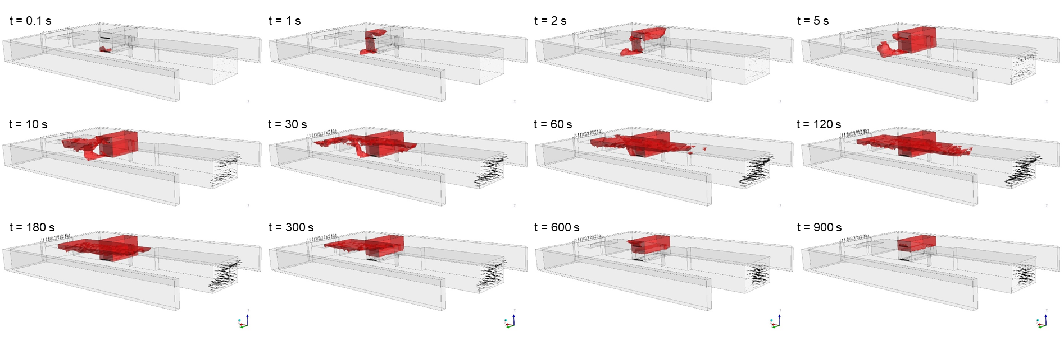
Figure 3. Time evolution of the flammable hydrogen cloud (4–75% vol) in the closed garage unit, vehicle parked head-first.
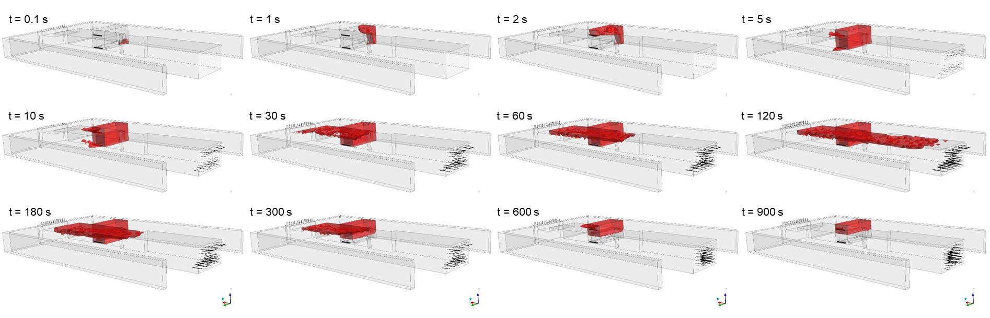
Figure 4. Time evolution of the flammable hydrogen cloud (4–75% vol) in the closed garage, vehicle parked in reverse.
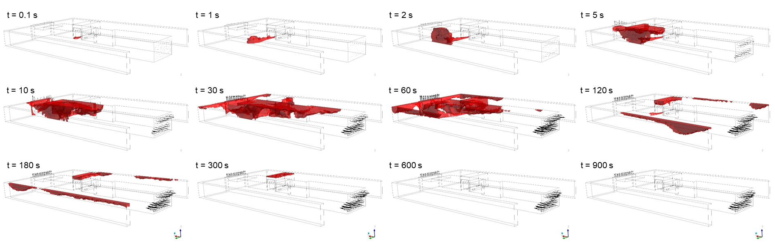
Figure 5. Time evolution of the flammable hydrogen cloud (4–75% vol) in the open garage unit, vehicle parked head-first.
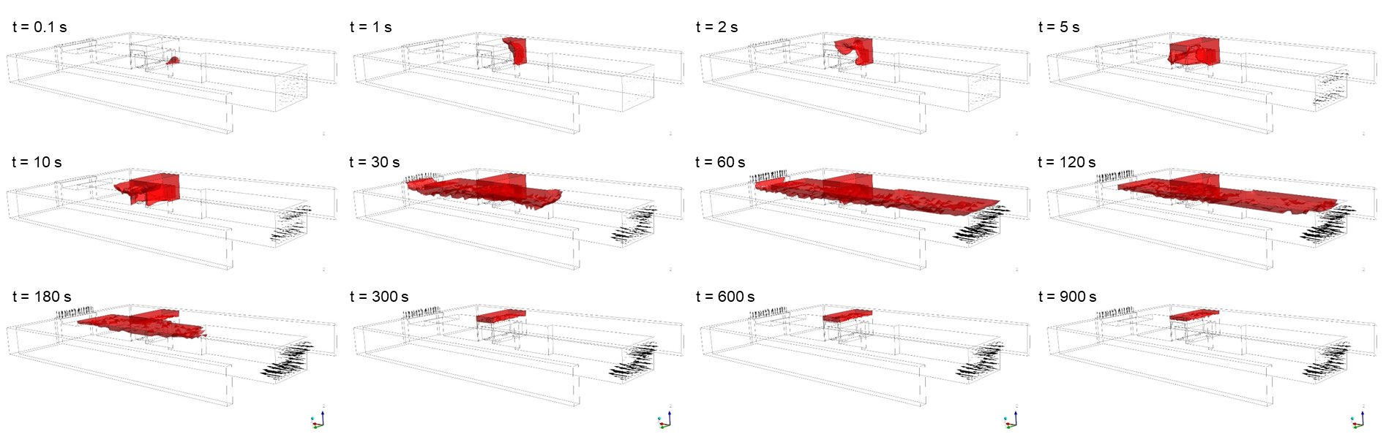
Figure 6. Time evolution of the flammable hydrogen cloud (4–75% vol) in the open garage unit, vehicle parked in reverse.
The volumetric ratio of the flammable cloud relative to the total garage volume (Figure 7) confirms these trends. In the closed unit scenarios, peak volumetric ratios of ~5.5% (head-first, ~100 s) and ~6.5% (reverse, ~120 s) are reached, decreasing to ~2% after 10 min. In the open unit scenarios, the head-first case reaches a peak of ~13.4% at ~30 s, returning to zero within ~5.5 min, while the reverse case peaks at ~9.7% at ~50 s, falling below 1% after 5 min.
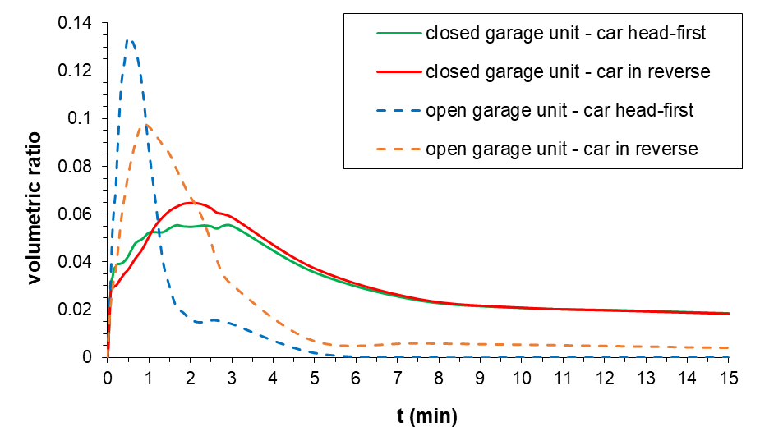
Figure 7. Volumetric ratio of the hydrogen flammable cloud (4-75%vol) over time.
Figure 8 reports the maximum volume of hydrogen cloud capable of supporting downward flame propagation (10–75% vol), which requires concentrations exceeding 10% vol (Giannissi et al., 2022). This risk is negligible for the open unit with head-first parking. In all other scenarios, concentrations above 10% vol remain confined to the garage unit and the immediately adjacent portion of the driving aisle.
Figure 9 shows the maximum volume of the most hazardous concentration range (32–42% vol), associated with high flame speeds and explosion risk (Giannissi et al., 2022). In open unit scenarios, explosion risk is negligible and limited to the very early stage of release. In closed unit scenarios, however, a significant explosion hazard persists.
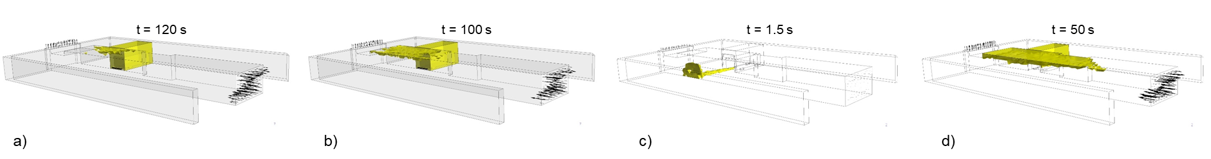
Figure 8. Maximum volume of the flammable hydrogen cloud supporting downward flame propagation (10-75%vol) for the four simulated scenarios: a) closed unit, head-first parking; b) closed unit, reverse parking; c) open unit, head-first parking; d) open unit, reverse parking.
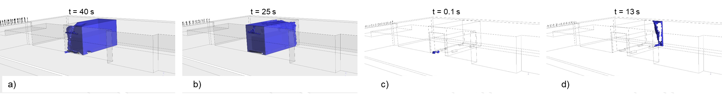
Figure 9. Maximum volume of the hydrogen cloud in the most hazardous concentration range (32-42%vol) for the four simulated scenarios: a) closed unit, head-first parking; b) closed unit, reverse parking; c) open unit, head-first parking; d) open unit, reverse parking.
  - Conclusions
This study investigated the hydrogen dispersion hazards arising from an accidental TPRD release in a real underground residential parking garage through CFD simulations performed with ANSYS CFX. Four scenarios were considered, combining two garage unit configurations (closed with louvered shutter vs. open) and two vehicle parking orientations (head-first vs. reverse).
When the garage unit is closed by a shutter, the flammable hydrogen cloud (4–75% v/v) occupies the entire enclosed volume within approximately 30 s of the start of the release. The volumetric ratio of the flammable cloud relative to the total garage volume reaches peak values of approximately 5.5% (head-first parking) and 6.5% (reverse parking) at around 100 and 120 s, respectively, and remains above 2% even after 10 min. Dangerous concentration ranges supporting explosive deflagration (32–42% v/v) persist within the garage unit throughout a significant fraction of the blowdown duration, indicating a severe explosion risk under these conditions.
When the garage unit is open, dispersion is considerably faster and more extensive. With the vehicle parked in reverse, the flammable cloud reaches a maximum volumetric ratio of approximately 9.7% at about 50 s and falls below 1% within 5 min. The most critical scenario is that of the open garage unit with a forward-parked vehicle: the hydrogen jet is directed forcefully outwards along the ground, the flammable cloud reaches a maximum volumetric ratio of approximately 13.4% at about 30 s, and propagates throughout the entire garage cross-section, including the adjacent building air interspaces; however, the cloud fully dissipates below the lower flammability limit within approximately 5.5 min, with negligible explosion risk.
Overall, the results demonstrate that the natural ventilation provisions currently required by the Italian national fire prevention code (2022) — which stipulate a total permanently open vent area of 2.5–4% of the floor area — are insufficient to adequately mitigate hydrogen accumulation in the most hazardous scenarios. Even in the analysed garage, which already exceeds the minimum code requirements, the simulations reveal critical flammability conditions in closed garage units. These findings strongly suggest that current safety regulations need to be revised to specifically address hydrogen-powered vehicles, including provisions on minimum ventilation requirements, the adoption of forced ventilation or active detection systems, and the implementation of dedicated parking strategies (e.g., mandatory reverse parking) for FCEVs in underground garages.
References
ANSYS, 2024, ANSYS CFX Release 2024 R2.
Dai J., Yang S., Yang Y., Fang Q., 2024, Research on the consequences of hydrogen leakage and explosion accidents of fuel cell vehicles in underground parking garages, International Journal of Hydrogen Energy, 77, 1296-1306.
e-Laboratory website <elab.hysafer.ulster.ac.uk> accessed 09.12.2025.
Giannissi S.G., Venetsanos A.G., Koutsourakis N., Tolias I.C., Bernard-Michel G., Studer E., Forero D., Martin M., Sauzedde F., Rattigan W., Moodie K., Pursell M., Xu Z., Grune J., Gaathaug A.V., Shentsov V., Cirrone D., Kashkarov S., Makarov D., Molkov V., 2022, Deliverable D2.3. Final report on analytical, numerical and experimental studies on hydrogen dispersion in tunnels, including innovative prevention and mitigation strategies, HyTunnel project <hytunnel.net/wordpress/wp-content/uploads/2022/09/HyTunnel-CS_D2.3-Final-report-on-dispersion-in-tunnels.pdf> accessed 09.02.2026.
Hussein H., Brennan S., Molkov V., 2020, Dispersion of hydrogen release in a naturally ventilated covered car park, International Journal of Hydrogen Energy, 45 (43), 23882-23897.
Italian Ministry of the Interior - Department of Fire, Public Rescue and Civil Defence - Central Directorate for Technical Prevention and Safety, 2022, Fire Prevention Code - Coordinated text of Annex I to Ministerial Decree of 3 August 2015 - Edition in force from 7 July 2022, Italy (in Italian).
Li J., Liu L., Bai W., Wu B., Dong J., Luo C., Tong L., 2025, Simulation and safety analysis of hydrogen leakage for hydrogen-powered vehicles in an enclosed parking garage, International Journal of Hydrogen Energy, 158, 150458.
Molkov V., 2012, Fundamentals of Hydrogen Safety Engineering I. BookBoon.
Molkov V., Kashkarov S., Sivaraman S., Makarov D., 2023, Hazards and Associated Risks of Hydrogen Vehicles in Underground Traffic Infrastructure, Chemical Engineering Transactions, 105, 43-48.
Russo P., Meo M.G., Mazzaro M., 2025, Safety Assessment of Hydrogen Release in Underground Car Parks: a CFD Study on Ventilation Effectiveness, International Conference on Hydrogen Safety 2025, September 22-26, Seoul, Republic of Korea, Paper ID272.
Shentsov V., Cirrone D., Makarov D., 2023, Effect of TPRD diameter and direction of release on hydrogen dispersion and jet fires in underground parking, Journal of Energy Storage, 68, 107771.

