 CHEMICAL ENGINEERING TRANSACTIONS  VOL. xxx, 2026 | A publication of  
The Italian Association
of Chemical Engineering
Online at www.cetjournal.it

Guest Editors: Valerio Cozzani, Bruno Fabiano, Genserik Reniers
Copyright © 2026, AIDIC Servizi S.r.l.
ISBN 979-12-81206-xx-x; ISSN 2283-9216

Influence of Vent Duct Shape on Explosion Propagation Behaviour of Vented Dust Explosions
Marius Bloching^{a,}*, Lorenz R. Boeck^{b} , Giacomo De Juli^{e}, Roland Bunse^{c}, Tobias Bock^{c}, Bernhard Lehner^{d}, Pavel Mach^{d}

ªREMBE® GmbH Safety + Control, Zur Heide 35, Brilon, Germany
^{b}REMBE® Inc., 9567 Yarborough Rd, Fort Mill, South Carolina, USA
^{c}REMBE® Research + Technology GmbH, Zur Heide 35, Brilon, Germany
^{d}Bühler AG, Uzwil, Gupfenstrasse 5, Switzerland
^{e}REMBE® S.rl., Via Maja 2, Brilon, 21051 Arcisate (VA), Italia

marius.bloching@rembe.de
Dust explosion venting is a common explosion protection measure. In indoor applications, vent ducts in accordance with EN 14491 (2012) are used to direct the explosion safely to the outside. Specific guidance is given in the standard how the vent duct should be designed, mandating area vent duct shape that is equivalent to the vent panel shape. According to EN 14491 guidance, rectangular vent panels should be used with rectangular vent ducts, and circular vents with circular vent ducts, respectively.
In practice, however, rectangular explosion vents are often combined with circular vent ducts allowing more economic and rigid design of the duct. This combination leads to the following differences in comparison to the combination of rectangular vents with rectangular vent ducts:
- The volume of the vent duct increases, and
- The cross-sectional area of the vent duct is larger compared to the area of explosion panel.
These deviations from EN 14491 (2012) guidance may have an influence on the properties of vented explosions.
This study investigates whether the shape of the vent duct affects the reduced explosion pressure p_{red} while comparing results to calculations according to EN 14491 (2012). Dust explosion tests were conducted for one combination of explosion volume and vent area while varying the following parameters:
- Vent duct shape;
- Vent duct length;
- Vent duct cover.
Experimental results show that the selection of vent duct cover has a significant influence on the reduced explosion pressure $p_{red}$. Overall observations show that EN 14491 (2012) not always yields conservative vent sizing guidance when adapting the shape of the vent duct within the limitations of the present study.
  - Introduction
Explosion venting using vent ducts to direct the explosion to the outside of a building is a common industry practice. Chapter 5.7 of EN 14491 (2012) gives specific guidance for the design of the vent duct, which should have similar dimensions and shape as the explosion vent panels they are connected to. Hence, rectangular vent panels are recommended to be used with rectangular vent ducts and circular vents with circular vent ducts, respectively. Industry practice shows that rectangular explosion vents are sometimes combined with circular vent ducts, allowing for a more economic and rigid design of the duct. This combination leads to larger volumes of the vent duct as well as an increase in cross-sectional duct area. No specific guidance is given in EN 14491 (2012) or NFPA 68 (2023) how such a design change may impact the explosion behaviour and reduced explosion pressure $(p_{red}$). However, it is known that secondary explosions in the vent ducts have an influence on the overall pressure development in the vessel (Bartknecht, 1993). Work by DeGood and Chathrathi (1991) also discussed the impact of additional parameters such as panel mass or weather covers. For the present study, a typical combination of explosion volume and vent duct was selected while varying the shape, length and cover of the vent duct, to systematically investigate the impact on key explosion characteristics. Experiments were conducted following the EN 14797 (2007) direct comparison method and the EN 14034 (2011) standard for determination of dust explosion characteristics. Vent area sizing was conducted using the EN 14491 (2012) approach that applies to straight pipes without bends, which is a key difference to NFPA 68 (2023) which allows the use of bends while considering them in the sizing equations.
  - Experimental methodology
Experiments were conducted in a 1.766 m³ test vessel at the REMBE® Research + Technology Center in Brilon, Germany representing a common filter volume and vent duct configuration. The test vessel was equipped with a rectangular vent measuring 420 x 520 mm². Two vent duct shapes were used in the experiments while maintaining the vent opening dimensions (Figure 1). Vent duct length and vent duct cover were altered. The vent opening was either covered with 50-µm aluminum foil representing an ideal vent cover, or with a commercial vent panel. Dust injection was accomplished using a single dust injector comprised of a 5-L compressed air reservoir with ball valve. Vessel pressure, $p$, was measured using two redundant pressure transducers. The aim of the tests was to investigate relative trends in reduced explosion pressure between the configurations considered. Repeat tests were not conducted due to scope limitations.
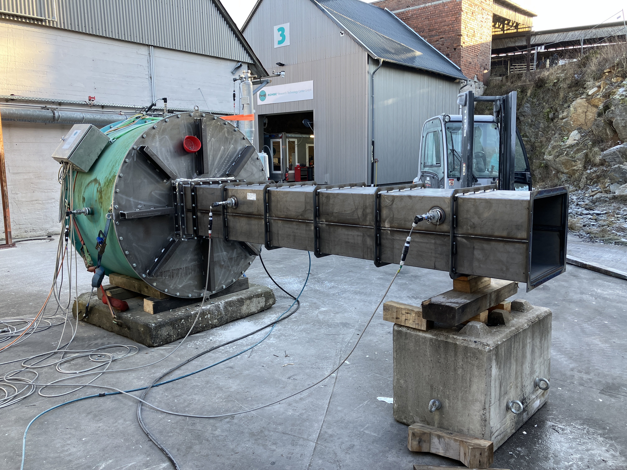 | 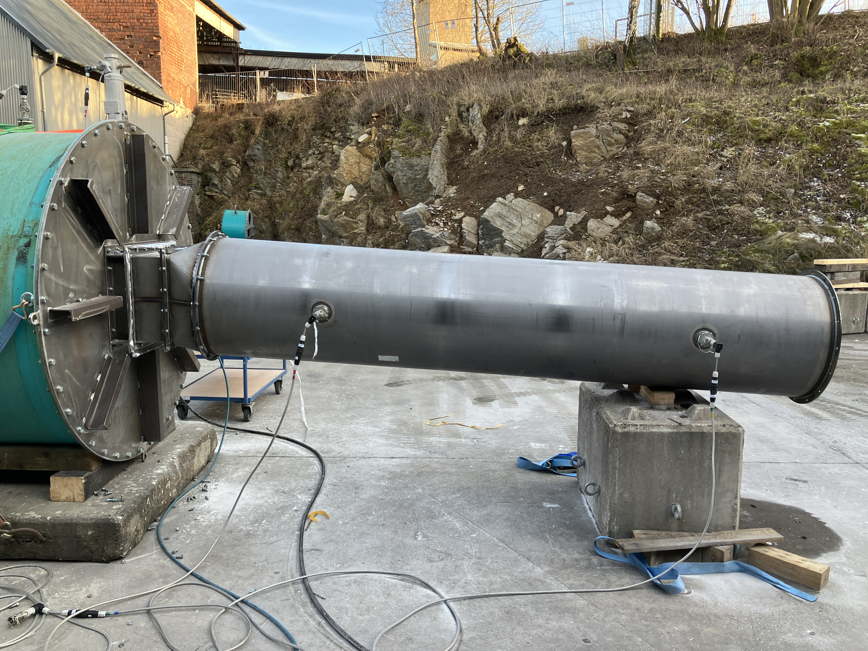
Figure 1: Experimental setup with two different vent duct shapes while maintaining dimensions of the vent opening to 420 x 520 mm²

The following test procedure was applied:
- Load dust container with pre-defined dust quantity and pressurize container with air to 20 bar-g.
- Inject dust and trigger ignition after specified delay.
- Flush vessel with air before and after each test.
The ignition delay time was selected to achieve the following deflagration index $K_{St}$:
- Corn starch (1000 g/m³): 680 ms for $K_{St}$ = 170 bar·m/s ± 12%
Vent duct shape, length, and end cover were varied between tests:
- Rectangular duct shape 420 x 520 mm² (same as the vent panel inner dimensions)
- Circular vent duct shape DN 600 with transition piece from 420 x 520 mm² to DN 600
Vent duct length
- 0.7 m (Transition piece), 3 m, 6 m, 9 m
Vent duct cover
- Open,
- Inertia free aluminum foil (p_{stat} ≤ 0.05 bar-g),
- Bird screen (mesh). Mesh size 25 mm. Wire thickness 1.4 mm
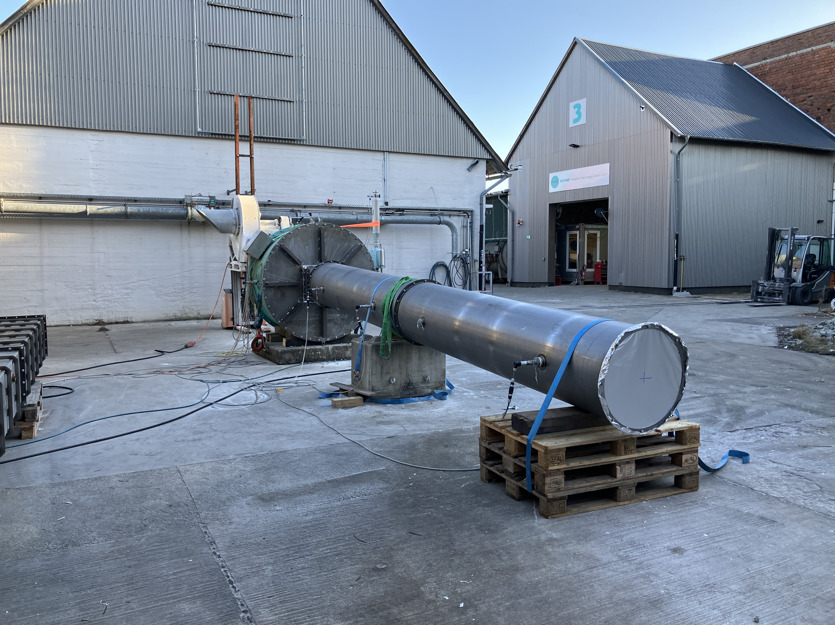 | 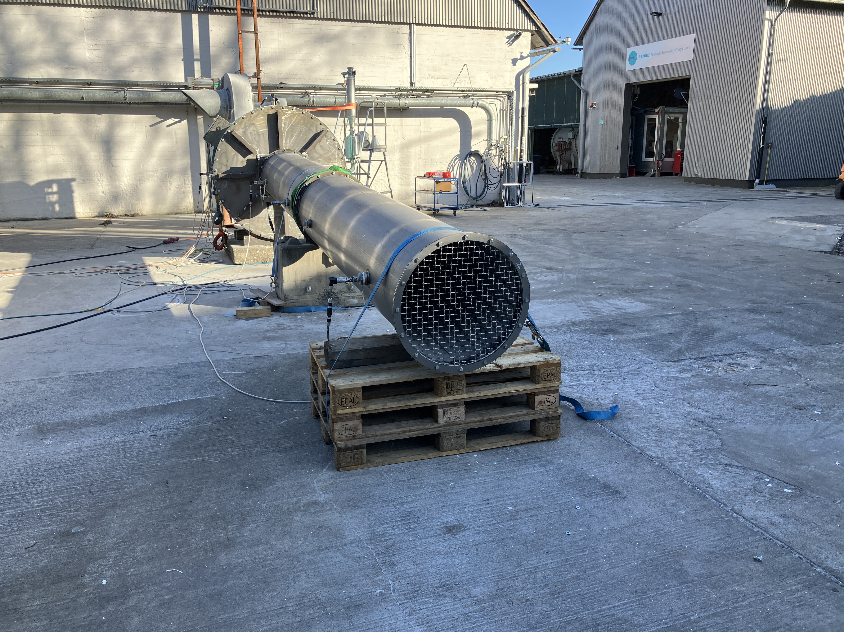
Figure 2: Experimental setup with vent duct with aluminum foil (left) and bird screen (right)
  - Experimental results and discussion
First, $K_{St}$ = 170 bar·m/s was determined via back calculation method described in EN 14491 (2012) and EN 14797 (2007), by conducting experiments without vent duct and inertia-free aluminum foil (Figure 3 left side). Results were compared to experiments with explosion vent panel EGV 420 x 520 (Figure 3 right side) determining an efficiency (EF) of approx. 75 % for the given volume, $p_{red}$ and $K_{St}$ configuration. The transition piece shown, showed no additional effects in comparison to experiments with aluminum foil.
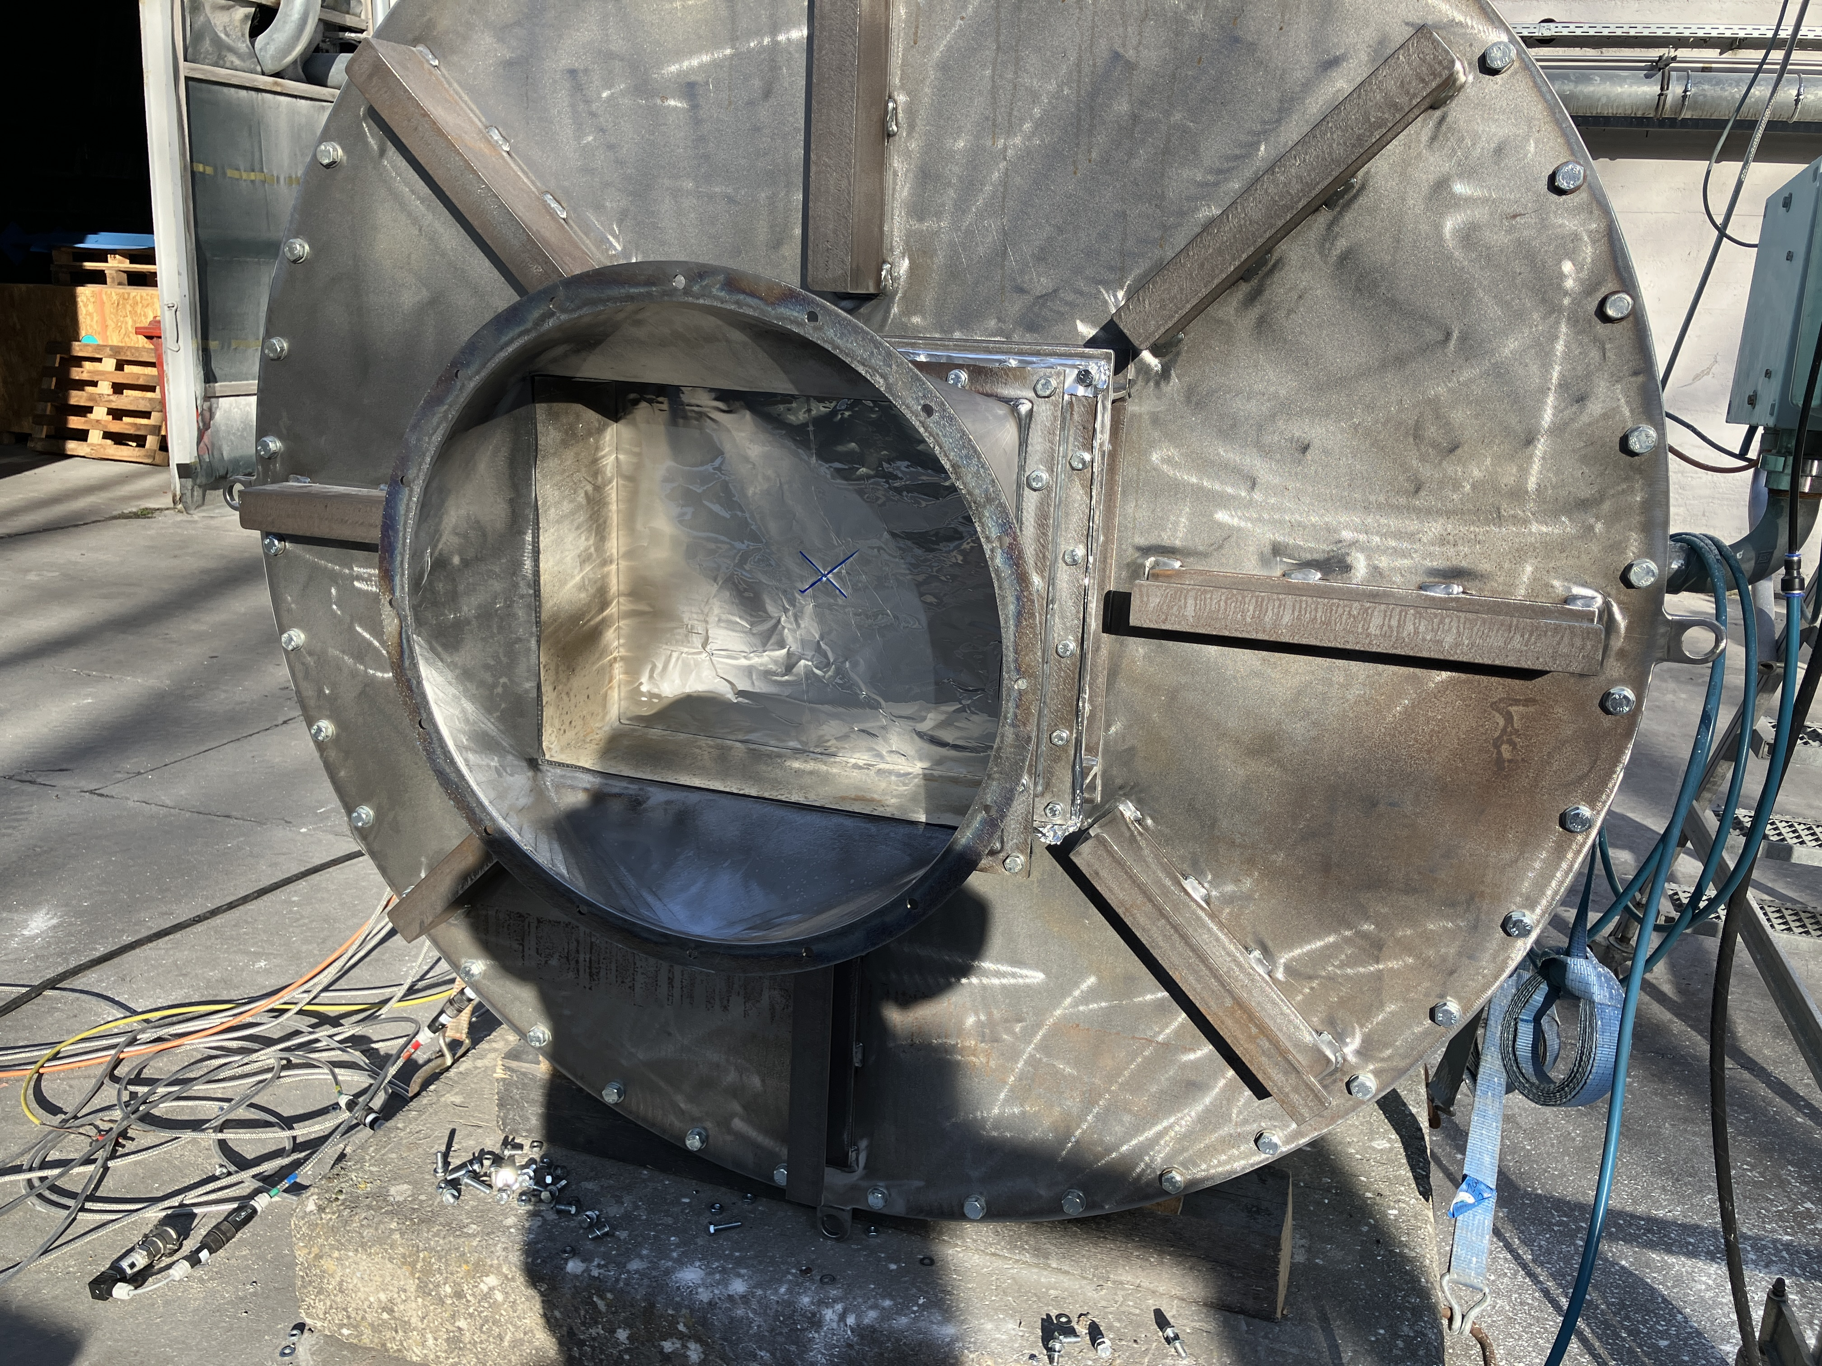 | 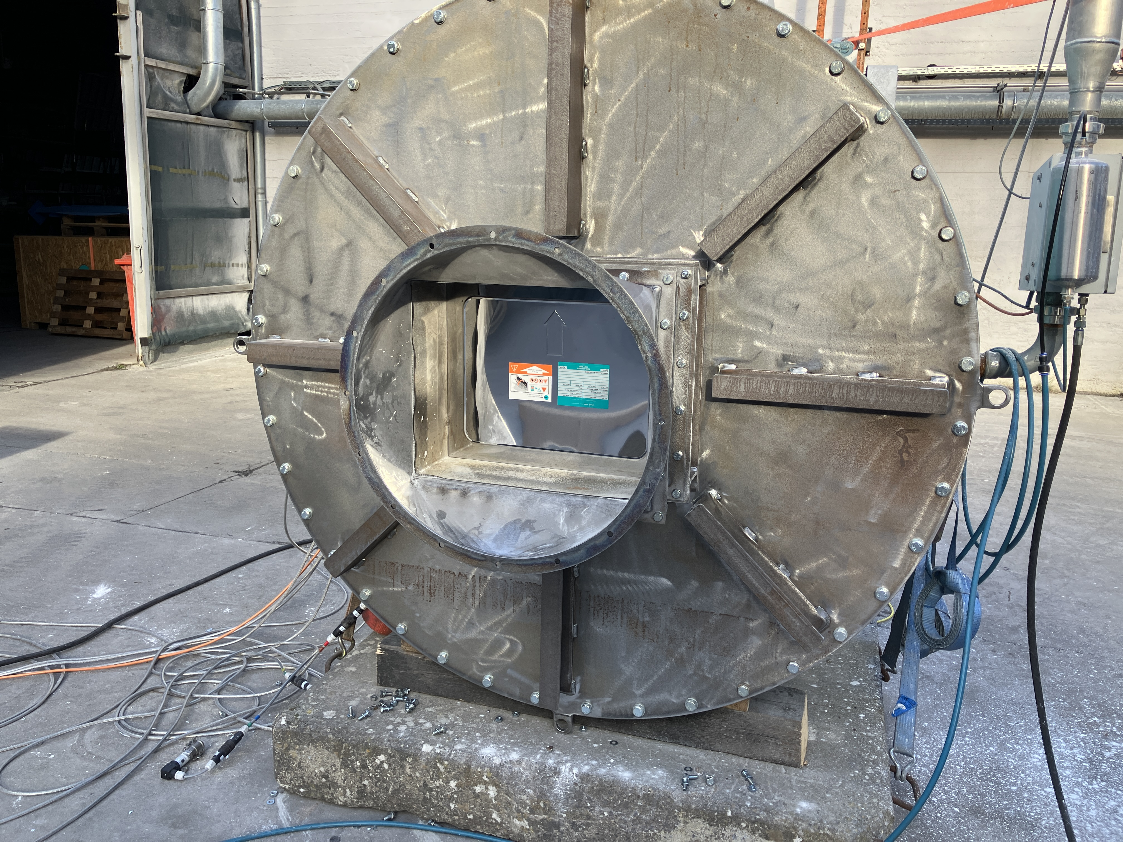
Figure 3: Experimental setup without vent duct with aluminum foil (left) and explosion vent panel EGV (right) for determination of efficiency (EF) of vent panel for the given configuration.

Following test configurations were investigated and compared to calculated $p_{red,max'}$predictions in accordance with EN 14491 (2012). Calculations were performed both assuming 100 % vent efficiency and the vent panel efficiency of 75 % determined by test.

- Vessel with explosion vent aluminum foil + no vent duct cover and varying duct shape and length
Figure 4 shows the reduced explosion pressures $p_{red}$ in the test vessel in direct comparison to the calculated $p_{red,max´}$predictions derived by EN 14491 (2012).
- Rectangular 420 x 520 mm² vent duct shape shows significantly lower pressures than predicted for both EF values.
- DN 600 vent duct shape shows higher $p_{red}$ than predicted for 100 % and 75 % EF for 6 m vent duct length.

Figure 4: Direct comparison of experimental results vs. pred,max´ predictions for experiments with explosion vent aluminum foil + no vent duct cover

- Vessel with explosion EGV + no vent duct cover and varying duct shape and length
Figure 5 shows the reduced explosion pressures $p_{red}$ in the test vessel in direct comparison to the calculated $p_{red,max´}$predictions derived by EN 14491 (2012).
- For rectangular 420 x 520 mm² vent duct shape, only one test was performed at 9 m duct length but shows significantly lower pressure than predicted for both EF.
- DN 600 vent duct shape shows good agreement with predicted $p_{red}$ for 75 % EF. 9 m vent duct length was not tested.

Figure 5: Direct comparison of experimental results vs. pred,max´ predictions for experiments with explosion vent panel EGV + no vent duct cover

- Vessel with explosion vent EGV + aluminum foil vent duct cover and varying duct shape and length
Figure 6 shows the reduced explosion pressures $p_{red}$ in the test vessel in direct comparison to the calculated $p_{red,max´}$predictions derived by EN 14491 (2012).
- Rectangular 420 x 520 mm² vent duct shape shows mostly lower pressures than predicted for both EF. For 6 m vent duct length the measured $p_{red}$ exceeds the prediction. At 9 m vent duct length the $p_{red}$ decreases compared to 6 m length.
- DN 600 vent duct shape shows good agreement with predicted $p_{red}$ for 75 % EF but also exceeds $p_{red,max´}$ predictions at 6 m vent duct length. 9 m vent duct was not tested.

Figure 6: Direct comparison of experimental results vs. pred,max´ predictions for experiments with explosion vent panel EGV + aluminum foil vent duct cover

- Vessel with explosion vent EGV + bird screen vent duct cover and varying duct shape and length
Figure 7 shows the reduced explosion pressures $p_{red}$ in the test vessel in direct comparison to the calculated $p_{red,max´}$predictions derived by EN 14491 (2012).
- Rectangular 420 x 520 mm² vent duct shape consists only of one test with 9 m length which shows lower pressures than predicted for both EF.
- DN 600 vent duct shape shows good agreement with predicted $p_{red}$ for 75 % EF but also exceeds $p_{red,max´}$ predictions at 6 m vent duct length significantly. 9 m vent duct was not tested.

Figure 7: Direct comparison of experimental results vs. pred,max´ predictions for experiments with explosion vent panel EGV + bird screen (mesh)
  - Conclusions
This study investigated how vent duct shape influences the reduced pressure of vented dust explosions for a given combination of test vessel and vent duct. Additional tested configurations included a light vent duct cover and bird screen. Key findings of this study include:
- Following the vent duct design guidance of EN 14491 yields mostly conservative results for the investigated experimental configurations.
- Transitioning from a rectangular vent to a circular vent duct tends to increase $p_{red}$in comparison to a rectangular vent duct. Potential reason for this is the increase in total duct volume at equal duct length. A more severe secondary explosion in the vent duct likely causes increased$p_{red}$ in the initiating vessel.
- In two cases with 6 m vent duct where additional vent duct covers were installed, covers led to experimental results that exceeded EN 14491 predictions. The test with 9 m duct and rectangular vent shape showed $p_{red}$ in line with the standard but still elevated in comparison to without cover.
- Even though EN 14797 considers the aluminum-foil vent duct cover used in this study as being inertia-free, the cover led to increased $p_{red}$ for all tested configurations. Potential reasons could be delayed venting of unburned material creating a more severe secondary explosion in the vent duct.
The results suggests that the vent duct design guidance of EN 14491 (2012) gives conservative results for the given test setup. Deviating from this guidance by transitioning to larger cross-sections and or covering the vent duct opening with aluminum foil tends to decrease the safety margin included in the EN 14491 (2012) equations. In cases with bird screens, sizing tends to be non-conservative. Further investigation on this setup will be done to expand the study and further substantiate individual results using repeat tests.
Acknowledgments
The authors thank Bühler AG for sharing experimental results for publication.
Nomenclature
EF – Venting device efficiency,
K_{St} – Dust deflagration index, bar·m/s
p_{red} – Reduced explosion pressure, bar-g
p_{red,max´} – Predicted reduced explosion pressure, bar-g for vent ducts
p_{stat} – Static vent burst pressure, bar-g
V – Vessel volume, m³
References
Bartknecht, W.(1993). Explosionsschutz. Heidelberg: Wolfgang Bartknecht. Springer
Boeck, L.R., Bauwens, C.R., Dorofeev, S.B., (2021). Modeling of explosion dynamics in vessel-pipe systems to evaluate the performance of explosion isolation systems. J. Loss Prev. Process. Ind. 71, 104477.
Eckhoff, R. (2003). Dust explosions in the process industries. Amsterdam: Gulf Professional Pub.
EN 14797 (2006). Explosion venting devices.
EN 14491 (2012). Dust explosion venting protective systems.
National Fire Protection Association, (2023). NFPA 68; Standard on explosion protection by deflagration venting. NFPA.

