 CHEMICAL ENGINEERING TRANSACTIONS  VOL. xxx, 2026 | A publication of  
The Italian Association
of Chemical Engineering
Online at www.cetjournal.it

Guest Editors: Valerio Cozzani, Bruno Fabiano, Genserik Reniers
Copyright © 2026, AIDIC Servizi U.R.L..
ISBN 979-12-81206-xx-x; ISSN 2283-9216

Combined Theoretical and Experimental Analysis of Dust Explosion Venting Efficiency
Lorenz R. Boeck^{a,}*, Marius Bloching^{b}
ªREMBE® Inc., 9567 Yarborough Rd, Fort Mill, South Carolina, USA
^{b}REMBE® GmbH Safety + Control, Zur Heide 35, Brilon, Germany
lorenz.boeck@rembe.us
Explosion vents represent a crucial passive explosion protection solution, distinguished by their simplicity, reliability, and cost-effectiveness. Accurate vent sizing is paramount for effective protection, with current engineering standards like NFPA 68 and EN 14491 incorporating effects including venting device efficiency—typically defined as the ratio of effective to geometric vent areas. Despite the universal physics underlying venting device performance, existing standards employ divergent methodological approaches, leading to significant variations in calculated vent area requirements. This research revisits the understanding of deflagration venting device efficiency by integrating physics-based models for vented dust deflagrations with kinetic models of vent panel response. The physics-based model is compared against established engineering equations, demonstrating efficiency trends across application parameters. The study shows how device efficiency approaches 100% under specific scenarios, particularly in large volumes with low reactivity. By emphasizing realistic explosion dynamics in modeling, this research contributes refinements to understanding deflagration vent performance and provides a path for unified incorporation of venting efficiency effects into international codes and standards.
  - Introduction

Deflagration venting remains the most widely adopted explosion mitigation strategy for industrial equipment due to its simplicity, reliability and cost-effectiveness. Central to the design of these systems is the accurate determination of the required vent area, which is governed by engineering standards such as NFPA 68 or
EN 14491 for combustible dust applications. These standards must account for venting efficiency (Ef), defined as the ratio of a device’s effective vent area (A_{E}) to its geometric area (A_{d}). This efficiency quantifies how a practical venting device, such as a hinged panel, deviates from an idealized, inertia-free membrane.

Currently, a significant methodological rift exists between international standards. The European approach for determining efficiency (EN 14797) relies on experimental large-scale tests, which can suffer from high scatter and limited repeatability and is limited to a specific range of test conditions. Conversely, the US standard
(NFPA 68) utilizes empirical correlations to account for mass inertia rather than relying on testing. These differing philosophies result in inconsistent efficiency values applied for identical venting devices and applications. As industry moves toward international harmonization (e.g., ISO 80079:50), there is a need for a unified and physically sound framework that accurately determines venting efficiencies for a wide range of application conditions and devices.

This research develops a physics-based theoretical framework for describing venting device efficiency. By integrating a state-of-the-art dust explosion model with a kinetic vent response model, we evaluate the impact of explosion dynamics, mechanical inertia, and application scaling. This physics-based approach provides a path for harmonizing international codes by emphasizing realistic interaction between combustion and mechanical deployment.
  - Physics-based Model Description
The model employed in this study integrates two distinct physical domains: the dynamics of vented dust deflagrations and the mechanical kinetics of the venting device. This approach builds upon the framework introduced in Boeck and Bloching (2026) where detailed mathematical derivations are provided.
    - Dust Deflagration Dynamics
The vented explosion is modeled using a mass-balance approach for burned and unburned mixtures, solved numerically via a Runge-Kutti method (Boeck et al., 2023).

Unlike "thin-flame" models that assume an infinitesimally thin reaction zone, this model utilizes a two-parameter combustion framework (Bauwens et al., 2024). This approach characterizes the process through:

- Turbulent Burning Velocity (S_{T}): The flame front expands spherically from a central ignition point. The velocity increases as a function of flame radius (r_{f}) due to interactions with growing turbulent length scales, reaching a maximum (S_{T,R}) at the vessel wall:

$$S_{T}=S_{T,R}{\left(\frac{r_{f}}{R}\right)}^{1/3}$$ | (1)

- Diffusion-Limited Combustion: Organic dusts typically combust according to homogeneous combustion, where oxygen diffusion and mixing with pyrolysis products, and potentially heat transfer, control the rate of reaction. The present model implements oxygen diffusion as the dominant rate-limiting mechanism, which is captured by the dimensionless parameter $χ$, representing the ratio of characteristic oxygen diffusion time to combustion time. For dusts such as cornstarch, for example, $χ≈0.12$ accurately reproduces pressure histories in closed vessels.

$$χ=\frac{τ}{R/S_{T,R}}$$ | (2)

The 2-parameter model allows for physically correct scaling of the pressure rise rate (dp/dt) across varying vessel volumes. A realistic representation of the explosion “pressure source term" is critical because the efficiency of the vent is not simply a mechanical property—it is a result of the dynamic competition between the accelerating combustion rate and the inertia-limited opening of the vent panel.
    - Mechanical Vent Panel Response
The venting device is modeled as a hinged rigid body where the opening kinetics are governed by a second-order differential equation for rotational motion. This model calculates the instantaneous opening angle $θ$ by evaluating the moment equilibrium between driving and resisting forces:

$$I\frac{d^{2}θ}{dt^{2}}=M_{\text{driving}}-M_{\text{bending}}$$ | (3)

The components of this equilibrium are defined as follows:

- Driving Moment (M_{driving}): The primary opening force is derived from the pressure differential ($∆p=p-p_{ambient}$) acting upon the geometric area A_{v} of the panel. The resulting force acts at the panel center, leading to the expression $M_{\text{dri}\text{ving}}=ΔpA_{v}\frac{L_{v}}{2}cos\left(θ\right)$, where L_{v} is the panel length perpendicular to the hinge.

- Inertial Resistance (I): The resistance due to mass is characterized by the moment of inertia. For a hinged rectangular panel, this is defined as $I=\frac{1}{3}m_{v}A_{v}L_{v}^{2}$, where m_{v} is the panel area density.

- Material Bending (M_{bending}): Counteracting moments from material deformation are integrated using elastic beam theory. The model converts the opening angle into an equivalent end deflection to determine the effective radius of panel curvature and the corresponding bending moment $M_{\text{bending}}=\frac{EI_{\text{beam}}}{R_{\text{eff}}}$.

- Plastic Deformation: When bending stresses exceed the material yield strength, the resisting moment reaches a plateau at the plastic limit.
- Effective Venting Area (A_{E}): As the panel rotates (up to a limit of 90°), the model geometrically calculates the evolving flow area formed at the side edges and the edge opposite the hinge:
$A_{E}=L_{v}\sin\left(θ\right)\left[W_{v}+L_{v}\cos\left(θ\right)\right]$. This effective area is fed back into the explosion mass-balance equations at each numerical time step, allowing for a fully coupled simulation of the vessel pressure development and the dynamic vent response.
    - Venting Efficiency Prediction
By comparing reduced pressures for vented explosions using practical venting devices and inertia-less foil, the method allows for determining the venting device efficiency. Figure 1 shows a sample calculation result for vessel and dust reactivity parameters given in the figure.

$V$ (m³) | 10
$K_{St}$ (bar·m/s) | 200
$A_{v}$ (m²) | 0.8
$m_{v}$ (kg/m²) | 10
$p_{stat}$ (bar-g) | 0.1
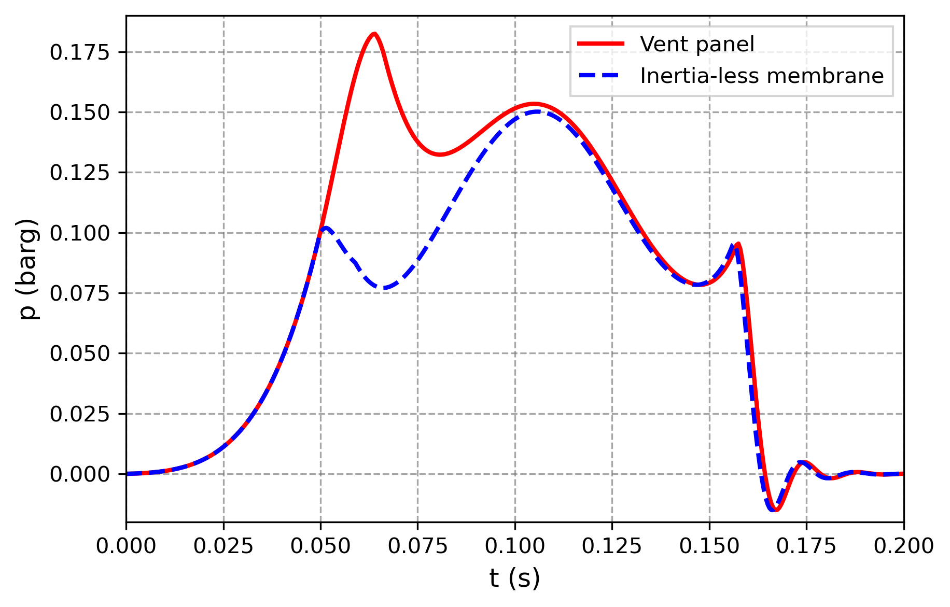
Figure 1: Sample calculations of pressure histories for vented explosions using inertia-less membrane and practical venting device.
By applying the EN 14491 relationship between reduced pressure and vent area, venting efficiency is inferred from the observed reduced pressures:

$$Ef=\frac{A_{E}}{A_{d}}={\left(\frac{p_{red, inertia-less}}{p_{red,venting device}}\right)}^{0.569}$$ | (4)

Overall, venting efficiency depends on various parameters, including both application parameters (V, K_{St}, p_{max}, p_{red}) and vent panel properties (m_{v}, p_{stat}, L_{v}, W_{v}, N_{v}, material properties).
  - Model Evaluation
To provide an empirical evaluation of the physics-based approach, the model is compared against the methodology currently used in NFPA 68 (2023) and Lorenz’s (2020) method.

- NFPA 68 (2023) simplifies the complex interaction between the explosion and the vent panel into a mass-inertia problem and employs an empirical correlation to calculate a mass threshold (M_{T}). If the vent panel's area density (m_{v}) falls below this limit, it is treated as a 100-% efficient, inertia-free device; otherwise, an area compensation factor is applied. While computationally straightforward, this empirical methodology results in a step behavior in efficiency predictions that does not reflect physical reality.

- The Lorenz (2020) Model offers another empirical alternative, originally developed for characterizing the efficiency of high-inertia reclosable explosion doors. This model introduces a resistance parameter (Q), which characterizes the device based on its moment of inertia relative to its geometric dimensions and hinge axis. By using a empirical exponential decay function, it predicts how this resistance reduces efficiency as a function of the vessel volume and dust reactivity.
    - Volumetric Scaling and Efficiency Trends
Figure 2 compares efficiency (Ef) predictions as a function of protected volume (V) for a sample set of application parameters (K_{St}, p_{max}, p_{red}) and vent panel properties (m_{v}, p_{stat}). The number of vent panels (N_{v}) was dynamically calculated to meet the vent area required to achieve the desired p_{red} of 0.15 bar-g used in this example, assuming individual panel dimensions of 0.61 m x 0.61 m.

All models qualitatively agree that efficiency increases with vessel volume. However, the quantitative progression differs significantly:

- NFPA 68 (2023): Employs a step-function approach that assumes 100 % efficiency once a specific mass threshold (M_{T}) is met, causing abrupt transitions in vent area requirements. This behavior is illustrated in Figure 2, where the unconstrained physics (dashed red) are compared against the threshold-limited constrained method (solid red).

- Lorenz (2020): Shows a continuous asymptotic approach to 100% but tends to be overly conservative for volumes exceeding 25 m³, according to the author. Several values of Q were considered to capture uncertainties of panel bending resistance contributions.

- Physics-based Model: Agrees closely with NFPA and Lorenz predictions for volumes up to 10 m³ followed by a smooth transition toward near-ideal efficiency (close to 100%) for volumes larger than 45 m³.

Crucially, the interplay between application parameters and vent closure properties dictates the quantitative divergence between models, as analyzed more extensively by Boeck and Bloching (2026). The results in Figure 2 thus characterize specific model behaviors for the present conditions rather than providing a universal solution, focusing on a regime of low p_{red} where venting efficiency is minimized and the influence of dynamic vent panel opening effects is most pronounced.
$K_{St}$ (bar·m/s) | 200
$p_{red}$ (bar-g) | 0.15
$m_{v}$ (kg/m²) | 10
$p_{stat}$ (bar-g) | 0.1
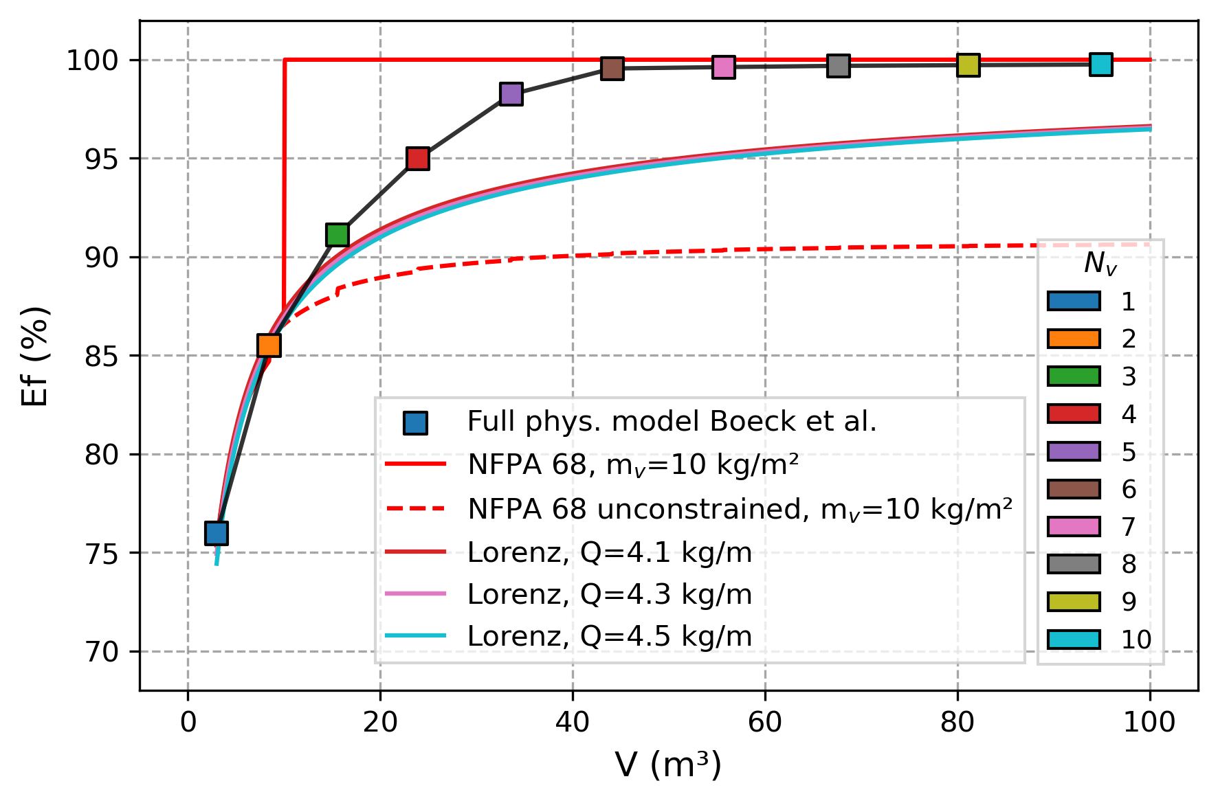
Figure 2: Volumetric scaling of venting device efficiency, including predictions of NFPA 68 (2023), Lorenz (2020), and physics-based model according to Section 2 of this work.
    - Impact of Explosion Regime
It was discussed previously (Boeck and Bloching, 2026) that efficiency may depend significantly on the reduced explosion pressure (p_{red}) relative to the static burst pressure (p_{stat}). At values of p_{red} close to p_{stat}, the dynamic vent opening behavior tends to dominate the reduced pressure, resulting in limited efficiency. At elevated p_{red} compared to p_{stat}, the balance between the maximum combustion rate and the capacity of the fully opened vent dominates over the dynamic vent opening behavior, allowing the device to achieve near-ideal efficiency. Quantifying the effect of p_{red} to p_{stat} ratio on venting efficiency requires specific additional investigation and validation, which will be addressed in future work.

  - Comparison with Experiments
A series of 36 large-scale dust explosion tests were conducted by independent third-party testing laboratories to evaluate venting efficiencies of hinged deflagration vent panels of varying construction in accordance with the direct comparison method of EN 14797. Experimental parameters covered wide ranges of test volumes
(1 m³ ≤ V ≤ 26.5 m³), dust reactivities (50 bar·m/s ≤ K_{St} ≤ 550 bar·m/s) and panel area density
(8 kg/m² ≤ m_{v} ≤ 17 kg/m²). Figure 3 compares venting efficiency results against the predictions of theoretical models including NFPA 68 (2023), Lorenz (2020), and the physics-based model of this work.
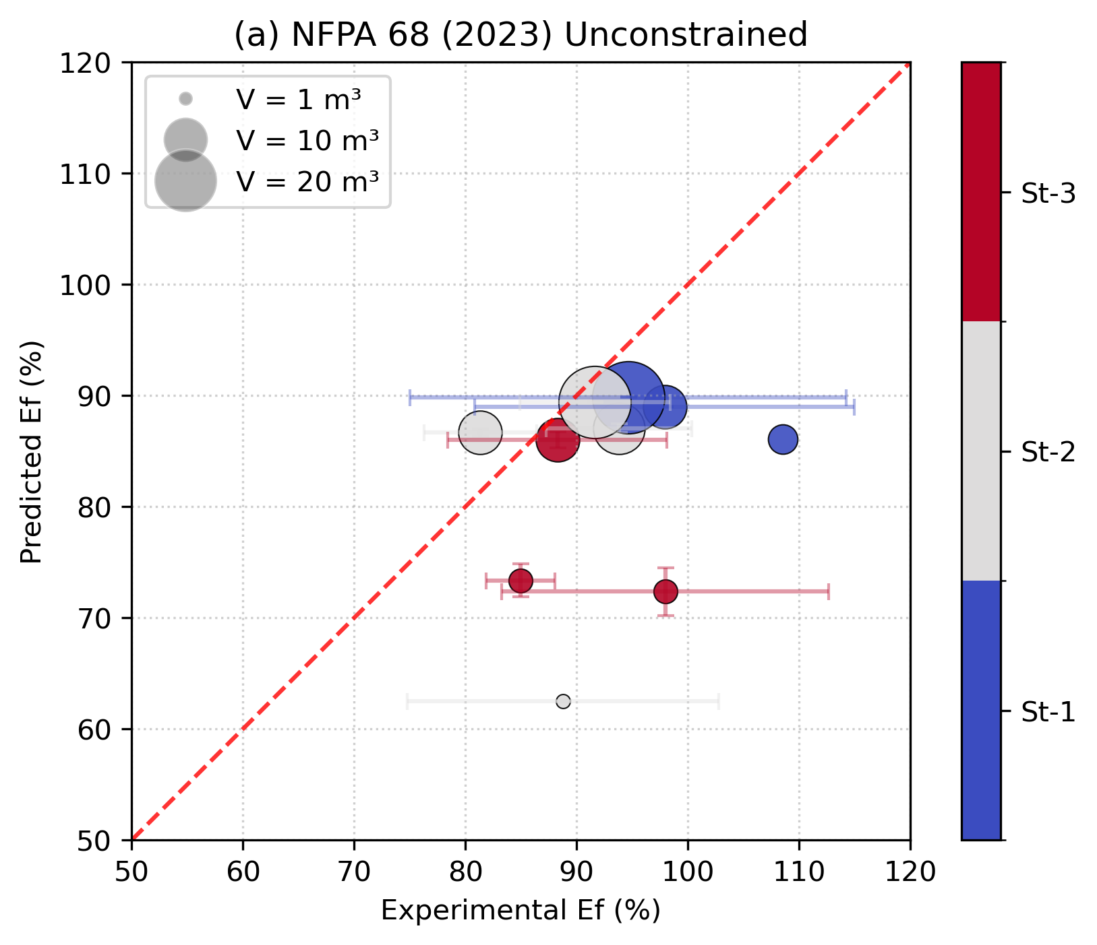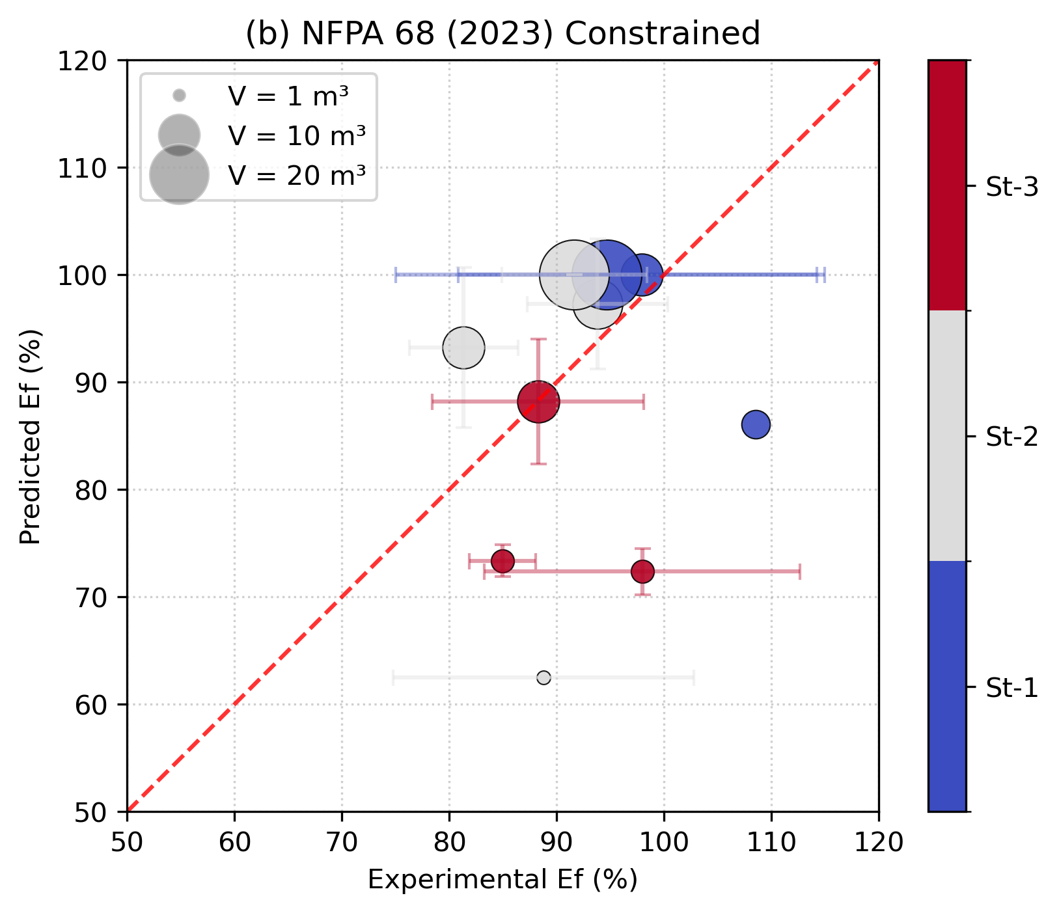
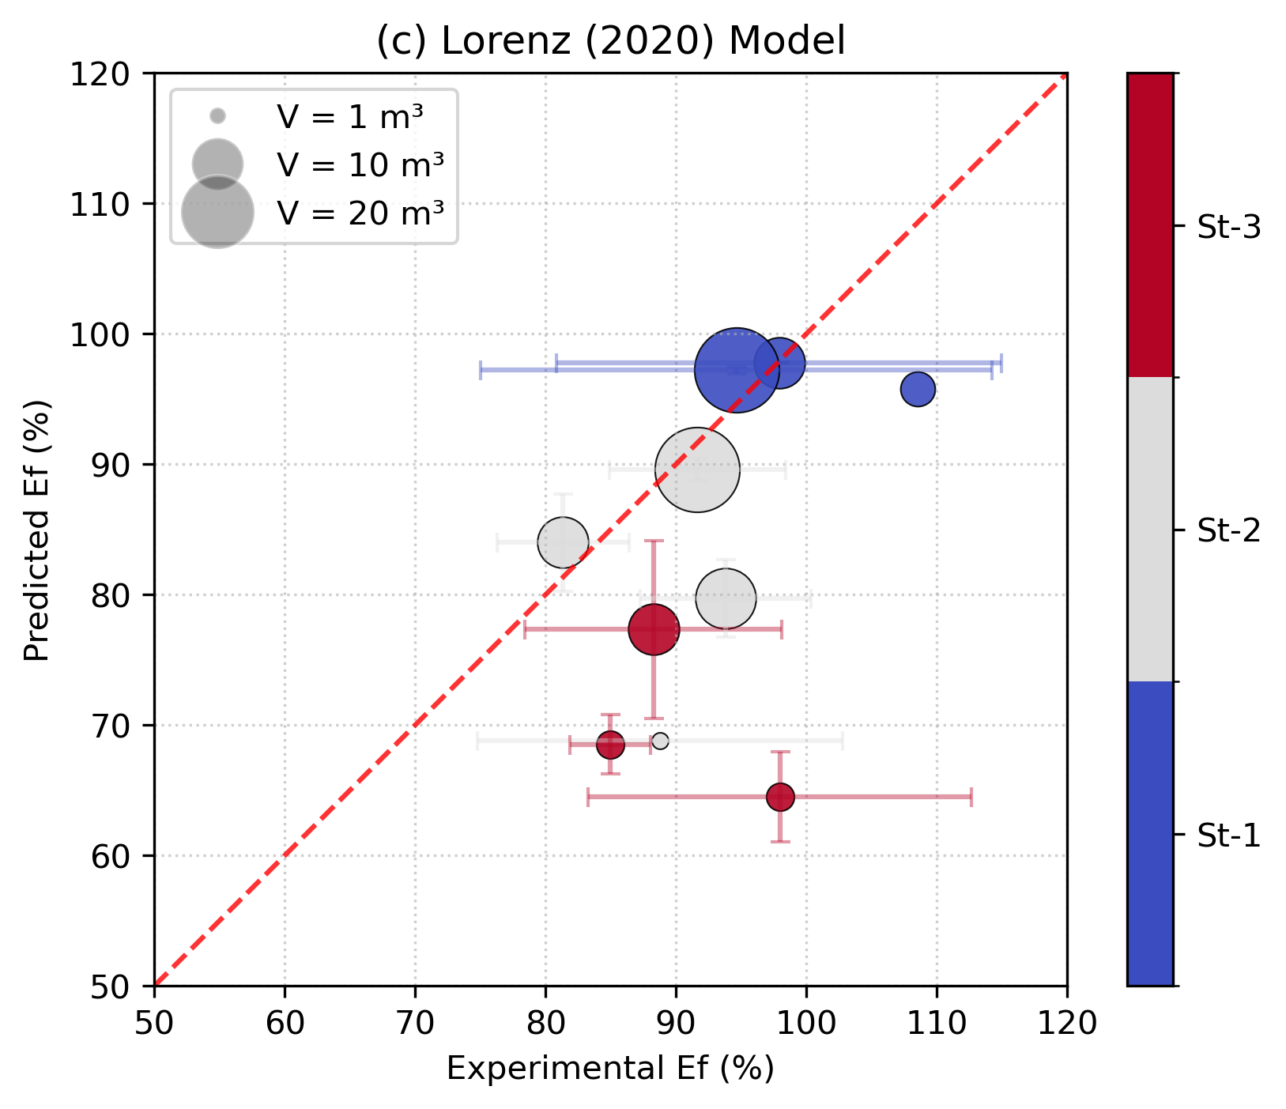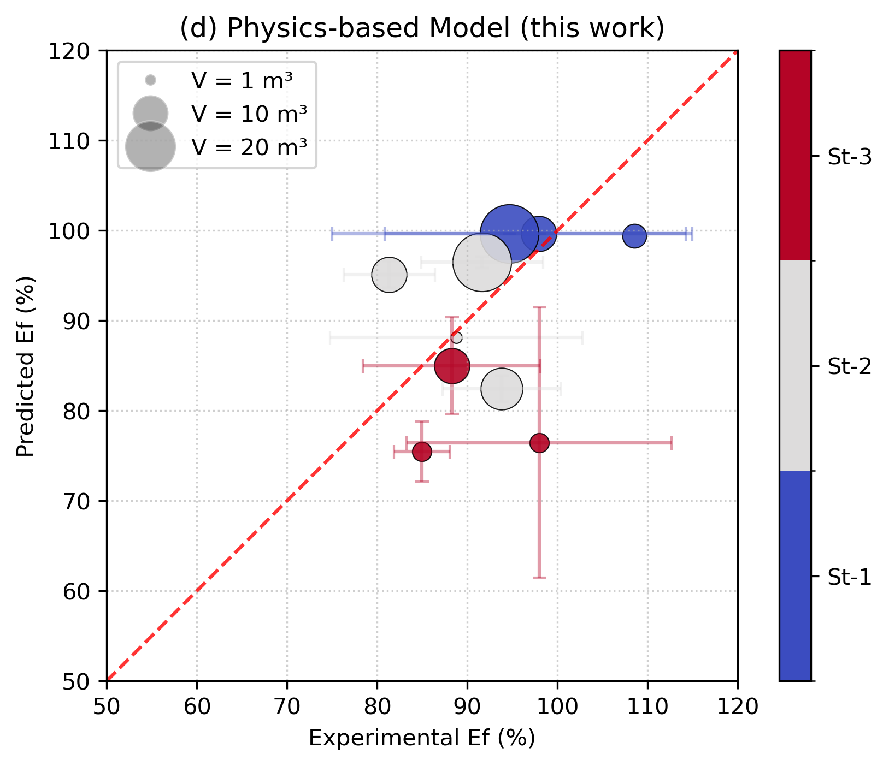
Figure 3: Binned parity analysis of venting efficiency (Ef) for (a) NFPA 68 (2023) Unconstrained, (b) NFPA 68 (2023) Constrained, (c) Lorenz (2020), and (d) Physics-based model. Markers represent experimental means sized by volume and colored by dust reactivity class, with error bars denoting one standard deviation of scatter.
Grouping tests into discrete bins based on vessel volume (V) and dust hazard class (K_{St}) helps manage the inherent experimental variability and reveals the underlying predictive performance of each model. A critical observation is the impact of the NFPA 68 mass threshold (M_{T}); comparing the unconstrained and constrained plots reveals the significant vertical step behavior to 100% efficiency when m_{v} < M_{T}. While this shift improves the model’s R² value, the experimental data (Ef) for these same cases may remain below 100%, suggesting that the constraint can introduce a non-conservative bias. In contrast, the Lorenz (2020) model and the physics-based model track the experimental results more consistently. While the Lorenz (2020) model provides largely conservative predictions of Ef consistent with its intended conservative calibration as a bounding curve to experimental data, the physics-based model provides the most accurate predictions for the present dataset as it reflects directly the interplay of explosion dynamics and vent panel deployment, suggesting it can be used as a basis for deriving future simplified engineering correlations for venting efficiency predictions. Conservative margins can be applied when developing such correlations as needed.
  - Conclusions
This study discussed how venting efficiency is not a static property of a venting device but rather a result of the interplay between explosion dynamics and the inertia-limited response of the device. The developed physics-based model, which integrates two-parameter dust deflagration dynamics with rotational vent panel kinetics, provides a robust theoretical framework for capturing this interaction. Key findings from the volumetric scaling analysis and empirical evaluation include:

- Model Divergence at Scale: While the physics-based model agrees closely with established NFPA 68 (2023) and Lorenz (2020) predictions for small volumes, models tend to diverge toward larger volumes. Validating models for large volumes remains a challenge due to the relative lack of large-scale test data and test-to-test variability inherent to dust explosions.

- NFPA 68 Limitations: The current NFPA 68 (2023) methodology exhibits a non-physical step behavior due to the application of mass threshold M_{T}. Experimental parity analysis reveals that assuming
100 % efficiency when m_{v} < M_{T} can introduce a non-conservative bias.

- Accuracy of the Physics-based Approach: The physics-based model achieved the highest predictive accuracy against the dataset of 36 large-scale experimental tests. Unlike empirical correlations, this approach directly reflects the interplay of explosion dynamics and mechanical vent deployment and provides controlled extrapolation behavior, making it a robust foundation for engineering methods.

Ultimately, the results suggest that the physics-based framework provides a viable path for the unified incorporation of venting efficiency into vent sizing methods. By replacing divergent methodological philosophies with a harmonized, mechanistic understanding of vent response, industrial safety standards can achieve greater consistency and reliability. Future work will focus on additional validation across a broader range of large-scale test data and development of simplified engineering correlations for incorporation into codes and standards.

Nomenclature
A_{d} ; A_{v} – Geometric vent area, m²
A_{E} – Effective vent area, m²
E – Elastic modulus, Pa
Ef – Venting device efficiency, -
I – Moment of inertia, kg·m²
K_{St} – Dust deflagration index, bar m/s
L_{v} – Length of vent panel normal to hinge, m
m_{v} – Area density of vent panel, kg/m²
M – Moment, N·m
M_{T} – NFPA 68 mass threshold, kg/m²
N_{v} – Number of vents, -
p_{max} – Maximum explosion pressure, bar-g
p_{red} – Reduced explosion pressure, bar-g
p_{stat} – Static vent burst pressure, bar-g
Q – Resistance parameter of venting device, kg/m
R – Vessel radius, m
R_{eff} – Effective radius of curvature, m
r_{f} – Flame radius, m
S_{T} – Turbulent burning velocity, m/s
S_{T,R} – Maximum turbulent burning velocity, m/s
t – Time, s
V – Vessel volume, m³
W_{v} – Width of the vent panel along the hinge, m
$θ$ – Vent panel opening angle, rad
$τ$ – Characteristic oxygen diffusion time, s
$χ$ – Ratio of diffusion and combustion times, -

References
Bauwens, C.R.L., Boeck, L.R., Dorofeev, S.B. (2024). Characterizing the reactivity of large-scale dust explosions with a dimensionless two-parameter model. Proceedings of the Combustion Institute, 40, 105280.
Boeck, L.R., Bauwens, C.R.L., Dorofeev, S.B. (2023). Large-scale dust explosions in vessel-pipe systems. Journal of Loss Prevention in the Process Industries, 82, 104980.
Boeck, L.R. and Bloching, M. (2026). Examining efficiency of deflagration vents through physics-based modelling. 16 International Symposium on Hazards, Prevention, and Mitigation of Industrial Explosions, Kaohsiung, Taiwan.
EN 14797 (2006). Explosion venting devices.
EN 14491 (2012). Dust explosion venting protective systems.
EN 14994 (2007). Gas explosion venting protective systems.
Lorenz, D. (2020). Modellgestützte Optimierung des Schutzsystems Explosionsklappe zur kontrollierten Druckentlastung verfahrenstechnischer Apparate bei Staubexplosionen. Ph.D. Thesis. Wuppertal.
NFPA 68 (2023). Standard on explosion protection by deflagration venting.

