 CHEMICAL ENGINEERING TRANSACTIONS  VOL. xxx, 2026 | A publication of  
The Italian Association
of Chemical Engineering
Online at www.cetjournal.it

Guest Editors: Valerio Cozzani, Bruno Fabiano, Genserik Reniers
Copyright © 2026, AIDIC Servizi S.r.l.
ISBN 979-12-81206-xx-x; ISSN 2283-9216

Experiments of hydrogen isotopes reaction with air in DEMO condition
*Damiano Capobiancoª, Roberto Sanchirico^{b}, Teresa Beoneª, Egidio Zaninª
ª RINA Consulting - Centro Sviluppo Materiali S.p.A Via di Castel Romano 100, 00128 Roma, Italy
^{b} CNR - Istituto di Scienze e Tecnologie per l' Energia la Mobilità Sostenibili (STEMS), P.le V. Tecchio, 80 - 80125 -Napoli , Italy

damiano.capobianco@rina.org
The experience from ITER (International Thermonuclear Experimental Reactor), highlights the importance of addressing fire and explosion risks involving hydrogen in future fusion plants, where hydrogen isotope inventories will be even larger, especially in DEMO (DEMOnstration power plant) and other fusion reactors. The study reviews safety cases related to hydrogen–oxygen reactions that could lead to explosions, analysing the chemical, thermodynamic and gas-dynamic aspects influencing such events. A literature review revealed significant inconsistencies in available data, due to differences in standards, experimental geometries, ignition energies and criteria. To overcome these gaps, various test rigs were compared, leading to the selection of a 20-liter spherical apparatus for a focused experimental campaign. The work evaluated LEL (Lower Explosion Limits) and UEL (Upper Explosion Limits) of hydrogen–air mixtures at sub-atmospheric condition between 5 and 100 kPa, also studying the temperature effect. Results were analysed using ASTM E918 to determine explosive limits under these conditions and to assess explosion severity through the Kst index.
  - Introduction
Scientific literature has long recognized that hydrogen flammability presents significant risks, especially in applications involving variable pressure and temperature conditions. Understanding the flammability limits of hydrogen-air mixtures is crucial to ensuring safety in various technological applications, including nuclear fission or fusion reactors. Following the experience of ITER (International Thermonuclear Experimental Reactor), particular attention should be afforded to the potential for fire and explosion events involving hydrogen. Substantial inventories of hydrogen isotopes will be present in parts of the ITER plant, and it might be expected that in DEMO (DEMOnstration power plant) these could be even higher, owing to the higher throughput of deuterium and tritium fuels [Taylor, N. 2017]. A real risk of explosion of a flammable gas in DEMO therefore exists due to mentioned hydrogen inventories and is mainly associated with the possible generation hydrogen/air mixture above the flammability limits. Such hydrogen (or its isotopes)- air mixtures can result from two types of events: An accidental hydrogen leak from fuel cycle pipework, pumping and storage systems into building rooms housing systems of the fuel cycle, including vacuum pumping, fuel processing, fuel storage, and fuel injection systems. An accidental air in-leakage into the vacuum vessel (VV) or connected volumes under vacuum. These so-called Loss of Vacuum Accident (LOVA) initiating events could lead to mobilization of a part of inVV hydrogen inventory and the formation of a hydrogen/air mixture above the flammable limit. These accidental scenarios are part of the reference scenarios to be studied for DEMO safety demonstration. Furthermore, additional hydrogen production can result from exothermic oxidation reactions of tungsten covered plasma facing components (PFCs) surfaces with steam in case of In VV Loss of Coolant Accident (LOCA) scenarios, which are also part of the design‑basis accidents to be considered for the safety demonstration (Figure 1). The relevance of hydrogen isotopes – air reactions also reside in the fact that requires lower ignition energies, commonly available either by thermal exchange with reaction chamber hot surfaces or resulting from electric arcs between electrostatically charged surfaces at different potentials and under vacuum

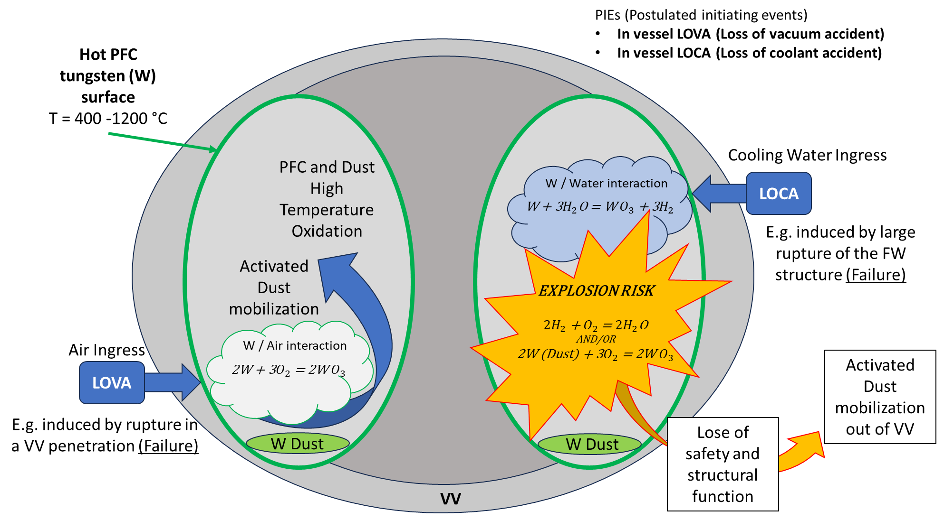
These reactions, in addition to potentially leading themselves to deflagration or detonation, may supply sufficient energy to trigger secondary explosions involving metallic and combustible tungsten dust eroded from vacuum vessel surfaces. Consequently, controlling hydrogen–oxygen interactions represent a key safety-related R&D challenge in support of DEMO licensing. This is particularly important given that hydrogen or dust explosions may simultaneously act as drivers for tritium inventory mobilization, pose a direct threat to the integrity of the vacuum vessel and interconnected systems, and cause the release of radioactive material into the surrounding building. In order to investigate hydrogen–oxygen interactions as a significant safety concern under these conditions, it is necessary to introduce appropriate explosion indices and reference standards that allow a consistent and quantitative description of the associated phenomena.
Figure 1 Example of LOCA / LOVA accident scenarios in tokamak

  - Observables and Explosion indices
Safety characteristics or explosion indices are the basis for the evaluation of qualitative and quantitative explosion risks [Tschirschwitz, R. 2015]. Safety characteristics of primary, secondary, and constructive explosion protection are used for the systematic assessment of explosion hazards. In primary explosion protection, the lower (LEL) and the upper explosion limits (UEL) are of particular importance for gases [Molnarne, M. 2005]. Important safety characteristics for gas explosions are the autoignition temperatures (AIT), the minimum ignition energies (MIE) as well as maximum explosion pressures (pmax), and maximum rate of pressure rise ((dp/dt) max). In general, the explosion indices are affected by the apparatus and material parameters [Schroder V. 2005]. Regarding the parameters strictly related to the material, these involve the composition of the flammable mixture, the presence, type, and quantity of inert, fuel, and oxidizing gases, but also the initial temperature, initial pressure, and the state of the flow. Regarding the parameters that are related to the apparatus, these involve the determination procedure (step, criterion), the type and size of the ignition vessel (closed, open, dimensions), and the ignition source (type, power, duration, and position). Reliable criteria for ignition testing include the visual criterion; the pressure‑rise criterion; and the temperature‑rise criterion. For this reason, it is important that the study of any explosion indices must include the specifications of the experimental apparatus, the criterion of flammability, and the experimental conditions. In many international and European regulations, a gas or gas mixture is classified as flammable if it has an explosion range in mixture with air at atmospheric condition [Tschirschwitz, R. 2015]. No standard is designed for the study of explosivity indices under sub-atmospheric conditions, such as those relevant for the VV fusion reactor. Among the explosion indices, determination of flammability limits represents a fundamental aspect of chemical process safety, as these parameters define the boundaries within which a combustible mixture can sustain flame propagation.
    - Hydrogen- Air explosion limits and literature gaps
Flammability limits of hydrogen in air are strongly dependent on both pressure and temperature. According to Lewis and von Elbe [Lewis, B 1987], the flammability range of hydrogen expands with increasing temperature and varies significantly with changes in pressure. Previous studies, such as those by Coward and Jones [Coward, H 1952], have confirmed that at pressures above 1 bar, the flammability limits tend to widen further, increasing the risk of combustion under controlled conditions. According to [NASA, 1997] a reduction in pressure below 101,3 kPa tends to narrow the range of flammability by raising the lower limit and lowering the upper limit. Qingchun Hu [Qingchun Hu, 2023] report that for a low-pressure environment, the range of flammability limits of hydrogen-air cloud would reduce as ambient pressure reduce significantly. Under elevated temperature the lower limit of hydrogen-air cloud flammability reduces from 3.9% at 20 °C to 1.5% at 400 °C, while the upper limit increases from 75.2% to 87.6%. A literature review also identified a gap of information particularly regarding sub-atmospheric initial pressure.
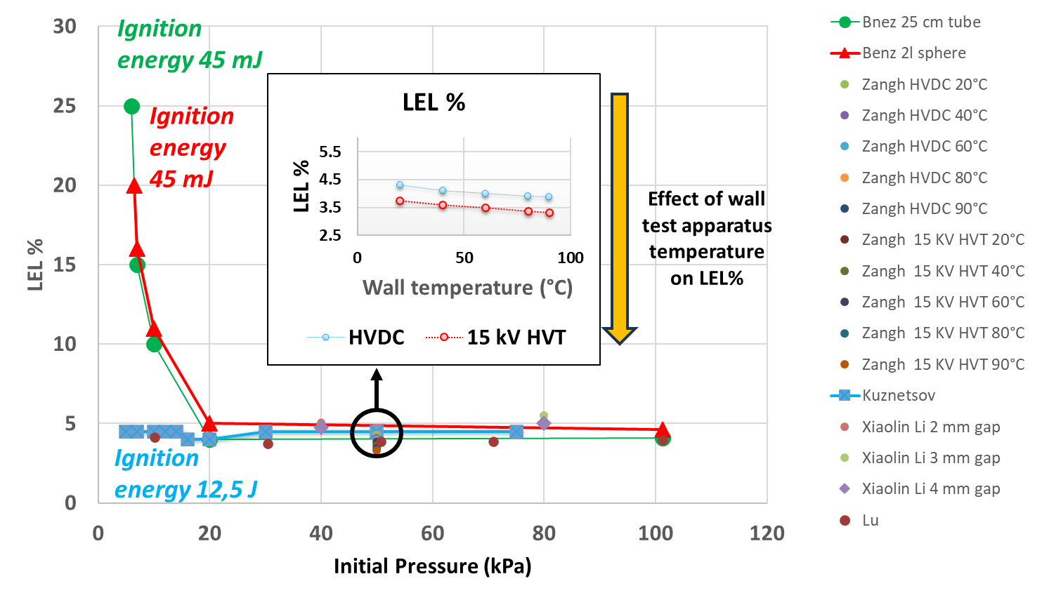

Figure 2 Bibliographic data collection on LEL in sub-atmospheric condition

The graph (Figure 2) summarize the bibliographic data collection of several tests to measure LEL done in sub atmospheric conditions. When comparing the available references at pressures below 20 kPa, the lower explosive limit (LEL) appears to be strongly influenced by the ignition energy. As the test pressure increases, the observed differences among the reported LEL values become more pronounced. This variability can be attributed to the strong influence of the experimental methodology, including the ignition system characteristics and the dimensions of the test vessel employed for LEL determination. The increase in gas temperature tends to decrease the LEL [Zhang, K. 2022]. Only some methods show comparable results, and the reason is that these methods use very similar apparatuses. Methods which consider closed vessels and the increase in pressure relative to the initial pressure, the LEL tends to be higher compared to methods that use visual techniques. Moreover, it was noted that the type of ignition source exploited in considered experiments, such as hot wire and spark or hot wall might impact on the measurement of explosion. Influence of vessel geometry and ignition criterion on measure of LEL and UEL are reported by Schroeder V. [Schroder, V. 2005] results of its investigation are summarized in Table 3.

Table 3 Explosion limits of hydrogen in air measured at room temperature and atmospheric pressure, given in mol% H₂ [Schroder, V. 2005].
 | DIN 51649 | EN 1839 (T) | EN 1839 (B) | ASTM E 681
LEL (H₂-Air) | 3.8 | 3.6 | 4.2 | 3.75
UEL (H₂-Air) | 75.8 | 76.6 | 77 | 75.1

To gain insight into the problem, define the safety domain boundaries in terms of LEL/UEL and to verify results collected in mentioned literature review, a series of tests in sub-atmospheric conditions in the region from 5 kPa up to 100. ASTM E918 norm was adopted and preferred to EN norm because of the higher pressure rise criteria (7% instead of 5%). The rationale for such choice is that lower pressure rise criterion tends to underestimate the measure of LEL.
  - Experimental setup
The experimental setup used in this study involves a 20-liter stainless steel sphere equipped with a jacket for the circulation of the fluid for temperature control (water) and an internal fan to ensure homogeneous hydrogen-air mixtures. A couple of piezoelectric transducers allow the acquisition of the pressures rise. The sphere is
  - Test methodology
The mixtures were prepared using the partial pressure method in a spherical vessel with controlled wall temperature. The sphere was first evacuated, then filled with air to a set initial pressure, after which hydrogen was added until the final pressure corresponding to the desired hydrogen concentration was reached. A fan operating at 1000 rpm ensured complete mixing, and a temperature-controlled bath set the internal wall temperature for each test. Ignition was performed with a 2-second spark between tungsten electrodes, triggered ten seconds after stopping the fan, using an energy of about 10 J. To determine the upper flammability limit, tests were carried out starting from an explosive hydrogen concentration and progressively lowering it until no flame propagation occurred. Throughout each experiment, pressure, temperature, and mixture composition were continuously monitored to establish the flammability limits of hydrogen–air mixtures under different pressures and wall temperatures.
  - Description of the results
For each test, pressure versus time curves for various hydrogen-air mixtures at 25 °C and 60 °C and different initial pressure were produced. As an example, the following figure (Figure 4) shows mean pressure versus time curves, obtained by averaging the results of three different experiments conducted under different experimental conditions at fixed hydrogen-air mixtures ( T = 25 °C and P0 = 0.75 and 0.25 bar), from these curves Pmax was obtained.
a | b
Figure 4 Mean pressure versus time curves for a) 10 % hydrogen-air mixtures at a temperature of 25 °C and an initial pressure of 0.75 bar and 0.25 bar and b) 70 % hydrogen-air mixtures at a temperature of 25 °C and an initial pressure of 0.75 bar and 0.25 bar.

In hydrogen-rich mixtures, the dP/dt is much higher compared to lean mixtures as shown by the steepness jumps in the various curves, at both high and at low pressures. Furthermore, the combustion phenomenon is much faster: the mixture ignites within 50 ms in rich mixtures, whereas in lean mixtures it ignites after 100 ms, evaluating the beginning of the curve growth after time 0 given by the start of the spark. From the tests performed, the raw results presented in Table 4 were derived. In this table, (V/V-%)_{High} corresponds to the highest concentration at which flame propagation is still observed when decreasing from richer mixtures. While, (V/V-%)_{Low} is the first value of (V/V-%)< (V/V-%)_{High} at which no flame propagation occurs according to ASTM E 918.The data in Table 4 indicate only a range of values within which the LEL and UEL under those conditions lies.
Table 4 Range over which the LEL and UEL lies at T wall 25 and 60 °C at different sub-atmospheric pressure
 |  | LEL |  | UEL
T (°C) | Po (bar) | V/V-% Low | V/V-% High | V/V-% Low | V/V-% High
25 | 0.05 | 6.0 | 7.5 | 58.5 | 60
25 | 0.1 | 4.0 | 5.0 | 71.5 | 72
25 | 0.25 | 4.5 | 5.5 | 75 | 76
25 | 0.5 | 4.5 | 5.5 | 74.5 | 75
25 | 0.75 | 5.5 | 6.0 | 77 | 78
25 | 1 | 5.5 | 6.0 | 77 | 78
60 | 0.05 | <5.0 | 5.0 | 50 | 55
60 | 0.1 | <4.0 | 5.0 | 70 | 71
60 | 0.25 | 4.0 | 6.0 | 78 | 79
60 | 0.5 | 4.0 | 5.0 | 79 | 80
60 | 0.75 | 5.0 | 7.0 | 78 | 79
60 | 1 | 5.0 | 6.0 | 78 | 79

To provide statistically consistent values of the LEL and UEL, a linear interpolation procedure was carried out. LEL and UEL values were determined by identifying the intersection between the regression line of mean values of Pmax/P0 at different (V/V-%) and the horizontal line at δ = 1.07 (Figure 5.). Each data point in Figure 5 is obtained as an average of 3 experimental points, considering Pmax value for a for a given H₂-Air mixture. Data for fitting were chosen considering the first values below the line at δ = 1.07 and the first values above the same line. This method ensures that the interpolated values are both accurate and reliable, enabling the identification of LEL and UEL as the intercept of the line fitted on experimental data and the reference line at δ = 1.07.

The analysis highlights a complex interaction between pressure, temperature and hydrogen–air flammability (Figure 6), driven by gas density, heat losses and molecular kinetics. Both the LEL and UEL show non-linear trends, with pronounced variations at low pressures and asymptotic behaviour as pressure increases.
Figure 5 Results collected during the runs carried out at P0= 1.0 bar and T= 25 °C. Solid symbols were used to assess the LEL by means of linear interpolation

Figure 6 LEL and UEL measured during experimental campaign

At 25 °C, the LEL decreases sharply between 0.05 and 0.10 bar, reaching a minimum due to enhanced molecular collisions as density increases from highly rarefied conditions. Above 0.25 bar, the LEL rises toward an asymptotic value of about 5 % vol near atmospheric pressure, consistent with increased heat losses and quenching effects. A similar trend is observed at 60 °C, although the asymptotic regime is reached at lower pressures owing to enhanced molecular activity at elevated temperature. The UEL shows complementary behavior. At 25 °C, it exhibits a minimum at 0.05 bar, followed by a strong increase with pressure, approaching an asymptotic value of approximately 78 % vol. This reflects the enhanced ability to sustain richer mixtures as density and radical chain efficiency increase. At 60 °C, the UEL follows the same trend but is lower at very low pressures, where diffusive losses dominate. The UEL–pressure curves intersect at about 0.14 bar: below this value, UEL at 25 °C is higher, while above it higher temperatures extend the flammability range. Overall, pressure has the dominant effect at very low values, where small changes strongly affect reactivity, while temperature primarily shifts the transition toward saturation by modifying molecular kinetics and diffusion.
Conclusions
In the context of assessing the risk of accidental explosions related to DEMO and other nuclear fusion machines, several combustion parameters of hydrogen-air mixture explosions were measured to define the explosibility domain under sub-atmospheric conditions. The study also evaluated how gas temperature can influence the explosibility limits. The study results can be useful for the study of incidental analysis problems and to support the licensing of future nuclear fusion reactors. As a perspective for future research, it will be necessary to conduct a dedicated investigation on the behaviour of Deuterium under analogous operating conditions, with the objective of determining its LEL and UEL. Given its distinct physicochemical properties, Deuterium requires a specific experimental assessment. Differences in molecular mass, collision dynamics, and chemical reaction kinetics with respect to Hydrogen may lead to significant variations in ignition behaviour and flammability boundaries.

Acknowledgments
This work has been carried out within the framework of the EUROfusion Consortium and has received funding from the EURATOM research and training programme 2023-2027 under grant agreement No 633053. The views and opinions expressed herein do not necessarily reflect those of the European Commission.

Coward, H. (1952) Limits of flammability of gases and vapors. Bulletin 503. Washington, DC: U.S. Bureau of Mines.

Kuznetsov, M. (2011) ‘Experiments for the hydrogen combustion aspects of ITER LOVA scenarios’, Fusion Engineering and Design, pp. 1–8. https://doi.org/10.1016/j.fusengdes.2011.01.050.

Kuznetsov, M. (2012) ‘Flammability limits and laminar flame speed of hydrogen–air mixtures at sub-atmospheric pressures’, International Journal of Hydrogen Energy, 37, pp. 17542–17549. https://doi.org/10.1016/j.ijhydene.2012.05.049.

Lewis, B. and von Elbe, G. (1987) Combustion, flames and explosions of gases. 3rd edn. Orlando, FL: Academic Press.

Molnarne, M. (2005) ‘Flammability of gas mixtures. Part 2: Influence of inert gases’, Journal of Hazardous Materials, 121(1–3), pp. 37–46. https://doi.org/10.1016/j.jhazmat.2005.01.033.

Molnarne, M. (2019) ‘Hazardous properties of hydrogen and hydrogen-containing fuel gases’, Process Safety and Environmental Protection, 130, pp. 1–11. https://doi.org/10.1016/j.psep.2019.07.012.

NASA (1997) Guidelines for hydrogen system design, materials selection, operations, storage, and transportation: Safety standard for hydrogen and hydrogen systems. Washington, DC: National Aeronautics and Space Administration.

Taylor, N. (2014) ‘Lessons learnt from ITER safety and licensing for DEMO and future nuclear fusion facilities’, Fusion Engineering and Design, 89(9–10), pp. 1995–2000. https://doi.org/10.1016/j.fusengdes.2013.12.030.

Hu, Q. (2023) ‘A review of hydrogen–air cloud explosions: The fundamentals, overpressure prediction methods, and influencing factors’, International Journal of Hydrogen Energy, 48, pp. 1–22. https://doi.org/10.1016/j.ijhydene.2022.11.302.

Tschirschwitz, R. (2015) ‘Determination of explosion limits and criterion for ignition under non-atmospheric conditions’, Journal of Loss Prevention in the Process Industries, 36, pp. 292–299. https://doi.org/10.1016/j.jlp.2015.01.012.

Li, X. (2023) ‘Lower flammability limit of hydrogen/air mixture under different electrode parameters, initial pressure and diluent gas’, International Journal of Hydrogen Energy, 48, pp. 1–12. https://doi.org/10.1016/j.ijhydene.2023.03.058.

Liu, X. (2014) ‘Influence of initial pressure and temperature on flammability limits of hydrogen–air’, International Journal of Hydrogen Energy, 39, pp. 1750–1757. https://doi.org/10.1016/j.ijhydene.2014.02.001.

Zhang, K. (2022) ‘Effect of ignition, initial pressure and temperature on the lower flammability limit of hydrogen/air mixture’, International Journal of Hydrogen Energy, 47, pp. 1–10. https://doi.org/10.1016/j.ijhydene.2022.02.224.

