 CHEMICAL ENGINEERING TRANSACTIONS  VOL. xxx, 2026 | A publication of  
The Italian Association
of Chemical Engineering
Online at www.cetjournal.it

Guest Editors: Valerio Cozzani, Bruno Fabiano, Genserik Reniers
Copyright © 2026, AIDIC Servizi S.r.l.
ISBN 979-12-81206-xx-x; ISSN 2283-9216

Navigation in Shallow Waters and Channels: Risk and Vulnerability Assessment in an Environmentally Sensitive Area
Tomaso Vairoª*, Dario Cangelosi^{b}, Vincenzo Incandela^{b}, Paolo Menegazzo^{c}, Andrea Pedroncini^{d}, Bruno Fabianoª
ªDICCA -Civil, Chemical and Environmental Engineering Dept. University of Genova, Via Opera Pia 15, 16145 Genova, Italy
^{b}CETENA S.p.A., Via Ippolito d'Aste 5, 16121 Genova, Italy
^{c}Autorità di Sistema Portuale del Mare Adriatico Settentrionale, Fabbricato 13, Santa Marta, 30135 Venice, Italy
^{d}DHI Italia, Via Bombrini, 11/12 16149 Genova, Italy
tomvairo@gmail.com
In recent years, there has been an increasing need for effective risk assessment methods to ensure the safety of navigation in shallow water channels, to protect vulnerable environments, on the one hand, and on the other to be ready for the relevant changes taking place with energy and environmental transitions. In this study, a risk assessment framework for shallow water navigation has been developed, with a focus on one of the most complex, multifaceted and significant area in Europe, the channel network in Marghera (Venice, Italy). The results based on bow-tie analysis, fault trees and event trees and vulnerability assessment that the most significant hazards in the study area were collisions, grounding, environmental impacts, and channel blockages. The risk-based framework can provide a robust basis for decision support for management and regulation of vessel traffic in environmental sensitive areas, and for developing effective technical and non-technical barriers and strategies for mitigating navigation risks.
  - Introduction
Navigational safety is a critical aspect of maritime transportation involving the identification, analysis, and management of risks associated with vessel operations. Over the years, various risk assessment methodologies have been developed to help maritime stakeholders evaluate, mitigate these risks and to set the basis for proper protecting sea environment and improving sustainable maritime traffic (Vairo et al., 2021), ranging from qualitative approaches (IALA G1138, 2022), to more advanced techniques, including quantitative and dynamic risk assessment (Vairo et al., 2026). Traditional ship traffic monitoring and management is no longer adequate considering the ongoing increase in maritime traffic, new technologies both transportation and storage as well novel energy carriers (Pasman et al., 2024), thus requiring deep consideration on the increased complexity of navigational and port systems and connected emerging risks (Vairo et al., 2026). A number of approaches were proposed to address the issue of risks associated with navigating surface waters and narrow channels, e.g. Adhita et al. (2023), applied the Hollnagel’s FRAM to analyse officers’ everyday performance in navigating the ships, for incorporating resilience in ship operations. The reader is addressed to the review by Fu et al., (2021) exploring models and approaches for identifying, analysing and evaluating risks to vessels and risk from vessels within the arctic environment.
Overall, the scientific literature suggests that risk assessment for navigation in shallow waters requires a combination of theoretical analysis, empirical data, and practical methods. Factors such as hydrological and meteorological conditions, traffic volume, channel status, navigation facilities, and vessel collision risk, should be considered, while implementing various methods to ensure safe and efficient navigation, like risk-based navigation, multi-criteria route planning and probabilistic approaches. Despite the availability of several risk assessment methodologies, there is still a need for further research to develop more comprehensive and effective frameworks for navigational safety assessment. Indeed, although detailed studies have been conducted on specific relevant aspects related to the risks of navigating shallow waters and narrow channels, a comprehensive approach that encompasses them all in a way that is easily understood by regulators and decision makers is still needed. This challenge is particularly relevant in complex navigational environments, such as Venice lagoon (Italy), where a multitude of multifaceted hazards can pose significant risks to vessel operations.
  - Methodology

The overall risk assessment framework shown in Figure 1 consists of three assessment stages, complemented by a vulnerability assessment step, providing a comprehensive evaluation of the risks associated with various hazards in this unique and complex environment.

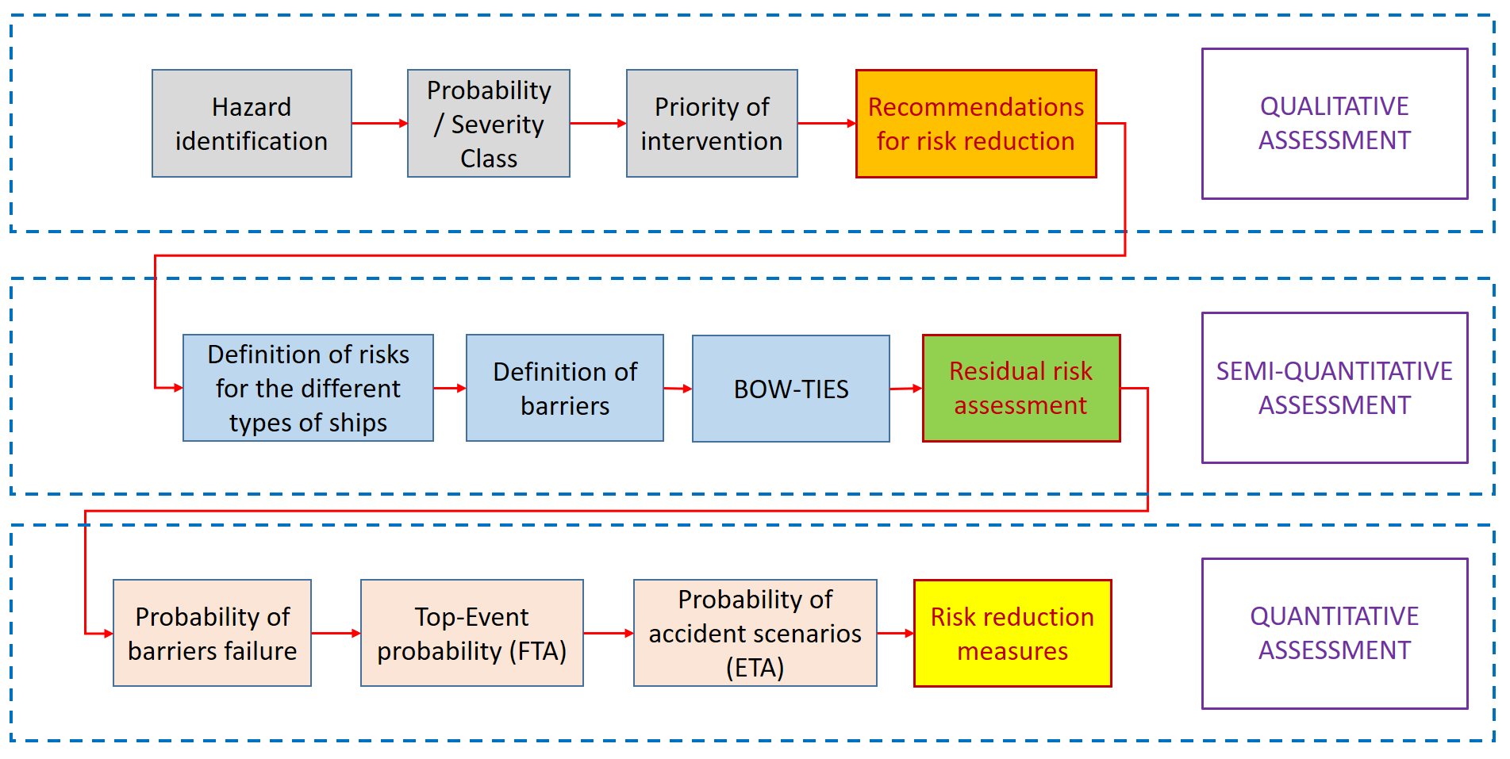
Figure 1: Navigational Risk Assessment conceptual framework.
By definition, marine accidents occur during ship operation and result in harm to the crew or other individuals (P), to the environment (E), or to the ship, assets, infrastructures (A). These events may range from minor incidents to high impact ones resulting in fatality or severe environmental/economic harm.
To the purpose of the following development the main ship categories were considered as follows:
Bulk carriers group includes all the ships whose ship type belongs to one of the following categories: “Bulk Carriers”, “General Dry Cargo Ships”, “Other Type of Ships”, and “OBO-Combination Carrier”. The ships whose payload was “RO-RO”, “TEU”, “FUEL”, and “DIESEL OIL” were excluded. “Heavy Load Carrier” ships were not included in this group. Containerships group includes all the ships which were recorded as such in the transits file. The ships whose payload was “TEU” but were not classified as “Containership” were excluded from this group. Cruise group includes all the “Passenger Ships” in the transits file. The statistics of accidental events is summarized in Table 1.
Table 1: Ten years-statistical analysis on accidental events.
Event type | Bulk [occ/y] | Container [occ/y] | Cruise [occ/y] | Tanker [occ/y]
Machine failure | 1.779E-04 | 4.413E-06 | 1.853E-06 | 4.332E-05
Loss of propulsion | 0 | 0 | 3.088E-05 | 6.017E-05
Grounding | 5.295E-05 | 2.452E-05 | 0 | 3.008E-05
Rudder failure | 1.588E-04 | 1.839E-05 | 0 | 4.513E-05
Blackout | 2.542E-04 | 1.471E-05 | 0 | 0
Fire on board | 0 | 7.355E-05 | 0 | 0
High wind | 5.295E-05 | 0 | 7.721E-05 | 0
Cable breakage | 3.177E-04 | 0 | 0 | 0
Flooding | 3.177E-04 | 0 | 0 | 0

Qualitative risk assessment was conducted using the SIRA methodology (IALA G1138, 2022) and was based on a brainstorming-type approach and expert elicitation, conducted in two workshops, involving the participation of the relevant stakeholders and allowing to identify relevant hazard summarized in Table 2 and credible accident scenarios.
Table 2: Hazard identification.
Code |  | Hazard
Ship-related hazards
 |  | Loss of control - steering and propulsion – channel
 |  | Loss of control - steering and propulsion - port area
 |  | Loss of buoyancy / stability
a. Unavailability of external manoeuvring gear (tug) – port
b. Unavailability of external manoeuvring gear (tug) – channel
 |  | Electro-instrumental failures
Hazards due to environmental conditions
 |  | Adverse weather conditions (fog, wind, tidal current)
 |  | Incorrect weather forecasts
 |  | Ice
 |  | Poor visibility
Navigation hazards
 |  | Accessibility problems (e.g., poor channel maintenance)
 | Unfavourable tidal conditions - low tide
 |  | Inconsistency between channel morphology and cartography
a. Incidents on land (fires, releases, explosions) – port
b. Accident ashore (fires, releases, explosions) – moorings
Human factor hazards
 |  | Pilot unavailability (accident / pilot failure / indisposition)
 |  | Human error (on board) - incorrect / untimely action
 |  | Human error (on board) - no action
External hazards
 |  | Route’s intersection with minor units
 |  | Presence of other ships / convoys
 |  | Floating obstacles
 |  | Human error (ashore) – management
 |  | Shore-based electro-instrumental failure - management

The subsequent step was based on bow-tie method, allows for the visualization of whole process of an accident scenario for known and emerging risks, potential consequences of each hazard and proper communication to various audiences, i.e. regulators, workforce, and local community (Brown et al., 2021). The Bow-Tie analysis aims at assessing the risk reduction after the implementation of the recommendations, which translates into preventive and protective barriers capable of interrupting the sequence of events leading to the final accident scenarios. Starting from Bow-Tie analysis, fault tree analysis was performed to identify the most critical failure modes and associated probabilities, model the different ways in which a system or process can fail and the sequence possibly leading to an accident or incident (Wielgosz et al., 2022). By identifying and analysing minimal cut sets, i.e. a combination of root events that, when they occur together, will cause the top event (the undesired outcome) to occur (Ren et al., 2017), it is possible to identify the root elements to which the system is most vulnerable and to define priorities for intervention. In this regard, the study allowed assessing the efficacy of existing measures for safe navigation in the explored context and pinpoint technical and non-technical safety barriers that require implementation.
At last, the study included a Systemic Vulnerability Assessment, a method used to identify and evaluate the vulnerability of complex systems, such as critical infrastructure, to a range of potential threats, including environmental hazards, cyber-attacks, and other forms of disruption disruptive events or shocks. Vulnerability assessment is a relevant extension of risk assessment for navigation, as it helps to identify areas of high risk and potential hazards, which can be used to inform risk mitigation strategies and to prioritize resources for reducing risks (Vairo et al., 2023). The stepwise process was developed as follows:
System definition: Defining the boundaries and components of the system to be assessed.
- Identification of hazards: identifying potential hazards or disruptive events that could affect the system.
- Risk assessment: evaluating the likelihood and potential consequences of the identified hazards.
- Vulnerability analysis: assessing the susceptibility of the system to the identified hazards, considering both the physical and organizational factors that may affect the system's response.
- Mitigation strategies: developing strategies to reduce the system's vulnerability to the identified hazards and to enhance its resilience in the face of disruptive events.
  - Results and discussion
An exemplary Bow-tie diagram is depicted in Figure 2, illustrating the core elements of the risk assessment process. The performed analysis relies on the concept of safety barrier clarified by Yuan et al (2022), as a physical or non-physical tool planned to prevent, control, or mitigate undesired events or accidents.

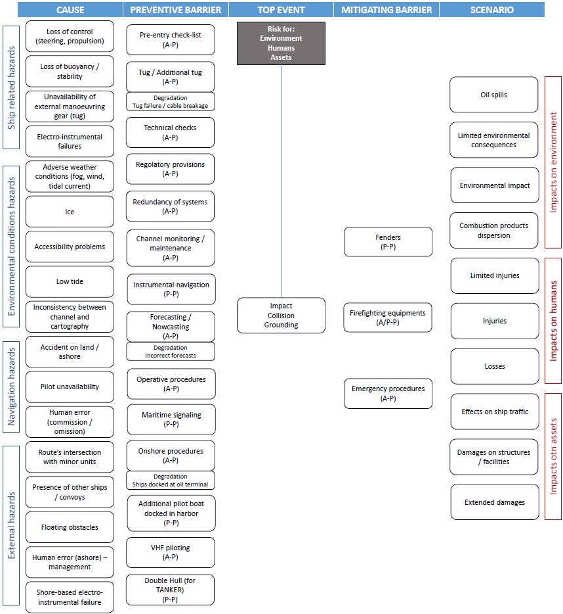

Figure 2: Development of the general Bow-tie for navigational risk (the first barrier letter stands for the barrier type: A/P Active/Passive, the second letter refers to possible Partial effectiveness P).
Table 3: Top Events probability assessment.
TOP EVENT (TE) Class | Bulk [occ/y] | Container [occ/y] | Cruise [occ/y] | Tanker [occ/y]
Ship related TE | 5.15E-04 | 4.90E-04 | 1.00E-11 | 6.01E-05
Environment related TE | 1.12E-03 | 1.03E-03 | 1.02E-03 | 1.03E-03
Waterway related TE | 1.09E-03 | 1.06E-03 | 1.00E-03 | 2.30E-04
Human based TE | 2.00E-04 | 2.00E-04 | 2.00E-04 | 2.00E-04
External threats related TE | 2.41E-03 | 2.41E-03 | 2.11E-03 | 1.22E-03
A summary of the results of the FTA is reported in Table 3 referring different credible Top Events.
It is worth noting that the results of the risk analysis evidenced that the accident scenarios with consequences for the categories environment (E), people (P) and assets (A) fall within the limits of acceptability. On these grounds, the subsequent vulnerability analysis was conducted to identify potential areas for improvement and optimisation of operations. Table 4 summarizes the root elements to which the explored system is most vulnerable. Within the proposed framework, system vulnerabilities are explicitly modelled as amplifying conditions that directly affect hazard activation.
When a specific vulnerability is present, the associated hazard is assumed to have a conditional probability of 1. In probabilistic terms, the vulnerability acts as a deterministic trigger for the corresponding reference accidental scenarios. The above vulnerabilities do not apply to all vessel categories, as some of them, e.g. cruise vessels, are designed with double redundancy control-system, with negligible vulnerability due to electro-instrumental failures
Table 4: Root elements in system vulnerability.
VULNERABILITY 1 | VULNERABILITY 2 | VULNERABILITY 3 | VULNERABILITY 4
Low visibility + Navigation assistance failure | Low tide + Navigation assistance failure | Severe weather conditions + Wrong weather report | Cross with smaller units + Navigation assistance failure

The occurrence of the above event chains would cause an increase in the frequency of top events by up to three orders of magnitude, with the corresponding effects on the accidental scenario. The effects of the defined vulnerabilities are summarized in Table 5, showing the differences between Standard (STD) Quantitative Risk Assessment (QRA) result, and those with the different identified vulnerabilities (V1, V2, V3 and V4) referring, for the sake of simplicity, only to “Tanker” ship category. Other ship categories are evaluated according to the same conceptual approach. The propagation of the existing vulnerabilities through the accidental sequence reflects a worst-case activation of a hazard, leading to an increase in accident scenario probabilities. The modelling choice treats vulnerabilities as critical modifiers - potentially increasing a node's probability to 1 - ensuring that structural, operational, or management weaknesses are immediately reflected in the data provided to decision-makers.
Table 5: Results of vulnerabilities evaluation over the categories E, P and A on tanker accident scenarios.
Ship / Category | Scenario | STD freq. | V 1 | V 2 | V 3 | V 4
Tanker  Environment (E) | Limited/ local environ. impact | 5.43E-06 | 5.21E-03 | 5.21E-04 | 5.33E-03 | 2.61E-04
Tanker  Environment (E) | Atm. dispersion | 5.48E-08 | 5.24E-05 | 5.24E-06 | 5.33E-06 | 2.62E-06
Tanker  Environment (E) | Fire | 5.47E-09 | 5.21E-06 | 5.24E-07 | 5.36E-05 | 2.62E-07
Tanker People (P) | Limited injuries | 2.73E-05 | 2.53E-02 | 2.53E-03 | 2.65E-02 | 1.26E-03
Tanker People (P) | Injuries | 2.73E-07 | 2.53E-04 | 2.53E-05 | 2.65E-04 | 1.26E-05
Tanker People (P) | Losses | 2.73E-10 | 2.53E-07 | 2.53E-08 | 2.65E-07 | 1.26E-08
Tanker Assets (A) | Effects on ship traffic | 2.47E-04 | 2.18E-01 | 2.18E-02 | 2.30E-01 | 1.09E-02
Tanker Assets (A) | Damage/loss | 1.37E-06 | 1.13E-03 | 1.13E-04 | 1.25E-03 | 5.60E-05
Tanker Assets (A) | Extended damage/loss | 1.37E-09 | 1.13E-06 | 1.13E-07 | 1.25E-06 | 5.60E-08

The vulnerability study highlights the crucial role of properly including system vulnerabilities in the analysis to be prepared, in such cases, even for the occurrence of unlikely events to which the system is nevertheless vulnerable, and which may therefore have non-negligible impacts. To increase the resilience of the explored complex navigation system and limit the scenario probability increase under the explored vulnerability conditions, the following areas for performance enhancement can be identified:
- Redundancy of electro-instrumental equipment (e.g. use of PPUs under severe conditions, e.g., Low visibility / Low Tide).
- Improvement of the visibility limits in fog (i.e. adaptive brightness and focused Led beams.
- Maritime light signals upgrade (e.g. advanced optical systems and real-time monitoring of light status).
- Weather nowcasting (hyper localized, near real-time update by ML integration of satellite and buoy data).
- Intelligent collection and analysis of traffic data and data-driven management utilizing AI techniques.
- Strict observance and control of enforced limits and regulations.
- Carrying out timely the planned channel and other relevant maintenance operations.
  - Conclusions
The risk-based framework developed in this paper can provide decision-makers with a structured approach to facilitate learning from navigation incidents and reinforcing the safety management in shallow waters. The capability was tested starting from the assessment of hazards associated with the navigation in the Malamocco -Marghera channel network, ranking them based on their likelihood and potential impact. An accurate quantitative risk assessment was conducted to evaluate the improvements that can be implemented to the technical and non-technical performance by safety barriers to mitigate or reduce the residual risks to an acceptable level. The concluding vulnerability analysis was performed to capture and control the actual conditions to which the navigation system is most sensitive. Implementing technical barriers and procedural, management and emergency measures, the credible risk consists in limited injuries related to intersections with minor units; limited damages on structures connected to groundings; effects on ship traffic related to groundings or floating obstacles. The correlation of the safety zones extent under different conditions, e.g., wind speed/direction, different LOCs etc. require developing a dynamic approach. Ongoing refinement of the study will consider utilizing Bayesian network to reduce potential uncertainties due to scarce incident data and expert elicitation, possibly attaining by a Bayesian updating approach a dynamic and realistic tool to support resilience and decision making. As a concluding remark, it should be noted that technology and data analytics continue to evolve implying a significant potential for advancing the state of the art in risk assessment for navigation, enabling safer and more effective navigation in a variety of contexts. From this observation, some promising research directions and challenges for future work include extending the framework to the assessment of emerging risks deriving from the energy transition, which requires the adaptation of existing maritime infrastructures to the new energy vectors and connected hazards.
Acknowledgments
The study was carried out within the framework of the Connecting Europe Facility European funded project “Channelling the Green Deal for Venice” (2020-2023) with the Maritime Authority - Coast Guard of Venice and main recipient the North Adriatic Sea Port Authority.
References
Adhita I.G.M.S., Fuchi M., Konishi T., Fujimoto S. 2023, Ship navigation from a Safety-II perspective: A case study of training-ship operation in coastal area, Reliability Engineering & System Safety, 234, 109140.
Brown K.R., VanBerkel P., Khan F.I., Amyotte P.R. 2021, Application of bow tie analysis and inherently safer design to the novel coronavirus hazard, Process Safety and Environmental Protection 152, 701–718.
Fu S., Goerlandt F., Xi Y. 2021, Arctic shipping risk management: A bibliometric analysis and a systematic review of risk influencing factors of navigational accidents Safety Science, 139, 105254.
IALA Guideline G1138, 2022, The use of the Simplified IALA Risk Assessment method (SIRA). Edition 2.0, December 2022. IALA, International Association of marine aids to navigation and Lighthouse Authorities.
Jeong, B., Lee, B.S., Zhou, P., Ha, S.-m., 2018. Determination of safety exclusion zone for
LNG bunkering at fuel-supplying point. Ocean Engineering, 152, 113–129.
Pasman H.J., Sripaul E., Khan F., Fabiano B., 2024, Energy transition technology comes with new process safety challenges and risks - What does it mean? Process Safety Progress, 43(2), 226–230.
Ren H., Chen X., Chen Y. 2017, Reliability based aircraft maintenance optimization and applications, Academic Press, ISBN: 978-0-12-812668-4.
Vairo T., Gualeni P., Reverberi A.P., Fabiano B. 2021, Resilience dynamic assessment based on precursor events: Application to ship lng bunkering operations, Sustainability 13, 6836.
Vairo T., Bruzzone A., Magrì S., Fabiano B. 2023, Understanding the vulnerability of complex systems. An integrated approach, Chemical Engineering Transactions, 99, 277–282.
Vairo T., Guarino S., Benvenuto A., Fabiano B., Setola R. 2026, Emergent risks in complex systems: A Bayesian perspective on uncertainty and prediction, Reliability Engineering & System Safety, 270, 112129.
Wielgosz M., Pietrzykowski, Z. 2022, The ship domain in navigational safety assessment, Plos One, 17(4), e0265681.
Yuan S., Cai J, Reniers G., Yang M., Chen C., Wu J. 2022, Safety barrier performance assessment by integrating computational fluid dynamics and evacuation modeling for toxic gas leakage scenarios, Reliability Engineering & System Safety, 226, 108719.

