 CHEMICAL ENGINEERING TRANSACTIONS  VOL. xxx, 2024 | A publication of  
The Italian Association
of Chemical Engineering
Online at www.cetjournal.it

Guest Editors: Valerio Cozzani, Bruno Fabiano, Genserik Reniers
Copyright © 2024, AIDIC Servizi S.r.l.
ISBN 979-12-81206-11-3; ISSN 2283-9216

Addressing safety and risk mitigation in academic laboratories: a case study
Francesca Gasparotto ª, Arian Grainca ^{b}, Paolo Mocellin ^{a,*}, Carlo Pirola ^{b}
ªUniversità degli Studi di Padova. Dipartimento di Ingegneria Industriale, Via Marzolo 9, Padova, Italia.
^{b}Università degli Studi di Milano. Dipartimento di Chimica, Via Golgi 19, Milano, Italia.
paolo.mocellin@unipd.it
This study addresses the critical need for effective risk assessment and mitigation strategies in academic research environments. As research laboratories engage in increasingly complex projects, ensuring the safety of personnel, equipment, and the surrounding environment becomes paramount. These settings are prone to various vulnerabilities, including manual operations, transient states, and diverse training backgrounds.
This work presents a case study focusing on the potential hazards and risks associated with Fischer-Tropsch synthesis. The analysis examines critical factors such as catalyst use, high-temperature reactions, potential by-products, and the influence of human error during manual operations.
Utilizing a systematic approach that incorporates interaction matrices and HAZOP analysis, the study identifies potential undesired scenarios, ranging from minor incidents to severe consequences, and evaluates their likelihood and impact. In response to the identified risks, the paper proposes targeted mitigation measures specifically designed for the Fischer-Tropsch experimental setting, structured as layers of protection.
The findings of this research offer valuable insights into laboratory safety in academic settings, providing a risk assessment and mitigation model adaptable to various experimental setups. By integrating theoretical frameworks with practical applications, this study aims to enhance safety standards in academic laboratories conducting Fischer-Tropsch synthesis and establish a foundation for continuous improvement in laboratory practices.
  - Introduction
Pursuing scientific knowledge within academic laboratories is fundamental to innovation and education. These dynamic environments, where theory meets practice, are the birthplace of new discoveries. Laboratories serve as arenas of experimentation and learning, where students and researchers continuously push the boundaries of science. However, this noble pursuit is accompanied by inherent hazards and potential risks (Mocellin et al., 2022). Academic laboratories are characterized by activities that involve handling hazardous chemicals, which may be flammable, toxic, carcinogenic, or reactive. Moreover, equipment with proper operating conditions is always present when focusing on chemical process experimentation. The operation of complex machinery, ranging from high-pressure systems to electrical devices, introduces additional layers of risk. Ensuring the safety of researchers, students, and staff in these environments is not merely a regulatory compliance issue but a fundamental ethical obligation. Safety measures are crucial to prevent accidents, which can lead to injuries, chronic health issues, or even fatalities. Beyond the immediate health impacts, accidents can disrupt the scientific process, leading to data loss, damage to expensive equipment, and significant delays in research progress. Moreover, safety incidents can erode trust in scientific institutions, affecting public perception and funding.
Despite the establishment of rigorous safety protocols and adherence to strict regulations, incidents in academic laboratories continue to occur with unsettling frequency. Recent statistics on accidents in academic settings indicate that more than 25% of personnel acting in labs have experienced unreported accidents or injuries. In addition, an aggravating factor is ascribed to the fact that around 27% of researchers have skipped risk assessment before performing experiments (Ayi and Hon, 2018), and one in four has not been appropriately trained for specific laboratory hazards. Teaching labs appear as the most affected framework (Ménard and Trant, 2020). Further statistics are provided by the U.S. Chemical Safety and Hazard Investigation Board (CSB), which reported 120 accidents in academic settings between 2001 and 2018. The consequences have ranged from limited impacts (e.g. need for evacuation) to severe injuries in around 100 cases (U.S. Chemical Safety and Hazard Investigation Board, 2018).
These incidents are not always the result of flagrant disregard for safety rules but can also arise from gaps in knowledge, insufficient training, or even complacency. This reality underscores the need for a culture of continuous improvement in risk management strategies (Stricker et al., 2019). Moreover, many qualitative and quantitative approaches are available and well-established for traditional risk assessment in the process industries.
HAZOP analysis and other safety assessment approaches are primarily applied in the process industry. More in detail, HAZOP is commonly employed during large-scale industrial facilities' design and operation phases to ensure safety and prevent accidents. In the context of chemical laboratories in research centers or universities, HAZOP cannot be applied as in industrial scenarios. Laboratories in educational institutions always deal with smaller-scale processes and different types of hazards compared to large industrial plants. However, universities and research institutions still prioritize safety and employ other risk assessment methods suitable for laboratory environments. Safety aspects in these laboratories are usually evaluated using different approaches based on specific operations. Particular attention is paid to the danger of individual reagents or specific working conditions (e.g. high temperature or pressure). However, these frameworks must consider particular characteristics for a careful risk assessment (Zakzeski, 2009). The activities carried out vary continuously, and human interventions on the equipment are frequent. The work protocols are continuously varied due to research needs, and the staff often comprises students with limited experience. In some cases, the performed operations can be carried out with dangerous, toxic, flammable, explosive reagents under severe conditions and in the presence of activators such as heterogeneous catalysts. In these contexts, HAZOP analysis can undoubtedly help detect and resolve potential critical issues, but it must be adapted to the size and characteristics of the laboratory world. In the scientific literature, examples of HAZOP analyzes on a laboratory scale are very limited and generally generic (Leggett, 2012) (Lei et al., 2023). Therefore, understanding the impact of process conditions on the safety framework of an experimental apparatus is critical, and the interaction among the different components (i.e. chemicals, materials, equipment, operating conditions and human factors) must be adequately accounted for to ensure a high level of safety.
In this direction, the present work discusses an attempt to systematize a quantitative risk assessment applied to an operating experimental setup that runs a Fischer-Tropsch synthesis. The aim is to detect critical sections and vulnerabilities while providing suggestions for improving the overall safety of the experimental apparatus. High-risk scenarios associated with deviations from the experimental test intent are identified, and proper risk reduction strategies are implemented.
  - Safety in academic laboratories
Research laboratories and industrial installations differ significantly in terms of safety due to their distinct operational environments, goals, and scales of operation. The specificities of equipment and safety protocols in each context reflect these differences:
- Scale and Scope of Operations: Research laboratories typically focus on small-scale, often exploratory experiments to generate new knowledge or test scientific hypotheses. This contrasts with industrial installations, where processes are significantly scaled up for production. The small scale of research labs may lead some to perceive the risks as lower, potentially leading to less stringent adherence to safety protocols than the rigorous safety standards applied in industrial settings​​.
- Safety Culture and Reporting: A significant challenge in academic research laboratories is underreporting accidents and a generally less developed safety culture than in industrial environments. Industrial labs benefit from a more structured approach to incident and near-miss reporting, which is crucial for ongoing safety improvements. Academic labs often lack this level of structure and rigor, leading to gaps in safety awareness and compliance​​.
- Training and Turnover: The dynamic nature of academic settings, characterized by high turnover and a mix of experience levels among researchers, poses unique challenges for maintaining a strong safety culture. This is in contrast to industrial labs, where employees typically have more stable roles and undergo regular, comprehensive safety training aligned with the specific hazards of their work environment​​.
- Personal Protective Equipment (PPE) and Safety Procedures: PPE use and adherence to safety procedures vary widely between academic and industrial settings. Industrial researchers are more likely to use risk assessment methods before experiments and consistently use PPE. At the same time, academic labs show lower compliance, partly due to a culture of autonomy and intellectual freedom that may prioritize research outcomes over safety protocols​​.
- Safety Training and Education: In academic research labs, safety education often emphasizes preparation for teaching rather than research, leaving a gap in safety training for research activities that involve new and potentially unknown hazards. Conversely, industrial and governmental labs strongly emphasize detailed safety planning, extensive safety checks before experiments, and a comprehensive safety training regime that contributes to a culture of safety respected at all levels of the organization​​.
- Regulatory Compliance and Oversight: Industrial installations are typically subject to stricter regulatory oversight than academic labs, driving a more disciplined approach to safety management. This includes detailed hazard evaluations, mitigation strategies, and direct reporting mechanisms for safety issues, which may not be as thoroughly implemented in academic settings​​.
In academic research laboratories, the pursuit of scientific knowledge often involves the handling of various hazardous materials and the operation of complex equipment. This environment inherently brings a range of hazards and risks, from chemical exposures to physical dangers and equipment malfunctions. Table 1 presents a detailed overview of these primary sources of hazard and risk. This framework aims to enhance the understanding of potential dangers within the lab and emphasize the importance of a comprehensive approach to laboratory safety.
Table 1: Overview of primary sources of hazards and risks in academic research laboratories.
Source | Description and example
Chemical Exposure | Exposure to hazardous chemicals is a primary risk. This includes direct contact with corrosive acids, bases, toxic reagents, or volatile organic compounds (VOCs) that can lead to chemical burns, poisoning, or respiratory issues. For example, handling hydrochloric acid without proper PPE can cause skin burns and inhalation injuries.
Reactive Chemical Hazards | Chemical reactions can pose risks due to the potential for explosive, exothermic, or otherwise uncontrollable reactions. This includes the use of peroxides, azides, or highly reactive metals. An example is the risk of explosion when working with peroxide-based materials under improperly controlled conditions.
Pressure and Vacuum Systems | Systems under high pressure or vacuum can fail, leading to explosions or implosions. Examples include pressure vessel rupture during high-pressure reactions or vacuum system collapse during distillation.
Thermal Hazards | Processes requiring high temperatures can lead to burns, fires, or thermal decomposition of materials, producing hazardous by-products. For instance, overheating an oil bath can lead to fires, while improperly managed exothermic reactions can result in runaway reactions.
Equipment and Instrumentation | Malfunction or improper use of laboratory equipment can lead to accidents. This includes stirrers, heaters, and pressure reactors. For example, failure of a magnetic stirrer in a closed system can lead to pressure buildup and potential rupture.
Electrical Safety | Laboratory equipment and instruments pose electrical risks, including shocks, short circuits, and fires, especially when improperly used or maintained. An example is the use of non-explosion-proof equipment in an environment where flammable vapors are present.
Ventilation and Air Quality | Inadequate ventilation can lead to the accumulation of toxic or flammable fumes or insufficient oxygen levels. For example, failing to use a fume hood when working with ammonia or other pungent gases can cause respiratory irritation or worse.
Personal Protective Equipment (PPE) | Failure to use or improper use of PPE can lead to exposure to hazardous substances. This includes lab coats, gloves, goggles, and face shields. An example of risk is not using flame-resistant lab coats while working near open flames or not utilizing appropriate gloves when handling cryogenic materials, which can lead to frostbite or burns.
Training and Safety Culture | Lack of adequate training and a weak safety culture contribute significantly to laboratory accidents. This includes not understanding the proper use of equipment, underestimating chemical hazards, and not engaging in regular safety meetings. An example is improperly scaling up reactions without adequate review of the hazards involved or bypassing safety protocols for expediency.
  - Methodology and results
The risk assessment of the experimental setup was based on a set of techniques focusing on peculiarities and the impact of human actions on the operability of the plant.
The following techniques were used to perform the analysis:
- Interaction matrix (IM).
- Hazard and operability analysis (HAZOP).
- Layer of protection analysis (LOPA).
The first technique, the interaction matrix, was adopted to determine any incompatibilities among substances, materials and operating conditions (CCPS, 2008). The second technique, i.e. the HAZOP analysis, systematically addressed deviations leading to potentially hazardous scenarios (Crawley and Tyler, 2015)(The British Standards Institution, 2016). The results of these two techniques set the basis for the subsequent approach according to a layer of protection analysis (LOPA). The LOPA was applied to scenarios classified as unacceptable or high-risk as a result of the HAZOP analysis (The British Standards Institution, 2017) (Clarke, 2023).
The case study focused on an operating experimental setup for performing Fischer-Tropsch (FT) syntheses where syngas mixtures are converted into hydrocarbons through a packed bed catalytic reactor at high temperature and pressure (Figure 1). FT synthesis is a sophisticated process sensitive to critical parameters, including temperature, pressure, composition and catalyst, each playing a crucial role in determining the final hydrocarbon composition. In this sense, variations in the operating conditions can induce relevant deviations in the process itself (Table 2) (Moulijn et al., 2013)(Evans and Smith, 2012). This affects the reactive section and downstream operations, which are strongly influenced by the nature and composition of the reaction outflow. As a general feature, the process is overall exothermic and requires a co-feed of hydrogen and carbon monoxide.
According to the HAZOP analysis, the process was divided into four relevant nodes: the mixing section with the preparation of the reactive mixture, the step of FT reaction, the separation of the outflow from the reactor, and the ultimate product analysis.
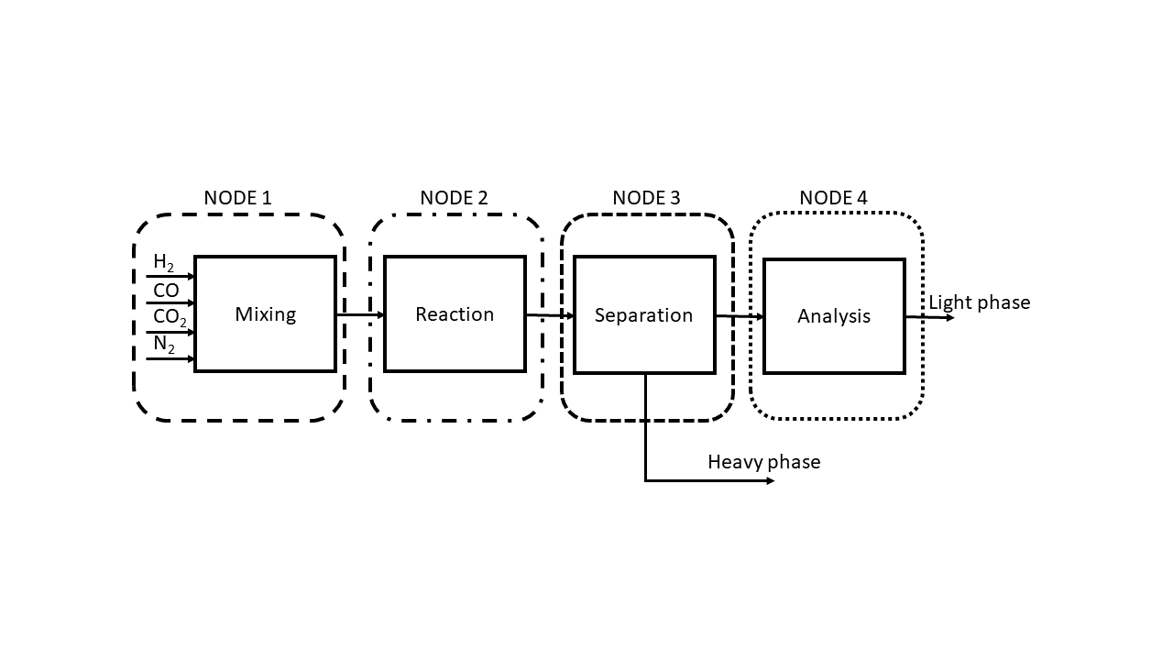
Figure 1: Block flow diagram and definition of the HAZOP nodes.
Table 1: Parameters of the FT synthesis (Moulijn et al., 2013)(Evans and Smith, 2012).
Temperature | Pressure | Composition | Catalyst
200-350°C | 15-50 bar | H₂/CO = 3/1 | Fe/Co-based
  - Results
A preliminary analysis of the interaction among chemicals, materials and operating conditions was performed and structured according to an interaction matrix (Figure 2). This step was critical to understanding incompatibilities among categories of chemicals or materials and to adequately investigate potential consequences. The analysis allowed for listing a set of critical incompatibilities due to the coexistence of flammable gases, pyrophoric catalysts and the formation, under deviated process conditions, of even corrosive molecules. In specific cases, the interaction with process conditions associated with very high temperatures or pressures in particular sections of the experimental setup would eventually enhance hazardous scenarios. These were formulated in detail in a HAZOP analysis focusing on the selected nodes and analyzing causes and implications of deviated process conditions on the general framework. The design intent of each node is reported in Table 3, while a selection of high-risk deviations is provided in Table 4.

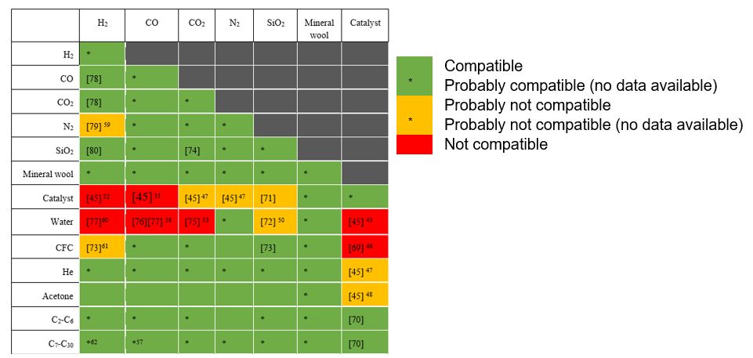
Figure 2: Extract of the chemicals interaction matrix implemented for the current case study.
Table 2: Description of nodes and operative conditions (design intent).
Node | Operation |  | Description | Operating conditions | Inherent hazard
1 | Mixing |  | Feeding and mixing of reactants in proper quantities | 20°C; 5-10 bar | Pressure reduction, mixing of streams
2 | Reaction |  | Fischer Tropsch reaction | 150-350°C; 20 bar | High temperature and pressure
3 | Separation |  | Separation of light and heavy phase | 5°C; 20 bar | Inadequate separation
4 | Analysis |  | Analysis of the gaseous phase | 60°C; 1 bar | -
Table 3: List of unprotected deviations at high risk. C: very severe risk (barriers are required). E: moderate risk. F: noticeable risk.
Node | Deviation | Initiating event category | Initial risk | Mitigated risk | Required SIL
1 | More flow rate | Human error | C | F | SIL 1
2 | More temperature/reaction rate | Human error | C | F | SIL 1
2 | Less pressure | System failure | C | E | SIL 3
2 | No (electric) power | System failure | C | E | SIL 3
3 | More pressure | Human error | C | F | SIL 1
Peculiar to the case study is that the deviations reported in Table 4 resulted in unprotected, i.e., no risk reduction strategies, systems, or procedures were implemented. This means that if any of the cited deviations occur, potentially hazardous outcomes could result. During the identification of potential causes, two primary initiating events were isolated: human error in performing operations and a technical failure. For example, a higher flow rate in Node 1 could be ascribed to an erroneous operation in dosing a specific reactant's flow rate through the dedicated manual valve. The HAZOP analysis allowed for discriminating among different consequences based on the feed line affected by the operational error. Apart from a preventive effort entirely based on adherence to the operative procedure and the operator's experience performing the operational task, no preventive or protection strategies were expected. Therefore, no process devices fully dedicated to managing the abovementioned deviations were preliminarily deployed.
According to a concerted risk matrix, each Top Event (TE) was assigned to an estimated risk class. The likelihood and the severity were distinguished according to a ranking based on four likelihood classes (unlikely, rare, probable, expected) and five severity classes (noticeable, great, serious, very serious, catastrophic). The combinations were systematized into different risk classes ranging from very low risks (not requiring additional risk reduction measures) to very high risks (requiring both active and passive barriers) (Table 3).
This framework estimated the required risk reduction factor for each TE, adapting the approach proposed in the IEC 61511 standard (Clarke, 2023)(The British Standards Institution, 2017). Specific additional and independent protection layers were identified based on the required risk reduction factor. It should be noted that, given the laboratory setting considered, a set of protection layers was already implemented. This included, for example, the laboratory hood and a pressure safety valve to protect against unexpected pressure increases but was insufficient to deal with most identified deviations, especially those ascribed to operational errors.
In light of the adopted methodology, additional protection layers were identified to reduce the risk of unprotected scenarios (Table 5). To ensure proper action, automatic systems were chosen to limit the possibility of human error while increasing the overall reliability of the system.
Table 4: An example of automatic protection layers to be implemented to reduce the top events risk.
Deviation | Additional protection layer | Comment
More temperature | Safety interlock on  TIC loop | This architecture automatically shuts off the furnace if the temperature in the FT reactor is too high.
No electric power | Backup utility supply and autostart of standby equipment | Provided the criticality of a supply loss, a dedicated supply unit is required with autostart.
More pressure | 2oo3 redundant scheme | Gained experience showed recurrent failures of PIs. Incorrect visualization leads to improper manual operations.
  - Conclusions
Ensuring safety in academic research laboratories requires a proactive and vigilant approach. This involves recognizing and understanding the unique hazards and characteristics of these environments and adopting effective risk mitigation strategies to safeguard the health and well-being of lab personnel. The effectiveness of safety measures relies on consistent compliance and enforcement, which can vary significantly across institutions depending on the prevailing safety culture and administrative support.
In this study, we conducted a quantitative risk assessment of a Fischer-Tropsch synthesis experimental setup. We identified high-risk scenarios, particularly those lacking risk-reduction measures, highlighting the need for implementing multiple layers of protection. This strategy effectively reduced the necessity for manual operations and minimized the likelihood of human error by incorporating automated devices to prevent undesirable events and maintain equipment integrity.
Our methodology enhanced the understanding of specific operational risks and established a benchmark for improving safety management and protocols. This approach contributes to creating a safer research environment and provides a model for continuous improvement in laboratory safety practices.
Acknowledgments
This work has been partially funded by Piano di Sostegno alla Ricerca (PSR 2021), Action A of the Dipartimento di Chimica, Università degli Studi di Milano. The Collegues Prof. Laura Prati and Prof. Alessandro Minguzzi are warmly thanked for their support and contribution to the work with the PNRR Spoke 9-PE2 project with the Politecnico di Milano.
References
Ayi, H.R., Hon, C.Y., 2018. Safety culture and safety compliance in academic laboratories: A Canadian perspective. J- Chem. Health Saf., 25, 6-12.
CCPS, 2008. Hazard Identification Methods, in: Guidelines for Hazard Evaluation Procedures. pp. 51–69.
Clarke, P., 2023. Chapter 1 - Introduction to functional safety, in: Clarke, P. (Ed.), Functional Safety from Scratch. Elsevier, pp. 1–26.
Crawley, F., Tyler, B., 2015. HAZOP: Guide to Best Practice, 3rd ed. ed. Elsevier.
Leggett, D.J., 2012. Lab-HIRA: Hazard identification and risk analysis for the chemical research laboratory. Part 2. Risk analysis of laboratory operations. J. Chem. Heal. Saf. 19, 25–36.
Lei, C., Wu, H., Sun, N., Ye, M., 2023. Chemical Laboratory Hazardous Chemical Management Based on HAZOP 11, 559–582.
Ménard, A.D., Trant, J.F., 2020. A review and critique of academic lab safety research. Nat. Chem. 12, 17–25.
Mocellin, P., 2022. Experimental methods in chemical engineering. Can. J. Chem. Eng., 100(12), 3450-3469.
Moulijn, J.A., Makkee, M., Diepen, A.E.: van, Moulijn, J.A., 2013. Chemical process technology. John Wiley & Sons, Chicester, pp. 171–220.
Stricker D., Gerweck N., Meyer T., 2019, Measuring the safety climate of academic laboratories to improve safety behaviours, Chemical Engineering Transactions, 77, 271-276.
The British Standards Institution, 2017. BS EN 61511-1:2017+A1:2017, Functional safety-Safety instrumented systems for the process industry sector- Part 1.
The British Standards Institution, 2016. BS EN 61882:2016, Hazard and operability studies (HAZOP studies) — Application guide.
U.S. Chemical Safety and Hazard Investigation Board, 2018. Laboratory Incidents January 2001 – July 2018
Zakzeski, J., 2009. Improving engineering research laboratory safety by addressing the human aspects of research management. J. Chem. Heal. Saf. 16, 5–20.

