|  |  |
| --- | --- |
| cetlogo ***CHEMICAL ENGINEERING TRANSACTIONS***  ***VOL. xxx, 2024*** | A publication of  aidiclogo_grande |
| The Italian Association  of Chemical Engineering  Online at www.cetjournal.it |
| Guest Editors: Valerio Cozzani, Bruno Fabiano, Genserik Reniers  Copyright © 2024, AIDIC Servizi S.r.l. **ISBN** 979-12-81206-11-3; **ISSN** 2283-9216 | |

Assessing Wet Scrubbing as Final Additional Stage for Dry Waste-to-Energy Flue Gas Treatment Lines

Carmela Chianese, Alessandro Dal Pozzo\*, Valerio Cozzani

Laboratory of Industrial Safety and Environmental Sustainability (LISES), Alma Mater Studiorum - Università di Bologna, via Terracini n.28, 40131 Bologna, Italy

a.dalpozzo@unibo.it

The conclusions on the best available techniques for waste incineration implemented in Europe by EU Decision 2019/2010 introduce ambitious targets for emission control. Provisions such as higher removal efficiency requirements for HCl and SO2 and the continuous measurement of Hg emissions can induce operators of existing waste-to-energy plants to contemplate a revamping of their flue gas cleaning lines to wet treatment, a guarantee of high abatement performance for both acid gases and micropollutants. However, wet treatment is associated with high investment costs and a relevant energy penalty related to the management of temperatures along the flue gas cleaning line, especially in the presence of tail-end deNOX treatments.

The present study examines a possible alternative, represented by the integration of a wet scrubbing system as a final flue gas treatment downstream of an existing dry acid gas removal system. An economic and environmental analysis is performed in order to assess the potential benefit conferred by the retrofit. Noteworthy reductions in operational costs, diminished consumption of reactants, and a concurrent decrease in waste generation are observed, depending on the SO2 load in the flue gas and the compatibility constraints with deNOX operation in the selective catalytic reduction reactor.

* 1. Introduction

The recent publication of the updated European reference document on the Best Available Techniques (BAT) for waste incineration (BREF WI, Neuwahl et al., 2019) has set ambitious and stringent targets for mitigating the emissions of waste combustion pollutants (Ardolino et al., 2020; Van Caneghem et al., 2019), particularly for acid gases like hydrogen chloride (HCl) and sulfur dioxide (SO2) that are typical of waste combustion (Cao et al., 2024). To ensure compliance with such targets and secure the renewal of environmental permits, existing waste-to-energy (WtE) plants might seek retrofitting of their flue gas treatment (FGT) systems (Schiavon et al., 2024). A survey by Dal Pozzo et al. (2018) highlighted that in recent years most of the retrofit and new build projects in WtE flue gas cleaning were based on dry treatment. Dry injection of powdered sorbents enables acid gas removal with lower investment costs and layout complexity compared to wet treatment systems based on scrubbing (Quicker et al., 2014). In addition, the introduction of multi-stage configurations has shown the possibility of significantly reducing operating costs and indirect environmental impacts of dry systems (Dal Pozzo et al., 2018). However, dry systems remain limited by the lower efficiency of gas-solid vs. gas-liquid reaction processes (Chin et al., 2005). If current HCl and SO2 emission limit values (ELVs) were to be significantly reduced, Dal Pozzo et al. (2023a) showed that existing dry FGT lines would suffer a disproportionately high increase in operating costs compared to wet systems. In addition, as per recent BAT guidelines (Neuwahl et al., 2019), WtE plants must start continuous emission monitoring for the trace pollutant mercury (Hg). While Hg concentrations are typically low, its release from waste incineration is strongly affected by the variability of the feedstock (Romero et al., 2020) and fluctuates significantly over time (Rumayor et al., 2018). Wet treatment provides an inherent buffer to counter Hg spikes, compared to the costly injection of activated carbon in dry FGT. Therefore, a reversal of the market trend seen in the last 10-15 years might be expected, with a renewed interest in wet scrubbing. On the other hand, the complete revamping of an existing dry FGT line to a wet treatment system presents a relevant drawback. If post-treatment flue gas reheating is required, e.g., to prevent the occurrence of a visible plume at the stack, or because the existing line includes a tail-end selective catalytic reactor (SCR) for ultra-low NOX emissions, the associated energy penalty more than offsets any cost savings related to lower consumption of reactant in the switch from dry to wet acid gas removal (Dal Pozzo et al., 2023b; Dong et al., 2020).

The present work examines an alternative solution that is potentially advantageous compared to a full revamping, i.e., the integration of a wet scrubbing system as a final flue gas polishing treatment downstream of an existing dry FGT line. A two-stage system is taken as a representative dry FGT line, at least for WtE plants that are already subject to strict acid gas ELVs. In this configuration, the wet treatment section can be placed downstream of the SCR, as the upstream dry stages reduce the SO2 load entering the SCR. Therefore, based on scenarios of pollutant loads in the raw flue gas, material and energy balances for the FGT with and without the wet stage addition are solved in order to estimate the variation in the operating costs of acid gas treatment.

* 1. Case study
     1. Reference technologies

The reference configuration of the two-stage system for the dry FGT is reported in Figure 1. Specifically, there are two phases of acid gas removal. In the first phase, acid gas removal is performed with direct furnace sorbent injection at high temperatures using dolomitic lime, facilitating a gas-solid neutralization reaction to reduce pollutant concentrations (Biganzoli et al., 2015). Subsequently, the flue gas leaving an electrostatic precipitator, employed to capture coarse ash, is sent to a Venturi reactor for the secondary acid gas treatment. Here, sodium bicarbonate and activated carbons are injected, with the first used to reduce efficiently acid gas concentration and the second employed for micropollutant adsorption (mainly Hg and dioxins). The further passage of the flue gas through the bag filter completes the neutralization reactions and separates flue gas from carbons, fine powders, and solid residues from the reaction with sodium bicarbonate. Eventually, after flue gas deacidification, the NOX load is reduced through selective catalytic reduction (SCR), via ammonia injection. The retrofit hereby analyzed consists of the addition of a wet scrubbing section as further acid gas abatement before flue gas release into the atmosphere. Such placement, downstream of the SCR, has two advantages:

* It avoids interference with SCR operation. The entrainment of solvent droplets containing soluble salts in the flue gas from the wet system into the SCR could potentially cause pore clogging in the catalyst, consequently diminishing its efficiency over time (Szymaszek et al., 2020).
* It reduces the need for flue gas reheating. The reheating required to bring the flue gas leaving the scrubber at 120 °C (typical temperature at stack) instead of 180 °C (typical SCR operating temperature) is significantly lower and generally achievable with heat integration within the flue gas line.

A double-step configuration is proposed for the operation of the wet scrubbing section: an “acid” step involving physical absorption of HCl (and Hg) in water, followed by a “neutral” step where SO2 is chemically absorbed by a solution of sodium hydroxide, NaOH (Velhow, 2015). The resulting wastewater undergoes physico-chemical treatment before safe discharge into the public sewage system. The two streams are typically mixed and treated with Ca(OH)2 for pH control and neutralization. Removal of heavy metal compounds is based on flocculation, by adding complexing agents, followed by precipitation. It is worth mentioning that the analyzed configuration is contemplated as a technique to consider in the determination of the BAT by the BREF WI, under the name of “Addition of wet scrubbing as a flue-gas polishing system after other FGC techniques”. The present study represents the first economic viability analysis for such retrofitting option in the open literature.

* + 1. Constraints

For economic viability analysis of the retrofit, a reference size of the WtE installation (200 t/d of treated waste, 45,000 Nm3/h of generated flue gas, 7200 h/y of operation) was taken into account. To consider the variability of waste composition, two different scenarios of inlet flue gas composition were analyzed and classified in two cases, as reported in Table 1, discernible by the different values of SO2 concentration. The HCl stack concentration was set at one-fourth of the target value indicated in the BREF WI, ensuring operational safety with a substantial margin. Another constraint was imposed on SO2 leaving the dry treatment stages, whose concentration value was fixed to 5 mg/Nm3, to prevent SCR catalyst poisoning. The economic analysis considered three scenarios of SO2 concentration which are summarized in Table 2: the set point above and two higher levels, set at 15 and 30 mg/Nm3, used to evaluate the effect of this constraint on operating costs. It is worth remarking that such values are based on plant operators’ decisions, upon recommendations of their SCR suppliers.

Figure 1: Gas treatment line integrated with a final wet polishing stage.

Table 1: Concentration of acid compounds (in mg/Nm3) in the 2 cases of inlet flue gas composition.

|  |  |  |
| --- | --- | --- |
| Acid compound | Case 1 | Case 2 |
| HCl | 1000 | 1000 |
| SO2 | 100 | 300 |

Table 2: Operating constraints for the different FGT configurations.

|  |  |  |
| --- | --- | --- |
| Configuration | CSO2, SCR [mg/Nm3] | CHCl, stack [mg/Nm3] |
| Existing FGT | 5 | 0.5 |
| FGT+WT\_5 | 5 | 0.5 |
| FGT+WT\_15 | 15 | 0.5 |
| FGT+WT\_30 | 30 | 0.5 |

* 1. Modeling
     1. Modeling of the process

The starting point for the analysis was the quantification of the feed rate of reactants required to obtain a given acid gas removal efficiency and the related generation rate of solid residues using mass balances for the acid gas removal processes. Models developed in previous studies were adopted, as outlined in the following.

For the dry stages, a semi-empirical model (Dal Pozzo et al., 2020) was used to establish the correlation between acid gas conversion and sorbent feed rate. The model discriminates the reactivity of different sorbents toward different acid compounds by the use of ni,j empirical parameters, tuned on actual operational data of full-scale acid gas treatment units. Details on the determination of ni,j for sodium bicarbonate via historical process data analysis and dolomitic lime via dedicated test runs can be found elsewhere (Dal Pozzo et al., 2020). For the wet scrubber, the methodology outlined by Dal Pozzo and Cozzani (2021) was adopted. Specifically, the acid scrubber was modeled as an equilibrium stage, performing the physical absorption of HCl by a recirculated water stream (water drain regulated by a pH setpoint of 0.5). The subsequent neutral scrubber was assumed to perform the removal of SO2 and the remaining HCl from the acid scrubber via the addition of a 10 % excess feed of NaOH. Wastewater treatment from the scrubber was characterized by the consumption of Ca(OH)2 for pH neutralization and the production of a solid sludge (mainly CaSO4, with a 50 % moisture content by weight).

* + 1. Economic and Environmental Analysis

The main focus of the economic analysis was the assessment of the operating costs associated with the proposed retrofitted configuration. Specifically, the cost entries expressed in €/kg, reported in Table 3, refer to the dry and wet treatment stages and are representative of a WtE plant in Northern Italy. The indirect environmental implications of the retrofit were also assessed, in terms of variations in reactant consumption and the related solid waste generation, with the existing FGT line serving as a benchmark. The outcomes of this environmental analysis are discussed in section 4.

Table 3: Cost entries and related unit cost values considered in the analysis.

|  |  |  |
| --- | --- | --- |
| Cost entries | Unit | Value |
| Dry treatment stage | | |
| Dolomitic lime | €/kg | 0.145 |
| Sodium bicarbonate | €/kg | 0.255 |
| Disposal  of residues | €/kg | 0.195 |
| Wet treatment stage | | |
| NaOH | €/kg | 0.203 |
| Water | €/kg | 0.600 |
| Wastewater treatment | | |
| Ca(OH)2 | €/kg | 0.022 |

* 1. Results and discussion

The results of the economic analysis for the two different cases of flue gas composition are reported in Figure 2. It is evident that the retrofit has an overall cost-reducing effect on operations. The most pronounced benefit from the retrofit is observed with a lower SO2 load in the inlet gas, showcasing reductions of up to 50 %, whereas its impact is less prominent in the case of high SO2 that imposes high acid gas removal in the dry stages to comply with the CSO2, SCR constraints. Generally speaking, at equal overall abatement performance, the lower the utilization of the dry stages the lower the costs, thanks to the higher efficiency of the wet scrubbing section in the removal of acid pollutants.

The distribution of the different cost contributions varies significantly with the inlet flue gas composition and the CSO2, SCR constraints. In general, sodium bicarbonate is highly reactive towards both HCl and SO2, while dolomitic lime demonstrates higher reactivity towards SO2 compared to HCl (Tamascelli et al., 2024). Consequently, in situations where flue gas concentration levels do not necessitate stringent abatement performance, dolomitic lime emerges as the preferred choice. Conversely, addressing high SO2 abatement requirements necessitates a high feed of both dolomitic lime and sodium bicarbonate.

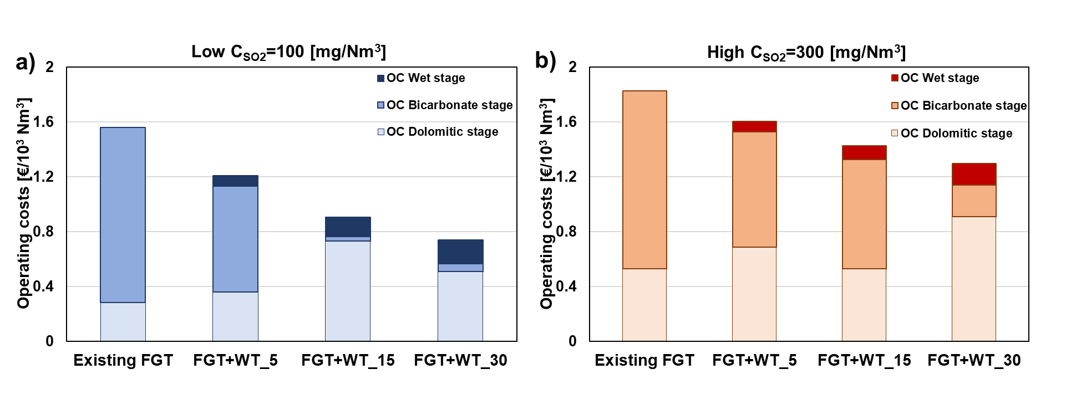*Figure 2: Operating costs for the reference (existing FGT) and integrated configurations (Retrofit) at different SO2 concentrations at the treatment line inlet. a) Low SO2 concentration (Case 1); b) High SO2 concentration (Case 2).*

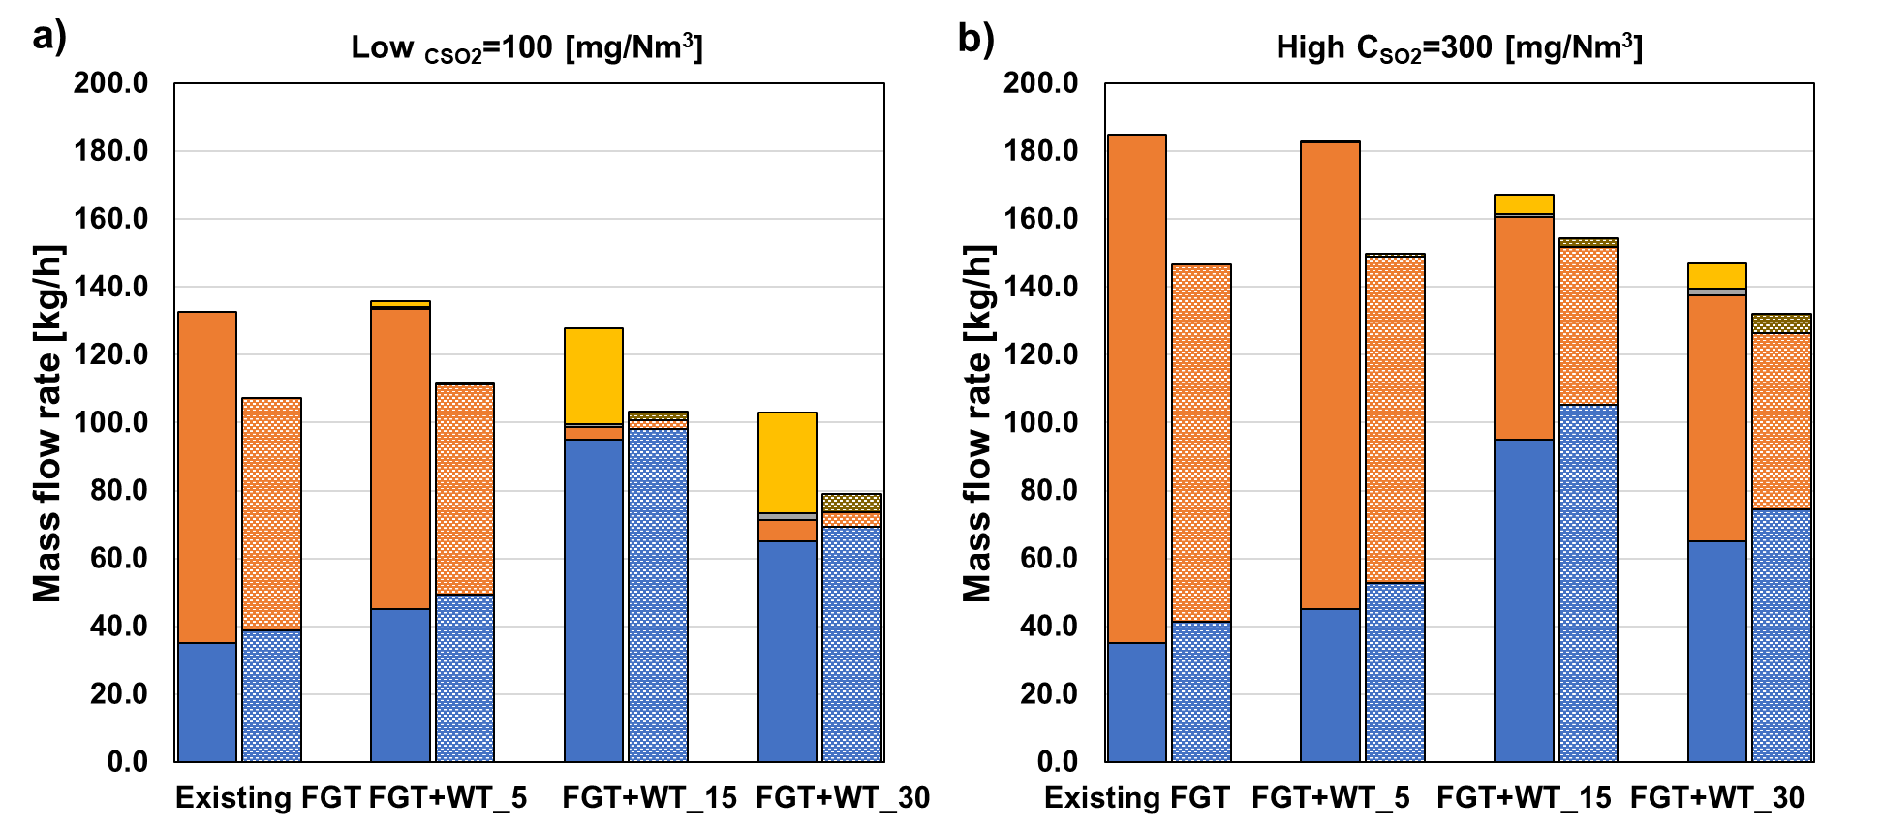Figure 3: Reactant consumption and related waste production for the reference and integrated configuration. Each column referred to the reactant consumption is coupled with a dotted column, representative of the waste production.

The impact of the retrofit can also be analyzed from the environmental perspective, in terms of material consumption and waste generation. Figure 3 illustrates the mass flow rates of reactants utilized in each stage alongside the corresponding waste generated. A positive environmental impact in this context is dependent on the CSO2, SCR constraints. If a CSO2, SCR = 30 mg/Nm3 is permissible at the SCR inlet, the retrofit can realize up to a 40 % reduction in overall waste generation from the acid gas treatment system. Vice versa, negligible effects are observed if the stricter CSO2, SCR limits of 5 or 15 mg/Nm3 have to be applied.

To better quantify the overall economics of introducing the wet retrofit for a WtE plant, a projection of the operating costs over 10 years of plant operation was performed in Table 3, considering a reference size of the FGT line of 45,000 Nm3/h. The analysis uses the existing FGT line as a reference, characterized by an HCl stack concentration of 0.5 mg/Nm3, and a limit value of SO2 concentration at the SCR level of 5 mg/Nm3. Considering the reference plant characterized by an inlet SO2 concentration of 100 mg/Nm3, the introduction of the additional wet treatment stage could result in total savings of 1.4 million €, corresponding to a net present value of 1 million €, assuming an interest rate of 5 %. Such figures can be compared to estimates of the investment cost for the wet scrubbing section, in order to assess the net economic benefit of the retrofit.

Table 3: Costs given by retrofit for a reference size of the flue gas treatment line equal to 45,000 Nm3/h.

|  |  |  |  |
| --- | --- | --- | --- |
| Cumulative operating costs over 10 years [M€] | | | |
| Case 1 | | Case 2 | |
| Existing  FGT**\*** | 5.1 | | 5.9 |
| FGT+WT\_5 | 3.7 (-27.5 %) | | 5.0 (-15.3 %) |
| FGT+WT\_15 | 2.7 (-47.1 %) | | 4.4 (-25.4 %) |
| FGT+WT\_30 | 2.2 (-56.9 %) | | 4.0 (-32.2 %) |
| **\*CHCl, out=0.5 mg/Nm3; CSO2, SCR =5 mg/Nm3** | | | |

* 1. Conclusions

This study delves into the feasibility of integrating a wet scrubbing system as a third stage in the acid gas removal process of an existing WtE plant equipped with a two-stage dry treatment system. Through economic analysis, the results suggest that the proposed retrofit offers potential benefits in terms of operating cost reductions, in particular for flue gases with lower SO2 loads. Clearly enough, the savings associated with the operation of the retrofitted system have to be compared with the investment cost for the installation of the wet scrubber. The reduction in operating costs over 10 years for representative mid-size WtE plants offers a reference value to which estimates of investment cost can be compared in order to assess the net benefit of such a solution. As for the environmental implications, integrating the wet polishing stage can reduce the mass of reactants and residues related to existing dry treatment units by up to 30 wt. %, depending on the permissible limit of SO2 concentration at the entrance of the SCR equipment.

References

Ardolino, F., Boccia, C., Arena, U., 2020, Environmental performances of a modern waste-to-energy unit in the light of the 2019 BREF document, Waste Management, 104, 94-103.

Biganzoli L., Racanella G., Rigamonti L., Marras R., Grosso M., 2015, High temperature abatement of acid gases from waste incineration. Part I: Experimental tests in full scale plants, Waste Management, 36, 98-105.

Cao, S., Cao, J., Zhu, H., Huang, Y., Jin, B., Materazzi, M., 2024, Removal of HCl from gases using modified calcined Mg-Al-CO3 hydrotalcite: Performance, mechanism, and adsorption kinetics, Fuel 355, 129445.

Chin T., Yan R., Liang D.T., 2005, Study of the reaction of lime with HCl under simulated flue gas conditions using X-ray diffraction characterization and thermodynamic prediction, Industrial & Engineering Chemistry Research, 44, 8730-8738.

Dal Pozzo A., Abagnato S., Cozzani V., 2023a, Assessment of cross-media effects deriving from the application of lower emission standards for acid pollutants in waste-to-energy plants, Science of The Total Environment, 856, 159159.

Dal Pozzo A., Capecci S., Cozzani V., 2023b, Techno-economic impact of lower emission standards for waste-to-energy acid gas emissions, Waste Management, 116, 305-134.

Dal Pozzo A., Cozzani V., 2021, Wastewater management of wet scrubbers in waste-to-energy facilities: A life cycle analysis, Chemical Engineering Transactions, 86, 619-624.

Dal Pozzo A., Guglielmi D., Antonioni G., Tugnoli, A., 2018, Environmental and economic performance assessment of alternative acid gas removal technologies for waste-to-energy plants, Sustainable Production and Consumption, 16, 202-215.

Dal Pozzo A., Lazazzara L., Antonioni G., Cozzani V., 2020, Techno-economic performance of HCl and SO2 removal in waste-to-energy plants by furnace direct sorbent injection, Journal of Hazardous Materials, 394, 122518.

Dong J., Jeswani H.K., Nzihou A., Azapagic A., 2020, The environmental cost of recovering energy from municipal solid waste, Applied Energy 267, 114792.

Neuwahl F., Cusano G., Gomez Benavides J., Holbrook S., Roudier S., 2019, Best Available Techniques (BAT) Reference Document for Waste Incineration. EUR 29971 EN.

Quicker P., Rotheut M., Noel Y., Schulten M., Athmann U., 2014, Treating WTE flue gases with sodium bicarbonate, Power, 158, 59-63.

Romero L.M., Lyczko N., Nzihou A., Antonini, G., Moreau, E., Richardeau, H., Coste, C., Madoui, S., Durécu, S., 2020, New insights on mercury abatement and modeling in a full-scale municipal solid waste incineration flue gas treatment unit, Waste Management, 113, 270-279.

Rumayor, M. Svoboda K., Švehla J., Pohořelý M., Šyc M., 2018, Mitigation of gaseous mercury emissions from waste-to-energy facilities: Homogeneous and heterogeneous Hg-oxidation pathways in presence of fly ashes, Journal of Environmental Management, 206, 276-283.

Schiavon, M., Ravina, M., Zanetti, M., Panepinto, D., 2024. State-of-the-Art and Recent Advances in the Abatement of Gaseous Pollutants from Waste-to-Energy, Energies, 17, 552.

Szymaszek A., Samojeden B., Motak, M., 2020, The deactivation of industrial SCR catalysts-a short review, Energies, 13, 3870.

Tamascelli N., Dal Pozzo A., Scarponi G.E., Paltrinieri N., Cozzani V., 2024, Assessment of Safety Barrier Performance in Environmentally Critical Facilities: Bridging Conventional Risk Assessment Techniques with Data-Driven Modelling, Process Safety and Environmental Protection, 181, 294-311.

Van Caneghem, J., Van Acker, K., De Greef, J., Wauters, G., Vandecasteele, C., 2019. Waste-to-energy is compatible and complementary with recycling in the circular economy. Clean Technologies and Environmental Policy, 21, 925-939.

Vehlow J., 2015, Air pollution control systems in WtE units: An overview, Waste Management, 37, 58–74.