|  |  |
| --- | --- |
| cetlogo ***CHEMICAL ENGINEERING TRANSACTIONS***  ***VOL. xxx, 2024*** | A publication of  aidiclogo_grande |
| The Italian Association  of Chemical Engineering  Online at www.cetjournal.it |
| Guest Editors: Valerio Cozzani, Bruno Fabiano, Genserik Reniers  Copyright © 2024, AIDIC Servizi S.r.l. **ISBN** 979-12-81206-11-3; **ISSN** 2283-9216 | |

Assessment of Damages to the Environment   
due to Natech accidents: a Case Study

Valentina Di Talia\*, Federica Ricci, Sarah Bonvicini, Valerio Cozzani

LISES – Dipartimento di Ingegneria Civile, Chimica, Ambientale e dei Materiali - Alma Mater Studiorum – Università di Bologna, via Terracini 28, 40131 Bologna (Italy)

\*valentina.ditalia2@unibo.it

One of the potential triggers for major accidents is natural events, the so-called Natech scenarios. The attention toward these accidents has been growing over the last decades, driven by the increasing frequency of natural events and the severe consequences they can entail. Indeed, serious hazards to human health and the environment arise from major accidents. Besides impacting ecosystems, environmental harm can also pose indirect threats to the population contaminating land, surface water, and groundwater. Extensive research has been conducted on the direct risks to the population originating from fires, explosions, and toxic releases, while the assessment of environmental damages was only marginally considered.

The necessity to create a methodology to evaluate damages to the environment is paramount to enable a comprehensive assessment of the risk posed by Natech accidents. The current study seeks to establish a methodological approach to assess consequences for the environment resulting from releases of Light Non-Acqueous Phase Liquids (LNAPLs) caused by Natech accidents on seawater. The methodology is applied to a fictitious case study to demonstrate its applicability and the relevance of the environmental contamination issues. The methods developed in the present study represent a step forward towards a comprehensive Natech risk assessment, paving the way for the inclusion of other environmental compartments.

* 1. Introduction

Natural events can induce major technological accidents in industrial contexts commonly denoted as Natechs (Krausmann et al., 2017). These events are related to the Loss Of Containment (LOC) of hazardous substances and are of particular concern due to their specific peculiarities, such as the simultaneous failure of multiple equipment items and the unavailability of traditional safety barriers, utilities and lifelines (Misuri et al., 2023). Over the recent decades, there has been a discernible increase in academic and industrial attention towards investigating the potential outcomes of Natech accidents, also propelled by the rising frequency of natural events (IPPC, 2018) and the potentially severe consequences to which they can lead (Krausmann et al. 2017).

The scenarios currently accounted for in the consequence assessment consider primarily humans (i.e., fires, explosions, toxic releases) but it was proven by Ricci et al. (2021) that environmental contamination is also a significant outcome. More specifically, the historical analysis of past Natech accidents (3,970 records) demonstrated that environmental contamination occurred in 44% of the cases and that it was mainly related to releases of Light Non-Acqueous Phase Liquid (LNAPL) substances. The Livorno oil spill (eNatech, 2021), the Tohuko oil spill (Krausmann and Cruz, 2013), and the Koeali acrylonitrile release (Girgin, 2021) are some paradigmatic examples of accidents where relevant contamination to the environment occurred. Hence, it is clear that Natech accidents represent a serious hazard both to human health and the environment.

While extensive research has explored the direct risks to the population arising from Natechs triggered by different natural events, there has been relatively less emphasis on quantitatively evaluating environmental damage (Mesa-Gomez et al., 2021) even though this specific assessment is prescribed by current legislation (i.e., the Seveso III Directive). In addition, besides directly harming the environment through the contamination of land, surface water, and groundwater, these effects may pose an indirect threat to the population.

In this context, the present study aims to establish a general methodological approach for assessing the environmental damages resulting from releases of LNAPL substances caused by Natech accidents. The methodology is tailored to address the effects of the LOC events in the marine environment, acknowledging the peculiarities of its sub-compartments. This novel approach is specifically designed to be integrated into the Natech Quantitative Risk Assessment (QRA) framework and it is based on the identification and quantification of the physical effects related to the release of LNAPLs into the sea.

To demonstrate the applicability of the methodology, a fictitious case study was designed. The quantification of the effects of an oil spill into the sea (i.e., off-shore) derived from the rupture of an atmospheric tank located on the coast (i.e., on-shore) is presented and discussed.

The methodology proposed represents a first step towards a more comprehensive assessment of the risk related to Natech accidents and lays the foundations for the inclusion of other environmental compartments.

* 1. Methodology

The QRA process - as defined by ISO 31000 (2018) - has been adapted over the years to address Natech events triggered by various typologies of natural hazards, focusing solely on the human target (Mesa-Gomez et al., 2021). The assessment comprises three key macro-phases: hazard identification, risk analysis and risk evaluation. Hazard identification involves identifying the potential hazards and sources of accidents, both internal and external to the analysed industrial site. Up to this stage, no significant differences arise while considering humans or the environment as the target. On the contrary, risk analysis entails evaluating the frequencies and the consequences of credible accidental scenarios and needs to be tailored for the target environment. In particular, it is important to consider the target environment when applying methods such as event trees in the frequency assessment (the ARAMIS project (Andersen et al., 2004) can be seen as an example). It is noteworthy that the event trees should acknowledge the possible disruption of safety barriers given that their failure is a credible scenario in the case of Natechs (Misuri et al., 2020). The rupture of a catch basin due to a natural event serves as an exemplary instance in this regard as it can lead to the unrestrained spread of the released substances in the area around the industrial facility, thereby exacerbating the consequences for the environment. Regarding consequence assessment, it is to highlight that it involves two sequential stages: source term modelling and effect modelling. While the former can be carried out with consolidated approaches (TNO, 1998), the latter requires to specifically acknowledge the peculiarities of the environmental compartments. Lastly, in the risk evaluation stage, specific metrics should be defined to quantify the risk to the environment. While for the human target risk is usually calculated in terms of fatalities in the form of individual or societal risk, considering the environment requires to account for different parameters.

* + 1. Consequence assessment

The methodology presented in this paper targets in particular sea water, acknowledging that accidental hydrocarbon spills are a significant source of marine pollution (ITOPFa, 2012) and that Natech events have the potential to cause substantial damage to the environment, especially when they involve the LOC of LNAPLs (Ricci et al. 2022). Furthermore, it is considered that hydrocarbon spills pose immediate and long-term harm to all four sea sub-compartments: sea surface, water column, sea bed and shoreline ([Stephansen et al., 2017](https://www-sciencedirect-com.ezproxy.unibo.it/science/article/pii/S0957582021003426?via%3Dihub#bib0335)).

To assess the severity of the impacts caused by a release of LNAPLs into the sea, it is paramount to acknowledge the processes that these substances undergo after the spill and to individuate parameters to characterize each sea sub-compartment. The fate and transport of LNAPLs (oil is considered as reference substance in this context) depend on a complex interplay of physical, chemical and biological processes, commonly known as “weathering” (ITOPFb, 2012). Weathering processes are directly linked with the action of currents and winds and depend on many different aspects such as the spill characteristics, the composition of the hydrocarbon mixture, the meteo-marine conditions during and after the spill and the morpho-bathymetry at the accident site (API, 1999).

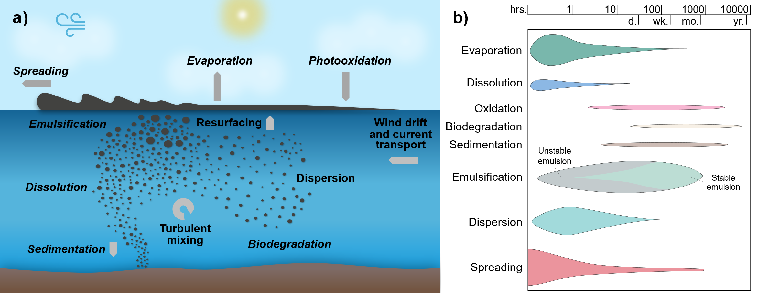

*Figure 1: a) Schematization of the weathering processes occurring after a release of oil into the sea (adapted from Keramea et al., 2021); b) Changes in the relative importance of the weathering processes over time (adapted from* ITOPFb, 2012).

Figure 1a outlines the weathering processes that occur after a release of oil into the sea, which include the spreading of the oil slick on the sea surface and the evaporation of its volatile components, the dispersion and the dissolution of the oil in the water column, and the oil interactions with the seabed and the coast. It is to remark that the relative importance of the weathering processes varies over time, significantly affecting the fate of the spill. For the sake of completeness, this aspect is described in Figure 1b.

The parameters to be addressed in the assessment of the effects of LNAPL releases per each sea-sub compartment have been identified taking into account all the aspects just presented and are reported in Table 1. Thus, after the individuation of the release scenario to be analysed at a specific location, the parameters that need to be quantified are the area of the oil slick on the sea surface, the contaminated volume of sea water, the length of the contaminated shoreline and the contaminated sea floor area. Specific software tools able to forecast the oil spill trajectory and the evolution of the oil mass balance in each sea sub-compartment - as the ones reviewed by Keramea et al. (2021) - can be employed to perform the assessment.

In addition, threshold values could be employed to assess the significance of the contamination per each sea sub-compartment, meaning that there is harm to the environment only if the contamination is above the threshold. Table 1 reports an example of threshold values proposed in the Norsk Olje & Gass reports.

Table 1: Parameters and threshold values for the consequence assessment related to LNAPL releases due to Natech accidents per sea sub-compartment.

|  |  |  |  |
| --- | --- | --- | --- |
| Sub-compartment | Parameter | Threshold value | Reference |
| Sea surface | Contaminated sea surface area | 0.001 mm thickness | Norsk Olje & Gass (2018a) |
| Water column | Contaminated water column volume | 58 ppb concentration | Norsk Olje & Gass (2018b) |
| Shoreline | Contaminated shore length | 0.2 tonoil/kmshoreline | Norsk Olje & Gass (2018c) |
| Sea floor | Contaminated sea floor area | 7 mgoil/kgdry sediment | Norsk Olje & Gass (2018d) |

* + 1. Case study

A fictitious case study inspired by a real installation was designed in order to test the proposed methodology. The scenario considered is the catastrophic rupture due to an earthquake of an atmospheric storage tank located on the coast, in the proximity of the Adriatic Sea (Puglia Region). The rupture causes the instantaneous release of 2000 tonnes of oil from the on-shore tank to the adjacent sea water.

The atmospheric tank has a diameter of 35 meters and a height of 3.6 meters, and it is filled at the 70% of its capacity with oil. The oil is assumed to be of the Arab Light Batelle type and its characteristics, retrieved from the the MEMW Oil Database (SINTEF, 2023), are summarized in Table 2.

Table 2: Arab Light Batelle oil characteristics (source: MEMW Oil Database (SINTEF, 2023)).

|  |  |
| --- | --- |
| Arab light oil characteristic | Value |
| Density | 0.864 g/cm³ (15°C) |
| API° | 32.3 |
| Pour point temperature | - 40°C |

The consequence assessment of the scenario targeting the sea and its sub-compartments required the selection of an appropriate software tool for the estimation of the parameters presented in Table 1. The software employed for the application is version 14.1.0 of OSCAR, the Oil Spill Contingency and Response model developed by SINTEF (2023). OSCAR is an advanced and recognized fate and transport model that allows the estimate of the effects of an oil release in the sea surface, water column, shoreline and sea floor provided the spill characteristics (e.g. oil mass spilt, oil typology, coordinates of the release) and the environmental conditions in the area where the spill is located (e.g., wind and current data). It is worth mentioning that the software has an internal database that provides bathymetry and coastal data for a specific location and that is able to model the oil weathering processes that start occurring immediately after a spill (Keramea et al., 2021).

In order to assess the consequences of the defined scenario, six deterministic simulations of the duration of 60 days each were performed to cover the whole year to acknowledge the seasonal factors that might influence the fate of the oil spill. The simulations starting dates are: 1st January (Simulation 1), 1st March (Simulation 2), 1st May (Simulation 3), 1st July (Simulation 4): 1st September (Simulation 5), 1st November (Simulation 6). The tests were conducted with a spatial resolution of 500 m per 500 m and a time step of 15 minutes and the oil thickness was set to initial and final values of 4 mm and 0.0007 mm, respectively. Wind and current data for a solar year were sourced from the Copernicus Marine Environment Monitoring Service database (CMEMS, 2023). The wind data used in the application had a temporal resolution of 1 hour, while the current data had a temporal resolution of one day and a horizontal spatial resolution of 1/24°, with 141 unequally spaced vertical levels. It is to note that some preliminary runs were performed to identify an appropriate duration of a single simulation keeping as a reference the relative importance of the weathering processes as summarized in Figure 1b.

The most hazardous simulation for each marine sub-compartment was identified based on the maximum extension of the contamination (i.e. maximum oil slick area, maximum volume of contaminated water column, maximum contaminated shoreline and maximum area of contaminated sea floor) and considering the threshold values presented in Section 2.1. The thresholds allow for addressing the significant effects of the analyzed release in each sub-compartment of the marine environment (i.e., values below the threshold can be neglected while assessing the consequences). The results obtained with this approach are to be used in the Natech QRA as the base for the quantification of the risk.

* 1. Results

The results of the deterministic simulations provide an estimate of the variation of the four parameters used to evaluate the damage to the environment (see Table 1) over 60 days. The most hazardous simulation per each sub-compartment was individuated based on the higher value above the threshold of the parameter analysed (i.e., worst-case scenario approach). Simulation 3, Simulation 1, Simulation 3, and Simulation 2 have been identified as the most hazardous for, respectively, the sea surface, the water column, the shoreline, and the sea floor. Figure 2 presents the trend over time of the extension of the contamination in the most hazardous simulation of each marine sub-compartment, estimated by applying the threshold values proposed in Table 1. As presented in the four graphs, concerning the scenario analysed, the maximum value of the polluted surface area is 1060 km2 on day 19, the maximum value of the polluted water column volume is 9.54 km3 on day 2, the maximum oiled shore length is 360 km on day 57 and the maximum contaminated sea floor surface is 56 km2 on day 60. These values, summarized in Table 3 for the sake of clarity, provide a straightforward quantification of the effects in each marine sub-compartment that can be used to assess the severity of a scenario (i.e., the consequences) in the Natech QRA context. It is also noteworthy that the present method sets a basis for designing the remediation strategies to be employed in each marine sub-compartment in the case of an accident. Remediation strategies must be chosen based on the nature of the released material and the specific environmental compartment of concern. In this regard, the methodology applied in this study not only calculates the extent of the damage on each compartment, but also identifies the most impacted ones providing guidance for prioritizing remediation actions.

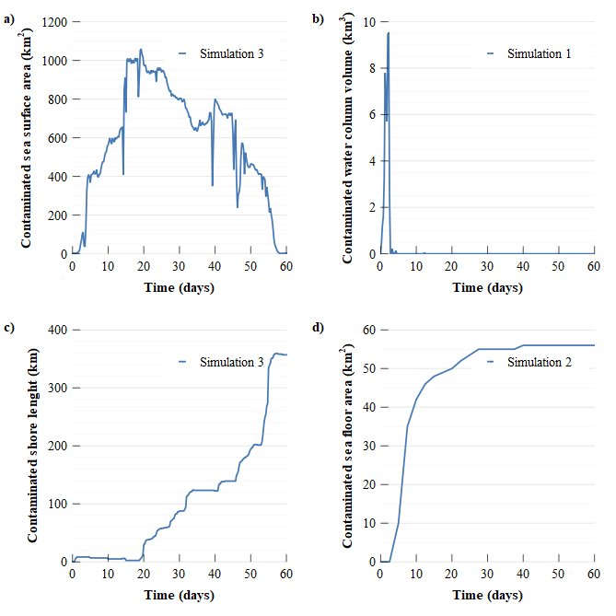

Figure 2: Variation over time of the relevant parameters for the most hazardous simulations: a) contaminated sea surface area, b) contaminated water column volume, c) contaminated shore length, and d) contaminated sea floor area.

Table 3: Results of the consequence assessment for the scenario analyzed in the case study.

|  |  |  |
| --- | --- | --- |
| Sea sub-compartment | Parameter | Result (maximum value) |
| Sea surface | Contaminated sea surface area | 1060 km2 |
| Water column | Contaminated water column volume | 9.54 km3 |
| Shoreline | Contaminated shore length | 360 km |
| Sea bed | Contaminated sea floor area | 56 km2 |

* 1. Conclusions

The methodology proposed provides an approach that can be applied in the context of Natech QRA for the quantification of the consequences of LNAPL releases in the marine environment acknowledging its sub-compartments: sea surface, water column, shoreline and sea floor. The methodology consists of quantifying a representative parameter per each marine sub-compartment by employing an adequate software tool. The parameters proposed are the area of the oil slick on the sea surface, the contaminated volume of the water column, the contaminated shoreline and the contaminated sea floor area. Considering the context of the application of the methodology, it should be also evaluated whether a specific level of contamination causes harm to the environment or not. To this aim, threshold values could be applied in the evaluation of consequences, including in the analysis only contamination above the threshold value.

The novel approach was applied to a case study inspired by a real installation to demonstrate its applicability. The results provide a clear quantification of the effects caused by the release in each of the four marine sub-compartments, setting the basis for the estimation of the risk targeting the environment in the Natech QRA. In the risk analysis, the quantified consequences should be integrated with the expected frequencies of the scenario to assess the risk. Furthermore, the results obtained for the target environment, and in this specific case for the sea, can be integrated with those calculated for the human target to draw a complete risk profile. Clearly enough, the methodology proposed in the present study creates the ground for defining specific methods to assess the consequences in other environmental compartments and represents a step forward in the definition of a comprehensive approach to perform Natech QRA able to include all possible targets.

References

Andersen H., Casal J., Debray B., De Dianous V., Duijm N. J., 2004, ARAMIS: Accidental Risk Assessment Methodology for Industries in the Context of the SEVESO II Directive, User Guide, Faculté Polytechnique de Mons, Major Risk Research Centre: Mons, Belgium.

API, 1999, Fate of Spilled Oil in Marine Waters: Where Does It Go, What Does It Do, How Do Dispersants Affect It? American Petroleum Institute, Publication n.4961, Washington.

CMEMS, 2023, Copernicus Marine Environment Monitoring Service database, <marine.copernicus.eu/>, accessed 15.12.2023.

eNatech, 2021, eNatech: Natural hazard-triggered technological accidents database, Eur. Comm. Jt. Res.Cent., <enatech.jrc.ec.europa.eu>, accessed 12.2.24

Girgin S., 2011, The natech events during the 17 August 1999 Kocaeli earthquake: aftermath and lessons learned, Nat. Hazards Earth Syst. Sci., 11, 1129–1140.

ITOPFa, 2012, Response to Marine Chemical Incidents, The International Tanker Owners Pollution Federation Limited, London, UK, Technical Information Paper n. 17.

ITOPFb, 2012, Fate of Oil Marine Oil Spills, The International Tanker Owners Pollution Federation Limited, London, UK, Technical Information Paper n. 2.

IPPC, 2018, Global warming of 1.5◦C. An IPCC special report on the impacts of global warming of 1.5◦C above pre-industrial levels and related global greenhouse gas emission pathways, The Context of Strengthening the Global Response to the Threat of Climate Change, Geneva, Switzerland.

ISO 31000, 2018, Risk management Guidelines, < iso.org/obp/ui/#iso:std:iso:31000:ed-2:v1:en>, accessed 1.02.2024.

Keramea P., Spanoudaki K., Zodiatis G., Gikas G., Sylaios G., 2021, Oil spill modeling: A critical review on current trends, perspectives, and challenges, Journal of Marine Science and Engineering, 9(2), 1–41.

Krausmann E., Cruz A.M., 2013, Impact of the 11 March 2011, Great East Japan earthquake and tsunami on the chemical industry, Nat. Hazards, 67, 811–828.

Krausmann E., Cruz A.M., Salzano E., 2017, Natech Risk Assessment and Management. Reducing the Risk of Natural-Hazard Impact on Hazardous Installations. Elsevier Inc.

Mesa-Gómez A., Casal J., Sánchez-Silva M., Muñoz F., 2021, Advances and gaps in natech quantitative risk analysis, Processes, 9(1), 1–14.

Misuri A., Ricci F., Sorichetti R., Cozzani V, 2023, The Effect of Safety Barrier Degradation on the Severity of Primary Natech Scenarios, Reliability Engineering & System Safety, 235, 109272.

Norsk Olje & Gass, 2018a, Bjørgesæter, A., ERA Acute Report 3 (2015): ERA Acute Phase 3 – Surface compartment, Acona Report n° 37571.

Norsk Olje & Gass, 2018b, Nilsen, H., Johnsen H.G., Nordtug T., Johansen, Ø., ERA Acute Report 2 (2006): threshold values and exposure to risk functions for oil components in the water column to be used for risk assessment of acute discharges (EIF Acute), Statoil contract n° C.FOU.DE.B02.

Norsk Olje & Gass, 2018c, Brude, O.W., Rusten, M., Braathen, M., ERA Acute Report 4 (2015): ERA Acute Phase 3 - Development of shoreline compartment algorithms, DNV GL Report n° 2015 – 0552.

Norsk Olje & Gass, 2018d, Stephansen, C., Sørnes, T.O., Skeie, G.M., ERA Acute Report 6 (2015): ERA Acute - development of seafloor compartment algorithms -biological modeling, Akvaplan-niva Report n° 5425.02.

Ricci F., Casson Moreno V., Cozzani V., 2021, A comprehensive analysis of the occurrence of Natech events in the process industry, Process Safety and Environmental Protection, 147, 703–713.

Ricci F., Bonvicini S., Moreno V.C., Cozzani V., 2022, The Quantitative Assessment of Damage to the Environment in Major Accidents Caused by Natural Events, Chemical Engineering Transactions, 90, 253–258.

SINTEF, 2023, <www.sintef.no/en/software/oscar>, accessed 10.02.2023.

Stephansen C., Bjørgesæter A., Brude O.W., Brönner U., Kjeilen-Eilertsen G., Libre J.M., Waterloo Rogstad T., Fjeld Nygaard C., Sørnes T., Skeie G.M., Jonsson H., Rusten M., Nordtug T., Reed M., Collin-Hansen C., Damsgaard J., 2017, ERA acute - a multi-compartment quantitative risk assessment methodology for oil spills, Poster Presented at the International Oil Spill Conference, 15-18 May 2017, Long Beach CA, US.

TNO, 1998, Methods for the Calculation of Physical Effects (Yellow Book), Committee for the Prevention of Disasters, CPR 16E, Sdu Uitgevers, The Hague.