|  |  |
| --- | --- |
| cetlogo ***CHEMICAL ENGINEERING TRANSACTIONS***  ***VOL. xxx, 2024*** | A publication of  aidiclogo_grande |
| The Italian Association  of Chemical Engineering  Online at www.cetjournal.it |
| Guest Editors: Valerio Cozzani, Bruno Fabiano, Genserik Reniers  Copyright © 2024, AIDIC Servizi S.r.l. **ISBN** 979-12-81206-11-3; **ISSN** 2283-9216 | |

Resilience Assessment of Chemical Sites   
Exposed to Natural Events

Matteo Valente\*, Federica Ricci, Valerio Cozzani

LISES – Department of Civil, Chemical, Environmental, and Materials Engineering- Alma Mater Studiorum – Università di

Bologna, via Terracini 28, 40131 Bologna (Italy)

matteo.valente6@unibo.it

The increasing threat posed by extreme natural disasters in industrial areas, where hazardous materials are handled, underscores the necessity for a robust safety management framework. Traditional safety management strategies based on the Quantitative Risk Assessment may fall short in assessing the long-term impacts of such events. Consequently, Resilience Engineering principles have been recently introduced in the context of process safety and Natech (natural hazards triggering technological disasters) accident response. Through a comprehensive review of the literature, the present study analyses existing methods for the quantitative resilience assessment of industrial systems to Natech events, focusing on chemical process plants and integrated energy systems. Moreover, the methodologies reviewed in this study are classified based on their key features, along with the resilience metrics adopted in the developed approach.

* 1. Introduction

Natech events (technological accidents triggered by natural events) have become a growing concern for regulatory authorities and industries (Mesa-Gómez et al., 2020), especially in areas susceptible to catastrophic natural disasters. However, they can be triggered as well by natural events having a moderate intensity, such as extreme temperatures (Ricci et al., 2020). The severity of Natech events is typically higher than conventional technological accidents (Cruz and Krausmann, 2008), primarily due to the ability of natural events to cause rapid and multiple failures (Krausmann and Cruz, 2013), potentially compromising utility systems (Misuri and Cozzani, 2022), safety barriers (Misuri et al., 2020), and emergency response (Ricci et al., 2024, 2022). This may lead to an increase in the frequency and consequences of complex unmitigated scenarios, thus enhancing the possibility of domino effects (Misuri et al., 2023). In addition, natural hazards can cause damage to essential external infrastructure, such as transportation networks and power supply systems, compromising the accessibility of the plant (Krausmann et al., 2017) and hindering recovery efforts. Therefore, the consequences of Natech accidents can go far beyond direct structural damage since the prolonged downtime period can cause significant economic losses. In this context, safety management strategies based on the Quantitative Risk Assessment (QRA) framework (e.g., Cozzani et al. (2014)) may be ineffective, considering the possible disabling of safety barriers during accidents (Misuri et al., 2020) and the inadequacy of such approaches in evaluating the long-term consequences of Natech events. In response to this issue, the application of resilience engineering principles in the framework of process safety and Natech management has gained significant attention in the last few years. Resilience engineering aims to develop a system able to withstand and rapidly recover from unexpected events (Hollnagel and Woods, 2006). Thus, a resilient chemical plant is able to co-exist with the threat of natural hazards, minimizing business interruption and economic losses when a technological accident is triggered. The application of resilience engineering to the chemical and process industry (CPI) is of vital importance as it can lead to new insights into creating a facility capable of handling disruptions that fall outside the set of conventional disturbances, such as natural events. In order to identify contributions and gaps in the applications of resilience in the CPI, Pawar et al. (2021) proposed a literature review on the application of resilience engineering within the fields of industrial systems. Similarly, Chen et al. (2023) conducted a comprehensive review of resilience applications in the context of process safety and environmental protection. However, a specific review addressing the quantitative resilience assessment in the framework of the management of Natech scenarios is still lacking.

The present study provides a review of the technical literature that proposes methods for quantitative resilience assessment in the context of process safety and Natech accidents. Specifically, an in-depth analysis was carried out to highlight key aspects and differences among the existing methodologies for resilience assessment in Natech accidents. The results show that although some common approaches are present in applying resilience engineering principles, substantial differences among proposed contributions are identified.

* 1. Methodology

The methodology reported in Figure 1 was applied to retrieve and analyse the available approaches for the quantitative resilience assessment of industrial installations vulnerable to Natech scenarios.

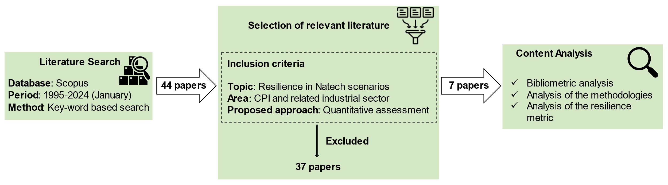

Figure 1: Flowchart of the methodology applied for collecting and analysing the relevant literature addressing the quantitative resilience assessment to Natech scenarios. CPI: chemical and process industry.

The relevant literature was collected by applying a systematic search approach. The time span considered in the search ranges from 1995, in line with the introduction of the term Natech by Showalter and Myers (1994), up to 2024 (January). The Scopus database was selected as the source for the bibliographic search and all types of documents (articles, conference papers, and book chapters) were included in the search to comprehensively cover all the available studies on the topic.

The first step of the methodology involves the literature search to gather documents relevant to the present study. In order to formulate an appropriate search query for the Scopus database, a set of relevant keywords and their synonyms were defined. Three main groups of keywords were identified: resilience, Natech, and chemical and process industry. These keywords were chosen to narrow the scope of the search to the framework of resilience to Natech scenarios within the chemical and process industry. In addition, Boolean operators were used to combine different search queries, and the keywords were searched within document titles, abstracts, and author-defined keywords. As a result, a total of 44 items were collected from the bibliographic database of Scopus. After, the search results were restricted to include only studies relevant to the scope of the present contribution. For this purpose, three specific inclusion criteria were established and applied:

1. *Topic*: the article should focus on the evaluation of resilience in Natech scenarios.
2. *Application areas*: the application area of the study is the CPI or related industrial sector.
3. *Proposed approach*: the article proposes a methodology for the quantitative resilience assessment.

After the application of such criteria, a total of 7 records were identified as pertinent. Notably, among them, the first article was published in 2019 although the time span considered in the literature search starts from year 1995.

Finally, the papers selected as relevant were analysed to outline a review of the latest development regarding the quantitative resilience assessment of industrial installations exposed to Natech events. A bibliometric analysis of all the selected documents was carried out to identify research topics, trends, and links among the contributions retrieved in the literature. The main features of the methodologies proposed in each paper were analysed to highlight similarities and differences among them. Moreover, the resilience metrics adopted in the methodologies reviewed were analysed to outline key aspects of their application.

* 1. Results
     1. Bibliometric analysis

A specific bibliometric analysis was used to identify connections among emerging topics and research interest in the framework of quantitative resilience assessment of industrial plants to Natech events. In detail, a co-occurrence analysis of terms was carried out for the relevant publications, involving the author and index keywords. To ensure clarity, synonymous terms were merged into a single term to avoid redundancy. The co-occurrence analysis was performed with VOSviewer, and the result is shown in Figure 2.

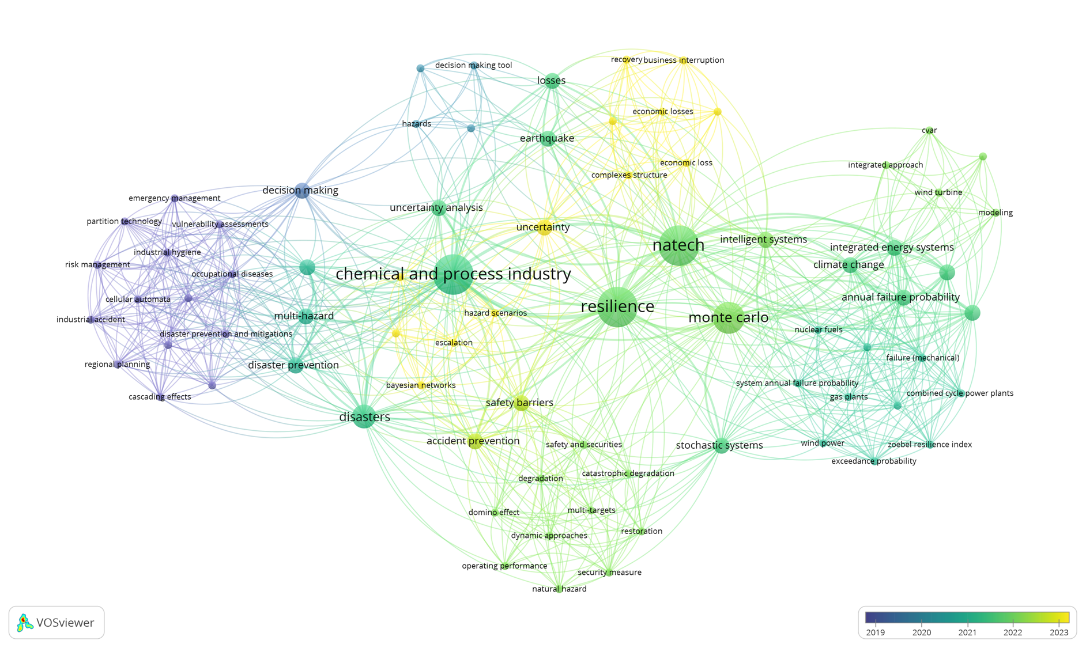

Figure 2: Result of the co-occurrence analysis of author and index keywords associated with the analysed literature. The temporal colour scale refers to the average publication year.

In the co-occurrence network displayed in Figure 2, the size of the nodes is proportional to the occurrence of a term among publications, while links between terms reflect the co-occurrence of terms in the publications (i.e., documents in which they are used together). Moreover, the network map is represented by applying a colour scale based on the average publication year of each term.

The network map clearly shows that the terms “Natech”, “resilience”, and "chemical and process industry" are the most used in the documents analyzed, validating the adequacy of the methodology applied to identify the relevant literature. Notably, nearly all terms in the network are connected to CPI, except for a distinct cluster linked to the term “integrated energy system”. This portion of the network is representative of articles addressing the resilience of power plants and integrated energy systems to Natech scenarios.

Recently, significant advancements have been made in the assessment of safety barrier degradation, effects of multiple primary scenarios, and domino effects. Indeed, terms such as “safety barriers”, “degradation”, “domino effects”, and “multi-target” are representative of the efforts of the research to include these advancements in the resilience assessment. Similarly, the presence of terms such as “Monte Carlo”, “Bayesian network”, and “uncertainty” reflects the efforts of the current research to incorporate the quantification of the uncertainty related to the possible cascading consequences involved in a Natech scenario. Finally, the position in the time interval of terms such as “recovery” and “restoration” reflects the growing importance of these aspects in the quantitative resilience assessment, especially in Natech scenarios.

* + 1. Overview of the methodologies

A detailed description of the methodologies collected is presented, highlighting key aspects and contributions to the resilience assessment of industrial plants exposed to Natech events. Table 2 presents an overview of the methodologies analyzed in this study. As can be seen, all the approaches are developed considering an industrial plant as the reference system, even if two studies (Di Maio et al., 2022, 2021) specifically consider integrated energy systems that comprise power plants and electricity infrastructures. Moreover, the table reports the category of natural events triggering Natech scenarios to which the methodology can be applied, as well as the natural events considered in the case study to validate the methodologies. Most of the studies are developed taking into account generic natural events and are validated with a case study involving floods or earthquakes. It is worth noting that these represent the natural events more studied also in the framework of Natech QRA. Differently, the methodology developed by Chen et al. (2022) is appliable both to intentional attacks and to generic natural disasters, however, it was validated assuming a disruption caused by an intentional attack. Also, the methodology proposed by Kalemi et al. (2024) was specifically developed for earthquakes.

Table 2: Overview of the characteristics of methodologies utilized in literature for quantitative resilience assessment. CPI: Chemical and Process Industry. IES: Integrated Energy System.

|  |  |  |  |  |  |  |
| --- | --- | --- | --- | --- | --- | --- |
| Reference | Year | Area studied | |  | Natural event | |
| CPI | IES |  | Methodology | Case Study |
| (Kalemi et al., 2024) | 2023 | ✓ | X |  | Earthquake | Earthquake |
| (Zeng et al., 2023) | 2023 | ✓ | X |  | Generic | Flood |
| (Di Maio et al., 2022) | 2022 | X | ✓ |  | Generic | Flood |
| (Chen et al., 2022) | 2022 | ✓ | X |  | Generic | NA |
| (Di Maio et al., 2021) | 2021 | X | ✓ |  | Generic | Flood |
| (Caputo et al., 2020) | 2020 | ✓ | X |  | Generic | Earthquake |
| (Chen et al., 2019) | 2019 | ✓ | X |  | Generic | Earthquake |

Table 3 highlights the key features of each methodology concerning the accident and the post-accident phase. Notably, not all the reviewed approaches incorporate the specific features of Natech scenarios. All the methodologies consider that a natural hazard might trigger multiple primary technological scenarios. However, only three of the proposed methods consider domino effects, and in a single case safety barrier degradation was considered. Indeed, the methodologies developed by Zeng et al. (2023) provided the most detailed assessment of the consequences of the Natech scenarios among all the analyzed approaches.

Relevant differences among the methodologies analyzed are also present in the assessment of the system recovery. The assessment typically considers two phases: adaptation and recovery. The adaptation involves tasks like cleanup and planning, with system performance remaining stable. Then, the recovery phase begins, focusing on activities to restore plant operability. Notably, in the approaches presented by Di Maio et al. (2021, 2022) the adaptation phase is not present, as they assumed the recovery activities to begin immediately after the end of the accident. Conversely, the other contributions include this phase for the assessment of system recovery. It is worth mentioning that Zeng et al. (2023) and Chen et al. (2019) did not specifically address the quantitative evaluation of the plant recovery phase.

Table 3: Summary of the specific features of the reviewed methodologies for the Natech accidents, and for the phases considered in the assessment of the recovery process.

|  |  |  |  |  |  |  |
| --- | --- | --- | --- | --- | --- | --- |
| Reference | Assessment of the accident phase | | |  | Assessment of the post-accident phases | |
| Multiple primary events | Safety barriers degradation | Domino effect |  | Adaptation | Recovery |
| (Kalemi et al., 2024) | ✓ | X | X |  | ✓ | ✓ |
| (Zeng et al., 2023) | ✓ | ✓ | ✓ |  | X | X |
| (Di Maio et al., 2022) | ✓ | X | X |  | X | ✓ |
| (Chen et al., 2022) | ✓ | X | ✓ |  | ✓ | ✓ |
| (Di Maio et al., 2021) | ✓ | X | X |  | X | ✓ |
| (Caputo et al., 2020) | ✓ | X | X |  | ✓ | ✓ |
| (Chen et al., 2019) | ✓ | X | ✓ |  | X | X |

* + 1. Analysis of the Resilience Metrics

The methodologies analyzed in this study adopted various resilience metrics, which are reported in Table 4 together with their most relevant features. Indeed, some of these metrics are based on the evaluation of the resilience curve, i.e. the evaluation of the plant performance from the impact of the natural disaster until the end of the recovery phase. In addition, resilience metrics can be classified as dynamic or static depending on their ability to incorporate temporal considerations into the metric. A dynamic metric can capture and describe the temporal aspects of system behavior, while a static metric does not account for the time dependence of the events.

Table 4: Classification of the resilience metric adopted in the analysed literature.

|  |  |  |  |
| --- | --- | --- | --- |
| Reference | Resilience metric | Curve based metric | Time dependence |
|
| (Caputo et al., 2020; Kalemi et al., 2024) | $$R=\frac{\int_{t_{0}}^{t^{*}}{C\left(t\right)dt}}{t^{*}-t_{0}}$$ | ✓ | Static |
| (Zeng et al., 2023) |  | X | Dynamic |
| (Di Maio et al., 2022, 2021) | $$R=1-\frac{E_{i}∙(t_{pr}-t_{0})}{2∙(t^{*}-t_{0})}$$ | ✓ | Static |
| (Chen et al., 2022) | $$R=\frac{\int_{t_{0}}^{t_{pr}}{f\left(t\right)dt}}{f\left(t_{0}\right)(t_{pr}-t_{0})}$$ | ✓ | Static |
| (Chen et al., 2019) | $$R=R_{CRC}∙R_{AC}$$ | X | Static |

In the methodology proposed by Caputo et al. (2020) and Kalemi et al. (2024), plant resilience is quantified as the integral of the operational capacity C(t) over the time, between the time of a seismic event (t0) and the control time (t\*), that represents the maximum expected time for full recovery considering all potential scenarios. Similarly, Di Maio et al. (2021, 2022) adopted the Zobel resilience index (Zobel and Baghersad, 2020), based as well on the integral of the resilience curve over time, where the interval (tpr-t0) is the time between the start of the system failure event and its restoration, Ei is the amount of energy that needs to be imported during the failure of the system thus representing the energy loss, and (t\* - t0) represents the maximum duration of the recovery process. Chen et al. (2022) adopted a dimensionless ratio for the resilience metric: the numerator represents the integral of the plant performance, f(t), from the disruption time (t0) to the time at which the plant is fully recovered (tpr). The denominator represents the integral of the planned performance over the same time interval, considering the undisturbed performance value f(t0).

As for the case of resilience metrics that are not based on the resilience curve, Zeng et al. (2023) adopted the one proposed by Henry and Ramirez -Marquez (2012), where R(t) is a time-dependent function that reflects the variations in performance over time. In detail, φ(t׀ej) represents the performance of the system at the generic time t related to the disruptive event ej, φ(t0) is the maximum performance of the system at the initial time t0, and φ(ta׀ej) is the lowest performance of the system at the time at which accident escalation ends (ta). Finally, in the methodology presented by Chen et al. (2019), the resilience is evaluated considering the contribution to the resilience of the coping and response capacity (RCRC) and the adaptive capacity (RAC), which are calculated assessing different probabilistic contributions for each of the two terms.

* 1. Conclusions

In the framework of Natech event management it is paramount to strengthen the resilience of affected systems, and the availability of methods that quantitatively assess the resilience is of primary importance. This study reviews methodologies for the quantitative resilience assessment of industrial systems to Natech events. Most of the analyzed methodologies addressed the assessment of the accident scenario as well as of the recovery from Natech accidents, which is one of the most relevant features of resilience assessment of such scenarios. In addition, the analysis of resilience metrics used in the reviewed methodologies shows that approaches based on the resilience curve are the most commonly used. However, the methodologies analyzed prove to be generally inadequate to include the specific features of Natech accidents in the assessment of the resilience scenario.

References

Caputo, A.C., Kalemi, B., Paolacci, F., Corritore, D., 2020. Computing resilience of process plants under Na-Tech events: Methodology and application to sesmic loading scenarios. Reliab Eng Syst Saf 195, 106685.

Chen, C., Li, J., Zhao, Y., Goerlandt, F., Reniers, G., Yiliu, L., 2023. Resilience assessment and management: A review on contributions on process safety and environmental protection. Process Safety and Environmental Protection 170, 1039–1051.

Chen, C., Reniers, G., Yang, M., 2022. A Resilience-Based Approach for the Prevention and Mitigation of Domino Effects. pp. 155–176.

Chen, G., Huang, K., Zou, M., Yang, Y., Dong, H., 2019. A methodology for quantitative vulnerability assessment of coupled multi-hazard in Chemical Industrial Park. J Loss Prev Process Ind 58, 30–41.

Cozzani, V., Antonioni, G., Landucci, G., Tugnoli, A., Bonvicini, S., Spadoni, G., 2014. Quantitative assessment of domino and NaTech scenarios in complex industrial areas. J Loss Prev Process Ind 28, 10–22.

Cruz, A.M., Krausmann, E., 2008. Damage to offshore oil and gas facilities following hurricanes Katrina and Rita: An overview. J Loss Prev Process Ind 21, 620–626.

Di Maio, F., Tonicello, P., Zio, E., 2022. A Modeling and Analysis Framework for Integrated Energy Systems Exposed to Climate Change-Induced NaTech Accidental Scenarios. Sustainability 14, 786.

Di Maio, F., Tonicello, P., Zio, E., 2021. A Modeling Framework for the Analysis of Integrated Energy Systems Exposed to NaTech Events Induced by Climate Change, in: 2021 5th International Conference on System Reliability and Safety (ICSRS). IEEE, pp. 293–297.

Henry, D., Ramirez -Marquez, J.E., 2012. Generic metrics and quantitative approaches for system resilience as a function of time. Reliab Eng Syst Saf 99, 114–122.

Hollnagel, E., Woods, D., 2006. Resilience Engineering Concepts and Precepts, 1st ed. CRC Press.

Kalemi, B., Caputo, A.C., Corritore, D., Paolacci, F., 2024. A probabilistic framework for the estimation of resilience of process plants under Na-Tech seismic events. Bulletin of Earthquake Engineering 22, 75–106.

Krausmann, E., Cruz, A.M., 2013. Impact of the 11 March 2011, Great East Japan earthquake and tsunami on the chemical industry. Natural Hazards 67, 811–828.

Krausmann E., Cruz A.M., Salzano E., 2017. Natech Risk Assessment and Management, Reducing the Risk of Natural-Hazard Impact on Hazardous Installations. Elsevier, Amsterdam, NL.

Mesa-Gómez, A., Casal, J., Muñoz, F., 2020. Risk analysis in Natech events: State of the art. J Loss Prev Process Ind 64, 104071.

Misuri, A., Cozzani, V., 2022. An Innovative Framework for Chemical and Process Facilities to Support a Comprehensive Natech Risk Assessment. Chem Eng Trans 90, 175–180.

Misuri, A., Landucci, G., Cozzani, V., 2020. Assessing the impact of natural hazards on safety barriers on the basis of expert elicitation. Chem Eng Trans 82, 109–114.

Misuri, A., Ricci, F., Sorichetti, R., Cozzani, V., 2023. The Effect of Safety Barrier Degradation on the Severity of Primary Natech Scenarios. Reliab Eng Syst Saf 235, 109272.

Pawar, B., Park, S., Hu, P., Wang, Q., 2021. Applications of resilience engineering principles in different fields with a focus on industrial systems: A literature review. J Loss Prev Process Ind 69, 104366.

Ricci, F., Moreno, V.C., Cozzani, V., 2020. Analysis of natech accidents triggered by extreme temperatures in the chemical and process industry. Chem Eng Trans 82, 79–84.

Ricci, F., Yang, M., Reniers, G., Cozzani, V., 2024. Emergency response in cascading scenarios triggered by natural events. Reliab Eng Syst Saf 243, 109820.

Ricci, F., Yang, M., Reniers, G., Cozzani, V., 2022. The Role of Emergency Response in Risk Management of Cascading Events Caused by Natech Accidents. Chem Eng Trans 91, 361–366.

Showalter, P.S., Myers, M.F., 1994. Natural Disasters in the United States as Release Agents of Oil, Chemicals, or Radiological Materials Between 1980‐1989: Analysis and Recommendations. Risk Analysis 14, 169–182.

Zeng, T., Chen, G., Reniers, G., Hu, K., 2023. Resilience assessment of chemical industrial areas during Natech-related cascading multi-hazards. J Loss Prev Process Ind 81, 104967.

Zobel, C.W., Baghersad, M., 2020. Analytically comparing disaster resilience across multiple dimensions. Socioecon Plann Sci 69, 100678.