|  |  |
| --- | --- |
| cetlogo ***CHEMICAL ENGINEERING TRANSACTIONS***  ***VOL. xxx, 2024*** | A publication of  aidiclogo_grande |
| The Italian Association  of Chemical Engineering  Online at www.cetjournal.it |
| Guest Editors: Valerio Cozzani, Bruno Fabiano, Genserik Reniers  Copyright © 2024, AIDIC Servizi S.r.l. **ISBN** 979-12-81206-11-3; **ISSN** 2283-9216 | |

European data and framework analysis of human-machine interaction in manufacturing 4.0: an update

Ilaria Lombardia,\*, Maria Grazia Lourdes Monacob, Sonia Capecea

aUniversity of Campania Luigi Vanvitelli, Via Roma 9, Aversa, Italy.

bUniversity of Verona, Piazzale L. A. Scuro10, Verona, Italy.

ilaria.lombardi@unicampania.it

With the integration of robotics and advanced technologies in 4.0 manufacturing processes, it becomes essential to predict and prefigure a proper design of the human-machine/robot interaction, optimizing the communication and the interchange between users and technology in accordance with national and international occupational safety and health (OSH) regulations and compliance with ergonomic principles. Therefore, new technologies applied to workplaces create challenges and opportunities for user safety and health. This change generates new challenges that increase the cognitive overload of operators who must acquire new skills. The identification of risks through reactive monitoring is a currently common approach in the industrial scenario, and the possibilities offered by the introduction of new "augmented security" technologies, which enable real-time data exchanges, can contribute to improve work activities. In this context, the importance of integrating the analysis and assessment of operators' psycho-physical states into task definition and work environment design emerges. The paper reviews literature and databases to provide an overview of workplace accident statistics and examines updated national and international safety regulations. It aims to design a framework identifying key priorities and actions to improve worker health and safety. This includes establishing main requirements, safe operating standards, and best practices for designing effective human-robot interactions, considering physical, functional, and perceptual aspects.

* 1. Introduction

Industrialization introduced tools and machines into everyday life and workplaces (Giugliano et al., 2023); only in the mid-twentieth Century the role of the operator gained more attention in the design process of work systems, leading to changes in design paradigms in the direction of user-centered design (Buono & Capece, 2016). National and international occupational safety regulations establish that prevention planning must integrate the analysis of work patterns and the correct design of environments and workstations by respecting ergonomic principles and adapting machines and tools to human capabilities, limitations, and anatomy. Automation and complex work processes require specific levels of training and skills, which can result in high levels of physical and mental stress (Sauer et al., 2019) leading to production errors and injuries. The analysis of statistical data highlights that occupational accidents are mainly due to poor work organization, inadequate operator training, complex system interfaces, and monotonous, repetitive tasks that lower attention thresholds. Key strategies for reducing accidents include enhancing training and information, as well as implementing Operator 4.0 monitoring and tracking systems. The study investigates the updated national and international regulatory plan for occupational safety to identify the key priorities and actions required to improve worker health and safety in the upcoming years. The study analyzed European workplace risks and injuries databases, EU-OSHA reports, and main European regulations, focusing on human-machine interaction. It also reviewed the International Organisation for Standardization (ISO) 2024, aiming to establish a framework with important specifications, safe operating guidelines, and recommended practices for designing physical, functional, and perceptual human-robot interactions. This approach will help ensure good practices and prevent workplace hazards.

* 1. Worker welfare and protection from a European perspective

The fifth industrial revolution - Industry 5.0 - prioritizes users in production systems, fostering innovative workplaces (Nahavandi, 2019), with an emphasis on technology benefiting users and addressing personalized needs (Javaid et al., 2020). The integration of advanced technologies like collaborative robotics and AI creates challenges and opportunities for occupational safety and health (OSH) (EU-OSHA, 2022a). The European Agency for Safety and Health at Work (EU-OSHA) provides guidance and tools to guide employers at all stages of the risk assessment process. In EU-OSHA reports, including the third European Survey of Enterprises on New and Emerging Risks (ESENER-3) (EU-OSHA, 2019), in 2021, just under 90 thousand injuries occurred in the manufacturing sector, of which 208 were fatal. The number of deaths decreased by 40 cases over the same period, but deaths related to occupational SARS-CoV-2 infection weighed much more in 2020 than in 2021; on the other hand, compared to the previous three-year period, the number of deaths is that of 2018 and still in line with the average for the period. Harmonized data from EU member states are provided in the overview of accidents compiled by safety inspectors from across Europe-"Labor inspectors' insights into perceived high-risk occupations and sectors in Europe", first released by EU-OSHA in 2023., Ranking the risk factors according to a sectoral approach, the sector with the highest not fatal accidents is Manufacturing (13,94 %). In the case of the manufacturing industry, several sub-sectors were reported, such as Metal Products Industry (excluding machinery and equipment), Base Metal Industry, and Wood and Cork Products Industry (Figure 1).

Although employees play a key role in the development of psychosocial risk prevention measures, the operator's psychological and physical well-being and training are still secondary. Nowadays, only 48.6 % of the industries consider employees as a key role in developing measures to prevent psychosocial risks. In this scenario, extrapolating statistical data from EU-OSHA's Open Data platform, the most encountered emerging risk issues in industrial plants (Figure 2) were the lack of continuous training (74.6%), repetitive movements (70.7%) and risk of accidents with machinery (73.2%). Even so, considering the categories of workers (in terms of labor relations) exposed to risks, temporary workers (55.82 %) often lack adequate training on both the proper execution of tasks and workspaces. From the summary of Open Data available by the EU-OSHA barometer database, among those who complain of work-related health problems, 17.8 % report at least two. Of those suffering from health problems, 65.0 % experience a bone, joint or muscle problem; instead of psychological problems such as stress, depression, and anxiety are felt by 13.7 % of those suffering from health problems. While psychosocial and ergonomic factors also related to human-machine interaction have led to critical issues, mechanization and digitization play an important role in mitigating these risks.

In particular, the introduction and use of digital technologies such as wearable devices and artificial intelligence prove to be an opportunity to support production processes and occupational safety (Körner et al., 2019). EU-OSHA states that the integration of new technologies such as artificial intelligence, new forms of employment as well as new and emerging risks may require special consideration by labor inspectorates, which must be prepared to meet the anticipated challenges. Important aspects to consider in workplaces are training, development of new inspection tools and methods, and promotion of a preventive culture involving all stakeholders.

Therefore, from the EU-OSHA-SLIC survey (EU-OSHA, 2023a), it appears that in today's production lines there is a need for continuous training to keep skills up-to-date, the presence of tasks that require repetitive movements, and there are high rates of accidents with machinery (Irastorza X, 2019).

Figure 1: (a) Safety and health workplace in Europe, (EU-OSHA, 2023b); (b) Sector and sub-sectors with higher health and safety risks (EU-OSHA, 2023a), graphic freely interpreted by the authors.

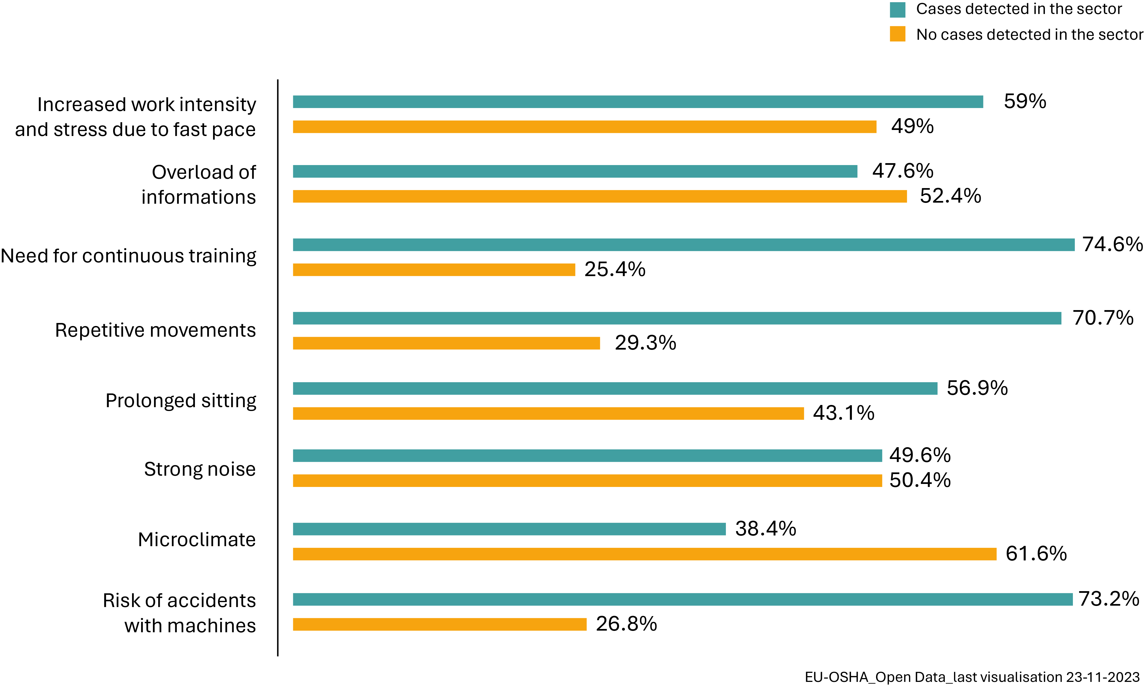

*Figure 2: Physical, environmental and emerging risks for the manufacturing sector.*

With the development of personal support technologies for Operator 4.0, the integration of different technologies could benefit workers and system performance (Torres Y., 2021). Such technologies, to date, are not widely used in industrial plants in Europe, and this is confirmed by statistical data: only 4.1% of companies in the industry use wearable devices with projection of other sensors, and only 10.4% use work performance monitoring systems.

Smart devices can enable monitoring of operators, speed up the delivery of task instructions, and monitor their mental and physical state to prevent workplace accidents by measuring breathing, heart rate, posture, and possible exposure to toxic gases. Access to this information contributes to overall process optimization. In addition, it is important to manage "alerts" about failures, errors in executed tasks, and problems on machines and systems. Receiving a notification when a machine stops working or when safety devices go off more often than usual can be valuable information. An 'appropriate design of the human-machine interface enables operators to respond quickly to changes or difficulties, thus improving efficiency by reducing downtime.

* 1. The role of smart technologies and European standards and Frameworks

Because of rapid changes in the work environment, preventive healthcare should focus on monitoring work capacity and promoting well-being throughout working life (Briggs et al., 2018; Russo et al., 2020). Management of psychosocial and organizational factors should cooperate with biomechanical, ergonomic, and medical aspects, effectively involving organizational and community stakeholders.

There have been many updates to the regulatory framework (Figure 3), especially regarding interaction-related ergonomic principles and the most recent standard - EN 17558:2023 - Ergonomics of PPE ensembles - on the ergonomic design and evaluation of PPE assemblies. It also proposed to revise the Machinery Directive, which addresses risks from digitization and the use of machinery that are also relevant to workers' health and safety. It also proposes the first legal framework on AI, which addresses the risks of certain AI systems used in the world of work, in the management of workers and in access to self-employment. Significant technological developments, particularly about display screen equipment and workplaces, and the changing needs and capabilities of an aging workforce, however, require further legislative updates.

Directive 90/270/EEC emphasizes the importance of a thorough analysis of workplaces "to determine the health and safety conditions of workers, with particular attention to eye hazards and problems of physical and mental fatigue." This directive anticipates technological developments, especially in displays and workplaces, and considers the needs of an aging workforce. Since the 2000s, the European Commission has focused on preventing emerging risks to workers by integrating well-being at work into worker protection. The European strategies for occupational health and safety (2014, 2020 and 2021-2027) recognize psychosocial risks as occupational aspects that can increase the risk of musculoskeletal disorders (Lu et al., 2012). However, they emphasize the need to coordinate interventions and actions within organizations to address these risks. The EU-OSHA 2020-2022 Healthy Workplaces Campaign focuses on psychosocial risks and the impact of new technologies on work organization. Work-related stress has long been a research priority, but considerable efforts have been made in recent years to bridge the gap between research and practice (Leka et al., 2015).

The European Framework Directive 89/391/CEE requires employers to assess and manage risks, including psychosocial risks, in advance. Neuroergonomic design principles in Industrial 4.0 environments need further development to improve operator safety and health.

Figure 3: National and International standards framework

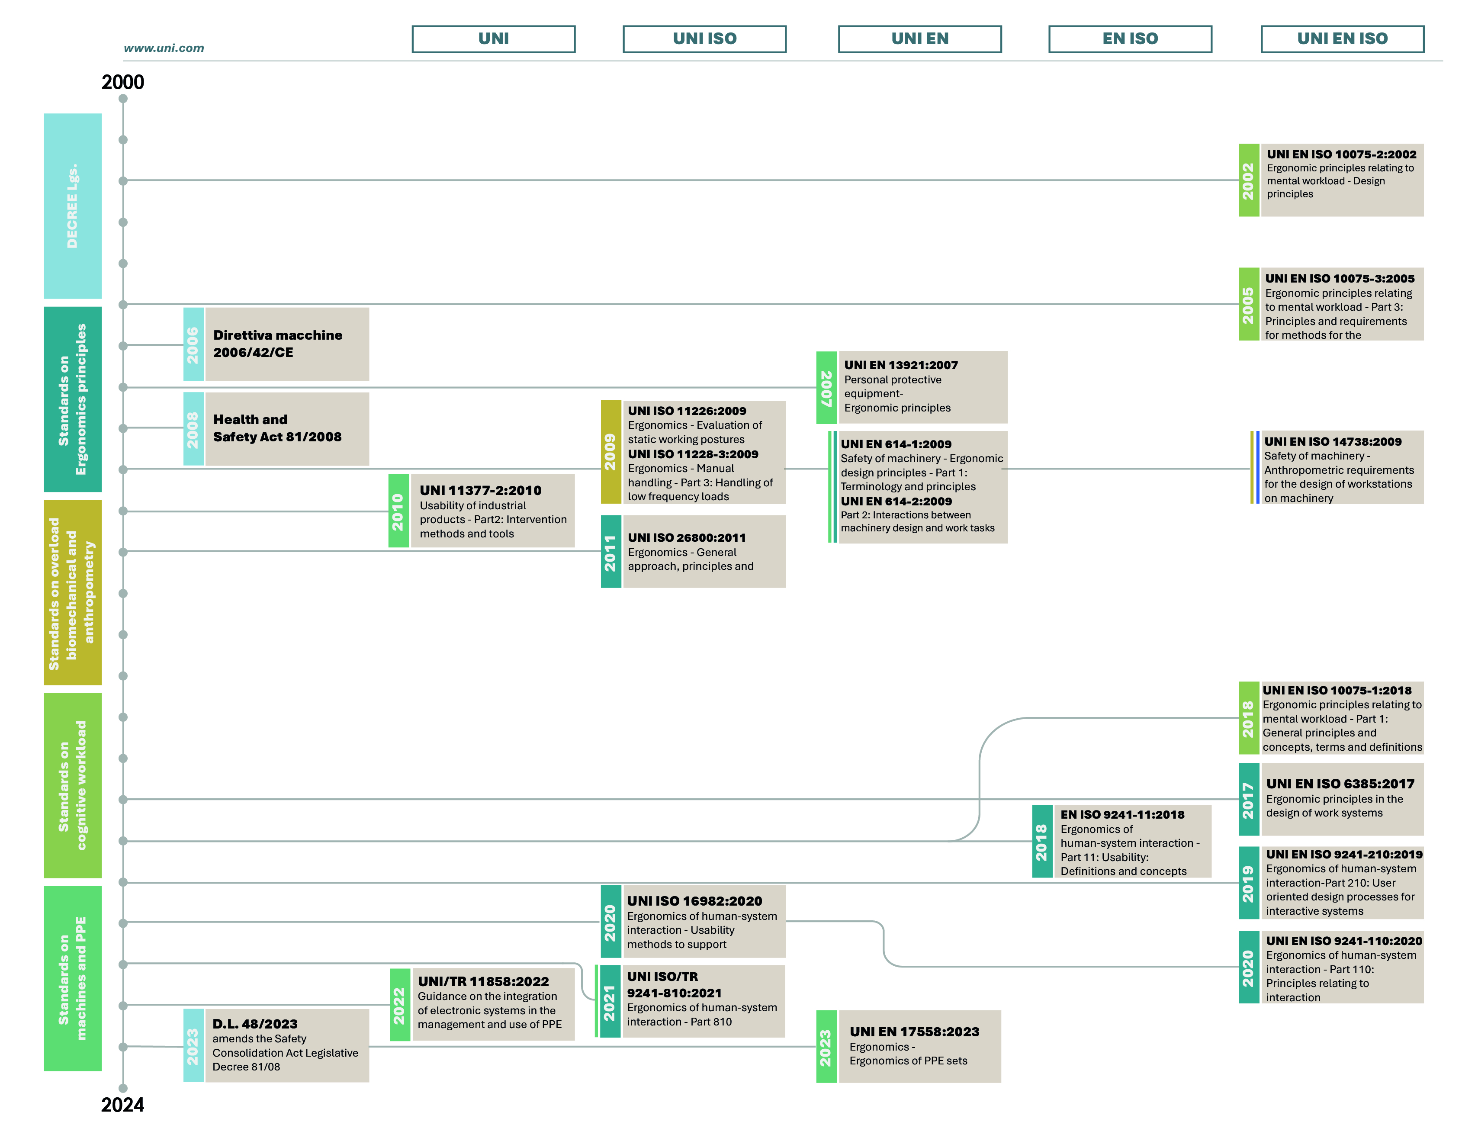Current legislation does not adequately study and regulate aspects related to human reliability, fatigue, and physical/cognitive stress during machine use. ISO 10075-3:2005 outlines the assessment and measurement of mental workload, stress, and its effects on workers. Updating standards for cognitive load analysis and assessment is necessary to align with technological advancements and Factory of the Future 5.0 work environments. This will improve work-life balance and support OSH implementation through accessible tools, awareness campaigns, and more efficient inspections. Robotization, the use of artificial intelligence, and the increased prevalence of remote work reduce the risks associated with hazardous tasks. However, new technologies also pose several challenges due to (i) increasing irregularity with respect to when and where work is done; and (ii) risks associated with new tools and machinery.

* 1. Discussion

Increased automation in human-computer interaction can lead to increased workload, frustration, and drowsiness among employees. Factors such as technical problems, usability, situational awareness, and qualification requirements can impact performance, job satisfaction, workload, and stress (Lombardi et al., 2022; Lai et al., 2014). The quality of interaction also impacts psychosocial working conditions. The evaluation of machine interaction and workplace safety can be done using two approaches: empirical, involving user samples, and analytical, involving analysts evaluating the machine and task environment using theoretical models (Lu et al., 2022). The creation of intelligent adaptive systems, which in turn can help reduce the detrimental effects of human error during the execution of complicated tasks, depends on sensitive and accurate collection of metrics to identify among various levels of mental effort and psychological stress in real time (Parent et al., 2019). Combining measurements of brain and physiological parameters is particularly useful for studies of mental state and emotions (Balconi & Molteni, 2015), as it provides a method for examining the theoretical process of fatigue, uncontaminated by technical interference because both detection methods are based on different operating principles. Work-related problems are not solely linked to ergonomic design of tools and workspace, workspace organization, user training, and new technologies. Digital OSH monitoring systems can significantly improve worker safety, health awareness, task allocation, injury prevention, well-being, and decision-making control. European workplaces often use these systems, especially in hazardous environments, but their deployment remains slow and limited, according to EU-OSHA's "Smart Digital Monitoring Systems for Occupational Safety and Health" (2023).

Modern industrial work often leads to high cognitive load due to environmental characteristics, task complexity, and work organization. While modern technologies reduce physical labor and increase flexibility, they also present stressors like technical problems, interruptions, and poor system usability. Operators struggle to develop or maintain awareness due to system complexity, inadequate visualization, lack of experience, inadequate training, and inadequate workstation design, resulting in musculoskeletal disorders (Lu et al., 2012; Greco et al., 2020). Therefore, the design of work activities and workstations should consider the cognitive and anthropometric load of the operator and, most of all, his involvement in risk assessment and interaction to improve safety in the workplace. In addition, it is crucial to improve Operator 4.0 training; technique and preparation must advance hand in hand so that the user is not subjected to high cognitive stress due to a lack of awareness of how to use the machine, ensuring optimal health and safety conditions.

There is a need to draw up an operational protocol for training, use and maintenance of machinery, and it becomes necessary to outline an integrated "augmented safety" instrument that allows the operator to be assisted at all stages of the production process and that reports psychophysical monitoring of the operator and any machine errors. European data on digital OSH monitoring systems also suggest that although these systems are becoming more prevalent in workplaces, their adoption continues to be relatively slow and limited.

According to the report "Smart digital monitoring systems for occupational safety and health: optimizing the uptake (2023)," digital monitoring systems for occupational safety and health are still in their infancy in some cases. Increased awareness of occupational safety and health needs, coupled with better opportunities provided by technology, has led to an increased adoption of these systems.

There are three main themes, which can be both drivers and obstacles in the adoption of digital OSH monitoring systems: technological progress, legislation and standardization, social and organizational factors. Current legislation does not specifically address the implications of technical changes in OSH monitoring, thus creating a grey area in terms of policy and practice. In terms of standardization aspects, the European Union plays a significant role in creating new markets and promoting interoperability between technologies from different manufacturers adopting different standards or lacking them. In line with the "zero victims" approach to work-related deaths in the European Union, the importance of making every effort to reduce such tragedies is emphasized. The Healthy Workplaces Campaign for 2023-2025 aims to raise awareness of the impact of new digital technologies on workplaces, addressing the challenges and exploiting the opportunities in terms of occupational health and safety. This will be pursued using specific and updated guidelines, as well as the implementation of smart "augmented safety" tools to ensure high protection for workers and sustainable solutions in the work environment.

It is important to systematize, on the one hand, the international regulatory framework and, on the other hand, new methods and approaches for the assessment of psychophysical overload.

* 1. Conclusion

The Industry 5.0 paradigm redefines production processes by focusing on human needs and integrating advanced technologies. Since the 2000s, the European Commission has focused on the prevention of emerging risks for workers, integrating well-being at work into worker protection, but statistics clearly show that the industrial sector still has a high accident rate, second only to the construction sector. In 2021, almost 90,000 accidents were recorded in the manufacturing sector, of which 208 were fatal. Those factors underline the importance of advanced safety measures and continuous updating of regulations.

The European regulatory framework, represented by directives such as the Framework Directive 89/391/EEC and Directive 90/270/EEC, requires employers to assess and manage risks, including psychosocial risks. However, technological developments require constant updating of the regulations. The integration of digital solutions and wearable devices can significantly improve the safety and health of workers. Digital monitoring systems offer opportunities to reduce accidents, improve safety awareness and optimise production processes. However, there is evidence that the uptake of these technologies is still limited. It is therefore essential to develop operational protocols that include ongoing training, machine use and maintenance, and 'enhanced safety' tools to support operators at all stages of the production process.

Despite technological advances, significant challenges remain. The high complexity of systems, lack of adequate training, poor usability of systems and repetitive movements contribute to psychological stress. Operators are often exposed to high cognitive load due to environmental characteristics, task complexity and work organisation. Addressing these challenges requires an integrated approach that considers the complex dynamics between individuals, technologies and the environmental context, and yet only 48.6% of industries consider employees to play a key role in the development of psychosocial risk prevention measures.

Industry 5.0 not only redefines production processes, but also promotes a holistic approach that considers the complex interactions between people, technologies and the environment. It is essential to adopt the principles of neuroergonomics to ensure the psychophysical well-being of operators, integrating international standards and guidelines with good ergonomic practices. This is the only way to ensure a safe, efficient and satisfying working environment.

References

Balconi, M. and Molteni, E. (2015) 'Past and future of near-infrared spectroscopy in studies of emotion and social neuroscience,' Journal of Cognitive Psychology, 28(2), pp. 129–146. <https://doi.org/10.1080/20445911.2015.1102919>.

Briggs, A.M. et al. (2018) 'Reducing the global burden of musculoskeletal conditions,' Bulletin of the World Health Organization, 96(5), pp. 366–368. <https://doi.org/10.2471/blt.17.204891>.

Buono, M., Capece, S., (2016). Design and Ergonomics innovative model of assessment and validity for passenger seats in the Aerospace industry. Ergonomia: sﬁde sociali e opportunità professionali dalla creatività alla pratica per aumentare l’impatto dell’ergonomia nella società, XI National Conference SIE 2016, p.p. 259.

Caiazzo, C. et al. (2023) 'Development of a neuroergonomic assessment for the evaluation of mental workload in an industrial Human–Robot Interaction assembly task: a comparative case study,' Machines, 11(11), p. 995. <https://doi.org/10.3390/machines11110995>.

Europe. Council Directive 90/270/EEC of 29 May 1990 on the minimum safety and health requirements for work with display screen equipment (Fifth individual Directive within the meaning of Article 16(1) of Directive 89/391/EEC)

EMPOWER - EMpowering transatlantic PlatfOrms for advanced WirEless Research, (2018). Doi: https://doi.org/10.3030/824994

EU-OSHA - Advanced robotics, artificial intelligence and the automation of tasks: definitions, uses, policies and strategies and Occupational Safety and Health (2022)a. Available at: https://osha.europa.eu/en/publications/advanced-robotics-artificial-intelligence-and-automation-tasks-definitions-uses-policies-and-strategies-and-occupational-safety-and-health

EU-OSHA – Barometer OSH. Available at: https://visualisation.osha.europa.eu/osh-barometer/. Last access: 20 november 2023.

EU-OSHA - Healthy Workplaces Good Practice Awards 2020-2022, (2022)b. Available at: https://osha.europa.eu/en/publications/healthy-workplaces-good-practice-awards-2020-2022

EU-OSHA – Labour inspectors' insights into perceived high-risk occupations and sectors in Europe: an EU-OSHA-SLIC survey, (2023)a, Available at: https://osha.europa.eu/en/publications/labour-inspectors-insights-perceived-high-risk-occupations-and-sectors-europe-eu-osha-slic-survey

EU-OSHA - Occupational safety and health in Europe: state and trends 2023, (2023)b. Available at: https://osha.europa.eu/en/publications/occupational-safety-and-health-europe-state-and-trends-2023

EU-OSHA – Smart digital monitoring systems for occupational safety and health: uses and challenges, 2023c, Available at: https://osha.europa.eu/en/publications/smart-digital-monitoring-systems-occupational-safety-and-health-uses-and-challenges.

EU-OSHA - Terza indagine europea fra le imprese sui rischi nuovi ed emergenti (ESENER 3), (2019). Available at: https://osha.europa.eu/it/publications/third-european-survey-enterprises-new-and-emerging-risks-esener-3

Giugliano, G. et al. (2023) 'Approaches and Technologies for the Human-Centered Industry 5.0.,' Proyecta 56 [Preprint], (3). <https://doi.org/10.25267/p56-idj.2023.i3.05>.

Greco, A. et al. (2020) 'Digital Twin for Monitoring Ergonomics during Manufacturing Production,' Applied Sciences, 10(21), p. 7758. https://doi.org/10.3390/app10217758.

Irastorza X., (2019). Third European Survey of Enterprises on New and Emerging Risks (ESENER 3), EU-OSHA – European Agency for Safety and Health at Work.

ISO - International Organization for Standardization (2024). https://www.iso.org/home.html.

Javaid, M. et al. (2020) 'Industry 4.0 technologies and their applications in fighting COVID-19 pandemic,' Diabetes & Metabolic Syndrome, 14(4), pp. 419–422. https://doi.org/10.1016/j.dsx.2020.04.032.

Körner, U. et al. (2019) 'Perceived stress in human–machine interaction in modern manufacturing environments—Results of a qualitative interview study,' Stress and Health, 35(2), pp. 187–199. <https://doi.org/10.1002/smi.2853>.

Lai, V.D. et al. (2014) 'A normal intensity level of psycho-physiological stress can benefit working memory performance at high load,' International Journal of Industrial Ergonomics, 44(3), pp. 362–367. <https://doi.org/10.1016/j.ergon.2013.11.015>.

Lombardi, I. et al. (2022) 'Human-Machine Interaction Safety in Manufacturing: a Scoping Review.,' AHFE International [Preprint]. <https://doi.org/10.54941/ahfe1002649>.

Lu, L. et al. (2022) 'Mental stress and safety awareness during human-robot collaboration - Review,' Applied Ergonomics/Applied Ergonomics, 105, p. 103832. <https://doi.org/10.1016/j.apergo.2022.103832>.

Magnet4Europe – 2020. Doi: https://doi.org/10.3030/848031

Mourtzis, D., Angelopoulos, J. and Panopoulos, N. (2022) 'A Literature Review of the Challenges and Opportunities of the Transition from Industry 4.0 to Society 5.0,' Energies, 15(17), p. 6276. <https://doi.org/10.3390/en15176276>.

Nahavandi, S. (2019) 'Industry 5.0—A Human-Centric solution,' Sustainability, 11(16), p. 4371. <https://doi.org/10.3390/su11164371>.

Parent, M. et al. (2019) 'The diagnosticity of psychophysiological signatures: Can we disentangle mental workload from acute stress with ECG and fNIRS?,' International Journal of Psychophysiology, 146, pp. 139–147. <https://doi.org/10.1016/j.ijpsycho.2019.09.005>.

Russo, F. et al. (2020) 'Prevalence of work related musculoskeletal disorders in Italian workers: is there an underestimation of the related occupational risk factors?,' BMC Musculoskeletal Disorders, 21(1). <https://doi.org/10.1186/s12891-020-03742-z>.

Sauer, J. et al. (2019) 'Social stress and performance in human-machine interaction: a neglected research field,' Ergonomics, 62(11), pp. 1377–1391. https://doi.org/10.1080/00140139.2019.1652353.

Tucci, M. et al. (2006) ‘Criteri per la valutazione dell’affidabilità umana negli impianti di processo’.

Europe. International Organization for Standardization, (2017). Ergonomic principles related to mental workload Part 1: General issues and concepts, terms and definitions Standard n. 10075-1:2017 [online]. Available at: <https://www.iso.org/standard/66900.html>

Italy. Ente Italiano di Normazione, (2023). Ergonomia - Ergonomia degli insiemi di DPI Atto normativo n. 17558:2023 [online], 31 agosto. Available at: https://store.uni.com/uni-en-17558-2023