|  |  |
| --- | --- |
| cetlogo ***CHEMICAL ENGINEERING TRANSACTIONS***  ***VOL. xxx, 2024*** | A publication of  aidiclogo_grande |
| The Italian Association  of Chemical Engineering  Online at www.cetjournal.it |
| Guest Editors: Valerio Cozzani, Bruno Fabiano, Genserik Reniers  Copyright © 2024, AIDIC Servizi S.r.l. **ISBN** 979-12-81206-11-3; **ISSN** 2283-9216 | |

Depressurization Simulation of Methane-Hydrogen Mixtures in Pipelines

Luigi Raimondi

Process Simulation Services, Via Piave 17, 20027 Rescaldina (MI), Italy

luigi.raimondi@xpsimworld.com

The reduction of carbon dioxide generated using natural gas for electric energy production or domestic usage is the main factor suggesting the addition of hydrogen. An increase in the use of hydrogen mixed with methane is one possible technology for mitigating greenhouse effects. Besides mechanical problems related to hydrogen embrittlement generated by hydrogen absorption, the presence of hydrogen changes the thermodynamic and transport properties of the natural gas. Different equations of state for an optimum simulation are tested for both steady-state and dynamic calculations. Depressurization of a pipeline can be performed as a scheduled or emergency operation. Hydrogen mixtures with natural gas are considered at ambient temperature and high pressures ranging from 150 bar to 250 bar. The reliable simulation of relief conditions (flow rate, pressure, and temperature) is a preliminary fundamental step for evaluating gas dispersion effects. This study analyzes the depressurization of a large-diameter pipeline, designed for natural gas transportation, now transporting methane-hydrogen mixtures across a distance of 20 km. Mixtures containing up to 10 % of hydrogen in moles are considered. The event of a leak at 15 km from the inlet point is considered. Differences between pure methane and its mixtures with hydrogen are evaluated and discussed. The methods presented allow the calculation of the discharged gas flow rate and its duration as fundamental data required for the evaluation of dispersion in the ambient and HSE evaluation.

* 1. Introduction

The consideration of green hydrogen as a low-carbon energy carrier brings attention to hydrogen storage and transport: a theme related to the consideration of green hydrogen as a renewable energy resource for meeting our commodity needs. The use of hydrogen, as a substitution for fossil fuels, is considered an environmentally friendly alternative since its combustion emits only water. One of the various possibilities of using hydrogen for reducing the carbon dioxide footprint is the mixing of some amounts with natural gas obtaining a fuel gas that generates a lower amount of carbon dioxide. The transport of such a gas can be facilitated by the large natural gas distribution network existing in highly populated countries such as Western Europe. From the engineering point of view, such an option requires the re-analysis of many technical problems generated by the presence of hydrogen mixed with natural gas. Apart from the well-known problem of the fragility, generated by atomic absorption of hydrogen in steel pipes, the impact of hydrogen on fluid thermodynamic properties is a topic to be considered in detail in any engineering project. The first consideration is that hydrogen is extremely flammable, being the flammability interval at atmospheric pressure between 4 % to 75 % in volume. These values can be compared with the methane flammability which ranges from 5 % to 15 %. So, it is extremely important to calculate the hydrogen dispersion in the air when a leak occurs in the pipeline. The changes experienced in the depressurization of pipelines transporting an H2-CH4 mixture are evaluated showing the main differences to pure methane fluid. This study begins with an initial thermodynamic analysis of the characteristics of natural gas (NG) mixture and of the changes obtained when an amount of hydrogen is added. In particular, the effects obtained in Joule-Thomson expansion are considered, since the pressure used in transporting the mixture is quite high and the final temperatures reached during the depressurization can be quite low. The thermodynamic and fluid flow calculations are performed using a process engineering simulation code, developed by the author (XPSIM, 2023), which allows the simulation of steady-state and dynamic effects.

* 1. Thermodynamic basis

An initial analysis of the thermodynamic properties of hydrogen and methane shows a large difference in the behavior of the two chemical components for Joule-Thomson effects which can be identified during isenthalpic depressurization. The critical properties of hydrogen and the two lightest components of natural gas methane, and ethane are summarized in Table 1. One can easily deduce, from the value of the critical temperature, that hydrogen will be never found in the liquid phase when the standard transportation conditions are considered. So, from the engineering point of view, the effect of hydrogen as a non-condensable chemical component will be the matter of the following analysis.

Table 1. Critical properties

|  |  |  |  |
| --- | --- | --- | --- |
| Component | Temperature, °C | Pressure, bar | Volume, m3 |
| Hydrogen | -239.92 | 13.16 | 0.06516 |
| Methane | -82.62 | 45.90 | 0.09901 |
| Ethane | 32.27 | 48.79 | 0.1481 |

Dealing with fluid depressurization, either operated as a controlled action or due to an emergency cause, a first thermodynamic analysis is the comparison of the Joule-Thomson effects. For the analysis, a natural gas (NG) composition is taken from a real project i.e. one “Blue Stream” simulation which is a long-distance pipeline crossing the Black Sea and transporting natural gas from Russia to Turkey.

Table 2. One real natural gas composition

|  |  |
| --- | --- |
| Component | Molar composition, % |
| Water | 0.0029 |
| Nitrogen | 0.9303 |
| Carbon Dioxide | 0.4100 |
| Methane | 97.5278 |
| Ethane | 0.8797 |
| Propane | 0.1397 |
| i-butane | 0.0149 |
| n-Butane | 0.0248 |
| i-Pentane | 0.0180 |
| n-Pentane | 0.2203 |
| n-Hexane | 0.0222 |
| C7+ | 0.0126 |

A simple characterization is obtained by calculating phase envelopes of simple natural gas (NG) and its mixture with hydrogen at 2.5 % in volume, as shown in Figure 1.

It is interesting to note, that the natural gas mixture can be transported as a single phase even at low temperatures and pressure values just above 70 bar. The addition of hydrogen greatly extends the pressure-temperature region where gas and liquid phases can coexist.

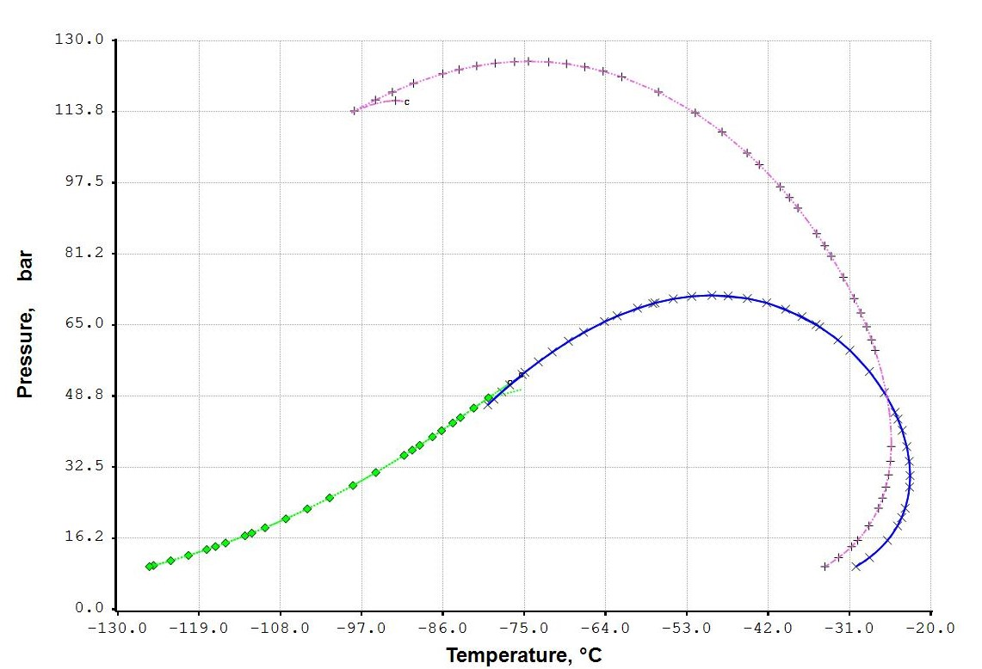

Figure 1- NG and Hydrogen phase envelope. Curves: (**◊**) NG bubble point, (**X**) NG dew point, (**+**) H2 2.5 % dew point.

The final temperature obtained by the Joule-Thomson expansion of a stream of natural gas with increasing quantities of hydrogen through adiabatic flash is given in Table 3.

Table 3. Final temperatures from isenthalpic depressurization

|  |  |  |  |  |
| --- | --- | --- | --- | --- |
| Property | NG | NG+H2 2.5% | NG+H2 5% | NG+H2 10% |
| Initial pressure, bar | 255 | 255 | 255 | 255 |
| Initial temperature, °C | 20 | 20 | 20 | 20 |
| Final pressure, bar | 5 | 5 | 5 | 5 |
| Final temperature, °C | -74.25 | -50.88 | -35.29 | -21.44 |

The temperature reached during the depressurization shows a sharp increase from -74 °C of pure natural gas to -21 °C when 10 % in volume of hydrogen is mixed with the methane stream.

The following Table 4 presents some typical compositions of imported natural gas from abroad and distributed in Italy. In the following dynamic simulations, one of these compositions i.e. the National one is used.

Table 4. Chemical compositions of natural gas in Italy (volume %)

|  |  |  |  |  |
| --- | --- | --- | --- | --- |
| Component | National | Russia | Holland | Algeria |
| Methane | 99.62 | 98.07 | 91.01 | 83.28 |
| Ethane | 0.06 | 0.60 | 3.70 | 7.68 |
| Propane | 0.02 | 0.22 | 0.88 | 2.05 |
| Butanes | 0.01 | 0.09 | 0.28 | 0.78 |
| Pentanes | 0.00 | 0.01 | 0.07 | 0.21 |
| Hexanes | 0.01 | 0.02 | 0.07 | 0.11 |
| Carbon dioxide | 0.02 | 0.11 | 1.11 | 0.19 |
| Nitrogen | 0.26 | 0.87 | 2.84 | 5.52 |
| Helium | 0.00 | 0.01 | 0.04 | 0.18 |

* 1. Thermodynamic and fluid dynamics models

The use of standard cubic equations of state such as the Soave-Redlich-Kwong SRK (Soave, 1972) and Peng-Robinson PR (Peng and Robinson, 1978) are usually the default choices in chemical engineering design. Other equations of state such as the GERG models are more exact at the cost of increased calculation times. These models are the GERG-2004 (Kunz et al., 2007) or the GERG-2008 (Kunz et al., 2012). However, the application of these equations to complex mixtures presents numerous problems associated with the large number of parameters required (over 100 per pure component) if compared to more simple cubic equations of state. Though hydrogen is included in the components set defined for the GERG-2008 equation, this equation was not applied in this study. The results, presented in the following pages, are calculated using the Peng-Robinson equation (PR, Peng and Robinson, 1976) for vapor-liquid equilibrium calculations and the Lee-Kesler model (LK, Lee and Kesler, 1975) for the evaluation of thermal properties i.e., enthalpy, entropy, density, heat capacity of the vapor and liquid phases. The PR equation provides good values for the vapor-liquid equilibrium constants but gives inaccurate values of thermal properties in the high-pressure and critical point regions. In these regions, the LK model provides accuracy comparable to the GERG models.

* 1. Pipeline depressurization analyses

The simulation of the depressurization of a pipeline is the first and fundamental step required for the subsequent analyses of the dispersion effects: the mass discharged, the related temperature and physical status, and the time required to obtain a complete discharge of its content are parameters fundamental for a complete HSE evaluation. Among the infinite possibilities of analysis of the depressurization of a pipeline transporting hydrogen-methane mixtures, some scenarios must be selected. We are now considering a 20 km long pipeline with a diameter of 18 in (0.460 m): i.e. a trunk line connecting the production site to a main distribution facility.

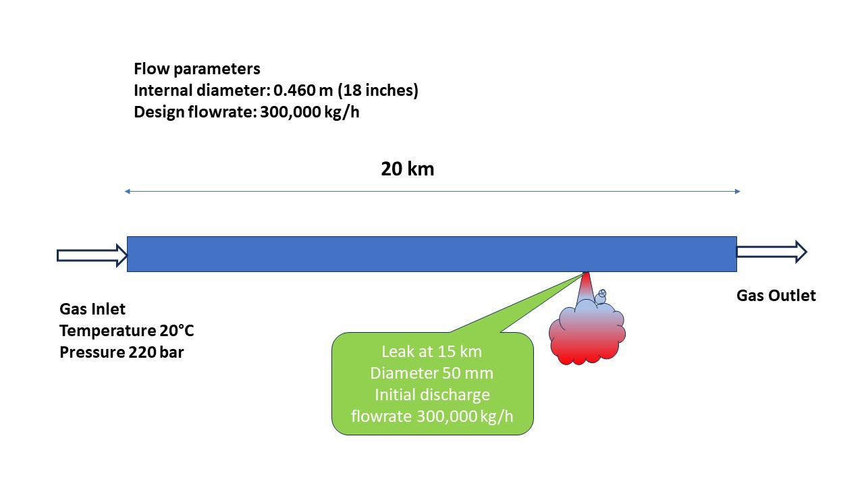

Figure 2. Schema of the simulated pipeline depressurization.

This example is taken from a recent engineering project, with only the pipeline length being limited to 20 km and the elevation profile assumed horizontal. The pipeline was designed to transport nearly 300,000 kg/h of natural gas and is buried at 1 m depth. It is assumed that a leak of diameter equal to 50 mm is created at a distance of 15 km from the initial point. The depressurization is analyzed by considering different fluid compositions: the first one is natural gas only, while three others have increasing amounts of hydrogen: 2.5 %, 5 %, and 10 % of the molar flow rate. The external ambient temperature is taken to be 20 °C and the heat exchanged between the flowing fluid and the external is fully modeled taking into account the metal conductivity and the soil properties (density, conductivity, and heat capacity). The global heat transfer coefficient is found to be around 1.55 W/m2 °C. The temperature profile across the pipeline metal wall, soil layers, and ambient, is calculated at each time step for each pipeline segment used to solve the finite volume equations. One of the main points is the calculation of the change of fluid temperatures associated with the Joule-Thomson effects when the internal fluid is subject to a fast depressurization. For the compositions considered in this study, a liquid phase would appear only when the natural gas contains a significant fraction of heavier hydrocarbons up to the C7+ fraction. The two-phase flow algorithms are based on the numerical developments presented by the author in previous studies (Raimondi, 2017) for the depressurization of pipelines. The numerical algorithms are based on the solution of the Navier-Stokes equations using a volume-of-fluid (VOF) schema and a compositional model that can track changes in fluid composition, as well as the formation and evolution of liquid waves along the pipeline distance and time. The reliability of the results was already discussed in a previous study (Raimondi, 2017) where calculated results were compared with experimental data for the ‘Isle of Grain’ LPG depressurization (Richardson and Saville, 1996). An example of the depressurization of carbon dioxide has been presented recently in this journal (Raimondi, 2022). The initial pipeline status is defined by a steady state simulation with an inlet pressure of 220 bar and a temperature of 20 °C. All cases assume that the leak occurs 1 hour after the initial simulation time, and is detected 10 minutes later when the inlet and outlet valves are closed. The history of the pipeline depressurization is shown in Figure 3, where the pipeline inventory and the leak flow rate are presented.

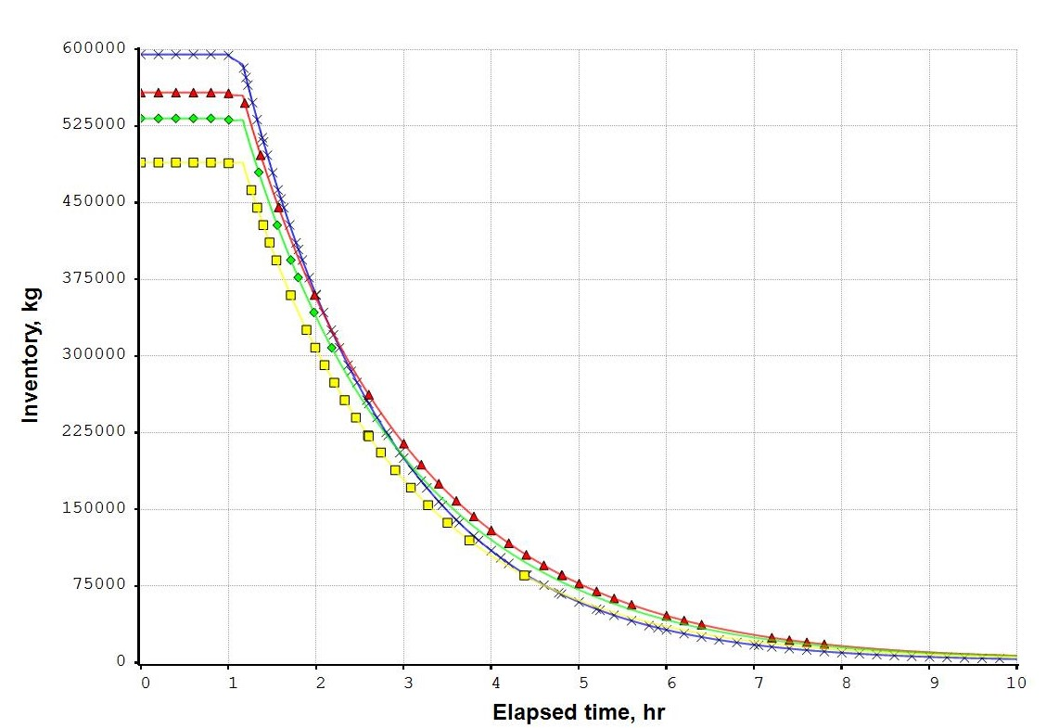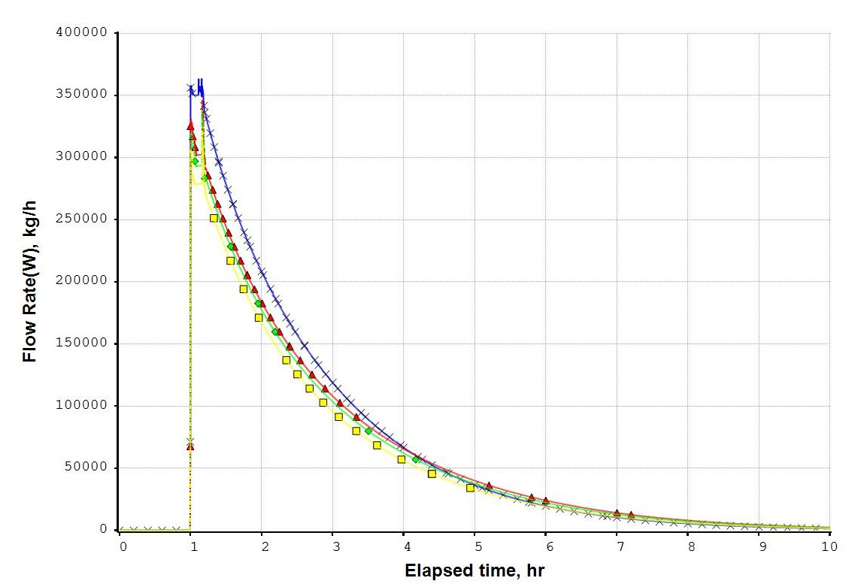

Figure 3. Pipeline inventory and leak flow rates. Curves: (**X**) Natural gas, (**Δ**) H2 2.5%, (◊) H2 5%, (■) H2 10%.

The simulation can catch many details at the various pipeline segments. For all cases examined the complete depressurization is reached around 9 hours after the leak occurrence. The discharge of the fluid through the leak is always at sonic conditions due to the high internal pressure vs ambient pressure ratio. Sonic velocity does not change significantly with the fraction of hydrogen. For the pure NG case, the maximum sonic velocity is reached at the initial pressure, with an average value of 560 m/s, which decreases to 440 m/s at the end of the depressurization. For the 10 % hydrogen mixture, the maximum sonic velocity is 565 m/s at initial conditions and the final value is 465 m/s. Fluid temperatures decrease during the depressurization as expected but the values reached are never too low to create fragility problems for the pipeline metal. For the cases simulated the minimum temperatures are around -10°C and are obtained at the outlet segment of the pipeline. Figure 4 shows the temperature history at the outlet section for the NG case and one hydrogen mixture (10 %) depressurization. One can notice in this figure the pressure wave generated by the leak formation which is reflected by the sharp oscillation of fluid temperature.

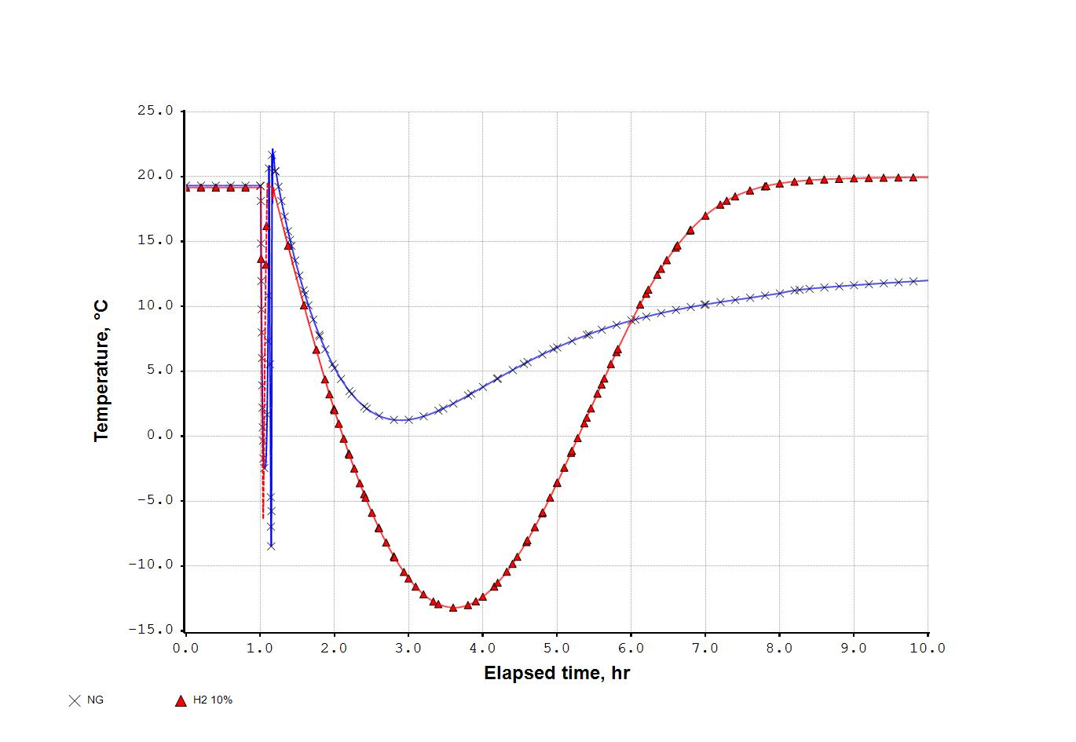

Figure 4. Temperature at pipeline exit. Curves: (**X**) Natural gas, (**Δ**) H2 10 %.

* 1. Conclusions

The simulation approach provides fundamental results for the safety analysis of the methane-hydrogen mixtures in pipelines. The study presents an overview of the effects of a leak in a pipeline transporting methane-hydrogen mixtures at a pressure of 220 bar over a 20 km distance. The calculation of the duration of the mass discharge and the maximum value of the fluid flow rate dispersed are the most important results for the following evaluation of dispersion effects in the nearby environment. The results of the simulations show that leaks with diameters of 50 mm can produce an initial peak discharge of around 300,000 kg/h. The rigorous thermodynamic framework provides the calculation of numerous operating parameters such as pressures, temperatures, gas flow rates, phase densities and velocities, and the local liquid holdup in case of heavier hydrocarbon condensation. The model can also provide an a-posteriori analysis of the leak’s thermal effects such as the lowest temperature reached by the fluid and the pipeline metal wall in contact. The process engineer would be able to identify the sections of the pipeline where possible metal failures could be expected. However, the addition of hydrogen reduces the JT effects obtained for the original natural gas. So, wall metal temperatures would be higher than those reached by a natural gas depressurization. The independent simulation software tool used shows its capabilities in the analysis of the new technical problems arising from the extended use of hydrogen as a greener energy carrier. The cases discussed are limited to hydrogen percentages not exceeding 10%, but mixtures with higher hydrogen content can be treated without problems.

References

Kunz O., Klimeck R., Wagner W., Jaeschke M., 2007, The GERG-2004 Wide-Range Equation of State for Natural Gases and Other Mixtures, Groupe Européen de Recherches Gazières, 2007

Kunz O., Wagner W., 2012, The GERG-2008 Wide-Range Equation of State for Natural Gases and Other Mixtures: An Expansion of GERG-2004, Journal of Chemical Engineering Data, 57, 3032-3091

Lee B.I., Kesler M.G., 1975, A generalized thermodynamic correlation based on three-parameter corresponding states, AIChE J., 21, 510-527.

Peng D.Y., Robinson D.B., 1976, A new two-constant equation of state, Ind. Eng. Chem. Fund. 15, 59–64.

Raimondi L., 2017, Compositional Simulation of Two-Phase Flows for Pipeline Depressurization, SPE Journal, 22, 4, 1242-1253.

Raimondi L., 2022, CCS Technology – CO2 Transportation and Relief Simulation in the critical Region for HSE assessment, Chem. Eng. Trans., 91

Richardson S.M., Saville G., 1996, Isle of Grain Pipeline Depressurization Tests, Health & Safety Executive.

Soave G., 1972, Equilibrium constants from a modified Redlich-Kwong equation of state, Chem.Eng.Sci. 27, 1197-1203

XPSIM (eXtended Process SIMulator), 2023, Reference Manual, Version 3.1., Process Simulation Services, www.xpsimworld.com.