|  |  |
| --- | --- |
| cetlogo ***CHEMICAL ENGINEERING TRANSACTIONS***  ***VOL. xxx, 2024*** | A publication of  aidiclogo_grande |
| The Italian Association  of Chemical Engineering  Online at www.cetjournal.it |
| Guest Editors: Valerio Cozzani, Bruno Fabiano, Genserik Reniers  Copyright © 2024, AIDIC Servizi S.r.l. **ISBN** 979-12-81206-11-3; **ISSN** 2283-9216 | |

Customizing a Weighted Scale for Precision in Fatigue Assessment within the Process Industry

Carlos Albarrán Morillo\*, Huxiao Shi, Gabriele Baldissone, Micaela Demichela

Applied Science and Technology Department, Politecnico di Torino, Turin, Italy

carlos.albarran@polito.it

In the diverse landscape of process industries, operators frequently undertake solitary activities such as routine inspections, instrument calibration, emergency response, equipment maintenance, sampling and testing, and isolation procedures. The heightened focus on physical fatigue management in these operations has sparked a critical re-evaluation of current approaches. Currently, the prevalent method for assessing physical fatigue relies on subjective testing, primarily employing the Borg scale. However, the intrinsic limitations, characterized by low accuracy and a lack of real-time measurement, hinder its refinement and effectiveness. Motivated by the potential of objective measures, this research introduces an innovative approach to measuring physical fatigue. Specifically, a smartwatch equipped to collect electrodermal activity, skin temperature, pulse rate, and motion parameters is employed. Data is gathered in a fitness environment simulating industrial tasks, providing valuable insights into physical fatigue dynamics. The objective data collected are then subjected to Principal Component Analysis (PCA) to derive two principal components: one related to physiological aspects and the other associated with motion dimensions. Subsequent linear regression analyses utilize these subscales to establish a physical fatigue-weighted scale based solely on factual data. The derived physical fatigue scale reveals promising applications as a customized warning system, exclusively leveraging a non-intrusive smartwatch.

* 1. Introduction

The process industries are complicated and demanding, with operators undertaking solo activities such as routine inspections, instrument calibration, emergency reactions, equipment maintenance, sampling and testing, and isolation protocols (Jamshidi, 2018). These operations might cause physical tiredness because operators must negotiate the demands with steadfast accuracy (Frederick et al., 1984). The rigorous nature of routine inspections and emergency reactions necessitates top physical fitness, but the cumulative impact can cause a progressive loss of energy and awareness. Instrument calibration and equipment maintenance demand prolonged concentration and physical effort, which adds to the strain felt by operators. Sampling and testing, which are critical for quality control and process optimization, need rigorous attention to detail, frequently requiring operators to work with heavy equipment and maintain lengthy focus. Isolation techniques, while critical for safety and contamination avoidance, need a thorough approach. When faced with life-threatening scenarios or exhaustion, workers are 99% more likely to make poor judgments (Gruhn and Cheddie, 2006). For this reason, the management of physical weariness is critical to the productivity, safety, and success of process industries (Randolph, 2015). In this dynamic industry, a novel method to detect and control physical stress is required to improve safety, increase productivity, and redefine fatigue management (Randolph, 2015).

Despite the subjective nature of fatigue, influenced by factors such as overall health, job demands, and circumstances, current evaluation methods lack the accuracy needed for a comprehensive understanding. The prevalent reliance on interviews and questionnaires introduces subjectivity and potential biases into the assessment, making it susceptible to individual mood variations or the willingness to provide accurate accounts of fatigue (Claros-Salinas et al., 2010).

To improve the reliability of tiredness evaluation, objective metrics must be included. Physical fatigue is directly related to the sympathetic nervous system (SNS) and assessing its influence on the body requires the use of several physiological indicators (Hirooka, 2020). These markers include factors such as heart rate, blood type, and skin responses, which together provide a thorough knowledge of the physiological foundations of fatigue (Bossung et al., 2023). Utilizing modern technology, particularly wireless sensors, allows for continuous monitoring of an individual's physiological data.

This instigates the current study to develop a physical fatigue-weighted scale grounded solely on physiological parameters collected via a single smartwatch. The resulting physical fatigue scale shows promising potential for applications as a tailored warning system, exclusively utilizing a non-intrusive smartwatch. It aims to provide a simpler yet effective scale for rapid fatigue detection.

The remaining sections detail the methodology, including the experimental design, participant information, and data collecting processes. The results and their discussion are then provided, followed by a thorough examination of the limits discovered. The conclusion focuses on the overall model performance and prospective applications.

* 1. Method
     1. Experimental design

wThe proposed methodology evaluates tiredness by simulating industrial duties in a fitness setting. Participants do physically demanding activities such as pushing, tugging, picking up, bending, and lifting, which are frequent in the factory environment. These tasks necessitate repetitive actions and the use of physical force, mimicking real-world labor conditions. To ensure safety and data quality, the study recruited participants who were physically fit and had experience with weightlifting. This approach facilitated the handling of heavier weights and increased repetitions during the exercises, resulting in more meaningful and precise data collection. Grouping participants according to their exercise styles and preferences is beneficial as it enhances the likelihood of their engagement and commitment to the program. The data for tiredness prediction is derived from the Empatica EmbracePlus bracelet, which offers real-time physiological signals based on the wearer's physical activity level. The bracelet continuously measures four major components: pulse rate, electrodermal activity (EDA), temperature and movement. The data associated with movement encompasses the activity count, accelerometer data, and step counts. Therefore, the smartwatch collects six different types of data. During the data collecting process in the fitness setup, the participants' exhaustion levels are labeled with the Borg scale or Borg test (Williams, 2017). This method allows individuals to subjectively rate their level of physical exertion on a scale ranging from 6 (no exertion) to 20 (maximum exertion). For additional details regarding experimental design and procedures, kindly consult the authors' prior publications (Albarrán Morillo and Demichela, 2023a; Albarrán Morillo and Demichela, 2023b).

* + 1. Subjects

The study included 33 healthy volunteers (21 men and 13 females) ranging in age from 21 to 41 years, with a mean of 25.6 ± 4.4 years. The sample size of 33 people employed in this study is quite big when compared to what has been described in the literature for investigations involving human physiological parameters. With this sample size, we have nearly reached the desired statistical power of 80% (34 individuals), which is critical for assuring the reliability and validity of the experimental findings. People with present or previous injuries, pain, discomfort, medical disorders, or those using drugs were eliminated from the first screening questions (see Figure 1). The participation was voluntary, with participants recruited through flyers distributed at a fitness center. Before data collection, each participant received an informed consent form. Participants were given the opportunity to review and understand this information before deciding whether to participate in the study.

* + 1. Procedure

The study uses a fitness setup to simulate industrial tasks safely and effectively. It employs various exercises, including weightlifting, resistance band exercises, isometric exercises, and bodyweight exercises:

* Weightlifting exercises target muscle groups involved in lifting, pushing, and pulling heavy objects.
* Resistance band exercises simulate tasks requiring pulling and pushing actions.
* Isometric exercises replicate holding specific positions suitable for those with mobility limitations or recovering from injuries.
* Bodyweight exercises simulate climbing, crawling, and bending movements.

Participants have the freedom to select exercises based on their fitness levels and preferences. Throughout the physical activity, participants wear the EmbracePlus device, which continually records physiological data. Baseline measurements are obtained 10 minutes before and after the activities to provide a reference point for comparing other data. These measurements assist in determining the participant's initial and end degrees of physical tiredness, allowing for the tracking of any changes that occur during the workout. The complete study for each participant lasts around 1 hour and 30 minutes, including baseline measurements. To label the acquired data, the Borg Test is used. The Borg Test is performed during brief rest times between exercises and every 2 minutes at the beginning and end of the session to monitor the recovery process (see Figure 1).

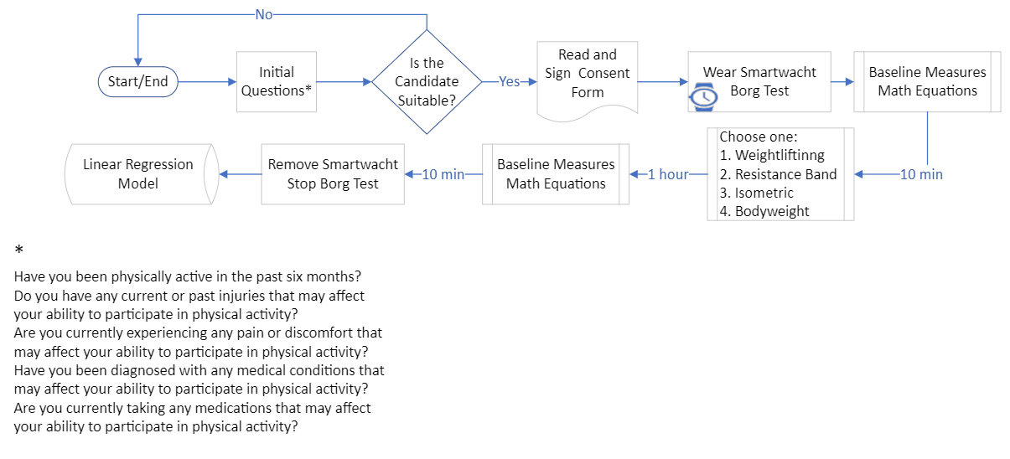

Figure 1: Data collection procedure in the fitness setup

* 1. Results and discussion

Principal Component Analysis (PCA) of objective measures

To facilitate practical integration and frequent monitoring, a dataset comprising six items would introduce considerable complexity to the analysis. In studies focusing on physical fatigue, researchers often employ PCA to reduce the dimensionality of complex physiological datasets (Brown et al., 2016; Nagahanumaiah et al., 2022). Consequently, PCA with varimax rotation was conducted on the data collected from the smartwatch (Wastell, 1981). This aimed to identify items that tended to cluster together, simplifying the scale by retaining fewer key items. These retained items would later be assigned weights. PCA was employed to transform potentially correlated variables into a set of linearly uncorrelated variables through orthogonal transformation, known as principal components. The comparison of information between these principal components and the original multiple variables is elucidated by the sum of squares of deviations or variances. PCA serves as a widely applied method for achieving dimensionality reduction, effectively reducing the complexity of the target system. In the specific context of varimax rotation within PCA, the principal components are optimally rotated to attain a simpler and more interpretable structure. This rotation ensures that variance is maximized along a few dimensions, enhancing the clarity and meaningfulness of the overall data representation.

Initially, the dataset underwent the Kaiser-Meyer-Olkin (KMO) test and Bartlett's Test to assess the presence of correlations among variables (Sweeting and Kharroubi, 2003). The outcomes of these tests endorse the practicality and appropriateness of feature-extraction techniques, specifically PCA. The KMO value stands at 0.761, accompanied by a highly significant p-value of <0.001. This implies that the chi-square value is statistically significant, leading to the rejection of the null hypothesis suggesting the variables' independence. Consequently, it is inferred that this dataset is well-suited for PCA.

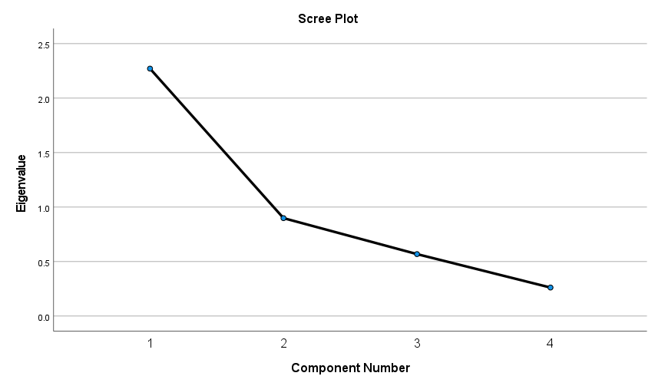

Figure 2: Scree plot of PCA

Table 1: Rotated component matrix of varimax rotation within PCA

|  |  |  |  |  |
| --- | --- | --- | --- | --- |
| **Rotated Component Matrix** | **Component**  **1** |  | **2** |  |
| **EDA**  **Pulse rate**  **Steps count**  **Activity counts** | 0.911  0.686 |  | 0.903  0.902 |  |

Based on the scree plot shown in Figure 2, two components are selected since it can explain 79.243% of the variance. Variables that are not related to these two components as well as whose factor loading is less than 0.5 have been removed. To reveal underlying relationships and structures between variables, the rotation method of Varimax with Kaiser Normalization has been applied (Table 1). The findings reveal the existence of two subscales, namely PC1 and PC2. PC1 is contributed by two factors EDA and Pulse rate, with the factor loading of (0.911 and 0.686), which can be construed as the physiological dimension, capturing variables such as electrodermal activity and pulse rate, while PC2 represents the motion dimension, encapsulating variables such as steps and activity count, with the factor loading of 0.903 and 0.902 respectively. Consequently, this allows the reduction of the original 6-dimensional features to a more concise 2-dimensional feature variable.

* + 1. Linear regression on the weighted scale

Concluding the analysis, linear regressions were performed to derive weights for the physical fatigue, utilizing PC1 and PC2 subsets as independent variables and the results of the Borg Test as the dependent variable. This approach, relying solely on objective measures, enhances the robustness of the index, ensuring a more reliable and objective evaluation of fatigue.

Prior to conducting linear regression, Structural Equation Modeling (SEM) (16) was executed to assess the model's fit and validate the relationships between the subset (PC1 and PC2) and observed data, laying the groundwork for subsequent regression analysis (Figure 3). The fit indices, including CMIN/DF (3.415), RMSEA (0.069), NFI (0.994), IFI (0.996), TLI (0.976), and CFI (0.996), collectively indicate a good fit for the explored structure.

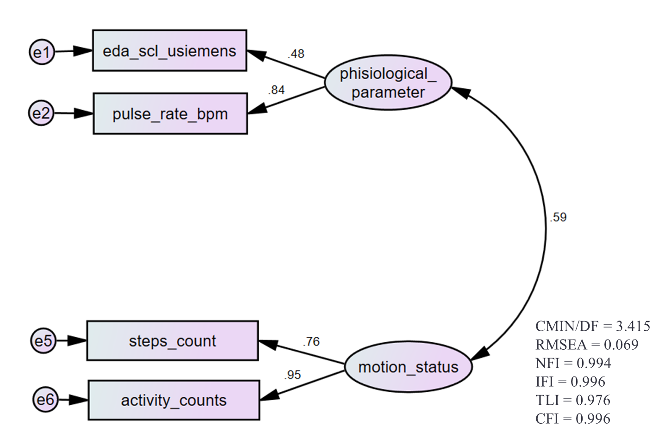

Figure 3. Validation results through SEM

At this stage, we were prepared to apply the regression model to our data. Initially, we set out with the null hypothesis assuming no linear relationship. However, the obtained p-value of less than 0.001 provides compelling evidence against the null hypothesis. This signifies a statistically significant linear relationship between the predictor variables (PC1 and PC2 subsets) and the dependent variable (fatigue level).

Furthermore, the coefficient of determination (R^2) is calculated to be 0.541. This R^2 value indicates that approximately 54.1% of the variability in the fatigue level or Borg Test can be explained by the linear regression model. In other words, over half of the observed variations in fatigue can be attributed to the identified objective factors represented by PC1 and PC2.

These results collectively support the rejection of the null hypothesis and affirm the strength and explanatory power of the linear regression model in capturing and understanding the relationship between the latent factors and fatigue level.

The calculated new fatigue index is represented by the Eq (1). Notably, PC1 carries a higher weight than PC2, indicating that PC1 holds more significance in the assessment of fatigue compared to motion dimensions. This underscores the influential role of physiological parameters, represented by PC1, in the overall evaluation of fatigue.

$NewFatigueIndex=5.115+7.079⋅PC1+4.755⋅PC2$ (1)

The model's assumption of a linear relationship between objective measures (PC1 and PC2) and fatigue levels may overlook non-linear physiological responses common in fatigue scenarios. Non-linearities, such as saturation points or threshold effects, could be overlooked, potentially impacting the model's accuracy. Additionally, while the sample size of 33 participants is reasonable, generalizing findings to broader populations or specific occupational groups necessitates validation with larger, more diverse samples. The exclusion criteria, targeting individuals with certain health conditions, introduces potential selection bias, limiting the model's applicability to a wider range of real-world scenarios. To enhance the model's utility and relevance, future studies may consider including participants with a broader range of health conditions encountered in real-world scenarios.

* 1. Conclusions

This study established a nuanced objective scale to enhance the precision of assessments of physical fatigue and facilitate their seamless integration into practical devices. This scale was crafted based on comprehensive objective measures obtained through a non-intrusive smartwatch. The smartwatch, in conjunction with a subjective Borg test questionnaire, concurrently gathered physiological parameters such as skin temperature, pulse rate, and electrodermal activity. Additionally, it captured intricate movement data during tasks designed to emulate various industrial activities, notably those prevalent in the process industry, including instrument calibration, emergency response, equipment maintenance, sampling and testing, and isolation procedures.

The complexity of objective data was distilled into two meaningful subscales through PCA, providing a more interpretable representation. The weighting solution was then meticulously derived through linear regressions. These regression models were strategically formulated, with two specific items (PC1 and PC2) serving as independent variables and preceding fatigue levels assessed through the Borg test acting as the dependent variable. Importantly, the fitness level was initially validated through Subject Matter Expert (SME) assessment, providing a robust foundation for subsequent analyses.

The potential applications of the physical fatigue scale utilizing a non-intrusive smartwatch are diverse and impactful. The developed scale serves as a customized warning system, leveraging the capabilities of a non-intrusive smartwatch for real-time monitoring and prompt alerts when the fatigue index reaches critical levels. This enhances safety across various industries. The primary goal is to offer a simplified yet effective scale for swift fatigue detection, crucial in dynamic work environments where quick identification is essential for maintaining optimal performance and preventing accidents. In scenarios where operators work alone, the fatigue scale can intelligently schedule rest periods. For example, implementing a warning system to prompt breaks when the fatigue index surpasses a predetermined threshold, such as 14, ensures that operators receive timely rest, mitigating the risk of exhaustion. As a forward-looking initiative, there is potential to study and develop a rest index with a corresponding scale. This involves comprehensive research on optimal rest periods, considering factors such as the nature of tasks, individual differences, and work duration.

Acknowledgments

This work is funded by CISC project, which is part of the grant H2020-MSCA-ITN-2020 grant agreement no.955901.

References

Albarrán Morillo, C., Demichela, M., 2023a, Exploring the Impact of Repetitive Exercise on Physical Fatigue: A Study of Industrial Task Simulation in a Controlled Fitness Setting, Chemical Engineering Transactions, 99(December 2022), 163–168.

Albarrán Morillo, C., Demichela, M., 2023b, A Data-Driven Framework to Model Physical Fatigue in Industrial Environments Using Wearable Technologies, Neuroergonomics and Cognitive Engineering, 102, 160–170.

Bossung, V., Singer, A., Ratz, T., Rothenbühler, M., Leeners, B., Kimmich, N., 2023, Changes in Heart Rate, Heart Rate Variability, Breathing Rate, and Skin Temperature throughout Pregnancy and the Impact of Emotions—A Longitudinal Evaluation Using a Sensor Bracelet, Sensors 23(14), 6620.

Brown, N., Bichler, S., Fiedler, M., Alt, W., 2016, Fatigue detection in strength training using three-dimensional accelerometry and principal component analysis, Sports Biomechanics 15, 139–150.

Claros-Salinas, D., Bratzke, D., Schröter, H., 2010, Subjective and objective assessment of fatigue, Journal of the Neurological Sciences 298(1–2), 165–166.

Frederick, L., Habes, D., Schloemer, J., 1984, An Introduction to the Principles of Occupational Ergonomics, Occupational Health Nursing 32(12), 643–645.

Gruhn, P., Cheddie, H., 2006. Safety Instrumented Systems. ISA International Society for Measurement and Control.

Hirooka, Y., 2020, Sympathetic Activation in Hypertension: Importance of the Central Nervous System, American Journal of Hypertension.

Jamshidi, M., 2008, System of systems engineering - New challenges for the 21st century, IEEE Aerospace and Electronic Systems Magazine, 23(5), 4–19.

Nagahanumaiah, L., Singh, S., Heard, J., 2022, Diagnostic Human Fatigue Classification using Wearable Sensors for Intelligent Systems, 17th Annual System of Systems Engineering Conference (SOSE), Rochester, NY, USA, 424-429.

Randolph, S.A., 2015, Fatigue Risk Management, Workplace Health & Safety 63(5), 236–236.

Sweeting, T.J., Kharroubi, S.A., 2003, Some new formulae for posterior expectations and Bartlett corrections, Test 12(2), 497–521.

Wastell, D.G., 1981, PCA and varimax rotation: Some comments on Rösler and Manzey, Biological Psychology 13, 27–29.

Williams, N., 2017, The Borg Rating of Perceived Exertion (RPE) scale, Occupational Medicine 67(5), 404–405.