 CHEMICAL ENGINEERING TRANSACTIONS  VOL. xxx, 2024 | A publication of  
The Italian Association
of Chemical Engineering
Online at www.cetjournal.it

Guest Editors: Valerio Cozzani, Bruno Fabiano, Genserik Reniers
Copyright © 2024, AIDIC Servizi S.r.l.
ISBN 979-12-81206-11-3; ISSN 2283-9216

Management of change (MOC) reviews applied for PEMFC systems
Guilherme S. Niekraszewicz ^{a,*}, Lucca R. S. A. Bastos, Ian J. D. Rezende, Leonardo O. S. Santana, Fernando L. P. Pessoa^{a,b}, Gerhard Ett
ªSENAI-CIMATEC University Center, Av. Orlando Gomes, 1845 - Piatã, Salvador - BA, 41650-010
^{b}Universidade Federal do Rio de Janeiro, R. Antônio Barros de Castro, 119 - Cidade Universitária, Rio de Janeiro - RJ, 21941-853
guilherme.niekraszewicz@aln.senaicimatec.edu.br
Research aimed at hydrogen fuel cells (HFC) has increased recently, driven by the need for viable alternative methods to generate energy for automotive vehicles, aside from fossil fuels. Before implementing hydrogen systems in vehicles, it is necessary to conduct comprehensive tests in a bench setup to ensure maximum efficiency before scaling up the system. Therefore, it is often essential to make modifications to the bench system to improve it. This paper aims to document the use of Management of Change (MOC) reviews to modify a proton-exchange membrane fuel cell (PEMFC) bench system. The previous layout included a hydrogen cylinder and three valves before the PEMFC: a pressure reduction valve, a pressure relief valve, and a shutoff valve. After the HFC, the non-reacted hydrogen and water produced during the reaction were eliminated through a purge valve. In the modified setup, an accumulator was added before the PEMFC, along with a non-reacted hydrogen reuse system that redirects the product exit of the HFC back to the accumulator. This change aimed to enhance the efficiency of electrical current production per mole and improve the process's safety by preventing hydrogen release into the atmosphere. To ensure the process's integrity and safety, MOC reviews were implemented, covering maintenance, operational, technical, and security aspects. This improvement enhances the system used by the team. MOC reviews are an essential engineering tool that increases the success rate of improvements in functioning processes, even minor ones. Additionally, the modifications to the PEMFC feed system have reduced operational costs and increased the bench's viability for use.
  - Introduction
In recent years, interest and demand for HFC’ technologies have grown remarkably. This interest is driven by the urgent need to find sustainable and efficient alternatives to fossil fuels, especially for powering automotive vehicles. With growing concerns about greenhouse gas emissions and the environmental impacts of conventional fuels, HFCs emerge as a promising solution for cleaner and more sustainable mobility (Aminudin, 2023).
Currently, we are witnessing a diversification in hydrogen applications, from large-scale industrial production to its use as an energy source for electric vehicles (Sazali, 2020). The development of HFC- powered electric vehicles has gained prominence, offering a viable alternative to conventional battery-powered electric vehicles (Aminudin, 2023).
In this context, the present research focuses on documenting and exploring the application of change management reviews to enhance a specific HFC test bench system. The goal is to identify opportunities for improvement in the bench's design and operation, aiming to increase its efficiency, safety, and reliability (Olsen, 2022). The test bench consists of the FCgen®-1020ACS Fuel Cell Stack from Ballard, a self-humidifying PEMFC. PEMFC technology is the most common and promising for automotive applications, but the HFC used in the test bench is an open cathode and has a low energy density. Open cathode HFCs don’t require a blower, increasing the system's efficiency (Sazali, 2020).

The current components of the test bench include a hydrogen supply system consisting of a hydrogen cylinder and three valves (pressure reduction, pressure relief, and shut-off), as well as a purge valve to eliminate unreacted hydrogen and water produced during the reaction. These components are essential to ensure adequate hydrogen supply and safe pressure control during tests (Ballard Power Systems Inc., 2016).
To ensure the safety and effectiveness of the proposed changes, change management reviews will cover technical, operational, safety, and regulatory aspects. These reviews will be essential to ensure that the changes are implemented efficiently and meet the highest standards of quality and safety required by the industry (Olsen, 2022).
Additionally, implementing these changes in the test bench aims to provide crucial information on the performance and feasibility of HFCs. By analyzing the results of these modifications, it will be possible to further evaluate the efficiency and safety of HFCs in controlled laboratory conditions. These insights will be essential to further optimize the design and operation of HFCs, thereby contributing to significant advances in HFC technology and its practical application in various areas, including automotive vehicles and alternative energy systems (Jouin, 2013).
  - Methodology
The methodology used to develop this project was MOC reviews, with the main objective of guaranteeing the effectiveness of some changes in a process and improving the efficiency or the security of the system without inserting more uncertainties in the process. Therefore, between the disciplines proposed by Olsen (2022), shown in Figure 1, were chosen operational, technical, security, and regulatory reviews.

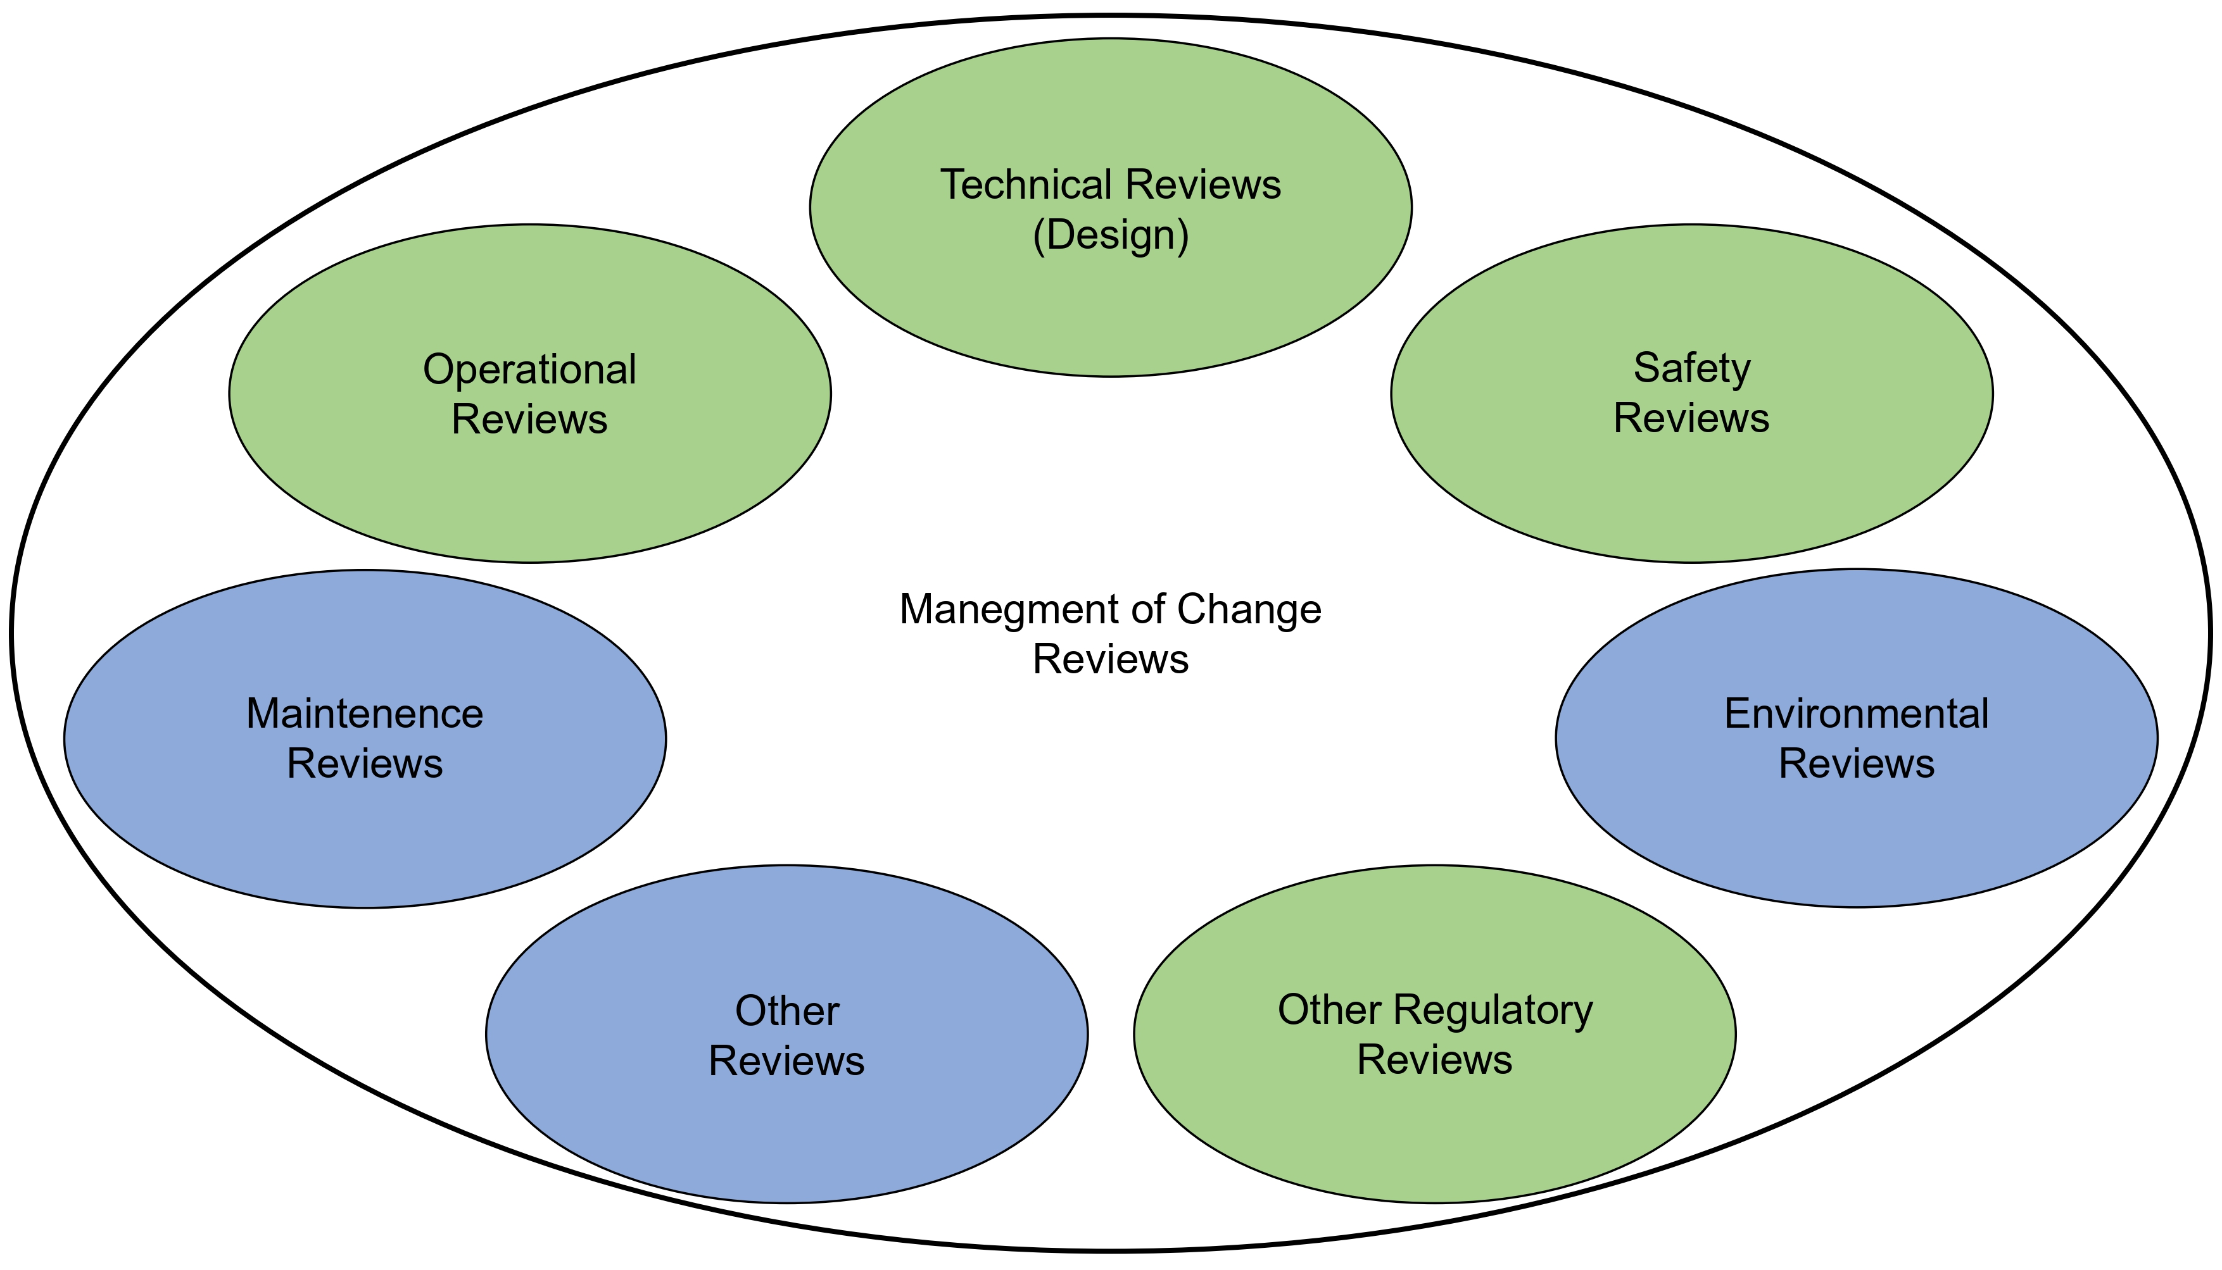
Figure 1: MOC Review’s Disciplines
Beside the reviews, a flowchart was developed to assist in the approve process of approval of changes in the process, as showed in Figure 2.
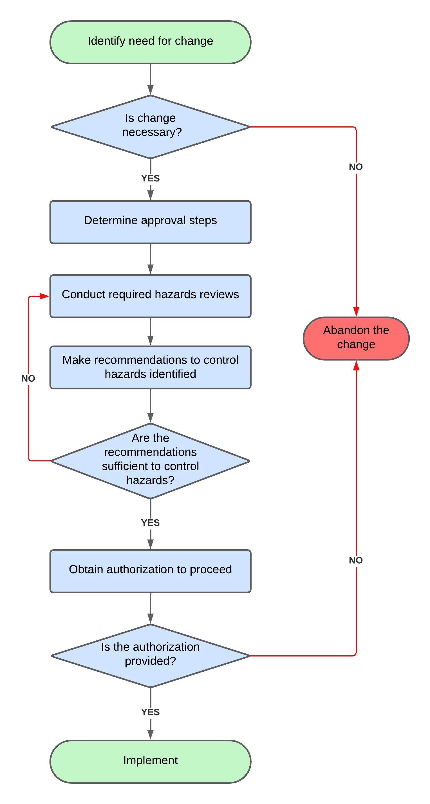
Figure 2: MOC reviews decision-making flowchart
  - Main Results
The test bench was constructed to represent manner-simply the powertrain that will be developed for TecH2’s Formula SAE car, built by SENAI CIMATEC University Center students for the H2 Challenge (H2C) competition. H2C is an initiative that aims to promote the opportunity for Engineering Students to work in the design and manufacturing of fuel cell-powered Baja and FSAE vehicles (SAE Brasil, 2024). The piping and instrumentation diagram of the test bench is shown in Figure 3.
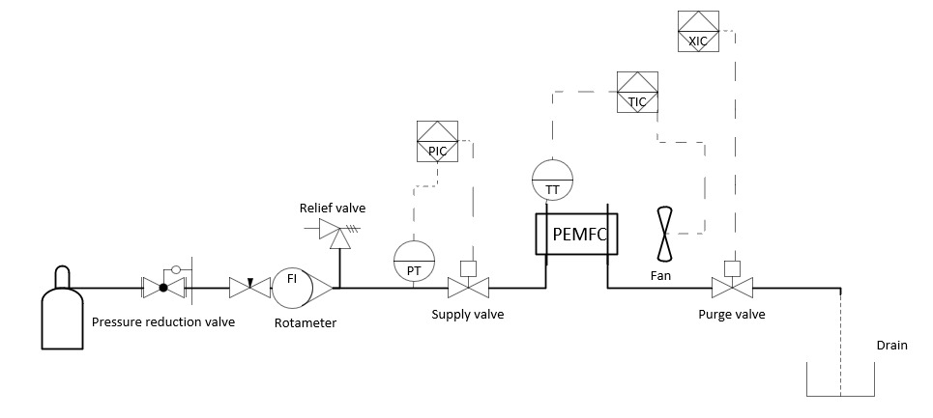
Figure 3: Piping and Instrumentation Diagram of the current test bench system
The changes proposed to the test bench are represented in Figure 4. The changes are the addition of an accumulator to ensure that there will always be hydrogen available for the stack; a hydrogen refeed system to avoid that non reacted hydrogen being discarded in the atmosphere; and the establishment of pressure, current, voltage, power, and temperature (control variables) monitoring and emergency emptying system for the stack if any of those variables exceed the safety standards (0.16-0.56 barg; 0-75 A; 18-36V; 0-2700 W; 6-75°C). The last is responsible for the actuator's control, such as the fan, responsible for the HFC cooling and O2 feed; start-up resistor relay, fuel cell relay, purge valve, and feed valve, responsible for controlling theHFC feeding system.
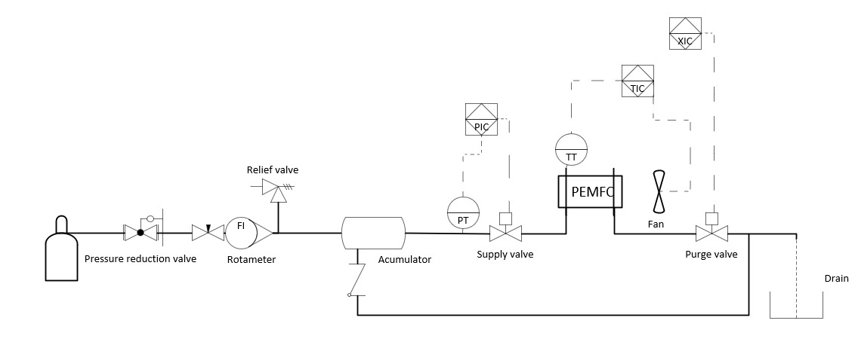
Figure 4: Piping and Instrumentation Diagram of the new system with the recommended changes
Table 1 represents the screening and assessment of MoC reviews, including the chosen disciplines and each subtask and those responsible for developing them.

Table 1: Screening and assessment of the MOC reviews

MOC Reviews | Screening done by: | Screening approved by: |  | Review facilitated or conducted by:
MOC Reviews | Project lead | Project lead | Discipline group rep. | Project lead | Discipline group rep.
Safety Reviews
Process Safety Reviews | X |  | X |  | X
Personal Safety Reviews | X |  | X |  | X
Technical Reviews
Design Reviews | X |  | X |  | X
Operational Reviews
Operational Reviews | X |  | X |  | X
Regulatory Reviews
Product’s Manual Reviews | X |  | X |  | X
Competition Rule Set Reviews | X |  | X |  | X

After defining the proposed changes for the test bench, the MoC reviews report was generated, as shown in Table 2.
Table 2: MOC report

Changes | Hazards eliminated | Hazards added | Recommendations
Add accumulator | Hydrogen starving on the fuel cell | None | Material and dimension specifications according to the Product’s´s Manual
Add hydrogen refeed system | Hydrogen output to the atmosphere | More complex system | Use the correct components according to the bibliographic review and Product’s Manual
Add pressure transistor | No pressure control on the stack | None | Use the correct specifications for the needed pressure
Add pressure relief valve | High pressure on the stack | None | Use the correct specifications for the system´s pressure

With the adoption of the mentioned improvements, the lack of a constant hydrogen flow to the fuel cell hazard, causing starvation and stack degradation, was resolved by adding the accumulator. Furthermore, the system's efficiency and safety were enhanced with the refeed system, preventing non-reacted hydrogen from being wasted and released into the atmosphere. Finally, the control variables monitoring system allows for fine-tuning of the system's operation and increased safety, preventing issues such as overpressure inside theHFC, which could cause leaks, component failure, and rupture of the stack; overheating of PEMFC, that could lead it to malfunction or permanent damage; and overcurrent, that may cause total electric failure of the stack.
The implementation of the accumulator is simple, as it is detailed in the Product manual. However, the refeed and control variables monitoring systems are more complex. The feedback system needs to be built based on other works documenting similar processes, as it is necessary to solve the issue of pressure variation at the stack outlet and its return to the feeding system. The monitoring system needs to follow the logic presented in the Product’s manual, and the control code must be checked to ensure that possible faults are detected, and the appropriate control response is triggered.
With the help of the tools offered by MoC reviews methodology, the project-led and working staff can work to guarantee the safety and effectiveness of the process, always following the Competition ruleset and Product manual for the HFC.
  - Conclusions
In conclusion, implementing the changes outlined in this study has shown significant potential to enhance the safety and efficiency of the test bench operation. The MOC reviews methodology has proven invaluable in guiding decision-making processes, particularly in evaluating the viability of proposed modifications. The addition of the accumulator, hydrogen refeed system, and stack control variables monitoring system if executed under the supervision of the project lead and team members, can ensure the process's safety while significantly improving the test bench's efficiency.
Moving forward, it is crucial to continue refining and optimizing these systems to ensure their seamless integration into the test bench environment. Deepening the study of the MoC reviews methodology will enable its application across various types of hydrogen systems, allowing for quick adaptation to different situations with the assistance of the 5W2H plan. Additionally, ongoing adherence to the Competition ruleset and product manual will be essential to maintaining the test bench's integrity and reliability.
In summary, the findings of this study highlight the importance of proactive MOC reviews in enhancing the effectiveness and safety of operational processes. By leveraging the insights gained from this research, future endeavors in HFC technology development can build upon these foundations to achieve even greater advancements in efficiency, sustainability, and safety.
References
Ballard Power Systems Inc.,2016, FCgen®-1020ACS Fuel Cell Stack and FCvelocity®-1020ACS Fuel Cell Stack Product Manual and Integration, Handling, Transportation and Storage Guide.
Olsen J.E., 2022, Management of Change Reviews for Small Modifications, Chemical Engineering Progress (CEP), December 2022, 35-38
SAE Brasil, H2 Challenge. <https://saebrasil.org.br/programas-estudantis/h2_challenge/> Accessed 29.06.2024
Aminudin, M. A. et al. An overview: Current progress on hydrogen fuel cell vehicles. International Journal of Hydrogen Energy, v. 48, n. 11, p. 4371-4388, 2023.
Sazali, Norazlianie et al. New perspectives on fuel cell technology: A brief review. Membranes, v. 10, n. 5, p. 99, 2020.
Jouin, M., Gouriveau, R., Hissel, D., Péra, M. C., & Zerhouni, N. (2013). PHM of Proton-Exchange Membrane Fuel Cells-A review. Chemical Engineering Transactions, 33, 1009.

