|  |  |
| --- | --- |
| cetlogo ***CHEMICAL ENGINEERING TRANSACTIONS***  ***VOL. xxx, 2024*** | A publication of  aidiclogo_grande |
| The Italian Association  of Chemical Engineering  Online at www.cetjournal.it |
| Guest Editors: Valerio Cozzani, Bruno Fabiano, Genserik Reniers  Copyright © 2024, AIDIC Servizi S.r.l. **ISBN** 979-12-81206-11-3; **ISSN** 2283-9216 | |

LNG risk mitigation: a comparison between active and passive barriers

Alessandro Pinciroli, Valentina Busini\*, Renato Rota

Politecnico di Milano - Dipartimento di Chimica, Materiali e Ingegneria Chimica “Giulio Natta” - Piazza L. da Vinci 32 – 20133 Milano (Italy)

valentina.busini@polimi.it

In the last years, there has been a rapid increase in the proposals for regasification terminals to import Liquefied Natural Gas (LNG) mainly due to the global uncertainties of the energy market. Therefore, there has been a fast increase in the interest in the risk assessment of LNG regasification terminals. LNG is not poisonous; instead, its rapid evaporation together with the vapour phase flammability presents a non-negligible risk. The concentration range in which the gas-air mixture at ambient conditions is flammable is about 4.4%v/v (Lower Flammability Limit - LFL) to 15% v/v (Upper Flammability Limit - UFL). One of the major accidental scenarios, involved in an LNG regasification terminal, is the breakage of a pipeline carrying natural gas in the liquid phase. This would result in the release of large amounts of LNG leading to a fast-evaporating pool and, consequently, to a large flammable cloud and possibly to fires and explosions. Therefore, mitigation measures must be provided to reduce the risk up to an acceptable value; among the various mitigation measures, a protective barrier able to limit the hazardous distance related to a given accidental scenario (and therefore to protect sensible population living close to the regasification terminal) can be used. In their simplest configuration, passive mitigation barriers are high walls acting as obstacles on the cloud path, therefore enhancing the flammable cloud-air mixing. Unfortunately, to be effective passive barriers often must be quite high, possibly preventing their practical implementation. As an alternative, active barriers can be used where the flammable cloud-air mixing is enhanced not only thanks to the wake effect of the wall but also to the direct entrainment into the flammable cloud. This entrainment can be induced (for instance) either by high-velocity jets or by fans. Therefore, the main aim of this paper is to provide a comparison among the pros and contras of using passive vs. active barriers to reduce the hazardous distance related to an accidental scenario in an LNG regasification terminal. In particular, the various barrier configurations were investigated through Computational Fluid Dynamic (CFD) simulations using the Ansys Fluent 2023R2 suite of programs.

* 1. Introduction

In recent years, proposals for regasification terminals to import liquefied natural gas (LNG) have increased rapidly. Consequently, the interest in risk assessment of LNG regasification terminals has increased rapidly too (Pitblado and Woodward, 2011).

LNG is non-toxic; on the contrary, its rapid evaporation as well as its flammability in the vapor phase pose a significant risk. The concentration range within which the gas-air mixture, under ambient conditions, is flammable is approximately 4.4% v/v (Lower Flammability Limit, LFL) to 15% v/v (Upper Flammability Limit, UFL).

One of the major accidental scenarios involving LNG regasification terminals is the rupture of pipelines transporting natural gas in the liquid phase. This would result in the release of large quantities of LNG leading to rapid evaporation and thus creating a large dense flammable cloud. Therefore, it is necessary to plan mitigation measures to reduce the related risk to an acceptable value. Among the various mitigation measures, protective barriers can be used since they can limit the hazardous distance involved in an accidental situation (and thus protect sensitive populations living near the regasification plant). In their simplest configuration, passive mitigation barriers are high walls that act as obstacles in the path of the cloud, thereby on one hand stopping the cloud movement, and on the other hand increasing the flammable cloud-air mixing thanks to the wake behind the wall (when the cloud pass over the barrier).

Unfortunately, to be effective, passive barriers often need to be quite high, which can hinder the practical implementation of such a mitigation measure (Busini et al., 2012, Nair and Salter, 2019). As an alternative, active barriers can be used where the flammable cloud-air mixing is enhanced not only by wall vortex effects but also by the air entrainment into the flammable cloud induced by mechanical devices, such as high-speed jets (Marsegan et al., 2016) or fans.

Therefore, the objective of this work is to provide a comparison between the advantages and disadvantages of using passive and active barriers to reduce the dangerous distance associated with an accident scenario in an LNG regasification unit. Various barrier configurations were investigated through computational fluid dynamics (CFD) simulations, using the Ansys Fluent 2023R2 suite of programs, and the computed hazardous distances from the LNG release point were compared.

* 1. Materials and methods

in this work, the hazardous distance from the release point of the LNG is defined as the maximum downwind distance, from the release point, with a methane concentration in the cloud larger than the LFL value.

Note that, since mitigation barriers are intended to protect sensitive targets near the facility, the barrier will typically be placed between the source and the target. Therefore, the worst case involves a wind direction from the release point towards the target; this motivates the choice of considering the maximum downwind distance when the wind flows towards the barrier as an indicator of the hazardous distance. Wind directions different from the one from the release point towards the barrier would significantly reduce the barrier efficiency, especially if the wind pushes clouds outside the barrier width.

To estimate such a hazardous distance, the cloud dispersion was numerically simulated through the Ansys Fluent 2023R2 suite of programs (ANSYS Inc., 2023), which implements and solves numerically the equations of mass, momentum, and energy conservation. As closure model, the k-w SST model in the RANS (Reynolds Averaged Navier Stokes) formulation was chosen to account for the turbulence effects along the lines of previous works published in the literature (e.g., Colombini & Busini, 2019; Kim et al., 2014; Schleder et al., 2015; Zhang et al., 2015).

In this work, the accidental scenario considered as a case study is the full-bore breakage of a pipeline with 1 m diameter carrying LNG in the liquid phase at -161.4 °C. The source term estimated through the integral model implemented in the suite of programs PHAST (Process Hazard Analysis Software Tools - DNV, 1999) and implemented in the simulation code through a dedicated UDF (User Defined Function) was a pool with a diameter of about 10 m. This case study is like that previously investigated to discuss the performances of passive mitigation barriers (Busini et al., 2011; Busini et al., 2012; Busini and Rota, 2014) as well as of active mitigation barriers that take advantage of high-velocity jets to enhance the cloud - air mixing (Marsegan et al., 2016). In particular, a barrier 6 m high and 700 m large was located 150 m downwind of the source pool and the effect on the hazardous distance of a passive barrier was compared to that of an active barrier that takes advantage of several fans located into the barrier to force the air behind the barrier to enter the cloud approaching the barrier from the other side, therefore enhancing the cloud - air mixing. The fans were introduced into the CFD simulation code through a dedicated boundary condition implemented in the suite of programs.

A typical result obtained by the simulations is shown in Figure 1 in terms of 3D cloud shape overcoming the passive barrier.

From such a result the LFL footprint can be easily obtained, therefore allowing for estimating the hazardous distance as previously defined.

*Figure 1: typical cloud shape computed though a CD simulation for the considered case-study.*

* 1. Results and discussion

The influence of the passive barrier, in terms of LFL footprint (note that in this work the LFL was selected as a hazard indicator; however, the same procedure can be easily repeated by considering half the LFL value as a hazard indicator, as often done in flammable cloud risk assessment) for a case-study like the one considered in this work has been previously investigated (Busini et al. 2012) and it can be summarized stating that the presence of the passive barrier can reduce the hazardous distance of about 50% (that is, from more than 500 m to less than 300 m) since the dense cloud splashes against the barrier and accumulates in front of it before overcoming the barrier with a limited dilution induced by the barrier wake effect.

The dilution of the flammable cloud can be increased by forcing the air entrainment not only through the limited wake effect of the passive walls but also through some forced convection. The effect of using high-velocity jets as active tools on the barrier has been previously investigated (Marsegan et al., 2016) and the obtained results can be summarized in Figure 2 through an efficiency parameter, $α$, defined as the percentage reduction of the hazardous distance induced by presence of an active device on the barrier:

|  |  |
| --- | --- |
| $$α=\frac{L_{P}-L_{A}}{L_{P}}∙100$$ | (1) |

In this definition, $L_{P}$ is the hazardous distance beyond the passive barrier, while $L_{A}$ is the hazardous distance beyond the active barrier. The reason for considering the hazardous distance from the barrier instead of the release source is that as far as the cloud does not overcome the barrier, the barrier fulfils its scope, that is, it stops the flammable cloud travel.

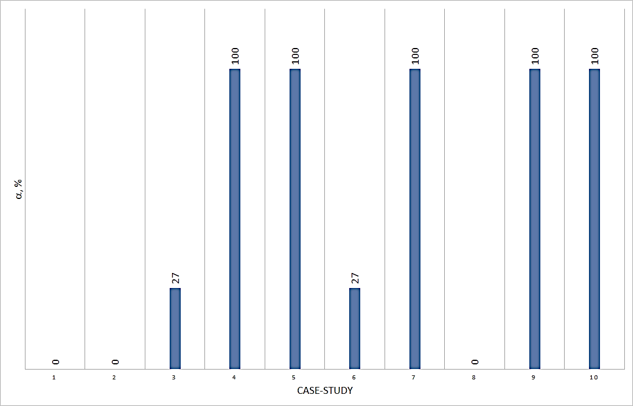

*Figure 2: efficiency parameter values for active barriers with high-velocity jest. Data from* (Marsegan et al., 2016)

From Figure 2 we can see that, depending on how the active device on the barrier (high-velocity jets in this case) is designed, the active barrier can behave like the passive one (that is, the efficiency parameter is equal to 0%) or even stop completely the cloud (that is, the efficiency parameter is equal to 100%) This call for a proper design of the active device, as discussed elsewhere (Marsegan et al., 2016). However, the real efficiency of even properly designed active barriers can be compromised by practical problems, such as (in the case of high-velocity jets as active devices) delay that can affect the activation of the large number of high-velocity jets required by a proper design. This delay time can be important since, considering (as an order of magnitude) a wind speed of 5 m/s and a barrier located 150 m downwind of the LNG release, the cloud would take just a few tens of seconds to reach the barrier. Moreover, many high-pressure compressors (in the case of air high-velocity jets) or huge amounts of overheated steam (in the case of steam high-velocity jets) are required, which implies a large power requirement.

If looking for active devices different from high-velocity jets, high-volume low-pressure fans could be considered. In this case, as shown in Figure 3a, several axial ventilators could be embedded into the barrier, therefore providing a direct inlet of clean air from beyond the barrier into the flammable cloud approaching the barrier and influencing the hazardous distance (Figure 3b).

|  |  |
| --- | --- |
|  |  |
| a. | b. |

*Figure 3 a.: example of an active barrier with several fans embedded; b.: example of an LFL contour in the case of several fans embedded.*

A typical result of the simulations carried out is shown in Figure 4 in terms of LFL footprint.

*Figure 4: LFL footprint for a passive barrier (upper half figure) and an active barrier (lower half figure).*

As a general behaviour, as expected, the presence of an active device (able to enhance the air–cloud mixing) on the barrier can strongly reduce the overcoming of the flammable cloud. In this work, four different designs of the active barriers (which differ mainly on the number and kind of fans embedded in the barrier) were simulated and the obtained results are summarized in Figure 5.

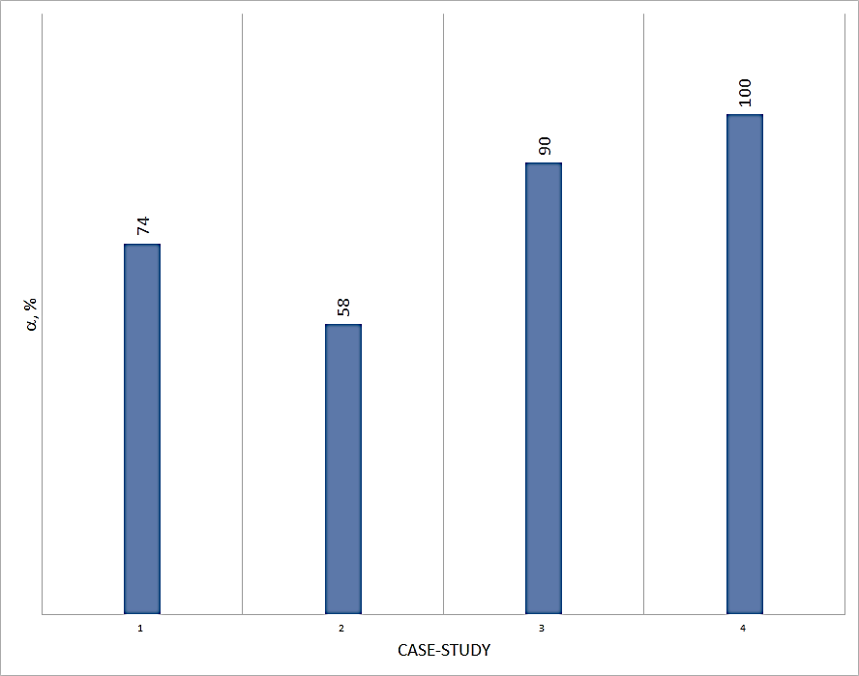

*Figure 5: efficiency parameter values for active barriers with* high-volume low-pressure *fans.*

As for the case of high-velocity jets, also the use of high-volume low-pressure fans requires a proper design to reach an efficiency parameter value close to 100%. However, also in this case the problem of the delay time is not completely solved since the activation of the required high-volume low-pressure fans can take a time comparable with the flammable cloud travel time from the release point to the barrier. Moreover, explosion-proof fans should be required, possibly strongly increasing the capital cost of the barrier. Finally, also high-volume low-pressure fans can require a large power amount, possibly (depending on the local electrical power availability) preventing the use of this kind of active barriers.

1. **Conclusions**

Different kinds of active barriers have some pros and contra to passive barriers. Active barriers involving high-velocity jets require a large amount of energy (compression work when using high-velocity air jets, or heat when using high-velocity steam jets); for the case study investigated, which is a catastrophic and less probable one, the energy required by active barriers with high-velocity jets is of the order of 105 MJ. However, for air jets, this amount of energy is required off-line to compress and store the required amount of air (therefore without any specific power requirement), while in the case of steam jets, this energy must be released in the meantime of the flammable cloud formation and dispersion up to the barrier, which requires a power of (as an order of magnitude) 103 MW. In both cases, additional (to passive barriers) capital costs are involved too, for the high-pressure storage vessels in the case of air jets, and the heating devices in the case of steam jets. Active barriers involving fans, for the case study investigated, require (as an order of magnitude) 10 MW of electric power, resulting in about (always as an order of magnitude) 103 MJ of energy. Therefore, additional costs are always involved for active barriers to passive barriers. However, to achieve the same efficiency as the active barriers, passive barriers require higher height; apart from increasing the cost of building passive barriers to the active ones, in some cases, the excessive height required can prevent the practical possibility of using passive barriers. On the other hand, the reliability of the passive barriers is intrinsically superior to that of the active barriers.

Thus summarizing, active barriers using both high-velocity jets or high-volume low-pressure fans when properly designed can fully stop the flammable cloud even in a major accidental scenario involving a massive release of LNG. However, several practical problems can prevent the installation of active devices on the barrier; in this case, a passive barrier properly designed (Busini et al., 2012) could be (when practically affordable) a reliable and efficient alternative.

References

ANSYS Inc., 2023, ANSYS Fluent 2023R2 user’s guide (Lebanon, NH, USA).

Bainbridge, K. (2003). An overview of the LNG shipping industry, fundamentals

Busini, V., Pontiggia, M., Derudi, M., Landucci G., Cozzani, V., Rota, R., 2011, Safety of LPG rail transportation. Chemical Engineering Transactions, 24, 1321-1326

Busini V., Lino M., Rota R., 2012, Influence of large obstacles and mitigation barriers on heavy gas cloud dispersion: a liquefied natural gas case-study, Industrial & Engineering Chemistry Research, 51, 7643-7650.

Busini, V., Rota, R., 2014, Influence of the shape of mitigation barriers on heavy gas dispersion. Journal of Loss Prevention in the Process Industries, 29, 13‐21.

Colombini, C., Busini, V., 2019, Obstacle Influence on High-Pressure Jets based on Computational Fluid Dynamics Simulations. Chemical Engineering Transactions, 77, 811-816

DNV, 1999, PHAST 6.0 technical reference manual (London, UK).

Kim, B. K., Mentzer, R. A., Mannan, M. S., 2014, Numerical Study on Physical Mechanisms of Forced Dispersion for an Effective LNG Spill Mitigation. Industrial & Engineering Chemistry Research, 53, 9488‐9498.

Marsegan C., V. Busini and Rota R, 2016, Influence of active mitigation barriers on LNG dispersion, Journal of Loss Prevention in the Process Industries, 44, 380-389.

Nair, S.R., Salter, J., 2019, Layout - A cost effective and powerful design step in risk management, Chemical Engineering Transactions, 77, 13–18

Pitblado R. M., Woodward J. L., 2011, Highlights of LNG risk technology, Journal of Loss Prevention in the Process Industries, 24, 827-836.

Schleder, A. M., Pastor, E., Planas, E., Martins, M. R., 2015, Experimental data and CFD performance for cloud dispersion analysis: The USP‐UPC project. Journal of Loss Prevention in the Process Industries, 38, 125‐138.

Zhang, X., Li, J., Zhu, J., Qiu, L., 2015, Computational fluid dynamics study on liquefied natural gas dispersion with phase change of water. International Journal of Heat and Mass Transfer, 91, 347‐354.