|  |  |
| --- | --- |
| cetlogo ***CHEMICAL ENGINEERING TRANSACTIONS***  ***VOL. xxx, 2024*** | A publication of  aidiclogo_grande |
| The Italian Association  of Chemical Engineering  Online at www.cetjournal.it |
| Guest Editors: Valerio Cozzani, Bruno Fabiano, Genserik Reniers  Copyright © 2024, AIDIC Servizi S.r.l. **ISBN** 979-12-81206-11-3; **ISSN** 2283-9216 | |

Identification of Substances Emitted During Combustion and Thermal Decomposition of Wood-Based Materials

Kamila Mizera\*, Monika Borucka, Jan Przybysz, Agnieszka Gajek

Central Institute forLabour Protection – National Research Institute, Czerniakowska 16, 00-701 Warsaw, Poland

kamila.mizera@ciop.pl

In this study, the thermal decomposition and combustion products of wood-based board and pellets were studied. Flammability parameters were determined using a cone calorimeter, and substances formed during the thermal decomposition and combustion of the materials studied were identified using a tube furnace (Purser furnace) and gas chromatography-mass spectrometer (GC-MS). It was observed that under well-ventilated conditions, complete combustion occurs without the release of hazardous substances. However, during flameless combustion, the resulting smoke contains a variety of substances that pose a threat to human health and life.

* 1. Introduction

The most common cause of death in fires is the effect on the human body of toxic gases present in the smoke that is generated. The main gaseous products most often leading to death are carbon monoxide and hydrogen cyanide. However, in addition to those mentioned, other suffocating or irritant gases are also included.

The behavior of a material during combustion and the amount of toxic products formed depends most on its composition, temperature and oxygen concentration. The development of a fire has been classified and divided into several types, from smoldering combustion and early, well-ventilated flames to fully developed unventilated flames (Bu and Gharajeh, 2019). During the development of a fire, it is important to ventilate the environment in which the fire has occurred. In confined spaces, such as buildings or means of transportation, fire conditions quickly change from well-ventilated to unventilated. These fires are larger, and at the same time produce larger amounts of toxic products harmful to humans.

The use in the construction industry of products based on wood and wood-based plastics, i.e. wood-based materials that are obtained by fusing or gluing together natural or previously improved wood, results in a number of wastes. These wastes can be characterized by different properties due to their origin, purpose and the use of additives in the form of resins (urea-formaldehyde, melamine-formaldehyde, phenol-formaldehyde), adhesives, paraffin, varnishes, veneers, films, etc. (Wasilewski, 2019). Post-consumer wood and wood plastic wastes have good fuel properties, so they can be a source of energy. Sawdust and shavings obtained at industrial plants are used to produce wood pellets, which are used for heating in central heating boilers, in single-family homes and district heating plants, and more (Kajda-Szcześniak, 2013). Knowledge about the harmfulness of burning waste wood-based panels and the resulting pellets is still insufficient. Due to the presence of about 10 % formaldehyde-urea, melamine or phenolic resins and their mixtures in wood-based panels, the waste also contains the mentioned compounds. As a result, CO2, SO2 or NO2 compounds are emitted in the pellets made from these wastes when they are burned. Lack of awareness causes people to choose cheaper, low-energy substitutes such as straw, sunflower or MDF pellets. It is illegal to use furniture to heat your home. Furniture boards are a waste product that has to be thermally recycled. This can only be done in special incinerators, as their combustion releases volatile organic compounds, polycyclic aromatic hydrocarbons, dioxins and formaldehyde.

This raises the need for detailed studies of the toxicity of the products of combustion of individual materials and building products that are commonly used in architecture and construction. The problem of toxicity of building materials and products used in interior architecture and building installations is constantly increasing.

Therefore, there is a need for detailed research into the toxicity of the combustion products of wood-based materials and to raise awareness among people of the dangers involved.

In this work, the study of volatile and semi-volatile organic compounds emitted during thermal degradation and combustion of pellet and wood-based panel. The steady state tube furnace has been used specifically to generate toxic products from real fires under different conditions. The released species have been sampling using solid phase microextraction technique (SPME) and identified using gas chromatography with mass selective detector (GC-MS). Measurements made by the cone calorimeter were used to determine the parameters associated with the rate of heat release from selected plant protection products. The determined parameters facilitated drawing conclusions on the size of the fire, its growth rate and consequently, the quantity and quality of the smoke emission.

* 1. Experimental

2.1 Materials

In the research presented here, a wood-based panel made of triple-pressed flake wood chips arranged at different angles to each other and bonded together with resin was used. The second material was a pellet made from sawdust of coniferous and deciduous trees, characterized, according to the manufacturer, by a low ash content and a high calorific value.

2.2 Measurements

Measurements using a cone calorimeter from Fire Testing Technology Ltd. were carried out in accordance with ISO 5660. Samples placed horizontally against the cone heat sink were subjected to a thermal radiation flux of 35 kW/m2. Samples of the test materials, measuring 100 x 100 mm and approximately 18 mm thick, were prepared by wrapping the edges of the samples with aluminium foil of the appropriate thickness and covering the underside with a ceramic blanket. The combustion reaction was initiated by ignition using a spark igniter. At least three measurements were taken for each material.

To study the formation of the gaseous burning products a state tube furnace method (Purser furnace) (Fig. 1), simulating fire conditions was used, in conformity with ISO/TS 19700:2007. Samples (15 g) of the tested materials were placed in a quartz form and put into the pre-heated furnace at 25 °C. Then the samples were heated to 900 °C with the air flow of 2 L/min (poor ventilation) and 10 L/min (well-ventilated conditions).

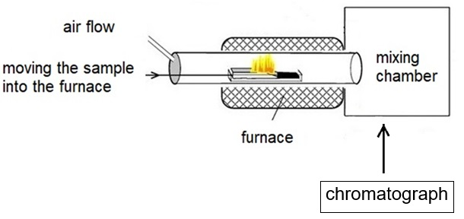

*Figure 1: Diagram of the structure of the tube furnace (Purser furnace) with the gas chromatograph (own study)*

The test run was only valid if the original airflow rates were correct, according to the ISO standard, and the selected steady-state conditions were maintained for at least 5 minutes during the test (Table1). If ignition occurred during a run without combustion or did not occur during a run with combustion, the furnace temperature was raised or lowered in 25°C increments until the required behavior was achieved.

Table 1: Conditions used during measurements carried out with the Purser furnace

|  |  |  |  |  |
| --- | --- | --- | --- | --- |
| Phase of fire | | Purser furnace temperature, °C | Basic air flow rate, L/min | Total air flow rate, L/min |
| 1. Non-flaming | 1b. Oxidative pyrolysis from externally applied radiation | 350 | 2 | 50 |
| 1. Well-ventilated flaming (representing a flaming, developing fire) | | 650 | 10 | 50 |

Volatile and semi-volatile compounds released during thermal degradation and combustion of selected materials were analyzed using a gas chromatograph (GC 7890 A from Agilent Technologies, Hanover, USA) with a mass spectrometer (MSD 5975 from Agilent Technologies, Hanover, USA). In order to achieve the desired results, solid-phase microextraction (SPME) was used as a technique to combine sampling and concentrating analyses, as well as introducing them into the chromatographic system (Borucka et al., 2023). A sample of the substance was taken from the mixing chamber by inserting SPME into the sampling ports using a divinylbenzene/carboxen/polydimethylsiloxane fiber (DVB/CAR/PDMS) (Supelco, Bellefonte, USA). Before use, the fibers were conditioned in the injection port, according to the manufacturer's instructions. After the SPME syringe was inserted into the mixing chamber, the gaseous thermal decomposition products were sorbed onto the SPME fiber. After collection (5 min), the SPME fiber was removed from the chamber and immediately desorbed in the GC injector for analysis.

Chromatographic separation was achieved on an HP-5MS fused silica capillary column (30 m × 0.25 mm × 0.25 μm layer thickness) using helium as carrier gas at a rate of 1 ml/min. The method of conducting the measurement involved 3 steps. The oven temperature was maintained at 35 °C for 3 minutes, then increased by 6 °C/min to 90 °C and maintained for 4 minutes. In the next stage, the temperature was increased by 8 °C/min to 200 °C and maintained for 4 minutes. Finally, the temperature was increased at 12 °C/min to 250 °C and held for 7 minutes. The GC injector port had a temperature of 250 °C. The MSD was operated by electronic shock (70 eV) in scan mode (25-450 m/z).

Chromatographic peaks were identified by comparing the mass ion of each peak with the NIST MS library. Only compounds with a probability higher than 60% were included based on the NIST library.

* 1. Results and discussion

**3.1 Fire behaviour**

Table 1 summarises the results obtained during combustion on the cone calorimeter, such as the maximum heat release rate peak (pHRR) and the time to obtain this peak (t-pHRR), the total smoke released (TSR) and the total heat released (THR).

Table 2: Comparison of calorimetric parameters of the testing materials

|  |  |  |  |  |
| --- | --- | --- | --- | --- |
| Material | pHRR, kW/m2 | t-pHRR, s | TSR, m2/m2 | THR, MJ/m2 |
| Pellet | 242 (9) | 485 (0) | 1834 (2) | 115 (2) |
| Wood-based panel | 244 (17) | 85 (0) | 1542 (15) | 165 (27) |

A key parameter in assessing the flammability of materials is the maximum heat release rate HRR. The value of this parameter is similar for both materials. The time to maximum heat release rate was significantly higher for pellets. The amount of heat and smoke released was similar for both materials.

**3.2 Analysis of fire effluent**

The main products identified in the fire gases released during the ~5-min steady-state periods are summarised in Table 3. More than 36 semi-volatile compounds were identified in the fire gases released during the combustion and thermal degradation of the materials tested. The highest number was detected during pyrolysis (phase 1b - Table 1).

Table 3: List of products identified in fire effluents released during ~5 min steady-state periods during different fire stages

| Detected products | CAS No. | Amounts, % | | | |
| --- | --- | --- | --- | --- | --- |
| Pellet | | Wood-based panel | |
| 350 °C | 650 °C | 350 °C | 650 °C |
| **COx, NOx** | - | 6,19 | 100,00 | 5,35 | 91,45 |
| **Oxalic acid** | 144-62-7 | 2,55 |  |  |  |
| **2-Hydroxy-Propanamide** | 2043-43-8 |  |  | 2,03 |  |
| **Hydroxy-Acetaldehyde** | 141-46-8 | 1,34 |  | 1,05 |  |
| **Acetic acid** | 64-19-7 | 3,02 |  | 2,77 |  |
| 1-Hydroxy-2-Propanone | 116-09-6 | 0,67 |  | 0,49 |  |
| 2-Propenoic acid | 79-10-7 |  |  | 0,23 |  |
| Succindialdehyde | 638-37-9 | 0,60 |  | 0,45 |  |
| 2-Oxo-methyl ester-Propanoic acid | 600-22-6 | 0,73 |  | 0,52 |  |
| **Furfural** | 98-01-1 | 3,11 |  | 2,18 |  |
| **2-Furanmethanol** | 98-00-0 | 2,73 |  | 1,73 |  |
| 1-(Acetyloxy)-2-Propanone | 592-20-1 | 0,37 |  | 0,25 |  |
| 4-Cyclopentene-1,3-dione | 930-60-9 | 0,16 |  | 0,12 |  |
| **2(5H)-Furanone** | 497-23-4 | 1,60 |  | 1,33 |  |
| **p-Benzoquinone** | 106-51-4 |  |  |  | 1,62 |
| **2-Hydroxy-2-Cyclopenten-1-one** | 10493-98-8 | 1,77 |  | 1,37 |  |
| Dihydro-3-methylene-2,5-Furandione | 2170-08-3 | 0,47 |  | 0,29 |  |
| Benzaldehyde | 100-52-7 | 0,51 |  | 0,47 |  |
| **5-Methyl**-**2-Furancarboxaldehyde** | 620-02-0 | 2,48 |  | 1,30 |  |
| 1-(Acetyloxy)-2-Butanone | 1575-57-1 | 0,74 |  | 0,36 |  |
| Phenol | 108-95-2 | 0,37 |  | 0,48 |  |
| **Hexanoic acid** | 142-62-1 | 1,24 |  |  |  |
| **3-Methyl-1,2-Cyclopentanedione** | 765-70-8 |  |  | 2,07 |  |
| 2,5-Furandicarboxaldehyde | 823-82-5 | 0,96 |  |  |  |
| **2-Methoxy-Phenol** | 90-05-1 | 7,54 |  | 5,85 |  |
| **Maltol** | 118-71-8 | 1,17 |  | 0,97 |  |
| 3-Ethyl-2-hydroxy-2-Cyclopenten-1-one | 21835-01-8 | 0,28 |  | 0,34 |  |
| **Creosol** | 93-51-6 | 11,57 |  | 10,19 |  |
| **Catechol** | 120-80-9 |  |  | 0,82 | 1,56 |
| **5-Hydroxymethylfurfural** | 67-47-0 | 1,21 |  | 1,36 |  |
| **4-Ethyl-2-methoxy-Phenol** | 2785-89-9 | 4,32 |  | 4,33 |  |
| 5-Acetoxymethyl-2-furaldehyde | 10551-58-3 | 0,33 |  | 0,42 |  |
| **2-Methoxy-4-vinylphenol** | 7786-61-0 | 3,95 |  | 5,37 |  |
| 2,6-Dimethoxy-Phenol | 91-10-1 |  |  | 0,89 |  |
| 2-Methoxy-4-propyl-Phenol | 2785-87-7 | 0,88 |  | 0,97 |  |
| 1-(4-hydroxy-3-methoxyphenyl)-2-Propanone | 2503-46-0 | 0,20 |  | 0,34 | 0,61 |

\* products in excess of 1 % have been highlighted in bold

The products formed during the pyrolysis and combustion of the materials tested are associated with the decomposition of wood. During decomposition of the materials at 350 °C, the main substances present in the emitted gases and fumes were creosol, 2-methoxyphenol, 4-ethyl-2-methoxyphenol and 2-methoxy-4-vinylphenol. Creosol is a phenolic aromatic compound that is a component of wood creosote. Creosote is a component of wood tar, a product of the dry distillation of wood (Zhang et al., 2023). Among other things, it is emitted from chimney flue gases when burning insufficiently dried wood. Maltol vapour was also present in the emitted gases. This substance occurs naturally in nature - it can be found, among other things, in the bark and needles of pine trees (Cai et al., 2023). Cresol is an eye and skin irritant.

Oxalic and acetic acid, furfural and 2-furanomethanol and other compounds were present in slightly lower proportions. Furfural is a biomass-derived compound obtained by hydrolysis and dehydration of xylan in lignocellulose, which contains an aldehyde group in its molecule and a conjugated double bond system in the furan ring (Sun et al., 2024). Furfural is a toxic and irritant substance. It has a toxic effect on the respiratory tract and is an irritant to the eyes and respiratory tract. A number of phenolic compounds and substances from the group of polycyclic aromatic hydrocarbons were also detected in the mixtures of emitted gases and fumes. Phenolic compounds, are a harmful substances, and has the toxic effect on aquatic life, causing long-lasting effects (Borucka and Celiński, 2019).

In the pyrolysis of the wood-based panel, the appearance of 2-hydroxy-propanamide, 2-propenoic acid, 3-methyl-1,2-cyclopentanedione, catechol and 2,6-dimethoxy-phenol was observed. In contrast, only the pellet identified the presence of hexanoic acid.

In the case of full combustion, the number of products identified was much lower. In the case of pellets, no products other than carbon and nitrogen oxides were identified. In contrast, in the case of wood-based panel, p-benzoquinone, catechol and 1-(4-hydroxy-3-methoxyphenyl)-2-propanone were detected. These compounds can cause irritation to the respiratory system and eyes, and can also lead to skin lesions. In addition, p-benzoquinone is highly toxic to the aquatic environment. Catechol, on the other hand, can cause genetic deformities and lead to cancer.

The examples of gas chromatography data of the gas samples released during thermal decomposition of selected materials are shown in Figure 2.

a)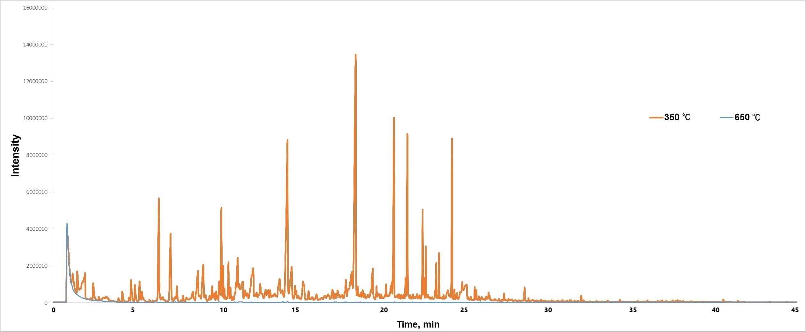

b)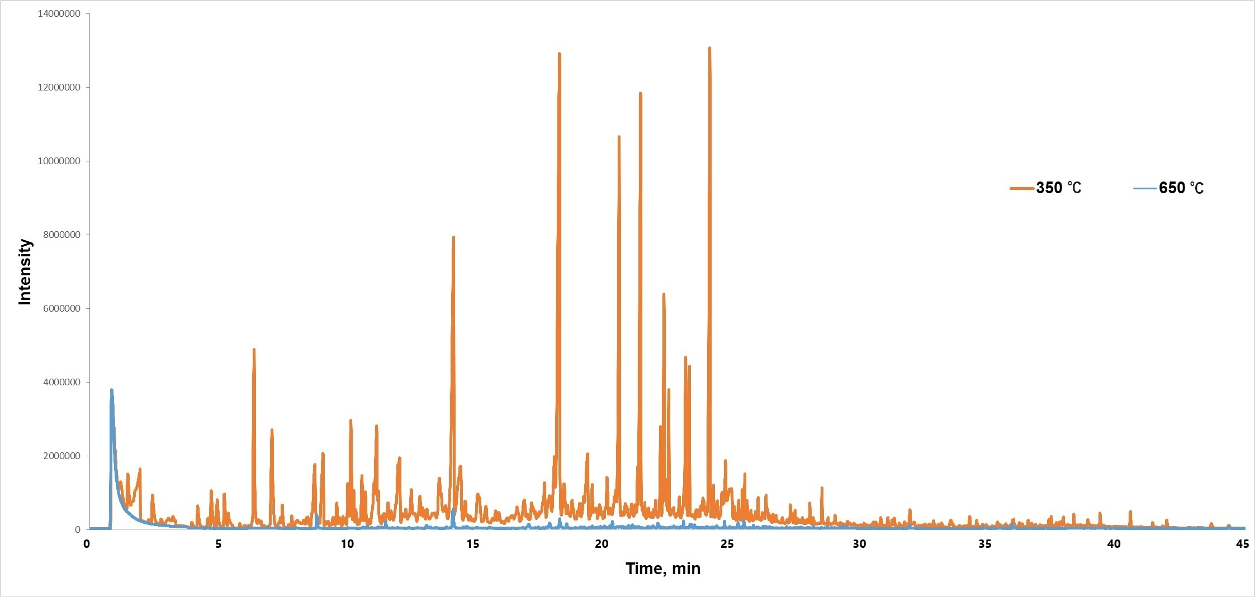

*Figure 2: Total ion chromatograms from GC–MS analysis of fire effluents obtained during thermal degradation of a) pellet and b) wood-based panel.*

* 1. Conclusions

Any combustion, whether intentional (space heating) or accidental (fire), leads to the formation of smoke. The danger this poses is due to the presence of a number of dangerous products resulting from the thermal decomposition and combustion of the material. The use of contaminated pellets as fuel, even worse in a boiler which is beginning to rust and is not regularly cleaned of residual dust, can lead to poisoning by chemicals which can enter the room with the smoke. The study revealed what substances are produced during pyrolytic conditions that can occur when a furnace malfunctions and becomes clogged. On the other hand, under well-ventilated conditions, when full combustion takes place (650 °C and an airflow of 10 L/min), the amount of the indicated substances is much lower for the slab. Thus, the most favourable conditions are those in which full combustion takes place, i.e. with good ventilation, in a clean fireplace.

In addition, it is important to be aware that the smoke passes up the chimney into the air we breathe. This is why it is important to raise awareness among pellet producers and the people who use them, as well as firefighters and others involved in rescue operations.

Acknowledgments

This paper was created on the basis of results of a research task carried out within the scope of the 6th stage of the National Programme “Governmental Programme for Improvement of Safety and Working Conditions”, funded by state services of the Ministry of Family, Labour and Social Policy (under the name of the Ministry of Family and Social Policy prior to December 12th, 2023).

task no. 3.ZS.08 entitled “Analysis of pollutant emissions to the air during combustion of wood-based panels and the resulting pellets”.

The Central Institute for Labour Protection – National Research Institute is the Programme’s main co-ordinator.

References

Borucka M., Celiński M., 20019, Thermal Degradation and Combustion Behavior of Antifungal Pesticides: Triadimenol and Tebuconazol, Chemical Engineering Transactions, 77, 139-144.

Borucka M., Mizera K., Przybysz J., Kozikowski P., Gajek A., 2023, Analysis of Flammability and Smoke Emission of Plastic Materials Used in Construction and Transport, Materials, 16(6), 2444.

Bu F., Gharajeh M.S., 2019, Intelligent and vision-based fire detection systems: A survey, Image and Vision Computing, 91, 103803.

Cai Z., Guo H., Zhou Q., Zhao Sh., Ding L., 2023, Simultaneous determination of maltol and maltol glucuronide in human plasma and urine by HPLC–MS/MS: Application in clinical study in patients with iron deficiency, Journal of Chromatography B, 1225, 123760.

Kajda-Szcześniak K., 2013, Evaluation of the basic properties of the wood waste and wood based wastes, Waste Management and Environmental Protection, 15, 1-10.

Sun X., Wang F., Zhang W., Zhao K., Liu X., 2024, Research advances on the catalytic conversion of biomass-derived furfural into pentanediols, Catalysis Communications, 106864, https://doi.org/10.1016/j.catcom.2024.106864.

Wasielewski R., 2019, The use of engineered wood wastes for energy production, Archives of Waste Management and Environmental Protection, 21, 1-18.

Zhang Z., Wang L., Zhou X., 2023, Study on adsorption behaviors of different cresols: First-principles calculation, Journal of Molecular Liquids, 390, 123120.