|  |  |
| --- | --- |
| cetlogo ***CHEMICAL ENGINEERING TRANSACTIONS***  ***VOL. xxx, 2024*** | A publication of  aidiclogo_grande |
| The Italian Association  of Chemical Engineering  Online at www.cetjournal.it |
| Guest Editors: Valerio Cozzani, Bruno Fabiano, Genserik Reniers  Copyright © 2024, AIDIC Servizi S.r.l. **ISBN** 979-12-81206-11-3; **ISSN** 2283-9216 | |

Application of Quantitative Risk Assessment to Hydrogen Transport Plants

Giacomo Battistib, Annamaria Di Padovab, Roberta Miglionicob , Fabrizio Talloneb, Valerio Cozzania,\*

aLISES- Laboratory of Industial Safety and Environmental Sustainability, DICAM, University of Bologna, via Terracini 28, 40131 Bologna,

bSaipem, Loss Prevention and Environment Department, Energy Carriers, via Toniolo 1, 61032 Fano, Italy

Valerio.Cozzani@unibo.it

The scientific community agrees in the need to limit the anthropic emissions of greenhouse gases into the atmosphere in order to mitigate the causes of climate change that has occurred in recent years. In order to fulfill this objective an extended decarbonization of industrial processes and an energy transition towards zero carbon emission sources are needed. Hydrogen currently represents one of the most promising solutions to achieve these goals, since it can be produced with low-emission technical solutions and may be used to produce mechanical or electric energy without the production of CO2. In the perspective of using hydrogen as an energy carrier, future plans to ensure its large-scale distribution concern the possibility to convert the currently existing natural gas grid infrastructures to the transport of hydrogen. However, there is currently a lack of technical regulations, codes and standards to ensure a safe design and operation of these infrastructures in case of their hydrogen conversion. For this reason, quantitative risk assessment (QRA) may represent an important tool to evaluate safety of hydrogen plant and to investigate if conversion to hydrogen of existing energy infrastructures could be considered sufficiently safe. Therefore, in this paper, critical issues and peculiarities related to hydrogen in the application of the QRA are examined. Furthermore, a case study was developed to assess the risk profile obtained considering an accidental release from a typical transport plant facility. Sensitivity analysis of results to different modeling parameters and benchmarking with those obtained for natural gas have been carried out, in order to highlight the potential safety concerns in case of hydrogen conversion of existing natural gas grid infrastructures.

* 1. Introduction

Quantitative risk assessment is a methodology that allows a formal and systematic evaluation of the frequencies and consequences of accidental scenarios that can occur in a plant, expressing the results in terms of risk for different possible categories of receptors (humans, environment, society). Although the application of the QRA is a well-established practice for the risk assessment of plants handling flammable gases, in case of hydrogen its application presents uncertainties related to the lack of specific databases (HySafe, 2022). In fact, the parameters required to estimate the failure frequencies and the models for consequence evaluation have been developed based on experimental evidence and past accidents that have involved Oil & Gas installations.

The chemical properties of hydrogen differ significantly from those of hydrocarbons, especially with respect to flammability and reactivity, and in how they affect the brittleness of steels. This makes the data and models that are used for the QRA unreliable and questionable. Therefore, this paper analyzes all the uncertainties related to hydrogen for the conduction of the risk assessment, from the hazard identification up to the consequence modeling, and presents possible solutions applied to a case study in order to understand the gaps and define a way forward for the application of QRA to hydrogen technologies.

* 1. Quantitative Risk Assessment methodology

Figure 1 shows a flowchart of the quantitative risk assessment methodology, divided into its main steps. For each step, the critical issues concerning the application of the methodology to hydrogen systems, if present, are highlighted. As it can be seen from Figure 1, several steps show criticalities in the case of the application to hydrogen. First of all, concerning the hazard identification and the evaluation of the release frequencies, the main issue raised by the hydrogen is related to the embrittlement phenomenon. In fact, it has been widely demonstrated that steels suffer serious deterioration of their mechanical properties after a long exposure to hydrogen (Louthan, 2008), resulting in a reduction of their fracture toughness and in an enhancement of the phenomena related to the generation and the propagation of microstructural defects (Hydrogen assisted cracking) (Laureys et al., 2022). Given these peculiarities, the release frequencies available in the main databases, obtained entirely from statistical studies on past accidents involving hydrocarbon processing plants, may not be representative for piping and equipment handling hydrogen. However, currently no specific database for failure frequencies of hydrogen processing components is available. The second critical issue concerns the frequency evaluation of the accident scenarios, which, as per the release frequencies, is carried out using ignition probabilities derived from hydrocarbon data and not conservative in the case of hydrogen, due to its higher reactivity compared to that of hydrocarbons. Relevance should be given to hydrogen flammability and, in particular, to the low value of the minimum ignition energy, with respect to those of hydrocarbons, which is approximately of 0.02 mJ (Hao et al.,2022). In the literature, specific data for hydrogen ignition probabilities are still limited and provided only for small release flow rates which may not be representative of the releases that could occur during a loss of containment in an industrial facility. Finally, with respect to the impact assessment of the accident scenarios, the main challenge posed by hydrogen is related to the Explosions modeling. In fact, due to the high reactivity of hydrogen, there are concerns about the potential to have severe deflagrations and even transitions from deflagration to detonation (DDT) in the case of low confinement and congestion. Currently, specific integral models for hydrogen Explosions are not available in validated software tools. Therefore, unless specific CFD codes are used, the modelling of these scenarios is still carried out using conventional generic models (Multi-energy and Baker-Strehlow-Tang (BST)), even if there is evidence concerning the poor accuracy of the results with respect to the experimental data available (Mélani et al., 2008).

The simulation of Fire scenarios is less problematic. In fact, a specific model (Miller Model) has been developed for hydrogen Jet Fires which allows a more accurate evaluation of these scenarios.

Finally, the application of the steps of the QRA methodology regarding the identification of the isolable sections and the risk assessment do not present critical issues linked to hydrogen as they do not depend directly on the chemical properties of the processed substances.

In the following section, a case study is provided in order to show the possible solutions to develop a QRA for hydrogen systems and to compare the risk to that obtained for natural gas.

*Figure 1: Quantitative risk assessment methodology: critical points in the application to Hydrogen.*

* 1. Case study

The case study focuses on the characterization of the risk associated to hydrogen accidental releases from a typical facility in the energy industry. The analysis had the following aims: 1) frequency evaluation for hydrogen releases considering the embrittlement; 2) Jet Fire modelling, comparing the specific model available for hydrogen with a generic model, 3) calculation of the overall risk profile and influence of the Explosions modelling. All the results were benchmarked with those obtained for methane, used as a representative substance for natural gas. The release conditions used for the analysis are presented in Table 1 and were obtained considering an isolable section representative of an inlet stream to the compression unit of a typical natural gas transport plant under the assumption to consider the same process conditions for methane and hydrogen. The release frequencies were evaluated with the IOGP database (IOGP, 2019) and then modified according to a methodology presented in literature (Milazzo et al., 2021) which allows the evaluation of a corrective factor for the release frequencies through the analysis of the failure causes that are actually possible in the plant and an expert judgement concerning the safety management system with respect to these critical issues. Therefore, the application of this methodology allowed a differentiation between the case of methane and of hydrogen, and, in particular, returned a more severe condition for the latter, given the criticalities on the steel discussed previously, related to the embrittlement phenomenon (the modified release frequencies for hydrogen resulted about twice those obtained for methane). Concerning the hydrogen ignition probabilities, in the case of the smaller release size (25.4 mm) they were evaluated according to the data provided in the HyRAM methodology (Groth at al., 2017). For the other two release sizes considered, which resulted in release flow rates higher than the ranges reported in the HyRAM methodology, the ignition probabilities were evaluated according to analyses conducted on the international database HIAD 2.0 (JRC, 2017), which is specific for incidents involving hydrogen. In particular, in the analysis of the database, 85% of the case reported an ignition. Therefore, this value was used as the total ignition probability associated to high release rates using the same ratio between immediate and delayed ignition probabilities as that reported in the HyRAM methodology, which is approximately 71/29. The Methane ignition probabilities were evaluated according to the IP/UKOOA standard using the “Small Gas Plant” look-up correlation (Energy Institute, 2019) considering a 30/70 ratio between immediate and delayed ignition for the two smaller release sizes and a 50/50 split for the largest. In both the case of hydrogen and of methane, the Explosion probability given a delayed ignition was considered equal to 40% for all the release sizes considered. All the analysis developed for the case study were conducted with the aid of the risk-specific software DNV SAFETI and the damage associated to the modelled scenarios was assessed as follows: a) for Jet Fires, a default Probit function was implemented in the software, considering an exposure time of 20 s; b) for Flash Fires a 100% lethality at the LFL concentration and a 50 % of lethality at the LFL/2 concentration were assumed; c) for Explosions, four levels of overpressure (0.3 bar, 0.14 bar, 0.07 bar and 0.03 bar) have been considered, attributing a corresponding lethality of 100%, 70%, 50% and 30%. All scenarios were modelled considering a horizontal release and two weather condition: 5D (Wind speed of 5 m/s and Pasquill class D) and 2F (Wind speed of 2 m/s and Pasquill class F).

*Table 1: Case Study Release Conditions (PTOT,ign: Total ignition probability)*

|  |  |  |  |  |  |  |  |  |
| --- | --- | --- | --- | --- | --- | --- | --- | --- |
| P  (bar) | T  (°C) | Hole size (mm) | CH4 | | | H2 | | |
| Release frequency (ev/y) | Discharge  flow rate  (kg/s) | PTOT,ign | Release frequency  (ev/y) | Discharge  flow rate  (kg/s) | PTOT,ign |
| 36 | 10 | 25.4 | 1.37 E-03 | 2.90 | 0.01 | 2.77 E-03 | 0.99 | 0.08 |
| 36 | 10 | 101.6 | 1.60 E-04 | 46.42 | 0.11 | 3.24 E-04 | 15.93 | 0.85 |
| 36 | 10 | 508 | 4.40 E-05 | 1160.59 | 0.60 | 8.91 E-05 | 398.33 | 0.85 |

All the risk results reported in the following paragraph are those obtained at 1m of height on a transect line originating from the release point; this specific representation of the risk has been chosen since in the case study where not considered preferential wind directions and therefore the risk results associated to the incidental scenarios modeled were not dependent on particular orientations with respect to the release source.

* 1. Results and Discussion

As previously mentioned, in recent years a specific Jet Fire model for hydrogen was developed, the Miller model (Miller, 2017). This new model is a multipoint source emitter type model and has been developed on a reasonably extensive dataset and implemented in the DNV SAFETI software. It was possible to carry out a comparative analysis of the scenarios with the results obtained from the classical cone modelling. This new model simulates the flame shape divided in two sections: the first, close to the release source, is dominated by momentum, while the second, which results inclined with respect to the ground, is dominated by buoyancy/wind. Table 2 presents the frequencies obtained for these scenarios, evaluated from the data presented in Table 1, and the distances reached by two different levels of thermal radiation. As reported in Table 2, the use of the new Miller model for hydrogen resulted, in each case investigated, in higher distances reached by the thermal radiation and therefore in larger areas impacted by these scenarios compared to the results obtained from the conventional Chamberlain model. This condition is strictly correlated to the higher flame lengths obtained with the use of the Miller model, that in the cases analyzed results approximately 20% higher than those obtained from the classical cone model. Furthermore, as per data reported in Table 2, hydrogen Jet Fires simulated with the new specific model present impact zones similar to those obtained for the methane, where the use of the classical model provided less severe conditions due to the shorter flame lengths.

*Table 2: frequencies and maximum distances reached by thermal radiation levels of 12.5 kW/m2 and 37.5 kW/m2 at ground for methane and hydrogen Jet Fires (worst case reported among the two weather conditions).*

|  |  |  |  |  |  |  |  |  |
| --- | --- | --- | --- | --- | --- | --- | --- | --- |
| Hole size (mm) | CH4 | | | H2 | | | | |
| Jet Fire  frequency (ev/y) | Maximum distance (m) | | Jet Fire  frequency (ev/y) | Maximum distance (m) | | | |
| Cone Model (Chamberlain) | | Cone Model (Chamberlain) | | Miller Model | |
| 12.5 (kW/m2) | 37.5 (kW/m2) | 12.5 (kW/m2) | 37.5 (kW/m2) | 12.5 (kW/m2) | 37.5 (kW/m2) |
| 25.4 | 5.46 E-06 | 22.61 | 19.78 | 1.47 E-04 | 16.91 | 15.21 | 23.27 | 18.95 |
| 101.6 | 5.03 E-06 | 88.60 | 72.74 | 1.96 E-04 | 63.47 | 54.19 | 82.93 | 65.85 |
| 508 | 1.32 E-05 | 351.28 | 270.32 | 5.40 E-05 | 288.23 | 229.80 | 351.40 | 269.63 |

The differences identified in the modeling have a strong influence on the local risk profiles associated to these scenarios, shown in Figure 2 as a function of the distance from the release source. As can be seen from the Figure, the risk profile obtained for hydrogen Jet Fires with the Miller model is always higher than that obtained from generic conventional models and falls to negligible values (<1.00 E-07 ev/y) for distances significantly higher, due to the greater impact zones of the thermal radiation, as discussed previously. Regarding the comparison with methane, although the Miller model resulted in similar distances reached by the thermal radiation, the risk profile obtained for hydrogen is always higher. This result derives from the higher frequencies obtained for hydrogen scenarios, as evident from the data reported in Table 2. This is also the reason why the risk profile obtained for hydrogen Jet Fires from non-specific general models is higher than that obtained for methane. These results highlight the importance of developing specific models to assess the consequences of hydrogen incident scenarios, in order to allow a more accurate analysis of related risks.

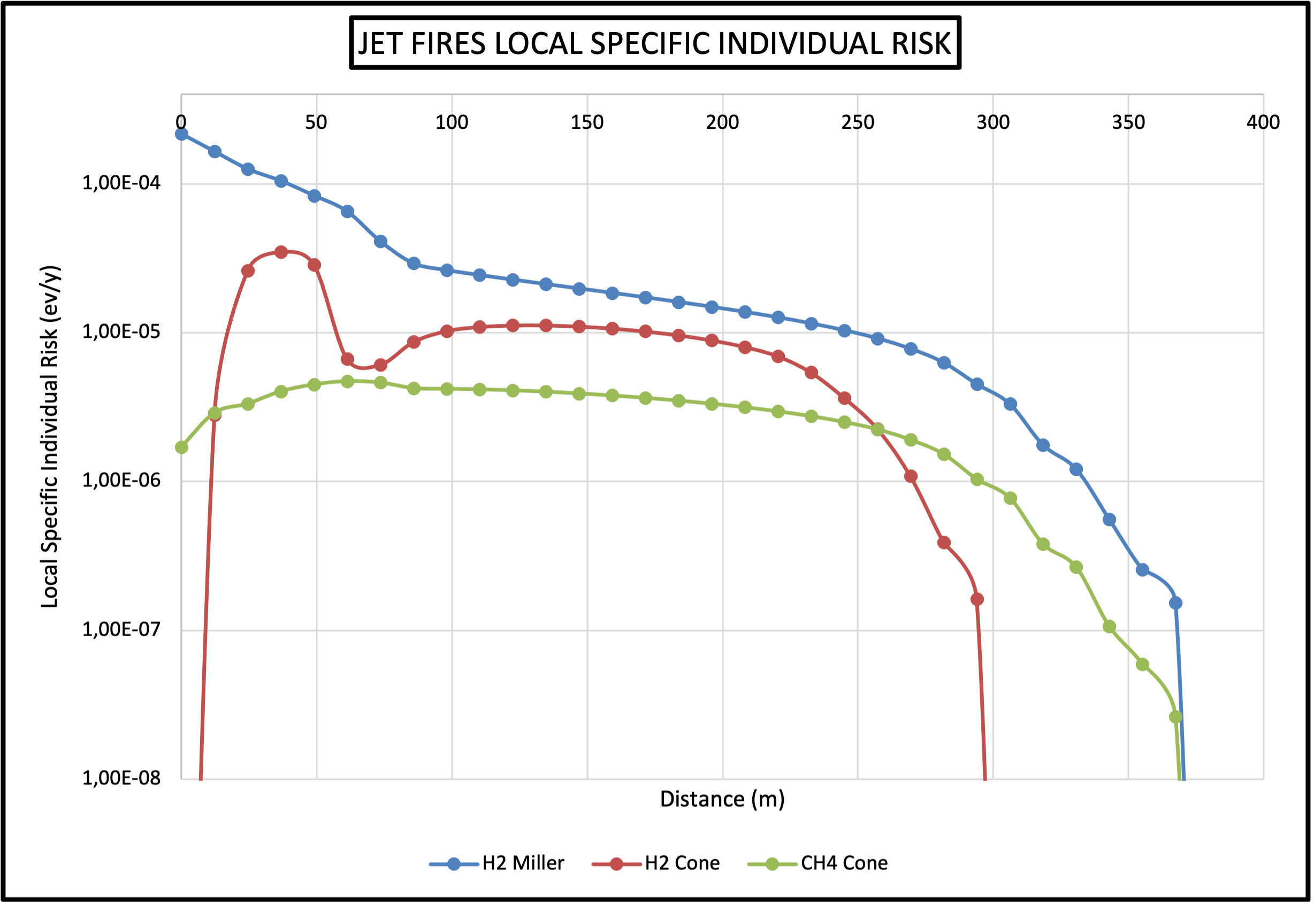

*Figure 2: Local specific individual risk (LSIR) profiles for H2 and CH4 Jet Fires.*

Concerning the overall risk profile associated to the accident scenarios that could arise from the releases reported in Table 1 (Jet Fires, Explosions and Flash Fires), in the simulation of the Explosions the presence of a congested area near the release point was considered. The geometric parameters of the congested area are reported in Table 3.

*Table 3: Geometric parameters of the congested area and used Explosion curves.*

|  |  |  |  |  |  |  |  |
| --- | --- | --- | --- | --- | --- | --- | --- |
| Geometric Parameter | | | | | Explosion Models and Curves | | |
| Distance from the release point (m) | Length (m) | Width (m) | Height (m) | VBR% | CH4 | H2 | |
| Multi-energy | Multi-energy | BST |
| 10 | 150 | 100 | 5 | 80 | 6 | 9 | DDT (Detonation) |

A high-volume blockage ratio (VBR) equal to 80% was conservatively considered. In the case of hydrogen, the Baker-Strehlow-Tang (BST) and the multi-energy models were considered in the analysis, in order to investigate the influence of the Explosion modelling on the overall risk. In the case of methane, only the multi-energy model was used. The specific curves used for the two models, shown in Table 3, were evaluated according to the guidelines published in literature (Ree et al., 2014) which guide the choice in relation to different parameters as the fluid reactivity, the degree of congestion and the geometry of the flame expansion (considered as 2D in these analyses). In the case of the hydrogen Jet Fires, the Miller model was used.

Figure 3 presents the local risk profiles obtained for methane and for hydrogen as a function of the distance from the release source. At short and medium distances from the release, both the profiles obtained for hydrogen (BST and Multi-energy) do not present particular differences, and result in significantly higher values than those obtained for methane, of approximately an order of magnitude. This increase in the risk obtained in the case of hydrogen is mostly due to the contribution of Jet Fire scenarios and to the more severe curves used for explosion modelling. Actually, at higher distances from the release, the differences between the two cases considered for hydrogen (BST and Multi-energy) are more evident, due to the different outcomes obtained from Explosion modelling. In fact, Figure 4 presents the iso-effect curves, evaluated at a frequency of 1.00 E-06 ev/y, obtained for the overpressure levels considered in the case study, and as shown in figures 4b and 4c, the higher differences in the impact zones of the hydrogen Explosions occurred at considerably long distances, approximatively in the range between 350-600 m from the release point. In particular, the BST model returned the most severe conditions with respect to the distances reached by the overpressure generated. Thus, as shown in Figure 3, the local specific individual risk obtained using this model falls to negligible values at slightly higher distances than in the case where the multi-energy model was used. In the case of methane, as shown in Figure 4a, the areas affected by dangerous levels of overpressures resulted definitely more limited, in relation to its lower reactivity, which makes these scenarios less severe.

*Figure 3: Local specific individual risk (LSIR) associated to CH4 and H2**releases (see Table 1).*

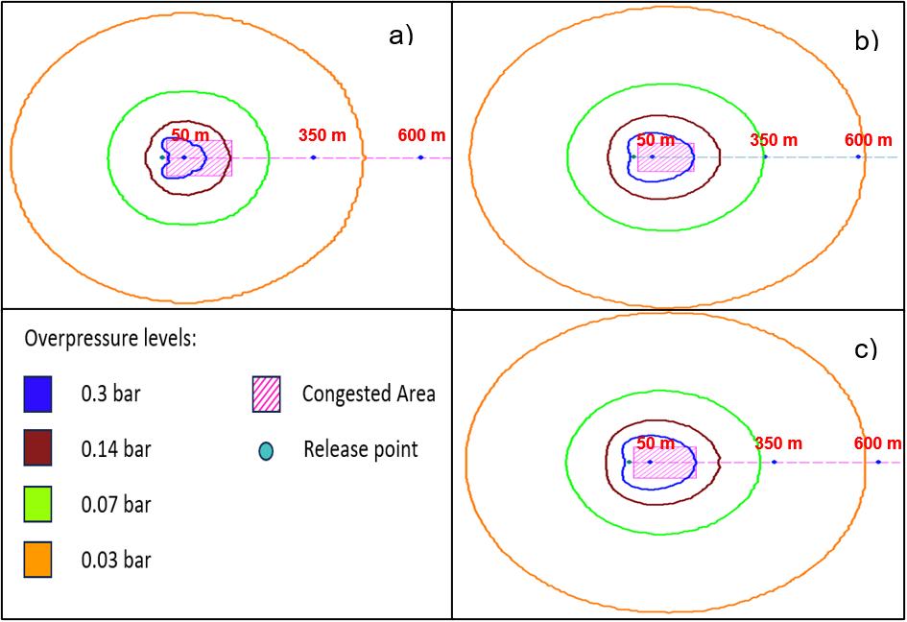

*Figure 4: Iso-effect curves for different overpressure levels at a frequency of 1.00 E-06 ev/y obtained for: a) CH4 (multi-energy), b) H2 (BST), c) H2 (multi-energy)*

Lastly, it is important to highlight that for the methane, as can be seen in Figure 3, the risk values fall to negligible values at higher distances than in the case of hydrogen. This is caused by the contribution of Flash Fire scenarios which, due to higher density of methane, have the potential to cause damage at considerably greater distances than those obtained for hydrogen, ensuring that for methane the risk persists, even if having low values (< 1.00 E-06 ev/y), at higher distances.

* 1. Conclusions

As shown in the case-study, the transition to hydrogen of the existing natural gas grid infrastructures may cause an increase of the risk profile associated to these facilities with respect to the current values, in particular in proximity of the release. The quantitative risk assessment thus represents a crucial tool for the evaluation of technical safety aspects, and to promote the review or the development of new specific codes and standards, to allow a safe operation of these facilities in the case of a conversion to hydrogen. Furthermore, the safety criteria that may be assessed through the quantitative risk analysis will also be fundamental to ensure a safe design and construction of future hydrogen transport facilities. However, it is important to highlight that the lack of specific data for hydrogen introduces uncertainties in the risk assessment, that may lead to inaccurate results regarding the actual conditions that could occur following an accidental release. An example are the results obtained for Jet Fire scenarios, where the new specific model for hydrogen shows that more severe radiation values may derive from hydrogen Jet Fires compared to those calculated using non-specific models. All these factors highlight the strong need of specific data for release frequencies and ignition probabilities, as well as of models specific for hydrogen, in order to provide a more accurate assessment of the related risk. In particular, the Explosion modelling is extremely critical for hydrogen, due to its high reactivity, that could lead to severe deflagrations and even to transitions from deflagration to detonation, for which the poor accuracy of the models currently available still introduce relevant uncertainties in the risk assessment.

References

Energy Institute, 2019, Guidance on assigning ignition probabilities in onshore and offshore quantitative risk assessments, Energy Institute, London

Groth K. M., Hecht E. S., 2017, HyRAM: A methodology and toolkit for quantitative risk assessment of hydrogen systems, International Journey of Hydrogen Energy, 42, 7485-7493

Hao L., Xuewen C., Yang L.,Yanbo S., Zilong N., Lin T., Weshan P.,Jiang B., 2022, Safety of hydrogen storage and transportation: An overview on mechanism, techniques and challenges, Energy Reports, 8, 6258-6269

HySafe, 2022, Engineering Design, Risk Assessment, and codes and Standards: Hydrogen Safety for Energy Applications.

IOGP, 2019, Report 434-01 Process Release Frequencies, International Association of Oil & Gas Producers, London

JRC, 2017, HIAD 2.0 The Hydrogen Incident and Accidents Database, Joint Research Centre of the European Commission

Louthan M.R., 2008, Hydrogen Embrittlement of Metals: A primer for the failure Analyst, Journal of Failure Analysis and Prevention, 8, 289-307

Laureys A., Depraetere R., Cauwels M., Depover T., Hertelé S., Verbeken K., 2022, Use of existing steel pipeline infrastructure for gaseous hydrogen storage and transport: A review of factors affecting induced degradation, Journal of Natural Gas Science and Engineering, 101, 104534

Mélani L., Sochet I., Rocourt X., Jallais S., 2008, Review of methods for estimating the overpressure and impulse resulting from hydrogen explosion in a confined/obstructed region.

Milazzo M. F., Uguccioni G., Malatesta G., Miglionico R., Tallone F., 2021, Assessment of the effect of technical and management characteristics on the frequency of release from piping: An application to a gas storage facility, Journal of Loss Prevention in the Process Industries, 71, 104446

Miller D., 2017, New model for predicting thermal radiation from flares and high-pressure jet fires for hydrogen and syngas, AIChE

Ree S., Kang T., 2014, Prediction of gas explosion overpressure interacting with structures for blast-resistant design, World Congress on Advances in Civil, Environmental and Materials Rese