|  |  |
| --- | --- |
| cetlogo ***CHEMICAL ENGINEERING TRANSACTIONS***  ***VOL. xxx, 2024*** | A publication of  aidiclogo_grande |
| The Italian Association  of Chemical Engineering  Online at www.cetjournal.it |
| Guest Editors: Valerio Cozzani, Bruno Fabiano, Genserik Reniers  Copyright © 2024, AIDIC Servizi S.r.l. **ISBN** 979-12-81206-11-3; **ISSN** 2283-9216 | |

Simulation Technology in Firefighter Training: Entering Enclosed Spaces

Miroslav Antonín

VSB - Technical University of Ostrava, Faculty of Safety Engineering

miroslav.antonin.st@vsb.cz

The use of various technologies is an essential part of the modern era. The main objective of firefighters is to provide quick and efficient assistance to people in danger and to protect their property. Despite the availability of modern emergency equipment, certain emergencies can be exceptionally challenging, underscoring the continued significance of individual firefighter performance. The XVR Simulation is a software tool for firefighter vocational training, providing a safe, virtual space for practicing decision-making procedures in emergency events. This technology finds its application not only in the rescue sector, but also in the field of occupational safety and industry. This paper describes the integration of virtual training into newly recruited firefighters preparing in the area of entering enclosed spaces and investigates its benefits. Compared are the outcomes of two groups of students in real training session. Group A, which participated in simulations on XVR before the real training, achieved better results. Comparing the medians of both groups, there is a 1.5-point difference on a 10-point scale. The procedure described in this paper can be used as a model to integrate simulation technology to desired topic within the scope of vocational training. Positive feedback and better results of the simulation group before real training reinforce the importance of this theme.

* 1. Introduction

Simulation technologies can take the form of simulators or specific computer software in which a virtual environment is created with the desired immersion and interaction capabilities. The selection of simulation technology and corresponding type of reality (virtual, augmented, etc.) enables to user interaction with these environments. These tools are designed to engage students and immerse them more deeply in the subject matter, potentially leading to a better understanding of the topic (Al-Ansi et al., 2023). The basic theoretical principles explaining the positive psychological effect in learning using serious games or other specific education software are the clear representation of education objectives and their meaning, the simplifying of content into manageable tasks, and the providing immediate feedback with positive reinforcement of student performance (Krath et al., 2021). Important for fire protection is the possibility to create educational scenarios based on real-life experiences and reflecting current methodologies. A few examples are listed below.

One of the most dangerous activities for firefighters is extinguishing fires in enclosed spaces. Research that compares two virtual training technologies—Cave Automated Virtual Environment and Virtual Reality (hereafter VR) with head-mounted displays—highlights their respective strengths and weaknesses in meeting training objectives. Ideally, both technologies should precede actual fire training to instill fundamental safety habits in a risk-free virtual setting (Grabowski, 2021). Next paper compares passive (videos, slides) and interactive (fire extinguisher model, simulations) fire safety training, finding interactive methods boost practical skills but not conceptual understanding (Morélot et al., 2021). Non-immersive simulation technology used for key decision making by emergency managers and authorities is described in (Moreno et al., 2014). This is another use of simulation in firefighting, but this time for decision making at the strategic level. Overview studies on this topic are also available, e.g. (Wheeler et al., 2021).

The above examples show that the integration of simulation technologies for training is a current topic across different fire protection disciplines. This paper aims to describe the integration of virtual training for newly recruited firefighters, with a focus on entering enclosed spaces. This topic was chosen because it assumes a similar level of initial knowledge among recruits, and it accounts for more than 10% of emergency events faced by professional firefighters in the Czech Republic (Sejbal, 2021). Similarly, other educational topics within firefighter courses can be addressed in this manner. Besides describing the integration of simulation technology into the educational process, the significance of the study lies in verifying its benefit through quantitative data and participant feedback.

* 1. Background

In this chapter, the selected simulation technology used in education is introduced first, followed by an explanation of the fundamental framework of the topic of entering enclosed spaces, which was the subject of both virtual and real training.

* + 1. XVR Simulation

The chosen simulation technology is the XVR Simulation program (hereafter XVR), which is used by firefighters, rescuers and police across 50 countries worldwide, boasting over 300 users (About XVR, © 2024). This software also stands as the most utilized tool for virtual training among rescue professions in the Czech Republic. Additionally, it is the only tool that is standardly used for practicing the decision-making process during emergency events at firefighter training centres in the Czech Republic (Antonín, 2022), and hence was selected for this paper.

This software enables simulations in a virtual environment that users can customise to meet the requirements of specific simulated scenarios. It supports simulations of minor emergency events, such as building fires, as well as major crisis situations, such as floods. The most widely used module of XVR platform is XVR On Scene, designed to immerse students in a specific role (e.g., team leader) at the scene of an operation and provide them with the experience of the decision-making process in a simulated situation. XVR can be used either as immersive VR with the use of VR Headset or as non-immersive with the use of a monitor and common controllers such as a keyboard and joystick. In this way (non-immersive) is XVR used in this research.

* + 1. Entering Enclosed Spaces

This issue is an integral part of the firefighting profession. Each country may approach this issue differently in terms of legislation, and this is naturally reflected in the actions of firefighters or other designated emergency services. In the legislative conditions of the Czech Republic, firefighters are allowed to enter a property or a building in cases of saving human lives, or health, or protecting their property. They are also authorised to enter in cases of reasonable suspicion of these events, where the decision-making process of the team leader comes into play.

The team leader´s actions are based on a thorough assessment upon arriving at the scene of the emergency event and evaluating all the identified circumstances. After assessing whether the fire unit should intervene at all, it is necessary to determine the level of time priority, explore entry options into the object, and determine the right entry method. Time Priority Levels and related parameters are established in the Entering Enclosed Spaces methodology (Milota, 2018) and are simplified described in Table 1.

Table 1: Time Priority Levels and related parameters

|  |  |  |  |
| --- | --- | --- | --- |
| Time Priority Level (TPL) | Threat level of the subject of intervention | Expected damage | Applicable method for entry example |
| TPL 1 (up to tens of minutes) | Low or No threat | Low | All non-destructive and some destructive methods |
| TPL 2 (unites of minutes) | Moderate threat | Moderate | Damage to the lock insert or handling of the window hardware |
| TPL 3  (tens of seconds to units  of minutes) | High threat | High | Breakage of glass panels, kicking or other destruction of doors |

Based on above mentioned information framework, a research design was created, which is described in more detail in the next part of this paper.

* 1. Methodology and Research Design

Newly recruited professional state and company firefighters participated in this research as part of their novice course, 54 firefighters in total. The research was conducted in two separate courses for novice firefighters. In one case, it involved company firefighters, and in the other case, it involved state firefighters. The information framework and research conditions were identical for both courses; hence, the results are presented as a whole. First, novice firefighters underwent a two-hour presentation on entering enclosed spaces, with particular emphasis on selected information, the crucial information, some of them are listed in Table 1. Next, participants were evenly divided into two groups with the following characteristics:

* Group A initially participated in XVR training and later in real training as well,
* Group B, on the other hand, only took part in real training.

Everyone completed a test on crucial information. The test consisted of 10 questions, and the students could score from 0 to 10 points. The participants took the test always before the training - Group A before the virtual one in XVR and Group B before the real training. The test aimed to identify the level of crucial information knowledge before the training. There was a one-week gap between the presentation, the XVR simulation, and the real training, similar to the timing observed during the novice course. To obtain a more comprehensive set of information for evaluation, Group A completed two questionnaires after completing the XVR simulation. The first questionnaire primarily explored their relationship with computer and console games, while the second focused on their subjective sense of presence during the simulation. For this purpose, the customised Slater-Usoh and Steed (Usoh et al., 2000) questionnaire was utilised because its use is not uncommon in similar studies (Morélot et al., 2021), and it is also appropriate due to its concise nature, comprising 6 questions. This brevity is considered suitable since in this research, it plays a marginal role.

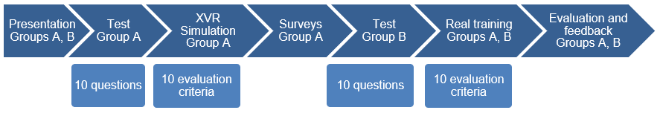

Figure 1: Research design

The building in the XVR simulation was created based on a real building where real training also took place, to achieve the maximum connection of the virtual and real worlds. Three model scenarios were created in total, each representing one of the three Time Priority Levels when entering enclosed spaces. Members of Group A underwent a different model scenario during their real training compared to the XVR simulation. In this way, they were faced with a new situation, but worked with the same crucial information, the application of which they had the opportunity to test during the decision-making process in the XVR simulation, unlike Group B.

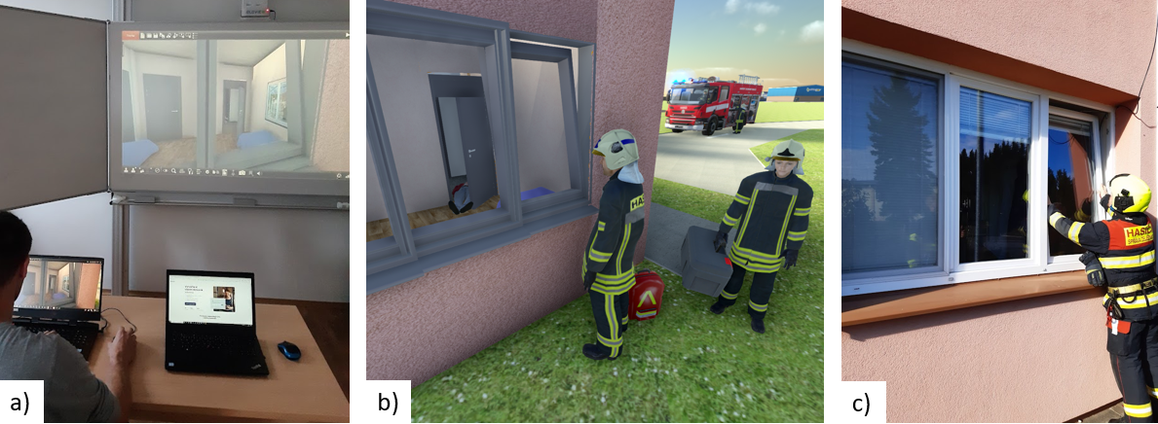

Figure 2: Selected research phases. a) Virtual training with XVR Simulation; b) XVR visualisation in more detail; c) Real training

The 10 Evaluation criteria were the same for both the XVR simulation and the all 3 real training scenarios. Similarly to the test, participants could achieve a maximum of 10 points; however, in this case, the instructor had the flexibility to assign half-points, 0.5, within the Evaluation criteria, unlike the test. Table 2 presents a general description of scenarios and 10 common Evaluation criteria.

Table 2: Scenarios and Evaluation criteria

|  |  |  |  |
| --- | --- | --- | --- |
| TPL | Scenario Situation |  | Common Evaluation Criteria |
| 1 | Assistance for the police. At the scene, a police patrol is requesting the firefighters to open the house due to suspicion of the owner's death. The owner´s daughter is abroad and her 75-year-old father is not answering the phone; a food delivery service was unable to reach him. There is a significant smell from the window. |  | 1) Initial survey and situation awareness.  2) Decision on whether the firefighters will intervene.    3) Time Priority Level determination.  4) Primary entry verification.  5) Secondary entry verification.  6) Assessing the need for a witness.  7) Informing the police.  8) Determination of the applicable entry method.  9) Further actions considering the situation.  10) Occupational safety assessment for responding firefighters |
| 2 | Rescue - opening the house, calling for help. Passers-by heard a cry for help as a gentleman inside the house fell and couldn't get up and move. The gentleman is conscious, communicating, and not bleeding. The doors cannot be opened, the windows are closed. |  |
| 3 | Fire - low-rise building.  Possible electrical installation fire, a slightly drunken neighbour smelt the smell of burnt wiring coming from the next apartment; the neighbour did not answer the door, but he does not know if he is at home. When firefighters arrive, there is no smell at first, after making a search there is smoke from the window. |  |

* 1. Results

One of the goals of this paper is to assess the benefit of simulation technology in education with a focus on the decision-making process. The criterion under observation is the performance of the participants in real-life training, which represents the culmination of the educational process.

* + 1. Quantitative Results

To determine whether there is a statistically significant difference between the results of Group A and Group B, it is necessary to select the appropriate statistical test. The first step involves verifying the assumption of normal distribution in both groups using the Shapiro-Wilk test. After conducting it at the standard 5% level of significance, the normal distribution hypothesis is rejected based on the p-value in Group A, while it is not rejected in Group B. Due to the violated assumption in Group A, it is required to employ a non-parametric test for comparing differences between the groups, specifically the Mann-Whitney test. Based on the calculated p-value of this test and the disparate median values in both groups, it is possible to conclude a statistically significant difference between Group A and Group B. The statistical software 'gretl' was used for the calculations, specific values are presented in Table 3.

Table 3: Quantitative Results

|  |  |  |  |  |  |  |  |  |
| --- | --- | --- | --- | --- | --- | --- | --- | --- |
| Group | Participants | Shapiro-Wilk test p-value | Mann-Whitney  test p-value | Median | Minimum | Maximum | Lower Quartile | Upper Quartile |
| A | 27 | 0.02241 | 0.00342 | 7.50 | 3.50 | 9.00 | 6.00 | 8.00 |
| B | 27 | 0.63632 | 6.00 | 1.50 | 9.50 | 4.00 | 7.00 |

The derived median values and both lower and upper quartiles favor Group A. This holds true even for the poorest score (minimum), whereas the best score (maximum) was achieved by a member of Group B. The most significant difference between Groups A and B is observed in the lower quartiles and the poorest scores. In both instances, Group A outperforms by 2 points, which, in the case of the lower quartile, signifies that 75% scored at least 6 points, as opposed to 4 points in Group B. Based on these qualitative results, incorporating simulations into the educational process before real-life training appears to be beneficial.

Figure 3 illustrates the cumulative results of 54 research participants in accordance to Table 3. Group A and Group B are color-coded to illustrate the impact of simulation technology on the outcome of real training.

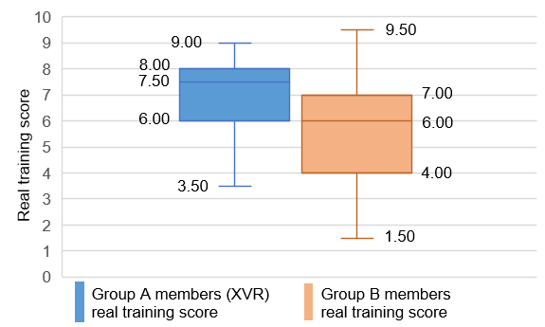

Figure 3: Cumulative results of 54 research participants

* + 1. Participant feedback

After the real training completion were the members of Group A asked for their feedback on simulation technology integration to their education process. Participants, in a free-form manner on video recordings, provided their feedback, and 24 of 27 members considered integration into education beneficial. The most commonly mentioned positive aspects are follows:

* Conducting a trial of survey and decision-making process in simulation before real training,
* Clarification of the correct decision-making process procedure after the XVR simulation and feedback from the instructor,
* Greater sense of confidence during a real training,
* The same building in both simulation and real training.

Participants agree simulation is a valuable educational supplement but shouldn't replace actual training, deemed most beneficial for practice. Three Group A members found simulation integration unhelpful, this form of learning did not suit them. The predominant positive feedback and better quantitative results of Group A, however, suggest the benefit of incorporating simulation technologies into education.

* + 1. Feel of Presence

The questionnaire, designed to assess the subjective sense of presence within a virtual environment, comprises six items distributed across three categories: the sensation of existing within the virtual space, the extent to which this space supersedes reality, and the memory of the virtual environment as a tangible location. Responses are gauged on a seven-point scale, with higher values indicating a stronger sense of presence. These scores are adaptable for various research objectives, as noted in (Usoh et al. 2000). For this study is analyzed the average score from 24 Group A participants (excluding 3 unreturned questionnaires). Notably, four individuals scored above the mean plus one standard deviation, marking these as high (6 or more points) by the questionnaire's standards. However, the questionnaire results reveal no significant link between the subjective sense of presence and obtained score in virtual training.

Table 4: Feel of Presence Evaluation

|  |  |  |  |
| --- | --- | --- | --- |
| Group A Members | Mean Score | Count Above the Mean | Count with High Score |
| 24 | 4.63 ± 1.29 | 11 | 4 |

* 1. Discussion

For future research, it would be interesting to increase the degree of immersion in the simulation (VR Headset) and compare the level of results. Nevertheless, one must always consider the context of the student's role. When playing the role of team leader and simulating a complex decision-making process, more immersion may also be a handicap, as the team leader during emergency event training is expected to communicate with other exercise participants, work with information and real documentation, etc.

The decision-making process is typically the responsibility of the team leader, as it involves accountability. During this research, the mentioned competence was transferred to novice firefighters, which might influence the obtained results. Nevertheless, the practical training was founded upon a set of clearly defined factors that the novice firefighters had the opportunity to memorize precisely due to the necessity of engaging in the decision-making process. Another potential topic from the field of firefighting practice using simulation technologies is hazardous substances detection or wounded triage in mass disasters where rescuers also must make the right decisions based on their knowledge and the conditions of the emergency event

* 1. Conclusions

The quantitative data from this study clearly indicate a positive impact of simulation technology on the educational process. Group A demonstrates superior and more compact results overall, as depicted in Figure 3. The most significant difference is observed in the lower quartiles and poorest scores, with Group A outperforming B by 2 points and showing a median difference of 1.5 points on a 10-point scale. This conclusion is further reinforced by the positive feedback received from 24 of the 27 participants in the virtual training. While real training remains indispensable, the use of simulation evidently enhanced preparedness and bolstered participant self-confidence before the real training. The process described in this paper can be adapted to the required area within professional education, and in light of the obtained results, it is advisable to examine additional opportunities for the integration of simulation technologies into the educational process.

Acknowledgements

I thank my mentor, Marek Smetana, Ph.D., for the XVR Simulation providing for this research, and the Fire Rescue Service of the South Moravian Region for facilitating the study. Special thanks to Second Lieutenant Darek Sejbal, Lieutenant Pavel Podloučka, and Lieutenant Štěpán Komosný for their indispensable support.

References

Al-Ansi, Abdullah M.; Jaboob, Mohammed; Garad, Askar and AL-ANSI, Ahmed, 2023. Analyzing augmented reality (AR) and virtual reality (VR) recent development in education. online. Social Sciences & Humanities Open. vol. 8, issue 1. ISSN 25902911. <doi.org/10.1016/j.ssaho.2023.100532> accessed 31.10.2023

Antonín, Miroslav, 2022. Vocational training of the basic bodies of integrated rescue system of the Czech Republic with the usage of the simulation technologies and the virtual reality. EDULEARN22 Proceedings online. ISSN: 2340-1117, pp. 2636-2645. <doi.org/10.21125/edulearn.2022.0677> accessed 06.10.2023

Grabowski, Andrzej, 2021. Practical skills training in enclosure fires: An experimental study with cadets and firefighters using CAVE and HMD-based virtual training simulators. online. Fire Safety Journal. vol. 125. ISSN 03797112. <doi.org/10.1016/j.firesaf.2021.103440> accessed 20.10.2023

Krath, Jeanine; Schürmann, Linda and Von korflesch, Harald F.O., 2021. Revealing the theoretical basis of gamification: A systematic review and analysis of theory in research on gamification, serious games and game-based learning. online. Computers in Human Behavior. vol. 125. ISSN 07475632. <doi.org/10.1016/j.chb.2021.106963> accessed 05.11.2023

Milota, Hynek, 2018. Entering into enclosed spaces. Spektrum (Association of Fire and Safety Engineering). Czech Republic, Ostrava. ISBN 978-80-7385-207-8. (in Czech)

Morélot, Sarah; Garrigou, Alain; Dedieu, Julie and N'kaoua, Bernard, 2021. Virtual reality for fire safety training: Influence of immersion and sense of presence on conceptual and procedural acquisition. online. Computers & Education. vol. 166. ISSN 03601315. <doi.org/10.1016/j.compedu.2021.104145> accessed 05.10.2023

Moreno, Aitor; Posada, Jorge; Segura, Álvaro; Arbelaiz, Ander and García-Alonso, Alejandro, 2014. Interactive fire spread simulations with extinguishment support for Virtual Reality training tools. online. Fire Safety Journal. vol. 64, p. 48-60. ISSN 03797112. <doi.org/10.1016/j.firesaf.2014.01.005> accessed 15.01.2024

Sejbal, Darek, 2021. Issues of Entering into enclosed spaces during Integrated Rescue System interventions. Bachelor thesis. Prague. Police academy of the Czech Republic in Prague, Faculty of security management,. (in Czech)

Usoh, Martin; Catena, Ernest; Arman, Sima and Slater, Mel, 2000. Using Presence Questionnaires in Reality. online. Presence: Teleoperators and Virtual Environments. vol. 9, issue 5, p. 497-503. ISSN 1054-7460. <doi.org/10.1162/105474600566989> accessed 20.01.2024

Wheeler, Steven G; Engelbrecht, Hendrik and Hoermann, Simon, 2021. Human Factors Research in Immersive Virtual Reality Firefighter Training: A Systematic Review. online. Frontiers in Virtual Reality. vol. 2. ISSN 2673-4192. <doi.org/10.3389/frvir.2021.671664> accessed 06.01.2024

XVR Simulation. About XVR, 2024. online. <www.xvrsim.com/en/about/> accessed 06.10.2023