|  |  |
| --- | --- |
| cetlogo ***CHEMICAL ENGINEERING TRANSACTIONS***  ***VOL. xxx, 2024*** | A publication of  aidiclogo_grande |
| The Italian Association  of Chemical Engineering  Online at www.cetjournal.it |
| Guest Editors: Valerio Cozzani, Bruno Fabiano, Genserik Reniers  Copyright © 2024, AIDIC Servizi S.r.l. **ISBN** 979-12-81206-11-3; **ISSN** 2283-9216 | |

Risk Assessment of the Implementation of Digital Elements Applied to Occupational Health and Safety

Slavomira Vargova\*, Martina Hanusova, Marie Magulakova

Tomas Bata University in Zlín, Faculty of Logistics and Crisis Management, Studentske namesti 1532, 686 01 Uherske Hradiste, Czech Republic

[vargova@utb.cz](mailto:vargova@utb.cz)

Occupational health and safety entail new and emerging risks. One such type of risk is the risks associated with the use of digital tools at work, considering the ageing population. This paper discusses new trends in occupational safety and health, with a focus on digitalisation in this area. The paper will start by focusing on the general possibilities of applying the elements of digitalization in this area. This will be followed by research in enterprises in the Czech Republic and Slovakia that use possible elements of digitalization in occupational safety and health compliance. The results of the investigation will be summarised in addition to the graphical representation by a strategic management analysis - SWOT analysis. The results of the research will provide an overview of the state of the use of digital means for subsequent analysis of possible risks associated with the use of new trends. The risk analysis will use qualitative risk assessment methods such as the WHAT-IF method and the risk matrix. Finally, recommendations will be made to minimize the risks that organizations might encounter when implementing digital tools in the field of occupational health and safety assurance.

* 1. Introduction
     1. Industry 4.0 tools

Industry 4.0 represents a new approach to industrial production where machines and products communicate and organize themselves through the production process. Its main elements are the interconnection of production with information and communication, autonomous data collection and processing, decentralized control and decoupled production. The implementation of these elements will affect the quality of work, skill requirements and work organization. The different levels of Industry 4.0 implementation divide companies according to the degree of digitalization and engagement with this philosophy (Sinay, 2018). Today's industrial robotics often replaces humans in non-ergonomic and dangerous tasks, such as handling heavy or dangerous objects. Automated robots can operate without a human presence and efficiently solve monotonous and repetitive tasks with high accuracy. Collaborative robots, a trend in Industry 4.0, enable safe collaboration with humans and improve the ergonomics of production processes and product quality. (Laciok, 2021)

New technologies in the field of artificial intelligence offer an opportunity to improve the monitoring of employee safety and health. Monitoring workers can help reduce various risk factors and provide warnings of stress and health problems. Real-time advice tailored to individual needs can influence employee behaviour and improve safety. However, ethical decisions and effective strategies are necessary to handle the sensitive personal data that such monitoring generates. (EU-OSHA, 2021)

Companies around the world are actively implementing smart technologies to improve workplace safety and provide employees with training in innovation and protection from workplace hazards. Digitalization saves time, reduces the burden on routine tasks and opens up new opportunities for innovation and development. Smart solutions, especially in the field of analytics, enable companies to assess workplace safety levels and automate information gathering processes. Virtual reality (VR) technologies are also proving to be an effective tool for training employees in occupational safety. However, these advanced technologies also bring new challenges, such as the potential replacement of some jobs by artificial intelligence and the associated job insecurity and psychosocial risks for employees. The COVID-19 pandemic has led to further innovations in the field of work, including the use of remote technologies for work organisation and hygiene compliance. (Abdrakhmanov, 2021)

This provides new opportunities for people and businesses, including improved health and safety. For example, teleworking can reduce travel time and the associated stress and risks of work-related accidents, and contribute to a better work-life balance. However, it can also bring health challenges, such as the need to address the psychosocial risks associated with lone working and the potential blurring of work-life boundaries, as well as ensuring workplace ergonomics. At the same time, it is likely that employees will increasingly work outside the traditional workplace or remotely. This may lead to a reduction in the risk of hazardous jobs, but also to new risks associated with autonomous devices and employee monitoring. Wearable technologies can also ensure the safety and health of employees in the work environment and increase efficiency. Digitalisation and ICT can help improve occupational safety and health by improving inspections of working conditions. The benefits of digitising work include improving work-life balance, reducing the risk of travelling to work, removing people from unsafe working conditions and the ability to monitor hazards in real time. (Abdrakhmanov, 2021)

Automation and robotics in the workplace are not new. Their development is essential for the transition of humanity to a new technological level. However, they carry various risks. Robotics can simplify a worker's life from repetitive and demanding tasks that can lead to risks of musculoskeletal, cardiac or mental problems. However, the introduction of new technologies can bring ergonomic risks, cyber risks and psychosocial risks associated with human interaction with AI and robotics. Benefits include removing people from hazardous environments, reducing the need for workers to perform dangerous tasks, and improving preventative measures.

In job roles that involve overseeing automated machines, making decisions at a decentralized level, and complex engineering tasks, employees are expected to have a higher level of responsibility and be proactive in responding to situations. It is also important that individuals are able to communicate effectively with others and manage their time properly. This encompasses many different aspects, including the different skill levels of employees, their technical or academic backgrounds, differences in age and educational attainment, life experience and cultural background. It is very important to promote the active involvement of professionals specializing in occupational health and safety in Industry 4.0. These experts have a key role to play in formulating risk profiles adapted to the specific requirements of the working environment in this area. It is also important that these experts have a responsibility for the development of comprehensive international standards aimed at protecting workers from various risks. The harmonious coexistence of people and machines in the workplace is dependent on the development and adherence to a set of regulations and guidelines. This idea is supported by a critical review conducted in 2022, which focuses on the application of Industry 4.0 technologies in the context of occupational safety and health. The involvement of companies, stakeholders and employees in workplace processes and measures is essential in terms of compliance with the Occupational Health and Safety Act. In addition, it is important to assess the global implementation of preventive and protective measures in this area, as suggested by Badri et al. (2018). To promote the positive ethical impact of Industry 4.0, it is essential to adopt a socio-technical perspective that includes the integration of technological advances, work organization and professional development linked to economic and social factors. (Singh, 2023)

* + 1. Global Industry 4.0 and Security 4.0 surveys

Industry 4.0 and its implementation in the workplace are being investigated worldwide and in individual countries.

An analysis conducted by the World Economic Forum suggests that in the near future some jobs will be enhanced by machines and computers rather than completely replaced. Automation focuses largely on routine and repetitive tasks, resulting in better use of human potential and talent, further increasing productivity and competitiveness. Approximately two-thirds of jobs contain at least 30% automated tasks and a quarter of jobs have more than 70% automated tasks. However, it is clear that the share of tasks performed by machines and computers will continue to grow.

In the summary report of the project Research on the potential for the development of artificial intelligence in the Czech Republic, a comparison of many jobs and professions is made. For some of them, it is estimated that up to 53% of skills can be replaced by AI.

The survey on the impact of Industry 4.0 on jobs examined whether employees have noticed changes caused by new technologies. It found that 18% of respondents felt that new technologies had changed their job roles, while 9% had not experienced any changes, with these changes being predominantly linked to digitalisation (52%), automation (26%) and robotics (15%).

Around 20% of respondents complained about the lack of communication about the changes brought about by Industry 4.0, while 43% were not satisfied with the information provided. This suggests that the majority of employees affected by these changes would have welcomed better and more detailed communication. Only 12% were completely satisfied and one in four respondents felt that they had at least received all the information they needed. This situation points to the need for improved communication between management and employees about new technologies and procedures.

Preparing for the implementation of modern technologies involves involving employees in the decision-making process, analysing the benefits and limitations, and ensuring appropriate vertical communication. Emphasis is also placed on ensuring the health and safety of employees when working with new technologies, including establishing rules for the use of artificial intelligence. (Ungerman, 2021)

According to ESENER (2019), it appears that in the Czech Republic, 25% of respondents answered positively to questions about discussing the effects of using digital technologies on occupational safety and health, while 75% answered negatively. In Slovakia, this was represented by 19% positive responses and 81% negative.

* 1. Methodology
     1. Survey in organizations

In the initial phase of the work, the aim was to gather basic information regarding the use of Industry 4.0 tools in companies and to assess their suitability in the field of Safety 4.0. The survey design is in line with the PDCA cycle for improving management systems. In addition to the initial questions designed to assess the integration of Safety 4.0 within the organization, a framework was developed to examine the adoption of Safety 4.0 management tools to ensure alignment with the management systems structure. As part of the self-examination, an assessment of the level of application of Safety Management and its tools was conducted, which included the integration of the 9 core pillars of Industry 4.0 into the organization. Therefore, the questions regarding the implementation of Industry 4.0 in the organization focused on assessing which technology pillars are predominantly used in safety management.

These pillars included autonomous robots, simulation/augmented reality, horizontal/vertical integration, IoT, cybersecurity, artificial intelligence, cloud computing, additive manufacturing, supply chain, and big data analytics.

Based on a questionnaire and structured interviews in organizations, an analysis of the current state of digitization tools was created, summarizing the views and experiences of organizations and predicting possible limiting factors.

* + 1. SWOT analysis

SWOT analysis belongs to the group of strategic management analysis, but it can be used as a risk identification technique. The prerequisite is the use of four quadrants (groups) divided into internal and external environments. The groups of characteristics from the internal environment represent the strengths and weaknesses sections. The group of characteristics from the external environment represent opportunities and threats. It is the weaknesses and threats that will be further worked with in the development of the next risk analysis. See Figure 1.

* + 1. What if and Risk Matrix

Weaknesses and threats defined in the SWOT analysis were further elaborated in the basic method of scenario development - what if analysis. The What if Analysis is based on causal dependence and assumes potential scenarios. In order to fulfil the essence of risk analysis, risks are subsequently assessed by a semi-quantitative assessment based on the premise of using rating scales. One of the basic methods of using scales for assessing likelihood (Table 1) and consequence (Table 2) as the main risk metrics is the risk matrix, sometimes also called the likelihood-consequence matrix (Table 3). The full What if analysis table (Table 4) also includes risk minimization measures.

* 1. Results

The results of the questionnaire survey of the organisations show that more than 67 % of the companies concerned are active in the automotive industry and 56 % of these companies have more than 1 000 employees.

Currently, an overwhelming 52% or more of these companies use mainly cloud computing, artificial intelligence and cyber security systems.

More than 50% of companies are actively engaged in meeting sustainability criteria, particularly in the areas of cloud services and cybersecurity, with cloud computing having a higher adoption rate of 44%.

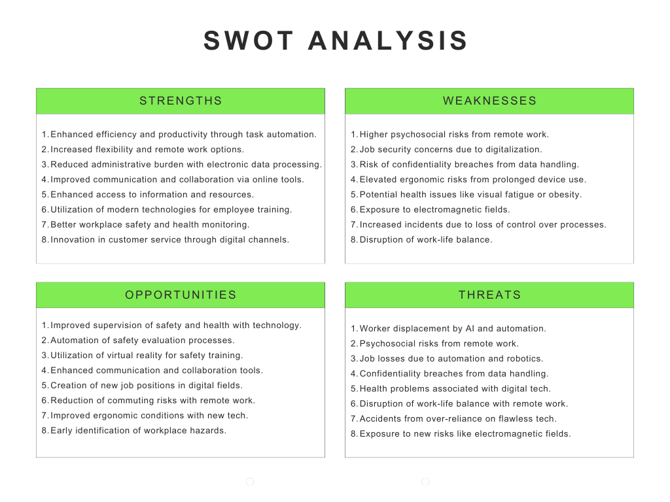

Figure 1: SWOT analysis of Industry 4.0 tools

Table 1: Probability Categories

|  |  |  |
| --- | --- | --- |
| Position | Title | Description |
| I. | Unlikely | has not happened |
| II. | Likely | one time in 5 years |
| III. | Probably | one time per year |
| IV. | Highly probably | monthly and more frequently |

*Table 2: Impact Categories*

|  |  |  |  |  |  |  |  |  |  |  |
| --- | --- | --- | --- | --- | --- | --- | --- | --- | --- | --- |
| Description (impact category, units) | | | | | | | | | | |
|  | |  | Human (individual/collective) | | Assets | | Financial losses | | | Process |
| Position | Title | | | number of injuries, sick days |  | CZK, % | | CZK, % | | Time, output units |
|  |  | | |  |  |  | | | |  |
| A  B  C  D | Irrelevant  Significant  Critical  Catastrophic | | | Minor injuries, slight mood changes  injuries requiring treatment or hospitalisation,  Death, burn-out syndrome, permanent consequences |  | No impact  Damage to property in 25 %  Property damage in 50 %  Serious damage to property 75% | | | Losses up to 25%  Losses up to 50%  Losses up to 75 % | slowed process  stopped but continued process.  tatal impact on the process |

*Table 3: Risk Matrix*

|  |  |  |  |  |
| --- | --- | --- | --- | --- |
| P/I | A | B | C | D |
| I. | 1 | 3 | 6 | 10 |
| II. | 2 | 5 | 9 | 13 |
| III. | 4 | 8 | 12 | 15 |
| IV. | 7 | 11 | 14 | 16 |

*Table 4: Part of the What if Analysis*

|  |  |  |  |  |  |  |  |
| --- | --- | --- | --- | --- | --- | --- | --- |
| Source/if |  | What |  | Action | P | I | R |
| Remote Work Psychosocial Risks  Job Security Concerns  Confidentiality Breaches  Ergonomic Risks  Job Losses |  | What if the psychosocial risks associated with remote work escalate further, leading to increased stress, isolation, and mental health issues among employees?  What if the concerns about job security intensify due to accelerated digitalization, resulting in widespread anxiety and decreased morale within the workforce?  What if there is a major breach of confidentiality resulting from mishandling of digital data, leading to legal consequences, loss of trust, and damage to the company's reputation?  What if ergonomic risks from prolonged device use worsen, resulting in a surge of musculoskeletal disorders and other health problems among employees?  What if the implementation of automation and robotics results in significant job losses across various industries, leading to social unrest and political upheaval? |  | Implement regular virtual team meetings and check-ins to foster social interaction and support among remote workers. Provide access to mental health resources and encourage employees to take breaks and prioritize self-care.  Implement comprehensive retraining and upskilling programs to equip workers with the skills needed for emerging digital roles, fostering job security, and boosting morale.  Implement regular cybersecurity training for all employees to ensure proper handling of digital data, conduct routine audits of data security protocols, and establish strict procedures for reporting and addressing any breaches promptly.  Implement regular breaks and ergonomic training sessions to educate employees on proper posture and device usage. Additionally, provide adjustable ergonomic equipment and encourage frequent stretching exercises to mitigate musculoskeletal disorders and promote overall employee health.  Implement retraining programs and social support to address job losses and prevent social unrest | III.    II.  II.  II.  II. | C.  C.  C.  D.  C | 12  6  6  13  9 |

* 1. Conclusions

This document dealt with an analysis of the potential risks of using elements of digitalisation and their impact on health and safety at work. In general, many Industry 4.0 tools can be discussed as sources of potential new and emerging risks. However, these tools greatly facilitate the system of work and create many opportunities that should outweigh the potential risks.First, a literature review was carried out to highlight the situation regarding the implementation of Industry 4.0 tools and surveys in organisations related to this. The results of the actual survey were then elaborated. In conclusion, it can be stated that digitisation brings with it a number of benefits. Improved work efficiency and productivity through the automation of routine tasks and processes and reduced paperwork and administrative burden through electronic storage and processing of data.Improved communication and collaboration between employees and teams thanks to online tools and platforms.Improved health and safety in the workplace through environmental monitoring, risk monitoring and early identification of potential hazards.Innovation in customer service and how to support clients through digital channels and tools.These positives show how digitalisation can bring many benefits to the work environment and to employees. It is very important to promote the active involvement of experts specialising in occupational safety and health in Industry 4.0. These experts have a key role to play in formulating risk profiles adapted to the specific requirements of the work environment in this area

Acknowledgments

This paper is a result of research co-financed by the internal project IGA/FLKR/2023/005, Tomas Bata University in Zlín.

References

ABDRAKHMANOV, Nail, 2022. Analysis of the relationship between the sustainable environmental health and occupational safety: problems, prospects and opportunities. In: IOP Conference Series: Earth and Environmental Science. IOP Publishing, p. 032046.

BALTA, Maria, 2021. Digitalization and co-creation of healthcare value: A case study in Occupational Health. Technological Forecasting and Social Change, 168: 120785. COSTANTINO, Francesco, et al. New and emerging hazards for health and safety within digitalized manufacturing systems. Sustainability, 2021, 13.19: 10948.

EU-OSHA 2019. How European Workplaces manage safety and health. Data visualization. [European map | ESENER (europa.eu)](https://visualisation.osha.europa.eu/esener/en/survey/detailpage-european-map/2019/emerging-risks-and-their-management/en_1/E3Q311/company-size/14/11/1)

LACIOK, Vendula; SIKOROVA, Katerina; FABIANO, Bruno and BERNATIK, Ales, 2021. Trends and Opportunities of Tertiary Education in Safety Engineering Moving towards Safety 4.0. Online. Sustainability. 13/524, s. 1-10. Available at: www://doi.org/10.3390/su13020524.

PALUMBO, Rocco; CAVALLONE, Mauro. Is work digitalization without risk? Unveiling the psycho-social hazards of digitalization in the education and healthcare workplace. Technology Analysis & Strategic Management, 2022, 1-14.

POPOV, Georgi; OVTCHAROVA, Jivka; SINAY, Juraj; KOTIANOVA, Zuzana and GLATZ, Juraj, 2018. INTERNATIONAL SCIENTIFIC JOURNAL INDUSTRY 4.0. Online. 3/5. 108, Rakovski Str., 1000 Sofia, Bulgaria.

SINGH, Pallavi, 2023. Impact of Industry 4.0 on Occupational Safety and Health. International Journal for Research in Applied Science & Engineering Technology. Roč. XI., č. 11, s. 1687-1692.

UNGERMAN, Jiri, 2021. The impact of advancing automation and digitalisation on employees' work competences, e.g. (in Czech)