 CHEMICAL ENGINEERING TRANSACTIONS  VOL. , 2023 | A publication of  
The Italian Association
of Chemical Engineering
Online at www.cetjournal.it

Guest Editors:
Copyright © 2023, AIDIC Servizi S.r.l.
ISBN 979-12-81206-XX-X; ISSN 2283-9216
Comprehensive mechanistic modelling of non-isothermal CO₂ adsorption in fixed packed bed
Federico Zedda^{a,b}, Mariano Casu^{a,b}, Federico Atzori^{a,b}, Roberto Orrù^{b}, Giacomo Cao^{a,b,c}, Alessandro Concas^{a,b,*}
ªDepartment of Mechanical, Chemical and Materials Engineering, University of Cagliari, Piazza d’Armi, 09123 Cagliari, Italy
^{b}Interdepartmental Center of Environmental Science and Engineering (CINSA), University of Cagliari, Via San Giorgio 12, 09124 Cagliari, Italy
^{c}Center for Advanced Studies, Research and Development in Sardinia (CRS4), Loc. Piscina Manna, Building 1, 09050 Pula (CA), Italy
alessandro.concas@unica.it
A model based on conservation laws was developed to simulate the continuous, non-isothermal CO₂ adsorption on porous materials in a packed bed. A set of parameters inferred from correlations between dimensionless numbers was used to mathematically solve the problem. The developed rigorous model includes a set of partial differential equations with proper boundary conditions. By adapting the equations for numerical solutions, it describes the process under unsteady state conditions, enabling the derivation of temperature and concentration profiles essential for process analysis. Finally, a sensitivity analysis was carried out to assess the effect of parameters on the model's solution.
  - Introduction
Nowadays the excessive production and uncontrolled release of greenhouse gases (GHG) in the atmosphere have caused significant environmental problems, with climate change being the main representation of it (Atzori et al 2023a). Since CO₂ is the most prevalent greenhouse gas in the atmosphere, studying an effective method for its removal represents a fundamental step in the direction of mitigating its effects. Electrifying processes and eliminating combustion are the most obvious paths to follow to directly cut the excessive amount of this gas in the atmosphere. Another potential option involves capturing this gas and utilizing it for innovative processes, such as power-to-x. Considering a future in which the only efficient use of CO₂ won’t be sufficient, a long-term solution could be the exploitation of extra-terrestrial resources. In accordance with ISRU (In Situ Resource Utilization) paradigm, Mars presents itself as the optimal choice for accommodating humanity, because of the presence of resources like atmospheric CO₂, water, and regolith, which could be processed efficiently to produce vital essentials like oxygen, water, and food (Brughitta et al. 2023) also using microalgae (Fais et al., 2022). Among the possible technologies that could be used a potentially cost-effective method for carbon capture from the atmosphere, is the adsorption of CO₂ on a porous bed. However, it is important to emphasize that those applications of gas capture systems specifically aimed at CO₂ removal are often hindered by their poor economic sustainability. Therefore, in the perspective of reducing CO₂ emissions or utilizing CO₂ from the atmosphere, it is crucial to identify and optimize techno-economic processes for its capture and reuse (Atzori et al 2023b).
Typically, in the chemical industry, adsorption processes can be divided into two major categories depending on the amount of pollutant present in the contaminated stream. Hence, we can distinguish between purification process and bulk separation process. In purification process, the pollutant is present in trace amount, while in bulk separation process, the pollutant is present in large quantities (Cavalcante, 2000). From the modelling point of view, this fact has deep implication. In purification process, the removal of the pollutant from the contaminated stream does not significantly influence the mass flow rate along the column, as there is no substantial mass leaving the gas phase and entering the adsorbent. Thus, in this case, a common approximation is considering constant volumetric flowrate and consequently constant gas velocity along the column. Contrary to purification process, in a bulk separation process, the mass migrating from the gas to the adsorbent is no longer negligible. This implies that, from a theorical perspective, considering constant volumetric flowrate and, hence, constant velocity along the column can become a weak assumption for the process. Capture the velocity variation along the column requires an additional vectorial equation, the momentum balance.
However, adding the momentum balance equation and, therefore, more precision in the behaviour of the model, comes with a significant computational cost. It is well known that solving the velocity-pressure coupling in systems in which the physical properties vary along the column implies implicitly solving the sound dynamics that moves with pressure waves. The highly distinct dynamics of sound and gas generate a stiff partial differential equation system. Given the significant challenges introduced by the momentum balance, the primary objective in this preliminary work is to investigate whether the system of equation with constant velocity is capable of reproducing bulk separation experimental data. Specifically, the aim of this preliminary work is to understand the extent of precision lost by the model without considering momentum balance.
  - Mathematical model
The column in exam was subdivided in three distinct control volumes: gas phase, stationary phase (includes adsorbed phase and adsorbent) and finally column wall. The three control volumes can exchange mass and heat between them, this allows to simulate the phase change from the gas to the adsorbed phase. The model is composed by a system of partial differential equations in time and column length coupled with ordinary differential equations in time.
$$\frac{∂{\overline{q}}_{i}}{∂t}=K_{i}\left(q_{i}^{*}-{\overline{q}}_{i}\right)$$ | (1)
$$\frac{DC_{i}}{Dt}=\frac{∂}{∂z}\left(D_{L,i}\frac{∂C_{i}}{∂z}\right)-\frac{1-ε}{ε}ρ_{P}\frac{∂{\overline{q}}_{i}}{∂t}$$ | (2)
$$C{\hat{c}}_{p,g}\frac{DT}{Dt}=\frac{Dp}{Dt}+\frac{∂}{∂z}\left(D_{T}\frac{∂T}{∂z}\right)+uf_{PD}+\frac{1-ε}{ε}β_{p}h\left(T_{st}-T\right)+\frac{1}{ε}β_{1}h_{w}\left(T_{w}-T\right)$$ | (3)
$$\left[{\tilde{c}}_{p,s}ρ_{P}+{\hat{c}}_{p,a}ρ_{p}\sum_{i=1}^{N}{{\overline{q}}_{i}}\right]\frac{∂T_{st}}{∂t}=\frac{1}{\left(1-ε\right)}k_{s}\frac{∂^{2}T_{st}}{∂z^{2}}+ρ_{P}\sum_{i=1}^{N}{\left(-∆{\hat{H}}_{i}\right)\frac{∂{\overline{q}}_{i}}{∂t}}+β_{p}h\left(T-T_{st}\right)$$ | (4)
$${\tilde{c}}_{p,w}ρ_{w}\frac{∂T_{w}}{∂t}=k_{w}\frac{∂^{2}T_{w}}{∂z^{2}}+β_{2}h_{w}\left(T-T_{w}\right)-β_{3}h_{amb}\left(T_{w}-T_{amb}\right)$$ | (5)
Eqn. (1) describes the evolution of the concentration of the i^{th} component in the adsorbed phase. The mass exchange term is expressed in form of linear gradient between the adsorbed concentration of equilibrium, given by the isotherm, and the effective concentration adsorbed. Thus, implies that all transport phenomena that can occur from the bulk gas to the particle are lumped in the coefficient $K_{i}$. Eqn. (2) simply describes the i^{th} mass transport in the gas phase. Eqn. (3) is the energy balance for the gas phase, wherein the viscous heat generated by gas passing through the adsorbent ($uf_{PD}$) and the pressure variation along the column induced by the constant velocity field ($\frac{Dp}{Dt}$), are explicitly express. The friction factor ($f_{PD}$) is expressed accordingly to Ergun’s equation. Eqn. (4) is the enthalpy balance for the stationary phase, in this equation appears the term of heat generation caused by the adsorption process. Eqn. (5) mediates the heat exchange from the interior of the column to the environment. To mathematically close the system an isotherm is needed. In this work the chosen one is a dual-site Langmuir; this form is capable to catch the competition between the species for the adsorption sites.
$$q_{i}^{*}=\frac{\left(α_{1,i}+α_{2,i}T\right)α_{3,i}e^{\left(\frac{α_{4,i}}{T}\right)}p_{i}}{1+\sum_{i=1}^{N}{α_{3,i}e^{\left(\frac{α_{4,i}}{T}\right)}p_{i}}}+\frac{\left(α_{5,i}+α_{6,i}T\right)α_{7,i}e^{\left(\frac{α_{8,i}}{T}\right)}p_{i}}{1+\sum_{i=1}^{N}{α_{7,i}e^{\left(\frac{α_{8,i}}{T}\right)}}p_{i}}$$ | (6)
From the thermodynamic point of view is considered valid the ideal gas law, in the form:
$$p=RTC$$ | (7)
    - Initial and boundary condition
The initial conditions are set for $t=0$ and $z∈[0,L]$. Pressure, temperature and composition of the gas inside the column are considered known.
$${\left.T\right|}_{t=0}={\left.T_{st}\right|}_{t=0}={\left.T_{w}\right|}_{t=0}=T^{0}$$ | (8)
$${\left.C_{i}\right|}_{t=0}=C_{i}^{0}=\frac{p^{0}}{RT^{0}}y_{i}^{0}$$ | (9)
$${\left.{\overline{q}}_{i}\right|}_{t=0}={\left.q_{i}^{*}\right|}_{t=0}=f\left(C_{1}^{0},…,C_{n_{comp}}^{0},T^{0}\right)$$ | (10)
The boundary conditions are set for $t>0$ and $z=0 ∨z=L$. At the inlet of the column, Danckwerts boundary conditions are supposed to be valid for i^{th} component and gas phase temperature.
$$C_{i}^{FEED}={\left.C_{i}\right|}_{z=0^{+}}-\frac{D_{L,i}}{u}{\left.\frac{dC_{i}}{dz}\right|}_{z=0^{+}}$$ | (11)
$$T^{FEED}={\left.T\right|}_{z=0^{+}}-\frac{D_{T}}{uρ_{g}{\tilde{c}}_{p,g}}{\left.\frac{dT}{dz}\right|}_{z=0^{+}}$$ | (12)
For the temperature relative to the stationary phase and the column wall, a simple Dirichlet boundary conditions are supposed to be valid.
$${\left.T_{st}\right|}_{z=0^{+}}=T^{FEED}$$ | (13)
$${\left.T_{w}\right|}_{z=0^{+}}=T_{amb}$$ | (14)
At the outlet of the column, the hypothesis of completely developed flux has been applied; therefore,
$${\left.\frac{dC_{i}}{dz}\right|}_{z=L^{-}}={\left.\frac{dT}{dz}\right|}_{z=L^{-}}={\left.\frac{dT_{st}}{dz}\right|}_{z=L^{-}}={\left.\frac{dT_{w}}{dz}\right|}_{z=L^{-}}=0$$ | (15)
  - Parameters
In the proposed model, several types of parameters are considered, including:
- Parameters of adsorbent material.
- Parameters of the column.
- Parameters of species.
- Parameters of transport.
- Parameters of the isotherm.
While the parameters of the adsorbed material, column and species are known a priori, the parameters of transport depend on the operating condition and are not as easily estimable. Given that the main goal of the future works will to simulate the system under conditions that are challenging to replicate experimentally, a set of correlation is used to estimate parameters of transport such as $K_{i}$ (Ruthven, 1984), $D_{L,i}$ (Kast, 1988), $D_{T}$ (estimated from material dispersion coefficient), $h$ (Bird, 2002), $h_{w}$ (Kast, 1988).
  - Model validation
To validate the model, we relied to the study conducted by Gutierrez-Ortega et al. (2022). Their study concerns to a mixture containing 85 % N₂ and 15 % CO₂. Since their study refers to a 15 % CO₂ elimination from the polluted stream, a bulk separation was performed. All the parameters, except for transport parameters, were set to replicate their operating conditions. Parameters of the isotherm were estimated thorough a nonlinear regression using experimental competitive isotherms data, also taken from Gutierrez-Ortega et al. (2022). The fitted parameters are available in Table 1 and the fitted isotherms are shown in the Figure 1a and 1b.
Table 1: Isotherm parameters for CO₂ and N₂
Parameters | CO₂ | N₂ | Units
$$α_{1}$$ | $$5.755$$ | $$9.509$$ | $$mol {kg}^{-1}$$
$$α_{2}$$ | $$-4.9∙{10}^{-4}$$ | $$-6.527∙{10}^{-4}$$ | $$mol {kg}^{-1}K^{-1}$$
$$α_{3}$$ | $$8.055∙{10}^{-4}$$ | $$1.903∙{10}^{-4}$$ | $${bar}^{-1}$$
$$α_{4}$$ | $$2347.918$$ | $$1737.595$$ | $$K$$
$$α_{5}$$ | $$2.952$$ | $$1.027$$ | $$mol {kg}^{-1}$$
$$α_{6}$$ | $$-9.8∙{10}^{-4}$$ | $$-3.9∙{10}^{-3}$$ | $$mol {kg}^{-1}K^{-1}$$
$$α_{7}$$ | $$1.439∙{10}^{-4}$$ | $$1∙{10}^{-4}$$ | $${bar}^{-1}$$
$$α_{8}$$ | $$2685.299$$ | $$2756.079$$ | $$K$$
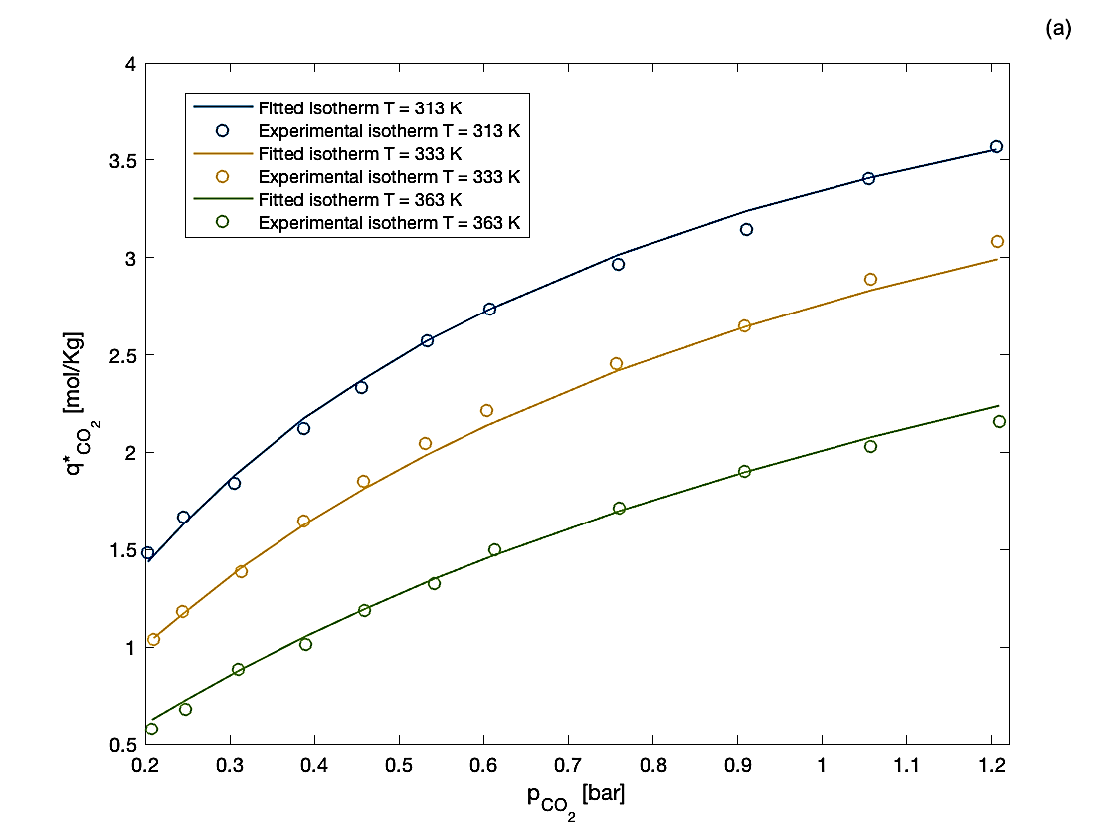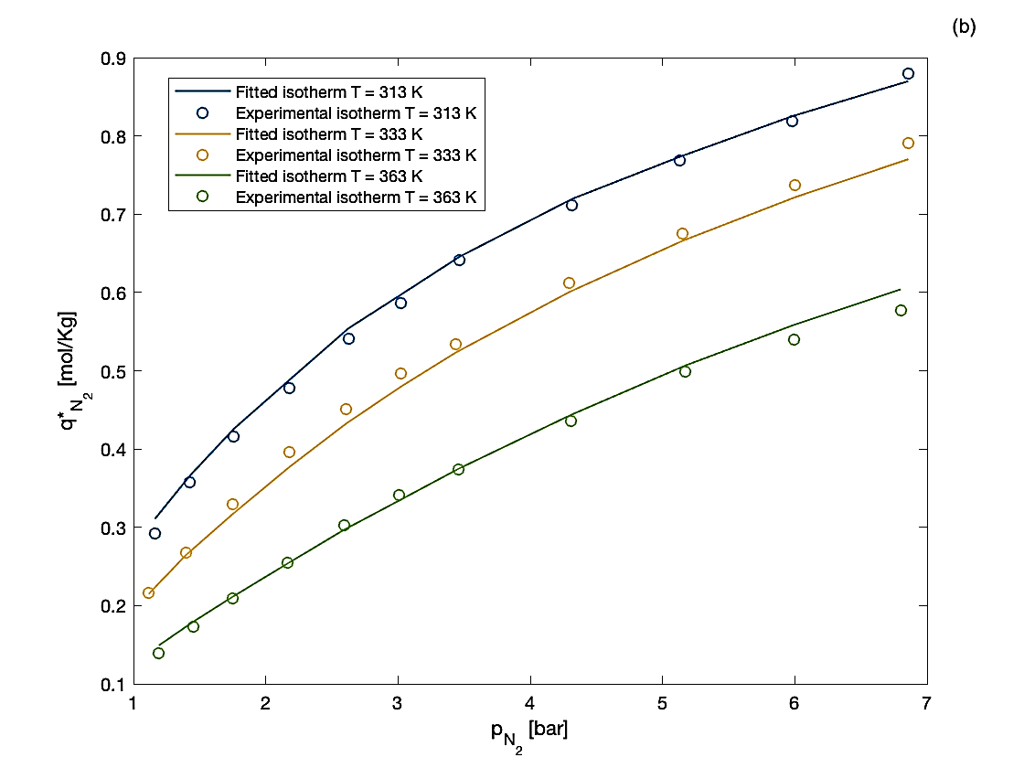
Figure 1: (a) Adsorption isotherm of CO₂ (b) Adsorption isotherm of N₂
  - Results
Obviously, the system of equations obtained can only be integrated numerically. Therefore, the equations were spatially discretized with a central second-order differencing scheme and integrated with a preconstructed MATLAB® ODE integrator.
The experimental data provided consist in a CO₂ breakthrough curve and a temperature profile. As shown in Figure 2a the model exhibits good agreement with the experimental data and reproduces the CO₂ breakthrough curve quite accurately. The temperature profile is captured only qualitatively (Figure 2b). In fact, the obtained error is on the order of 2 K when considering the maximum value, and moreover, the theoretical solution is delayed by approximately 150 seconds.
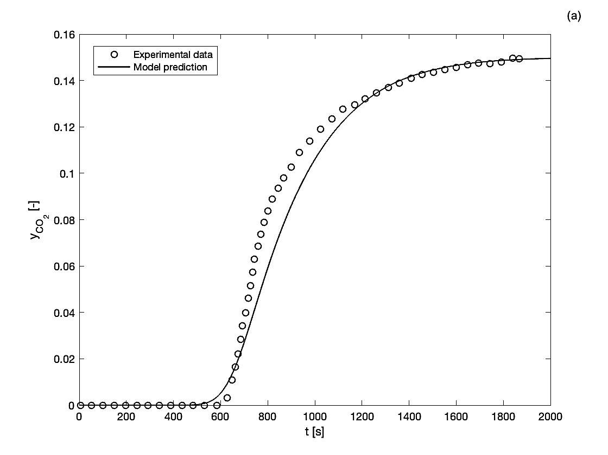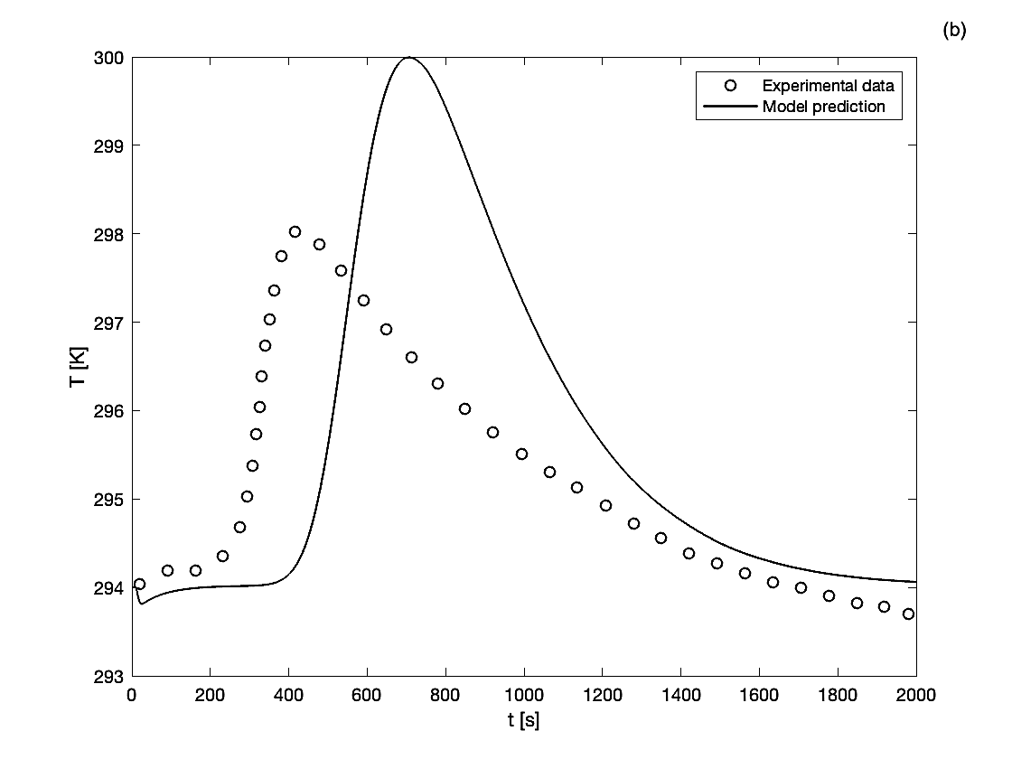
Figure 2: (a) Breakthrough curve (b) Temperature profile
For completeness in Figure 3a and in Figure 3b are reported the time profile along the column. As expected, the outlet of the column saturates later because it is reached by CO₂ later compared to the inlet of the column. Similar consideration can be applied for temperature; at the inlet of the column there is more pollutant that can potentially be adsorbed, resulting in higher temperatures.
  - Sensitivity analysis
Once a reference solution is obtained, it is important move the model away from it to verify if it exhibits a physical behaviour in various situations. Since the breakthrough curve of CO₂ was quite accurate, all the subsequent analysis is based on it. The proposed variations involve temperature, pressure, and column void fraction. If the operative temperature increases the breakthrough curve of CO₂ moves on the left, this means that the column saturates faster. The explanation lies in that adsorption is an exothermic process and is therefore disadvantaged by a temperature increase. If the operative pressure increases more CO₂ simply enters in the column and consequently the column saturates faster.
The last parameter being moved was the column void fraction $ε$, this parameter has various effect on the column’s performance. In this preliminary study, the primary visible effect is on the breakthrough curve. If the column void fraction increases, for definition, the amount of adsorbent material in the column decreases and thus the column saturates faster. However, an increase in the column void fraction reduces the pressure drop along the column (consider for example Ergun friction factor). Therefore, it will be interesting in future work optimize this parameter to achieve the better combination of gas adsorption and pressure drop. It is important remind that lower pressure drop indicates lower energy consumption.
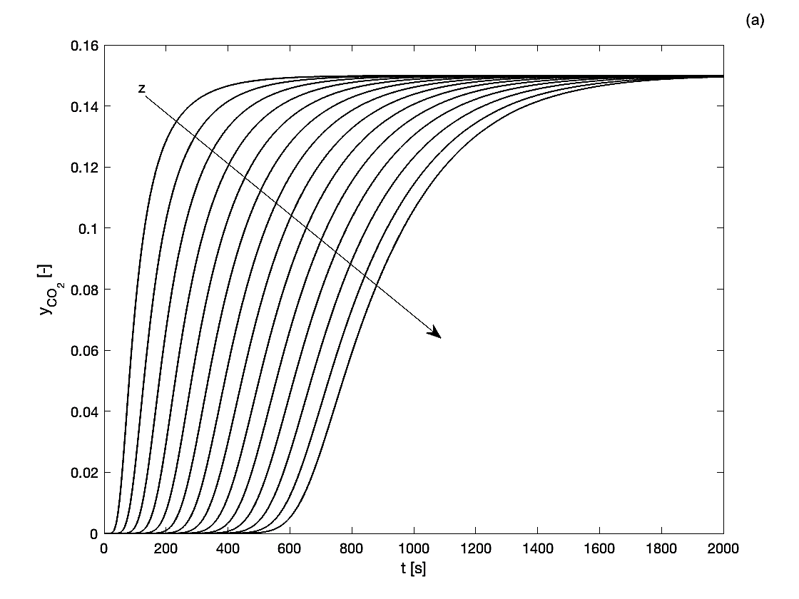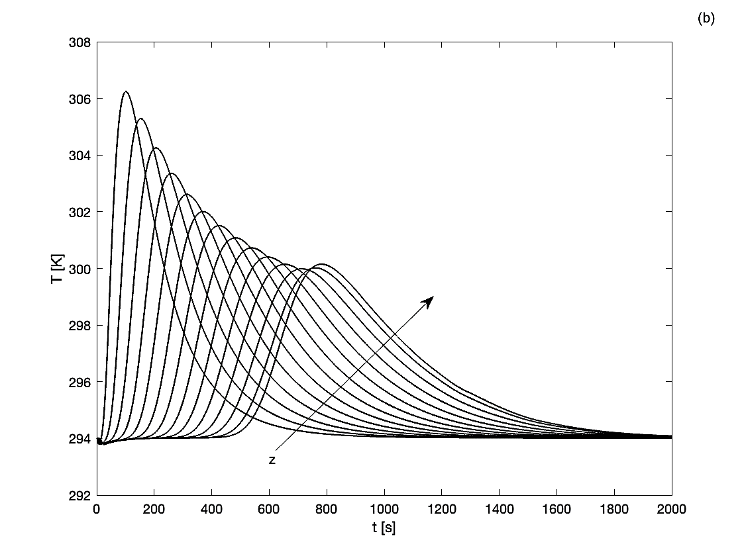
Figure 3: (a) Concentration profiles of CO₂ along the column (b) Temperature profiles along the column
Figure 4: (a) Effect of operative temperature (a) and pressure (b) on breakthrough curve
Figure 5: Effect of column void fraction on breakthrough curve
  - Conclusions
In this study, we demonstrate that a simple and easy-to-implement method for obtaining information on a bulk separation process is sufficient for a first approximation. In fact, the agreement with the experimental data for the breakthrough curve is good, regardless the use of the momentum balance. However, the trade-off of this approach is that model is not completely able to grasp the temperature profile. In the context of a preliminary design, where the interest may be focused solely at the saturation capacity of the column and the maximum temperature reached by the system, this approach proves to be efficient and timesaving. Otherwise, if there is a need to optimize the process, it might be better to use more accurate models that include the momentum balance. It is important to emphasize that this model framework represents the first step toward a simulation in which it will be possible to extrapolate useful information on the adsorption process performed on Mars without relying on estimated parameters from experimental data difficult to obtain.
Nomenclature
${\overline{q}}_{i}$ – adsorbed concentration, mol/kg

$q_{i}^{*}$ – equilibrium adsorbed concentration, mol/kg
$K_{i}$ – mass transfer coefficient, 1/s
$C_{i}$ – concentration in gas phase, mol/m³
$D_{L,i}$ – material dispersion coefficient, m²/s
$ε$ – column void fraction, -
$ρ_{P}$ – particle density, kg/m3
$C$ – total gas concentration, mol/m³
${\hat{c}}_{p,g}$ – gas phase specific heat, J/(mol K)
$T$ – gas phase temperature, K
$p$ – pressure, Pa
$D_{T}$ – energy dispersion coefficient, W/(m K)
$u$ – superficial gas velocity, m/s
$f_{PD}$ – Ergun friction factor, Pa/m
$β_{p}$ – particle surface / particle volume, 1/m
$h$ – heat transfer coefficient, W/(m² K)
$T_{st}$ – stationary phase temperature, K
$β_{1}$ – internal surface / internal volume, 1/m
$h_{w}$ – heat transfer coefficient, W/(m² K)
$T_{w}$ – wall temperature, K
${\tilde{c}}_{p,s}$ – specific heat of the adsorbent, J/(kg K)
${\hat{c}}_{p,a}$ – adsorbed phase specific heat, J/(mol K)
$k_{s}$ – adsorbent thermal conductivity, W/(m K)
$∆{\hat{H}}_{i}$ – enthalpy of adsorption, J/mol
${\tilde{c}}_{p,w}$ – specific heat of the wall, J/(kg K)
$ρ_{w}$ – wall density, kg/m³
$k_{w}$ – wall thermal conductivity, W/(m K)
$β_{2}$ – internal surface / wall volume, 1/m
$β_{3}$ – external surface / wall volume, 1/m
$h_{amb}$ – heat transfer coefficient, W/(m² K)
$T_{amb}$ – environment temperature, K
$R$ – universal gas constant, J/(mol K)
$α_{j,i}$ – isotherm parameter, (see Table 1)
$p_{i}$ – partial pressure of i^{th} component, bar

Acknowledgments
This work has been developed within the framework of the project eINS- Ecosystem of Innovation for Next Generation Sardinia (cod. ECS 00000038) funded by the Italian Ministry for Research and Education (MUR) under the National Recovery and Resilience Plan (PNRR) - MISSION 4 COMPONENT 2, "From research to business" INVESTMENT 1.5, "Creation and strengthening of Ecosystems of innovation" and construction of "Territorial R&D Leaders".
F.Z., F.A, M.C. performed their activity in the framework of the PhD in Innovation Sciences and Technologies at the University of Cagliari, Italy.
References
Atzori F., Barzagli F., Varone A., Cao G., Concas A., 2022, CO₂ absorption in aqueous NH₃ solutions: Novel dynamic modeling of experimental outcomes, Chemical Engineering Journal, 451, 138999.
Atzori F., Barzagli F., Dai S., Concas A., Cao G., 2024, A new model-aided approach for the design of packed columns for CO₂ absorption in aqueous NH₃ solutions. Chemical Engineering Science, 119780.
Bird R. B., Stewart E. W., Lightfoot E. N., 2002, Transport phenomena (2nd edition), J. Wiley & Sons, New York, USA.
Brughitta E., Atzori F., Gamboni E., Foddi S., Casula M., Fais G., Manca A., Pantaleo A., Cao G., Concas A., 2023, Cultivation of Cyanobacteria and Microalgae using Simulated in-situ Avalaible Resources for the Production of useful Bio-compounds on Mars: Modelling of Experiments, Chemical Engineering Transactions, Vol. 98.
Cavalcante C.L., 2000, Industrial adsorption separation processes: Fundamentals, modeling and applications, Latin American Applied Research, 30, 357–364.
Fais G., Manca A., Concas A., Pantaleo A., Cao G., 2022, A novel process to grow edible microalgae on Mars by exploiting in situ-available resources: Experimental investigation. Acta Astronautica, 201, 454-463.
Gutierrez-Ortega A., Montes-Morán M.A., Parra J.B., Sempere J., Nomen R., Gonzales-Olmos R., 2022, Comparative study of binderless zeolites and carbon molecular sieves as adsorbents for CO2 capture processes, Journal of CO₂ utilization, 61, 102012.
Kast W., 1988, Adsorption from the gas phase, engineering principles and technical processes, VCH Verlagsgesellschaft, Weinheim, Basel, Cambridge, New York.
Ruthven D. M., 1984, Principles of adsorption and adsorption process, A Wiley-Interscience publication, J. Wiley & Sons, New York, USA.

