|  |  |
| --- | --- |
| cetlogo ***CHEMICAL ENGINEERING TRANSACTIONS***  ***VOL. xxx, 2024*** | A publication of  aidiclogo_grande |
| The Italian Association  of Chemical Engineering  Online at www.cetjournal.it |
| Guest Editors: Valerio Cozzani, Bruno Fabiano, Genserik Reniers  Copyright © 2024, AIDIC Servizi S.r.l. **ISBN** 979-12-81206-11-3; **ISSN** 2283-9216 | |

Semi-quantitative Dust Hazard Analysis: advantages and limitations of using a Risk Matrix in DHA

Andrea Gritti\*; Leonardo Michele Carluccio; Lorenzo Pellegrini

DEKRA Italia s.r.l., Process Safety Business Unit, Via Fratelli Gracchi 27, 20122 Cinisello Balsamo (MI)

andrea.gritti@dekra.com

The management of dust hazards within industrial environments remains a critical concern, as sadly testified by the catastrophic events occurred in recent history. Dust Hazard Analysis (DHA) is a risk assessment technique used for identifying, managing, and mitigating the risks related to the handling, production, and storage of combustible dusts. This study explores the efficacy of employing a semi-quantitative approach within the framework of DHA, leveraging a Risk Matrix to assess and define the severity and likelihood of potential hazardous events associated with combustible dust.

The semi-quantitative method presented herein integrates qualitative expert judgments with quantitative data, fostering a comprehensive evaluation of various scenarios involving dust-related hazards: central to this approach is the utilization of a Risk Matrix, where severity and likelihood classes are intersected to generate risk levels associated with identified dust-related scenarios. This allows the prioritization of mitigation strategies, focusing resources on high-risk scenarios while acknowledging lower-risk occurrences. Furthermore, the use of a common Risk Matrix facilitates the decision-making process, allowing the same benchmark to be applied to the recommendations and actions emerging from different risk assessment techniques (e.g., HazOp).

The study underscores the value of a semi-quantitative approach in DHA, highlighting the potential and the limitations of the current model, offering a structured methodology that aids stakeholders in decision-making processes concerning risk mitigation and control measures, ensuring the safety and integrity of industrial operations.

* 1. Introduction

The importance of conducting accurate and reliable risk assessments on combustible dust is sadly highlighted from the numerous incidents involving combustible dust occurred in the industry, where Agriculture & Food industry has the biggest share (Perelli et al., 2023). As reported in the next table (Table 1) and the following graph (Figure 1), extracted from the 2022 Combustible Dust Incident Report (Cloney, 2023), 49 fatalities occurred due to combustible dust incidents (fires and/or explosion) in the 2022, with an average of 32 fatalities/year in the 5 year period from 2018 to 2022, with a trend that is not decreasing.

Table 1: Dust explosion statistics in the 5 year period 2018-2022 (Cloney, 2023)

|  |  |  |  |
| --- | --- | --- | --- |
|  | 2022 | 2018 - 2022 | 5 years average |
| Fires | 154 | 884 | 177 |
| Explosion | 50 | 290 | 58 |
| Injuries | 89 | 608 | 122 |
| Fatalities | 49 | 156 | 32 |

Figure 1: Dust explosion trend in the 5 year period 2018-2022 (Cloney, 2023)

The necessity to build a more reliable and consistent methodology to perform Dust Hazard Analysis (DHA) led us to explore the application of a Risk Matrix to the DHA. The introduction of a semi-quantitative approach to DHA (i.e., using probability and severity levels to characterize every fire / flash fire / explosion scenario of the DHA) allows the methodology to be systematically applied in different facilities, from petrochemical to pharma, creating a more structured analysis in which the following elements of the DHA are included:

* Hazardous Area Classification (HAC) – applying the zoning system supported by the International Electrotechnical Commission (IEC 60079-10-2:2015), or Class / Division system supported by the National Fire Protection Association (NFPA 70, National Electrical Code – NEC);
* Ignition Risk Assessment (IRA), including electrostatic risk assessment (Carluccio et al., 2023);
* Consequence Analysis
* Evaluation of existing Basis of Safey (BoS);
* Safety Management System for identified scenarios.
  1. Methodology

All the information necessary in the development of the study is gathered during site visits and analysis of the plant and process documentation, and then collected into a worksheet, where the first four columns (i.e., Location, Hazardous Area Classification, Ignition Risk Assessment, Consequence Analysis respectively) represent the starting point for the development of the semi-quantitative DHA. In the following table is reported an example of a typical worksheet used for the study.

Table 2: Semi-quantitative DHA worksheet

|  |  |  |  |  |  |  |  |  |  |  |  |
| --- | --- | --- | --- | --- | --- | --- | --- | --- | --- | --- | --- |
| Location | HAC | IRA | Consequences | Risk  Ranking | | Existing Barriers | Risk  Ranking | | Recommendations | Risk  Ranking | |
|  |  |  |  | L | S |  | L | S |  | L | S |
| Dust collector | Zone 20 (internal volume – dirty side) | 1. Static electricity | Explosion of the equipment […] |  |  | Explosion vents |  |  | Ensure correct grounding and bonding |  |  |
| 2. Electrical equipment | Explosion of the equipment […] |  |  | Explosion vents |  |  | Ensure equipment compliance |  |  |
| 3. […] | […] |  |  |  |  |  |  |  |  |

The definitions of Zones is reported in paragraph 2.1.

The Risk Matrix used for the semi-quantitative DHA is reported in Figure 2, and the severity and frequency levels are described in Table 3 and Table 4.



Figure 2: DEKRA Risk Matrix

Table 3: Severity levels

|  |  |  |
| --- | --- | --- |
| Level | Description | Definition |
| 1 | Moderate | Minor injuries or illnesses only requiring first aid (infirmary) |
| 2 | Serious | Serious injury causing last time and possible longer term effects |
| 3 | Very serious | Lethal effect (one possible death), multiple serious injuries leading to hospitalization, potentially deadly illnesses, permanent disability |
| 4 | Major | Multiple deaths inside the site, lethal effects on inhabited areas located outside the site |
| 5 | Catastrophic | Multiple deaths inside the site, lethal effects widely including inhabited areas outside the site (several deaths) |

Table 4: Frequency levels

|  |  |  |  |
| --- | --- | --- | --- |
| Level | Description | Frequency (events/year) | Definition |
| 1 | Extremely improbable | F < 10-6 | < 1 case in 1000000 years |
| 2 | Improbable event | 10-6 < F ≤ 10-5 |  |
| 3 | Extremely rare event | 10-5 < F ≤ 10-4 |  |
| 4 | Rare event | 10-4 < F ≤ 10-3 |  |
| 5 | Probable event | 10-3 < F ≤ 10-2 |  |
| 6 | Occasional event | 10-2 < F ≤ 10-1 |  |
| 7 | Common event | F ≥ 10-1 | ≥ 1 case in 10 years |

* + 1. Hazardous Area Classification (HAC)

The Hazardous Area Classification follows the usual path described in IEC 60079-10-2 (2015), starting from the identification of the possible sources of emission and the characterization of the grade of emission. Then, a zone is attributed to each emission source. Every hazardous area identified will be a row in the worksheet, and Ignition Risk Assessment will be conducted in the next column.

The zones are defined as follow (IEC 60079-10-2: 2015):

* Zone 20: a place in which an explosive dust atmosphere, in the form of a cloud of dust in air, is present continuously, or for long periods or frequently;
* Zone 21: a place in which an explosive dust atmosphere, in the form of a cloud of dust in air, is likely to occur in normal operation occasionally;
* Zone 22: area in which an explosive dust atmosphere, in the form of a cloud of combustible dust in air, is not likely to occur in normal operation but, if it does occur, will persist for a short period only.

As reported in the Italian standard CEI 31-56 (repealed in 2018, following the update of the IEC 60079-10-2 standard), it is possible to assign a probability of occurrence to each zone, as reported in the following table.

Table 5: Explosion atmosphere probability according to CEI 31-56, Table 5.8-A

|  |  |
| --- | --- |
| Zone | Probability to have an explosive atmosphere in one year |
| Zone 20 | P > 10-1 |
| Zone 21 | 10-3 < P ≤ 10-1 |
| Zone 22 | 10-5 < P ≤ 10-2 |

* + 1. Ignition Risk Assessment (IRA)

For each row (i.e., for each hazardous area identified), all the possible ignition sources will be listed – a comprehensive list of ignition sources is reported in the standard EN 1127-1 (2019) – together with the respective probability to be present in the hazardous area. According to the standard, three classes of likelihood of occurrence are present, in terms of presence of the ignition source:

1. Ignition sources which can occur continuously or frequently (i.e., ignition sources which can occur during normal operation);
2. ignition sources which can occur in rare situations (i.e., ignition sources which can occur solely as a result of foreseeable malfunctions);
3. ignition sources which can occur in very rare situations (i.e., ignition sources which can occur solely as a result of rare malfunctions).
   * 1. Consequence Analysis

For the analysis of the consequences, among all the aspects to be taken into account, the starting point is the pentagon of the explosion, in order to understand the physical effect resulting after the ignition.

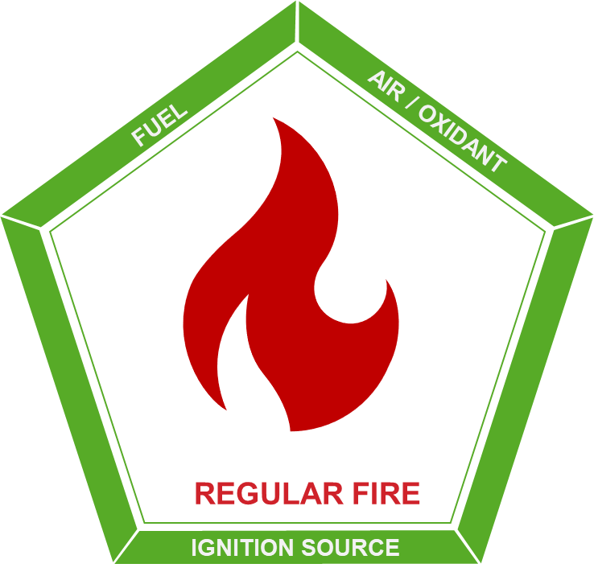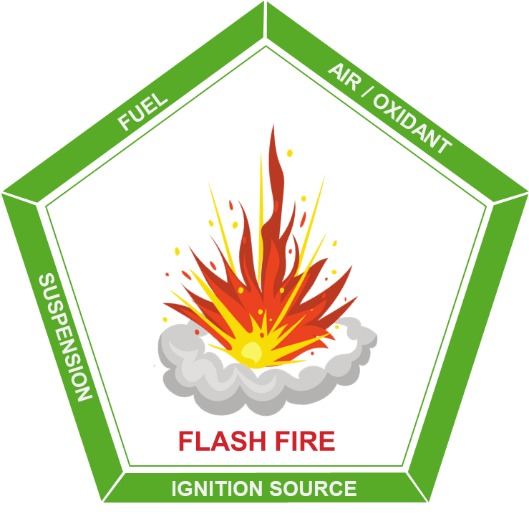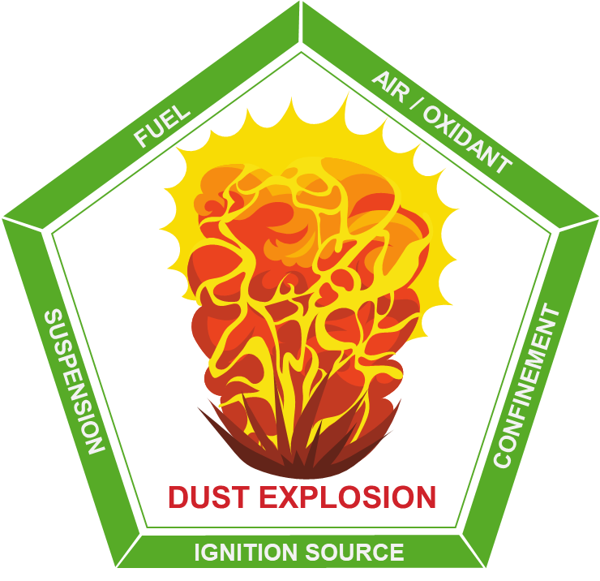

Figure 3: Consequences of ignition, based on the pentagon of fire

As a simplified approach, it is possible to assume that, if the ignition occurs in the internal volume of the equipment, the consequence will be an explosion; if the ignition occurs in an open area, the consequence will be a flash fire; if the ignition occurs in a dust layer, the consequence will be a regular fire.

In this way, in order to assess the potential impact of dust-related incidents, it is possible to evaluate the severity of each potential consequence on a qualitative scale.

Table 6: Correlation between Severity Levels and DHA common scenarios

|  |  |  |
| --- | --- | --- |
| Severity Level | Description | DHA common scenario |
| 5 | Catastrophic | To be assessed |
| 4 | Major | Explosion propagation |
| 3 | Very serious | Explosion |
| 2 | Serious | Flash fire |
| 1 | Moderate | Fire |

This simplified approach can be used as a starting point for the Consequence Analysis, but deep understanding of the process and of the plant conditions is needed in order to assess the most probable consequence resulting from the ignition. For example, during start-up, shut-down or maintenance operations, it may be possible that the equipment is almost empty and the amount of combustible dust inside the equipment is not enough to generate an explosion (in this particular case, the consequence would be an internal flash fire).

Additionally, it may be possible that, following an external flash fire or explosion, a pressure wave could perturbate any dust deposit present in the surrounding, leading to its dispersion and following generation of a bigger cloud of dust (depending on the level of accumulation), secondary ignition and bigger flash fire or even secondary explosion scenario. Furthermore, in case of internal explosion of the equipment, the propagation of the flame front in the connected equipment and the projection of fragment shall always be considered.

Other parameters to be considered are the explosivity characteristics of the particular dust, like, for example: Maximum explosion pressure $p_{max}$ and Maximum rate of explosion pressure rise .

* + 1. First Risk Ranking (Raw Risk) and conditional parameters

The Raw Risk is evaluated considering the severity of the scenario, assessed according to the methodology described in paragraph 2.3, together with the probability to have simultaneously the hazardous area and the ignition. In addition, further probabilistic considerations could be made when evaluating the Raw Risk, regarding the probability of the operator presence in the area affected by the fire / flash fire / explosion scenario; in particular, the approach described in the following table can be used:

Table 7: Presence factor parameters

|  |  |
| --- | --- |
| Description | Definition |
| No operators are present in the area | P < 15 min/shift |
| No operators are expected in the area | 15 min/shift ≤ P < 1 h/shift |
| Operators are always present in the area | P ≥ 1 h/shift |

* + 1. Evaluation of existing Basis of Safey (BoS)

The basic principles of explosion prevention and protection shall be applied in the following order (EN 1127-1, 2019):

1. Prevention:
   1. avoid or reduce hazardous explosive atmospheres; this objective can mainly be achieved by modifying either the concentration of the flammable/combustible substance to a value outside the explosion range or the concentration of oxygen to a value below the limiting oxygen concentration (LOC);
   2. avoid any possible effective ignition source;
2. Protection:
   1. halting the explosion and/or limiting the range to a sufficient level by protection methods, (e.g., isolation, venting, suppression and containment); in contrast to the two measures described above, here the occurrence of an explosion is accepted.

It is worth pointing out that the first choice shall always be the avoidance of a hazardous explosive atmosphere (including housekeeping to limit the accumulation of dust layers).

* + 1. Second Risk Ranking (Mitigated Risk)

The Mitigated Risk is evaluated taking into account the reliability of the existing safeguards (e.g., inerting, management of the ignition sources, venting and isolation), reducing the frequency of the scenario.

For example, the following PFDs can be assigned, as reported in the Guidelines for Initiating Events and Independent Protection Layers in the Layer of Protection Analysis (CCPS, 2015):

* Explosion panels on process equipment: PFD = 10-2;
* Vent panels on enclosure: PFD = 10-2;
* Automatic fire suppression system for a room: PFD = 10-1;
* Personal Protective Equipment (PPE): PFD = 10-1;

Furthermore, when inerting is used to avoid the presence of oxygen inside the equipment, it is possible to reduce the hazardous area classification according to the reliability of the inerting control system (Process Control Engineering – PCE). In particular, the following table can be used, as reported in VDI/VDE 2180 blatt 6 (2013), using Safety Integrity Levels (SIL) (IEC 61508, IEC 61511):

Table 7: Necessary risk reduction as a function of the initial and the target zone with the use of PCE system

|  |  |  |
| --- | --- | --- |
| Zone | | Required reliability of the PCE system |
| Initial | Target |
| 20 | 21 | SIL 1 |
| 20 | 22 | SIL 2 |
| 20 | nEx | SIL 3 |
| 21 | 22 | SIL 1 |
| 21 | nEx | SIL 2 |
| 22 | nEx | SIL 1 |

Where:

* Initial = Present zone without measures for zone reduction;
* Target = Zone achieved after measures for zone reduction;

It is worth noticing that, when the initial zone is Zone 20 and the target zone is nEx, a dedicate risk assessment is needed to critically evaluate the particular case where a SIL 3 loop is used to reduce HAC.

* + 1. Establishing Safety Management System for identified scenarios

For each scenario for which the Mitigated Risk is not acceptable, recommended actions will be indicated in order to reduce the risk up to an acceptable level. The resulting list of recommendations shall be the foundation of an action plan to reduce the explosion risk. The actions resulting from the DHA can be prioritized according to the Mitigated Risk level and a cost-benefit analysis. After the completion of the recommendations (or after important modification/incidents), the analysis should be reviewed to assess the new level of risk.

* 1. Limitations of the model and Conclusions

The main aspect to be addressed is to ensure a good and reliable calibration of the Risk Matrix, to have a consistent risk evaluation. This point leads to the second key aspect of the presented methodology: to have a reliable risk assessment, plant visit and qualitative evaluations are needed; quantifying the risk with exact numerical values is neither realistic nor necessary: the numerical values for risk reduction should only be considered as an indication of magnitude. To conclude, the semi-quantitative analysis contributes to create a more structured approach to conduct DHA, and the use of the Risk Matrix to prioritize the resulting recommendations, allows to compare the outcomes of the DHA with other results coming from different semi-quantitative risk assessment techniques (e.g., HazOp, HazId), facilitating the integration of all the outcomes into a common Safety Management System. Thus, all the actions to be implemented to reduce the level of risk of the plant can be addressed systematically generating a synergic model.

Nomenclature

BoS – Basis of Safety

DHA – Dust Hazard Analysis

HAC – Hazardous Area Classification

HazOp – Hazard and Operability analysis

HazId – Hazard Identification analysis

IEC – International Electrotechnical Commission

IRA – Ignition Risk Assessment

NEC – National Electrical Code

nEx – Non Explosion Risk

NFPA – National Fire Protection Association

PCE – Process Control Engineering

PFD – Probability of Failure on Demand

PPE – Personal Protective Equipment

SIL – Safety Integrity Levels

References

Carluccio L.M., Perelli S., 2023, Electrostatic Risk Assessment for Combustible Dust Atmospheres, Chemical Engineering Transactions, 104, 61-66.

Center for Chemical Process Safety of the American Institute of Chemical Engineers, 2015, CCPS – Guidelines for initiating events and independent protection layers in layer of protection analysis -

Cloney, C., 2023, “2022 Combustible Dust Incident Report - Version #1” DustEx Research Ltd. Retrieved from <http://dustsafetyscience.com/2022-Report>.

International Electrotechnical Commission, 2015, IEC 60079-10-2 Explosive atmospheres - Part 10-2: Classification of areas - Explosive dust atmospheres, Geneva, Switzerland.

International Electrotechnical Commission, IEC 61508, Functional safety of electrical/electronic/programmable electronic safety-related systems, Geneva, Switzerland

International Electrotechnical Commission, IEC 61511, Functional safety – Safety instrumented systems for the process industry sector, Geneva, Switzerland

National Fire Protection Association, NFPA 70, 2023, National Electrical Code,

European Committee for Standardization / European Committee for Electrotechnical Standardization, CEN / CENELEC, 2019, EN 1127-1 Explosive atmospheres - Explosion prevention and protection - Part 1: Basic concepts and methodology.

Perelli S., D'Angelo D., Pellegrini L., 2023, Analysis of Dust Fires and Explosions in the Food Processing Industry, Chemical Engineering Transactions, 104, 169-174.

VDI/VDE 2180 Blatt 6, 2013-06, Safeguarding of industrial process plants by means of process control engineering (PCE). Application of functional safety in the context of explosion protection (original title: Sicherung von Anlagen der Verfahrenstechnik mit Mitteln der Prozessleittechnik (PLT) Anwendung der funktionalen Sicherheit im Rahmen von Explosionsschutzmaßnahmen). Berlin: Beuth Verlag