 CHEMICAL ENGINEERING TRANSACTIONS  VOL. xxx, 2024 | A publication of  
The Italian Association
of Chemical Engineering
Online at www.cetjournal.it

Guest Editors: Valerio Cozzani, Bruno Fabiano, Genserik Reniers
Copyright © 2024, AIDIC Servizi S.r.l.
ISBN 979-12-81206-11-3; ISSN 2283-9216

Monitoring and Management of Naphthenic Acid Corrosion in Distillation Units of a Petroleum Refinery
Giuseppe Chiofalo^{b}, Fabrizio D’Antonio^{b}, Antonino Giacobbe^{a,*}, Egnazio Ollà^{b}, Alessandra Saraceno^{b}, Nazareno Scarfati^{b}, Gaetana Triscari^{b}
ªDepartment of Engineering, University of Messina, Contrada di Dio, 98166 Messina, Italy
^{b}Raffineria di Milazzo S.C.p.A., Contrada Mangiavacca, 98057 Milazzo (ME), Italy
antonino.giacobbe@studenti.unime.it
The continuous increase in fuel prices at refueling stations and the costs of extraction, refining and supply chain management leads the Companies to purchase low-cost crude oils, characterized by high acidity and high sulphur content. The processing of such crude oils results in a drastic increase in corrosion rates, relative to sulfidation and naphthenic acid corrosion mechanisms, thus, it is necessary to take mitigation actions, conducting a cost-benefit assessment and reviewing inspection and maintenance plans. A petroleum refinery has implemented a monitoring system, through ultrasonic corrosion probes, and an inhibitor injection system at specific points in its atmospheric distillation units; the goal is to manage crude oil with TAN (Total Acid Number) value that not exceed 1.5 mg(KOH)/g.
In this report, the layout and operation of the system are described, with a brief mention of the used inhibitor’s family; the choice of injection and monitoring points and the measured corrosion rate are presented for the first months in service.
  - Introduction
The oil and gas industry classifies crude oils according to the API Grade and to the sulphur content (Al-Moubaraki and Obot, 2021). The availability of light and sweet crude oils is gradually decreasing and there is an increasing reliance on so-called “tertiary recovery techniques”, by injecting steam, gas or detergent-like surfactants in the reservoir, to lower the surface tension that prevents the oil droplets from moving, or on the extraction of heavier and more acidic crude oils (US DoE, 2024). Acid crude oils are cheap, so they are more profitable, but they have higher quantities of metals, aromatic compounds and sulphur: this implies greater processing difficulty and higher costs for ensuring plant integrity (Figure 1):

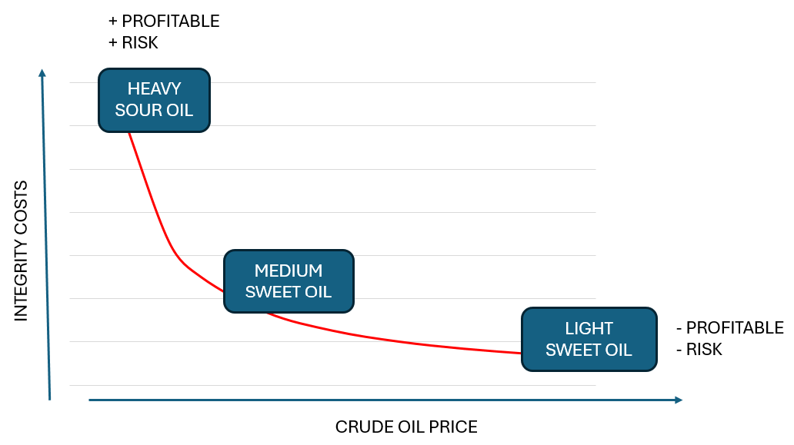
Figure 1. Trend of crudes features and integrity costs
To manage crudes with higher acidity, a petroleum refinery has implemented a corrosion monitoring system and an inhibitor injection system in its atmospheric distillation units. The ultrasonic probes allow to monitor the corrosion process continuously, obtaining a snapshot of the current situation, without relying only on corrosion tables or on scheduled inspections to determine the residual life.
  - Damage mechanisms and mitigation methods
In atmospheric and vacuum distillation units, the main damage mechanisms affecting high service temperature sections are:
- Naphthenic acid corrosion. At room temperature naphthenic acids are not corrosive, but they become so for carbon steels at temperatures above 200 °C, reaching peak reactivity around 350 °C and then decreasing again above 400 °C (Al-Moubaraki and Obot, 2021). Their corrosivity is closely linked to the TAN, which is a measure of acidity determined by the amount of potassium hydroxide (in mg) required to neutralise 1 g of crude. The naphthenic acid risk corrosion depends on acid concentration, sulphur content, operating temperature, equipment metallurgy, flow velocity and surface conditions.
- Sulfidation. Sulfidation is a high temperature corrosion mechanism, occurring without free water in the stream and directly connected with sulphur content and service temperature. It is generally an irreversible corrosion process, in which the sulphur can penetrate the alloy substrate along the grain boundaries, thereby affecting the mechanical integrity of structural components (Sanabria Cala et al., 2017). Corrosion rate is well described by McConomy curves, plotted for a given S% value and for various types of materials: sulfide corrosion rates are plotted depending on the temperature and they are used to predict the relative corrosivity of crude oil at operating temperatures above 200°C.
There are different techniques used to mitigate and control the corrosion process: blending with low-acid crude, conversion of naphthenic acids through esterification and decarboxylation processes, surface coating, cathodic protection, corrosion inhibitors.
Focusing on corrosion inhibitors, they are substances that, when diluted in small percentages in hydrocarbons, reduce corrosion rate, by forming a protective film on the surface of the base metal: this film prevents the corrosive substance from coming into contact with it. A good inhibitor must be stable, not incline to precipitation and not incline to forming emulsions; it must also possess good solubility in hydrocarbons. At temperatures close to 200 °C, organic inhibitors such as alkyl phenols, polysulphides, acid amines, thiazolidines and thiophosphates are particularly effective: oil refineries use inhibitors based on phosphate esters, injected in small quantities into critical areas of the distillation units (Bota et al, 2019).
  - NAP acid crude oil project
In this report, an experience recently carried out in two Crude Distillation Unit (CDU) of a petroleum refinery will be described, where an inhibitor injection system and an “on line” thickness measurement system have been implemented, with the target of increasing design TAN limit up to 1.5 mg(KOH)/g.
One of CDU, named CDU_4, accordingly with equipment metallurgy, was addressed to High Sulphur crude processing; the second CDU, named CDU_3, is addressed for low sulphur crude processing. The project was conducted in two stages:
- Risk Matrix Definition. Based on the equipment metallurgy, temperature, maximum TAN, maximum S% and flow velocity, circuits exposed to higher risk of naphthenic acid corrosion were identified. The risk matrix highlights three risk categories: Low Risk (CR<0.13 mm/y), Moderate Risk (0.13<CR<0.254 mm/y) and High Risk (CR>0.254 mm/y). The circuits with high risk level are: Preheat train (hot side), Furnace Transfer Line, Medium and Low Pumparounds, Light and Heavy Gasoil and Residue extraction line.
- Corrosion inhibitor selection, corrosion and monitoring points definition. In this stage, locations and monitoring point are identified.
    - Corrosion inhibitor
The inhibitor is a chemical compound from thiophosphate ester family, but the detailed formula is not available because it is covered by industrial licence. The anti-corrosive action is based on stabilization of the protective ${Fe}_{x}O_{x}$ film in the process side of service equipment, reached with a higher concentration of phosphorus than other commercial inhibitors (5.0 % vs 2.2 %). Tests carried out by the Manufacturer show that it is very effective at high temperatures, high speed and high acidity. Focusing on the difference between the protective layer obtained with this molecule and the layer obtained with a traditional thiophosphate ester, the film is thicker and more homogenous.
    - Injection and monitoring points
The criteria applied for the injection points are:
- Position them in the coldest part of the circuits
- Use a dilution stream, called carrier, to guarantee a good distribution; if temperature is below 150 °C, the injection point can be avoided
- For pumparound circuits, the injection points are placed closer to the column, allowing for better protection of the tower internals
- The nozzles are oriented to spray co-currently to the stream.
State-of-the-art wireless ultrasonic probes were used for monitoring: ultrasonic thickness sensors are non-intrusive tools, used for monitoring and providing reliable measurements; they are connected to the remote server to store and process the acquired information.
  - Layout and injection system
Starting from P&I diagrams, materials and plant sections subject to corrosion by naphthenic acids were identified (Figure 2, 3):
- Pre-heating exchanger train (from exchanger E6 to the furnace). Injection point is at the inlet of the E6 A/D exchangers (A train) and of the E6 E/H exchangers (B train); as the temperature is above 170 °C, a dilution crude flow is required: a crude oil withdrawal is foreseen at the outlet of the P2 A/B/C pumps and the dilution ratio is set at 20:1. For monitoring, two sensors are placed downstream of E8 D and H, in the horizontal pipe after the first bend.
- Transfer Line. Here there are no injection points because it is already protected by the injection upstream of the furnace. For monitoring, six sensors are installed at the outputs of the furnace F1.
- Medium Pumparound. The injection point is in the column return, as being the closest and coldest place; moreover, in this way the column and the GAL circuit will also be protected, without adding additional injection points. Since both P10 A/B pumps are usually in operation, two monitoring sensors were installed in the discharge area, at the first bends before the common line.
- Low Pumparound. The low pumparound injection point is in the column return; this protects the GAP extraction without adding additional injection points. The carrier used is the same selected for the RLM circuit. The acquisition point is placed in the common line, at the outlet of pump P9: since this is the hottest recirculation of the whole unit, three sensors have been installed in the horizontal line section.

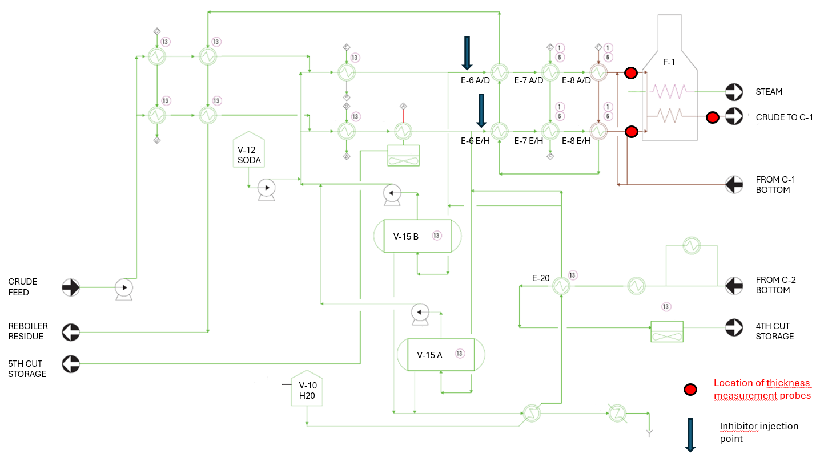
Fig. 2. Simplified P&I diagram of the pre-heating section of the low sulphur CDU
- Kero Side Cut. As the maximum temperature reached in this section is about 190 °C, there is no need to add inhibitor; moreover, as the circuit is low risk, only one sensor is installed in the common line at the P5 A/B outlet.
- LGO Side Cut. This section is protected by the inhibitor injected into the Medium Pumparounds circuit; there are 2 sensors installed, one on the outside of the first bend in the P6 A pump discharge, the second on the outside of the first bend in the common line.
- HGO Side cut. Here we have the same condition of the LGO circuit: the plant section is protected by the inhibitor injected into the Low Pumparounds circuit, entering column C1; two sensors are installed at the discharge of P7 pump, on the outside of the first two bends.
- Atmospheric Residue. Even though this section is subject to extra dosing from the preheating circuit, it is convenient to have a redundant injection point to allow more flexibility in the crude processing. The injection point is located on the common line at the intake of the three P8 pumps; crude or diesel can be used indiscriminately as carriers, with a minimum dilution ratio of 1:50. Since only two of the three P8 pumps are usually in service, two sensors are installed downstream of the pumps, on the two consecutive bends of the common line.
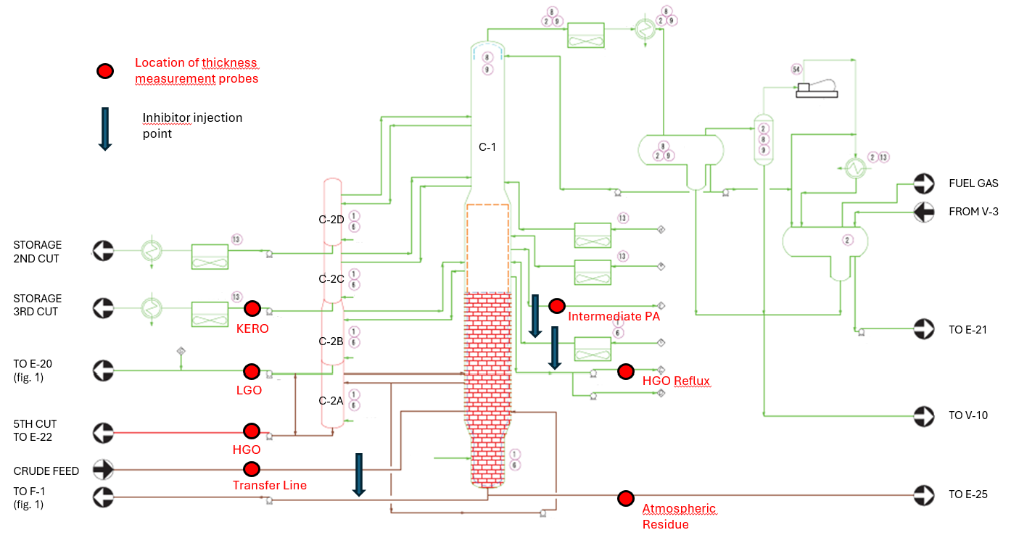Fig. 3. Simplified P&I diagram of column, pumparounds and side cuts of the low sulphur CDU
  - Results
TAN and sulphur data of the processed blanks, service temperatures and thicknesses measured by sensors were collected: for the CDU_4 the reference period is about 150 days, for the CDU_3 it is only 60 days. Feed’s characteristics on a monthly basis are shown in Table 1.
The data from the sensors were plotted as a time function and a linear regression was carried out, referred to measurement time, to obtain the equation representing the trend; the slope was calculated to obtain the material lost and the corrosion rate over the operating time range; finally, an extended projection was made to one year of operation, obtaining the annual corrosion rate. Figures 4, 5 and 6 show thickness trends for the high sulphur distillation unit CDU_4, Tables 3 and 4 contain the results obtained:
Table 1: Processed crudes’ characteristics from September 2023 to January 2024, on a monthly basis
 | CDU_3 |  | CDU_4
 | S [%] | TAN [mgKOH/g] | S [%] | TAN [mgKOH/g]
September 2023 | 0.154 | 0.097 | 1.947 | 0.103
October 2023 | 0.158 | 0.096 | 2.072 | 0.112
November 2023 | 0.146 | 0.099 | 2.148 | 0.124
December 2023 | 0.148 | 0.125 | 1.872 | 0.106
January 2024 | 0.131 | 0.072 | 2.015 | 0.118

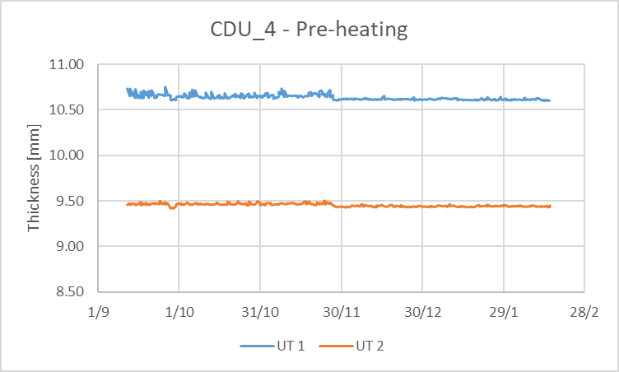 | 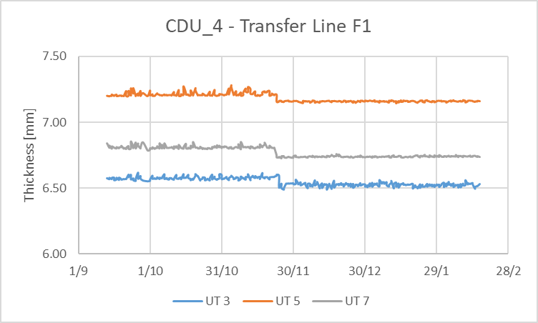
(a) | (b)
Figure 4 a) b): Thickness measurements of pre-heating and transfer line sections of the high sulphur distillation unit
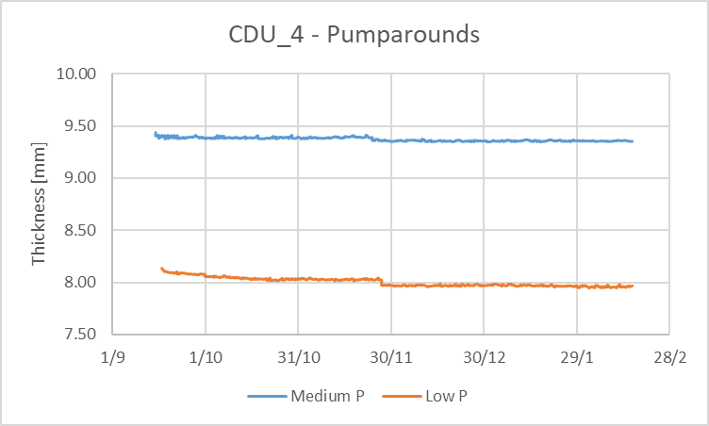 | 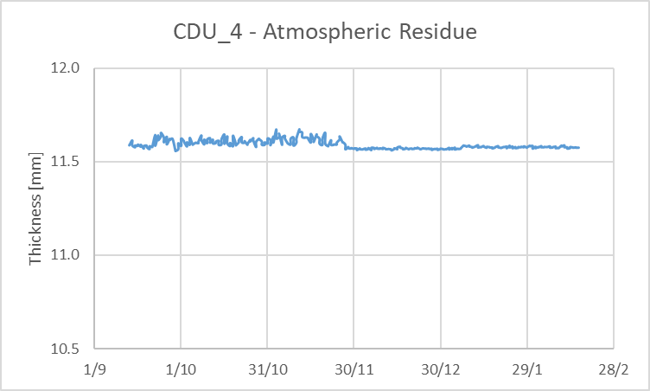
(a) | (b)
Figure 5 a) b): Thickness measurements of pumparounds and of the atmospheric residue sections of the high sulphur distillation unit
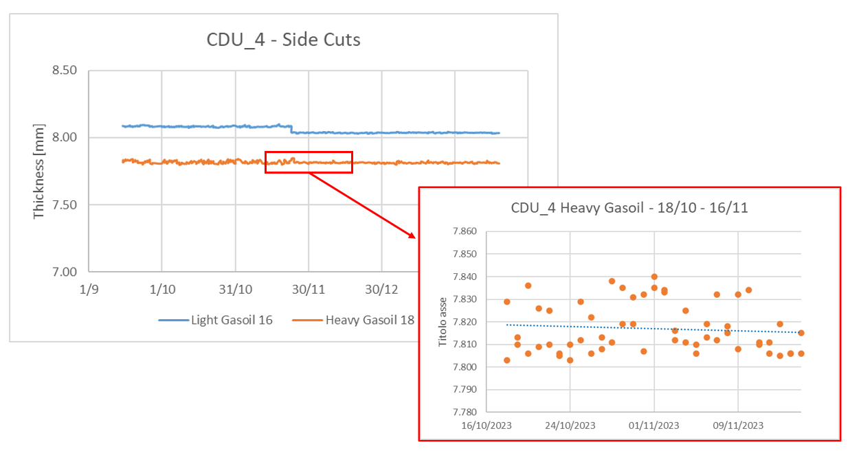
Figure 6: Thickness measurements of the side cuts section of the high sulphur distillation unit and zooming during the processing period of the acid crudes
In the examined period, the feed crudes have canonical characteristics, as shown in the monthly average values in Table 2; higher acidity crude oils were treated only in a time interval of 29 days, in CDU_4, with 0.20≤TAN≤0.38 and 1.9≤S%≤2.9. Focusing attention on heavy gasoil HGO and on the atmospheric residue, where products with higher acidity and higher sulphur content are concentrated, the corrosion rates are comparable with the average monthly values (Figure 6): therefore, no increase in the corrosion rate was noted.
Table 3: Result obtained for CDU_3 on a 60-day reference period and comparison between the average CR measured, McConomy CR and RBI CR
CDU_3 |  | Material | Design Temp [°C] | Average ∆s [mm] | Average CR [mm/y] | McConomy CR [mm/y] | RBI CR [mm/y]
 | Pre-heating | A335 P5 | 260 | 0.004 | 0.016 | 0.030 | 0.060
 | Transfer Line | A335 P5 | 360 | 0.003 | 0.019 | 0.200 | 0.100
 | Medium P | API 5L Gr. B | 200 | 0.012 | 0.067 | 0.030 | 0.060
 | Low P | API 5L Gr. B | 283 | 0.009 | 0.054 | 0.180 | 0.150
 | LGO | API 5L Gr. B | 265 | 0.007 | 0.038 | 0.080 | 0.095
 | HGO | AISI 316L | 350 | 0.001 | 0.006 | 0.030 | 0.029
 | Atm Residue | A335 P5 | 354 | 0.004 | 0.024 | 0.200 | 0.060
Table 4: Results obtained for CDU_4 on a 150-day reference period and comparison between the average CR measured, McConomy CR and RBI CR
CDU_4 |  | Material | Design Temp [°C] | Average ∆s [mm] | Average CR [mm/y] | McConomy CR [mm/y] | RBI CR [mm/y]
 | Pre-heating | A335 P5 | 270 | 0.051 | 0.120 | 0.150 | -
 | Transfer Line | A335 P5 | 365 | 0.086 | 0.202 | 0.510 | 0.250
 | Medium P | API 5L Gr. B | 210 | 0.056 | 0.132 | 0.050 | 0.093
 | Low P | API 5L Gr. B | 250 | 0.089 | 0.209 | 0.180 | 0.120
 | LGO | API 5L Gr. B | 258 | 0.063 | 0.150 | 0.180 | 0.085
 | HGO | A335 P5 | 350 | 0.039 | 0.091 | 0.510 | 0.100
 | Atm Residue | A335 P9 | 358 | 0.041 | 0.096 | 0.250 | 0.040
  - Conclusions
During these few months in operation, the thickness losses due to corrosion have been negligible: given the sulphur content and acidity of the processed crudes, the corrosion rates are much lower than those estimated from the McConomy curves. There are different reasons for this: the corrosion inhibitor injected actually made it possible to control the corrosion attacks; the McConomy curves are very conservative and they take into account worst-case scenarios; the period in which the acidic crude was treated was quite short to see any significant effect on the corrosion rate.
The experimental campaign will continue in the next months with the processing of more and more acidic oils and for longer periods, which will make it possible to determine more precise corrosion rates and to detect the gap between actual and expected rates.
References
Al-Moubaraki A.H., Obot I.B., 2021. Corrosion challenges in petroleum refinery operations: Sources, mechanisms, mitigation and future outlook, Journal of Saudi Chemical Society, 25, 10-14.
Johnson D.W., Hils J.E., 2013. Phosphate Esters, Thiophosphate Esters and Metal Thiophosphates as Lubricant Additives. MDPI, Lubricants 1(4), 132-148.
Bota G., Jin P., Farelas F., Robbins W., 2019. Phosphate Esters Inhibitors in Naphthenic Acid Corrosion – An Experimental Evaluation, Corrosion Conference Expo, Paper N. 13491, Nashville (USA).
Sanabria Cala J., Laverde Catano D., Pena Ballesteros D., Merchan Arenas D., 2017. Influence of Temperature and Time on the Corrosion by Sulfidation of AISI-316 Steel exposed under Transfer Line., CET, 57, 715-720.
Ramirez C., 2017. The Science and Technology of Unconventional Oil, 1st Edition, Publisher: Elsevier, Amsterdam.
Sotoodeh, K., 2021. Subsea Valves and Actuators for the Oil and Gas Industry, Publisher: Elsevier, Gulf Professional Publishing, ISBN: 9780323906050.
U.S. DoE, 2023, Enhanced Oil Recovery, Office of Fossil Energy and Carbon Management, <energy.gov/fecm/enhanced-oil-recovery> accessed 29.02.2024.

