|  |  |
| --- | --- |
| cetlogo ***CHEMICAL ENGINEERING TRANSACTIONS***  ***VOL. xxx, 2024*** | A publication of  aidiclogo_grande |
| The Italian Association  of Chemical Engineering  Online at www.cetjournal.it |
| Guest Editors: Valerio Cozzani, Bruno Fabiano, Genserik Reniers  Copyright © 2024, AIDIC Servizi S.r.l. **ISBN** 979-12-81206-11-3; **ISSN** 2283-9216 | |

Integrating IOW in the Estimation of the Risk of an Atmospheric Distillation Unit by Using a bayesian Network

Antonino Giacobbea,\*, Giuseppa Ancionea, Maria Francesca Milazzoa, Fabrizio D’Antoniob, Paolo Bragattoc, Elpida Piperopoulosa

aDepartment of Engineering, University of Messina, Contrada di Dio, 98166 Messina, Italy

bRaffineria di Milazzo S.C.p.A., Contrada Mangiavacca, 98057 Milazzo (ME), Italy

c Università Campus Biomedico, Via Alvaro del Portillo, 21, 00128 Roma, Italy

giacobbe.antonino@studenti.unime.it

Sulfidation and naphthenic acid corrosion are well-known damage mechanisms, hence, there are many ways to deal with them. These mechanisms are common in refineries and petrochemical industry due to the treatment of sour crude oils. The industrial manager usually takes advantages from the use of sour crude oils from an economic point of view, but at the same time he/she has to cope with sulfidation and naphthenic acid corrosion because of their implication on safety. A recent study, which is based on the use of a bayesian network for the management of the previous mentioned corrosion mechanisms and the dynamic updating of the Residual Useful Lifetime (RUL), has been improved. The new approach integrates the estimated RUL in the risk evaluation, giving a dynamic update of the position of the equipment in the risk matrix by introducing the performance coefficients (KPI – Key Performance Indicators) belonging to the Asset Integrity. The approach has been applied to the pre-heating section of an atmospheric distillation unit of the Milazzo Refinery. The parameters that have been taken into consideration are the material metallurgy, the characteristics of feedstock, the temperature and the number of inspections carried out during a reference period. An attempt has been made to link the approach to the integrity operating windows (IOW), which have been already implemented in a homemade software by the I&T department of the refinery.

1. Introduction

In recent years, the Oil&Gas industry has focused on so-called tertiary recovery techniques and on the extraction of heavier and more acidic crude oils. Recovery techniques allow the extraction from the deposit to be pushed beyond 30% of its nominal volume, but require significant economic and technological efforts; acid crudes, on the other hand, are cheap but they contain higher amounts of metals, aromatic compounds and sulphur: this implies greater difficulty in processing, increased costs to ensure the safety and the integrity of the facilities, a greater associated risk.

In atmospheric and vacuum distillation units, the main damage mechanisms are naphthenic acid corrosion and hydrogen sulphide corrosion. Naphthenic acids are made of cyclopentane and cyclohexane rings, a lateral aliphatic chain and a terminal carboxylic group; their formula is (CnH2n+zO2), with n number of carbon atoms and z represents zero or negative even integers. They exhibit corrosive features toward metals, in particular toward carbon steels: when temperature exceeds 200°C, the corrosive phenomenon activates, it achieves the reactivity peak around 350°C and then it diminishes over 400°C (Al-Moubaraki and Obot, 2021). The mechanism involves three main reactions: naphthenic acids react with iron and they form iron naphthenates; simultaneously, hydrogen sulphide reacts with the base metal to form solid iron sulphide, which deposits onto the metal surface; finally, hydrogen sulphide reacts with iron naphthenates to produce iron sulphides and to regenerate naphthenic acid. It is clear how the acidic component is always renewed, the deposited film on the surface is removed and the base metal is consumed. The factors that influence these reactions are crude’s features (sulphur and TAN), temperature, flow velocity, metallurgy and surface conditions. Sulfidation, or hydrogen sulphide corrosion, is a phenomenon that occurs in oil containing sulphur species between 230 and 425°C (Rebak, 2011): the reduction of hydrogen and the oxidation of iron are responsible for the formation of iron sulphide FeS, which forms a pseudo-passive and not tenacious film. Several film morphologies are known but the boundary between one morphology and another one is not yet well delineated. The factors that determine the corrosion rate and the formation of iron sulphide are flow velocity, temperature, partial pressure of H2S, concentration of H2S, exposure time, concentration of dissolved salts and organic acids, metallurgy, presence of oxygen and chemical properties of the fluid.

There are several techniques to keep the corrosion process under control: blending with lower acidity crude oils, conversion of naphthenic acids through esterification and decarboxylation processes, coating of surfaces, cathodic protection, corrosion inhibitors. However, the recent trend is to monitor the phenomenon continuously, to determine the plant health and choose maintenance and corrective actions according to what is happening. Therefore, static preventive maintenance, based on the replacement of consumable components at a given deadline, is no longer effective; predictive maintenance is more appropriate. Predictive maintenance is, by definition, a type of maintenance that consists of constant monitoring of the asset condition, through the application of sensors: these sensors provide real-time data that, when processed using appropriate mathematical models, can predict when maintenance action will be needed. bayesian networks represent a probabilistic data processing technique.

In this paper, a recent bayesian network model (Ancione et al., 2023), developed to handle the previously mentioned corrosion mechanisms and dynamic updating of the Residual Useful Life (RUL), is improved to integrate the estimated RUL into the risk assessment. The approach provides a dynamic update of equipment position in the risk matrix by introducing Key Performance Indicators (KPIs) belonging to Asset Integrity (RAM, 2023); in fact, one of the performance indicators of an asset integrity management system concerns the performed inspections, as it will be seen later. The manuscript is organized as follows: Section 2 describes the proposed methodology for defining a performance coefficient for dynamic updating of equipment position in the plant risk matrix; Section 3 presents the case study used to apply the methodology; Section 4 provides some results and a brief discussion. Finally, Section 5 reports the conclusions of the work.

1. Methodology

A bayesian network (BN) is a directed acyclic graph in which nodes represent variables, arcs represent direct dependencies between variables and the intensity of these dependencies is quantified through so-called conditional probabilities (Pearl, 1988). It allows estimating the a posteriori probability of a variable, exclusively from a priori knowledge of the variables connected to it (Torres-Toledano, 1998). The structure of the network itself returns the direct and indirect relationships between the variables involved. The centre of the network is Bayes' Theorem of Eq. (1). It defines the conditional probability of a variable: given two events A and B with nonzero probabilities, the conditional probability of A with respect to B is given by the product of the conditional probability of B with respect to A and the probability of A, divided by the probability of B

|  |  |
| --- | --- |
|  | (1) |

In reliability analysis, the most difficult events to predict are dependent random events. bayesian networks allow the explicit representation of such events (Torres-Toledano, 1998):

* Common causes. Events causing multiple elementary failures.
* Mutually exclusive primary events. The occurrence of one event automatically excludes the other.
* Stand-by redundancies. When one component fails, the standby component is put into service, so the standby component becomes more susceptible to failure.
* Components under load. The failure of one component results in an increased load on the remaining components; as a result, the remaining components are more susceptible to failure.

The approach proposed in this work takes inspiration by a model presented by Ancione et al. (2023) and it extends it in order to integrate the contribution of inspections and define a risk index for the dynamic updating of the risk matric. It consists of a bayesian network model represented by 8 nodes, 5 of them are independent variables and 3 dependent variables. The independent nodes (or parent nodes) are *Sulphur*, *TAN*, *Temperature*, *Initial Conditions* and performed inspections (named *Inspections*); the dependent nodes (or child nodes) are *Corrosion Rate* (CR), *Consumed Life* (ΔRUL) and *Risk Index* (k). The CR node is a child of *Sulphur*, *TAN* and *Temperature* nodes, according to the Standard API 581 (2016). The ΔRUL node depends on *Initial Condition* and CR, whereas the k node depends on ΔRUL and *Inspections*. The variables are discretised according to the criteria established in Table 1 and 2. The relationships between CR and *Initial Conditions* are shown in Table 3 and those regarding the Risk Index node are reported in Table 4. Concerning the *Inspections* node, it takes into account the number of performed inspections compared to the number of inspections scheduled in a defined reference period.

*Table 1. State definition of Sulphur, TAN, Temperature, and Corrosion Rate.*

|  |  |  |  |  |  |  |  |
| --- | --- | --- | --- | --- | --- | --- | --- |
| Sulphur [S%] | | TAN [mgKOH/g] | | Temperature [°C] | | CR [mm/y] | |
| State name | Range | State name | Range | State name | Range | State name | Range |
| S1 | ≤ 0.3 | S1 | ≤ 0.5 | S1 | ≤ 232 | Very\_Low | ≤ 0.075 |
| S2 | 0.3 – 0.5 | S2 | 0.5 – 1.1 | S2 | 232 - 260 | Low | 0.075 – 0.15 |
| S3 | 0.5 – 1.05 | S3 | 1.1 – 2.5 | S3 | 260 - 288 | Med\_Low | 0.15 – 0.25 |
| S4 | 1.05 - 2 | S4 | 2.5 – 3.5 | S4 | 288 - 315 | Medium | 0.25 – 0.35 |
| S5 | 2 – 2.75 | S5 | > 3.5 | S5 | 315 - 343 | Med\_High | 0.35 – 0.50 |
| S6 | > 2.75 |  |  | S6 | 343 - 371 | High | 0.50 – 1 |
|  |  |  |  | S7 | 371 - 392 | Very\_High | 1 – 1.5 |
|  |  |  |  | S8 | > 392 | Highest | > 1.5 |

*Table 2. State definition of Initial Condition, Inspection, and Risk Index nodes*.

|  |  |  |  |  |  |  |
| --- | --- | --- | --- | --- | --- | --- |
| Initial Conditions | | Inspections | | Risk Index | | |
| State name | Range [%] | State name | Range [%] | State name | Coefficient | Value |
| Normal | 10 - 100 | S1 | 80 - 100 % | Low | $$f_{1}$$ | 0.25 |
| Warning | 5 - 10 | S2 | 50 - 80 % | Medium Low | $$f_{2}$$ | 0.35 |
| Pre-Critical | 2 - 5 | S3 | ≤ 50% | Medium | $$f_{3}$$ | 0.50 |
| Critical | ≤ 2 |  |  | Medium High | $$f_{4}$$ | 0.65 |
|  |  |  |  | High | $$f_{5}$$ | 1.00 |

Table 3. Definition of Consumed Life (ΔRUL) node.

|  |  |  |  |  |  |  |  |  |  |
| --- | --- | --- | --- | --- | --- | --- | --- | --- | --- |
|  | | CR [mm/y] | | | | | | | |
| Very Low | Low | Med-Low | Medium | Medium High | High | Very High | Highest |
| Initial Conditions | Normal | L | N | N | H | H | VH | VH | VH |
| Warning | N | N | H | H | VH | VH | VH | VH |
| Pre-Critical | N | N | H | H | VH | INT | INT | INT |
| Critical | H | H | VH | INT | INT | INT | INT | INT |

L = Low; N = Normal; H = High; VH = Very High; INT = Intolerable.

Table 4. Definition of Risk Index (k) node.

|  |  |  |  |  |  |  |
| --- | --- | --- | --- | --- | --- | --- |
|  | | ΔRUL | | | | |
| Low | Normal | High | Very High | Intolerable |
| Inspections | 80 – 100 % | Low | Low | Medium | Medium-High | High |
| 50 – 80 % | Low | Medium-Low | Medium | Medium-High | High |
| ≤ 50 % | Medium-Low | Medium | Medium-High | High | High |

The *Residual Useful Lifetime* (RUL) is obtained by subtracting the life actually consumed from the reference period, usually 10 years (expressed in days), as given by Eq. (2):

|  |  |
| --- | --- |
|  | (2) |

The *Consumed Life* (ΔRUL), also expressed in days, is calculated by Eq. (3):

|  |  |
| --- | --- |
|  | (3) |

where pn are the states probabilities of ΔRUL node and Δt is the time interval considered, whereas the numerical coefficients represent the states weights defined.

The k parameter represents the weight average of the node, and it is calculated with Eq. (4). It is a coefficient that amplifies or reduces the overall risk value changing the position of the equipment in the Risk matrix (R) of (Eq. 5) in the considered plant section and after the examined time interval:

|  |  |
| --- | --- |
|  | (4) |

where $f_{i}$ coefficients represent the weights assigned for each state of the k node (see Table 2) and ri the states probabilities of same node.

|  |  |
| --- | --- |
|  | (5) |

In which P is the failures probabilities matrix and C being the associated consequences matrix.

1. Case study

The case study is represented by an atmospheric distillation unit of the Milazzo Refinery. Two equipment were examined: the second preheating train (E8 A/H) and the transfer line down to the furnace (F1). Both are identified in Figure 1. The materials, the degradation mechanism, and the nominal conditions of the items analysed are given in Table 5. Furthermore, to each of them is associated an integrity operating window (API RP 584, 2014), respectively: IOW 76 with upper threshold 254°C, and IOW 78 with upper threshold 365°C.

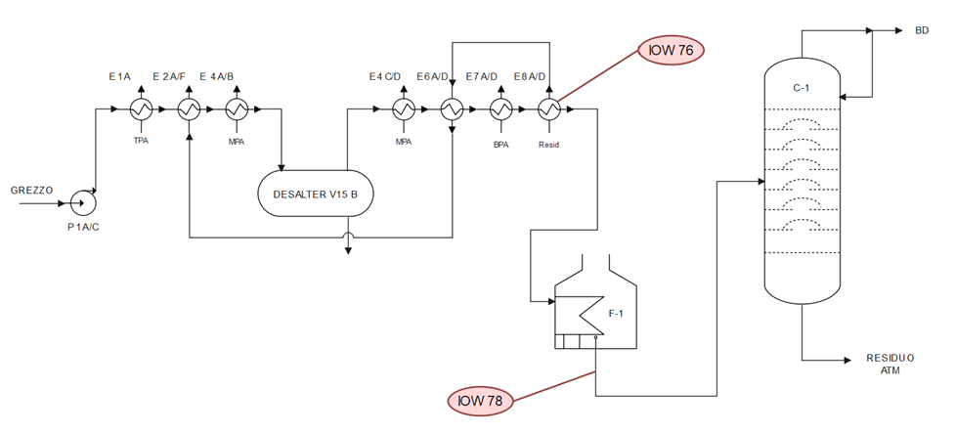

*Figure 1. Simplified P&I diagram of the first part of the examined distillation unit and the IOW locations*

Table 5. Characteristics and nominal conditions of the items.

|  |  |  |  |  |
| --- | --- | --- | --- | --- |
| Item | Damage Mechanism | Material | TN [°C] | SN [wt %] |
| E-8 | Sulfidation | Carbon Steel | 266 | 3.3 |
| F-1 | 5 Cr | 362 | 3.3 |

TN nominal temperature, SN nominal sulphur percentage.

* 1. Results and discussion

For the sake of brevity, only the results for the first equipment analysed are reported here. Figure 2 provides the feed data characterised by Sulphur and TAN of the crudes processed in the July-September 2023 quarter [Δt is 90 days]. Figure 3 illustrates the hourly detected temperatures and the upper threshold IOW concerned, whereas Figure 4 shows the bayesian network model applied to the case study concerning the carbon steel item.

|  |  |
| --- | --- |
|  |  |
| (a) | (b) |

*Figure 2. Sulphur (a) and TAN (b) trends of July-September 2023 quarter*

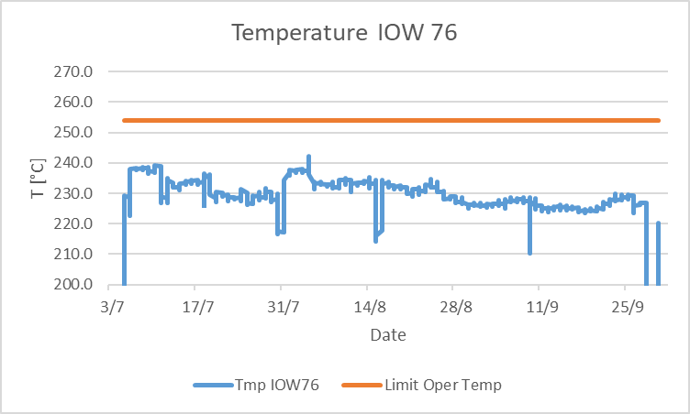

*Figure 3. Temperature trend of IOW 76 during the July-September 2023 quarter*

Figure 4. Bayesian network for the Carbon Steel crude preheating section.

The CR node has been trained according to the API 581, with respect for the sulfidation mechanism for carbon steel. Then the data from the crude oils processed in the quarter analysed has been loaded into the model. Considering that the initial condition of the examined equipment is normal (between 10 and 100% of the design life), the ΔRUL estimated for the period observed has been about 43 days, that means the remaining useful lifetime is equal to 3607 days on a 10-year basis. This first result highlights a significantly reduced lifetime consumption compared to that expected, i.e. 90 days. Furthermore, considering that the performed inspections have been in the range of 80 - 100 %, the Risk index obtained is 0.251. Assuming that the risk of the plant section in operating design conditions is 50%, it is reduced by 75% under current operating conditions: this means that, for a given scenario of damage, the change in operating conditions leads to a variation of the Risk Index. Such variation, according to Eq. (5), can affect the overall Risk value and it can be represented by means an iso-risk graph to show the corresponding position of the item in the Risk matrix of the plant (Figure 5).

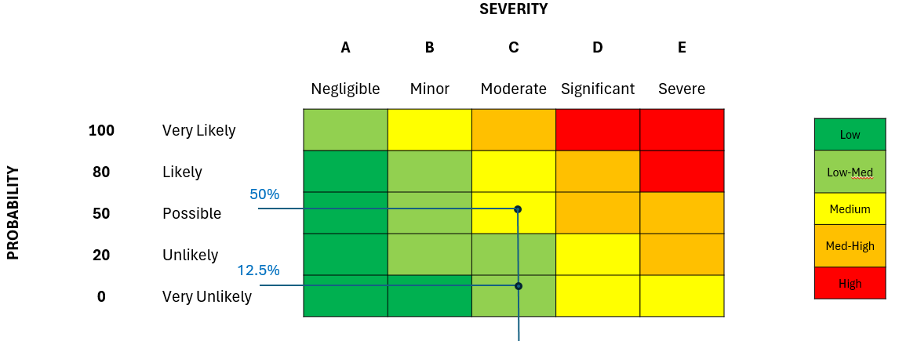

Figure 5. The impact in changing the operating conditions: the consumed life was reduced by 50% and the risk was reduced by 75%.

1. Conclusions

The proposed approach, using bayesian networks methodology, exploits data from sensors to understand the operating conditions and characteristics of processed crudes. While traditional RBI approaches allow for quantitative risk assessment as a function of measured thicknesses over a predefined time range, this approach exploits data obtained continuously: this facilitates the prediction of the damage mechanisms’ progression, the remaining useful life of the plant section and the associated risk. As a result, decisions on plant utilization can be made, strengthening mitigation techniques if excessive damage is detected or exploring more aggressive operating conditions if possible. In addition, it is planned to extend this methodology to other plant sections, including those with different damage mechanisms and metallurgies, with the goal of mapping the entire atmospheric distillation unit.

Acknowledgments

This work has been funded by the project DYN-RISK (BRIC/2019 ID = 02)

References

Al-Moubaraki A.H., Obot I.B., 2021, Corrosion challenges in petroleum refinery operations: Sources, mechanisms, mitigation, and future outlook, Journal of Saudi Chemical Society, 25, 10-14.

Ancione G., Bartolozzi V., Bragatto P., Milazzo M.F., 2023, Monitoring Equipment Corrosion due to Sour Crude Oils: a Bayesian Approach, Chemical Engineering Transactions, 99, 337-342.

API RP 581 (American Petroleum Institute), 2016, Risk-Based Inspection Methodology, 3rd ed. API Publishing Services, Washington (USA).

API RP 584 (American Petroleum Institute), 2014, Integrity Operating Windows, 1st ed. API Publishing Services, Washington (USA).

Torres-Toledano, J.G., 1998, “Bayesian Networks for Reliability Analysis of Complex Systems”, Progress in Artificial Intelligence [Conference], Lisbon, Portugal, 31th Agust-2nd September.

Pearl, J., 1988, Probabilistic Reasoning in Intelligent Systems: Network of Plausible Inference, 1st edition Morgan Kaufmann, Los Angeles (USA).

RAM S.C.p.A. (Raffineria di Milazzo), 2023, Manuale del Sistema di Gestione dell’Asset Integrity (Confidential).

Rebak R.B., 2011, Sulfidic corrosion in refineries – A review, Corrosion Reviews, vol. 29, p. 123-133.

US Department Office of Fossil Energy and Carbon management <https://www.energy.gov/fecm/enhanced-oil-recovery> accessed 24.02.2024.