 CHEMICAL ENGINEERING TRANSACTIONS  VOL. xxx, 2024 | A publication of  
The Italian Association
of Chemical Engineering
Online at www.cetjournal.it

Guest Editors: Valerio Cozzani, Bruno Fabiano, Genserik Reniers
Copyright © 2024, AIDIC Servizi S.r.l.
ISBN 979-12-81206-11-3; ISSN 2283-9216

Acoustic Emission Localization in Steel Pipes Through Entropy-Information Analysis
Denis Bogomolov*^{,a}, Camilla B. Laroccaª, Sina Zolfagharysaraviª, Lorenzo M. Peppiª, Evgeny Burda^{b}, Canio Mennuti^{c}, Giuseppe Augugliaro^{c}, Luca De Marchi^{d}, Alessandro Marzani^{e}
ªAdvanced Research Center on Electronic Systems (ARCES), University of Bologna, Viale Carlo Pepoli 3/2, 40123 Bologna BO, Italy
^{b}Omsk State Technical University, 644050, Omsk, Russian Federation
^{c}INAIL, Department of Technological Innovations and Safety of Plants, Products and Anthropic Settlements, Laboratory of innovative safety technologies, Monte Porzio Catone Research Center (RM), Italy
^{d}Department of Electrical, Electronic and Information Engineering (DEI), University of Bologna, Viale del Risorgimento 2, 40136, Bologna, Italy
^{e}Department of Civil, Chemical, Environmental and Materials Engineering (DICAM), University of Bologna, Viale del Risorgimento 2, 40136, Bologna, Italy
denis.bogomolov2@unibo.it

The present study aims to introduce an innovative entropy-based denoising technique to enhance the accuracy of TDoA (Time Difference of Arrival) in source localization techniques based on acoustic emissions (AE). The approach focuses on the challenging scenario of industrial pipelines in energy and transportation systems characterized by high level of noise. Conventional methods for estimating the TDoA of AE sources, are generally hindered by external interferences in near-industrial scenarios, leading to distorted AE signals. The proposed approach encompasses a comprehensive analysis of signal waveforms, integrating local entropy to effectively compensate for the presents of noise, and employing the Akaike Information Criterion (AIC) to estimate the TDoA. To evaluate the performance of the proposed method, a two-stage experimental campaign was conducted on a pressurized hydraulic circuit. The first stage involved verifying the statistical reliability of the proposed algorithm by employing the Hsu-Nielsen test (pencil lead break) at multiple points along a series of pipes. In the second stage, an ad-hoc system was devised to induce accelerated corrosion on the same piping while capturing raw acoustic emission waveforms. Various levels of Gaussian noise, reflecting distinct signal-to-noise ratios, were added to the recorded raw waveforms to simulate diverse industrial interference scenarios. The findings illustrate significant enhancement in the accuracy and repeatability of AE source localization. The proposed entropy-based denoising technique showcases substantial potential for advancing damage detection and localization within the Process & Power Industry.
  - Introduction
The Acoustic Emission (AE) method serves as a powerful tool for evaluating the structural integrity of industrial infrastructures. AE offers the distinct advantage of passively capturing the acoustic waves traveling through a structure, enabling the detection of active sources of degradation such as active corrosion. Meanwhile, corrosion is a significant ongoing issue in the chemical processing and petroleum industries, where it can cause substantial degradation of process equipment and systems if not properly managed. This deterioration compromises the equipment's integrity, rendering it susceptible to failures under regular operating conditions. Such failures frequently result in process safety incidents that could have serious human, environmental, and financial repercussions (Nicola et al., 2013).
AE monitoring is advancing with the deployment of permanently installed real-time systems, which face challenges like detecting faint signals amidst noisy environments at initial defect stages (Wirtz and Söffker, 2018). Accurate source localization further depends on precisely determining the time of arrival (ToA) at various transducers to calculate the time difference of arrival (TDoA) between signals, a method widely used in localization models (Jiang and Xu, 2012).
Despite technological advancements, noise remains a significant hurdle for detection of ToA in AE signals. Towards a solution to denoising of signals, various researchers such as, e.g. Karamzadeh et al., (2013) proposed wavelet transform-based approaches to obtain noise-cleaned time series at different scales to pick up the ToA. However, the computational complexity of the wavelet transforms, as well as the noise factor of AE signals described above, are pushing researchers to find alternative efficient ways to process AE signals especially when simple computational algorithms are needed in embedded systems for real-time monitoring scenarios.
Bogomolov et al., (2023) previously showcased an entropy-based noise reduction algorithm effective on an aluminium plate in a laboratory-controlled environment. The present work extends its application to a more complex case related to pipeline networks operating pressurized water and incorporating Gaussian noise in the signal processing phase. The novelty of this paper also lies in the threshold selection strategy that automatically distinguishes useful signal entropy from noise entropy, making the method more applicable.
  - Methodology and theoretical background
Numerous automatic Time of Arrival (ToA) estimation algorithms have been developed, with the Akaike Information Criterion (AIC) being particularly prevalent (Zhou et al., 2019). The latter it is used to assess both the performance of noise reduction techniques and the ToA estimation by applying it on AE signals pre- and post the application of the proposed filtering method. The accuracy of ToA estimations is compromised by both systematic and stochastic errors; systematic errors can be offset by Time Difference of Arrival (TDoA) computations, while stochastic errors introduce uncertainty in AE source localization, affecting damage localization reliability. Therefore, this study focuses on evaluating the precision of localization errors by analysing raw AE signals from two sensors positioned on a pressurized pipe. The experiments, which include pencil breaks and induced corrosion, mimic the progression of structural damage under controlled industrial conditions. This approach provides a robust framework for objectively assessing the effectiveness of the proposed algorithm in identifying and localizing damage within the infrastructure.

2.1 Information entropy theory
The proposed noise reduction algorithm utilizes the concept of local entropy h_{i}, a method that draws on Shannon's information entropy as demonstrated in the study by Martin et al., (2023). The h_{i} values can be interpreted as instantaneous and average entropy values of the sample. The mathematical formulation of h_{i} uses an empirical probability distribution derived directly from the samples of the signal under examination:
$$h_{i}= -\log_{2}{P_{ie}}$$ | (1)
where h_{i} is the local entropy expressed in bits of the i-th sample of the signal, and P_{ie} is the empirical probability of occurrence of the i-th sample in the series of samples that make up the signal. To obtain an estimate of the local entropy h_{i}, the signal samples must be represented through a histogram constructed on a suitable number of intervals of equal width. For efficient partitioning of the instantaneous signal values, it is proposed to use Crutchfield-Packard’s method which was discussed in detail in the authors' previous work (Bogomolov et al., 2023). For the sake of clarity, Figure 1b demonstrates the calculation of local (instantaneous) information entropy from the initial AE signal on which Gaussian noise is superimposed (see Figure 1a).

2.2 Formulation of the entropy-based denoising procedure
In Acoustic Emission signals, higher information entropy values are observed in less frequent i-th samples, indicating anomalies or process changes, while lower entropy values correlate with normal, predictable events (samples), such as periodic signals or similar noise components. To address this, the work proposes an entropy filtering method that removes signal components below a certain entropy threshold k, thereby filtering out low-value noise and periodic samples. This method involves calculating the signal samples' information entropy (h_{i}), applying a variable threshold k for filtering based on h_{i} values, and then assessing the average informativeness of filtered samples. The threshold k and the output of entropy filtering are demonstrated through the analysis of average informativeness h_{AV}, with the process and results depicted in Figure 1c and 1d, respectively, highlighting the method's ability to enhance signal clarity by excluding noise-relevant components. To obtain the curve shown in Figure 1c, filtering is applied using entropy and zeroing the remaining samples below the threshold value by iteratively applying the threshold k with a step of 0.1 bit (x-axis). On the y-axis, averaging the local entropies from the minimum to the maximum h_{i} values calculated by eq. 1, represents the average informativeness of the remaining samples after iterative filtering by k. In this manner a surge of informativity associated with AE in the form of a change in the curve is observed. This inflection point of the curve (stressing on y-axis, h_{AV} value) can be considered the threshold for discriminating between noise and AE signal. For a more holistic overview of the information-entropy analysis of the AE signals, readers are encouraged to refer to Bogomolov, D., et al., 2023.
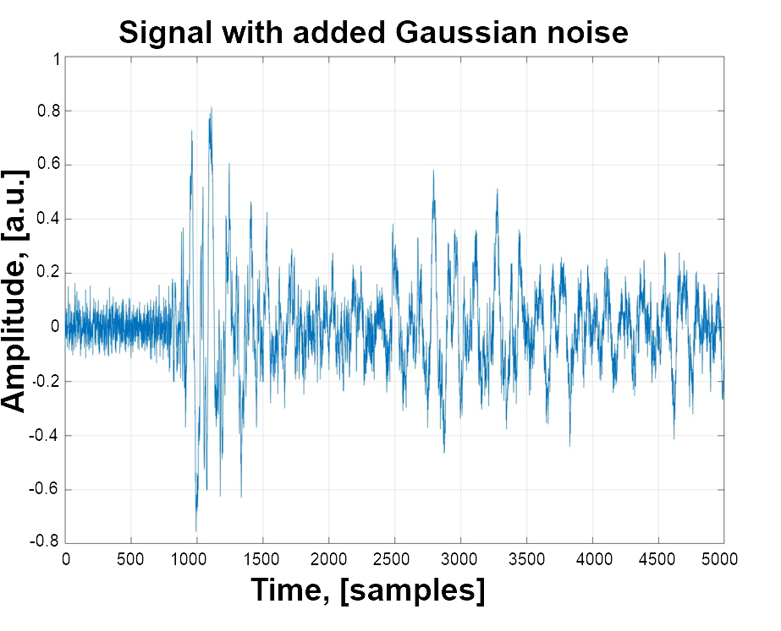 | 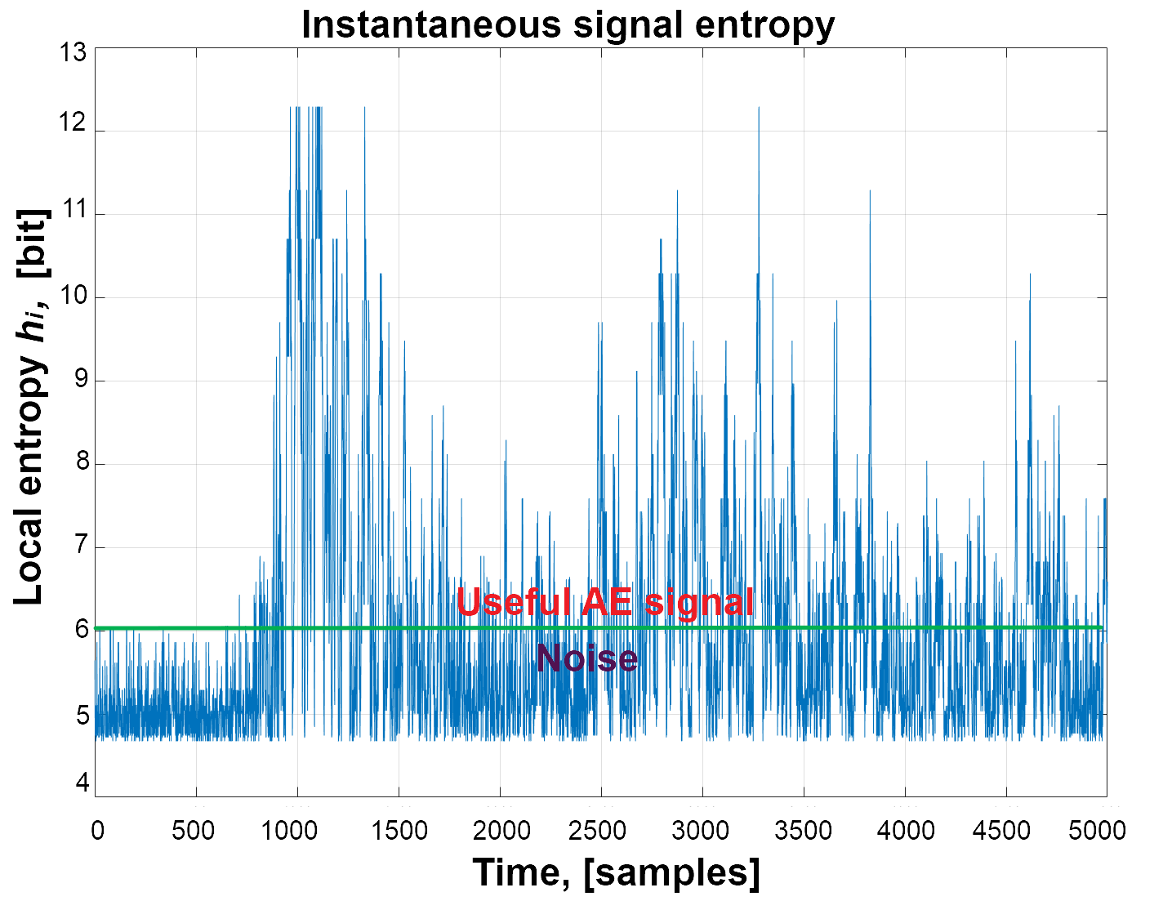
a) | b)
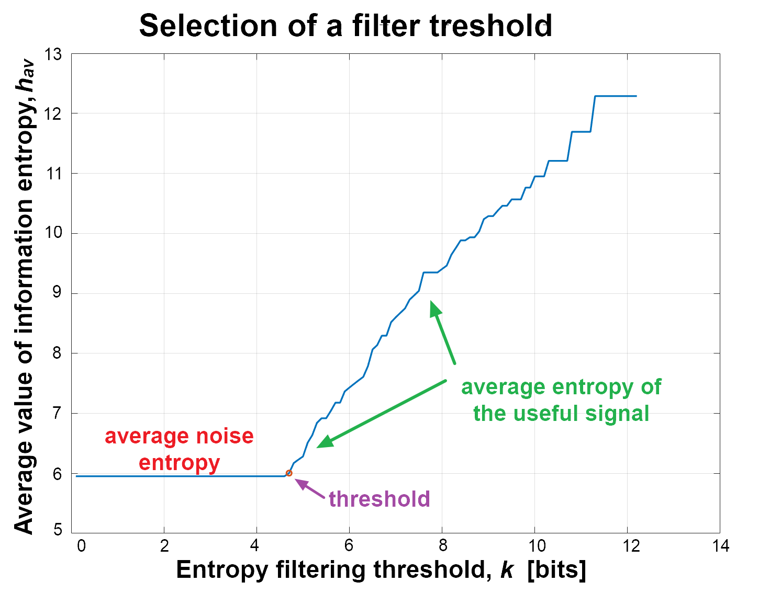 | 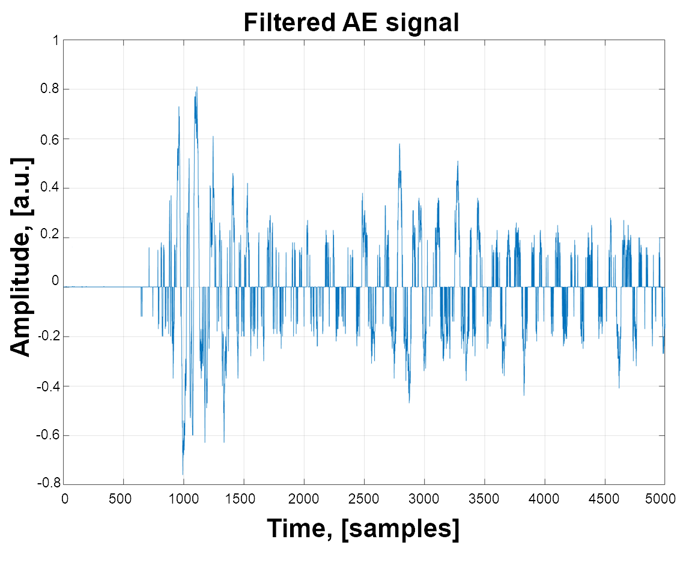
c) | d)
Figure 1: Entropy filtering procedure. a) Initial AE signal with simulated Gaussian noise (SNR=10dB); b) Calculation of the local entropy of a noisy signal; с) Graph of filtering threshold selection based on the average value of information entropy; d) Filtered AE signal
  - Experimental validation
To quantitatively verify the effectiveness of the proposed algorithm, based on the analysis of the entropy of AE signals, an ad-hoc experiment was designed on a hydraulic circuit located at the University of Bologna. The hydraulic circuit, shown in Figure 2a, is made up of a series of galvanized and painted carbon steel pipes and is capable of circulating water up to a pressure of 16 bar. The tests were carried out on a 1-meter-long pipe segment with an outer diameter of 112 mm and thickness of 5 mm. The specimen was equipped with two AE sensors (S1 and S2), namely G10 piezoelectric sensors provided by Qing Cheng AE Institute. For the data acquisition, a miniaturized AE acquisition system, capable of acquiring, pre-processing, and characterizing AE signals in real time and continuously from three piezoelectric sensors, thus lending itself to monitoring operations presented by Bogomolov, D., et al., (2021). The frequency response of the device offers stable behavior from 10 kHz to 600 kHz, with a maximum attenuation of 3 dB.
The test comprised of two stages: (1) performing Hsu-Nielson test, and (2) applying induced corrosion. During all the stages, the water pumping system shown in Figure 2 pressurized the circuit up to 5 bars. The raw AE signals were acquired by the AE system and then stored and processed on a laptop using MATLAB software. For each target, namely the points P1-P4 shown in Figure 2, the experiments were repeated ten times, with a constant window of 5000 samples, a pre-trigger of 1500 samples, and a sampling rate of 2 MHz. Both AE channels of the acquisition system were synchronized in time.

3.1 Hsu-Nielsen test
The first part of the experiment focuses on the localization of acoustic sources, typically associated with phenomena of corrosion or metal fracture. To activate the acoustic waves, a consolidated approach in the acoustic emission field was employed: the Hsu-Nielsen test, commonly known as the "pencil lead break". This procedure involves breaking a 0.5 mm diameter pencil lead, positioned about 3 mm from the tip and inclined at a 30° angle on the outer surface of the conduit. This operation generates an intense acoustic impulse, like a natural source of AE, which propagates along the pipeline as mechanical waves that the AE sensors can detect. During the experiment, a professional pencil provided by Vallen Systeme GmbH, compliant with ASTM E976 standard, was used. The positions of the targets P1-P4 (namely the positions of the Hsu-Nielsen sources) in relation to the position of the AE sensors placed on the pipe, as well as a photo of the Hsu-Nielsen test, are illustrated in Figure 2b.
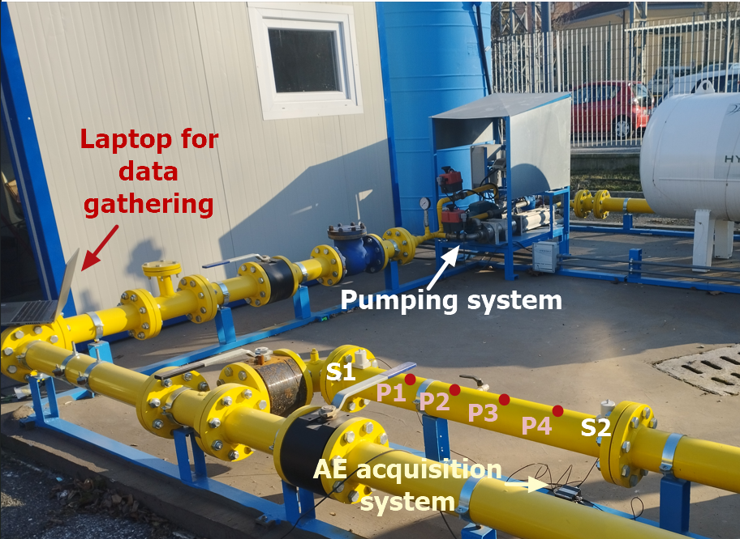 | 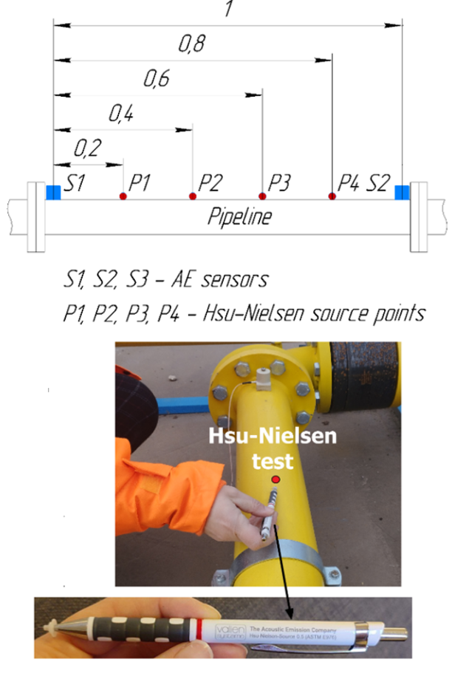
a) | b)
Figure 2: Experimental Setup 1: a) Layout of AE sensors S1-S2 and test targets P1-P4 for wave generation via the Hsu-Nielsen method; b) Schematic representation of target positions along the pipe (top) and photographic documentation of the Hsu-Nielsen test execution (bottom)

3.2 Corrosion test
To set up the corrosion experiment, the authors were inspired by the experiments conducted by Rao et al. (2017). The proposed setup relies on the principle of accelerated electrochemical galvanization corrosion. The reaction chamber, created on a 3D printer, is glued to the pipe using silicone adhesive at 70 cm from the position of sensor S1. The chamber's lower section is left open to facilitate contact between the pipe and the saline solution that flows through the chamber at a rate of 0.60 liters per minute, propelled by a micro diaphragm pump. The continuous flow of the solution (3,5% NaCl) has the main objective of preventing the settlement of corrosion product, iron oxide, which can further affect the rate of corrosion during the test. This aids in maintaining the corrosion rate and prevents further oxidation of iron oxide to iron hydroxide, which is insoluble. The chamber's upper section features a threaded hole that admits a bolt. To preserve the integrity of the pipeline, a bolt located 4 mm from the surface of the pipe metal was chosen as the target of corrosion, which acts as the anode. Therefore, AE waves propagate from the corroded bolt through the salt solution and reach the pipe metal surface (the cathode), which next propagate along its surface and are then detected by AE sensors. Figure 3a shows a photograph of the experimental setup, while Figure 3b illustrates a schematic of the corrosion process. Thus, after starting the corrosion process, fifteen acoustic emission raw signals with a pronounced onset of the signal were gathered.

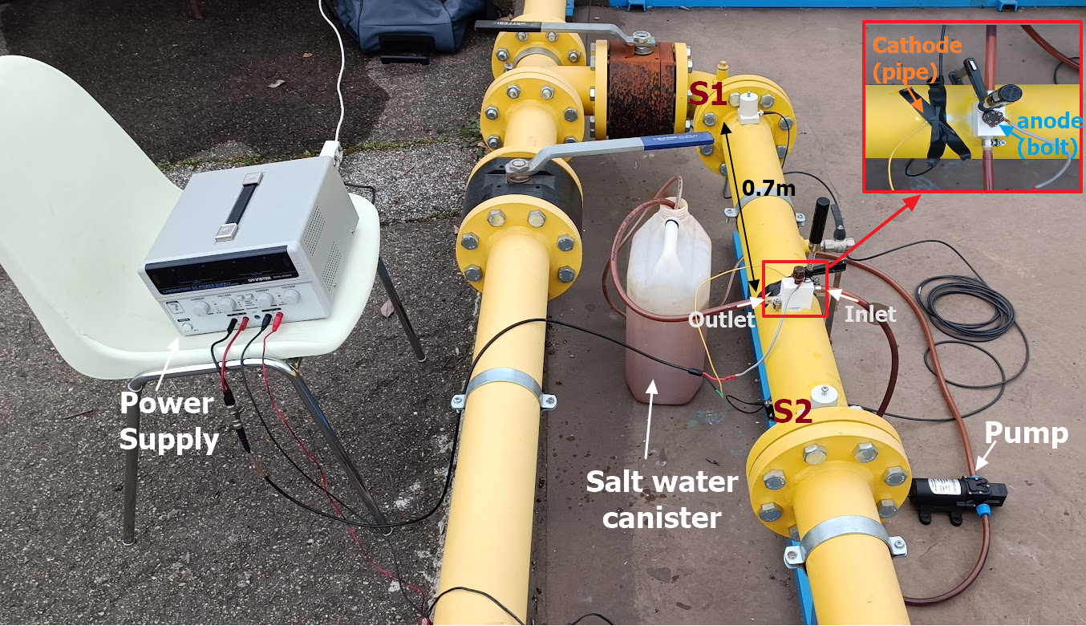 | 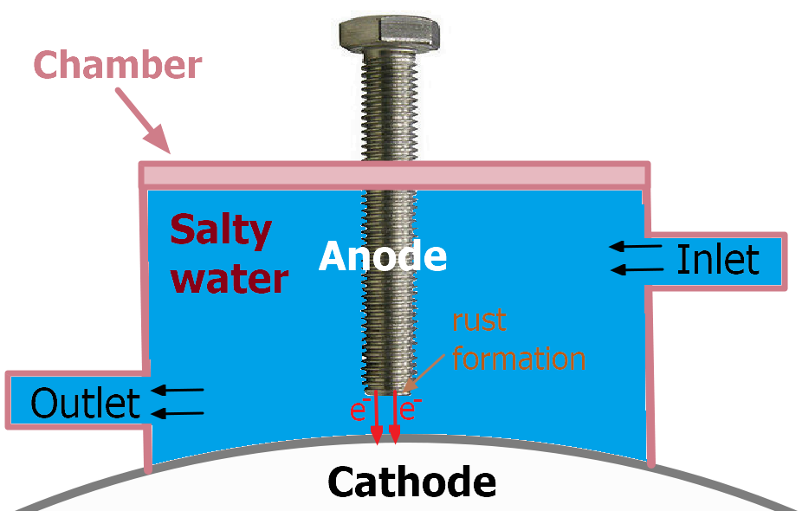
a) | b)
Figure 3: Experimental Setup 2. Overview of the experimental setup for induced corrosion test; b) Schematic of the corrosion process running in the chamber

3.3 Analysis
To assess the proposed filter's efficacy, ToA estimates were computed for signals pre- and post-filtering using the AIC. Then, TDoAs was determined to enable one-dimensional localization within the pipe's geometry, assuming straight-line acoustic signal propagation along the pipe axis, with radial effects disregarded. Axial localization relied on TDoA estimates at two sensors and the signal velocity V, following Hongyu et al. (2021). This approach simplifies the model by excluding the multimodal and dispersive aspects of guided wave propagation, focusing primarily on evaluating the denoising algorithm's effectiveness.
  - Results and discussions

4.1 Waves Velocity Analysis
The experimental setup in question along the pipe path features flanges and bends that affect the propagation of mechanical waves in terms of mode and velocity, complicating the estimation of the source position. Consequently, to assess the wave propagation velocity, empirical velocities were adopted. After collecting all the data with the two AE sensors deployed on the section of the pipe during Hsu-Nielsen test, the median average wave propagation velocity V̅ was estimated. Moreover, the average wave propagation velocity was estimated separately for the signals filtered with the proposed algorithm. As a result, according to formula 2, the wave propagation speed V_{i} was estimated for each measurement by formula 2.
$$V_{i}= \frac{L-2∙X_{P_{j}}}{∆t}$$ | (2)
where L is the distance between two sensors, X_{Pj} is the distance between the source and the nearest sensor, and ∆t is the difference in TDoAs between two sensors based on the AIC algorithm output.
In this way, calculated velocities (median function ([V]) in MATLAB) were 3000 m/s without filtering and 2010 m/s post-filtering. The variation is due to the AIC detecting faster guided wave modes (a mix of longitudinal, torsional, and flexural modes) without filtering, while filtering removes the weaker modes along with noise. This filtering results in more stable and repeatable outcomes, as the faster modes waveforms, which are more attenuated, doesn't consistently appear across all experiments.

4.2 Analysis of the efficiency of the entropic filtering method
Figure 4 shows an example of the operation of the proposed noise cancellation algorithm applied to a signal with a signal-to-noise ratio of 10 dB. Specifically, Figure 4a displays a signal from the Hsu-Nielsen test, with its onset detected by the AIC method, marked by a red star against the AIC curve in orange. In Figure 4b, synthetic noise is added to this signal, resulting in a noticeable shift in the signal's onset detected by AIC. Figure 4c then shows the signal's local entropy after filtering, revealing a weaker wave mode obscured by noise, and enabling accurate onset detection by AIC. Lastly, Figure 4d presents the signal after entropic noise removal, demonstrating effective ToA detection similar to initial waveform shown in Figure 4a.
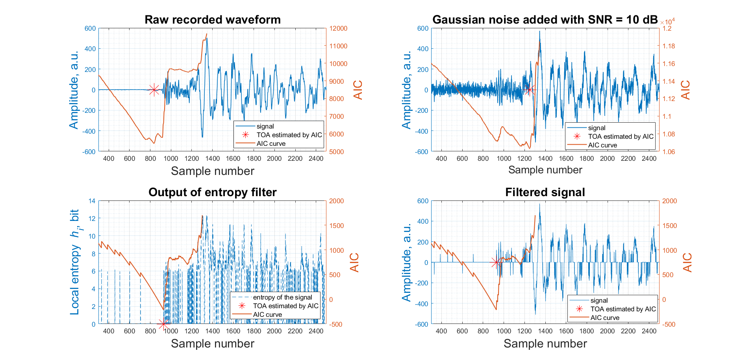
a) | b)
c) | d)
Figure 4: ToA estimations with AIC. a) Raw waveform; b) Added noise at SNR = 10 dB to the raw signal; c) Local entropy after filtering; d) Filtered signal

Table 1 summarizes the localization error for both experimental scenarios and the impact of the filtering algorithm by estimating 1) the average error in source localization and 2) the average error variance. Localization accuracy notably decreases during the induced corrosion experiment, particularly when the signal-to-noise ratio (SNR) is below 20 dB. However, this drop is largely due to the weak intensity of raw AE signals from corrosion compared to the much stronger Hsu-Nielsen signal, which was about a 23 dB higher signal amplitude. In summary, applying the filtering algorithm significantly reduces error by 2 to 4 times and improves result repeatability, with error variance decreasing by up to 7 times at higher noise levels.
Table 1: Summary of the localization results before and after filtering
Experiment name | Filtered?  (Yes/No) | Simulated Gaussian noise level by various SNRs, dB
 |  | No noise | 40 | 30 | 20 | 10 | 8 | 4 | 2 | 1
Mean average error, m
Hsu-Nielsen Test | N | 0.068 | 0.055 | 0.089 | 0.086 | 0.113 | 0.149 | 0.194 | 0.189 | 0.208
 | Y | 0.022 | 0.021 | 0.021 | 0.021 | 0.02 | 0.014 | 0.045 | 0.09 | 0.065
Corrosion Test | N | 0.283 | 0.283 | 0.285 | 0.433 | 0.58 | 0.617 | 0.795 | 0.831 | 1.073
 | Y | 0.132 | 0.132 | 0.104 | 0.121 | 0.361 | 0.372 | 0.402 | 0.393 | 0.426
Average variance of localization error, m
Hsu-Nielsen Test | N | 0.03 | 0 | 0.003 | 0.003 | 0.007 | 0.013 | 0.035 | 0.042 | 0.045
 | Y | 0.001 | 0.001 | 0.001 | 0 | 0 | 0 | 0.004 | 0.012 | 0.006
Corrosion Test | N | 0.028 | 0.028 | 0.028 | 0.115 | 0.094 | 0.103 | 0.211 | 0.178 | 0.379
 | Y | 0.011 | 0.011 | 0.012 | 0.013 | 0.033 | 0.054 | 0.057 | 0.055 | 0.064
  - Conclusions

The need to find simple mathematical solutions aimed at filtering signals with low SNR values is an urgent task in AE monitoring applications. This work presents a noise reduction algorithm for monitoring AE events under conditions like Process & Power industrial scenario. The results obtained from the application of the proposed algorithm demonstrated a significant increase in accuracy in determining the location of the AE source with increments ranging from 2 to 4 times, especially under critical noise conditions. Moreover, the use of the proposed filtering approach contributed to increasing the statistical stability localization through multiple repetitions, as confirmed by the low variance of the average error. The proposed approach is computationally efficient and algorithmically straightforward, optimized for real-time monitoring applications. The positive experimental outcomes, underscore its utility in improving AE signal processing in industrial environments. Moving forward, the research will focus on the practical application and rigorous testing of the developed denoising algorithm embedded into a compact continuous monitoring system (presented in Bogomolov et al., 2021), specifically in challenging heavy industrial noise environments.

Acknowledgments

The presented work has been partially supported by the project “DS2: Digital Smart Structures”, funded by INAIL (National Institute for Insurance against Accidents at Work), BRIC 2021.

References

Bogomolov, D., Burda, E., Testoni, N., Kudryavtseva, I., De Marchi, L., Naumenko, A., Marzani, A. Entropy-Based Technique for Denoising of Acoustic Emission Signals. In Proceedings of the European Workshop on Structural Health Monitoring, Eds. Springer International Publishing, 2023, pp. 630–639.
Bogomolov, D., Testoni, N., Zonzini, F., Malatesta, M.M., De Marchi, L., Marzani, A. Acoustic emission structural monitoring through low-cost sensor nodes. In Proceedings of the International Conference on Structural Health Monitoring of Intelligent Infrastructure, SHMII, 2021, pp. 383-388.
Hongyu, L., Lei, G., Lu, Z., Yajun, S. The Acoustic Emission Source Localization in the Pipeline Network with consideration of Radial Position of Defect. In Proceedings of the Journal of Physics, ATAMI 2021, 19-21 November 2021, Wuhan, China, 2021, pp. 1904–1912.
Jiang, Y., Xu, F., Research on source location from acoustic emission tomography. In Proceedings of the 30th European Conference on Acoustic Emission Testing & 7th International Conference on Acoustic Emission, Granada, Spain, 2012.
Karamzadeh, N., Javan Doloei, G., Reza, A.M. Automatic Earthquake Signal Onset Picking Based on the Continuous Wavelet Transform. IEEE Transactions on Geoscience and Remote Sensing 2013, 51, 2666–2674.
Martin, N., England, J., Baker, G. Mathematical Theory of Entropy. Encyclopedia of Mathematics and Its Applications, Vol. 12, 2013.
Nicola S., Leon S., Nayak S., Mentzer R., Mannan M., 2013, Revisiting Age Old Corrosion Problem with Modern Tools and Techniques, Chemical Engineering Transactions, 31, 673-678.
Rao, J.; Ratassepp, M.; Lisevych, D.; Hamzah Caffoor, M.; Fan, Z. On-Line Corrosion Monitoring of Plate Structures Based on Guided Wave Tomography Using Piezoelectric Sensors. Sensors 2017, 17, 2882. https://doi.org/10.3390/s17122882.
Wirtz, S.F., Söffker, D., Improved signal processing of acoustic emission for structural health monitoring using a data-driven approach. In proceedings of the 9th European Workshop on Structural Health Monitoring, Manchester, UK, 2018.6.
Zhou, Z., Cheng, R., Rui, Y., Zhou, J., Wang, H. An Improved Automatic Picking Method for Arrival Time of Acoustic Emission Signals. IEEE Access 2019, 7, 75568–75576.

