|  |  |
| --- | --- |
| cetlogo ***CHEMICAL ENGINEERING TRANSACTIONS***  ***VOL. xxx, 2024*** | A publication of  aidiclogo_grande |
| The Italian Association  of Chemical Engineering  Online at www.cetjournal.it |
| Guest Editors: Valerio Cozzani, Bruno Fabiano, Genserik Reniers  Copyright © 2024, AIDIC Servizi S.r.l. **ISBN** 979-12-81206-11-3; **ISSN** 2283-9216 | |

Occupational safety in the management of PET plastic waste generated by the Lot 57 camp in Camisea and analysis of economic losses due to poor segregation

Grese Hanampaa, Christiaan E. Morenob, Zanhy L. Valencia-Reyesb,\*, Fiorella V. Güereb, Alex S. Armas-Blancasb, Alejandro Menab, Hellen F. Blancasc, Giner E. Díazd, Sixto S. Mendozae, Guillermo L. Vilcheza

aUniversidad Nacional Tecnológica de Lima Sur, Sector 3 Grupo 1A 03, Av. Central, Villa EL Salvador, Lima 15834, Perú

bUniversidad Nacional Mayor de San Marcos, Ciudad Universitaria, Lima 15081, Perú

cUniversidad Nacional de Educación Enrique Guzmán y Valle, Lurigancho-Chosica 15472, Perú  dUniversidad Pontifica de Cataluña, España eUniversidad César Vallejo, Av. Alfredo Mendiola 6232, Los Olivos 15314, Perú

\*zvalenciar@unmsm.edu.pe

Solid waste management is a problem in large cities around the world. Factors such as population growth, urban population concentration, poor industrial and commercial development, changes in consumption patterns, and improvements in living standards have led to an increase in solid waste generation in cities. The various stages of solid waste management are: generation, storage, collection, transportation, handling, treatment and final disposal. As far as Latin America and the Caribbean are concerned, waste management generally uses "collection and final disposal" schemes that neglect the utilization, recycling and treatment of waste, as well as hygienic and environmentally sound final disposal (Sáenz & Urdaneta, 2020). Mining and hydrocarbon activities are very important to the growth of the country's economy. Peru is the world's third largest copper producer and sixth largest gold producer. The national economy is dominated by mining, hydrocarbon and manufacturing activities; the territory given to international companies has tripled for the development of the country. More than 70% of the Peruvian Amazon is covered by oil and gas deposits available for exploration and extraction. These areas of the Amazon overlap with indigenous communities, nature reserves and areas reserved for remote peoples. A third of the electricity consumed by Peru comes from the natural gas extracted from Camisea (del Castillo, 2015). Waste constitutes an important risk factor for the personnel involved in its handling, and at the same time contributes to the deterioration of the environment. The majority of the workers who work in camp lot 57 come from native communities or areas near this place, they do not have a culture and environmental awareness, due to their little knowledge, so they do not believe in caring for the environment. Most people think that the benefits that nature offers us will never end, which is why at the time of receiving the training talks, not everyone paid attention to the supervisors, needing constant feedback on solid waste management, in order to be able to do so. Comply with the established waste management and final disposal procedure, requiring constant supervision, to avoid poor segregation. Due to the lack of environmental culture of the workers, they combine the waste and this is where the poor segregation occurred, leaving the marketable waste characteristics that the buyer does not require for reuse, which is why marketing is affected and it is transported with another destination that would be a landfill for final disposal. The purpose of this study was to carry out an analysis of the existing legislation in the country to guarantee the protection and safety of workers during waste management, and it could be seen that it is still insufficient and that it expresses the obligations in a very general way. For the protection and safety of workers, as well as analysing the economic losses due to the poor segregation of waste generated in camp lot 57 by compiling the daily forms of waste temporarily stored in the camp. The general objective of the article is to evaluate occupational safety in the management of PET plastic waste generated by the Lot 57 camp in Camisea, identifying current practices and proposing improvements, as well as analysing the economic losses derived from the poor segregation of this waste, in order to optimize waste management and reduce associated costs.

* 1. Introduction

As the population grows, the amount of plastic waste generated is increasing at an alarming rate. More than 1.3 billion tons of plastic are produced every year to meet the needs of today's world (Jatan et al., 2020). It is estimated that global waste will increase by 70% by 2050. Solid waste management remains a challenge, especially in underdeveloped areas (Le Dinh et al., 2023). Plastic is a cheap, light, versatile and durable material that fulfils a variety of functions in various industries. However, the viability of plastics has made them a major source of waste, improper waste disposal further increases the negative impact on the environment (Tee & Sy, 2023). The use of PET began to develop in the 2010s, in addition to being more economical than HDPE, the use of PET reduces the weight of the container by 25%, it also reduces water consumption by 20% and consumption of energy from the manufacturing process by 13% (León et al., 2022). In the world, in almost all the activities we carry out daily, we generate waste that may or may not be reusable. It is almost inevitable to generate waste, therefore, it is very important to take responsibility for this pollution of the environment, which can cause damage to our health. Create regulations to protect the safety and health of workers. One of the most important regulations is the Working Environment Act. Although the management of waste for recycling purposes can have a negative impact on the environment, this impact is very small compared to the impact associated with unregulated solid waste generation and management. Recycling of materials consumes relatively little energy and helps save natural resources. Research has successfully shown that effectively implementing recycling programs in any region reduces the amount of waste generated, ultimately reducing disposal and processing costs. In developing and developed countries, plastic recycling can provide various economic benefits (Hashmi et al., 2023). This situation has generated some degree of regulatory attention through the General Directorate of Environmental Health, whose General Law No. 27314 on Solid Waste and its Regulations, through Legislative Decree No. 1278, approves the Law on Comprehensive Solid Waste Management Supreme Decree No. 014-2017-MINAM that establishes the institutional framework for the management and handling of solid waste (Jiménez-De-aliaga et al., 2020).

The purpose of health and safety management is to identify, assess and reduce health and safety risks in working conditions involving materials, parts, machinery and equipment. Activities and activities related to waste collection and disposal have inherent risks due to the hazards of substances and materials that can have a negative impact on the environment and work environment. In addition, when dealing with waste, special attention should be paid not only to routine procedures, but mainly to possible dangerous situations that may arise in special or emergency situations (Mazzi, 2023). Peru's Camisea gas field contains almost 90% of the country's natural gas reserves. In the 1990s, the government introduced a policy aimed at harnessing Kamisi gas for domestic consumption. This policy was lifted in the 2000s, allowing private developers to export 40% of Camisea's proven reserves, equivalent to a third of Peru's total reserves (Leung & Jenkins, 2014). Taking into account the consequences of pollution, the Lot 57 camp in Camisea, Cusco, Peru has implemented containers of different colours in specific places and at the same time with the commitment of the companies that provide services, there is also a warehouse of waste which is in charge of Megapack Trading S.A.C., where both hazardous and non-hazardous waste is received, this waste is generated in the camp, exploration sites and plants, for this same commitment to improve the quality and preservation of the environment, the companies they are aware of carrying their waste in the colour of the corresponding container and properly labelled to make disposal or marketing easier. But due to new companies that have won tenders and their change of personnel, we have begun to see the harmful segregation and lack of labeling of the waste that enters the warehouse, which has consequences, such as the increase in waste that goes to landfill of dangerous and non-hazardous, and the marketing of waste that can be reused such as cardboard, paper, plastic bottles, these come combined or stained with various waste which are no longer suitable for our customers who buy these, due to this problem arises the economic analysis of how much is being lost by taking the waste to a landfill and how much could be saved by carrying out good segregation and recovering a percentage of what was spent, being an opportunity cost for the company.

* 1. Proposed model
     1. Occupational safety

Create regulations to protect the safety and health of workers. One of the most important regulations is the Working Environment Act. In August 2011, the Working Environment Law No. 29783. The law establishes several requirements, the purpose of which is to create a culture of prevention of occupational risks in the country. All companies operating in Peru must comply with this law (Cruz & Huerta-Mercado, 2015).

* + 1. Estimation of solid waste generation

The solid waste from the Nuevo Mundo Lot 57 operational base camp is generated by the different locations (Kinteroni Asset, U400 Compression Project, Mashira Gx, Sagari Ax, Sagari Bx) including the camp itself. Waste is classified, according to the handling it receives, into hazardous and non-hazardous, which must be segregated in its respective coloured bag and labelled. The different companies that generate their waste deliver them to the temporary Megapack warehouse where a staff receives them, which proceeds with the weighing and recording in a daily form, this form has one original and two carbonless copies, one carbonless copy is delivered to the person who leaves the waste and another remains archived in the Megapack warehouse, and finally the original is delivered to the Repsol supervisor.

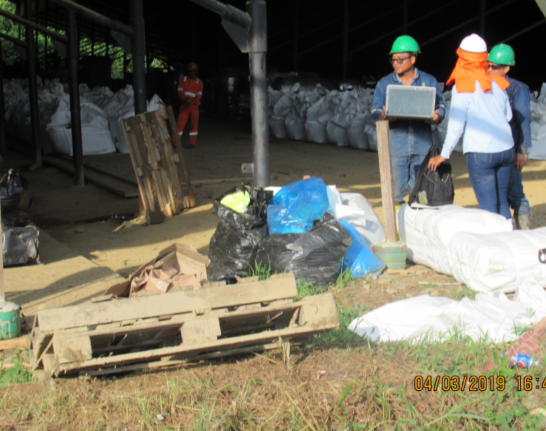

Figure 1: Weighing of waste by solid waste warehouse staff

* + 1. Estimation of solid waste sold

In this analysis, we will focus clearly on marketable solid waste such as paper and cardboard, PET plastic and metals, which have an established price in the market, as shown in Table 1.

Table 1: Costs of materials established in the market per Kg

|  |  |
| --- | --- |
| Material | Cost in the market (S/) |
| paper and paperboard | 0.40 |
| metal (scrap) | 0.40 |
| plastic PETs | 0.60 |

* + 1. Estimation of solid waste taken to final disposal

The different waste from the new world operational base camp, lot 57, whether hazardous or non-hazardous, that arrives at the temporary waste warehouse when its transfer begins, is taken from the warehouse to Bahía 3 (it belongs to the new world operational base) and is then transferred to a boat by river which takes approximately 7 to 10 days to reach Pucallpa to the temporary Megapack waste warehouse that is established there so that it can later be transported by land in trucks which lasts 2 to 3 more days until it arrives. As a final point to a filling. All this transfer generates expenses in transportation and security filling, which are shown in table 2.

Table 2: Transportation costs and final disposal of hazardous and non-hazardous solid waste

|  |  |  |
| --- | --- | --- |
|  | No dangerous (Petramas)  costs (S/) | Dangerous (Taris)  costs (S/) |
| Land transportation cost via Pucallpa - final disposal per ton | 498.00 | 498.00 |
| Waste disposal cost per ton | 35.00 | 350.00 |

* + 1. Estimation of economic loss

The economic loss has become more noticeable, because the existing buyers no longer accepted the marketable waste. In 2017 and in mid-2018, this inconvenience was not much noticed, which is why this reduction began to occur. Of waste has been put into the evaluation, which identified that the waste that is marketed especially with PET plastic was being segregated inadequate, since it arrived after 20 days, it arrived with an unpleasant odour and that in turn was stained with different liquids. Which is why it began to hurt their sales.

* 1. Results
     1. Occupational safety

The prevention of occupational risks must be understood as a permanent activity that must be integrated into all of the company's actions and at all its hierarchical levels. Employers shall develop and implement occupational health and safety plans in accordance with applicable regulations to include the necessary technical measures to control risks where they occur, assess imminent risks, minimize risks by using safe work methods, processes and equipment and adopt collective protection. Prioritize measures for personal protection, incorporate preventive and/or protective measures based on the best principles recommended by available technical means, provide equipment and personal protective equipment according to the risks, provide the necessary human, material and financial resources to ensure full compliance with health and safety plans. Figure 2 shows the training status of all Nuevo Mundo Base Camp personnel.

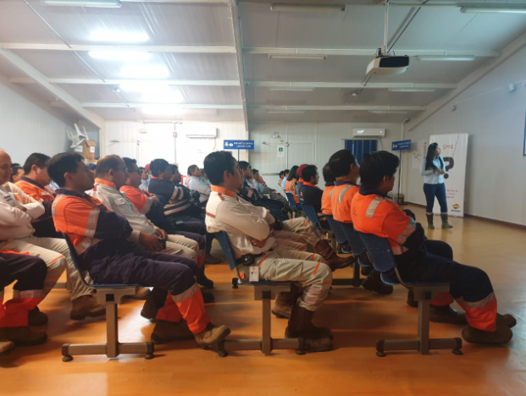

*Figure 2: Training for personnel at the Nuevo Mundo operational base camp*

* 1. Estimation of economic losses in PET plastic

Polyethylene terephthalate (PET) is a recyclable material that is increasing, causing adverse environmental effects due to the current ways of disposing of PET products, once they are used by the end consumer (Valderrama et al., 2017). A large amount of PET consumed becomes waste and requires a large area for storage. Many of these tons of material cannot be completely recycled (Saucedo et al., 2021).

Table 3: Expenses made in moving PET plastic to final disposal 2017, 2018 and 2019

|  |  |  |  |  |
| --- | --- | --- | --- | --- |
|  | Amount in ton | Transport | Final disposition | Total cost (S/) |
| Plastic PET 2017 | 36.960 (62 %) | 18,406.08 | 1,293.60 | 19,699.680 (62 %) |
| Plastic PET 2018 | 17.542 (30 %) | 8,735.916 | 613.97 | 9,349.886 (30 %) |
| Plastic PET 2019 | 4.780 (08 %) | 2,380.44 | 167.30 | 2,547.740 (8 % ) |
| Total | 59.28 (100 %) |  |  | 31,597.30 (100 %) |

Table 4: Opportunity cost of PET plastic in marketing and transportation during 2017, 2018 and 2019

|  |  |  |  |  |  |
| --- | --- | --- | --- | --- | --- |
|  | Amount in ton | Cost per Kg | Marketing cost | Transport cost | Opportunity cost (S/) |
| Plastic PET 2017 | 36.960 | 0.6 | 22,176 | 18,406.08 | 40,582.08 (62 %) |
| Plastic PET 2018 | 17.542 | 0.6 | 10,525.2 | 8,735.916 | 19,261.116 (30 %) |
| Plastic PET 2019 | 4.780 | 0.6 | 2,868 | 2,380.44 | 5,248.440 (8 %) |
| Total |  |  | 35,569.2 | 29,522.436 | 65,091.636(100 %) |

Table 5: Summary of expenses and opportunity costs during 2017, 2018 and 2019

|  |  |  |
| --- | --- | --- |
|  | Transportation and final disposal expenses | Opportunity cost |
| Plastic PET 2017 | 19,699.68 (62%) | 40,582.08 (62%) |
| Plastic PET 2018 | 9,349.89 (30%) | 19,261.12 (30%) |
| Plastic PET 2019 | 2,547.74 (8%) | 5,248.44 (8%) |
| Total | 31,597.30 (100 %) | 65,091.636 (100%) |



*Figure 3: Comparison of Expenses and Opportunity Cost of PET plastic during 2017, 2018 and 2019 (in Peruvian Soles S/)*

In 2017, 2018 and 2019, expenses were incurred to transport the residual PET plastic to the landfill. This was a total of 59.28 tons that could not be marketed. These expenses included transportation from Pucallpa to Lima and the cost of the landfill. Sanitary where it amounts to a total of S/31, 597.3, this amount can be seen in Table 3, if this same amount in tons had been marketed in Pucallpa during those 3 years, an amount would have been recovered and there would even be a profit, which would be called opportunity cost identified in table 4, in which it can be seen that the PET plastic marketed with good segregation could have cost a total of S/65, 091.64. Table 5 shows a summary of expenses and opportunity costs during 2017, 2018 and 2019; In a differentiated manner, it is observed for all the values of the opportunity cost to be greater than the final disposal expenses. Likewise, Figure 3 shows the notable differences graphically with the best value for the opportunity cost.

* 1. Conclusions

The prevention of occupational risks must be understood as a permanent activity that must be integrated into all of the company's actions and at all its hierarchical levels. The economic losses in the commercialization of solid PET plastic waste from the new world operational base camp lot 57 from 2017, 2018 and until March 2019 were S/40, 582.08, S/19, 261.12 and S/5, 248.44 respectively. The total amount of non-hazardous recyclable waste generated by the new world operational base camp lot 57 during 2017, 2018 and until March 2019 of PET plastic waste 60 tons. The total amount of non-hazardous waste that was disposed of during 2017, 2018 until March 2019 of PET plastic was 59.3 tons. The amount of waste that was not marketed and was put into the final disposal during 2017 to 2019, generated by the Nuevo Mundo Lot 57 operational base camp, was 59.3 tons of PET plastic waste. In conclusion, the proper management of PET plastic waste in the Lot 57 camp in Camisea is crucial for both occupational safety and economic efficiency. The evaluation of current practices also revealed the reduction of substantial economic losses associated with poor management. Implementing training programs for staff is a fundamental step to achieve more effective and safe management of PET plastic waste. These changes would not only benefit the work environment, but would also contribute to the environmental sustainability and operational efficiency of the camp.

References

Cruz, I., Huerta-Mercado, R., 2015, Occupational Safety and Health in Peru. *Annals of Global Health*, *81*(4), 568-575. https://doi.org/10.1016/j.aogh.2015.08.027

del Castillo, C., 2015, Camisea, compensaciones y diversificación de actividades de subsistencia en la comunidad nativa de Cashiriari (Cusco-Perú). *Debates en Sociología*, *41*, 53-82. https://revistas.pucp.edu.pe/index.php/debatesensociologia/article/download/14625/pdf/

Hashmi, S. I., Hewage, H. T. S. A., Visvanathan, C., 2023, Cleaner production auditing for plastic recycling industry in Pakistan: A baseline study. *Chemosphere*, *337*(March), 139338. https://doi.org/10.1016/j.chemosphere.2023.139338

Jatan, R., Solank, S., Saharna, S., Bhardwaj, J., Ramvijay., 2020, Pyrolysis of Waste Plastic into Fuel. *International Journal of Recent Technology and Engineering*, *9*(1), 2600-2604. https://doi.org/10.35940/ijrte.A2662.059120

Jiménez-De-aliaga, K. M., Meneses-La-riva, M. E., Gutiérrez-Orellana, B. E., Rey-Córdova, N. G., Suyo Vega, J. A., Baldárrago-Baldárrago, J. L. A., Robladillo-Bravo, L. M., Jiménez-Sánchez, L. I., 2020, A cross-sectional study on the environmental culture and occupational health of informal waste pickers in Lima, Peru. *Medwave*, *20*(6), 1-8. https://doi.org/10.5867/medwave.2020.06.7952

Le Dinh, C., Fujiwara, T., & Phu, S. T. P., 2023, An Analysis of Biodegradable Solid Waste Flow in Vietnam. *Chemical Engineering Transactions*, *106*(May), 619-624. https://doi.org/10.3303/CET23106104

León, N., Santana, O., Klotz, M., Ganesan, K., Carrasco, F., Dagréou, S., Maspoch, M., Valderrama, C., 2022, Implications of the Circular Economy in the Context of Plastic Recycling: The Case Study of Opaque PET. *polymers*, *14*(21), 1-16. https://doi.org/10.3390/polym14214639

Leung, L., Jenkins, G. P., 2014, An economic evaluation of Peru’s liquefied natural gas export policy. *Energy Policy*, *74*(C), 643-654. https://doi.org/10.1016/j.enpol.2014.06.028

Mazzi, A., 2023, Environmental and safety risk assessment for sustainable circular production: Case study in plastic processing for fashion products. *Heliyon*, *9*(11), e21352. https://doi.org/10.1016/j.heliyon.2023.e21352

Sáenz, A., & Urdaneta, J., 2020, Manejo de residuos sólidos en América Latina y el Caribe. *Omnia*, *3*, 121-135. https://www.redalyc.org/pdf/737/73737091009.pdf

Saucedo, J., Atoche, J., Muñoz, S., 2021. Uso de los agregados PET en la elaboración del concreto: Revisión de la literatura. *Avances Investigación en Ingeniería*, *18*(2). https://doi.org/10.18041/1794-4953/avances.2.6942

Tee, M., Sy, C., 2023. A Simulation Model to Analyze the Efficacy of Plastic Waste Management Policies. *Chemical Engineering Transactions*, *103*(February), 1-6. https://doi.org/10.3303/CET23103001

Valderrama, M., Chavarro, L., Osorio, J., Peña, C., 2017, Estudio dinámico del reciclaje de envases pet en el Valle del Cauca. *LASALLISTA de investigación*, *15*(1), 67-74. https://doi.org/10.22507/rli.v15n1a6