|  |  |
| --- | --- |
| cetlogo ***CHEMICAL ENGINEERING TRANSACTIONS***  ***VOL. xxx, 2024*** | A publication of  aidiclogo_grande |
| The Italian Association  of Chemical Engineering  Online at www.cetjournal.it |
| Guest Editors: Valerio Cozzani, Bruno Fabiano, Genserik Reniers  Copyright © 2024, AIDIC Servizi S.r.l. **ISBN** 979-12-81206-11-3; **ISSN** 2283-9216 | |

Industrial Pressures and Assessment of Biochemical River Quality: a Short-cut Methodology

Valentina Di Taliaa\*, Paola Di Flurib, Domeneghetti Alessiob, Antonioni Giacomoa

Dipartimento di Ingegneria Civile, Chimica, Ambientale e dei Materiali - Alma Mater Studiorum - Università di Bologna

aSede di via Terracini 28, 40131, Bologna (Italy)

bSede di Viale del Risorgimento 2, 40136, Bologna (Italy)

\*valentina.ditalia2@unibo.it

In Europe, a comprehensive assessment of surface water bodies is hindered by a widespread deficiency in quality monitoring data, both spatially and temporally, which impedes sustainable water management. In light of this challenge, this paper proposes a multidisciplinary short-cut methodology to estimate the biochemical quality of rivers determined by primary anthropogenic pollution sources acting as the most significant pressure on surface water.

The proposed methodology comprises three main steps:

1. Identifying primary anthropogenic pollution sources and assessing their relative expected pressures on river water,
2. Spatially allocating identified sources along the river using a raster-based approach, and
3. Assessing the overall biochemical state of surface water.

The industrial activities considered significant for river quality deterioration include establishments under the Seveso Directive, activities subject to the IPPC-IED discipline, and wastewater treatment plants. Contaminated sites are also considered, representing former industrial activities that continue to indirectly impact water bodies. To address the scarcity of monitoring data, the methodology relies on accessible official documentation for the assessment.

The methodology was applied to a river basin exposed to various industrial pressures in the North of Italy. The obtained results have been compared with available water quality records to check the methodology's ability to reproduce the trend of measured data along the main river stem. The results of this preliminary investigation suggest that the developed approach has the potential to be a valuable tool for assessing biochemical river quality in regions with limited monitoring data.

* 1. Introduction

Surface water quality deterioration resulting from anthropic activities is a global concern (Vigiak et al., 2023) that requires to be addressed with robust and sustainable management strategies based on the knowledge of the actual water quality of rivers. However, in Europe, the assessment of the ecological status of waterbodies is often hampered by poor monitoring systems in terms of spatial and temporal coverage (Malaj et al., 2014), also posing a challenge to establishing correlations between water quality and the most significant anthropic pressures exerted upon a watercourse (Grizzetti et al., 2017). Among the heterogeneous pressures that can affect the ecological status of surface waters, industrial effluents stand out due to the wide variety of pollutants they introduce in the aquatic environment during normal operations (Adewumi et al., 2011).

The assessment of surface water ecological status typically relies on index-based methods mainly dependent on monitoring data (e.g., Uddin et al., 2021; Mirauda et al., 2021), posing limitations in the case of unmonitored or poorly monitored watercourses. Some recent studies have attempted to overcome this constraint by defining approaches focused on characterizing the pollution sources affecting surface waters (e.g., Arrighi et al., 2010; Ouyang et al., 2015). However, these approaches do not allow for the identification of the most impacted sections of a river.

In this context, an innovative short-cut methodology is proposed to assess the biochemical quality of surface waters at a basin or sub-basin level. Its main novelties are the procedure defined for the identification and the characterization of the most relevant pollution sources using public authoritative data and the approach defined to spatially allocate the results obtained from the characterization phase along a watercourse, taking into account the location of the sources and the hydrologic characteristics of the river. The methodology was applied to a sub-basin in the North of Italy (Emilia Romagna Region), and the results were analyzed and compared with the available monitoring data to validate their consistency.

* 1. Methodology

The present work proposed an index-based methodology to assess surface water's biochemical quality starting from easily accessible data on the pressures exerted on a defined area (i.e., on a basin or sub-basin). The approach comprises three main steps that will be described in the following sections:

1. identification and characterization of the relevant anthropogenic pressures (Section 2.1),
2. spatial allocation of the identified pressures along the river (Section 2.2), and
3. assessment of the overall biochemical state of surface water considering the hydrological characteristics of the watercourse (Section 2.3).
   * 1. Identification and characterization of the anthropogenic pressures

Industrial activities are considered the most significant anthropic pressure that affects surface water quality (Adewumi et al., 2011). Among these, establishments governed by Directive 2012/18/EU (Seveso activities) and Directive 2010/75/EU (IPPC-IED activities) are of particular concern as they potentially detain or produce substantial quantities of substances harmful to the aquatic environment (Shafiei Moghaddam et al., 2023). Additionally, wastewater treatment plants and contaminated sites are very likely to contribute to the overall oxygen demand of a watercourse: while wastewater treatment plants are a potentially significant source of nutrients to receiving water bodies (Su et al., 2021), contaminated sites are likely to contribute to pollutant levels in surface waters primarily due to run-off from former industrial areas (Chaudhry and Malik, 2017). Thus, Seveso establishments, IPPC-IED activities, Wastewater Treatment Plants (WWTPs) and Contaminated Sites (CSs) can be considered the most relevant typologies of anthropic pressures that affect the quality of surface water and were accounted for as reference pollution sources in the present assessment.

The first step of the methodology involves the quantification of the pressure that can derive from the discharges of the abovementioned activity typologies through the Biochemical Pressure Index (BPI), which is defined as the product of five parameters which address the main characteristics of wastewater releases potentially harmful to surface water’s ecological status, as presented in Equation 1:

$BPI=D⋅T⋅F⋅ H⋅S$ (1).

In the equation, *D* represents the discharge type, *T* indicates the presence or absence of treatment before discharge, *F* addresses the fate of the discharge considering its receiving element, *H* indicates the presence or absence of hazardous substances toxic to the aquatic environment as defined in the Classification, Labelling and Packaging (CLP) Regulation (EC) No 1272/2008, and *S* represents the size of the discharge.

The BPI is to be calculated for each pollution source (i.e., for each discharge) reported in the area of interest. The quantification requires retrieving the official documentation regarding each industrial activity (see Section 3 for further details) and attributing a score to each parameter referring to the severity scale presented in Table 1. The scale was defined by expert judgment, and the choices were verified with an ex-post validity check (see Section 4). The scores for parameter *D* were attributed based on the classification provided by Directive 91/271/EEC, which is widely employed to address anthropic discharges, ranging from uncontaminated surface run-off water to the most hazardous industrial wastewater. Parameters *T* and *F* allow to consider two crucial barriers to water pollution: wastewater treatment within activity premises and after discharge collection in the public sewer, respectively. In both cases, the absence of treatment implicitly indicates a higher pollution load into the water bodies. Regarding parameter *H*, the attribution reference is the lower and upper threshold values reported in Annex I, Part 1, section E of the Seveso Directive, and the scores are to be attributed per activity typology addressed. It is to be noted that for Seveso and IPPC-IED activities, the presence of hazardous substances toxic to the aquatic environment is evaluated only for discharges of typologies 3 and 4 (see parameter *D,* Table 1). Finally, parameter *S* accounts for the size of the discharge in terms of cubic meters of water discharged per year. This value is directly provided in the documentation or, alternatively, it can be easily derived from the Population Equivalent Ratio considering an average value of water flow treated per Population Equivalent. Moreover, considering that for small WWTPs the discharge rate is often not provided, it was assumed that in case of missing information, the discharge can be considered to be of the smaller size (i.e., 0.5 score).

Table 1: Parameters and relative severity scale for the BPI index assessment.

|  |  |  |
| --- | --- | --- |
| Parameter | Attribute | Score |
| D | Uncontaminated surface run-off water | 1 |
|  | Domestic wastewater | 2 |
|  | Contaminated surface run-off water and washing wastewater | 3 |
|  | Industrial wastewater | 4 |
| T | Yes | 0.5 |
|  | No | 1 |
| F | Public sewer | 0.5 |
|  | Surface water body | 1 |
| H | Absence | 1 |
|  | Presence, regardless of quantity for IPPC-IED activities and to a lesser extent of the lower-tier requirements for Seveso activities | 1.5 |
|  | Presence in quantities between the lower-tier and upper-tier requirements for Seveso activities | 2 |
|  | Presence exceeding the upper-tier requirements for Seveso activities | 3 |
| S | 0 – 103 m3/year | 0.5 |
|  | 103 – 104 m3/year | 1 |
|  | 104 – 105 m3/year | 1.5 |
|  | 105 – 106 m3/year | 2 |
|  | 106 – 107 m3/year | 2.5 |

In addition, given that WWTPs and CSs exhibit more homogeneous characteristics compared to Seveso and IPPC-IED sites, a set of reasonable assumptions was developed to simplify the characterization process by assigning predetermined scores to the parameters, as presented in Table 2. For what concerns WWTPs, the only parameter requiring determination is *S*, given that the size of the plants significantly affects the pollutant load on watercourses. Regarding CSs, only parameter *H* needs to be evaluated according to the reported state of remediation: a score of 1 is given if remediation is completed, while a score of 1.5 indicates ongoing remediation. As for the other activity typologies, these choices were verified with an ex-post validity check (see Section 4).

Table 2: Common assumptions for BPI parameters assessment for WWTPs and CSs.

|  |  |  |  |  |  |
| --- | --- | --- | --- | --- | --- |
| Activity typology | D | T | F | H | S |
| WWTP | 2 | 0.5 | 1 | 1 | [0.5-3] |
| CS | 4 | 0.5 | 1 | [1-1.5] | 0.5 |

* + 1. Spatial allocation of the anthropogenic pressures along the river network

The characterization of the anthropogenic pressure is followed by the spatial allocation of the pollution sources along the river network, considering their distribution within the area of interest (i.e., river basin or sub-basin). The procedure involves the identification of the hydraulic paths of each release point through a raster-based approach and adopting a Digital Elevation Model (Garbrecht and Martz, 1997; Lehner et al., 2008), and river segmentation (i.e., when an allocated source reaches the main watercourse, a new segment has to be defined).

To spatially assess the total pressure exerted on the river analyzed, a Cumulative Biochemical Pressure Index (CBPI) is to be calculated as the sum of the BPI of each pollution source*,* considering its discharge location along the river, which corresponds to a specific river segment *i,* as presented in Equation 2:

$CBPI= \sum_{i}{{BPI}_{i}}$ (2).

The CBPI acknowledges the pollutant cumulation moving downstream since it also considers the BPI of present and previous (i.e., upstream) segments. Furthermore, it is to be noted that increasing index values are expected when moving downstream.

* + 1. Assessment of the overall biochemical water quality

The biochemical quality of surface water depends on the pollutant load related to the pressures exerted on the river and on the physical and chemical processes that naturally concur with the self-depurative capacity of watercourses (e.g., dilution, dispersion, biodegradation).

The last step of the methodology consists of assessing the biochemical quality of surface water within the analyzed area, referring to the same river segments on which the CBPI attribution was performed. For this purpose, the Biochemical Quality Index (BQI) was defined – for a river segment *i* - as presented in Equation 3:

${BQI}_{i}=\frac{{CBPI}_{i}}{A_{i}}$ (3).

In the equation, *Ai* is the drainage area extracted at each new discharge point along the watercourse, determined by adopting a Digital Elevation Model and employing specific GIS software tools (e.g., GRASS GIS tool), and *CBPIi* is the Cumulative Biochemical Pressure Index calculated for the river segment under examination with the same procedure described in Equation 2. It is important to note that the drainage area *Ai* can be considered a proxy of the expected river flow (Yang et al., 2019), thus, as a dilution parameter of the pressure load estimated in the previous phases.

* 1. Case study

A case study was designed to evaluate the proposed methodology. The catchment of the Reno River (Emilia Romagna Region, Italy) was selected for the application because of the numerous and heterogeneous anthropic pressures within the area and due to the availability of monitoring data necessary to verify the validity of the approach proposed. The defined case study area covers 971 km2 and contains 46 industrial activities (identified according to the approach presented in Section 2.1): 1 Seveso establishment, 4 IPPC-IED activities and 41 WWTPs. Moreover, four active monitoring stations provide data on the biochemical status of surface waters. A representation of the area is provided in Figure 1a.

According to the proposed methodology, the BPI was calculated for all the discharges of the industrial activities identified in the area. The documentation required for the characterization was retrieved from official sources, listed for the sake of completeness in Table 3. Subsequently, the CBPI and the BQI index were estimated along the river network.

Table 3: Data sources employed for the characterization of the anthropic pressures.

|  |  |
| --- | --- |
| Activity typology | Data source |
| Seveso | Bologna Prefecture, <[prefettura.it/bologna/multidip/index.htm](https://www.prefettura.it/bologna/multidip/index.htm)>  IPPC portal of Emilia Romagna Region,<[ippc-aia.arpa.emr.it/ippc-aia/Homepage.aspx](http://ippc-aia.arpa.emr.it/ippc-aia/Homepage.aspx)> |
| IPPC-IED | IPPC portal of Emilia Romagna Region, <[ippc-aia.arpa.emr.it/ippc-aia/Homepage.aspx](http://ippc-aia.arpa.emr.it/ippc-aia/Homepage.aspx)> |
| WWTP | WWTPs database of Emilia Romagna Region, <[datacatalog.regione.emilia-romagna.it/catalogCTA/dataset/depuratori-della-regione-emilia-romagna-1506530997461-718](https://datacatalog.regione.emilia-romagna.it/catalogCTA/dataset/depuratori-della-regione-emilia-romagna-1506530997461-718)> |

The BQI values obtained by applying the proposed methodology to the Reno catchment were analyzed to verify the consistency of the proposed approach through the comparison of BQI values with actual water quality data, keeping the four monitoring stations as a reference. The analysis was performed by addressing the yearly average of the Chemical Oxygen Demand (COD) recorded at the four stations, given that this parameter can be considered directly correlated with the BQI as it represents a recognized indicator of the quality of surface waters. The COD data were retrieved from the Emilia Romagna environmental agency *ARPAE* portal <[dati.arpae.it/](https://dati.arpae.it/)>.

* 1. Results

The proposed methodology allows a straightforward semi-quantitative assessment of the biochemical status of surface water in a river basin, starting from the characterization of the anthropic pressures (i.e. the discharges of selected industrial activities) exerted on a river network.

The methodology application to the case study area provided an assessment of the biochemical quality of surface water in the main river body through the assessment of the BQI. For the sake of clarity, Figure 1b presents the drainage areas and the BQI values obtained, ranging from 0 (in green) to 0.103 (in red). As expected, higher BQI values occur downstream.

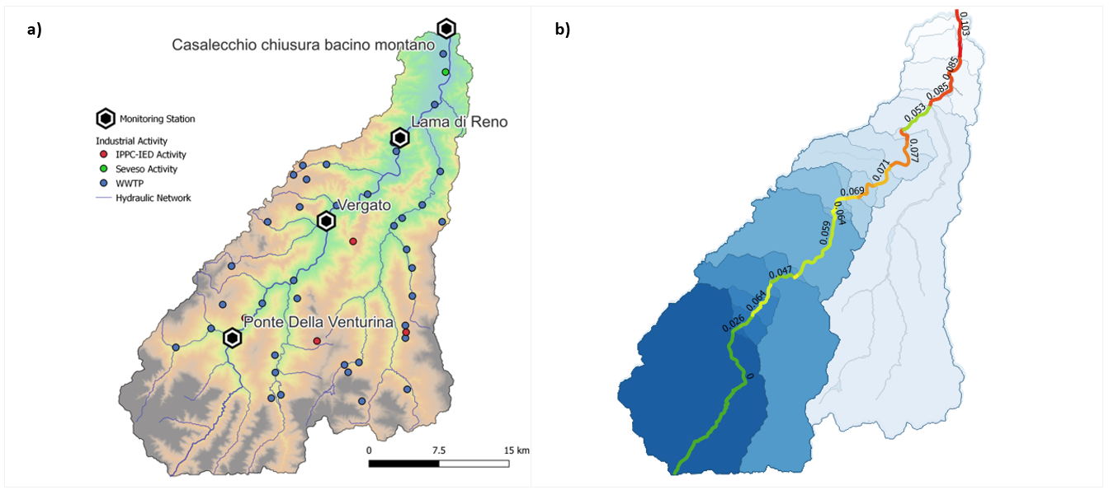

Figure 1: a) Case study area representation with the position of the 46 industrial activities and the 4 monitoring stations; b) BQI values obtained for the main river of the analyzed network.

First, the BQI values obtained in correspondence with the four monitoring stations were analyzed together with the yearly averaged COD recorded in the same locations to verify the consistency of the methodology. It is to be noted that BQI and COD values are not directly comparable. Thus, their trends were analyzed using different scales, as presented in Figure 2a. It can be seen from the graph that the BQI values obtained reproduce well the general water quality trend recorded along the river.

Furthermore, the overall contribution of the activity typologies and the specific contribution of the single activity were assessed, taking the BQI value obtained at the basin’s closing section as a reference (Figure 2b). It is interesting to observe that, although the overall contribution to the BQI of the 41 WWTP plants is 67% of the total BQI, the specific contribution per single activity of this typology is only 6% (i.e. a single average WWTP impacts only for 6% on the overall water quality). Vice versa, the overall contribution of the only Seveso plant in the case study area to the BQI is 19%, and its specific contribution is 63%. These results are particularly interesting as they show that the methodology can take into account the intrinsic characteristics of the industrial pressures analyzed.

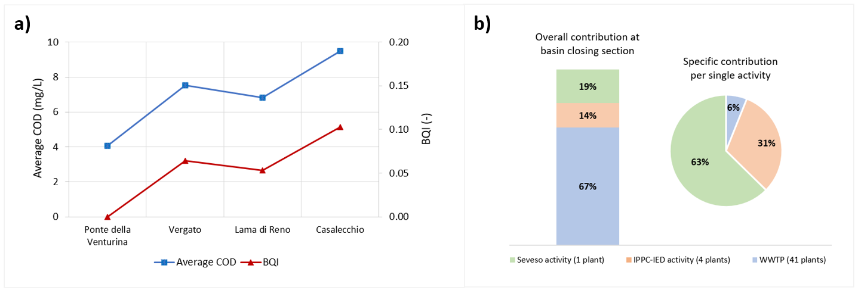

Figure 2: a) Recorded average COD (left axis) and estimated BQI (right axis) considering the four monitoring stations within the case study area; b) Overall contribution of the activity typologies and specific contribution per single activity referring to the BQI value obtained at the basin’s closing section.

* 1. Conclusions

The index-based methodology presented in this paper provides a novel approach for a straightforward estimate of the biochemical water quality in a river catchment. The main novelties of the approach are the procedure defined for identifying and characterizing the significant anthropic pressures within an analyzed area, and the method proposed to acknowledge the evolution of the pollutant loads in the river network, also considering the self-depurative capacity of the watercourses. Notably, the methodology accounts for the normal operations of the industrial activities identified as relevant pressures and considers an estimated average surface water flow in the river network.

The application proposed in the case study, which employed the recorded quality data of a real-existing river catchment in the North of Italy, confirmed the capability of the methodology to take into account the intrinsic characteristics of the industrial pressures analyzed and to faithfully replicate variations in water quality along the river network. Clearly enough, the methodology proposed could be employed to implement water management plans, especially in the case of poor monitoring networks.

Acknowledgements

The research has been partially funded by the European Union – NextGenerationEU through the Alma Idea 2022 research initiative of the Alma Mater Studiorum Università di Bologna.

References

Adewumi I., Ogbiye A., Longe E., Omole D., 2011, Effect of industrial effluents on water quality of River Atuwara in Ota, Nigeria, Urban Agriculture, Cities and Climate Change, Cuvallier Verlag, Gottingen, Germany.

Arrighi C., Masi M., Iannelli R., 2018, Flood risk assessment of environmental pollution hotspots, Environmental Modelling and Software, 100, 1–10.

Chaudhry F.N., Malik M.F., 2017, Factors Affecting Water Pollution: A Review, Journal of Ecosystem & Ecography, 07(01).

Garbrecht J., Martz L.W.,1997, The assignment of drainage direction over flat surfaces in raster digital elevation models, Journal of Hydrology, 193(1–4), 204–213.

Grizzetti B., Pistocchi A., Liquete C., Udias A., Bouraoui F., van de Bund W., 2017, Human pressures and ecological status of European rivers, Scientific Reports, 7(1), 205.

Lehner B., Verdin K., Jarvis A., 2008, New Global Hydrography Derived From Spaceborne Elevation Data, Eos, Transactions American Geophysical Union, 89(10), 93.

Mirauda D., Caniani D., Colucci M.T., Ostoich M., 2021, Assessing the fluvial system resilience of the river Bacchiglione to point sources of pollution in Northeast Italy: A novel Water Resilience Index (WRI) approach, Environmental Science and Pollution Research, 28(27), 36775–36792.

Malaj E., von der Ohe P.C., Grote M., Kühne R., Mondy C.P., Usseglio-Polatera P., Brack W., Schäfer R.B., 2014, Organic chemicals jeopardize the health of freshwater ecosystems on the continental scale, Proceedings of the National Academy of Sciences, 111(26), 9549–9554.

Ouyang L.L., Shi Y.R., Yang J.Q., Mao S.J., Yuan Q., Wang Y. L., 2022, Water quality assessment and pollution source analysis of Yaojiang River Basin: A case study of inland rivers in Yuyao City, China, Water Supply, 22(1), 674–685.

Poikane S., Salas Herrero F., Kelly M.G., Borja A., Birk S., van de Bund W., 2020, European aquatic ecological assessment methods: A critical review of their sensitivity to key pressures, Science of The Total Environment, 740, 140075.

Shafiei Moghaddam P., Jahangiri K., Sohrabizadeh S., Hassani N., Hoseini Moghaddam M., Tehrani G.M., 2023, Foresight of the Consequences of the Hazmat Release From an Oil Refinery on the Surrounding Urban Community Following an Earthquake: A Natech Scenario Analysis, Disaster Medicine and Public Health Preparedness, 17, e79.

Su D., Ben W., Strobel B.W., Qiang Z., 2021, Impacts of wastewater treatment plant upgrades on the distribution and risks of pharmaceuticals in receiving rivers, Journal of Hazardous Materials, 406, 124331.

Uddin Md.G., Nash S., Olbert A.I., 2021, A review of water quality index models and their use for assessing surface water quality, Ecological Indicators, 122, 107218.

Vigiak O., Udías A., Grizzetti B., Zanni M., Aloe A., Weiss F., Hristov J., Bisselink B., de Roo A., Pistocchi A., 2023, Recent regional changes in nutrient fluxes of European surface waters, Science of The Total Environment, 858, 160063.

Yang S., Büttner O., Kumar R., Jäger C., Jawitz J.W., Rao P.S.C., Borchardt D., 2019, Spatial patterns of water quality impairments from point source nutrient loads in Germany’s largest national River Basin (Weser River), Science of The Total Environment, 697,134145.