 CHEMICAL ENGINEERING TRANSACTIONS  VOL. xxx, 2024 | A publication of  
The Italian Association
of Chemical Engineering
Online at www.cetjournal.it

Guest Editors: Valerio Cozzani, Bruno Fabiano, Genserik Reniers
Copyright © 2024, AIDIC Servizi S.r.l.
ISBN 979-12-81206-11-3; ISSN 2283-9216

Risk Assessment of Oil Storage Facilities Exposed to Tsunami Hazard
Antonio Vitale^{a,}*, Federica Ricci^{b}, Georgios Baltzopoulosª, Valerio Cozzani^{b}, Iunio Iervolino^{a,c}
ªDipartimento di Strutture per l’Ingegneria e l’Architettura, Università di Napoli Federico II, Via Claudio 21, 80125 Naples, Italy.
^{b}LISES – Laboratory of Industrial Safety and Environmental Sustainability, Department of Civil, Chemical, Environmental and Material Engineering, University of Bologna, via Terracini 28, 40131, Bologna, Italy.
^{c}IUSS Scuola Universitaria Superiore di Pavia, Piazza della Vittoria 15, 27100 Pavia, Italy.
antonio.vitale5@unina.it
The term NaTech was coined to describe events where natural hazards trigger technological accidents in industrial facilities. Structural damage to the installations, caused by natural events such as earthquakes or tsunami, may cause loss of containment, which may in turn lead to fires, blasts, or dispersion of toxic gases. Thus, NaTech quantitative risk assessment (QRA) requires a measure of structural risk to provide estimates of future losses and a detailed assessment of the consequences arising from such losses. This paper presents an industrial risk analysis for anchored atmospheric storage tanks subjected to tsunami hazard, by means of a multidisciplinary approach integrating structural analysis and consequence assessment. This is performed for a case study consisting of a waterfront tank farm located at a coastal Italian site. The first part of the analysis requires calculation of the structural failure rate of storage tanks that suffer content release due to damage induced by tsunami inundation, via models of probabilistic hazard for the site of interest and the vulnerability (fragility) of the examined structures. Structural failure rates are evaluated for various numbers of simultaneous waterfront storage tank failures, using tsunami fragility curves for variable tank geometry and filling level. The failure rates and consequence analysis for the tank farm are then used as input parameters for the NaTech QRA, leading to the calculation of risk figures for tsunami hazard.
  - Introduction
Quantitative assessment of industrial risk due to natural hazards is primarily focused on studying the consequences that natural events, such as earthquakes, tsunamis, hurricanes or lightning storms, can provoke. These events can induce structural damage to the installation with consequent loss of the containment. Therefore, technological accidents triggered by natural events, also called NaTech events, may be the cause of other hazardous events such as flash fires, pool fires and vapour cloud explosions involving several industrial units in a domino effect (Mesa-Gomez A. et al. 2020; Suarez-Paba M.C. et al. 2019). NaTech risk assessment follows a structured outline based on the characterization of the natural hazard at the site of interest, the study of the vulnerability of the structures exposed to natural hazard events, the simulation of accidents with escalation scenarios, and the estimation of the consequences (Lees, 2012). Traditionally, the crucial point for a quantitative risk assessment (QRA) is the evaluation of the vulnerability or, more specifically, of the behaviour of different facilities under the natural events. As an example, for atmospheric storage tanks, that are the object of this study, technical literature is available for seismic actions, providing vulnerability studies based on observed damage from past events, as in Salzano et al. (2003). On the other hand, other vulnerability models are based on structural analysis on finite element models as Bakalis et al. (2017). Furthermore, for the tsunami action, simplified approaches are developed by Landucci et al. (2012).
In the study presented herein, a NaTech QRA is discussed, referring to a case-study coastal refinery located in a site in southern Italy (Milazzo, Sicily) featuring anchored atmospheric storage tanks exposed to tsunami hazard. The structural damage and the consequences due to the loss of contents are discussed considering the examined storage tanks for different levels of oil filling.
  - Methodology
The QRA methodology is split into three main steps: assessment of the hazard at the site of interest, evaluation of the vulnerability of the considered structures, and the modelling of consequences. Hazard and the vulnerability assessment allow to evaluate the risk in terms of structural failure frequency (rate). The structural failure rates are then used for simulating the consequences, in terms of fatalities, that may arise from accidental events due to loss of content.
    - Probabilistic tsunami hazard analysis
Tsunamis are triggered by other natural events, such as earthquakes, volcanic eruptions, submarine landslides, atmospheric disturbances, or asteroid impacts. A probabilistic tsunami hazard analysis (PTHA) for the case study of Milazzo, was developed by Volpe et al. (2019), considering tsunamis generated by earthquakes. PTHA was performed via numerical simulations of inundation scenarios for a grid covering an area including the refinery. Figure 1a shows some of the grid points located around the tanks. At each point, a hazard curve is obtained by PTHA. This curve depicts the annual rate of tsunamis exceeding different threshold values of inundation intensity $\left(λ_{Φ}\right)$. The inundation intensity chosen, herein, is the inundation level $\left(Φ\right)$, defined as the ratio between the maximum inundation depth $\left(h_{w}\right)$, that is the maximum height of the wave measured near the structure from the ground level during the simulated inundation, and the maximum filling height $\left(h_{f,max}\right)$ of the tank.
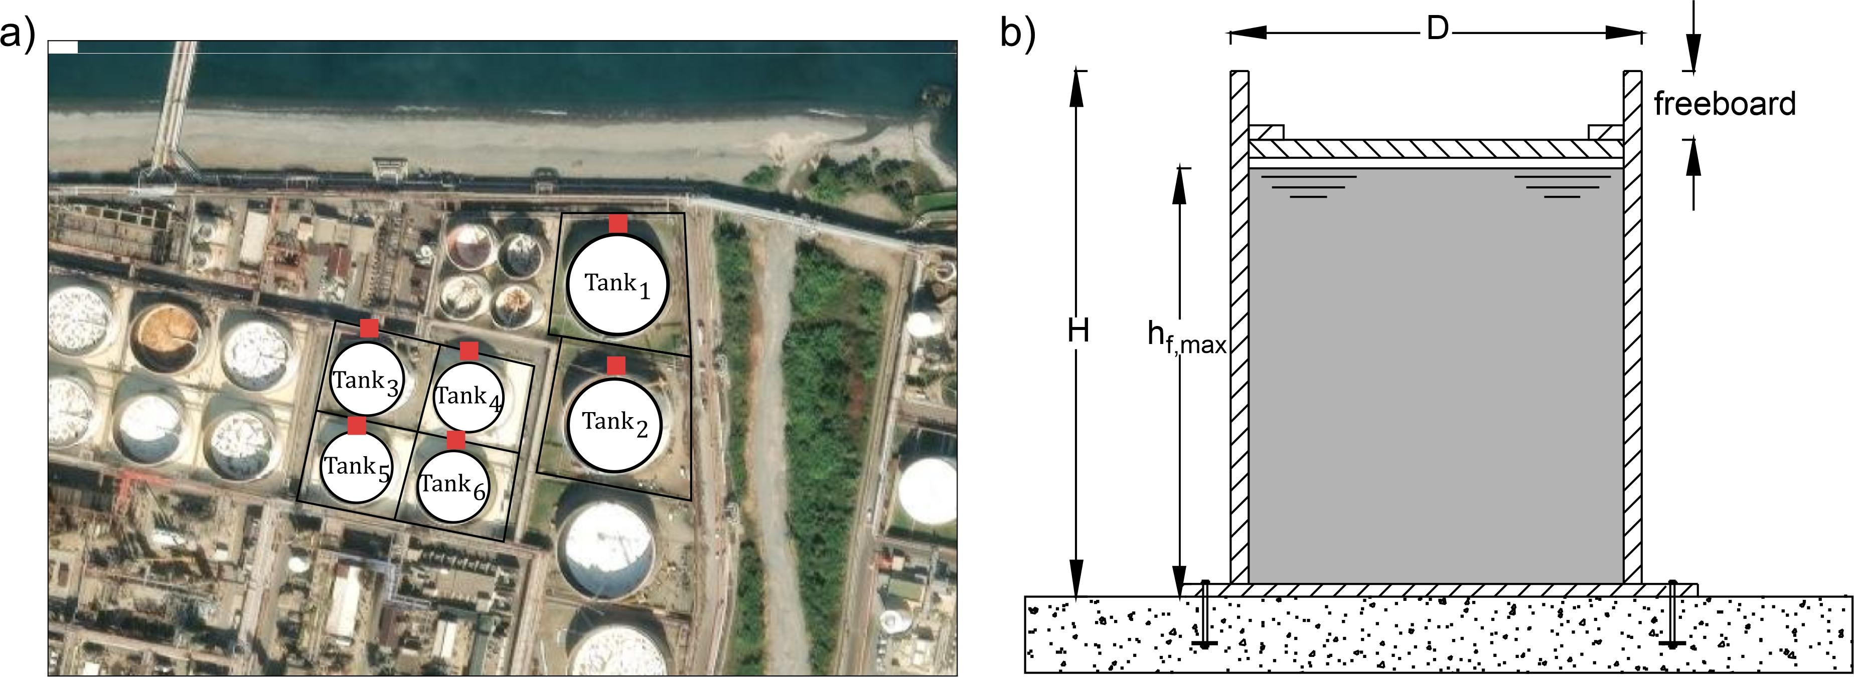
Figure 1: a) Grid points of interest for the tsunami hazard assessment. b) Schematic representation of an anchored storage tank.
    - Tsunami fragility functions
The vulnerability analysis was carried out for anchored atmospheric storage tanks under tsunami-induced actions. Tsunami actions were modelled following a quasi-static approach, where the external pressure acting on the vessel can be considered as the sum of a hydrostatic and hydrodynamic component including a buoyant-force pressure acting from under the base plate. These actions may trigger a series of failure mechanisms that govern the tank's response. More specifically, the radially acting hydrostatic pressure can induce shell buckling due to the rise of critical compressive circumferential stresses on the thin-walled cylindrical structure. On the other hand, the hydrodynamic pressure component, so-called drag force, can cause shear failure in the anchors leading to sliding of the tank, when the frictional forces in the steel-concrete foundation interface are exceeded. Finally, the combined effects of buoyant and hydrodynamic forces can cause the uplift of the tank, potentially leading to anchors’ failure, due to exceeding the steel capacity, or with the concrete cone breakout. This behavior was modelled by performing nonlinear static analysis on finite element models of the tanks, while varying the internal liquid filling level, the inundation depth and the flow velocity. A detailed description of the modelling and analysis can be found in Vitale (2024), while the results are briefly summarized herein.
The vulnerability analysis resulted in the development of fragility functions expressing the probability of failure conditional on a given value of the intensity measure. The tsunami fragility functions express the probability of a tank suffering structural damage that leads to loss of containment, given a certain inundation level $\left(Φ\right)$ and filling level $\left(Ψ\right)$, as expressed per Eq. (1):
$$P\left[F| Φ,Ψ\right]=1-\prod_{i=1}^{3}{e^{-{\left(\frac{Φ}{a_{i}\left(Ψ\right)}\right)}^{b_{i}\left(Ψ\right)}}},$$ | (1)
where $Φ={h_{w}}/{h_{f,max}}$ and $Ψ={h_{f}}/{h_{f,max}}$ are the normalized inundation depth and filling degree; and$h_{f}$ is the height of the internal liquid. The subscript $i = 1,2,3$ indicates the activation of each of the three failure mechanisms (shell buckling, shear failure of the anchors, and uplift due to tension failure of the anchors), with $a_{i}(Ψ)$ and $b_{i}(Ψ)$ being the scale and shape parameters of a Weibull distribution, respectively. The value of these coefficients is available in Vitale (2024) for different values of tank height-to-radius ratio.
    - Rate of multiple simultaneous structural failures
The structural failure rate of a storage tank with a given filling level $Ψ$, is provided by Eq(2):
$λ_{f,j}=ν∙P\left[F_{j}\right]=\int_{0}^{100\%}{P\left[F_{j}|Φ,Ψ\right]∙\left|dλ_{Φ,j}\right|}$, | (2)
that is, the product of the tsunami occurrence rate (of any intensity) at the site, $ν$, and the probability of failure given a tsunami event of tank j out of n, $P\left[F_{j}\right]$, or – equivalently – the integral of the fragility curve times the absolute value of the hazard curve’s differential. This rate represents the average annual number of tsunamis that trigger the release of contents due to tank structural damage.
For the consequence analysis, one should consider the simultaneous occurrence of structural failure in more than one tank. If failure of various industrial units can be assumed stochastically independent (Cozzani et al. 2014), for a group consisting of $n$ tanks, the probability to observe exactly $k$ out of $n$ failed tanks is:
$$P\left[F=k\right]=\sum_{i=1}^{\left({n \atop k}\right)}{\prod_{j=1}^{n}{\left\{1-P\left[F_{j}\right]+δ_{ij}∙\left(2∙P\left[F_{j}\right]-1\right)\right\}}}$$ | (3)
where $i=1,2,…,\left({n \atop k}\right)$ is the number of combinations of k failed tanks out of n, and $j=1,2,…,n$ is the number associated to each individual tank. The symbol $δ_{ij}$, is an indicator function equaling one if the j-th tank has failed, and zero otherwise. Finally, the rate of simultaneous failure of k tanks can be obtained from Eq(4):
$λ_{f}\left(k\right)=ν∙P\left[F=k\right]$. | (4)
    - Consequence analysis and risk assessment
Considering the failure mechanisms described in Section 2.2, the instantaneous release of the complete tank content was considered in the consequence analysis. In addition, a worst-case approach was applied to the QRA, following Ricci et al. (2024). The method entails including a single representative scenario for each tank in the analysis, chosen to be the worst-case in terms of consequences. The quantification of NaTech scenarios including the possibility of simultaneous multiple equipment failures was performed following the methodology proposed by Cozzani et al. (2014). Individual and societal risk indices can then be calculated, reflecting the consequences of the technological scenarios on human life. Specifically, consequences are quantified via (local specific) maps of the individual risk (IR). In these maps, the annual death rates of an unprotected individual, assumed in a specific location around the area of the plant, continuously exposed to accident scenarios arising from all the risk sources considered are reported. The societal risk, on the other hand, is a measure to evaluate the risk of multiple fatalities. The outcomes are illustrated by means of F/N plots, in which N is the number of deaths and F(N) is the cumulative annual frequency of accidents with N or more deaths (Uijt de Haag, Ale, 2005). Societal risk can be also expressed using more concise risk indices: the Potential Life Loss $\left(PLL\right)$ and the Expectation Value $\left(EV\right)$, calculated according to Eqs (5) and (6) respectively:
$$PLL=\sum_{N}{f\left(N\right)∙N }$$ | (5)
$$EV=\sum_{N}{f\left(N\right)∙N^{α}}$$ | (6)
in which $f\left(N\right)$ is the annual frequency of scenarios causing $N$ fatalities, and $α$ is a parameter used to give more relevance to the consequences of the accidents leading to multiple fatalities. In the present study, a value of 2 is attributed to the $α$ parameter (Misuri et al. 2023). A conventional QRA for the industrial site was also performed following the approach proposed by Uijt de Haag and Ale (2005) to compare the results of risk figures. Specifically, F/N curves were calculated considering only internal failures and including also the scenarios triggered by the tsunami (Antonioni et al. 2009).
  - Case study
QRA was carried out for the case study of a hypothetical coastal refinery located in Milazzo (ME) in southern Italy. The facilities considered are the six atmospheric storage tanks in Figure 1a. All tanks are anchored to the base and equipped with a floating roof. The roof moves with the internal liquid up to a height ensuring a freeboard to avoid spillage. A typical section of the examined tanks is shown schematically in Figure 1b, while the main features are provided in Table 1. Typically, the contents are highly flammable substances, like crude oil and gasoline, which are considered in the case study.
Table 1: Geometric properties, storage liquid and basin area of the case study tanks.
ID item | Height [m] | Diameter [m] | Content | Catch basin area [m²]
${Tank}_{1}$, ${Tank}_{2}$ | 16 | 55 | Crude oil | 7600
${Tank}_{3}$, ${Tank}_{4}$, ${Tank}_{5}$, ${Tank}_{6}$ | 13 | 40 | Gasoline | 3200

The tsunami QRA is performed considering the tanks with three different degrees of filling: 10%, 50%, and 90%. For consequence evaluation, pool fires were considered as the worst-case scenario after a catastrophic failure of the tank. The probability of immediate pool fire ignition for tsunamis is assumed $0.013$ (Ricci et al. 2021). Established literature models were applied for consequence analysis (Van Den Bosh & Weterings, 2005). For the sake of simplicity, a single set of meteorological conditions was considered: a uniform wind distribution and neutral atmospheric stability (wind speed at 5 m/s, Pasquill class D). For societal risk calculation, a uniform population density of 50 inhabitants/hectare was considered, with a presence probability of 60%.
  - Results and discussion
Figure 2a presents the hazard curves derived from the PTHA for the grid points identified by the red squares in the Figure 1a. The hazard results show that tanks located closer to the coast, as ${Tank}_{1}$ and ${Tank}_{3}$, are generally at greater hazard. In addition, for the site of the case study, the inundation levels considered in PTHA never reach values larger than half of the height of the tanks, more specifically, slightly more than $40 \%$ for ${Tank}_{3}$, about the $37 \%$ for ${Tank}_{1}$ and ${Tank}_{4}$, about the $30 \%$ for ${Tank}_{2}$, ${Tank}_{5}$ and ${Tank}_{6.}$
All tanks have about the same height-radius ratio, thus, the fragility curves of Figure 2b can be representative of all of them. The figure shows the fragility curves for the three normalized filling levels considered: $10\%$, $50\%$, and $90\%$. As can be seen, an almost empty tank is more vulnerable than a full tank.
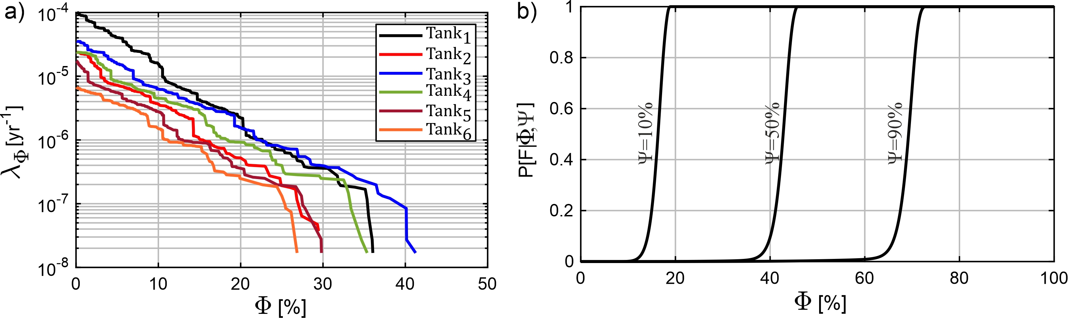
Figure 2: a) Hazard curves associated with each tank. b) Fragility functions for three filling levels.
Table 2: Structural failure rates of each tank for the three filling levels.
$$Ψ$$ | $$λ_{f} \left[1/y\right]$$
$$[\%]$$ | $${Tank}_{1}$$ | $${Tank}_{2}$$ | $${Tank}_{3}$$ | $${Tank}_{4}$$ | $${Tank}_{5}$$ | $${Tank}_{6}$$
10 | 3.94E-06 | 1.03E-06 | 2.77E-06 | 1.39E-06 | 6.14E-07 | 3.89E-07
50 | 4.97E-09 | 1.07E-09 | 4.96E-09 | 1.61E-09 | 5.68E-10 | 3.59E-10
90 | 6.03E-10 | 1.37E-10 | 4.54E-10 | 2.22E-10 | 7.24E-11 | 4.42E-11
Table 3: Probability of failure of exactly k tanks given the failure at least one for the three filling levels.
$$Ψ$$ | $$P\left[F=k|F≥1\right]$$
$$[\%]$$ | $$k=1$$ | $$k=2$$ | $$k=3$$ | $$k=4$$ | $$k=5$$ | $$k=6$$
10 | 0.87 | 0.12 | 8.31E-03 | 3.24E-04 | 6.64E-06 | 5.57E-08
50 | 0.99 | 1.51E-04 | 1.16E-08 | 4.85E-13 | 1.04E-17 | 9.12E-23
90 | 0.99 | 1.79E-05 | 1.67E-10 | 8.53E-16 | 2.27E-21 | 2.45E-27

The fragility and the hazard curves are integrated to derive the structural failure rate of each tank and the values are reported in Table 2. As expected from the fragility models, failure rates in Table 2 are higher for near-empty tanks. For the consequence analysis, all rates of $k$ simultaneous tank failures are considered, with $k$ spanning all values from $1$ to 6. In Table 3 a more parsimonious version of that result is shown, that is the probability of observing exactly $k$ failed tanks given that the tsunami event has caused at least one failure, $P\left[F=k|F≥1\right]$. From the values reported in the table, it appears that the probability of observing the simultaneous failure of more units than one, given that the tsunami has caused at least one failure has occurred, ranges from an order of ${10}^{-1}$ up to ${10}^{-8}$ for 10% filling level, depending on the number of failures.
The rates obtained considering the simultaneous failures are then used together with the consequences assessment results to provide risk figures. Figure 3 illustrates the local specific IR maps considering the tsunami impact on the case-study tank facility. The calculation is performed considering all tanks simultaneously found in one of three filling levels: 10% (panel a), 50% (panel b), and 90% (panel c). The contour lines indicate that by increasing the filling level, the IR due to tsunami hazard decreases. This effect is especially pronounced between filling levels of 10% to 50%, where the maximum individual risk decreases by three orders of magnitude. This trend somehow reflects the one related to the failure rates of tanks, strongly influenced by the filling level. On the contrary, consequences are less affected by the reduction of the content, since the liquid loss covers the entire catch basin even with smaller filling levels, leading to similar consequences arising from pool fire. Noteworthy, the duration of the pool fire increases considerably as the filling level increases, but in all cases considered it is well above twenty seconds, which are considered in the probit function for calculating the death probability (Van Den Bosh CJH, 1992).
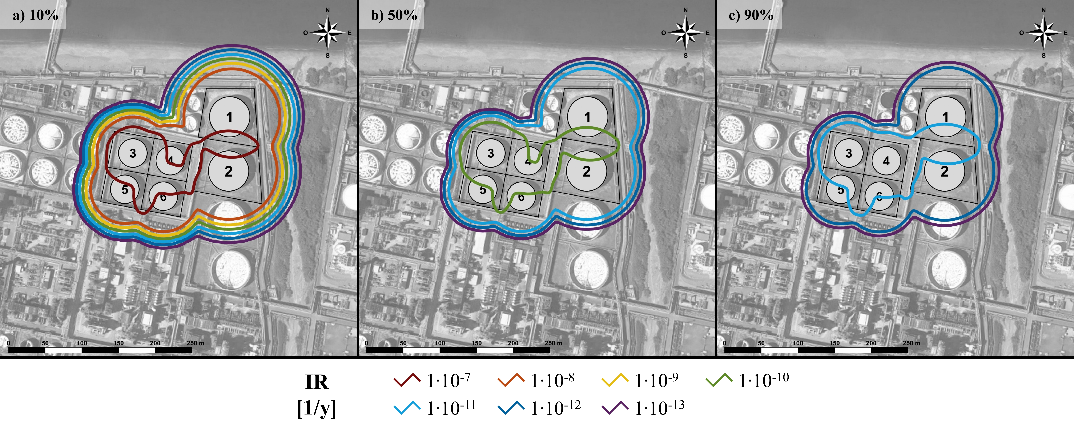
Figure 3: Local specific maps of Individual Risk considering different filling levels in the tanks. a) 10%. b) 50%. c) 90%.
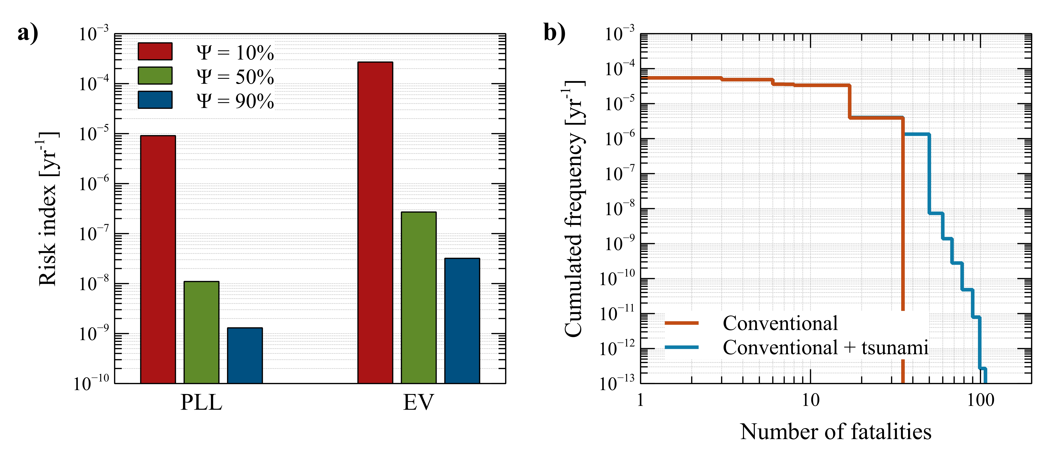
Figure 4: (a) Risk index calculated for the three filling levels considered in the analysis. (b) Societal risk expressed in terms of cumulative frequency vs number of fatalities calculated for conventional activities.
Figure 4 shows the societal risk outcomes. Panel a) illustrates the values of the risk indices, PLL and EV, for the three filling levels considering accident scenarios triggered by tsunami action. The order of magnitude of both indices decreases with increasing tank filling levels, confirming the trend discussed previously. Panel b) compares the F/N curves considering the conventional risk (red curve) and conventional risk adding the contribution of the tsunami risk (blue curve). Conventional risk refers to the potential hazards associated with typical activities and internal failures. The calculation of the tsunami risk is carried out considering the tanks with a uniform distribution of the three filling levels included in the study. The comparison between the red and blue curve reveals that up to twenty fatalities, the tsunami risk has a negligible impact, yet beyond this value, tsunami significantly increases the potential for fatalities. In fact, conventional causes of accidents lead to a maximum of about thirty-five fatalities, while the addition of tsunami risk may cause a death toll of about one-hundred due to the possible multiple simultaneous failures of tanks.
  - Conclusions
This paper presented a comprehensive QRA analysis for a petrochemical plant of anchored atmospheric storage tanks under tsunami action, in southern Italy, examining their behaviour for three filling levels. The key results of the analysis are that the tanks are more vulnerable for low filling levels; and that the values of structural failure rates are strongly influenced by the hazard at the site. While this case study is based on an actual petrochemical facility at that location, a limited number of tanks was considered, to maintain the computational burden of QRA manageable. Therefore, these results are useful in a comparative sense, rather than for considerations of risk acceptability for the entire facility. In fact, the QRA results show that, for this site, tsunami hazard is a non-negligible source of risk if compared to the conventional activities risk.
Acknowledgments
The study presented was developed within the RETURN “Multi-risk science for resilient communities under a changing climate” (National Recovery and Resilience Plan-NRPP, Mission 4, Component 2, Investment 1.3 – D.D. n.341 15/3/2022, PE0000005); PRIN 2017 Assessment of Cascading Events triggered by the Interaction of Natural Hazards and Technological Scenarios involving the release of Hazardous Substances funded by the Italian Ministry of Universities and Research; and within the activities with ReLUIS-DPC (Rete di Laboratori d’Ingegneria Sismica-Dipartimento di Protezione Civile) 2022−2024 research agreement, funded by the Italian Department of Civil Protection.
References
Antonioni G., Bonvicini S., Spadoni G., Cozzani V., 2009, Development of a framework for the risk assessment of NaTech accidental events, Reliability Engineering & System Safety, 94 (9), 1442-1450.
Bakalis K., Vamvatsikos D., Fragiadakis M., 2017, Seismic risk assessment of liquid storage tanks via nonlinear surrogate model, Earthquake Engineering Structural Dynamics, 46, 2851-2868.
Cozzani V., Antonioni G., Landucci G., Tugnoli A., Bonvicini S., Spadoni G., 2014, Quantitative assessment of domino and NaTech scenarios in complex industrial areas, J Loss Prev Process Ind, 28, 10-22.
Landucci G., Antonioni G., Tugnoli A., Cozzani V., 2012, Release of hazardous substances in flood events: Damage model for atmospheric storage tanks, 106, 200-216.
Lees F., 2012, Lees’ Loss Prevention in the process industries: Hazard identification, assessment and control, Department of Chemical Engineering, Texas A&M University, Texas, USA.
Mesa-Gomez A., Casal J., Munoz F., 2020, Risk analysis in Natech events: State of the art, Journal of Loss Prevention in the Process Industries, 64, 1040
Misuri A., Ricci F., Sorichetti R., Cozzani V., 2023, The Effect of Safety Barrier Degradation on the Severity of Primary NaTech Scenarios, Reliability Engineering and System Safety, 235, 1-16.
Ricci F., Misuri A., Scarponi G. E., Cozzani V., Demichela M., 2024, Vulnerability Assessment of Industrial Sites to Interface Fires and Wildfires, Reliability Engineering and System Safety, 243,1-16.
Ricci F., Moreno V. M., Cozzani V., 2021, A comprehensive analysis of the occurrence of Natech events in the process industry, Process Safety and Environmental Protection, 147, 703-713.
Salzano E., Iervolino I., Fabbrocino G., 2003, Seismic risk of atmospheric storage tanks in the framework of quantitative risk analysis, Journal of Loss Prevention in the Process Industries, 16, 430-409.
Suarez-Paba M. C., Perreur M., Munoz F., Cruz A. M., 2019, Systematic literature review and qualitative meta-analysis of Natech research in the past four decades, Safety Science, 116, 58-77.
Uijt de Haag PAM, Ale BJM. Guidelines for Quantitative Risk Assessment (Purple book). The Hague (NL): Committee for the Prevention of Disasters; 2005.
Van Den Bosh CJH, 1992, Methods for the Determination of Possible Damage to People and Objects Resulting from Releases of Hazardous Materials (Green Book). The Hague (NL): Committee for the Prevention of Disasters.
Van Den Bosh CJHJH, 2005, Weterings RAPM. Methods for the calculation of physical effects due to releases of hazardous materials (liquids and gases) (Yellow Book) third. The Hague (NL): Committee for the Prevention of Disasters.
Vitale A., 2024, Earthquake and tsunami multi-hazard risk analysis of a petrochemical plant, PhD Thesis, Tutors: Iervolino I., Baltzopoulos G., Cito P., University of Naples Federico II, Naples, IT.
Volpe M., Lorito S., Selva J., Tonini R., Romano F., and Brizuela B., 2019, From regional to local SPTHA: efficient computation of probabilistic tsunami inundation maps addressing near-field sources, Natural hazards and Earth System Sciences, 19, 455-469.

