|  |  |
| --- | --- |
| cetlogo ***CHEMICAL ENGINEERING TRANSACTIONS***  ***VOL. xxx, 2024*** | A publication of  aidiclogo_grande |
| The Italian Association  of Chemical Engineering  Online at www.cetjournal.it |
| Guest Editors: Valerio Cozzani, Bruno Fabiano, Genserik Reniers  Copyright © 2024, AIDIC Servizi S.r.l. **ISBN** 979-12-81206-11-3; **ISSN** 2283-9216 | |

Comparison of 2D and 3D Representations of Explosion Hazardous Areas

Levene Tugyi\*, Zoltán Siménfalvi, Gábor L. Szepesi

University of Miskolc, Department of Chemical Machinery

levente.tugyi@uni-miskolc.hu

The representation of potentially explosive areas depends on the flammable and explosive properties of the substances used, such as gases/vapors or dust, and the conditions under which they are present in the technology. The ATEX (ATmosphères EXplosibles) directives, specifically Directive 99/92/EC - risks from explosive atmospheres (ATEX -137), define the possible explosive areas as Zone 0, 1, 2 for gases/vapors and Zone 20, 21, 22 for flammable dusts. Guidance on the classification of these zones is provided by standards such as EN IEC 60079-10-1:2020 "Classification of areas – Explosive gas atmospheres" and EN IEC 60079-10-2:2015 "Classification of areas – Explosive dust atmospheres." Taking into account the type, quantity, concentration, and operational parameters of explosive substance present in the given technology, and considering relevant regulations and standards applicable to the technology, it is necessary to determine the extent and type of explosive hazard areas and represent them visually. It is possible to use 2D (two-dimensional) and 3D (three-dimensional) representation modes. 2D representation is a well-established and accepted method, 3D representation is a new approach. The difference between the two lies in how detailed and spatial information they provide about explosive hazard areas. Each method has its own advantages and application areas. 2D representation can be realized in the form of floor plans, blueprints, and maps. These drawings typically indicate the location, boundaries, and other related information of explosive zones in the horizontal and vertical dimensions. 3D representation utilizes spatial modeling, providing a more detailed presentation of the terrain's topography and the location of hazardous areas in the vertical dimension as well. The richness of detail in 3D representation allows for a more realistic depiction and aids in understanding the spatial relationships of objects and equipment within the area. Both types of representation have their own advantages, and the choice of application depends on specific needs and available information. In the study, the explosive hazard areas of a storage tank will be depicted using both 2D and 3D techniques.

* 1. Introduction

Explosive atmospheres are defined by national legislation and regulations and harmonised European and national standards. They may arise from vapours from flammable gases or liquids and from explosive technologies involving the manipulation of particulate matter or dusts. The legislative or standard background is used to establish the type of Zone, which is Zone 0, 1 or 2 for gases/vapours and Zone 20, 21, 22 for dusts, and its horizontal and vertical extent.

For a given technology, the potential explosion hazard zones must be shown, as they are mandatory and clarify the mandatory limits for the selection and use of explosion-proof equipments. The aim is to ensure that electrical and non-electrical products are not a potential source of ignition in explosive atmospheres. In addition, it can support more activities in the field of health, safety and environment (HSE), such as the issuing of flammability work permits in hazardous areas. Explosion hazard zones can be visualised using 2D (two-dimensional) or even 3D (three-dimensional) representations. There can be several forms of 2D representation, depending on the detail and information required to illustrate the technology. Blueprints or layout drawings are basic local 2D representations that show the structure of an area, its buildings, rooms, technological equipment and other important objects. Potential sources of release (equipment, wiring) and their explosive zones can be marked on them. The so-called overall plot plans, which show the whole factory and the different plants located there from a bird's eye view, provide an overview of the explosive areas and their locations on a global scale. There are many of 2D graphics software, CAD-based, which can be used to produce plans and various representations, including of explosive hazard areas. Examples include AutoCAD, DraftSight, CorelDRAW, Microsoft Visio, Inkscape, LibreCAd, etc. These software are partly free and require varying degrees of computer and human resources, so the choice depends on the purpose and level of 2D design software required. It is important to choose software that meets your needs and is easy to apply to your design tasks. 3D rendering gives a more detailed and realistic representation of the environment and allows viewers to better understand the complexity of the area and potential hazards. It also provides the opportunity for virtual tours and interactive visualisations to help gain a detailed understanding of the area. 3D software is 3D CAD based software such as Autodesk Inventor, Solid Edge, Solidworks, Rhino, or SketchUp. These software can be used at local and global scales, but at factory scale, GIS software such as ArcGIS or QGIS can help manage maps and spatial data, including 3D data. 3D models are created using hazardous area simulation software such as ANSYS-CFD and FLACS-CFD, which have their own built-in 3D modules (ANSYS Discovery, CASD). A comparison of 2D and 3D programs was studied by Hwang and Hahn (2017). These software allow the simulation of explosive dispersion, effects and other hazardous events in the 3D model environment. However, it is important to use accurate data and expert knowledge in the modelling, especially when dealing with explosive environments. The use of 3D software often implies a learning curve. For those who have not used this type of software before, it takes time to learn how to use it and to effectively find all its features, and these sophisticated 3D software typically have high system requirements. For both representations, the standards EN IEC 60079-10-1:2020 “Classification of areas - Explosive gas atmospheres“ and EN IEC 60079-10-2:2015 “Classification of areas. Explosive dust atmospheres” shall apply (EN IEC 60079-10-1, 2020; & EN IEC 60079-10-2, 2015). It is not advisable to deviate from these markings, as they are accepted and applied worldwide, but different colours can be used to indicate the explosive zones and, for several relevant explosive substances in a technology, a multicolour representation is recommended to ensure that the explosive zones are clear and unambiguous for all to read.2D representations can often be sufficient for design and safety purposes, while 3D representations can provide more sophisticated and detailed information that can help support various design and management decisions. Today, 2D representation and its application is the most common, but with the evolution of the design software user environment, it is easier and simpler to use 3D geometric models compared to 20 years ago. The aim of this study is to present the aforementioned options for representing explosive atmospheres through a storage tank and to examine their various advantages, disadvantages and their applicability in the field.

* 1. Hazardous area classification of the storage tank

Possible potentially explosive areas are identified for a storage tank and represented in 2D and 3D. The flammable liquid stored in the tank is benzene, which has a flash point of -11°C. In Hungary, for the determination of explosion protection measures for storage tanks, it is first necessary to refer to the standard MSZ 9790:1985 "Flammability classification of flammable liquids and melts". Flammable liquids can be classified as flammability classes I, II, III or IV according to their flash point. In the case of benzene, it is classified as a Class I flammable liquid according to subsection 2.1 of the standard. Subsequently, according to subsection 1.2 of the standard MSZ 15633-1:1992, the formation of an explosive atmosphere is expected for flammable liquids of degree of ignition I. For flammable liquids of Class I and II, explosion protection measures are always necessary under normal storage conditions. Explosion protection approaches for storage tanks in different countries are summarised by Levente Tugyi et al. (2023) starting with the flammability classification of flammable liquids and ending with the extent of the explosive zones. The MSZ 9910-1:1993 standard applies to the definition of explosion hazard zones for the benzene storage tank as a process unit, as well as for the damage control. According to Table 3 of the standard, the R value in this case is 2.0 m. The extents of the identified hazardous areas are given in Tables 1 and 2 according to MSZ 9910-1:1993.

Table 1: Storage tank explosive atmospheres by MSZ 9910-1:1993

|  |  |  |  |  |
| --- | --- | --- | --- | --- |
| Sources of release | Horizontal extent | Vertical extent | Type of Zone | Comments |
| Breathing valve | 2.0 m | 3 metres above the valve,  down to the tank top | Zona 1 |  |
| Breathing valve | 4.0 m | 3 metres above the valve,  down to the tank top | Zona 2 | Beyond Zone 1 |
| Outline/shell of  the tank | 1.0 m | 1.0 m | Zona 2 |  |
| Interior of the tank | Full interior | | Zona 0 |  |

Table 2: Containment explosive atmospheres by MSZ 9910-1:1993

|  |  |  |  |  |
| --- | --- | --- | --- | --- |
| Sources of release | Horizontal extent | Vertical extent | Type of Zone | Comments |
| Concrete wall | enclosed space | 0.8 m above the upper edge | Zona 1 |  |
| Out of concrete wall | from outer edge of the wall 6.0 m | 0.8 above ground | Zona 2 |  |

* + 1. 2D representation

The explosion hazard areas of the storage tank are shown in 2D in Figure 1 from side view and in Figure 2 from top view. Markings according to EN IEC 60079-10-1:2020.

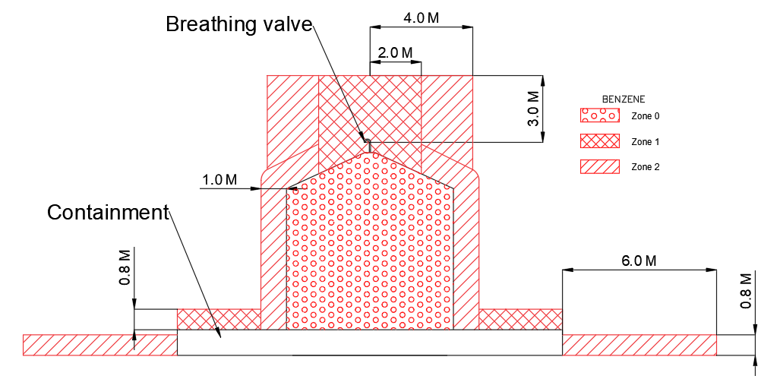

*Figure 1: Storage tank explosive atmosphere from side view* (2D)

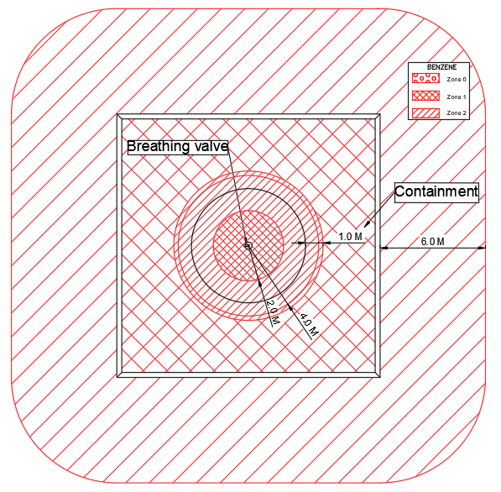

*Figure 2: Storage tank explosive atmosphere from top view* (2D)

Figure 1 and Figure 2 show the boundaries of the hazardous areas with their respective markings, and their extents. These 2D representations can be easily produced using both paid and free software. It requires no special technical skills and can be learnt quickly. The different section views can be used to efficiently generate extension files that are easily accessible and interpretable by designers, operators or other relevant persons. In addition, paper-based views can be easily taken into hazardous areas of operation, assisting in various inspection and maintenance reviews, such as explosion-proof fabrication inspections or electrostatic charging and sparking protection reviews. The disadvantage is that a lot of detailed data cannot be displayed at a given moment in time, so that it can be interpreted well. It also requires a good spatial vision to understand the sections, which is not always easy for a drawing of a complex process unit.

* + 1. 3D representation

The 3D visualisation technology is a potential option for informative visualisations as today's technology advances. It has not yet been used so much, but it is starting to appear in the representation of hazardous areas, both because a 3D representation is very interpretable and visual in any other field, and because it can provide a professional advantage over operators and competitors in terms of operational and maintenance efficiency and safety. The storage tank explosion hazard areas described in this study are shown in 3D in Figure 3 from a side view and in Figure 4 from a bird's eye view.

In this representation technique, the hatchings given by the standards cannot be used, but can be distinguished by using a combination of colours by zones for proper identification. Different zones should be marked with different colours. The zones around the storage tank shown in Figures 3 and 4 are solid glass appearance in the geometric model, and their transparency could be increased to clearly illustrate their location around the tank. However, the zone established inside the tank is not represented. In addition, the geometry model does not include the tank breather. It is merely a properly fixed position away from the potential explosive areas that are depicted but are named as sources of release in the two figures. It was necessary to fit the dimension lines separately, looking at the parameters of the extents.

A 3D image was not generated from the top view angle only, as it would not have carried more information than the 2D top view in Figure 2.

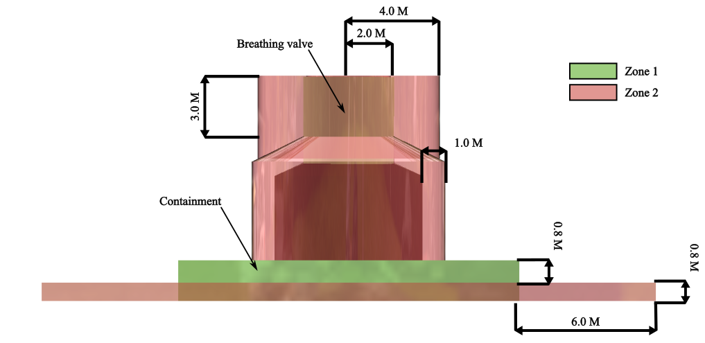

*Figure 3: Storage tank explosive atmosphere from side view* (3D)

In many cases, the person responsible for technological explosion protection only wants to see the depicted zones, and the associated description is not very interesting and does not want to use it, but the 2D or 3D representation is often only interpreted in conjunction with the description.

Another transition between 2D and 3D representation is usually when views are created from a 3D geometric model to represent potentially explosive areas in 2D. Such a figure is in fact neither a 2D nor a 3D representation, somewhere in between, but there are examples (BH eStore, 2024). The 3D rendering was also partly the subject of a study by Almeida et al (2022) and is also used by companies (CCP, 2024; & SMS, 2024).

*Figure 4: Storage tank explosive atmosphere from* bird's eye view (3D)

It can be seen from the previous figures that 3D models provide a very informative way to visualise the relationship between the tank as a process facility and the associated explosive atmospheres. In the 3D design software, you can walk around, rotate the geometry, take a closer look at specific local areas, and anyone can do this with free available so-called viewer programs such as Autodesk Navisworks Freedom. However, care must be taken to ensure that the file extension ensures interoperability between software. The most common 3D file formats are .stl, .obj, .fbx, .dae, .3ds, .ply, .iges, .step (stp) and .dxf files. Globally, a 3D model can also be used for virtual walks and it is possible to draft 2D sectional drawings, although these can be time consuming depending on the capacity of the computer. This can result in a large model that is too detailed and contains all elements, making it unmanageable. This can even be a problem when viewing in 3D.

However, if computer infrastructure is adequate, the 3D representation of explosive hazard areas and associated data can be well implemented in a Building Information Modeling (BIM) methodology. A BIM model is a digital representation of a building or infrastructure that contains all relevant geometric, geographic, temporal and technical information which is well described Kristen and Kenneth (2012) and Lino et al (2015). In relation to hazardous areas, a BIM model can be useful for safe design, operation and maintenance. It is suitable for system integration and provides the opportunity to integrate with other design and safety systems, such as production facilities and security systems for hazardous areas. In addition, the model allows for a complete management of the building life cycle. In this context, life-cycle management can help to manage, control and document changes related to hazardous areas. In practice, it is a great help in optimising operational processes, such as accessing a single interface, integrating review obligations.

One of disadvantage is the expertise required for modelling, as a lack of such expertise can lead to difficulties when using more complex functions and techniques. Such features include, for example, constraints and matching of elements. The use of zones assigned to colours, in a 2D section or even in a 3D plot, if generated in black and white, does not make sense of the differences. Compared to a paper-based print, a 3D model provides most of the information electronically. For an explosive technology, only a explosion explosion-proof design tablet or other eletrical equipments (phone, notebook) that meets the minimum technical requirements (gas subgroup, temperature class) for specific hazardous areas can be used to view the 3D model, which can quickly run out of battery power, hampering workflow. For electrostatic verification, only 2D sections can be used, but for lightning protection it can be of great help in comparing with rolling spheres.

* 1. Conclusions

The 2D is a much simpler and easier to use representation technique than 3D, although there are arguments for using both. The 2D representation of potentially explosive areas does not require any particular human and computer resources, unlike 3D representation. For the former, .pdf or other printable file formats are readily available, although for 3D this can be done by drafting, but this is cumbersome. All in all, 3D rendering is very informative and has a lot of potential operational benefits, but is not yet appropriate due to its difficult applicability. The advantages and disadvantages of 2D and 3D are summarized in Table 3. The explosive interior above the liquid surface in the storage tank could not even be represented in the 3D case. In addition, the proposed marking according to the standard was also not applicable, specific, well-defined colors should have been possible to depict. These findings are generally true for the storage tank under investigation, but also for other industrial installations. Otherwise, the load on the computer was less during 2D drawing and did not require as much system resources as in the 3D case. As modelling software evolves to provide a more user-friendly environment, this representation methodology will gain ground. Currently, 2D representation techniques can cover the needs of designers, operators and reviewers or other design disciplines.

Table 3: Advantages and disadvantages of 2D and 3D representation

|  |  |  |
| --- | --- | --- |
|  | Advantages | Disadvantages |
| 2D representation | It is easy to make, requires no special technical skills and can be exported quickly, | Not suitable for displaying a lot of detailed data, good spatial vision to understand sections |
| 3D representation | Informative, easy to understand, | Zoning needs to be deviated from, expertise required for proper 3D modelling, high computer demand, 2D sections cumbersome to produce |

References

Almeida, J.C., Sardá, A.P. and Oliveira, H.S. (2022) ‘Classification of hazardous areas - natural gas installations’, International Journal of Advanced Engineering Research and Science, 9(3), pp. 066–071. doi:10.22161/ijaers.93.10.

BH eStore, EQUIPMENT FOR HAZARDOUS AREA, <https://bh-estore.com/media/wysiwyg/downloads/ZONE\_.JPG>

CCP Engineering Inc., Area Classification For Hazardous Locations <https://www.ccpengineering.com/area-classification---hazardous-locations.html>

EN IEC 60079-10-1, 2020, Explosive atmospheres - Classification of areas - Explosive gas atmospheres, International Electrotechnical Commission

EN IEC 60079-10-2, 2015, Explosive atmospheres - Classification of areas - Explosive dust atmospheres, International Electrotechnical Commission

Hwang JY, Hahn KH. A case study of 2d/3d cad virtual prototype simulation programs to enhance student performance in student-centered fashion design education. J Textile Eng Fashion Technol. 2017;3(1):578-584. DOI: 10.15406/jteft.2017.03.00088

Kristen Barlish, Kenneth Sullivan, How to measure the benefits of BIM — A case study approach, Automation in Construction, Volume 24, 2012, Pages 149-159, ISSN 0926-5805, <https://doi.org/10.1016/j.autcon.2012.02.008>

Lino Maia, Pedro Mêda, João G. Freitas, BIM Methodology, a New Approach - Case Study of Structural Elements Creation, Procedia Engineering, Volume 114, 2015, Pages 816-823, ISSN 1877-7058, <https://doi.org/10.1016/j.proeng.2015.08.032>

SMS – Safety Management Services - Electrical Classification, Hazards, and Protection Training < https://smsenergetics.com/training/electrical-classification-hazards-protection-training>

Tugyi, L., Z. Siménfalvi, G. Szepesi, and Z. Kerekes. 2023. “Hazardous Areas Classification for in Flammable Liquid Storage Tanks.” MULTIDISZCIPLINÁRIS TUDOMÁNYOK: A MISKOLCI EGYETEM KÖZLEMÉNYE 13 (2): 116–134. doi:10.35925/j.multi.2023.2.11