|  |  |
| --- | --- |
| cetlogo ***CHEMICAL ENGINEERING TRANSACTIONS***  ***VOL. xxx, 2024*** | A publication of  aidiclogo_grande |
| The Italian Association  of Chemical Engineering  Online at www.cetjournal.it |
| Guest Editors: Valerio Cozzani, Bruno Fabiano, Genserik Reniers  Copyright © 2024, AIDIC Servizi S.r.l. **ISBN** 979-12-81206-11-3; **ISSN** 2283-9216 | |

A Simple and Inherent Safe Mechanosynthesis Method for Producing Tin Metal Nanoparticles Dispersions

Andrea P. Reverberia\*, Marco Vocciantea, Marco Salernob, Omar Sodaa, Bruno Fabianoc

a DCCI – Department of Chemistry and Industrial Chemistry, Genoa University, via Dodecaneso 31, 16146, Genova, Italy

b DIFI – Department of Physics, Genoa University, via Dodecaneso 33, 16146 Genova, Italy

c DICCA – Department of Civil, Chemical and Environmental Engineering, Polytechnic School, Genova University, via Opera Pia 15, 16145, Genova, Italy

reverb@dichep.unige.it

A method for the synthesis of Sn nanoparticles (NPs) is presented, whose technique is based on a reagentless comminution process, where bulky Sn metal undergoes a surface abrasion with release of zerovalent metal NPs produced by metal-ceramic balls collisions in a liquid medium embedding and dispersing the as-formed NPs. Two different techniques have been adopted and compared, according to the geometry of the pristine bulky metal. In a former case, a Sn metal precursor is shaped in foil form covering the surface of a magnetic stirring device, keeping abrading spheres in agitation in a liquid phase. In a latter case, the metal precursor, in form of spheres, is kept in agitation in a liquid phase together with the abrading balls, whose hits and friction with the Sn spheres lead to the formation of the corresponding NPs. Three different capping agents, one of which of natural origin, have been dissolved in the liquid phase to prevent NPs aggregation, with positive effects in long-term stabilization. The particles have been characterized for shape and diameter by dynamic light scattering (DLS) and transmission electron microscopy (TEM). The technique here proposed may represent a promising method, in line with the paradigms of inherent safety, for the synthesis of stable Sn NPs dispersions as a valid alternative to Ag NPs in pharmacology and other biomedical applications.

* 1. Introduction

Nanotechnology has currently achieved a leading role in many areas of everyday’s life. As a first rough classification of nanostructured materials, they can be split into organic or inorganic compounds. The former, like nano-enhanced sorbents, have found extended uses in nano-bioremediation carried out by biochar and other carbonaceous substances, often of pyrolytic origin (Chiarioni et al., 2006), for water and soil decontamination (Rajput et al., 2024). Biopolymers like chitosan (Oliveira Silva et al., 2021) are a very versatile ingredient for the manufacturing of nanocomposites particularly useful in chemisorption of pollutants of various origin (Petrelli et al., 2020). Organic semiconducting nanoparticles (NPs) represent one of the most recent challenges for the realization of photovoltaic panels of the last generation (Zhang et al., 2023), well relevant to the energy transition issue, which is bringing notable changes and safety implications in design concepts, materials, equipment, and process operation (Pasman et al., 2024). In phototherapeutics, organic NPs have proven to be a promising instrument in cancer therapy, owing to a satisfactory non-invasiveness combined with a limited number of side effects (Xie et al., 2023). Inorganic NPs represent a numerically more extended subset (Li et al., 2024), probably owing to a wider variety of techniques developed over the past decades of experimental research (Banis et al., 2017). Wanting to create a subdivision on the basis of composition instead on synthesis methods, one can group them into two basic categories, i.e. into multi-compositional and zero-valent NPs. They offer absolutely innovative physicochemical properties, including an atypical diffusivity of tracer molecular species in their structure, often requiring an ad-hoc mathematical formalism in performing a correct data regression (Vocciante et al., 2016). In the former case, nanostructured thermostable oxides like Al2O3 (Gevorkyan et al, 2017) and ZrO2 (Korableva et al., 2021) have been employed as refractory materials, often prepared by thermolysis of precursors in flames or by sol-gel methods. TiO2 NPs proved to be very useful for photocatalytic dissociation of pollutants embedded both in liquid and in gaseous phase. A very rich literature is nowadays focused on how to make TiO2 NPs capable of being activated by visible light in place of ultraviolet (UV) radiation (Rashid et al., 2024), with obvious advantages in costs and in plant simplification. Transition metal oxide NPs, like ZnO NPs, are a cornerstone as sorbents in the abatements of pollutants in anionic form (Igwegbe et al., 2019) or even as phytostimulating agents improving seed germination in modern agriculture (Sanchez-Perez et al., 2023). Likewise, zerovalent metal NPs are in the hotspot owing to their fields of application spanning over seemingly disparate disciplines (El-Naggar et al., 2024). While noble metal NPs dispersions attracted a great attention in past and recent literature (Reverberi et al., 2020), the same cannot be said for more electropositive elements, probably due to the greater inherent instability of the relevant NPs towards oxidation, but there are important exceptions. Patel and Sharma (2023) successfully utilized metal Cu NPs, obtained by a standard redox technique, for the photocatalytic abatement of anionic and cationic dyes in aqueous medium. It was speculated that hydroxyl and superoxide radicals were the most active agents carrying out water purification. Staying on the subject of Cu NPs, Maruda et al, (2023) observed that the diameter of the dispersed NPs has a strong influence on the tribological characteristics of the fluid and the roughness of friction surfaces. Intriguingly, in the family of NPs made of non-noble elements, the attention of the scientific community is not uniformly distributed. Specifically, tin metal NPs seem to strengthen this conjecture, as the scientific works focused on their synthesis are somewhat limited in number, despite their importance in thermal energy storage systems (Bhandari et al., 2015). Their preparation is usually based on wet chemical methods, where a precursor based on Sn soluble salts undergoes a chemical reduction, in the presence of suitable capping agents, leading to the formation of zeropositive Sn NPs (Thacharon et al., 2022). In this paper, a green, top-down and safety-sound method for the production of Sn NPs is proposed, using a precursor made of bulky Sn and a tribological process in aqueous medium. The paper is structured as follows. In Section 2, materials and methods are described, with particular attention to the mechanosynthesis device. In Section 3, the as-obtained NPs are characterized in shape. Finally, in Section 4, the conclusions are drawn in view of a possible scale-up of the process here described.

* 1. Experimental setup
     1. Materials and methods

Sn metal flakes (Sn, 99.9%, American Elements, Los Angeles, USA), yttria-zirconia spheres (YSZ, ZrO2 95% / Y2O3 5%, 4mm diameter, Pingxiang, Jiangxi, China) polyvinyl pyrrolydone (PVP, (C6H9NO)x, 40kDa, 99%, La Farmochimica, Genova, Italy), saponin (SA, 8-25%, Sigma-Aldrich, Milano, Italy) and myristyl trimethylammonium bromide (MTAB, C17H38NBr, 99%, Sigma Aldrich, Milano, Italy) were used as purchased. Deionized water was used in all experimental tests, which were carried out at room temperature.

Tin flaxes underwent fusion in a ceramic crucible and were further converted into a spheroidal shape of 4 mm diameter in order to make them suitable to be comminuted in a custom-made miller which will be described in the following section. Separately, a fraction of tin was cast into a mould and suitably laminated in foil with a thickness of approximately 0.5 mm through stretching-compression and subsequently shaped to cover the magnetic stirrer as described in section 2.2.

The particle characterization for diameter has been carried out by dynamic light scattering (DLS, Zetasizer Nano, Malvern Panalytical, Malvern, UK), using a disposable polystyrene cuvette holding 1.3 cm3 of liquid for each sampling. Particle shape and composition were determined by transmission electron microscopy (TEM, JEOL 2100 Plus, Akishima, Japan), by collecting 20 μL of liquid embedding the suspended particles on a 3 mm copper lacey grid. This aliquot was allowed to stand for 24 h under vacuum to carry out solvent evaporation. The as obtained solid residue was graphitized by physical vapor deposition (PVD) and finally scanned by a 200 kV electron beam, using a maximum current of 105 μA.

* + 1. The mechanosynthesis technique

Tin particles were obtained according to two different experimental mechanosynthesis techniques, which will be here defined as jacket method (JM) and ball method (BM). Both methods were carried out using the same vessel, namely a round-bottom glass tube of 34 mm outer diameter in which 10 cm3 of water containing a selected capping agent were dropped for each experiment. The stirring element is a polytetrafluoroethylene (PTFE) bar with a length of 30 mm and a diameter of 6 mm, having a magnetic core. The capping agent concentrations were 5% for PVP and 3% for MTAB and SA, respectively, and they were never mixed together. The two methods differ from one another according to the following points:

* In the JM, the stirring element is coated by a Sn metal plate. It is surrounded by 70 YSZ balls, which are agitated thanks to the drag imposed by the rotating motion of the magnet. The Sn metal coating acts as a sacrificial precursor subject to comminution by hits and abrasion exerted by the surrounding ceramic balls. All these components are wetted by the aforementioned liquid volume, where a capping agent has been previously dissolved.
* In the BM, the stirring element is uncoated and it is surrounded by 70 YSZ balls together with 10 Sn balls. All of them, including the liquid volume, are dragged along by the motion of the agitating element.

Essentially, in both cases, the metal NPs are formed by impact and friction produced by the presence of the ceramic spheres, colliding against a tin foil in JM and against tin spheres in BM. Figure 1 gives a visual representation of what has just been described.

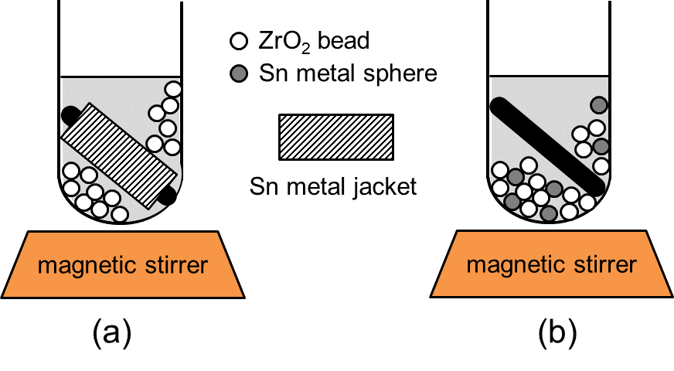

*Figure 1: (a): Scheme of the JM mechanosynthesis apparatus. A black skew PTFE stirring bar is covered by a Sn metal sleeve, acting as a metal precursor. (b): Scheme of the BM mechanosynthesis apparatus. A PTFE stirring bar is left uncoated and some Sn metal spheres act as a metal precursor.*

In the present experimental campaign, some precautions have been adopted to prevent a surface oxidation of Sn NPs, according to the following operations:

* The liquid holdup (deionized water) has been bubbled with argon for 30 min before adding the capping agents. Such operation could not be carried out after their dissolution, as these capping agents are powerful surfactants, which would have resulted in a considerable production of foam.
* The vessel was fitted with a sealing cap, provided with an inlet and outlet duct to allow a continuous flow of inert gas.

In all experimental tests, the comminution process lasted 3h. The as-prepared NPs, collected in the supernatant after settling for 24h, were further characterized as described in the following section.

* 1. Results and discussion

In the present work, the JM technique represents a variant of a comminution scheme adopted in previous studies (Reverberi et al., 2020). For this reason, a comparison between JM and BM methods has been intentionally proposed, in order to better understand the physicochemical processes underlying the different mechanical techniques. Irrespective of the mechanical details, these schemes belong to the well-known top down methods for inorganic NPs synthesis, representing a green alternative to the conventional bottom-up methods. In fact, the latter are subject to several constraints that may have negative consequences on the environment for the reasons outlined in the following:

* Bottom-up methods for metal NPs synthesis generally require the presence of precursors in ionic form. This amounts to saying that soluble salts of cations are subject to a chemical transformation (thermolysis, reduction, electrolysis and others) leading to the formation of zerovalent elements in atomic state, with further aggregation in primary particles. When redox processes are adopted, reducing agents are required, and their environmental soundness is often questionable depending on their chemical characteristics. Additionally, reducing agents may have a variable strength as electron donors, and this pose a crucial drawback whose main consequence is discussed in the following point.
* In case of zerovalent metal nanosynthesis driven by redox processes where weak electron donors are employed, the reduction yield may be quite low, leaving a considerable fraction of unreacted precursor, which represent a potential environmental threat owing to its content in noxious cations. This phenomenon is especially pronounced the more electropositive the precursor cations are.

The aforementioned points can be an incentive for the use of top-down methods as those adopted in the present study, but it should be noted that these techniques are often affected by a serious drawback consisting in a dramatically large distribution of NPs diameters.

The first experimental tests have been carried out using PVP as capping agent. Surprisingly, both in JM and in BM mode, PVP proved to be almost completely inefficient in terms of NPs production. Namely, only a lustrous metallic dispersion of microparticles was produced, which settled completely after 6h, leaving a clear and essentially NPs-free solution from DLS analysis. This outcome is somewhat atypical when PVP is used for Sn metal NPs synthesis in standard redox bottom up-processes. In fact, Shirai et al. (2016) obtained stable Sn NPs to be used in conductive inks by reducing Sn acetate with NaBH4 at 160 °C adopting PVP as a capping agent. Furthermore, PVP proved to be highly efficient as stabilizer in many different cases concerning zerovalent metals like Cu NPs (Lu et al., 2023) and Ag NPs (Arjun et al., 2022). Admittedly, in the present study, the affinity of nanosized Sn towards PVP is strongly conditioned by a pristine adsorption of the capping agent at the surface of the bulky metal precursor, a fact totally absent in a bottom-up redox process. On these grounds, only the experimental data concerning the other two capping agents will be presented and thoroughly discussed in the remainder of this paper.

In Figure 2, the particle diameter distribution function has been plotted for the four different cases, namely for BM and JM, using two different capping agents, namely MTAB and SA, for each comminution technique. Specifically, the upper panels refer to BM, while the lower ones refer to JM. It can be observed that SA has superior performances with respect to MTAB, despite the cationic character of the latter. In particular, Sn NPs stabilized with SA have an average diameter of 18 and 35 nm in case of BM and JM method, respectively. In the case of Sn particles stabilized with MTAB, the results have a reversed trend and the corresponding NPs diameters are shifted towards higher values. Namely, according to the well-known size classification adopted by physicists, Sn NPs of 88 nm average diameter have been obtained when using JM, while only Sn microparticles of 110 nm average diameter are synthesized when using BM. These results clearly show that a natural capping agent like saponin may lead to a more valuable product whenever the target is a size minimization. Essentially, the advantages related to the use of this capping agent are twofold, namely an environmental soundness and a better product in technical terms, well in line with the recent research shift towards green and inherently safer nanoparticles synthesis (Reverberi et al., 2018).

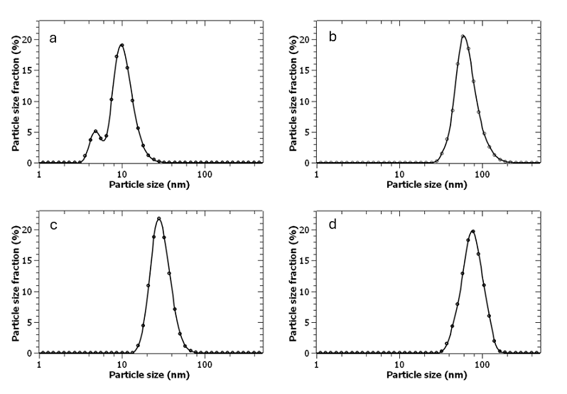

Figure 2: (a): Upper-left plot: BM with SA; (b): Upper-right plot: BM with MTAB; (c): Lower-left plot: JM with SA; (d): Lower-right plot: JM with MTAB.

Table 1: Statistical data of Sn particle diameter distribution function according to the mechanosynthesis method and the choice of capping agent.

|  |  |  |  |  |
| --- | --- | --- | --- | --- |
| Method / capping agent | Average  Diameter (nm) | Peak  diameter (nm) |  | Standard  Deviation (nm) |
| BM / SA | 18 | 5 ; 10 |  | 2 ; 3 |
| BM / MTAB | 110 | 61 |  | 30 |
| JM / SA | 35 | 28 |  | 9 |
| JM / MTAB | 88 | 82 |  | 40 |

In Figure 3, a TEM image of Sn NPs taken from a BM/SA sample has been reported. A cluster of agglomerated particles is clearly observable, together with a widespread dispersion of primary particles. The grey curves surrounding the NPs are due to the presence of a specific capping agent, leaving a solid residue of organic composition during evaporation of the solvent.

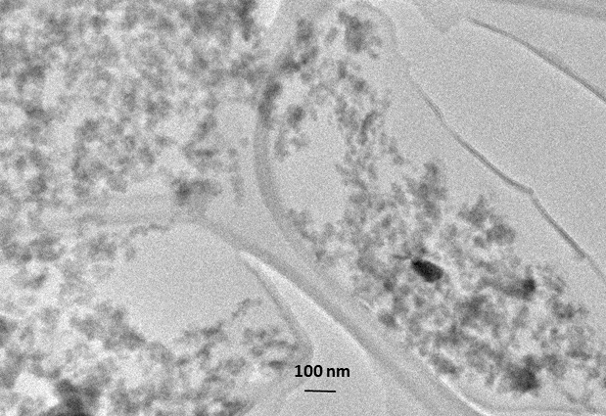

Figure 3: TEM image of Sn NPS obtained by jacketed Sn milling in the presence of SA as capping agent.

* 1. Conclusions

In this study, two comminution techniques, based on different mechanical schemes, have been proposed for the synthesis of Sn NPs. Three different types of surfactants have been adopted, in order to investigate the combined effect of a mechanosynthesis scheme with the effectiveness of a natural and artificial capping agent.

The conclusions can be summarized in the following points:

* Both top-down mechanosynthesis methods here adopted proved to be efficient in Sn NPs formation.
* Saponin and MTAB were active in damping agglomeration, while PVP was totally useless.
* The present method may represent a valid alternative to standard bottom-up schemes in metal NPs synthesis.

A future development of the present study will be focused on the realization of a similar process at a larger scale, within the limits imposed by a reduced scalability of a stirring magnetic field.

References

Arjun P.N.J, Sankar, B., Shankar K.V., Kulkarni, N.V., Sivasankaran S., Shankar B., 2022, Silver and silver nanoparticles for the potential treatment of COVID-19: A review, Coatings 12, 1679.

Banis G., Koulia M.E., Ferraro A., Molino A., Karatzad D., Chianese S., Musmarra D., Hristoforou E., 2017, An innovative application of super-paramagnetic iron oxide nanoparticles for magnetic separation, Chemical Engineering Transactions 60, 85-90.

Bhandari R., Anderson R.M., Stauffer S., Dylla A.G., Henkelman G., Stevenson K.J., Crooks R.M., 2015, Electrochemcal activity of dendrimer-stabilized tin nanoparticles for lithium alloying reactions, Langmuir 31, 6570-6576.

Chiarioni A., Reverberi A.P., Fabiano B., Dovì V.G., 2006, An improved model of an ASR pyrolysis reactor for energy recovery, Energy 31, 2460 – 2468.

El‑Naggar N.E.-A., El‑Sawah A.A., Elmansy M.F., Elmessiry O.T., El‑Saidy M.E., El‑Sherbeny M.K., Sarhan M.T., Elhefnawy A.A., Dalal S.R., 2024, Process optimization for gold nanoparticles biosynthesis by Streptomyces albogriseolus using artificial neural network, characterization and antitumor activities, Scientific Reports 14, 4581.

Gevorkyan E., Lavrynenko S., Rucki M., Siemiatkowski Z., Kislitsa M., 2017, Ceramic cutting tools out of nanostructured refractory compounds, International Journal of Refractory Metals & Hard Materials, 68,142–144.

Igwegbe C.A., Rahdar S., Rahdar A., Mahvi A.H., Ahmadi S., Banach A.M., 2019, Removal of fluoride from aqueous solution by nickel oxide nanoparticles: equilibrium and kinetic studies, Fluoride 52, 569-579.

Korableva E.A., Anashkina A.A., Lemeshev D.O., Zhukov D.Yu., 2021, Development of ZrO2-based refractory ceramic nanostructured materials for high-temperature applications, Russian Journal of Non-Ferrous Metals, 10, 13-20.

Li Q., Lin L., Zhang C., Zhang H., Ma Y., Qian H., Chen X.-L., Wang X., 2024, The progression of inorganic nanoparticles and natural products for inflammatory bowel disease, Journal of Nanobiotechnology, 22, 17.

Lu R., Hao W., Kong L., Zhao K., Bai H., Liu Z., 2023, A simple method for the synthesis of copper nanoparticles from metastable intermediates, RSC Advances 13, 14361–14369.

Maruda R.W., Arkusz K., Szczotkarz N., Wojciechowski S., Niesłony P., Królczyk G.M., 2023, Analysis of size and concentration of nanoparticles contained in cutting fluid during turning of 316L steel in minimum quantity lubrication conditions, Journal of Manufacturing Processes 87, 106–122.

Oliveira Silva A., Sousa Cunha R., Hotza D., Machado R.A.F., 2021, Chitosan as a matrix of nanocomposites: A review on nanostructures, processes, properties, and applications, Carbohydrate Polymers 272, 118472.

Patel S.S., Sharma R.K., 2023, Facile fabrication of Pluronic-mediated copper nanoparticles using microwave techniques and their application as the photocatalysts for various organic dyes degradation, Materials Today Communications 37, 106990.

Pasman H, Sripaul E, Khan F, Fabiano B., 2024, Energy transition technology comes with new process safety challenges and risks—What does it mean? Process Safety Progress, 1‐5.

Petrelli L., Ferro S., Reverberi A.P., Vocciante M., 2020, Removal and recovery of heavy metals from tannery sludge subjected to plasma pyro-gasification process, Journal of Cleaner Production 273, 123166.

Rajput P., Kumar P., Priya A.K., Kumari S., Roghie S., Shiade G., Rajput V.D., Fathi A., Pradhan A., Sarfraz R., Sushkova S., Mandzhieva S., Minkina T., Soldatov A., Wong M.H., Rensing C., 2024, Nanomaterials and biochar mediated remediation of emerging contaminants, Sci. Total Environ. 916, 170064.

Rashid R., Shafiq I., Gilani M.R.H.S., Maaz M., Akhter P., Hussain M., Jeong K.-E., Kwon E.E., Bae S., Park Y.-K., 2024, Advancements in TiO2-based photocatalysis for environmental remediation: Strategies for enhancing visible-light-driven activity, Chemosphere 349, 140703.

Reverberi A.P., Vocciante M., Salerno M., Ferretti M., Fabiano B., 2020, Green synthesis of silver nanoparticles by low-energy wet bead milling of metal spheres, Materials 13, 63.

Reverberi A.P., Varbanov P.S., Lauciello S., Salerno M., Fabiano B., 2018, An eco-friendly process for zerovalent bismuth nanoparticles synthesis. Journal of Cleaner Production 198, 37-45.

Sánchez-Pérez D.M., Flores-Loyola E., Márquez-Guerrero S.Y., Galindo-Guzman M., Marszalek J.E., 2023, Green synthesis and characterization of zinc oxide nanoparticles using Larrea tridentata extract and their impact on the in-vitro germination and seedling growth of Capsicum annuum, Sustainability, 15, 3080.

Shirai H., Nguyen M.T., Ishida Y., Yonezawa T., 2016, A new approach for additive-free room temperature sintering of conductive patterns using polymer-stabilized Sn nanoparticles, Journal of Materials Chemistry C 4, 2228-2234.

Thacharon A., Jang W.-S., Kim J., Kang J., Kim Y.-M., Kim S.W., 2022, Non-oxidized bare metal nanoparticles in air: A rational approach for large-scale synthesis via wet chemical process, Advanced Science 9, 2201756.

Vocciante M., Reverberi A.P., Dovì V.G., 2016, Approximate solution of the inverse Richards' problem, Applied Mathematical Modelling 40, 5364 – 5376.

Xie Q., Tang J., Guo S., Zhao Q., Li S., 2023, Recent progress of preparation strategies in organic nanoparticles for cancer phototherapeutics, Molecules, 28, 6038.

Zhang S., Zhang H., Yang S., Zhang X., Li S., Huang L., Jing Y., Xiao L., Zhang Y., Han B., Kang J.-J., Zhou H., 2022, Synthesis and application of green solvent dispersed organic semiconducting nanoparticles, Nano Research, 16, 13419−13433.