|  |  |
| --- | --- |
| cetlogo ***CHEMICAL ENGINEERING TRANSACTIONS***  ***VOL. xxx, 2024*** | A publication of  aidiclogo_grande |
| The Italian Association  of Chemical Engineering  Online at www.cetjournal.it |
| Guest Editors: Valerio Cozzani, Bruno Fabiano, Genserik Reniers  Copyright © 2024, AIDIC Servizi S.r.l. **ISBN** 979-12-81206-11-3; **ISSN** 2283-9216 | |

The Application of the HoRAM Method for a Comprehensive Sustainability Assessment of Emerging Solar Technologies: A Case Study on Perovskite and Organic Solar Cells

Angela Ciotolaa,b,\*, Michele Geromettab, Simone Colombob,c

a Institute for Technology Assessment and Systems Analysis, Karlsruhe Institute of Technology, 76131 Karlsruhe, Germany

b School of Industrial Engineering and Information Engineering, Politecnico di Milano 20133 Milan, Italy

c Symlogik (spin-off of the Politecnico di Milano), Via dei Piatti, 3, 20123 Milan, Italy

\* [angela.ciotola@polimi.it](mailto:angela.ciotola@polimi.it)

Despite the foreseen technical performance improvements, the deployment of Perovskite Solar Cells (PSCs) and organic Solar Cells (OSCs) faces uncertainties due to their relatively low maturity. Risks span from Health, Safety, and Environment (HSE) impacts to material and investment costs, performance, as well as production process unreliability. Nevertheless, assessment of potential risks at the early stages of technological development is considered necessary to ensure the responsible and sustainable deployment of these technologies.

Current methodologies such as Life Cycle Assessment (LCA), cost analyses, and technical feasibility studies provide valuable insights into specific aspects but fall short in addressing the complexity and uncertainty inherent in emerging technologies. The primary focus of this study is to introduce an innovative methodology, Holistic Risk Analysis and Modelling (HoRAM), a logic-based decision engineering tool that employs artificial intelligence, specifically cognitive computing, to comprehensively assess risks associated with PSCs and OSCs.

The outcomes of this research are anticipated to provide decision-makers with critical insights at various stages of research and scaling up of PSCs and OSCs. By offering a methodology that goes beyond conventional assessment methods, HoRAM contributes to informed decision-making, reducing the reliance on extensive data sets and facilitating the responsible advancement of emerging solar technologies in the market.

The results of our study highlight key differences in the cost structure of the two technologies. Although the expected costs for PSCs and OSCs are similar, at 148€ and 134€ respectively, the main cost drivers differ significantly. For OSCs, material costs are the predominant factor, whereas for PSCs, costs are more evenly distributed across CAPEX, OPEX, process unreliability and raw materials. These findings highlight the importance of *ad hoc* mitigation strategies for effectively reducing overall risk and, consequently, cost.

* 1. Introduction

In the current stage of Europe's energy landscape, the continent copes with the need to transition towards a sustainable, low-carbon economy while navigating geopolitical tensions and the global move away from fossil fuels. The pressing need for energy security is highlighted by volatile energy prices and a call for independence from energy imports, particularly in light of recent geopolitical developments. Against this, renewable energy technologies, notably photovoltaics (PV), emerge as possible solutions (IEA, 2023).

Among emerging solar technologies, Perovskite Solar Cells (PSCs) and Organic Solar Cells (OSCs) stand out due to their improved conversion efficiency potential, low production costs, and low environmental impact. Indeed, silicon solar panels, historically dominant in the solar industry thanks to their efficiency and reliability, are now facing competition from emerging technologies like PSC and OPV. These novel technologies, marked by unique properties such as high efficiency, flexibility and lightweight design, low production costs, and reduced environmental impacts, have gained attention for their potential to overcome certain limitations of silicon-based panels(B. Chen et al., 2023). Despite their promising advantages, challenges in stability, durability, and large-scale manufacturing scalability have to be addressed to proceed with their commercial deployment.

As the world pursues sustainable development, it is necessary to integrate sustainability considerations into the design of emerging technologies, such as energy payback time, use of hazardous materials, longevity, recyclability, and overall environmental and social impacts. For this reason, comprehensively evaluating uncertainties for hazards and threats at every stage, from construction to reuse, is crucial for the successful development and commercialization of these promising emerging technologies (Carneiro et al., 2022). This paper underscores the importance of evaluating a spectrum of risks, including technical feasibility, operational challenges, safety hazards, political implications, and societal impacts associated with the selected emerging solar technologies. To address this need, the paper proposes the application of a relatively new methodology — the Holistic Risk Analysis and Modelling (HoRAM) method (Colombo, 2019). HoRAM allows to account for both qualitative and quantitative variables, enabling the study of complex systems and phenomena by including political, economic, technical, and environmental considerations. This methodology explores the uncertainty in complex systems where traditional approaches may turn up to be inefficient, especially in high-uncertainty situations such as emerging technologies. More specifically, risk, meant as the uncertainty of coming across events or conditions that may either have adverse effects (hazards/threats) or positive outcomes (opportunities), is here translated in terms of gains and losses in the production cost of PSCs and OSCs. By understanding the influence of both endogenous variables (i.e., process-related, such as reworks, delays, production loss and wastes, accidents, carbon footprint, etc.) and exogenous variables (i.e., external to the production process, such as market price fluctuations, raw material availability, geopolitical constraints, etc.) on production costs, the research aims to identify potential barriers and opportunities that could arise for the feasible, sustainable and safe implementation of these technologies. By adopting a systemic approach, decision-makers can identify and address potential technical, operational, safety, economic, ethical, and societal risks associated with the production processes of these technologies. Consequently, this paper aims to emphasize the importance of a holistic risk assessment for guiding energy entrepreneurs, investors, and policymakers in navigating the complex landscape of these emerging solar technologies.

* 1. The HoRAM method

The HoRAM method, aligned with ISO 31000 principles, can be seen as a sort of dynamic event tree analysis, that differs from deterministic event trees in that it incorporates step-by-step decisions (i.e., the path towards the goal is shaped based on the steps chosen at each time and it is not pre-defined since the beginning). In that sense, it generates new knowledge. Following the identification of the decision-making problem at hand, HoRAM involves three key steps (Colombo, 2019): 1) System characterization: this step explores the system or the process/phenomenon under exam, identifying key variables and their hierarchy by considering temporal dynamics and variable interactions. In order to perform this task, different tools that help the visualization of the interconnections amongst variables and their hierarchical prioritization can be used, such as the Gantt chart and the Functional Analysis (FA); 2) Risk level identification: this complex phase involves the model creation in its logic-stochastic and phenomenological components. The logic-stochastic side of the model employs questions representing system variables and their positive/negative outcomes, each associated with a probability of occurrence, and considers the possible interrelations of the variables in the model. For example, the variable “Inkjet printing” can be in its positive state “Well Performed” or in its negative one “Not Well Performed”; the probability of having a negative state is given by the reliability of the printing process, and, in the event of a low-quality printing, a lower efficiency of the cell is expected). The phenomenological part of the model calculates impact values associated with the variables’ states (i.e., the numerical consequence associated with the occurrence of an event). In this way, the HoRAM method respects the definition of risk, intended as probability (contained in the logic-stochastic part of the model) multiplied by the impact (i.e., the numerical consequence contained in the phenomenological part of the model). Once the model is built, in an iterative way till satisfaction and realistic representation of the system or process is reached, the cloud-based platform Klarisk® is used to perform the simulations and get the aimed results (i.e., universe of possible scenarios, Critical Function List (CFL), Complementary Cumulative Distribution Function (CCDF), Risk Distribution Function (RDF), Maximum, Minimum and Expected impact value of the decision-making variable chosen). 3) Risk treatment: the final phase involves a proactive analysis of results and formulation of mitigation strategies that are then implemented in the model in terms of change of probability or/and impact values, inclusion of other variables, modification of stochastic influences and logical constraints which can be translated in an iteration of step 1 and/or 2 till improvement of the overall risk be reached. The revised model is then simulated to validate the efficacy and efficiency of the proposed changes, ensuring effective risk mitigation. Figure 1 graphically shows the presented workflow. More specifically, step 1 and 2 will be further discussed in chapter 3, while step 3 will be addressed in chapter 4.

Distinctive features of HoRAM, reason why it was selected for this study, include its flexibility in considering qualitative and quantitative variables, a complete stochastic approach for scenario creation (respecting the three coherence principles), and a logic-driven modelling (in contrast to the data-driven ones). Operating as a unified solution, HoRAM offers the possibility to perform a holistic analysis of system uncertainties, including political, economic, societal, environmental, and technical dimensions simultaneously. By integrating scenario creation with the impact assessment within a single framework, HoRAM eliminates the risk of information loss or omissions during methodological couplings. It generates scenarios readable in natural language (with their probabilities) and, unlike data-driven methodologies, logic prevails on data quantity and quality, characteristic that makes it suitable to assess emerging technologies, such as OSC and PSC, for which data are usually lacking due to their low maturity.

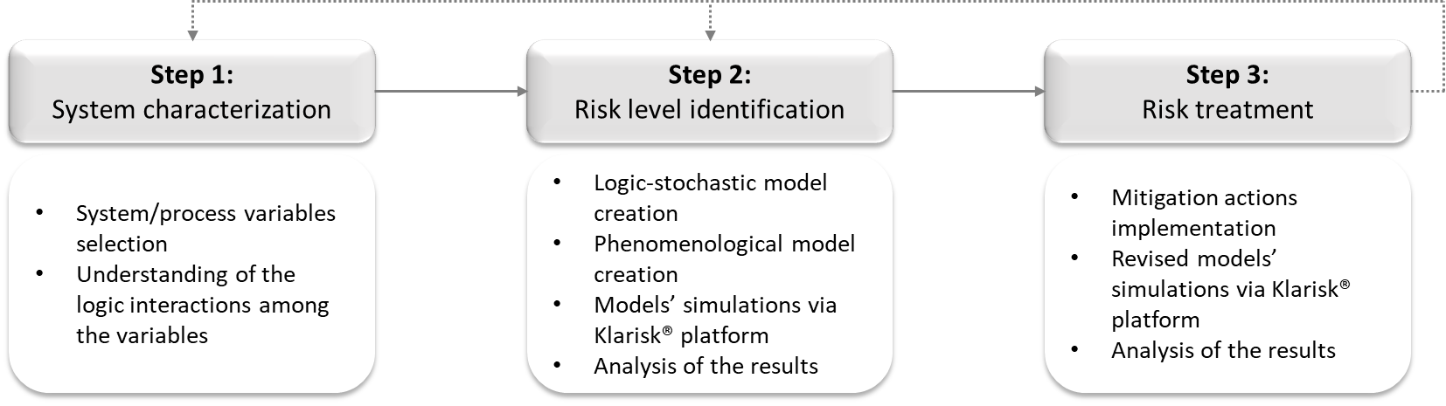

*Figure 1: Graphic representation of the steps needed for the HoRAM method*

* 1. Results

In the following chapter, a presentation of the application of the HoRAM method for the risk assessment of the production processes of OSC and PSC is provided.

* + 1. System characterization

When starting the analysis with the HoRAM method, the preliminary step is to define the aim and scope of the analysis. This part of the analysis process aims to describe risks, considered as potential gains and losses (i.e., pure and speculative), within the production processes of OSCs and PSCs. The analysis includes operational, technical, safety, environmental, and market-related variables. Despite significant variations in OSC and PSC types, their fundamental structure remains similar. An active layer at the core, responsible for the photovoltaic effect, distinguishes the cell. OSC utilizes organic molecules, while PSC incorporates a perovskite crystalline structure as active layer. Transport layers above and below extract charges, and electrodes on both sides create the electric circuit to collect generated electricity. Transparent electrodes enable light penetration. These layers, deposited over glass or plastic substrates depending on the desired flexibility, are sealed with encapsulation to prevent air, moisture, and water intrusion (S. Chen et al., 2020). Numerous configurations that could include the presence of interlayers and/or the integration of two layers in a single one, reveal the absence of a unique ideal setup. Each layer and production method present pros and cons, necessitating system integration for efficient and stable solutions. Fabrication methods are characterised by different deposition techniques that impact efficiency, cost, and scalability. This study focuses on solution-based processes, known for achieving high efficiencies and their suitability for large-scale manufacturing. The configurations for both OSC (taken from the study of (Koppitz et al., 2018; Tam et al. 2022)) and PSC (adapted from the studies of (Awais et al., 2022; H. Li et al., 2022; Lim et al., 2020; Yun et al., 2019; Tam et al. 2022)) shown in Figure 2a and 2b and detailed in Table 1, represent the chosen use cases for these emerging solar technologies.

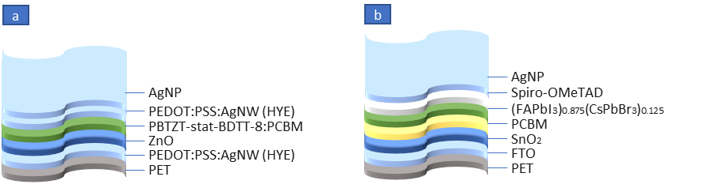

*Figure 2: a) OSC and b) PSC cell architectures*

Table 1: OSC and PSC layer composition

|  |  |  |
| --- | --- | --- |
| **Layer** | **OSC** | **PSC** |
| Substrate  Bottom electrode  Electron Transport Layer  Interlayer  Active Layer  Hole Transport Layer  Top Electrode | PET  PEDOT:PSS:AgNW (HYE)  ZnO  -  PBTZT-stat-BDTT-8/PCBM  PEDOT:PSS:AgNW (HYE)  AgNP | PET  FTO  SnO2  PCBM  (FAPbI3)0.875(CsPbBr3)0.125  spiro-OMeTAD  AgNP |

Around 3,000 variables were selected after performing a functional analysis and a Gantt chart based on an extensive literature review other than expert interviews. The selected variables include technical failures, delays, waste of materials, occupational and environmental accidents, leakages, and spills, always considering both logic-stochastic (i.e., probability and logical interactions of the events) and phenomenological aspects (i.e., associated costs in the occurrence of each event). Capital investments (i.e., machinery cost, etc.) and operating costs (i.e., material-related expenses, rent, taxes, utilities, salaries, etc.), fluctuating based on market responses, are also included and calculated based on the annual production that the company is willing to achieve and the number of processes required to produce the selected cell configuration in the large-scale production.

* + 1. Risk level identification

The variables considered allowed the creation of a generalized model structure that offers significant advantages due to its flexible and adaptable nature. By considering a broader range of variables that include various processes and steps, even those not required for the analysis of the cell configurations under exam, it provides flexibility in analysis. This means that if a different setup, such as a different cell configuration, needs to be analysed, it will be a matter of activating the relevant variables already present in the model and adjusting their probability and impact values, without the need to undergo the process of selecting new variables.

To gain a more detailed understanding of the outcomes, the model followed a two-step simulation process. Initially, the authors activated variables related solely to process uncertainties, disregarding potential fluctuations in capital expenditure (CAPEX), operating expenditure (OPEX), and raw material costs. Subsequently, a second simulation incorporated to the found spectrum of potential contributions arising from process uncertainties the variability of the aforementioned factors. This comprehensive approach aimed to derive a holistic cost production range for both PSCs and OSCs in their chosen configurations.

The simulated universe, equal in size for the two types of cells, comprised 810 scenarios. Notably, the residual probability (indicating the portion of the universe not analysed) was zero, meaning that the results are coming from the analysis of the entire universe rather than a portion of it.

Before delving into the findings, it is important to highlight the difference in complexity between the chosen organic and perovskite use cases. The organic configuration is characterized by a simpler structure and production process and, thus, incurred in substantially lower CAPEX and OPEX compared to the intricate perovskite counterpart. The configuration choice is also reflected in the process unreliability, where a more complex process inherently carries higher risks, particularly concerning machinery failures and delays.

In light of these considerations, PSCs emerged as comparatively more expensive than OSCs, as indicated in Table 2. Given the considered uncertainty factors related to process unreliability and price fluctuations, the expected cost of production for OSCs is 134€/m² and its variability ranges from 109€/m² (minimum value corresponding to the best-case scenario) to 482€/m² (maximum value corresponding to the worst-case scenario), while PSCs are expected to be approximately 148€/m², with a minimum of 122€/m² and a maximum of 920€/m² in the worst-case scenario.

Table 2: Production costs for OSCs and PSCs



Assuming constant CAPEX and OPEX, further analysis illustrated distinct contributors to the final cost, as shown in Figure 3a and 3b. The results highlighted different behaviours for OSCs and PSCs, with material costs significantly influencing OSCs, especially in their minimum and expected values. In contrast, PSCs were more impacted by CAPEX, OPEX, and operational costs than material expenses.

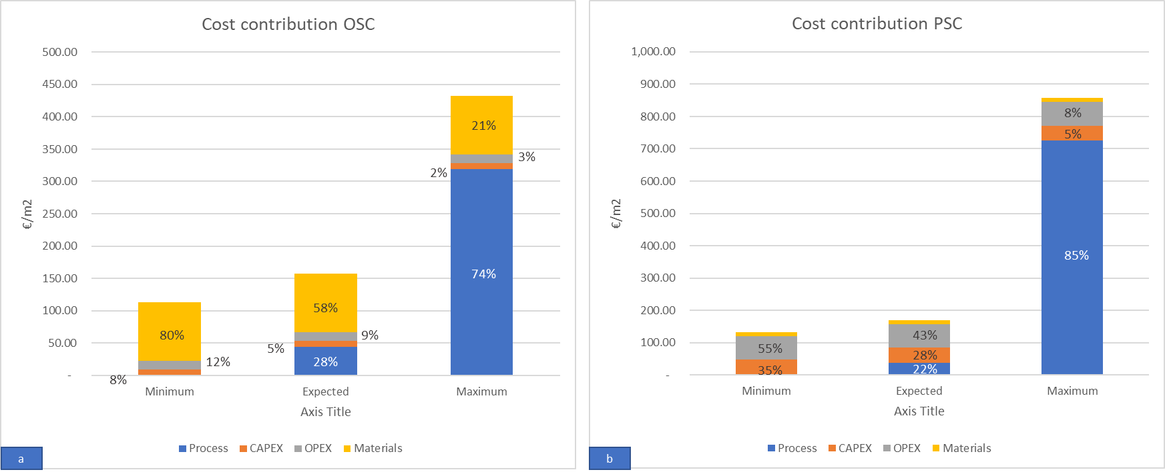

*Figure 3: Cost contributions for a) OSCs and b) PSCs*

The cloud-based platform Klarisk offers as decision-making tools also the Complementary Cumulative Distribution Function (CCDF) and the Risk Distribution Function (RDF). Figure 4 (compared CCDF) highlighted that OSCs are much less risky than PSCs, and this can be derived by the fact that the curve for OSCs (in blue) is lower (for nearly its entire extension) than the one of PSCs (in yellow) along with the entire x-axis (i.e., magnitudes, €/m²). Figure 5 (RDF) reinforced this observation, highlighting the extended risk classes for PSCs (in yellow) with respect to those of OSCs.

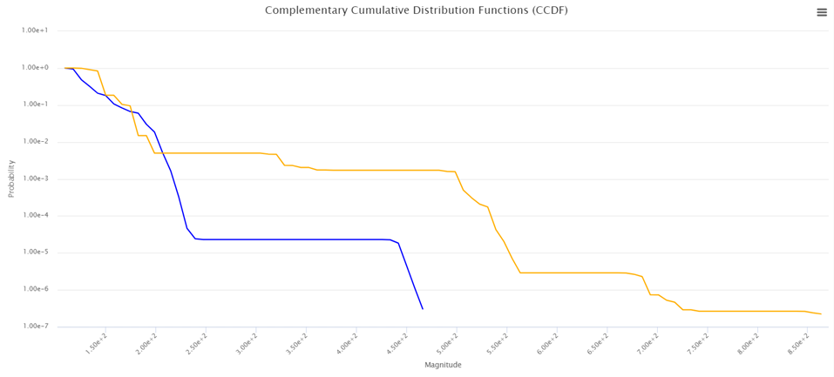

Figure 4: Compared CCDF of OSCs (blue line) and PSCs (orange line)

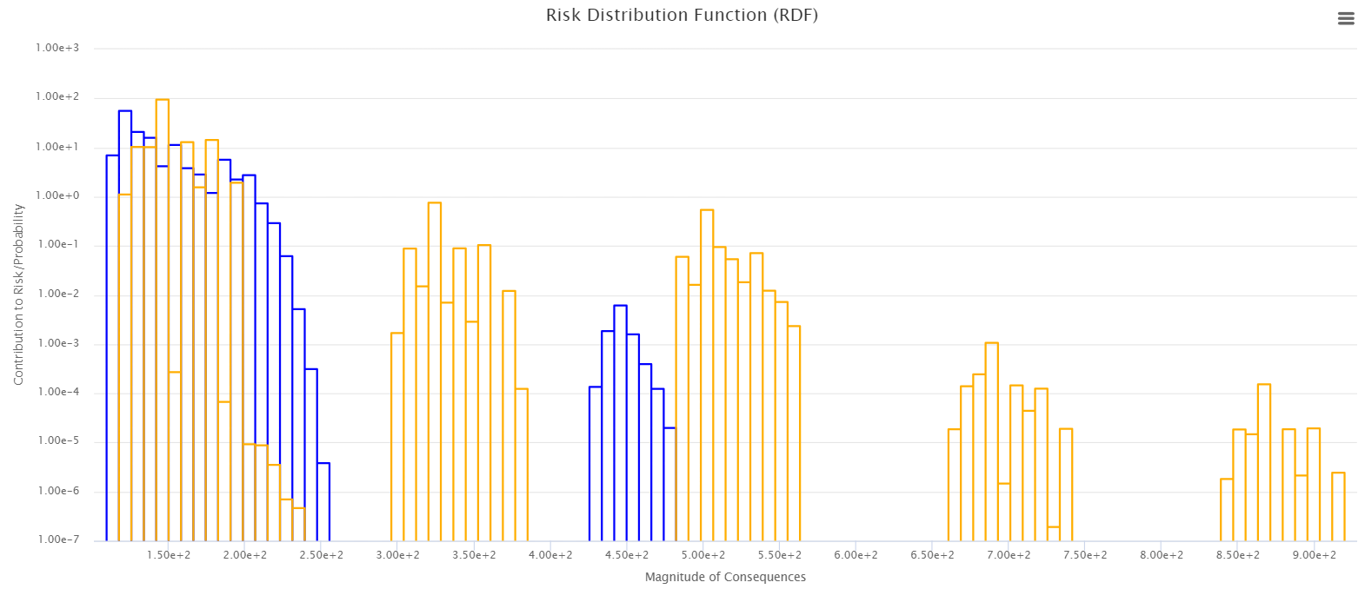

Figure 5: Compared RDF for OSCs (blue spectrum) and PSCs (orange spectrum)

* 1. Discussion and conclusions

This paper highlights the critical importance of conducting comprehensive risk assessments, particularly for emerging technologies, to adopt a risk-by-design approach and facilitate their successful market penetration. The use of HoRAM as a methodological framework was aimed at verifying its suitability, given that its interesting flexibility and interdisciplinary nature can enable more holistic studies.

To validate the efficacy of the HoRAM method, this study applied it to the risk assessment, specifically focusing on the cost of production, for two use cases: a PSC and an OSC configuration. The results, related to the chosen configurations, showed that OSCs are less risky to produce than PSC. A clear exemplification of this outcome is given by their expected production cost, which is 134€ and 148€ respectively. A detailed analysis of the cost contributors provided by this study could be of relevance for researchers and companies which aim to invest in these technologies, given that such a study enables more strategic planning and resource allocation for the development and commercialization of PSCs and OSCs. Indeed, the outcomes of this study provide valuable insights that can support decision-making processes, guiding stakeholders in identifying and implementing effective mitigation strategies to decrease the highlighted risks. Moreover, these results allow stakeholders to make informed investment decisions for future technological advancements.

It is worth to note that additional simulations incorporating mitigation actions should be conducted to refine recommendations and provide more detailed insights (step 3 of the HoRAM method). For example, it could be of interest to change the dimensions of the modules to understand if the proportion of costs is maintained. Modifying the configuration of the cells, thanks to the flexibility of the generalised model at the basis of the study, emerges as another viable solution to explore and assess. This adaptability enables stakeholders to select and activate processes as needed, offering a dynamic approach to address potential risks.

References

Awais, M., Thrithamarassery Gangadharan, D., Tan, F., & Saidaminov, M. I. (2022). How to Make 20% Efficient Perovskite Solar Cells in Ambient Air and Encapsulate Them for 500 h of Operational Stability. *Chemistry of Materials*, *34*(18), 8112–8118. https://doi.org/10.1021/acs.chemmater.2c01422

Carneiro, A. L., Martins, A. A., Duarte, V. C. M., Mata, T. M., & Andrade, L. (2022). Energy consumption and carbon footprint of perovskite solar cells. *Energy Reports*, *8*, 475–481. https://doi.org/10.1016/j.egyr.2022.01.045

Chen, B., Yang, Z., Jia, Q., Ball, R. J., Zhu, Y., & Xia, Y. (2023). Emerging applications of metal-organic frameworks and derivatives in solar cells: Recent advances and challenges. *Materials Science and Engineering R: Reports*, *152*(December 2022), 100714. https://doi.org/10.1016/j.mser.2022.100714

Chen, S., Deng, Y., Gu, H., Xu, S., Wang, S., Yu, Z., Blum, V., & Huang, J. (2020). Trapping lead in perovskite solar modules with abundant and low-cost cation-exchange resins. *Nature Energy*, *5*(12), 1003–1011. https://doi.org/10.1038/s41560-020-00716-2

Colombo, S. (2019). The Holistic Risk Analysis and Modelling (HoRAM) method. *Safety Science*, *112*, 18–37. <https://doi.org/10.1016/j.ssci.2018.09.018>

IEA. (2023). Europe’s energy crisis: Understanding the drivers of the fall in electricity demand.

Koppitz, M., Wegner, E., Rödlmeier, T., & Colsmann, A. (2018). Hot‐Pressed Hybrid Electrodes Comprising Silver Nanowires and Conductive Polymers for Mechanically Robust, All‐Doctor‐Bladed Semitransparent Organic Solar Cells. *Energy Technology*, *6*(7), 1275–1282. https://doi.org/10.1002/ente.201700960

Li, H., Zuo, C., Angmo, D., Weerasinghe, H., Gao, M., & Yang, J. (2022). Fully Roll-to-Roll Processed Efficient Perovskite Solar Cells via Precise Control on the Morphology of PbI2:CsI Layer. *Nano-Micro Letters*, *14*(1), 79. https://doi.org/10.1007/s40820-022-00815-7

Lim, K.-S., Lee, D.-K., Lee, J.-W., & Park, N.-G. (2020). 17% efficient perovskite solar mini-module *via* hexamethylphosphoramide (HMPA)-adduct-based large-area D-bar coating. *Journal of Materials Chemistry A*, *8*(18), 9345–9354. https://doi.org/10.1039/D0TA02017F

Li, Z., Klein, T. R., Kim, D. H., Yang, M., Berry, J. J., van Hest, M. F. A. M., & Zhu, K. (2018). Scalable fabrication of perovskite solar cells. *Nature Reviews Materials*, *3*(4), 18017. <https://doi.org/10.1038/natrevmats.2018.17>

Tam, K. C., Saito, H., Maisch, P., Forberich, K., Feroze, S., Hisaeda, Y., Brabec, C. J., &#38; Egelhaaf, H.-J. (2022). Highly Reflective and Low Resistive Top Electrode for Organic Solar Cells and Modules by Low Temperature Silver Nanoparticle Ink. *Solar RRL*, 6(2). https://doi.org/10.1002/solr.202100887

Yun, A. J., Kim, J., Hwang, T., & Park, B. (2019). Origins of Efficient Perovskite Solar Cells with Low-Temperature Processed SnO 2 Electron Transport Layer. *ACS Applied Energy Materials*, *2*(5), 3554–3560. https://doi.org/10.1021/acsaem.9b00293