|  |  |
| --- | --- |
| cetlogo ***CHEMICAL ENGINEERING TRANSACTIONS***  ***VOL. xxx, 2024*** | A publication of  aidiclogo_grande |
| The Italian Association  of Chemical Engineering  Online at www.cetjournal.it |
| Guest Editors: Valerio Cozzani, Bruno Fabiano, Genserik Reniers  Copyright © 2024, AIDIC Servizi S.r.l. **ISBN** 979-12-81206-11-3; **ISSN** 2283-9216 | |

Experimental study of aluminum flame propagation in duct with obstacles

Clément Chanuta, Farès Saad Al Hadidia, Frédéric Heymesa, Ernesto Salzanob,\*

aLaboratoire des Sciences des Risques, IMT Mines Alès, Alès, France

bDipartimento di Ingegneria Civile, Chimica, Ambientale e dei Materiali, Università di Bologna, Bologna, Italy

ernesto.salzano@unibo.it

To accurately model the consequences of accidental dust explosions, numerical simulations of the flame propagation process are required. A key parameter in these models is the burning velocity ($S_{u}$), which represents the consumption rate of the reactants by the flame front. Experiments are therefore needed to determine the burning velocity, and the influence of turbulence on this velocity; as well as to validate these models of flame propagation. In this article, aluminum flame propagation inside a vertical duct with obstacles is studied. The aim of the obstacles is first to increase the turbulence just in front of the flame front, in order to quantify its influence on the burning velocity. The second objective of the implementation of the obstacles is to obtain experimental data in a more complex geometry in order to validate the models. During these experiments, the flame propagation is recorded and the unburned flow velocity is measured using the TR-PIV (Time-Resolved Particle Image Velocimetry) technique. This innovative measurement of the unburned flow velocity is important not only for the accurate determination of the burning velocity, but also to validate these numerical simulations. An increase in the propagation velocity and the burning velocity is observed as the flame propagates toward the obstacles.

* 1. Introduction

Dust explosions represent a major risk in many industrial sectors (food processing, pharmaceuticals, metallurgy, etc.). However, the mechanism of flame propagation during such an explosion is not well understood, especially for metallic dusts (Goroshin et al., 2022). Predicting the consequences of a dust explosion in an accidental situation is mandatory for risk analysis. To model accurately these consequences, numerical simulations of the flame propagation process are required. A key parameter of the model is the burning velocity (Su), which represents the consumption rate of the reactants by the flame front (Skjold, 2007). Experiments are therefore needed to determine this burning velocity, and the influence of turbulence on this velocity; as well as to validate these models of flame propagation. To validate the models, experiments with more complex geometries are generally studied, for example by inserting obstacles to disturb the flame propagation process.

Experimental estimation of the burning velocity is still challenging, especially for non-volatile dusts such as metals (Goroshin et al., 2022). Different experimental setups and analysis methods can be used to deduce the burning velocity. Burning velocity can be determined by studying stabilized flames (Goroshin et al., 1996; Julien et al., 2017) or confined explosions (Dahoe and de Goey, 2003). Nevertheless, the mechanism of flame propagation cannot be analyzed with these experimental setups. Burning velocity can also be deduced by visualizing the propagation of the flame in tubes; this burning velocity is generally determined by using the so-called “open-tube method” (Di Benedetto et al., 2011). The main limits of this method are the accurate measurement of the flame surface area and the estimation of the thermal expansion (usually estimated by assuming an adiabatic flame). Details of this method and of these limitations can be found in (Chanut et al., 2020). In this current paper, the burning velocity is deduced by using the “direct method” presented in a previous paper (Chanut et al., 2022).

While data on unburned flow velocity are important for validating flame propagation models, few studies have been carried out in the literature on the unburned flow velocity ahead of a propagating dust flame. Han et al. (2001) studied lycopodium dust flame propagation in a vertical duct (1800 mm high with 150 x 150 mm square cross-section). The flame is propagating from the open bottom end up to the closed top end of the prototype, thus with a low propagation velocity. These authors synchronized a laser with a camera to obtain the particles velocity ahead the flame front and the variations of concentration near the flame front. Proust (2006) studied some dust flames (starch dust, sulphur flower and lycopodium) propagating in a vertical duct (1500 mm high with 100 x 100 mm square cross-section). The flame is propagating from the open bottom end up to the closed top end of the prototype. This author synchronized a laser with a camera to obtain an estimation of the unburned flow velocity ahead the flame.

In this article, experiments are carried out to study the influence of obstacles on the propagation of aluminum flames. These experiments have two main objectives. The first objective is to obtain data on the evolution of the burning velocity and on the influence of turbulence on this burning velocity. Indeed, the insertion of obstacles increases the turbulence level just ahead of the flame front. In addition, the second objective of these experiments is to obtain useful data for accurately validating numerical simulations. For this purpose, the propagation of the flame front will be studied but also the unburned flow just ahead the flame front. The experimental study of the unburned flow just ahead the fast-propagating flame of metal dust is challenging, innovative and mandatory for the development and the validation of numerical models. This measurement of the unburned flow velocity is based on the TR-PIV (Time-Resolved Particle Image Velocimetry) technique.

* 1. Materials and Methods
     1. Experimental setup

The prototype used to study the influence of obstacles on flame propagation is adapted from a prototype previously described in (Chanut et al., 2022). This prototype is a vertical tube divided into three different sections (700 mm height for each section and 150 x 150 mm square cross-section). Dust is injected only into the two lower sections of the prototype by the discharge of pressurized vessels connected to injection tubes located in the corners of the prototype. The dust cloud is ignited by an electrical spark located in the lower part of the prototype, 1 second after the end of the dust dispersion (closure of the valves). The injection system on each section of the prototype and the dispersion at moment of ignition have been widely studied in a previous work (Asquini, 2019). The flame propagates from the closed bottom end of the prototype up to the open top end of the prototype; an exhaust duct is located at the top of the third section of the prototype.

For these experiments, fence-type obstacles are located on two opposite walls in the upper section of the prototype. The location and dimensions of the obstacles are detailed in Figure 1. The blockage ratio, defined as $BR=2h/l$ where $h=25 mm$ is the obstacle height and $l=155 mm$ is the channel height, is set at 0.32. The thickness of the obstacles is set at 15 mm. The distance between two successive obstacles is 135 mm.

Aluminum powder with a mean diameter of 20 microns is studied; the dust concentration is about 375 g.m-3. Dust concentration is estimated by weighing the powder inside the injection tube before and after each experiment.

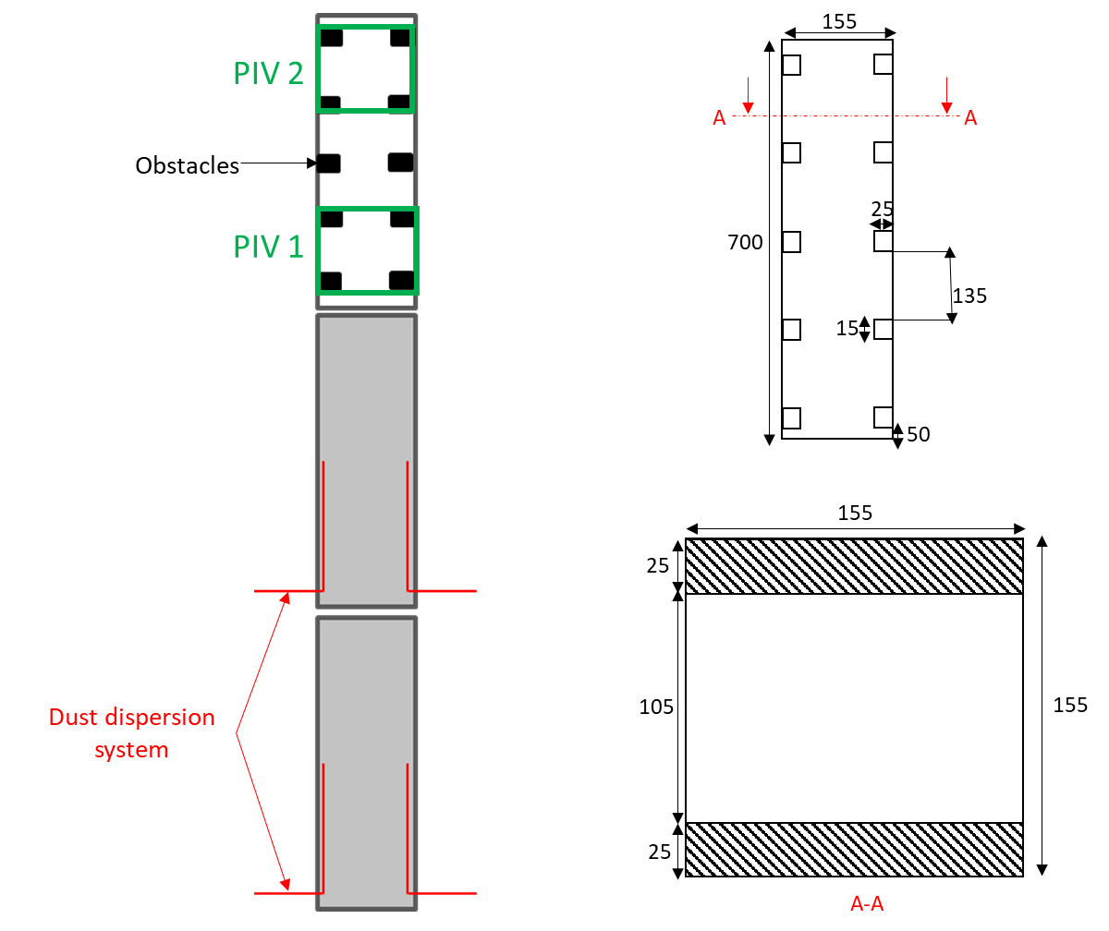

Figure 1: Presentation of the experimental setup (left) and details of the obstacle arrangement (right)

* + 1. Optical setup

The objectives of this study are to determine the evolution of the propagation velocity (i.e. the flame velocity in the laboratory referential) and the unburned flow velocity. These two data are important to validate numerical simulations but also to develop a model of the combustion process by determining the burning velocity.

Propagation velocity is obtained by visualizing the light emitted by the flame front using two high-speed cameras. The first one, a Photron SA3 camera, records the flame propagation in the two lower sections of the prototype. The second one, a Photron SA5 camera, records the flame propagation toward the obstacles in the upper section of the prototype.

TR-PIV (Time-Resolved Particle Image Velocimetry) technique is implemented to determine the unburned flow velocity ahead the propagating flame front. With this technique, using a high-repetition-rate laser synchronized with a high-speed camera, 2D maps of velocity vectors in a plane of the flow are deduced from an adaptative algorithm; DynamicStudio software is used to perform this analysis. As shown in Figure 1, a first PIV zone is set up between the two first obstacles using a TR-PIV LITRON 30-1000 (energy of 30 mJ at the frequency of 1 kHz) synchronized with a Phantom V711 camera. A second PIV zone is set up between the last two obstacles using a TR-PIV LITRON 15-1000 (energy of 15 mJ at the frequency of 1 kHz) synchronized with a Phantom V2512 camera. Both cameras are equipped with a band-pass filter to detect only the laser light scattered by the particles.

* + 1. Method for estimating the burning velocity

The method for estimating the burning velocity, from the propagation velocity (Vp) and the unburned flow velocity (Ug), is adapted from the method presented in a previous paper (Chanut et al., 2022) and is illustrated in Figure 2.

First, the propagation velocity is determined from the images of the direct visualization of the light emitted by the flame front. Then, the unburned flow velocity field is determined from the images obtained by TR-PIV. The unburned flow velocity just ahead the flame front (Ug) is determined as the spatial mean of 20 velocity vectors (17 mm) along the horizontal axis located just ahead of the detected flame front. The burning velocity is then deduced as the difference between the propagation velocity and the local unburned flow velocity.

This measurement is therefore a direct local measurement of the burning velocity at the tip of the flame front (center of the channel). The red square in Figure 2 shows the zone extracted for this analysis.

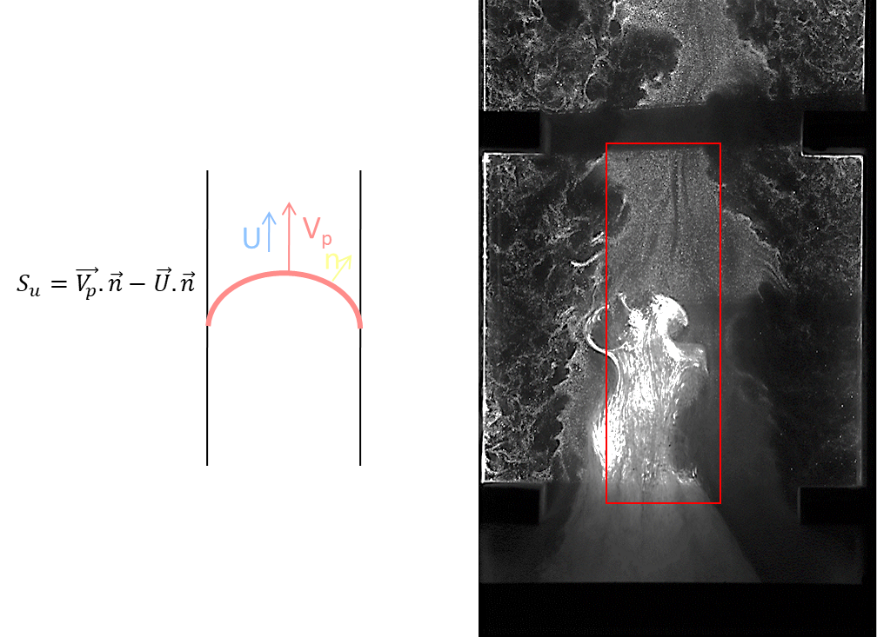

Figure 2: Illustration of the method for estimating the burning velocity

* 1. Results
     1. Visualization of the unburned flow

The unburned flow is recorded using the TR-PIV technique. Images of the evolution of the fresh dust cloud between the first two obstacles are shown in Figure 3; below the images, the indicated time is relative to the ignition of the dust cloud. The dust is initially dispersed only on the first two sections of the prototype. Then, due to the thermal expansion of the burned products, the dust clouds is pushed toward the third section, i.e. between the obstacles. From these images, we can observe that the dust cloud is highly heterogenous; the cloud is more concentrated in the center of the prototype than near the walls, due to the presence of the obstacles.

These data could be qualitatively compared with simulations of dust transport (dispersion) due to the propagating flames (thermal expansion) in the presence of obstacles (more complex geometry). In addition, from these images, unburned flow velocity field is obtained over time and can be quantitatively compared with numerical simulations to validate the modeling of the fresh flow and of the turbulence.

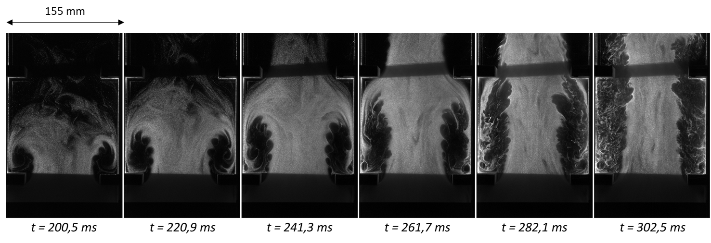

Figure 3: Evolution of the dust cloud between the two first obstacles

* + 1. Visualization of the flame propagation process

The light emitted by the flame front is recorded by high-speed cameras in order to study the flame propagation process. Figure 4 shows the evolution of the position of the flame front over time for the three sections of the prototype; as previously mentioned, obstacles are only implemented on the third section. This figure also shows an image of the flame front on the second section (on the left) and an image of the flame on the third section with obstacles (on the right). On the first two sections of the prototype, the flame front is smooth and its shape is quite parabolic. On the third section equipped with obstacles, the flame surface area is higher and the flame front is more complex. A significant increase of the propagation velocity of the flame front is observed as the flame passes toward the third section equipped with obstacles.

Figure 5 shows the evolution of the propagation velocity of the flame front on the third section of the prototype. The green vertical lines represent the instant when the flame front reaches the start of an obstacle. The red dotted vertical lines represent the instants of the selected images shown in Figure 6. An influence of the obstacles on the propagation velocity is observed; the propagation velocity increases from around 10 m.s-1 when the flame reaches the first obstacle up to 25 m.s-1 when the flame reaches the top of the prototype.

From the images shown in Figure 6, we can observe that the flame front has a complex shape. A delayed combustion inside the recirculation zones (located between the adjacent obstacles) is also observed, leading to an increase of the flame surface area.

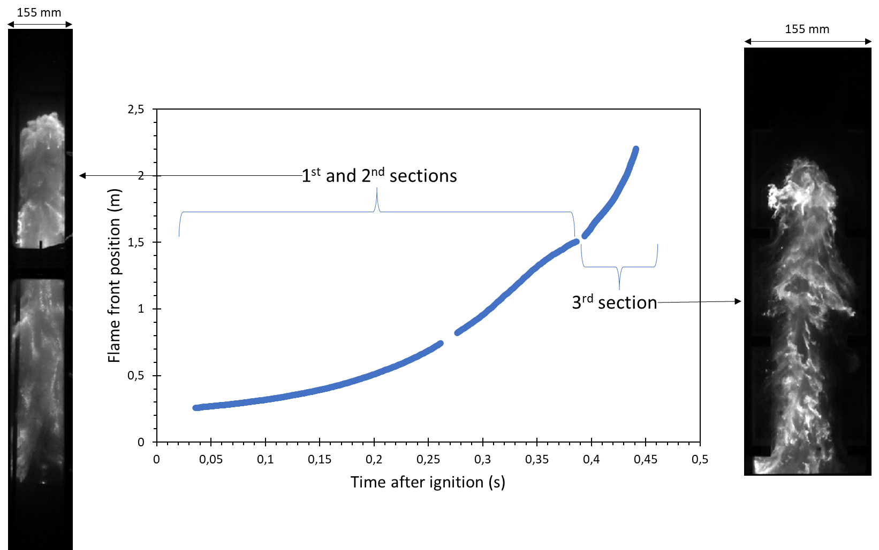

Figure 4: Evolution of the height of the flame front over time

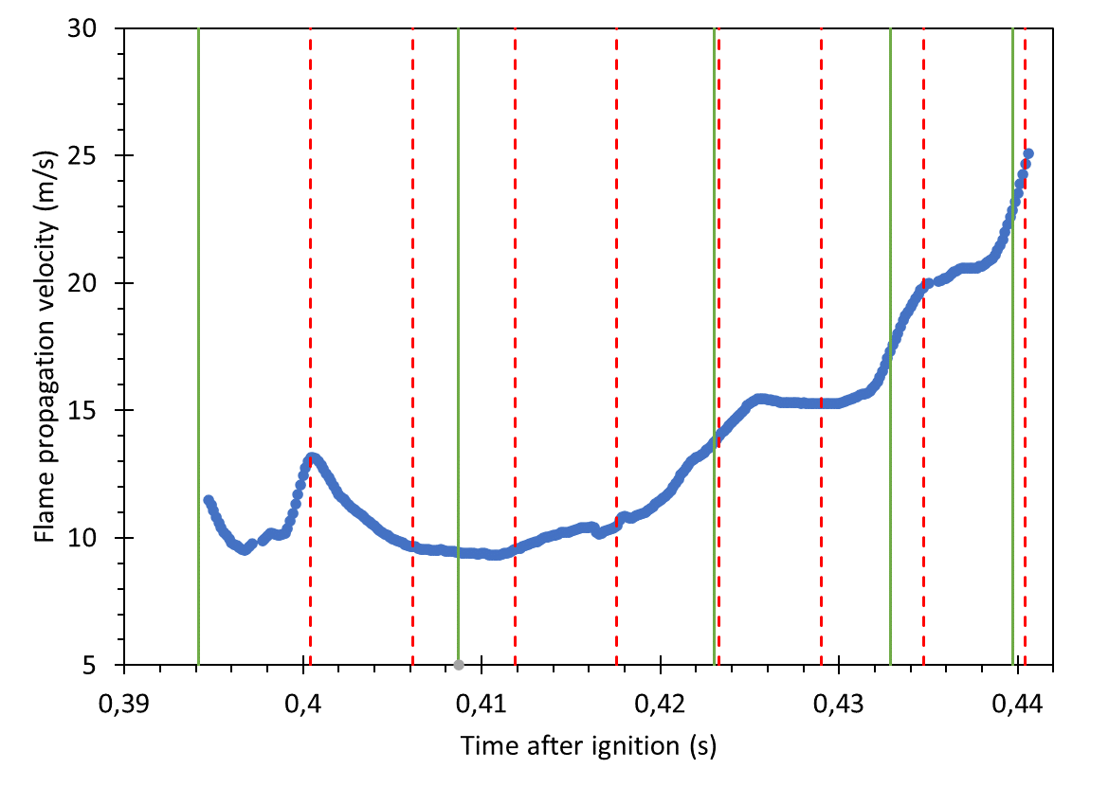

Figure 5: Evolution of the propagation velocity on the third section equipped with obstacles

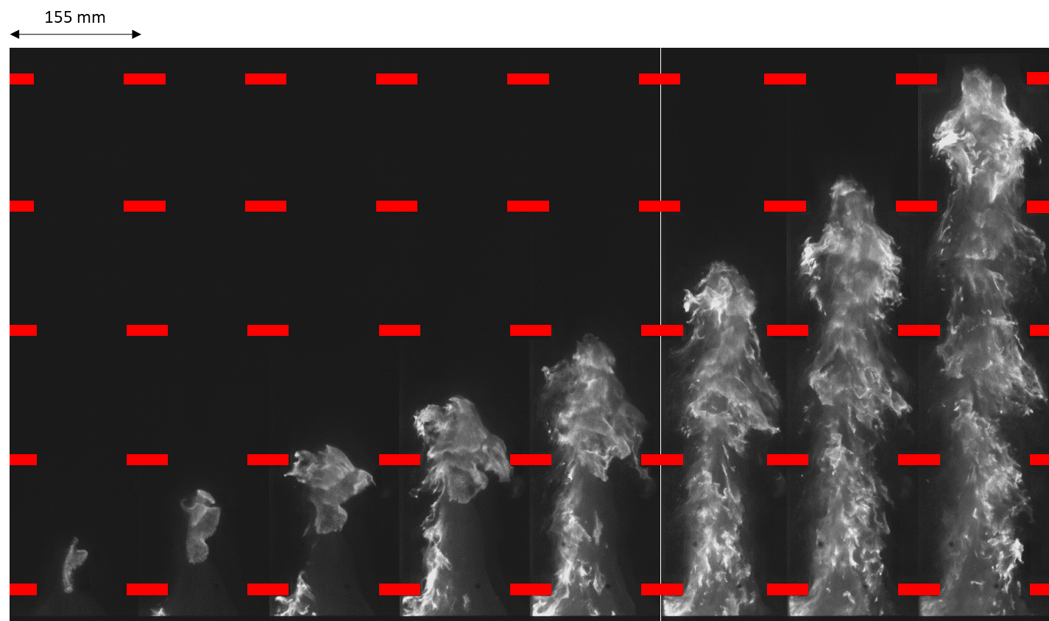

Figure 6: Selected images of the flame front propagation on the third section equipped with obstacles

* + 1. Estimation of the burning velocity

As previously mentioned, the flame propagation velocity and the unburned flow velocity just ahead the flame front can be obtained by analyzing the images. The difference between these two velocities corresponds to the burning velocity. A burning velocity of 1.1 m.s-1 is obtained for the “PIV zone 1” (zone between the first two obstacles) while a value of 5.1 m.s-1 is obtained for the “PIV zone 2” (zone between the last two obstacles).

The value of 5.1 m.s-1 may seem high. However, calculating this velocity “manually”, a value of around 5 m.s-1 is also obtained. To obtain “manually” this data, we measured the distance between the flame front and a “recognizable” part of the unburned flow (local gradient of concentration).

* 1. Conclusions

Experiments were carried out to analyze the propagation of aluminum dust flame inside a vertical tube equipped with obstacles. Aluminum with a mean diameter of 20 µm was studied. The two main objectives of the current study were:

* To determine the burning velocity, and the influence of turbulence on this burning velocity, in order to develop numerical models of aluminum flame propagation
* To obtain experimental data useful for validating these models in a more complex geometry (presence of obstacles)

The main innovative feature of this study is the measurement of the unburned flow velocity just ahead the propagating aluminum flame by TR-PIV (Time-Resolved Particle Image Velocimetry). This measurement is important for deducing the burning velocity without any assumptions about the flame temperature or the flame shape. In addition, these data are important for accurately validating the modeling of the flame propagation process. This measurement is difficult to implement in the case of propagating aluminum dust flame; which probably explains why this optical configuration has not been more widely used in the literature.

From these experiments, the influence of the obstacles on the flame propagation process has been studied. The dispersion by the obstacles of the unburned cloud, due to the thermal expansion induced by the propagating flame, has also been observed. By analyzing the data obtained by TR-PIV, the burning velocity has been determined by subtracting the unburned flow velocity at the center of the channel to the propagating velocity. Burning velocity up to 5 m.s-1 is measured while the flame reaches the top of the visualization part of the vertical prototype.

Simultaneous data of propagation velocity and unburned flow velocity are important for accurately validating the flame propagation models. Previous experiments have been carried out to study a stationary flow inside the section equipped with obstacles, in order to quantify the turbulence induced by the presence of these obstacles. For this purpose, preliminary experiments were carried out inside a wind tunnel equipped with the third section of the prototype equipped with obstacles. These preliminary experiments are important for validating the modeling of the obstacle-induced turbulence in numerical simulations. By this way, the turbulence can be validated with a stationary flow without modeling the combustion process.

Acknowledgments

The authors are grateful to IRSN (Institut de Radioprotection et de Sûreté Nucléaire) for scientific and financial support to this project.

References

Asquini, E., 2019. Influence of turbulence on flame propagation during dust explosion. Sapienza University of Rome. https://doi.org/10.5281/zenodo.3706671

Chanut, C., Al Hadidi, F.S., Heymes, F., Lopez, C., 2022. Simultaneous Measurement of Burning Velocity and Turbulence Intensity Ahead of the Flame Front during Aluminium Flame Propagation. Chem. Eng. Trans. 90, 391–396. https://doi.org/10.3303/CET2290066

Chanut, C., Heymes, F., Lauret, P., Lopez, C., 2020. Experimental determination of aluminum burning velocity during flame propagation in a tube. Chem. Eng. Trans. 82, 205–210. https://doi.org/10.3303/CET2082035

Dahoe, A.E., de Goey, L.P.H., 2003. On the determination of the laminar burning velocity from closed vessel gas explosions. J. Loss Prev. Process Ind. 16, 457–478. https://doi.org/10.1016/S0950-4230(03)00073-1

Di Benedetto, A., Garcia-Agreda, A., Dufaud, O., Khalili, I., Sanchirico, R., Cuervo, N., Perrin, L., Russo, P., 2011. Flame propagation of dust and gas-air mixtures in a tube 11–13.

Goroshin, S., Fomenko, I., Lee, J.H.S., 1996. Burning velocities in fuel-rich aluminum dust clouds. Symp. Combust. 26, 1961–1967. https://doi.org/10.1016/S0082-0784(96)80019-1

Goroshin, S., Pale, J., Bergthorson, J.M., 2022. Some fundamental aspects of laminar flames in nonvolatile solid fuel suspensions. Prog. Energy Combust. Sci. 91. https://doi.org/10.1016/j.pecs.2022.100994

Han, O.S., Yashima, M., Matsuda, T., Matsui, H., Miyake, A., Ogawa, T., 2001. A study of flame propagation mechanisms in lycopodium dust clouds based on dust particles’ behavior. J. Loss Prev. Process Ind. 14, 153–160. https://doi.org/10.1016/S0950-4230(00)00049-8

Julien, P., Whiteley, S., Soo, M., Goroshin, S., Frost, D.L., Bergthorson, J.M., 2017. Flame speed measurements in aluminum suspensions using a counterflow burner. Proc. Combust. Inst. 36, 2291–2298. https://doi.org/10.1016/j.proci.2016.06.150

Proust, C., 2006. Flame propagation and combustion in some dust-air mixtures. J. Loss Prev. Process Ind. 19, 89–100. https://doi.org/10.1016/j.jlp.2005.06.026

Skjold, T., 2007. Review of the DESC project. J. Loss Prev. Process Ind. 20, 291–302. https://doi.org/10.1016/j.jlp.2007.04.017