 CHEMICAL ENGINEERING TRANSACTIONS  VOL. xxx, 2024 | A publication of  
The Italian Association
of Chemical Engineering
Online at www.cetjournal.it

Guest Editors: Valerio Cozzani, Bruno Fabiano, Genserik Reniers
Copyright © 2024, AIDIC Servizi S.r.l.
ISBN 979-12-81206-11-3; ISSN 2283-9216

An Integrated Systems Thinking Approach for Assessing and Comparing the Safety of Hydrogen and Ammonia Storage
Julio Ariel Dueñas Santana^{a,}*, Almerinda Di Benedetto^{b} , Ernesto Salzano^{c}
ª Scuola Superiore Meridionale. School for Advanced Studies. Università degli Studi di Napoli Federico II. Largo S. Marcellino, 10, 80138, Napoli, Italia.
^{b} Dipartimento di Ingegneria Chimica, dei Materiali e della Produzione Industriale, Università degli Studi di Napoli Federico II, P.le Vincenzo Tecchio 80, 80125, Napoli, Italia
^{c} Dipartimento di Ingegneria Civile, Chimica, Ambientale e dei Materiali, Università degli studi di Bologna, Via Terracini 28, 40131, Bologna, Italia.
* julioariel.duenassantana-ssm@unina.it ; julio.duenas94@gmail.com
The increasing global demand for cleaner energy sources implies the use of H₂ which poses significant safety issues. One of the major safety issues in H₂ management is the storage, based on extreme condition technology (high pressure and/or very low temperatures). Alternatively, instead of H₂, ammonia may be used since storage of NH₃ is much simpler from a technological point of view. From a safety point, the comparison between the risk of H₂ storage and NH₃ storage has still to be understood. The energy (H₂) sector worldwide is a dynamic and complex system, relying on the mutual interactions between different factors like safety, risk, sustainability, political and social decisions, and economic impact. The understanding and management of global behaviour can be obtained by taking into account all the interactions among these factors. In order to deal with such complex systems, system thinking, and system dynamics approaches could be developed and used. The present work aims to develop an integrated Systems Thinking approach for assessing and managing the safety of storage systems with a particular focus on the comparison between hydrogen and ammonia. The developed models integrate the complex interdependencies considering material properties, environmental conditions, and storage infrastructure. Systems Thinking is used for mapping the intricate network of interdependencies, considering storage vessel design, regulatory frameworks, and emergency response plans. Therefore, by adopting this holistic perspective, potential vulnerabilities and leverage points of the system are identified which lead to improving the overall safety of gas storage systems. Additionally, this research explores the dynamic behaviour of safe storage under different scenarios, including temperature fluctuations, pressure changes, and potential leaks. The development of System Dynamics-based models offers valuable insights for policymakers, industry stakeholders, and researchers alike. The integration of a Systems Thinking approach allows for a better understanding of the complex interactions involved in the safe storage of these technologies for informed decision-making and advancements in gas storage technologies.
  - Introduction
Hydrogen has been recognized worldwide as a potential energy carrier in the present and in the near future by considering technology readiness and improvements (Cipolletta et al., 2022). One of the most crucial challenges linked to this fuel is linked with its storage. Several pathways have been implemented (in large or small scales) for hydrogen storage: (1) pressurised (gas) hydrogen (GH₂), (2) liquid hydrogen (LH₂), (3) liquid organic energy carrier (LOHC), (4) methanol (CH₃OH), and (5) liquid ammonia (NH₃). Among these storage technologies, GH₂ and NH₃ have been used on a major scale due to the technology and infrastructure readability. GH₂ can store 42.2_kgH₂/m³ , while NH₃ has a volumetric hydrogen content of 121 kgH₂/m³ (Aziz et al., 2020). Additionally, NH₃ as a hydrogen-carrier can compete with LH₂ because this last contains 70.8 kgH₂/m³, with methanol (99_kgH₂/m³) and with LOHC (47.3 kgH₂/m³) (Jeong et al.,2022). However, for extracting hydrogen from NH₃ an endothermic catalytic decomposition reaction is needed (Klerke et al., 2008). It requires around 30.6_kJ/mol.H₂, more energy than what is necessary for LH₂ (0.907 kJ/mol.H₂) or methanol (16.3 kJ/mol.H₂). Moreover, ammonia is well-known as a toxic substance, with an IDLH of 300 ppm, but due to its odor, which it can be detected even at low concentrations in the air (Tawalbeh et al., 2022). Also, NH₃ is much less flammable than H₂, being an asset for its safe storage.
Furthermore, the safe storage of H₂ is considered a complex task, due to the multiple interdependencies among the risk associated with the fuel properties, the incentives for the adoption of the fuel as a potential energy carrier, the government policies, the costs, the market acceptance, and the safety management itself (Dueñas Santana et al., 2024). Thus, how to address the complexity that emerged from the safe storage of H₂? One way to do so is using an integrated Systems Thinking approach (Salzano et al., 2014) by integrating Causal Loop Diagram (CLD), and Forrester Diagrams (System Dynamics-based models) (Sterman, 2002). This work aims to compare and assess the safe storage of GH₂ and liquid NH₃ (the most used hydrogen storage technologies) by providing an integrated Systems Thinking framework.
  - Methodology
The proposed integrated methodology is divided into three main stages. The first step focuses on building a CLD for capturing the complex interactions among the variables that can influence the adoption rate of the energy (H₂) storage technology. For this purpose, it is necessary to develop the feedback loops and connect the variables following the identified causalities. This stage proposes a new qualitative model (a CLD) for showing this interconnectedness, which is clarified by causal tracing (using Vensim software). The second stage goal is to develop a System Dynamics-based model for quantifying the fire and explosion, and the toxic and environmental risk linked to the hydrogen storage using GH₂ and NH₃. In this model, the property hazards, the operational risks, the consequences of a possible release, the volume risk factor, and the safety management strategies are considered. Additionally, the delays between the increased risk and the activation of the contingency plans are computed as well as the feedback loops between the risk factors and the safety management actions. Finally, the third stage aims to compare and analyze the safe storage of GH₂ and NH₃ by using the aforementioned developed models.
  - Results and discussion
In this section, the main results linked with the development of the three-stage proposed methodology are exposed and discussed.
    - Causal Loop Diagram for analysing the adoption of hydrogen storage technologies (Stage 1)
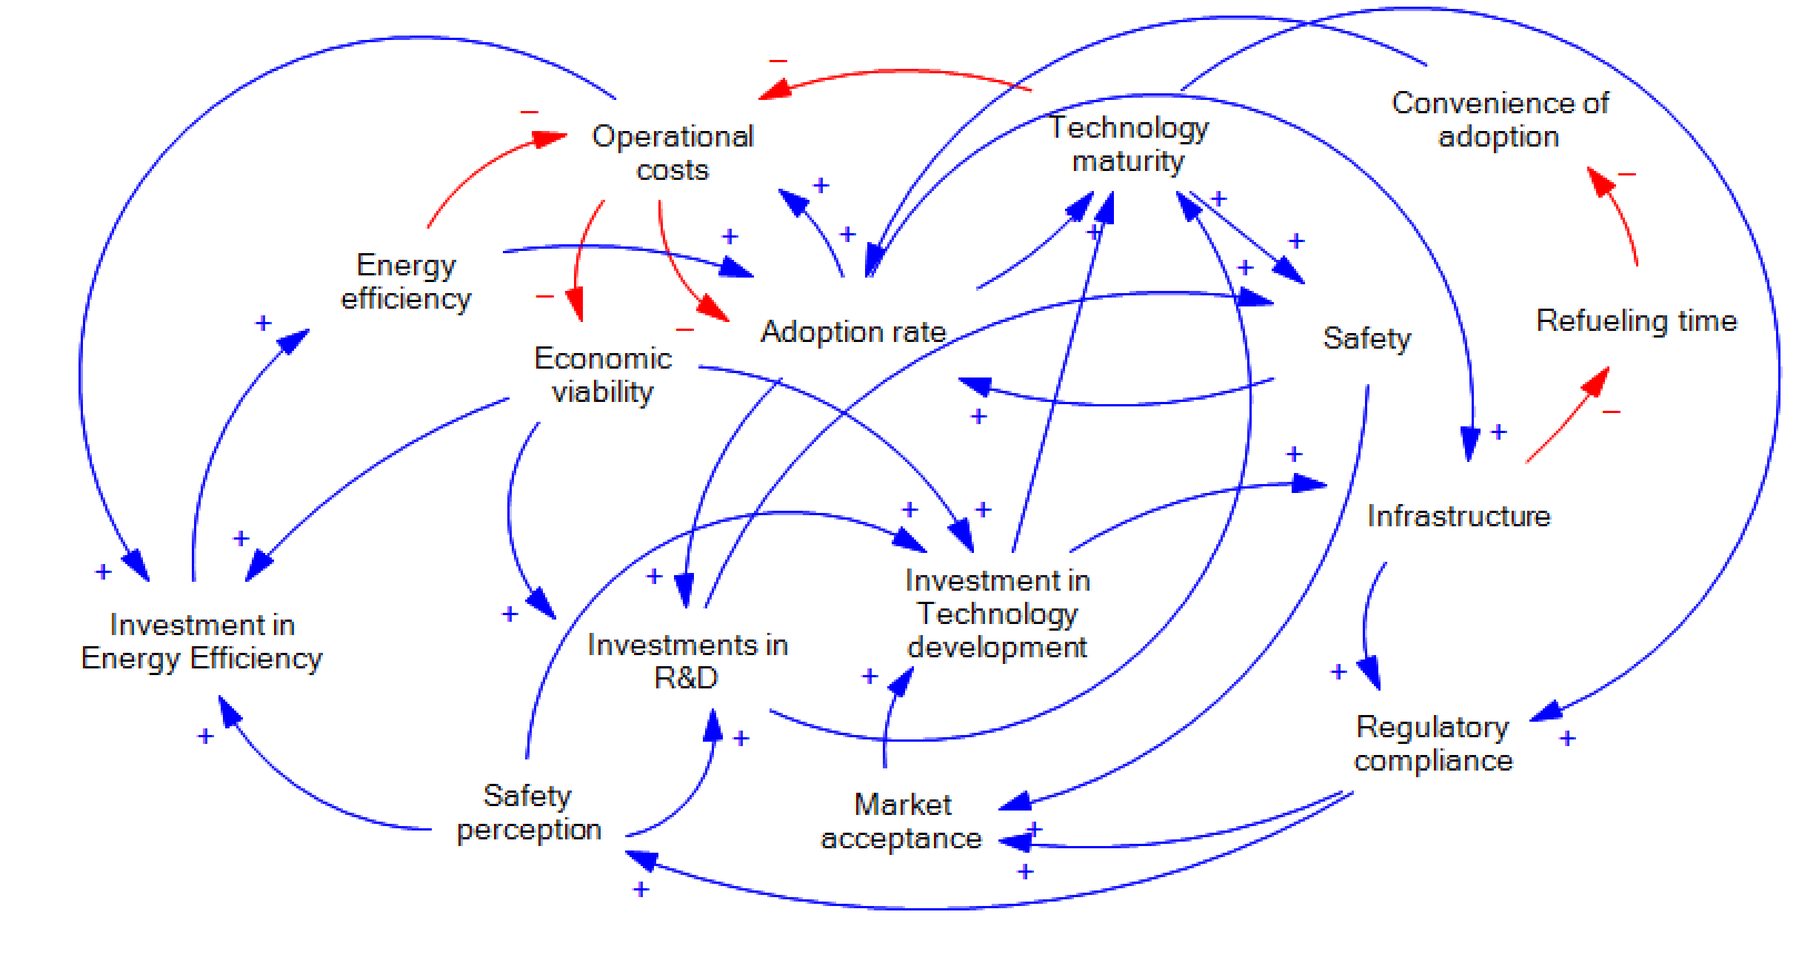
Table 1 shows the integrated feedback loops for building the CLD (Figure 1). In Figure 1, an arrow with a positive sign (+) means that an increase in the first variable increases the second variable above what it would otherwise have been; and an arrow with a negative sign (-) means that an increase in the first variable decreases the second variable below what it otherwise would have been.
Figure 1: CLD for analysing the adoption of hydrogen storage technologies
Table 1: Feedback loops for building the CLD by analysing the adoption of hydrogen storage technologies
No. | Feedback loop | Loop description
01 | Cost-driven adoption loop | As the cost associated with hydrogen storage technologies decreases (due to the effect of advancements in technologies, or scale economies), the adoption rate of these technologies increases. Then, higher adoption rates can lead to additional cost reductions by using increased production volumes and technology innovation.
02 | Technology maturity and safety loop | When hydrogen storage technologies mature, they become safer due to improved design, materials, and manufacturing processes. Enhanced safety features increase consumer confidence and regulatory acceptance, which accelerates the technology adoption itself.
03 | Refuelling time and convenience loop | Decreased refuelling time will lead to more convenience in using hydrogen as fuel, attracting more consumers, and stimulating infrastructure development (e.g., refuelling stations). Then, as infrastructure improves, refuelling times are going to decrease.
04 | Safety and regulatory compliance loop | Meeting regulatory safety standards enhances consumer confidence and market acceptance, driving increased investment in technology development and infrastructure. Then, compliance with standards also reduces the risk of accidents by reinforcing safety perception.
05 | Energy efficiency and cost reduction loop | Improvements in energy efficiency reduce the operational costs associated with hydrogen storage systems, making them more economically viable. Lower costs encourage further investment in energy efficiency technologies, driving a cycle of continuous improvement.
06 | Technology maturity and standards compliance loop | As hydrogen storage technologies mature, they become more likely to meet industry and regulatory standards for safety and performance. Then, this compliance with standards increases market acceptance, triggering further technology development.
07 | Safety and market acceptance loop | Safer hydrogen storage systems lead to more market acceptance, and more investments in safety features and technology, triggering safer hydrogen storage systems.
08 | Energy efficiency and adoption loop | Improvements in energy efficiency lead to a higher adoption rate, but this has associated more operational costs, which force investment in energy-efficient technologies, and in the end, this will bring more energy efficiency.

After building the CLD for analysing the adoption rate of hydrogen storage systems, it is possible to identify the causal relations of this variable and the main variables influenced as well (by causal tracing). Figure 2 shows the causal tracing for the adoption rate of hydrogen storage systems.
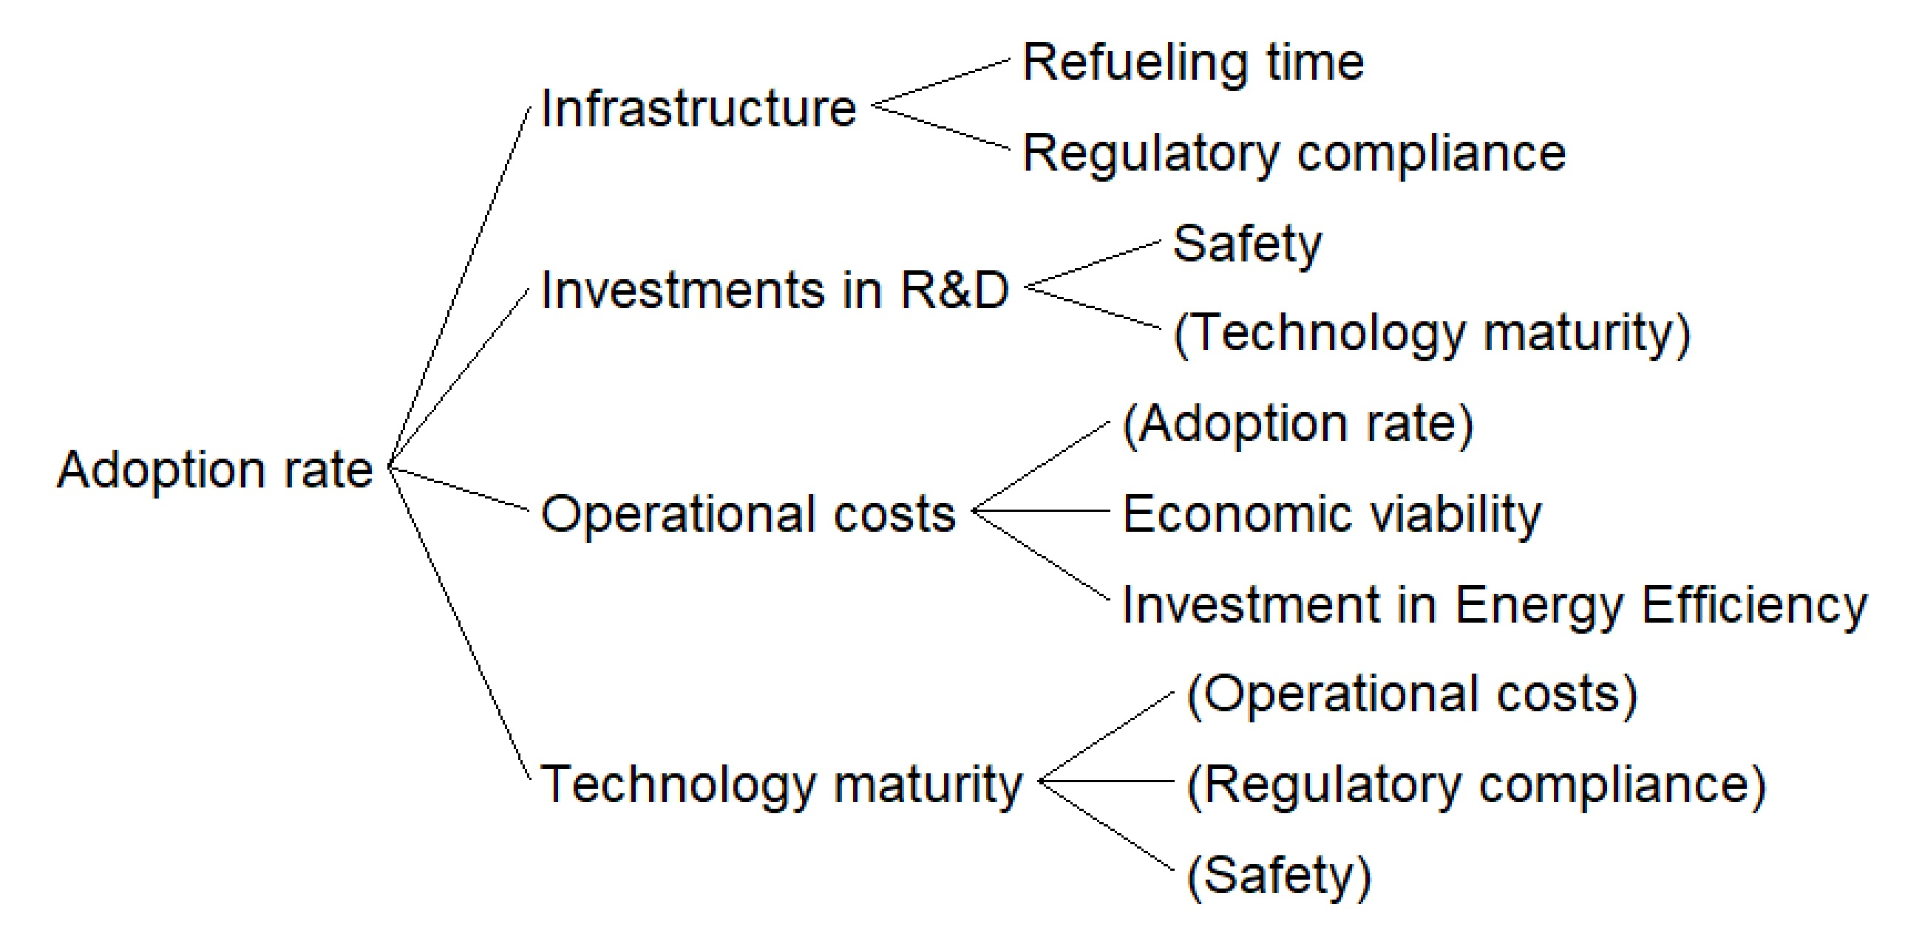
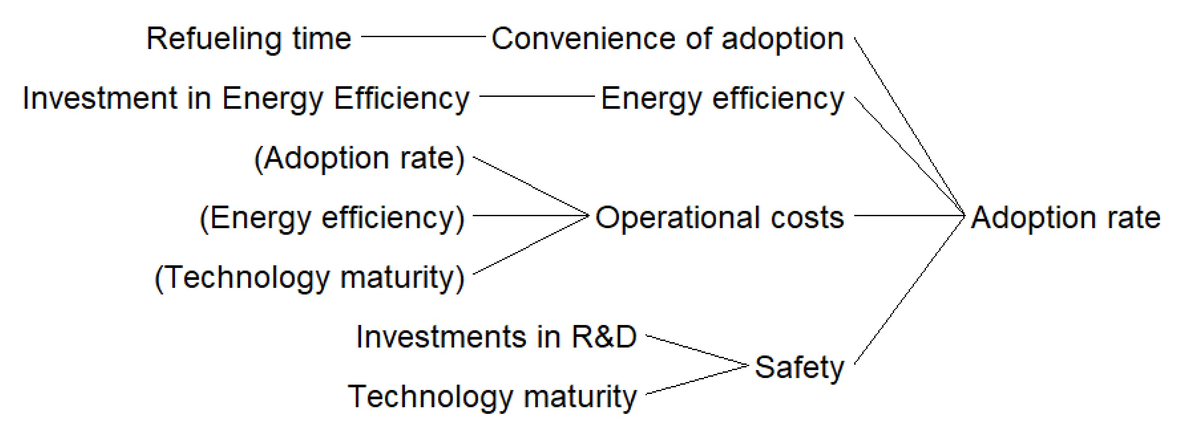
Therefore, the main identified variables linked with the increase in the adoption rate of hydrogen storage systems are the convenience of adoption, the energy efficiency, the operational costs, and the safety. From eight feedback loops, after considering the interconnections and loops, a huge amount of new feedback loops emerged, as a result of the complexity linked to this system. Figure 3 shows a complexity analysis considering the number of feedback loops linked to each variable and its maximum length.
Figure 2: Causal tracing for the adoption of hydrogen storage technologies

Figure 3: Complexity emerged from the developed CLD
The maximum number of feedback loops is 89, linked precisely to the analysed variable adoption rate, followed by technology maturity (85), and operational costs (75). Notice that the maximum length for each variable is 14, which means that this is a complex interdependent system.
    - System Dynamics-based model for hydrogen safe storage assessment (Stage 2)
For developing the System Dynamics (SD)-based model for hydrogen safe storage assessment, and for comparing GH₂ with NH₃, two main stocks are proposed (they represent accumulation): Fire and Explosion Risk, and Toxic and Environmental Risk. For each stock, there is an inflow rate (represented by the increased risk rate) and an outflow rate (represented by the safety management features). Moreover, the delay effects between the increased risk level and the activation of the contingency plans are considered. The other variables are auxiliary and represent the physical-chemical properties of each storage material, the scope of the possible scenarios (such as jet fires, VCE), and toxic properties and their scope. Figure 4 shows the developed SD-based model.
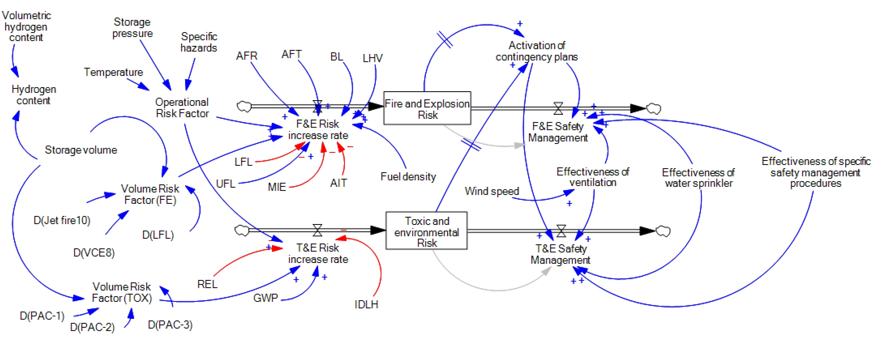
Figure 4: System Dynamics-based model for computing the risk associated with the hydrogen storage systems
Additionally, it is considered that an increase in the risks will trigger the activation of the contingency plans (which certain delay), and this will lead to better safety management in order to reduce the detected increased risk.

    - Assessment and comparison of hydrogen storage systems (Stage 3)
Figure 5 and Figure 6 show the dynamic risk for fires and explosions, and for toxicity and environmental impact respectively, by comparing the GH₂ and the NH₃, as well as, considering normal and poor safety management plans.

Figure 5: Comparison of the Fire and Explosion Risk associated with GH₂ and NH₃ considering good and poor safety management procedures using the developed SD-based model (left-normal scale, right-log scale)
Figure 6: Comparison of the Toxicity and Environmental Risk associated with GH₂ and NH₃ considering good and poor safety management procedures using the developed SD-based model (left-normal scale, right-log scale).
From the performed simulations, it is noted that the predominant risk associated with GH₂ is the fire and explosion risks, and the one linked to NH₃ is the toxic and environmental risk. This result was expected as it was clearly reported in the literature (Wen et al., 2023). It is a way to validate the proposed model. What is new is that as the delays were considered, it is important to highlight that these effects influence more the predominant risk associated with each hydrogen storage system.
Moreover, higher risk profiles were obtained when the safety management was considered poor, which is supported by the literature (Wijayanta et al., 2019). Also, the delay effects in the case of poor safety actions are weaker than for good safety. The action of the safety control measures leads to a gradual stabilization of the risk levels for both storage technologies. The maximum risk reached with good safety performance is lower than the minimum risk associated with a poor safety management application, reinforcing the idea that investing in safety will be of paramount importance for the adoption of storage hydrogen systems.
  - Conclusions
This research developed an integrated Systems Thinking approach for assessing and comparing gaseous hydrogen and liquid ammonia as hydrogen storage technologies. A Causal Loop Diagram is provided, by capturing the complex interdependencies linked to the adoption of the hydrogen storage systems in the market. Furthermore, a System Dynamics-based model is proposed to compute the fire and explosion risk and the toxic and environmental risk (as the stocks) associated with the storage of the aforementioned pathways.
The advantages of using the developed models and future research lines are as follows:
- The CLD can be further transformed into a Forrester Diagram, and in this way, it will be possible to quantify the adoption rate using real data.
- The SD-based model can be used in the presented form for assessing and comparing other hydrogen storage technologies.
- These two models can be used and extended for developing a unified framework for Risk Assessment and Safety Management in the chemical industry and the energy sector by considering the complex interdependencies among the economy, the environment, and society.
Overall, by considering a Systems Thinking framework, it is possible to capture the emerged complexity and the interaction among the analysed variables linked to the safety of hydrogen storage.

Acknowledgments
The authors gratefully acknowledge the financial contribution from the Scuola Superiore Meridionale and the University of Naples Federico II.

References

Aziz, M., TriWijayanta, A., & Nandiyanto, A. B. D, 2020, Ammonia as effective hydrogen storage: A review on production, storage and utilization. Energies, 13 (12), 3062.
Cipolletta, M. Casson Moreno, V, Cozzani, V, 2022, Green Hydrogen Production Routes: a Inherent Safety Assessment, Chemical Engineering Transactions 90, 55-60.
Dueñas Santana, J.A., Di Benedetto, A., González Gómez, O., Salzano, E., 2024, Towards sustainable hydrogen production: An integrated approach for Sustainability, Complexity, and Systems Thinking in the energy sector, Journal of Cleaner Production 449, 141751.
Jeong, S. Y., Jang, D., & Lee, M. C, 2022, Property-based quantitative risk assessment of hydrogen, ammonia, methane, and propane considering explosion, combustion, toxicity, and environmental impacts. Journal of Energy Storage, 54, 105344.
Klerke, A., Christensen, C. H., Nørskov, J. K., & Vegge, T, 2008, Ammonia for hydrogen storage: Challenges and opportunities. Journal of Materials Chemistry, 18 (20), 2304–2310.
Salzano, E., Di Nardo, M. Gallo, E. Oropallo, LC. Santillo, 2014, The application of System Dynamics to industrial plants in the perspective of Process Resilience Engineering, Chemical Engineering Transactions 36, 457-462.
Sterman, JD. System Dynamics: Systems Thinking and Modeling for a Complex World, 2002, Massachusetts Institute of Technology. Engineering Systems Division.
Tawalbeh, M., Murtaza, S. Z. M., Al-Othman, A., Alami, A. H., Singh, K., & Olabi, A. G, 2022, Ammonia: A versatile candidate for the use in energy storage systems. In Renewable Energy, 194, 955–977.
Wen, D., Liu, S., Ning, Z., Aziz, M, 2023, Techno-economic evaluation of hydrogen and ammonia as energy carriers in a multi-generation system. Energy Conversion and Management, 277, 116670.
Wijayanta, A. T., Oda, T., Purnomo, C. W., Kashiwagi, T., Aziz, M, 2019, Liquid hydrogen, methylcyclohexane, and ammonia as potential hydrogen storage: Comparison review. In International Journal of Hydrogen Energy, 29, 15026–15044.

