|  |  |
| --- | --- |
| cetlogo ***CHEMICAL ENGINEERING TRANSACTIONS***  ***VOL. xxx, 2024*** | A publication of  aidiclogo_grande |
| The Italian Association  of Chemical Engineering  Online at www.cetjournal.it |
| Guest Editors: Valerio Cozzani, Bruno Fabiano, Genserik Reniers  Copyright © 2024, AIDIC Servizi S.r.l. **ISBN** 979-12-81206-11-3; **ISSN** 2283-9216 | |

Risk Management of a SPA

Katerina Vichova\*, Slavomira Vargova, Marie Magulakova

Tomas Bata University in Zlín, Faculty of Logistics and Crisis Management, Studentske namesti 1532, 686 01 Uherske Hradiste, Czech Republic

[kvichova@utb.cz](mailto:kvichova@utb.cz)

A SPA is one of the types of health care. The legislation states that a healthcare facility is any space that is intended for the provision of health services. Furthermore, it is noted that one of the types of health care is medical rehabilitation care. This care is provided precisely on the premises of the SPA. The purpose is to maximally restore the client's physical, speech, sensory, and psychological functions.

However, in the SPA, it is also necessary to solve risk management. SPAs represent an infrastructural element and, at the same time, can be considered as a soft target. Therefore, significant attention must be paid to this issue, and the area of risk analysis for these elements be addressed. As part of the contribution, risk identification and analysis will be carried out. In the results of this paper, types of threats to SPA facilities will be published—methods such as brainstorming, What If analysis, and Ishikawa diagram will be used. Based on the performed analysis, recommendations for SPA facilities will be proposed.

* 1. Introduction

European Commission (2019) confirmed climate change is an existential threat to Europe and the world. Climate change has several adverse effects. European Parliament (2022) added that climate change brings long-term changes in average climate conditions that can reduce certain infrastructures' capacity, efficiency, and lifespan. Molina et al. (2020) stated that heat waves are among the most relevant extreme climatic events due to their societal impacts. This study confirmed Salimi and Al-Ghamdi (2020) and added that climate change has negative social and economic aspects, such as damaged infrastructure, energy shortage, water, and food scarcity. Dong et al. (2020) pointed out that based on numerous disasters, there is the risk of disruption in roadways cut off to critical facilities (such as healthcare facilities). Several publications confirmed that society depends on the functions of infrastructures, which are extremely important for the population, economy, state institutions, and organizations. (Rehak et al., 2024; Hromada et al., 2021; Novotny and Janosikova, 2020; Splichalova et al., 2020; Katopodis and Sfetsos, 2019; Cirdei, 2018; Rehak et al., 2017) It is these infrastructure elements that are exposed to adverse events. Kong (2024) stated that to mitigate the impact of these disasters, attention should be paid to natural disaster risk management. It added to Bernatik et al. (2013) that territorial risk analysis and mapping represent a problem that is becoming increasingly essential in connection with considerations about protecting territorial critical infrastructure. The growing interdependencies between infrastructure and sectors are the result of an increasingly cross-border and interdependent network of service provision using key infrastructure across the Union, among other sectors in health. (European Parliament, 2022) Health care is divided into several types: preventive, diagnostic, curative, etc. One of them is medical rehabilitation care. (Act, 2011) The purpose is to restore the patient's physical, cognitive, speech, sensory, and psychological functions to the maximum extent possible by eliminating functional disorders, replacing some function of his organism, or slowing down or stopping the disease and stabilizing his health. (Act, 2011) This care is provided precisely on the SPA premises. As was mentioned above, the SPA is one of the infrastructure elements. It is necessary to solve risk management there. The aim of this paper is to prepare the risk analysis of a SPA. The paper will be divided into methodology, central part - results, and discussion, with recommendations for protecting an SPA and crisis communication.

* 1. Methodology

This research was realized by the support of the European project Interreg V-A SK-CZ program with financial support from the European Regional Development Fund. Several scientific methods were used in this paper. Primarily, methods of risk analysis were used. Firstly, a What If analysis was used. This method is used to analyze the potential risks of the selected process. It is based on brainstorming, focusing on finding possible impacts. (Grasseova et al., 2012) This method is focused on analyzing a current state - identification of risks for the SPA. This method was divided into two parts – internal and external threats. Secondly, an Ishikawa diagram (Fishbone diagram) was used. This method logically stratifies an issue (product, process, or problem) into subgroups that meet fixed categories. Deposing the matters into rational subgroups is an essential aspect of all analyses. (Watson and Spiridonova, 2019) Next, several general methods were used, such as identification, comparison, and literature review.

* 1. Results

Crisis management represents a summary of activities, including risk analysis and evaluation. It is the risk analysis that is necessary for the adoption of additional measures that lead to the minimization of risks in a SPA. Risk analysis is carried out based on brainstorming. As mentioned in the methodology chapter, the What If method was first chosen for risk analysis in the SPA. The analysis of the risks leading to a possible crisis in the SPA sector focuses primarily on technical and social risks. The analysis does not consider risks based on the possible economic and demographic situation leading to an economic crisis in the SPA sector. The results of this method are shown in the following two tables.

Table 1: Risk analysis - internal threat

|  |  |  |  |
| --- | --- | --- | --- |
| Hazard/Threat | Possible Scenario |  | Action |
| Bomb threat  Booby trap  Forced entry  (hostage taking)  Fire  Receipt of suspicious shipment  Leakage of hazardous substance into the sewer  Soil contamination in the area of natural resource (water)  Gas leak  Gas explosion | Non-operational capability of the SPA object, damage of health/death, damage of property.  Explosion, damage of health/death, closing of the SPA facility, non-operational capability of the SPA object.    Damage of health/death, closing of the SPA facility, non-operational capability of the SPA object.  Explosion, damage of property, non-operational capability of the SPA object.  Explosion, fire, damage of health/death, spread of disease.  Water contamination, damage of human health/death.  Pollution of water sources.  Damage of human health/death, explosion of SPA equipment, non-operational capability of the SPA object.  Damage of human health/death, damage of property, non-operational capability of the SPA object. |  | Interruption of SPA procedures;  evacuation of clients and employees to the evacuation point.  Interruption of SPA procedures;  denial of access to the endangered place;  evacuation of clients and employees to an evacuation point.  Interruption of SPA procedures;  evacuation of all detained persons to a hidden area outside the SPA building.  Interruption of SPA procedures;  evacuate clients and employees to the evacuation point;  turn off the electricity;  turn off the gas supply.  Interruption of SPA procedures;  do not touch the suspicious shipment;  cover it with packaging and mark it;  evacuate clients and employees to the evacuation point;  turn off the electricity.  Immediately contact the territorial crisis authority and find out whether it is possible to carry out an evacuation;  in case the connection does not take place;  occupy the premises of the SPA without the sewer outlet;  sealing all sewer entrances.  Interruption of SPA procedures;  interruption of the use of natural resources.  Interrupting of SPA procedures;  evacuation of clients and employees to the evacuation point;  opening windows and securing them against drafts.  Interruption of SPA procedures;  evacuation of clients and employees to the evacuation point;  turn off the electricity;  turn off the gas supply. |
|  |  |  |  |

Table 1 shows the results of a risk analysis, which is focused for the internal threats. As can be seen, there are several threats which could interrupt the SPA. Based on the mentioned activities, in all cases must be interrupt the SPA procedures and the clients and employees must be evacuated. Clients and employees are evacuated to the predetermined evacuation point. It is one of the necessary points in the crisis preparedness plan of SPA.

Table 2: Risk analysis - external threat

|  |  |  |  |
| --- | --- | --- | --- |
| Hazard/Threat | Possible Scenario |  | Action |
| Epidemic  An explosion in the vicinity of SPA with  a threat to SPA building by fire  An explosion in the vicinity of SPA with  a threat to SPA from combustion fumes | Spread of disease, restrictions on SPA operation, closing of the SPA facility.  Damage of property, damage of human health/death.    Damage of human health/death. |  | Compliance with the rules of hygiene according to the instructions of health authorities and hygiene authorities.  Interruption of SPA procedures;  evacuation of clients and employees to the evacuation point;  turn off the electricity;  turn off gas supply.  Interruption of SPA procedures;  occupy spaces on the side away from the incident, preferably on higher floors;  seal windows and doors;  use improvised means of protection;  reduce movement to a minimum. |
| Radiation accident  Interruption of  drinking water  supplies  Interruption of  gas supply  Interruption of electricity supply  Leakage of a dangerous substance in the vicinity  Snow disasters,  frost  Storm and strong  wind gusts  Landslides  Flood  Inversion, smog situation | Water contamination, damage of human health/death, non-operational capability of the SPA object.  Non-operational capability of the SPA object.  Non-operational capability of the SPA object.  Non-operational capability of the SPA object.  Water contamination, damage of human health/death, suspension of SPA operation  Water supply freezing, traffic disruption.  Disturbance of the stability of the SPA object, shutdown of energy supply, threat to the SPA object, traffic disruption.  Pollution of water sources, traffic disruption.  Shutdown of energy supply, flooding of the SPA area, pollution of water sources, landslides.  Traffic disruption, damage of human health/death. |  | Interruption of SPA procedures;  hiding in SPA building on the ground floor and basement;  use of improvised means of protection;  call back to the building clients and employees who are moving around the premises or near SPA.  Close the main water shut-off and all water taps;  ensure emergency water supply (drinking water, utility water - toilets);  inform clients and employees about the measures taken.  Close the main gas shut-off;  determine measures to ensure the operation of SPA (heating, cooking);  ensure a replacement supply of heat and food;  inform clients and employees about the measures taken.  Turn off the main electricity shut-off,  turn off all electrical appliances;  provide replacement electricity source;  provide replacement fuel supply;  inform clients and employees about the measures taken.  Interruption of SPA procedures;  occupy spaces on the side away from the accident, preferably on higher floors;  use improvised means of protection;  reduce movement to a minimum  Ensure the removal of snow on the flat roofs SPA;  provision of access roads - arrival of employees to the SPA;  disposal of dangerous icicles.  Interruption of SPA procedures in necessary;  ban to leave SPA building;  occupy the lower floor of the building;  call back to the building clients and employees who move outside SPA building.  Interruption of SPA procedures;  evacuation of clients and employees to the evacuation point;  turn off the electricity;  turn off the gas supply.  Interruption of SPA procedures;  evacuation of clients to the other objects and SPAs / home care;  turn off the electricity;  turn off the gas supply;  prepare flood barriers.  Ban for clients and employees for leaving SPA building;  calling back to the building clients and employees who are moving around the premises or near SPA;  reduce ventilation. |

Table 2 shows the results of a risk analysis focused on the external threats. As can be seen, several threats could interrupt a SPA. A SPA process can be threatened by events caused by man or nature. In some cases, it

could be a combination. However, unlike internal threats, evacuation is not always required. For these events, appropriate procedures must be established to handle them.

The following figure 1 shows the Ishikawa diagram. It is a universal method that serves to identify the causes and effects. It applies both in terms of quality and safety. Ishikawa diagram is based on the use of groups of causes, up to eight groups of causes can be used. In this paper, the basic three groups of causes were used, based on the basic human-machine-environment system. The initial grouping of internal and external threat sources in the previous tables have already been directly categorised by origin within the Ishikawa diagram. The main problem addressed in this paper is the “Crisis in SPA” (fish head). Both primary causes, see Table 1 and Table 2, and secondary causes, which arise from the primary causes and lead directly to the consequence given in the head of the fish, were used in the construction of the diagram. The groups of causes in a SPA that can cause a crisis are shown in Figure 1.

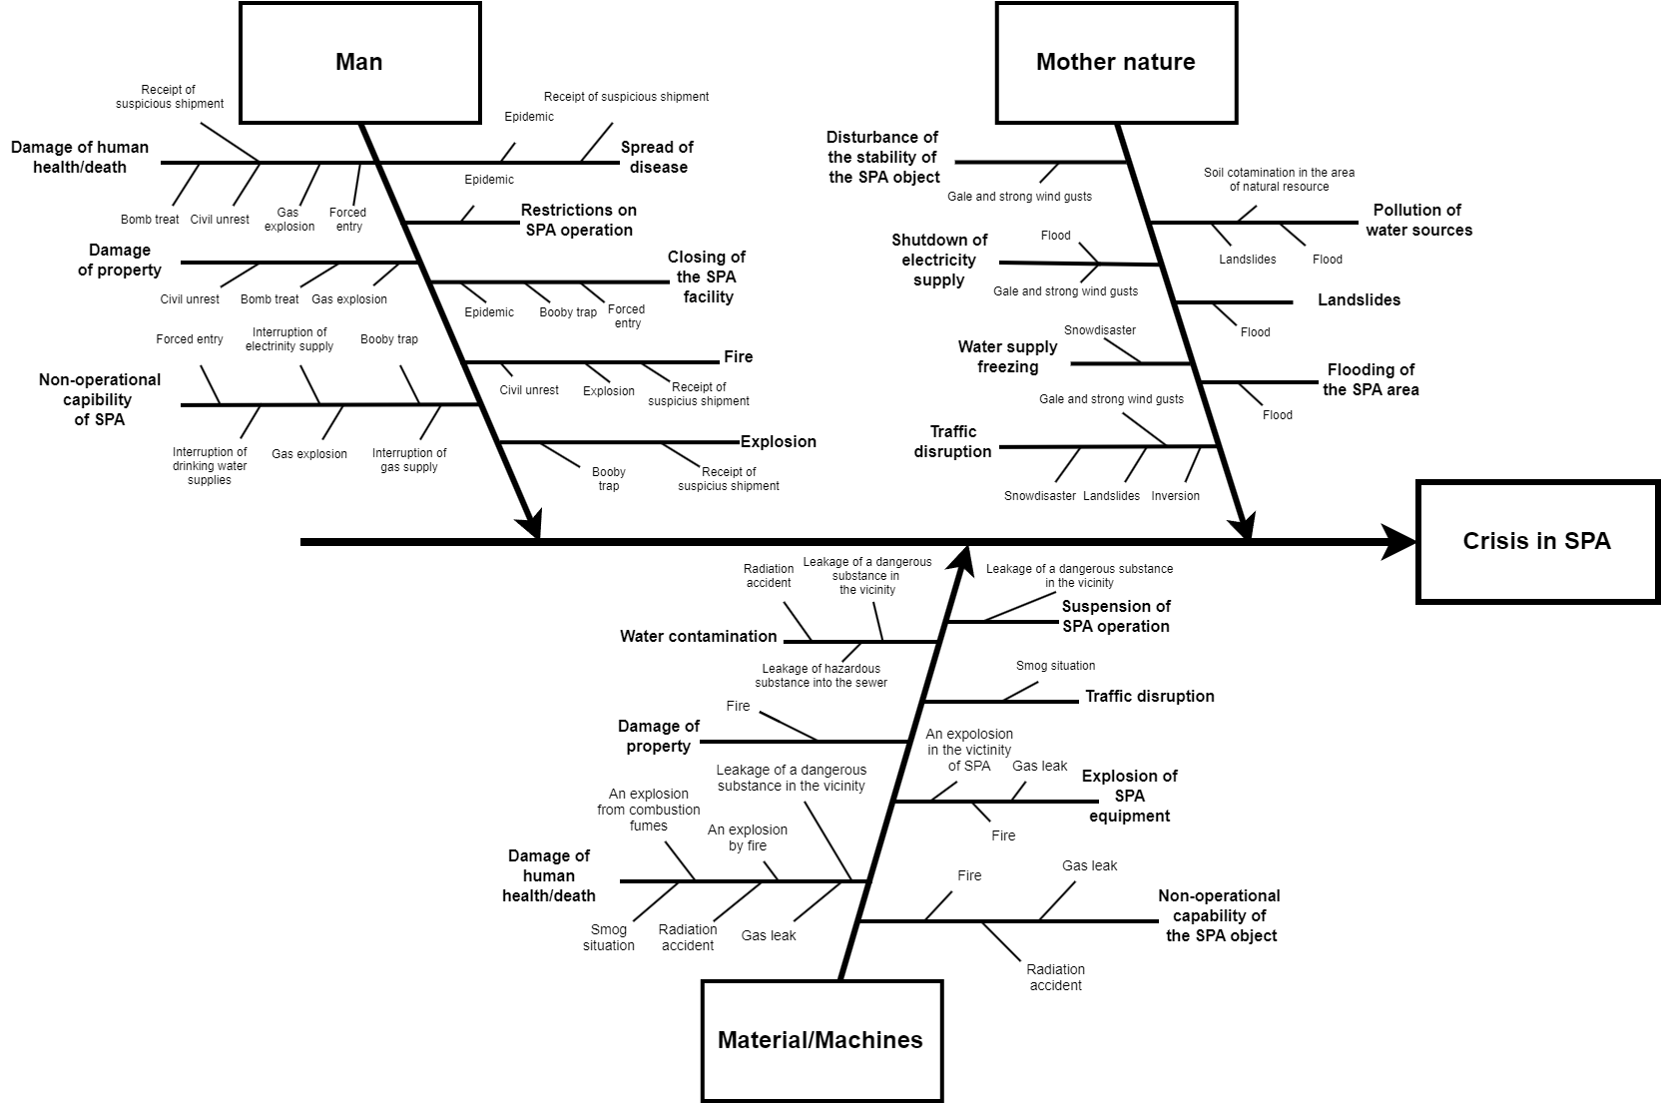

*Figure 1: Ishikawa diagram*

* 1. Discussion and Conclusion

This paper presents a risk analysis for a SPA in the Czech Republic, focusing on disaster preparedness for clients and employees. While specific risk analyses exist for individual organizations, general analyses for SPAs are rare, with more attention typically given to health risks. The study proposes actions for handling internal and external threats and recommends a tailored risk identification and preparedness plan, including crisis communication, for SPAs. The paper highlights the impact of climate change on disaster frequency and emphasizes the importance of protecting infrastructure. The main findings include a risk analysis using an Ishikawa diagram to explore potential crisis scenarios in the SPA industry.

Acknowledgments

This paper is a result of research co-financed by the Interreg V-A SK-CZ program with financial support from the European Regional Development Fund, and internal project IGA/FLKR/2023/005, Tomas Bata University in Zlín.

References

Act 374 of 8th December 2011 about Medical Emergency Service (Czech Republic).

Bernatik A., Senovsky P., Senovsky M., Rehak D., 2013, Territorial Risk Analysis and Mapping, Chemical Engineering Transactions, 31, 79–84.

Cirdei I.A., 2018, Improving the Level of Critical Infrastructure Protection by Developing Resilience, Land Forces Academy Review, 4(92), 237–243.

Dong S., Esmalian A., Farahmand H., Mostafavi A., 2020, An Integrated Physical-Social Analysis of Disrupted Aaccess to Critical Facilities and Community Service-loss Tolerance in Urban Flooding, Computers, Environment and Urban Systems, 80, 1–19.

European Commission, 2019. Communication from the Commission to the European Parliament, the European Council, the European Economic and Social Committee and the Committee of the Regions. The European Green Deal. Brussel, 2019.

European Parliament, 2022. Directive (EU) 2022/2557 of the European Parliament and of the Council of 14 December 2022 on the resilience of critical entities and repealing Council Directive 2008/114/EC. Brussel, 2022.

Grasseova, M., Dubec, R., Rehak, D., 2012, Business Analysis in the Hands of a Manager, 33 Most Used Strategic Management Methods. Praha: Albatros Media.

Hromada M., Rehak D., Lukas L., 2021, Resilience Assessment in Electricity Critical Infrastructure from the Point of View of Converged Security, Energies, 14(6), 1–20.

Katopodis T., Sfetsos A., 2019, A Review of Climate Change Impacts to Oil Sector Critical Services and Suggested Recommendations for Industry Uptake, Infrastructures, 4(4), 1–30.

Kong F., 2024, Rising to the Climate Challenge: Better Understanding the Rural Rainstorm Flooding Disaster Risk Management Using Practical Insights from China, 25(2).

Molina M.O., Sánchez E., Gutiérrez C., 2020, Future Heat Waves over the Mediterranean from an Euro-CORDEX Regional Climate Model Ensemble, Scientific Reports, 10, 1–10.

Novotny P., Janosikova M., 2020, Designating Regional Elements System in a Critical Infrastructure System in the Context of the Czech Republic, Systems, 8(2), 1–24.

Rehak D., Hromada M., Ristvej J., 2017, Indication of Critical Infrastructure Resilience Failure, Safety and Reliability – Theory and Applications, Taylor and Francis Group, London, UK, 963–970.

Rehak D., Splichalova A., Hromada M., Walker N., Janeckova H., Ristvej J., 2024, Critical Entities Resilience Failure Indication, Safety Science, 170, 1–16.

Salimi M., Al-Ghamdi S.G., 2020, Climate Change Impacts on Critical Urban Infrastructure and Urban Resiliency Strategies for the Middle East, Sustainable Cities and Society, 54, 1–17.

Splichalova A., Patrman D., Kotalova N., 2020, Predictive Indication of Performance Failure in Electricity Critical Infrastructure Elements, Chemical Engineering Transactions, 82, 7–12.

Watson G.H., Spiridonova E.A., 2019, Fish (Bone) Stories: Reimagining the Fishbone Diagram for the Digital World, Quality Progress, 52(8), 14–23.