|  |  |
| --- | --- |
| cetlogo ***CHEMICAL ENGINEERING TRANSACTIONS***  ***VOL. xxx, 2024*** | A publication of  aidiclogo_grande |
| The Italian Association  of Chemical Engineering  Online at www.cetjournal.it |
| Guest Editors: Valerio Cozzani, Bruno Fabiano, Genserik Reniers  Copyright © 2024, AIDIC Servizi S.r.l. **ISBN** 979-12-81206-11-3; **ISSN** 2283-9216 | |

Consequences of partial vessel failure in BLEVE and liquid full fill rupture events

El Mehdi Laamartia,b, Frederic Heymesb,\*, Albrecht Michael Birka

aDepartment of Mechanical and Materials Engineering, Queen’s University, Kingston, Ontario, Canada

bInstitut des Sciences des Risques, Institut Mines-Télécom, IMT mines Alès, 6 avenue de Clavières, 30319 Ales, France

[frederic.heymes@mines-ales.fr](mailto:frederic.heymes@mines-ales.fr)

The Boiling liquid expanding vapor explosion (BLEVE) refers to a catastrophic explosion that occurs when a vessel containing a pressure liquified gas at a temperature well above its atmospheric boiling point experiences total loss of containment. The vessel completely opens and hazards are produced posing risks to nearby populated areas and critical infrastructure. Studying partial failures aids in developing strategies to minimize potential damage from associated hazards such as ground load, projectiles, and near-field overpressure. Understanding the characteristics of partial failure mechanism provides valuable insights for identifying factors influencing vessel opening and increasing the severity of BLEVE incidents. New small-scale propane 2022 BLEVE experiments on 589 cm3 aluminium vessels were conducted at IMT mines Ales, France, for different operating conditions. Through a sensitivity analysis, this study investigates the factors contributing to partial failure, and how the type of opening contributes to a less or more powerful hazards.

* 1. Introduction

In the realm of hazardous materials and industrial safety, the acronym BLEVE stands for Boiling Liquid Expanding Vapor Explosion. This phenomenon, referred to as BLEVE, corresponds to the sudden explosive release of expanding vapor and the flashing superheated liquid. Such occurrences result from the abrupt rupture of pressurized vessel, because of extraneous variables, during the storage and transportation of pressurized liquids. The consequential destruction potential of a BLEVE event in proximity to populated areas has attracted considerable attention from emergency responders due to its capacity of producing devastating consequences on both human life and infrastructure. A BLEVE event produces various hazards, including aerial overpressures, fireballs, vapor clouds, projectiles, and ground loads, all of which possess the potential to inflict damage on surroundings, leading to substantial and dramatic losses. For instance, in January 2024, a BLEVE incident took place in Mongolia, when a tank truck, collided with a car, resulting in at least 11 people injured, three firefighters deceased and buildings engulfed in fire.

In the face of such disasters, the effective control of BLEVE incidents hinges upon an understanding of their underlying mechanisms. Birk et al. (2007) elucidates the opening mechanism as a critical condition for a BLEVE, stating that the total loss of containment (TLOC) leading to complete opening of the vessel is a prerequisite for the full expansion of its contents. However, unlike typical catastrophic BLEVEs resulting from complete failures, some incidents involve only partial failures, impacting the characteristics of associated hazards. For instance, it has been demonstrated by authors, like Westin et al. (1971) that the types of failure and projectiles distances are strongly related. The factors determining whether a failure is partial or complete in an explosion are not thoroughly understood. A better understanding of failure mechanism holds the promise of reducing associated hazards.

Baker et al. (1973) were pioneers in investigating diverse failure modes of cylindrical vessels and successfully developed correlations to predict the fragment effect. The analysis made assumptions about the symmetry of the vessel’s opening, resulting in vessel breaking into two equal halves, and assumed uniform vessel thickness. Anderson et al. (1974) delved into stress rupture failure in tank cars, employing Larson-Miller approach and analyzing the time-to-failure. Venart et al. (2000) explored potential failure mechanisms and their consequences in BLEVE. He observed that failure dynamics were linked to crack instability, rapid over-pressurization, or rapid quenching of the crack tip supported by thermo-hydraulics, resulting in uncontrolled vessel failure. Moreover, he found that the dimensions of the initial fissure formed are contingent upon the metal temperature, fill level and the energy of the vapor phase. In contrast, McHenry et al (1987) focuses on failures where the crack starts in a circumferential direction and maintains this mode throughout failure.

Numerous experiments conducted at various scales, over the years have sought to enhance the understanding of the dynamics involved in BLEVE. Medium-scale experiments carried out by Birk and Cunningham (1994) focused on 1.9 m3 pressurized vessels filled with propane, while larger scale investigations were undertaken by Balke et al. (1999) on 45 m3 tanks also filled with propane. The primary objectives of these experiments were on exploring the far-field overpressure generated by BLEVE events. Building upon this body of research, controlled experiments were conducted on a smaller scale during the Laamarti 2022 experimental campaign.

This paper delves into the dynamics of failure opening by presenting results obtained from a 2022 test campaign involving vessels measuring 300 mm in length and 50 mm in diameter. Each vessel was mounted on four load cells and surrounded by blast gages. The tests were conducted under various operating conditions, by changing the controlled variables such as burst pressure, fill level, and weakened length. Different types of failures were observed, ranging from partial to total opening of vessel walls. The study explores the factors influencing these diverse opening dynamics and investigates how the type and mode of failure impacts associated hazards.

* 1. Experimental apparatus

The 2022 experimental campaign on small scale BLEVE (Laamarti 2022) involved vessels, featuring a length-to-diameter ratio (L/D) of 6, equating the dimensions of 300 mm in length and 50 mm in diameter. The vessels were filled with 99.5 % propane and subjected to electric heating of the fluid until failure. It is noteworthy that no combustion was observed during these experiments. The tests were conducted for various independent variables, such as burst pressure $P_{f}$ [Barg], the liquid fill fraction $φ$ [%] and the weakened length $L_{c}$ [mm]. The term “weakened or cut length” refers to the length along the vessel top where wall thickness is removed to facilitate controlled bursting at predetermined pressures. Notably, the rupture always occurred at the top of the vessel, along the machined weakened length. Figure 1 provides both top and side views of the vessel, illustrating the location of the machined length.

*Figure 1: Top and side view of the vessel*

The vessels used in the experiments were made from annealed aluminium 6061 T6, which was tempered to T0 to reduce the yield and ultimate strength. This tempering process involved extended duration heating, surpassing the metal’s recrystallization point, followed by a slow cooling regimen. To preserve their properties, the tubes were stored in a freezer at -20 ⁰C until use. Throughout the experiments, variations in the independent variables resulted in the generation of a new BLEVE dataset, specifically on the near-field overpressure and ground load. The data collection employed high-speed instruments, including high-speed cameras, thirteen pencil blast gages positioned at various locations and orientations, as well as four load cells and additional equipment. The 2022 experimental campaign comprised 36 tests.

* 1. Types of failure

Throughout the experimental campaign, failures were obtained once the weakened vessel walls reached a point where they could no longer withstand the elevated stresses from the high internal pressure. The failure obtained corresponds to a ductile deformation which is the extent of a plastic deformation where the material undergoes a non-reversible change in shape due to the application of stresses exceeding the yield point. This compromise in material strength can manifest into two fundamental types of failure categorized as partial opening failure and total opening failure. This categorization holds significant importance, as indicated by Birk et al. (2007), where the type of failure is a critical criterion to determine whether this explosion corresponds to a BLEVE. The BLEVE necessitates the rapid and complete expansion of the vessel’s contents, which is achievable only through catastrophic failure, often referred to as total loss of containment (TLOC). Figure 2 presents examples of tube failures with distinct openings obtained during the 2022 experimental campaign.

*Figure 2: Different types of failure from small scale BLEVE Laamarti 2022 (1) Fish mouth, (2) partial a-symmetrical, (3) incomplete opening, (4) full and complete opening.*

Partial opening refers to the scenario where the structural integrity of a material or structure is compromised to some extent. This involves the development of axial crack along the weakened length and partial bending of the metal frame without complete fracture. There are three common types of partial opening:

* **Fish mouth opening** [Figure 2 (1)]: is characterized by a lip-shaped opening that resembles the shape of a fish mouth.
* **Asymmetrical opening** [Figure 2 (2)]: is characterized by an uneven distribution of forces along the vessel walls, leading to an imbalance in the rupture pattern. It involves forces that are not uniformly distributed, causing the vessel to open fully from one side while the other side remains unchanged.
* **Incomplete opening** [Figure 2 (3)]: is characterized by an opening that does not achieve its maximum full extend.

On the other hand, the total opening failure [Figure 2 (4)] involves a complete and catastrophic breakdown of the structure. The rupture starts in an axial direction and then once reaching the limits of the weakened length, the crack branches in the circumferential direction until the vessel walls are flattened on the ground.

*Figure 3: Types of failure front/side view (1). Fish mouth (2). Asymmetrical (3). Incomplete (4). Total opening*

It is noteworthy that both small and large fish mouth openings are possible. Additionally, there might be minimal distinction between (3) incomplete and (4) full opening. This work is based on the hypothesis that a full opening necessitates an open area greater than twice the cross-sectional area of the vessel.

* 1. Experimental results

The analysis of the experimental results revealed a significant correlation between operating conditions and the type of failure. New insights were obtained regarding the consequences of types of failure on associated hazards, illustrated by ground load and overpressure. The opening of the vessel is a complex function of the vessel weakening (weakened length) and the energy stored in the vessel lading (burst pressure, fill level).

* + 1. Influence of operating conditions

A summary of Laamarti 2022 BLEVE experiments is presented in Figure 4 for different operating conditions. The weakened length varied from 150 to 50 mm, respectively half and 1/6 of the vessel length. Furthermore, diverse failure pressures were investigated, ranging from 11 to 34 Barg. Various fill levels, spanning from 5% to 100%, were examined, with the 100 % fill level representing a special case of BLEVE wherein failure occurred under compressed liquid rather than saturation conditions, representing another mode of failure.

*Figure 4: Small-scale BLEVE (Left) Laamarti 2022 experiments (Right) P-T graph for hydrostatic/saturation failure – circles denote partially failed tests, with each circle labelled by its corresponding test number.*

The test data shown in Figure 4 (left) are detailed in Tables 1, presenting their respective characteristics, including the type of failure and the mode in which failure occurred. For the 100 % fill level tests Figure 4 (right), two types of failure pressure are distinguished. Before the vessel goes 100 % full, the pressure is determined by the propane saturation pressure. When the vessel goes 100 % full, the pressure is determined by the vessel stiffness and the liquid thermal expansion (hydrostatic pressure). After the vessel goes 100 % full, compressed liquid is obtained. A rapid rise in pressure is seen as the liquid is heated after the vessel reaches 100 % full. When the vessel fails with a compressed liquid, the pressure will drop rapidly to the saturation pressure. The discrepancy between these two pressures is the degree of compressed liquid. The pressure will continue to drop, and the liquid will enter superheated state. This will cause the liquid to flash and a 2 phase-flow will leave the vessel. During this process, there will be a pressure transient as the 2-phase chokes and there may be pressure recovery in the vessel that helps drive the failure opening. Some authors consider the saturation pressure as the definitive failure pressure. However, in Figure 4, the 100 % fill level tests are represented with the failure pressure of the compressed liquid.

Table 1: Partial failure tests from BLEVE Laamarti 2022

|  |  |  |  |  |  |  |
| --- | --- | --- | --- | --- | --- | --- |
| Test | $P_{f}$ [Barg] | $L_{c}$ [mm] | $φ$ (%) | $P_{f}$ [Barg] at saturation | Type  of failure | Mode of failure |
| 1 | 19.8 | 150 | 100 | 15.3 | Fish mouth | Hydrostatic |
| 11 | 14.1 | 150 | 100 | 13.8 | Incomplete | Hydrostatic |
| 12 | 24.9 | 150 | 100 | 14.0 | Asymmetrical | Hydrostatic |
| 17 | 14.9 | 100 | 50 |  | Incomplete | Saturation |
| 21 | 18.6 | 75 | 20 |  | Incomplete | Saturation |
| 22 | 14.9 | 75 | 50 |  | Incomplete | Saturation |
| 25 | 13.9 | 100 | 20 |  | Incomplete | Saturation |
| 30 | 18.3 | 75 | 50 |  | Incomplete | Saturation |
| 32 | 22.8 | 75 | 100 | 17.9 | Asymmetrical | Hydrostatic |
| 34 | 14.8 | 125 | 50 |  | Incomplete | Saturation |

Figure 4 reveals that all cases failing at 100 % fill level resulted in partial failure. Initially, this may be attributed to the observed lower burst pressure when considering the pressure at saturation. However, upon closer examination, Test 32 from Table 1, demonstrated that even with high failure pressure, vessel partial failure persisted. In this specific BLEVE scenario, the rupture is attributed to the high pressure from compressed liquid. When the vessel fails this pressure drops rapidly and there is no vapour space to do work on the vessel wall. The liquid must flash to vapour to do expansion work on the wall, and this takes time. This flashing process is not able to fully open the vessel – with other fill levels there is vapour space, and this is available immediately to do work on the vessel wall. The impact of fill level on the type of failure can be seen in Figure 4 (Left). Specifically, at 90 % fill level, a complete failure occurred for a 75 mm weakened length within the 15-20 Barg range, whereas lower fill levels resulted in partial failure (Test 30 and 21). For 90 % fill level, the vapour space is small and will depressurize very quickly, sending the liquid into superheat state which produces powerful flashing. At high fill levels (excluding 100%), more liquid is available, extending the duration of flashing which is sufficient to open the vessel. This was observed at small failure pressures only, wherein the vessel opening is predominantly governed by the fill level.

The pivotal role of failure pressure in vessel opening is underscored by the observation that lower values of failure pressure consistently resulted in partial failure. This outcome is attributed to the reduced energy available in the vapour to fully open the vessel walls. Conversely, for other cases, those failing at lower pressures partially failed even for large, weakened length. While failure pressure plays an important role in vessel opening, at low values the uniformity of the weakened length thickness determines whether the vessel will open completely or partially. The manual machining process introduces non-uniformity of weakened length and therefore dictates the position of where the crack starts. The vessel will open faster when the crack starts in the middle of the weakened length. In this case, the crack grows in both directions and the vessel opens faster. The observed behavior is explained using fundamental engineering principles, including the thin-walled assumption, maximum normal stress assumption, and the von Mises theory. These theories, considering both hoop and longitudinal stresses, provide a framework to understand the behavior under various thicknesses. The estimated failure pressure is determined from equation (1). This assumes the vessel fails when the von Mises stress based on hoop and longitudinal stress is equal to the material ultimate strength.

|  |  |
| --- | --- |
| $$P_{fail}=\frac{σ_{UTS}4t}{\sqrt{3}D}$$ | (1) |

Additionally, weakened length proves to be a significant factor influencing the type of opening; for instance, some cases with 75 mm and all cases with 50 mm weakened length demonstrated partial failures even at significant failure pressure (18 Barg).

* + 1. Ground Load and overpressure.

Figure 5 illustrates the peak ground load and overpressure for various cut lengths and failure pressures.

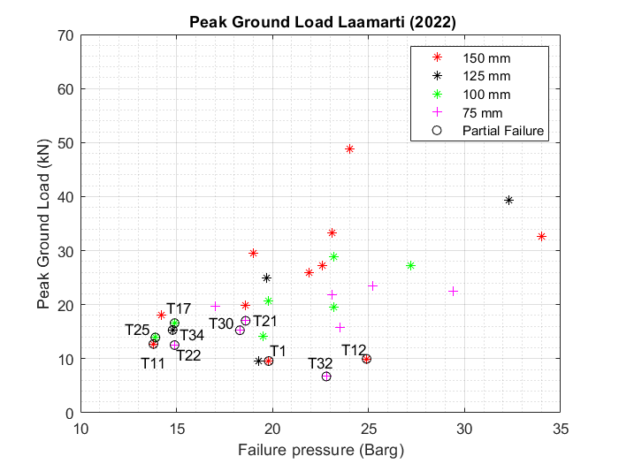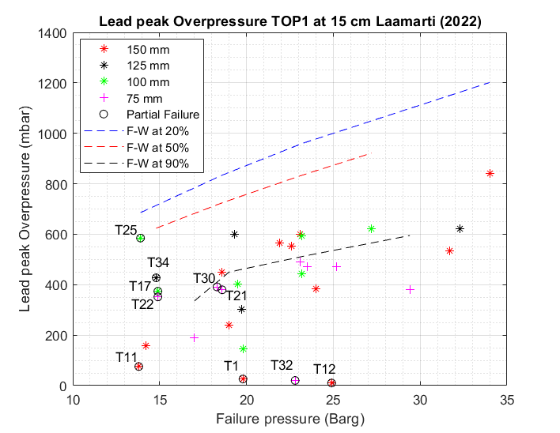

*Figure 5: Hazards from Laamarti 2022 small-scale BLEVE a. Peak ground Load b. Lead peak overpressure with Friedman-Whitham prediction at different fill levels.*

The graph indicates that tubes experiencing partial failure, even at varying weakened lengths, had the lowest values of ground load. The compromised sections of the tube may lead to reduced overall load-bearing capacity, thereby influencing the ground load measurements. Certainly, the partial failure acts as a safety mechanism, reducing the resultant ground force. Indeed, the uneven distribution of the load over time along the load cells serves as a preventive measure against the concentration of forces and the occurrence of elevated ground loads. Regarding near-field overpressure, a total of 19 strategically positioned sensors were employed at various locations and orientations to track overpressure in both space and time. Figure 5b. illustrates the lead peak overpressure obtained from a sensor situated 15 cm above the tube in the vertical axis. The lead peak overpressure is represented for different tests at varying operating conditions.

The partially failed cases are marked with circles which aids in understanding the impact of opening type on near-field overpressure. Observations indicate that cases with a 100 % fill level experiencing partial failure showed lower peak overpressure [T1, T32, T11, T12]. However, the type of opening does not consistently correlate with lower peak overpressure across all partial failures. Notably, Test 25 and 17 depicted in Figure 5b. yield distinct lead peak overpressure despite experiencing similar degree of vessel opening and operating conditions (failure pressure and weakened length). This difference stems from the different fill levels, 20 % and 50 %, respectively. The lower fill level, in this case, resulted in a higher lead peak overpressure. This underscores the high contribution of the vapor phase in the formation of lead peak overpressure and, crucially, the inverse relationship between fill level and lead peak overpressure.

These findings obtained from small-scale experiments, suggest that while the type of failure does not significantly alter overpressure magnitude, it does affect the overpressure directionality. Lead peak overpressure overprediction is achieved through Friedman-Whitham approach, wherein formula integrates shock tube equations, accounting for failure pressure and fill level. In certain scenarios, the maximum lead peak overpressure occurs between 15 cm and 20 cm vertically, highlighting the importance of overprediction.

* 1. Conclusions

In conclusion, the Laamarti 2022 small-scale propane BLEVE experiments were conducted to replicate real-world BLEVE scenarios under varying initial conditions. The investigation revealed diverse failure modes, including hydrostatic failure and rupture under saturation conditions, with different types of failure such as partial and complete opening of the vessel walls. The study demonstrated a pronounced correlation between controlled variables and the type of failure, particularly for failure pressure and weakened length. The liquid full cases at hydrostatic conditions did all fail partially, likely attributed to phase change responsible of vessel opening. While partial failures from the test campaign exhibited the lowest peak ground load, they did not all consistently yield to lower lead peak overpressure. Indeed, the liquid fill level played a crucial role, as the vapor phase contributes to the overpressure. Reducing the BLEVE hazards through partial failure is feasible, but a trade-off must be considered in operating conditions. For example, reducing the failure pressure may decrease risks from BLEVE but may increase the likelihood of BLEVE occurrence. Liquid full cases showed an interesting behaviour which requires a further in-depth investigation of the underlying dynamics.

Nomenclature

$P_{fail}$– Failure pressure, m

$σ_{UTS}$– – Ultimate material tensile strength, MPa

φ – Fill level, %

$t_{w}$– Weakened length thickness, m

Lc – Weakened length, m

References

Anderson, C.E., Norris, E.B., 1974. "Fragmentation and Metallurgical Analysis of Tank Car RAK 201." Report No. FRA-OR&D 75-30, Federal Railroad Administration, Washington, DC

Baker, W.E., Cox, P.A., Westine, P.S., Kulesz, J.J., Strehlow, R.A., 1983. Explosion hazards and evaluation. Elsevier Scientific Pub. Co. doi:10.1016/0010-2180(85)90099-9

BBC News. (2024, January 24). " Mongolia: Three dead after liquified natural gas tanker crashes." BBC

Retrieved from <https://www.bbc.com/news/world-asia-68079262>.

Birk, A.M., Heymes, F., Aprin, L., Slangen, P., Eyssette, R., Lauret, P., 2016. Near field blast effects from BLEVE. Chem. Eng. Trans. 48, 283–288, <http://dx.doi.org/10>.

Birk, A.M., Cunningham, M.H., 1996. "Liquid temperature stratification and its effect on BLEVEs and their hazards." Journal of Hazardous Materials, 48(1–3), 219–237.

Birk, A.M., Davison, C., Cunningham, M., 2007. Blast overpressures from medium scale BLEVE tests. J. Loss Prev. Process Ind. 20, 194–206. doi:10.1016/j.jlp.2007.03.001

Eyssette, R., 2018. PhD Thesis: Characterization and modeling of near-field BLEVE overpressure and ground loading hazards. Queen’s University (Canada) / IMT Mines Ales (France).

McHenry, H.I., Read, D.T., Shives, T.R., 1987. "Failure analysis of an amine-absorber pressure vessel." Materials Performance, 26, 18–2.

Venart, J E S, 2000, Boiling Liquid Expanding Vapour Explosions: possible failure mechanisms and their consequences, IChemE Hazards XV; Symp. Series No. 147, pp. 121-138.

Westin, W.E., 1971. "Summary of Ruptured Tank Cars Involved in Past Accidents." Report No. RA01-2-7, Railroad Tank Car Safety Research and Test Project, Chicago, IL.