|  |  |
| --- | --- |
| cetlogo ***CHEMICAL ENGINEERING TRANSACTIONS***  ***VOL. xxx, 2024*** | A publication of  aidiclogo_grande |
| The Italian Association  of Chemical Engineering  Online at www.cetjournal.it |
| Guest Editors: Valerio Cozzani, Bruno Fabiano, Genserik Reniers  Copyright © 2024, AIDIC Servizi S.r.l. **ISBN** 979-12-81206-11-3; **ISSN** 2283-9216 | |

Ageing management in Seveso establishments by an ontology application

Giuseppa Ancionea,\*, Silvia M. Ansaldib, Paolo Bragattoc, Patrizia Agnellob, Maria Francesca Milazzob

aDipartimento di Ingegneria, Università di Messina, Contrada di Dio, 98166, Messina, Italy

bInail, Dipartimento di Innovazione Tecnologica, via Fontana Candida 1, 00077 Monteporzio Catone (Roma), Italy

cDipartimento di Ingegneria, Università Campus Biomedico, via Álvaro del Portillo, 21, 00128 Roma, Italy

giusi.ancione@unime.it

The ageing management has a high relevance for the energy transition in the Seveso industry. Despite the expectation of the new technologies and the reduced reliance on traditional oil sectors, the ageing management is still a crucial issue, this is due to the slow replacement of petroleum-derived products. The use of green alternatives and the reconversion of existing plants point towards the need for early management of ageing in new low carbon technologies. In this context the potential of digital technologies support for a safe extending of equipment lifetime. The challenges posed by emerging digital technologies must be analysed to develop appropriate solutions and improve control activities. This paper explores the use of ontologies in the ageing management of Seveso facilities, particularly in activities with high cognitive content, such as incident analysis, risk assessment, maintenance management, and inspection planning. The aim of the work is to present a revised ontological model for the ageing management and the developed software tool, named *OntoAgeingFishbone*. This approach has been created for assessing the adequacy of ageing management programs and has been applied to a case study.

* 1. Introduction

Ageing is defined as the effect of deterioration on equipment, machinery, plant, and structures. It occurs when the designated useful lifetime is approaching or exceeding. The ageing management in the process industries is essential to assure the plant reliability and availability and it is also crucial for accident prevention (Van Wijk et al., 2013). It requires up-to-dated knowledge about damage mechanisms, failure rates, inspection techniques, as well as human and organizational factors. In future, the relevance of ageing management will not even decrease as the demand for CO2 emissions reduction and the energy transition towards low-carbon technologies will grow. This is explained because the replacement of petroleum-derived products will take time, and existing plants will continue to operate for years (Mohr et al. 2015). Additionally, the use of green fuels and new low-carbon technologies will require maintaining and strengthening ageing management techniques including the development of knowledge that will result from experimental studies about the new materials, the products, and the damage mechanisms, as well as about control techniques in these new sectors (Rezaei-Male, 2019).

The approach discussed here represents a combination of the ageing index method by Milazzo and Bragatto (2019) adopted by the Italian ministerial (MASE, 2021), which is based on the Ishikawa or fishbone analysis (IEC 2019), and a revised version of the deterioration mechanisms ontology given by Bragatto et al. (2020). A web-app designed to make the two approaches interacting is briefly introduced and a case study of a Seveso establishment shows the application of the methodology. Some results are shown and finally, after a short discussion, the conclusions are given.

* 1. Methodology

The new methodology, represented by an ontology model, merges a previous ontology (Bragatto et a., 2020) in a revised and extended version, and the ageing fishbone model (MASE, 2021).

Ontologies are a formal way to represent concepts and their relationships in a specific domain using reasoning rules. They are essential for effectively digitalizing the management processes (Leal, 2005). A few papers emphasize the benefits of the ontologies in various activities, including process safety (Rodríguez and Laguìa, 2019), maintenance management (Ebrahimipour et al., 2010; Masmoudi et al., 2021), inspection planning (Saeed et al., 2018), incident analysis Single et al., 2020a), and risk assessment (Single et al., 2020b; Ebrahimipour et al., 2010; Hodkiewicz et al., 2021; Aziz et al., 2019).

The *Ageing FishBone model* is used to assess the adequacy of the ageing management in Seveso establishments. It evaluates the factors affecting ageing, which are organized into categories to cover technical, human and organizational aspects and discriminated in accelerating and decelerating factors. In the ageing fishbone model, a score is assigned to each factor. The final index is a weighted algebraic mean of these factors. A positive index indicates an adequate ageing management.

The proposed approach, i.e. the ontological model described in this paper, expands upon the initial version of *ontoAgeingFishbone*, which focused on managing deterioration mechanisms and inspection techniques for static containment system and was widened to include:

1. the maintenance management of the entire establishment,
2. the rotating machinery and their inspection techniques
3. the Safety Management Systems, and
4. the scores related to the ageing fishbone model.

Some definitions about key elements of an ontological model are provided (i.e., *class, instance, relation, object property, data property, assertion, standard* and *used-defined annotation*).

A *class* represents a group or category having similar properties. An *instance* refers to a certain individual or entity that belongs to a class. Classes are useful for the constructing an organised knowledge structure. *Relations* indicate the connections or associations between entities or concepts within a given domain. They can be expressed through *object properties* and *data properties*. *Object properties* describe relationships between i*nstances*, while *data properties* relate to their data values. *Data properties* aid to provide information about individuals in an ontology. An *assertion* represents a statement or proposition made about a specific *class* or *instance*. It serves as a foundation for reasoning and inference processes, representing facts, beliefs, or assumptions in an ontology. A *standard annotation* refers to predefined annotations defined by the ontology. Annotations are typically developed by ontology designers and have a formal specification that defines their meaning and usage. *User-defined annotation*, on the other hand, refers to annotations created by users to meet their specific needs or requirements. They offer flexibility and allow the addition of context-specific information to ontology entities. More details about ontology can be found on the W3C website.

The main elements considered in the proposed ontological approach are shown in Figure 1.

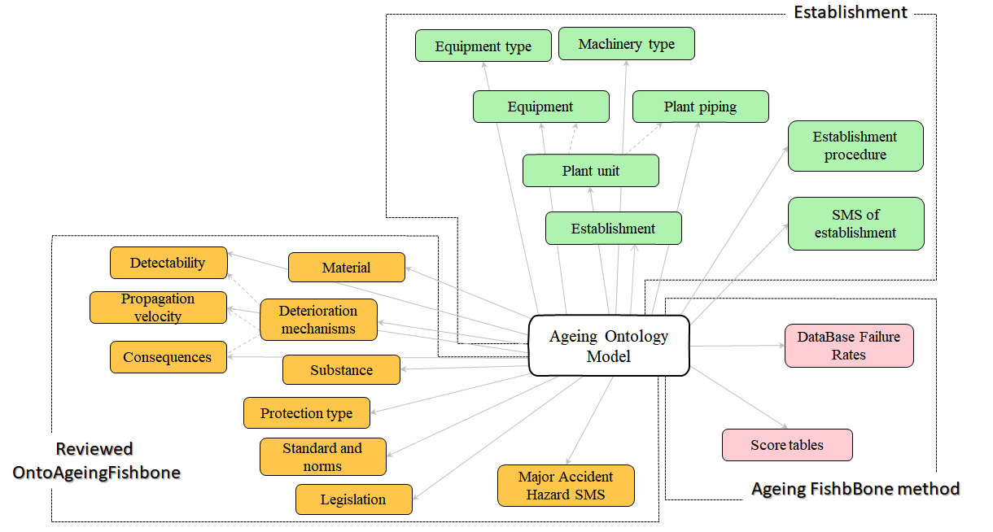

*Figure 1. Main classes of the Ageing Ontology model.*

The extension of the new ontology is described in the following:

a) Establishment - A new section has been added to the *ontoAgeingFishbone model* to represent the hierarchical structure of the establishment. Its main *relations* are represented by arcs to connect elements (classes and instances) to each other according to *assertion* defined by experts.

b) Machinery and their relations - Rotating machineries have been included according to the latest Italian guideline for ageing management. For this reason, it was necessary to define and include the deterioration mechanisms affecting them. Each mechanism has three ontological relations related to propagation speed of the phenomenon, detectability, and consequence according to the API 571 (2011) and expert knowledge. New relations have been also defined to associate inspection techniques to such mechanisms and their effectiveness in detecting the phenomena. It is important to note that the instances included in the Mechanism for Machinery class do not represent an exhaustive list of all potential mechanisms that can affect dynamic machines.

c) Revised SMS - The Major Accident Hazard Safety Management System, which is designed to address major hazard accidents, plays a significant role in managing the integrity status of equipment. The key elements of this system and relates structure were slightly revised. For example, the *Inspection Technique* class has been expanded to include a sub-class called *Techniques for Machinery*, in addition to *invasive* and *non-invasive* sub-classes already present in the deterioration ontology model.

d) Integration of the *Ageing Fishbone* features - The new features introduced in the new ontology are the factors and sub-factors implemented as classes, instances, and relations. Furthermore, each factor and sub-factor is assigned a score. Most of these integrations have been allocated in The *Score Table* class. Such class has been introduced and its sub-class names correspond to the ageing factors. The instances of these classes represent the parameters provided by the ministerial guideline. The score of each *instance* has been assigned by means a *data property* value.

* + 1. Web-application

A web-app has been created to assist in verifying dynamically the critical equipment ageing and in its management. The application features a User Interface (UI) that resembles the *Ageing FishBone model* and incorporates ontological connection to link ageing factors and sub-factors. The application’s architecture is divided into main sections: back-end, front-end, authorization, and external services. Figure 2 shows the scheme of the architecture. Each section includes references to key functionalities, with arrows denoting module interactions and data flow directions. Users are granted access to different functionalities based on their role, such as administrator, establishment user, inspector, and knowledge expert.

The back-end of the application consists of three main parts: database management, knowledge management, and index elaboration. Database management allows administrators accessing the database, while knowledge management contains ontologies and query functionalities for accessing information. The index elaboration section calculates factors and indexes associated with an establishment. The external knowledge service facilitates the expansion of the application, e.g. by adding new damage mechanisms or new technologies, i.e. mechanism due a new material, new process, or techniques derived by the innovation technology, etc. The authentication service provides users with appropriate access rights based on their profile, and it also manages ontology models and their association with establishments. The front-end of the application includes input and output functionalities. For each establishment it is possible to define units and equipment and assign equipment to specific parts of it.

One of the main goals of this application is the easy updating of the knowledge by means the replacing the ontology model file without having to modify the implementation code. The updating of the knowledge could be relating to new damage mechanisms.

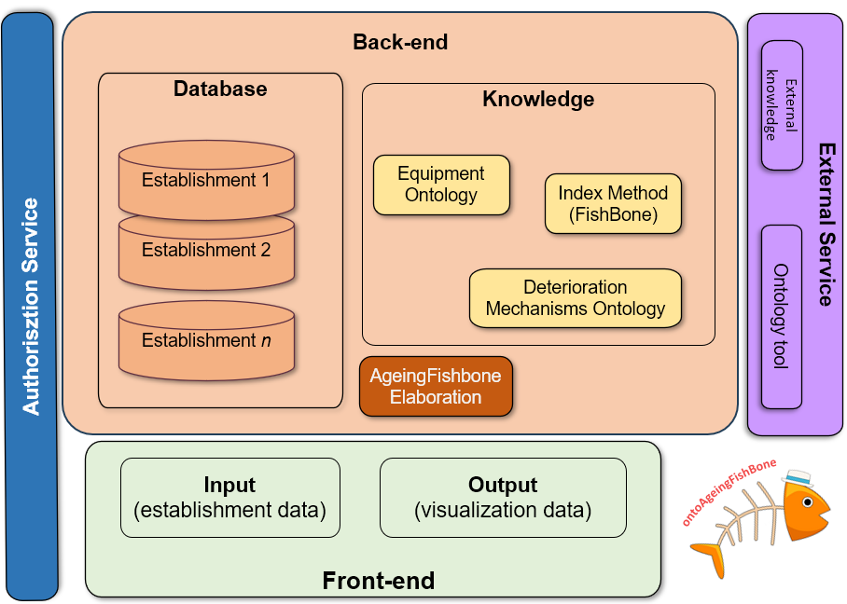

*Figure 2. The web-application structure*

* + 1. Case Study

The case study concerns a major hazard establishment, in accordance with the SEVESO III Directive, transposed into Italy by legislative decree no. 105/2015. It is a logistics depot for bulk chemicals and petrochemicals. Critical equipment is atmospheric storage tanks (n.10), oil pipelines (n.2), and a pump (n.1). The products are only stored and do not undergo any transformation. These substances are subsequently shipped, as needed, to chemical, petrochemical, etc. or any other industry that use them within their production processes. The variability of the stored products is an important characteristic for this study because it requires frequent stops for cleaning certain equipment in order to ensure safety and stability of the handled substances. Table 1 lists equipment, included in the depot, with their identification code and date of commissioning.

Static equipment is made of carbon steel while dynamic one (the pump) is made in steel. Some tanks (S1 and S2) have already exceeded the maximum operating age for which they were designed by the 150%.

The prevalent deterioration mechanisms, detected during the inspection, are provided in Table 2.

Table 1: List of Equipment

|  |  |  |  |  |  |  |  |  |  |  |
| --- | --- | --- | --- | --- | --- | --- | --- | --- | --- | --- |
| ID Equipment | Equipment Name | Date Commissioning | ID Equipment | Equipment Name | Date Commissioning |  |  |  |  |  |
| S01 | Tank 01 | 01/01/1963 | S08 | Tank 08 | 01/01/1985 |  |  |  |  |  |
| S02 | Tank 02 | 01/01/1963 | S09 | Tank 09 | 01/01/1985 |  |  |  |  |  |
| S03 | Tank 03 | 01/01/1963 | S10 | Tank 10 | 01/01/1985 |  |  |  |  |  |
| S04 | Tank 04 | 01/01/1983 | L1 | Pipeline 1 | 01/01/1993 |  |  |  |  |  |
| S05 | Tank 05 | 01/01/1983 | L2 | Pipeline 2 | 01/01/1993 |  |  |  |  |  |
| S06 | Tank 06 | 01/01/1983 | P1 | Pump | 01/01/2003 |  |  |  |  |  |
| S07 | Tank 07 | 01/01/1983 |  |  |  |  |  |  |  |  |

Table 2. Main Deterioration Mechanism for the case study

|  |  |
| --- | --- |
| Deterioration mechanism | ID Equipment |
| Atmospheric corrosion | S1, S2, S3, S7, S9, S10 |
| Soil corrosion | S8, L2 |
| Microbiologically induced corrosion | S4, L1 |
| Erosion/Corrosion | S5, S6 |
| Mechanical fatigue | P1 |

* 1. Results

To estimate the ageing index of the chemical depot, data from critical equipment have been uploaded into the developed web-app. Figure 3 displays two examples of interaction between the *Ageing FishBone* method and the ontological model within the software. Figure 3a shows a screenshot where the selection of the prevailing deterioration mechanism for the equipment is possible. This selection is conditioned by the equipment typology thanks to the ontological model. In other words, the numerousness and mechanisms that can affect rotating machines differ from those that can involve static systems, hence different options are available in the drop-down menu according to the equipment's typology. Figure 3b illustrates the selectable inspection techniques for a given equipment.

|  |  |
| --- | --- |
|  |  |
| a) | b) |

*Figure 3. OntoAgeingFishbone User Interface: a) selection of deterioration mechanism for equipment; b) selection of inspection technique for equipment.*

*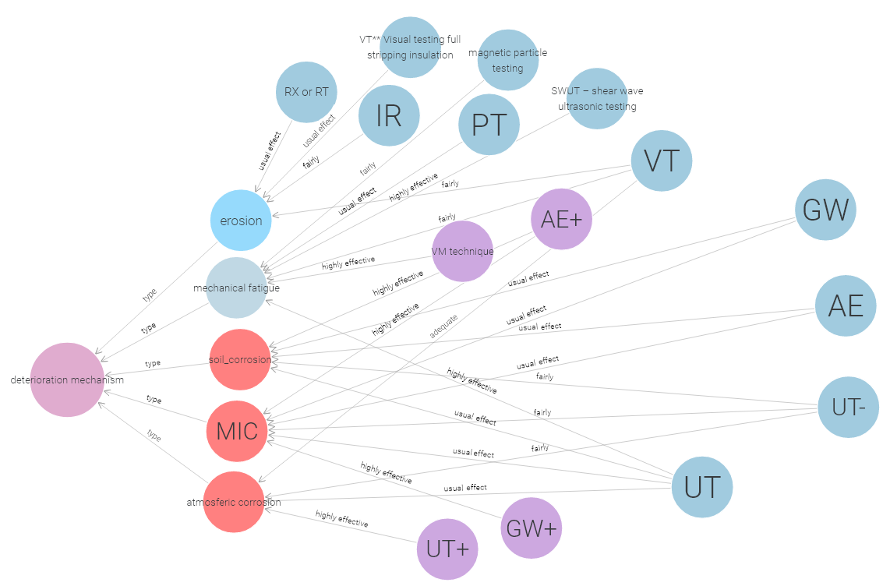*

*Figure 4. Graphical representation of the detected deterioration mechanisms, the techniques that can be used with them and their effectiveness.*

These available options, due to the ontological relations, are closely linked to the previously selected deterioration mechanism. Each technique corresponds to a detection effectiveness, allowing easier selection according to individual establishment requirements. Figure 4 demonstrates the ontological relationships that connect the deterioration mechanisms of the case study with their associated techniques through a graph database, whereas Table 3 provides the list of the abbreviations shown in Figure 4. Such relationships (directed edges) are characterized by an effectiveness judgment. After loading the information relating to the equipment from Table 1 according to the guideline, the web-app calculated the overall ageing index of the depot which is equal to 0.65. The positive index indicates that an adequate ageing management has been made, however some margins for improvement are possible.

*Table 3. Abbreviations of deterioration mechanisms and inspection techniques with respect to the case study.*

|  |  |  |  |  |
| --- | --- | --- | --- | --- |
| Name of the istance | Abbreviation | Name of the istance |  | Abbreviation |
| Microbiologically induced corrosion mechanism | MIC | Radiography |  | RX or RT |
| Acoustic Emission Testing | AE | Shear Wave Ultrasonic Testing |  | SWUT |
| Acoustic Emission Monitoring | AE+ | Ultrasonic Testing with spot measure less than 20% |  | UT- |
| Guided Wave testing | GW | Ultrasonic Testing |  | UT |
| Guided Wave monitoring | GW+ | Ultrasonic Monitoring |  | UT+ |
| Infrared Camera | IR | Vibration Monitoring |  | VM techinique |
| Magnetic Particle Testing | Magnetic particle testing | Visual Testing |  | VT |
| Penetrating Liquids | PT | Visual Testing full stripping insulation |  | VT\*\* |

* 1. Conclusions

The ageing management of Seveso facilities is of high importance, even in the context of energy transition. This study highlighted the interaction between the *Ageing FishBone* method and the ontological approach within the ageing ontology model and the software developed. Overall, the application of ontologies in the ageing management of Seveso facilities, provides a promising approach for effective safety management. The use of digital technologies and the integration of cognitive content in decision-making processes can enhance control activities and contribute to the overall success of safety management programs.

A great effort has been made in the past years by academia and industry on ageing phenomena and today there is a valuable wealth of knowledge. It is possible to share this knowledge, keep it alive and transfer it to new plants based on green technologies through ontologies. Ontology has the ability to organize and represent knowledge on a certain topic. Ontology, as this work demonstrates, can be a solid basis to develop a software that puts up-to-date knowledge on the topic of "ageing" in the industrial context.

Acknowledgments

This work has been funded by INAIL within the projects DRIVERS (BRIC/2021 ID = 03) and RE-SET (BRIC/2022 ID=02).

References

American Petroleum Institute API, 2011, Damage Mechanisms Affecting Fixed Equipment in the Refining Industry, API Recommended Practice 571, 2nd ed., Washington, US.

Aziz, A., Ahmed, S., & Khan, F.I., 2019, An ontology-based methodology for hazard identification and causation analysis. Process Safety and Environmental Protection, 123, 87-98

Bragatto, P., Ansaldi, S.M., Agnello, P., Di Condina, T., Zanzotto, F.M., Milazzo, M.F., 2020, Ageing management and monitoring of critical equipment at Seveso sites: An ontological approach, Journal of Loss Prevention in the Process Industries, 66, 104204.

Ebrahimipour, V., Rezaie, K., & Shokravi, S., 2010, An ontology approach to support FMEA studies. Expert Systems with Applications, 37(1), 671-677.

Hodkiewicz, M., Klüwer, J. W., Woods, C., Smoker, T., & Low, E., 2021, An ontology for reasoning over engineering textual data stored in FMEA spreadsheet tables, Computers in Industry, 131, 103496.

Leal, D. (2005). ISO 15926 Life cycle data for process plant: An overview, Oil & gas science and technology, 60(4), 629-637

Masmoudi, O., Jaoua, M., Jaoua, A., Yacout, S., 2021, Data Preparation in Machine Learning for Condition-based Maintenance, Journal of Computer Science, 17 (6), pp. 525-538.

Milazzo, M.F., Bragatto, P., 2019, A framework addressing a safe ageing management in complex industrial sites: The Italian experience in «Seveso» establishments, Journal of Loss Prevention in the Process Industries, 58, pp. 70-81. doi: 10.1016/j.jlp.2019.01.005

Ministero dell’Ambiente e della Sicurezza Energetica (MASE), Repubblica Italiana, 2021, Valutazione Sintetica dell’adeguatezza del Programma di Gestione dell’Invecchiamento Delle Attrezzature Negli Stabilimenti Seveso. <https://www.mase.gov.it/pagina/documenti-di-indirizzo-linee-guida-o-altra-documentazione-di-interesse> (accessed on 19 September 2023) (in Italian).

Mohr, S.H., Wang, J., Ellem, G., Ward, J., Giurco, D., 2015, Projection of world fossil fuels by country, Fuel, 141, 120-135.

Rezaei-Malek, M., Mohammadi, M., Dantan, J., Siadat, A., Tavakkoli-Moghaddam, R., 2019, A review on optimisation of part quality inspection planning in a multi-stage manufacturing system, International Journal of Production Research, 57, 4880 - 4897

Rodríguez, M., Laguía, J. 2019, An Ontology for Process Safety, Chemical Engineering Transactions, 77, 67-72

Saeed, M.R., Chelmis, C., Prasanna, V.K., 2018, Smart Oilfield Safety Net-An Intelligent System for Integrated Asset Integrity Management. InSPE Annual Technical Conference and Exhibition D031S032R007

Single, J.I., Schmidt, J., Denecke, J., 2020a, Ontology-based computer aid for the automation of HAZOP studies. Journal of Loss Prevention in the Process Industries, 68, 104321.

Single, J.I., Schmidt, J., Denecke, J., 2020b, Knowledge acquisition from chemical accident databases using an ontology-based method and natural language processing, Safety Science, 129, 104747.

Van Wijk, L., Wood, M., Vetere Arellano, A., 2013, Corrosion‐related accidents in petroleum refineries: lessons learned from accidents in EU and OECD countries, Publications Office. https://data.europa.eu/doi/10.2788/37909.

Website W3C. OWL Web Ontology Language Reference https://www.w3.org/TR/owl-ref/ (accessed on 12/01/2024).