 CHEMICAL ENGINEERING TRANSACTIONS  VOL. , 2024 | A publication of  
The Italian Association
of Chemical Engineering
Online at www.cetjournal.it

Guest Editors:
Copyright © 2023, AIDIC Servizi S.r.l.
ISBN 979-12-81206-XX-X; ISSN 2283-9216

NaTech: Extreme Wind Likelihood Method Analysis
Ballinari Davideª, Barozzi Marcoª, Genna Giovanni^{b}, Perelli Sara^{b}, Copelli Sabrina^{a,*}
ª University of Insubria, Department of Science and High Technology, via Valleggio 9, 22100, Como (CO), Italy
^{b} DEKRA Italia s.r.l., Process Safety Business Unit, Via Fratelli Gracchi 27, 20122 Cinisello Balsamo (MI), Italy
*sabrina.copelli@uninsubria.it
Industrial accidents can be triggered by natural hazards (as earthquakes, floods, lightning, and extreme temperatures) which can result in fires, explosions, or release of hazardous substances. These high impact accidents are called NaTech (Natural Hazards Triggered Technological Accident). NaTech can determine huge damages and their rapid growth in the latter years is also associated with climate change evolution. In this context, refineries are among the facilities majorly affected by NaTech and the presence of large amounts of hazardous materials makes easier to envisage potentially catastrophic scenarios. Risk assessments should include NaTech scenarios, and this should come with the availability of robust and efficient screening tools for safety engineering applications. Due to the complexity of extreme natural events, no general or reference models are officially available, leaving to the analyst the duty to estimate aspects such as probability of occurrence of an extreme natural event. Extreme events weather databases are also often incomplete, reporting data on past natural events with insufficient information for risk assessment purposes. This is particularly true for extreme winds. This paper applies a modified version of a literature reference model, based on the analysis of the occurrence of extreme winds on a Lat-Long quadrant classification. A grid choice dependence is shown, highlighting the variation of extreme winds likelihood of extreme winds on 3 Italian refineries located close to the sea. By changing the reference area for extreme winds analysis, the screening analysis leads to different results.
Keywords: hazards, NaTech, refineries, risk analysis, natural events
  - Introduction
In the last decades, severe and extreme weather events have increased in frequency and intensity (Ricci et al., 2020). Heatwaves, storms and heavy precipitation, tornado and droughts are just some examples of severe natural events having an unavoidable impact on human life (Seneviratne et al., 2021). Industrial facilities are also interested by the growth in frequency and intensity of these events since they can cause severe industrial accidents. This kind of scenario is usually referred to as NaTech (Natural Hazards Triggered Technological Disasters) (Ricci et al., 2020). NaTech include earthquakes, tornadoes, storms, heatwaves and others that can result in toxic releases, fire and explosions, which can negatively affect people, buildings and environment (Castro Rodriguez et al., 2023). NaTech scenarios, moreover, can potentially determine huge economic loss for the industries involved (Ricci et al., 2021). Referring to Ricci et al. (2021), it is possible to notice how the number of NaTech events, in a period of time included in 2000-2017, is growing constantly both in Europe and USA, with particular attention in Europe. For these reasons, it is possible observe a general increase of NaTech awareness by authorities, academy, and enterprises, especially for chemical and petrochemical plants (Krausmann, 2010). Regulations gave enormous support to industries, with the aim of improving environmental protection and process safety (Jain et al., 2017). The safety management system of a plant must be reliable, frequently updated and be focused on the identification of the potential hazards which can lead to an accident, estimating both likelihood and magnitude (Kalantarnia et al., 2010). Most of refineries located in European countries are interested by Directive 2012/18/EU (Seveso III), receipted in Italy with D.Lgs 105/15, with the scope of establishing rules to prevent relevant accidents. According to the standard ISO 31000:2018, it is also necessary to identify risk criteria and indicate how events likelihood is estimated. The probability estimation must be done by using assumptions and criteria able to sustain the likelihood credibility (Necci & Krausmann, 2022). Oil refineries are industrial installations that can be interested by major industrial accidents, including NaTech and domino effects (Krausmann et al., 2011). Some data about the consequences of petrochemical plant disasters are summarized in Table 1, where it is worth noticing that NaTech events (Japan in 2011 and Argentina in 2013) can lead to economical and human consequences as those ones caused by human or technological errors.
Table 1: Incidents with largest losses (reference of US$ in 2012) (adapted from Jain et al., 2017)
Year | Incident | Location | Plant type | Fatalities | Property Loss (US $ million)
2001 | Toulouse, France | France | Petrochemical | 29 | 680
2004 | Skikda gas explosion | Algeria | Gas processing | 26 | 940
2005 | Mumbai High North | India | Upstream | 22 | 480
2010 | Deepwater Horizon | US | Upstream | 11 | 600
2011 | Sendai (earthquake) | Japan | Refinery | 18 | 600
2013 | Geismer explosion | US | Petrochemical | 2 | 510
2013 | Fire (flooding) | Argentina | Refinery | - | 500

According to Directive 2012/18/EU, the operator should draw up a safety report, including specifications about the possible major-accident scenarios and their probability, with a summary of the events which may trigger each scenario. The causes can be internal or external. NaTech are natural hazards, and as such, they are considered as an external event as, for example, a tornado (Directive 2012/18/EU, Annex II, Chapt.4). Since oil refineries are usually made of a high number of unit operations and components, a risk analysis for NaTech scenarios must necessarily use a suitable screening tool to identify, at a first glance, which elements of a plant may be interested by NaTech. Usually, a screening tool should involve the following aspects: literature data revision, natural events likelihood estimation and hazardous plant areas identification. A literature data revision, that is the starting point of a risk screening analysis, is necessary to search for and collect general information about the natural events that can impact the plant, along with the potentially most critical components. The likelihood of natural events can be calculated with the support of external tools, which provide a micro-zonation of the areas subjected to certain events. As an example, for earthquakes and floods, there are tools that can help in identifying the level of exposure. In Italy, ProDis (developed from CEI- Comitato Elettrotecnico Italiano) provides micro-zoning maps for lighting; Italian Civil Protection and CNR (Centro Nazionale di Ricerca) provides micro-zonation for earthquakes. PAI (Piano di Assetto Idrogeologico), PGRA (Piano Gestione Rischio Alluvioni) and APSFR (Area a Potenziale Rischio Significativo di Alluvioni) are tools, typically delivered in form of interactive maps, to define the level of exposure to different flood events. After those maps are recovered, they can be intersected with the petrochemical facilities, to see which ones can potentially provide major hazards. However, according to the authors’ knowledge, for what concerns extreme winds, there are no official references on how to estimate the level of exposure of a chemical plant to extreme wind phenomena. It is possible to use official weather databases to describe this aspect. The most reliable one in Europe is ESWD (European Severe Weather Database), which provides a list of many extreme events, including tornadoes, gustnadoes and severe winds. The aim of this paper is to pose the attention on the limitation to the likelihood estimation of extreme winds in Italy. This will be showed considering three preliminary screening carried out on 3 Italian refineries (Livorno, Milazzo and Taranto) all close to the sea, using a procedure proposed by Santamato (2022) to identify the tornado propensity level of the selected area. It will be shown that, by using data that comes from ESWD, different probability levels can be found according to different areas of extension for the analysis.
  - Materials and methods
The method for exposure evaluation to extreme wind events is based on the work of Santamato (2022). The method is organized in three steps. The first one is the evaluation of the site-specific propensity, that is related to the probability of occurrence of an extreme wind. The second is a screening of the plants with low, medium and high propensity. This classification is derived from an historical analysis conducted with ESWD and tornado events observed are elaborated using a specific matrix to link frequency with a frequency index (FI) and the intensity, calculated with Fujita (F) scale, with an intensity index (II). A screening score is derived and converted into a propensity level. For medium-high indexes, a risk assessment is required. In this case, the frequency of the event $F_{i,eff}$ (event/year) to strike the plant (the one effectively required to estimate the risk) is derived with a scaling factor, as represented in Eq. 1. $F_{i}$ is the probability index on the whole area. The aim of this paper is to show how a different size of the analyzed area could lead to different tornado propensities and frequencies quantification. The analysis will be focused on the impact of the portion of area analyzed for extreme winds propensity.
$F_{i,eff}=F_{i}∙\frac{Surface (plant)}{Surface (cell)}$ (1)
    - Case study
The study involves three different Italian refineries plants located in Livorno, Milazzo and Taranto, as showed in Figure 1. As all these refineries are located in similar geomorphological areas, the presence of sea contribution to extreme wind events is considered.
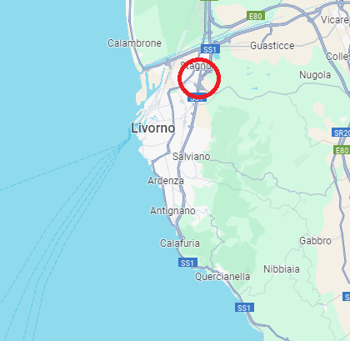  a | 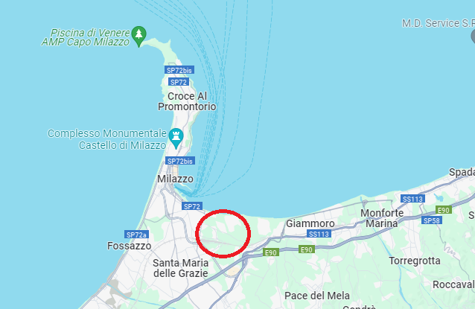  b | 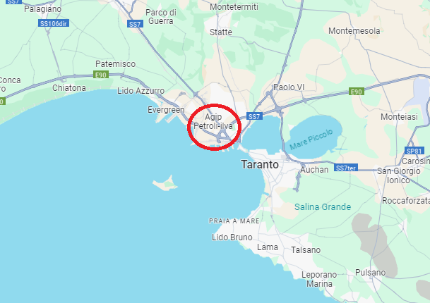  c
Figure 1: Italian refinery locations from Google Maps. a) Livorno, b) Milazzo, c) Taranto
Table 2 reports all the coordinates of the area used for the ESWD analysis, along with the extension of surface areas and the width of the plants (derived from Google Earth), used to calculate the scaled frequency.
Table 2: Quadrants localization and extensions (coordinates in WGS-84 lat N/long E format)
Location | Quadrant Coordinates | Extension [km²] | Second area Coordinates | Extension [km²] | Plant extension [km²]
Milazzo (ME) | 38-39;15-16 | 9676 | 38-38.5;15-15.5 | 2475 | 2.12
Taranto (TA) | 40-41;17-18 | 9402 | 40.25-40.75;17-17.5 | 2350 | 2.75
Livorno (LI) | 43-44;10-11 | 8986 | 43.25-43.75;10.1-10.6 | 2422 | 1.6
    - Extreme wind events
At first, extreme wind classification is done by splitting the Italian peninsula in quadrants following latitude and longitude lines, as showed in Figure 2 (as proposed in the original method). A total number of 58 quadrants using meridians (from 7° to 19° East) and parallels (from 36° to 47° North) are identified.
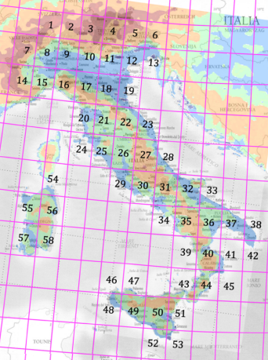  a | 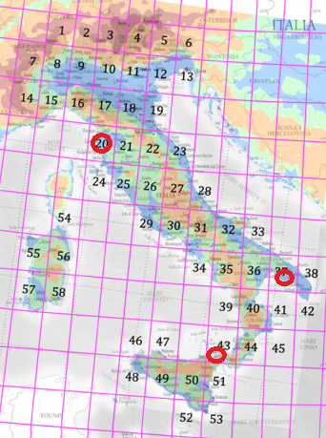  b
Figure 2: Italy maps, a) quadrants created with latitude and longitude lines, b) refineries localization
A single area in the map is included between two consecutive meridians and parallels, but, while the distance between two parallels remains the same, it increases for the meridian passing by the North Pole towards the Equator. So, the area size is not equal for all quadrants and could change by up to 14 % (Santamato, 2022). The historical analysis performed with ESWD allows to identify these extreme wind events: gustnadoes, tornadoes and severe winds. A gustnado is a vortex occurring along a gust front of a convective storm. It extends upward from the earth's surface, but it is not connected with a cloud. A tornado is a vortex from a few m to a few km in diameter, extending between a convective cloud and the earth's surface, that may be visible by condensation of water and/or by material that is lifted off the earth's surface. A severe wind is a gust measured with a speed of at least 25 m/s or one doing such damage that a wind speed of 25 m/s or higher is likely to have occurred. ESWD allows to select different settings to refine the research. For this paper, the tornado settings are the following: a) Analysis time: 50 years (from Jan.1974 to Jan.2023), since it matches with a typical industry life cycle; b) Events selected: gustnado, tornado, severe wind; c) Location: over land, water and unknown, in order to consider land and sea contribute; d) Report status: QC1 (report confirmed by reliable source), QC2 (scientific case study); e) Geographical coordinates: the quadrant where the plant is located according to Figure 2. Once the tornado likelihood in the area is estimated, the estimation procedure will be reiterated by changing the geographic coordinates, considering a zone closer to the plant. Geomorphological features impact the exposure to extreme winds, so, considering a simple quadrant may give unreliable results. In the results obtained with ESWD, some tornado classification is provided in accordance with Fujita Scale (F) while others in accordance with International Fujita Scale (IF), proposed and adopted by European Severe Storm Laboratory (ESSL, 2023). To conduce the present analysis, the following IF to F conversion was applied: IF 0.5 into F1 (e.g. for Livorno event on 05-08-16), from IF 1 into F1 (e.g. for Taranto event on 12-11-14) and IF 1.5 into F2 (e.g. for Livorno on 19-10-23). Considering that there is not an official procedure to do this conversion, it was chosen by similarity of wind velocities in F and IF class description, as indicated in Table 3 and Table 4. Alternatively, the conversion was made according to the damage information available in the records.
Table 3: International Fujita scale classification  INTERNATIONAL FUJITA SCALE (essl.org)  Grade Class Wind velocity (±20%)  IF 0 – IF 0.5 Weak 90 km/h – 120 km/h  IF 1 – IF 1.5 Moderate 150 km/h – 180 km/h  IF 2 – IF 2.5 Significative 220 km/h – 250 km/h  IF 3 Strong 290 km/h  IF 4 Devastating 380 km/h  IF 5 Catastrophic 470 km/h | Table 4: Fujita scale classification  FUJITA SCALE (Santamato, 2022)  Grade Class Wind velocity  F 0 Light 64-116 km/h  F 1 Moderate 117-180 km/h  F 2 Significant 181-253 km/h  F 3 Severe 254-332 km/h  F 4 Devastating 333-418 km/h  F 5 Incredible 419-512 km/h
Since IF 0.5 has a wind velocity included between 96-144 km/h (120 km/h ±20 %) and that F1 is included between 117-180 km/h, IF 0.5 class is closer to a F1 class rather than F0, associated with lower wind velocities. IF1 class was converted in F1 because both average wind velocities are close. In one case IF 1.5 was converted in F2 is due the fact that in the event description the following information was reported: “flipped car suggest an IF2 rating but being the only D.I. [Damage Indicator] for that rating with not supporting surrounding damage, IF1.5 rating is given on other supportive D.I.s”. So, this event could be considered in the middle between IF 1.5 and IF2. Lacking specific information, it is deemed more proper to convert it as an F2 class, rather than F1.
  - Results and discussion
Historical tornado analysis has been conducted, using ESWD, by applying the settings indicated in the Table 5.
Table 5: Settings data for tornado likelihood analysis
Locations | Milazzo (ME), Taranto (TA), Livorno (LI)
Time period | From 01-01-1974 to 31-01-2024 (50 years)
Events | Gustnado Tornado Severe Wind
Report Status | QC1, QC2
The results are reported in Table 6, Table 7 and Table 8 and, respectively, in Figure 3, Figure 4 and Figure 5. For what concerns Milazzo site, 108 tornadoes and 25 severe winds have been reported over 50 years. Taranto quadrant is the less exposed to tornadoes, with 65 registered events and 30 severe winds.
Livorno quadrant reads the same number of tornadoes as Milazzo, but a remarkably higher number of sever winds, with a total of 163 observations. In all cases, most of tornadoes fall in F1 and F0 class.
Since gustnadoes have not been observed on any of these sites, this kind of natural event will not be considered anymore in the analysis. Following the likelihood estimation procedure of the original method, tornado likelihoods obtained for each site are showed in Table 9. At this point, a different geographical area was used to conduce the historical analysis, respect the previous ones, which follow a whole quadrant as a reference area. The new settings, the same as the ones indicated in Table 5, are chosen by halving the size of the quadrants and pose refineries location indicatively in the middle of the area, to concentrate the analysis in a zone closer to the plants, possibly being more representative of the region of interest. As an example, Taranto quadrant, shown in Figure 4, includes both Ionian Sea (south) and Adriatic Sea (North). The two coasts are subjected to different meteorological phenomena, due to different positions. It is reasonable then to assume that a region of interest for an historical analysis should be representative of the geomorphological contest of the location.
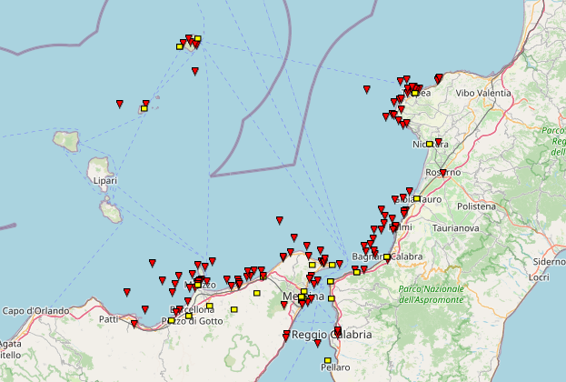  Figure 3: Area considered with ESWD for Milazzo  Milazzo plant |  | Table 6: Milazzo (ME) analysis results  Location Milazzo (ME)  Events type n. Notes  Gustnado 0 //  Tornado 108 101 not classified 6 in F0 class 1 in F1 class  Severe wind 25 Wind speed from 25.8 m/s to 34.9 m/s
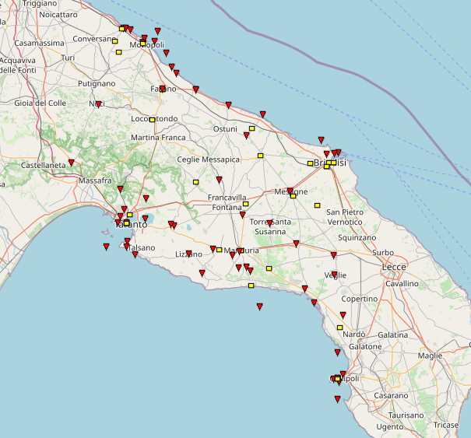Figure 4: Area considered with ESWD for Taranto  Taranto plant | Table 7: Taranto (TA) analysis results  Location Taranto (TA)  Events type n. Notes  Gustnado 0 //  Tornado 65 41 not classified 8 in F0 class 14 in F1 class 1 in F2 class 1 in F3 class  Severe wind 30 //

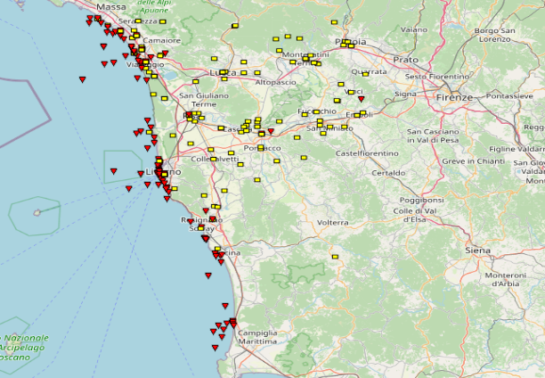  Livorno plant  Figure 5: Area considered with ESWD for Livorno | Table 8: Livorno (LI) analysis results  Location Taranto (TA)  Events type n. Notes  Gustnado 0 //  Tornado 108 93 not classified 4 in F0 class 8 in F1 class 3 in F2 class  Severe wind 163 Wind speed from 22.3 m/s to 38 m/s
Table 9: Tornado propensity level for the analyzed sites
Sites | Screening score | Tornado Propensity Level
Milazzo (ME) | 8.5 | Low
Taranto (TA) | 19 | High
Livorno (LI) | 18 | High
The obtained results are showed in Table 10. The total number of identified events is lower, with 39 tornadoes detected close to Milazzo, 16 around Taranto, and 55 for Livorno. Considering that the area of interest is about half of the quadrant, Milazzo and Taranto record less than half of the events registered previously. This can be related to the fact that the original quadrant considers many different regions for these locations, involving zones that are naturally more exposed to such events. The updated tornado propensity levels are reported in Table 11.
Table 10: Results of tornado likelihood analysis
Location | Milazzo (ME) |  | Location | Taranto (TA) |  | Location | Livorno (LI)
Events | n. | Notes | Events | n. | Notes | Events | n. | Notes
Tornado | 39 | 2 in F0 | Tornado | 16 | 3 in F0  2 in F1  1 in F3 | Tornado | 55 | 2 in F0  3 in F1  2 in F2
By comparing the two different sets, Tornado Propensity Level is the same for Milazzo (low), but it lowered from high to medium for Taranto and Livorno. Screening score decreased anyways for all of the cases, going from 8.5 to 5 for Milazzo, from 19 to 10.5 for Taranto and from 18 to 13.5 for Livorno.
Table 11: Tornado propensity level for the analyzed sites
Sites | Screening score | Tornado Propensity Level
Milazzo (ME) | 5 | Low
Taranto (TA) | 10.5 | Medium
Livorno (LI) | 13.5 | Medium
Finally, by considering the effective evaluation of the scaled probability screening indexes on the plant, as reported in Table 12, it is possible to notice that, by considering a different zone for the selection of the historical analysis, the screening score results lower (and this is straightforward, due to the fact that lesser events are found), but also the scaled probability decreases of about one order of magnitude, where computable.
Table 12: Comparison of probability and frequency indexes estimation
 | Whole quadrant |  |  |  | Reduced area
Location | Plant/Cell area [km²] | Screening score | F_{i}  [event/y] | F_{i,eff}  [event/y] | Plant/Cell area[km²] | Screening score | F_{i}  [event/y] | F_{i,eff}  [event/y]
Milazzo(ME) | 2.19∙10⁻⁴ | 8.5 | n.d. | n.d | 8.57∙10⁻⁴ | 5 | n.d | n.d
Taranto (TA) | 2.92∙10⁻⁴ | 19 | 3 | 8.76∙10⁻⁴ | 1.17∙10⁻³ | 10.5 | 1 | 1.17∙10⁻³
Livorno (LI) | 1.78∙10⁻⁴ | 18 | 3 | 5.34∙10⁻³ | 6.66∙10⁻⁴ | 13.5 | 1 | 6.66∙10⁻⁴
  - Conclusions
In this work, the importance of reliable screening tools for NaTech risk analysis is underlined. Starting from a literature work, it was shown that, for what concerns the likelihood assessment for extreme winds exposure of chemical plants, the most practical method is using validated database, such as the ESWD. However, since no official reference is given on how to conduct historical analyses, it was shown that, by modifying the reference area for the collection of data, results may change drastically. The variation of results can be associated to both to the lack of data or related to a different morphology of the zone interested by extreme winds. It is recommended to use the model proposed by including a zone dependence analysis, studying how focussing on a zone closer to the interested plant leads to different results. In conclusion, despite the research and the information available nowadays for what concerns extreme winds, the lack of officially and generally acknowledged screening tools for NaTech scenario is still a crucial aspect for safety engineering applications.
References
Castro Rodriguez D.J., Pilone E., Camuncoli G., Demichela M., 2023, Implementation of a NaTech Vulnerability Index in a Seveso Establishment, Chem. Eng. Trans., 100, 43-48.
European Severe Storms Laboratory, 2018, The International Fujita (IF) Scale for tornado and wind damage assessments < https://www.essl.org/cms/wp-content/uploads/IF-scale_v1.0d.pdf> accessed 4/12/2023
Jain P., Pasman H.J., Waldram S.P., Rogers W.J., Mannan S.M., 2017, “Did we learn about risk control since Seveso? Yes, we surely did, but is is enough? An historical brief and problem analysis”. J. Loss Prev Process Ind, 49, 5-17.
Kalantarnia M., Khan F., Hawboldt K., 2010, Modelling of BP Texas City accident using dynamic risk assessment approach, Process Saf. Environ. Prot., 88, 191-199.
Krausmann E., 2020, Analysis of NaTech risk reduction in EU Member States using a questionnaire survey”. JRC European Commission
Krausmann E., Renni E., Campedel M., Cozzani V., 2011, Industrial accidents triggered by earthquakes, floods, and lightning: lessons learned from a database analysis”. Nat Hazards, 59, 285-300.
Necci A., Krausmann E., 2022, NaTech risk management, JRC Technical Report.
Santamato F., 2022, Definizione di un approccio semplificato per la valutazione del rischio NaTech determinato da tornado, M.Sc Thesis, Politecnico di Milano.
Ricci F., Casson Moreno V., Cozzani V., 2020, Analysis of NaTech Accidents Triggered by Extreme Temperatures in the Chemical and Process Industry, Chem. Eng. Trans., 82, 79-84.
Ricci F., Casson Moreno V., Cozzani V., 2021, A comprehensive analysis of the occurrence of NaTech events in Process Industry, Process Saf. Environ. Prot., 147, 703-713.
Seneviratne S.I. et al., 2021, Weather and Climate Extreme Events in a Changing Climate. Cambridge University Press, Cambridge, United Kingdom and New York, NY, USA, 1513–1766, doi:10.1017/9781009157896.013.

