Combining Smart Glasses and thermal imaging as a tool for water stress detection in greenhouses: A preliminary study

Gabriele Sara, Giuseppe Todde, Daniele Pinna, Maria Caria*
Department of Agricultural Sciences, University of Sassari, Viale Italia 39/A, 07100 Sassari (Italy)
*Corresponding: mariac@uniss.it, Tel. +39079229375

Keywords. Augmented reality, AR headset, Digital farming, Precision Agriculture, Protected cultivations
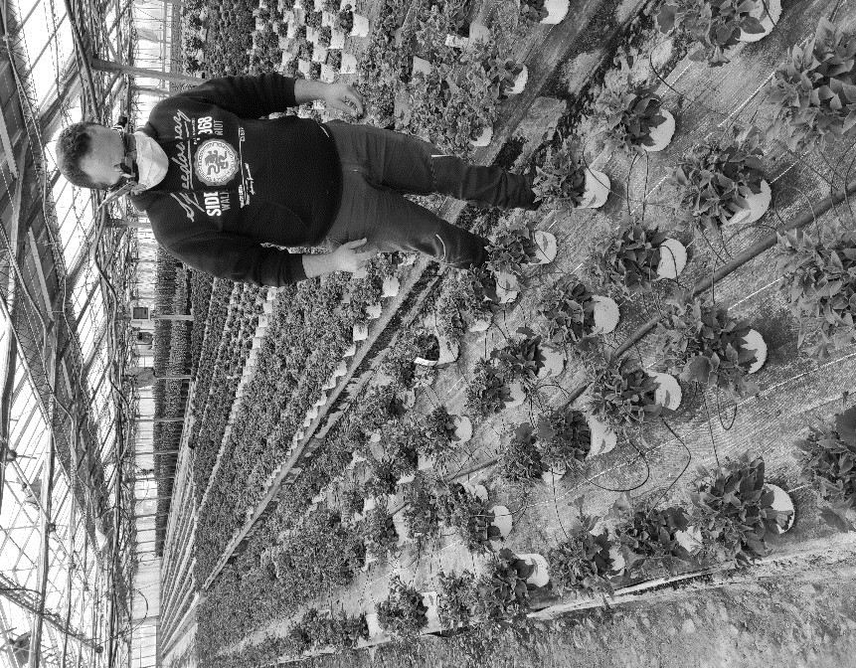
Abstract. The aim of the study was to combine low-cost thermal imaging camera with smart glasses to evaluate the feasibility of augmented reality system for monitoring water stress under protected conditions. The tests were performed in a greenhouse on 208 Petunia hybrid 'Surfinia' plants arranged in 4 rows. All the plants were irrigated to reach field capacity, while 15 of them did not received irrigation water for seven days before the trials. Three qualified operators had to identify the plants in water stress condition, using 3 operative modes: naked eyes (NE); thermal imaging camera (Thermal Compact Pro, Seek, USA) associated with a smartphone (TSP); thermal imaging camera associated with smart glasses (TSG, M400, Vuzix, USA). For each operator was recorded the operative time, the success rate and the number of errors in identifying the plants under water stress. The results showed a general low rate of water stressed plants identification in the three operative modes considered (NE: 13.3%; TSP: 6.6%; TSG: 6.6%). On the other hand, the unsuccessful detection of the plants in water deficit made by the operators was reduced about 40% when adopting the TSG as compared to NE operative mode. Moreover, the time needed to complete the task was higher adopting the TSP solution (4.60 minutes) than TSG and NE (2.63 and 1.85 minutes respectively). These outcomes represent a preliminary study concerning the implementation of augmented reality devices to support operators detecting plants in water stress, in order to improve work performances during on-field activities. It is therefore important to carry out further studies to evaluate and improve the use of thermal imaging cameras combined with Smart Glasses in different working conditions, to highlight limits and opportunities of this wearable solution.
Figure 1. Operator wearing Smart Glasses combined with thermal imaging camera during on-field tests

