**Improvement in durum wheat production using prescription maps from multispectral UAV surveys**

Maura Sannino1, Rossella Piscopo1, Salvatore Faugno1, Mariano Crimaldi1*

1 University of Naples “Federico II”, Department of Agricultural Sciences. Portici (NA), Italy.

[1 maura.sannino@unina.it](mailto:1%20maura.sannino@unina.it); [rossella.piscopo@unina.it](mailto:rossella.piscopo@unina.it); [salvatore.faugno@unina.it](mailto:salvatore.faugno@unina.it);

[*mariano.crimaldi@unina.it](mailto:*mariano.crimaldi@unina.it), phone: 081-2539257

**Keywords: UAV, prescription maps, multispectral survey, grain production**

**Abstract.** Precision agriculture has become increasingly central to agricultural production management over the years. The production system of grain crops requires high mechanization and ranges over medium to large areas, which makes the adoption of these precision systems compatible with the management system. The goal of this work is the use of multispectral surveys for the creation of prescription maps in order to improve the production of durum wheat. The work has been conducted in a conventional Italian cereal farm in Southern Italy (Avellino area) with the aim of verifying the reduction in terms of inputs to be used for production. A survey of the cultivation of durum wheat has been conducted, through images obtained from multispectral surveys using UAVs. The images have been processed by specific software to subsequently create vegetation indices (NDVI, SAVI, MSAVI, LCI). The various indices have been analyzed to evaluate the potential causes that led some areas of the field to produce less than others, generating a prescription map that has been used in subsequent treatments (variable dosage of fertilizer) leading to an improvement in production and highlighting a significant saving of fertilizer compared to previous classical treatments.

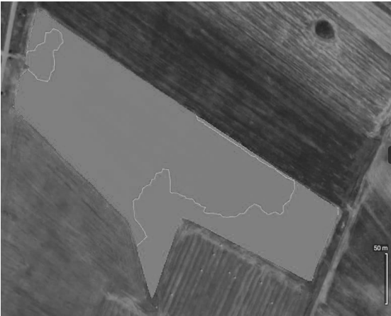

*Figure 1 – Prescription map from multispectral UAV survey*