Weed Control By Hot Vegetable Oil And Eugenol Spray

Roberto Oberti*, Aldo Calcante, Enrico Ferrari, Marco Torrente, Sara Vitalini, Tommaso Tadiello, Marcello Iriti, Luca Bechini

Università degli Studi di Milano, DiSAA - Dipartimento di Scienze agrarie e ambientali, Via Celoria 2, 20133 Milano (Italia) - email: [roberto.oberti@unimi.it](mailto:roberto.oberti@unimi.it)

**Keywords.** Non-chemical weed control, thermal weeding, vegetable oil, spray.

**Abstract.** More than one third of the total amount of pesticides used in Europe are herbicides. For this, non-chemical weed control plays a strategic role in achieving one of the major and more ambitious objectives of the Green Deal, i.e. to reduce by 50% the use of chemical pesticides in agriculture by 2030.

Among promising alternatives to chemical herbicides, thermal treatments aim to damage the external tissues of the weed, causing a loss of evapotranspiration control, with consequent breakdown of cellular membranes and plant drying in the field.

In this study, we investigated the phytotoxic activity of a mixture of eugenol, one of the main components in the essential oils of several aromatic plants, with hot vegetable oil. To this aim experimental tests of spray applications of hot soybean oil + eugenol (1.6% w/w) mixture were conducted on white mustard (Sinapis alba L.) grown in 30 x 30 cm trays as a surrogate weed. The mustard plants were treated at two stages of growth (2 leaves and 6 leaves) by applying two different volume rates (175 L/ha and 525 L/ha) of: i) soybean oil at two temperatures (120 °C and 220 °C); ii) soybean oil + eugenol (1.6% w/w) at a temperature of 120 °C; iii) water + eugenol (1.6% w/w).

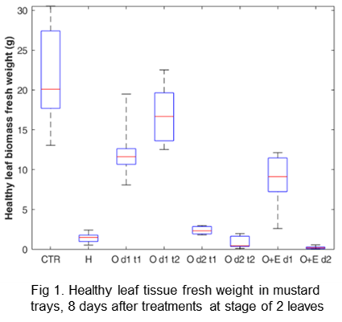The spraying tests were carried out by means of a laboratory prototype developed for this study, and able to deliver liquid spray at controlled temperature. The effect on plants was non-destructively monitored by imaging techniques during 8 days after treatments, and finally assessed by destructive harvest and manual separation of damaged from healthy plant tissue.

Weight reduction in fresh and in dry biomass, compared to untreated plants was used as quantitative index of the treatment efficacy.

High volume spraying of hot oil was found to produce a reduction in green biomass similar to contact herbicide, while hot oil + eugenol mixture resulted to provide even higher weeding efficacy.