Smart Irrigation Systems For Treated Wastewater Reuse

G. Mancuso a,*, V. Alagna b, G. D. Perulli a, B. Morandi a, A. Toscano a

a Department of Agricultural and Food Sciences, University of Bologna

b Department of Agricultural, Food and Forestry Sciences, University of Palermo

* Corresponding author: e-mail g.mancuso@unibo.it; Tel. +39 051 20 9 6182

**Keywords.** wastewater reuse, “smart” irrigation, drip irrigation, fertigation, circular economy.

**Abstract.** Climate change is causing an irreversible modification of the hydrological cycle, leading to unpredictable water availability, exacerbating water scarcity and contaminating water resources. Water scarcity is having a huge impact on agricultural irrigation, and therefore on food production. The treated wastewater (WW) reuse is a sustainable and resilient solution to face water scarcity and thus to preserve freshwater quantity and quality. WW is continuously produced by WW facilities and it contains nutrients, mainly N and P, which are essential elements for crop growth. With this in mind, one of the main activities performed within the VALUE CE-IN research project was the analysis of the effects of treated WW reuse on the efficiency of precision irrigation (drip irrigation) and fertigation systems at an experimental field site. In particular, the effects of secondary- and tertiary-treated domestic WW on crops (horticultural and orchards), soil, and soil-plant interaction were investigated. The experimental activity focused on the implementation of a "smart" pilot system (Figure 1), located within a full-scale WW treatment plant. The system was equipped with an automated control unit, which allowed the continuous treated WW quality control as well as the management of fertigation activities, based either on previously set or monitored parameters (e.g., crop nutritional and water needs, treated WW nutrient content, etc.).

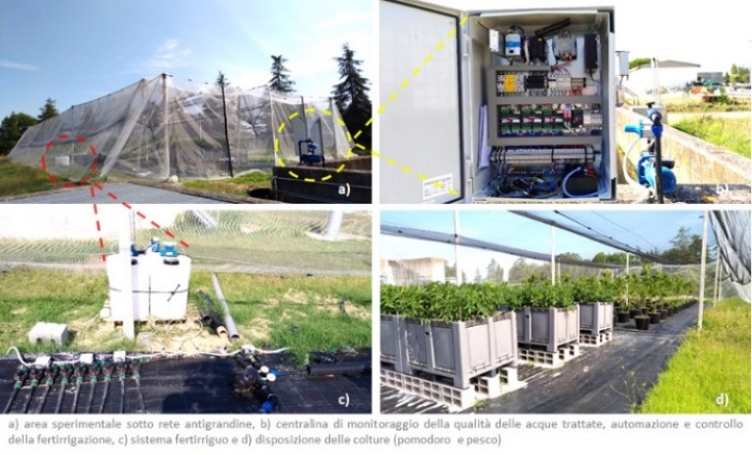

**Figure 1**. "Smart" pilot system.

The research proved that WW reuse can be a sustainable and safe practice using both secondary- and tertiary-treated WW, highlighting the importance of carrying out regular monitoring of WW quality and automatic irrigation systems, having positive effects on the operational costs and the environment, in accordance with the circular economy approach.